
UNIVERSITY OF ZAMBIA
SCHOOL OF MINES
DEPARTMENT OF GEOLOGY
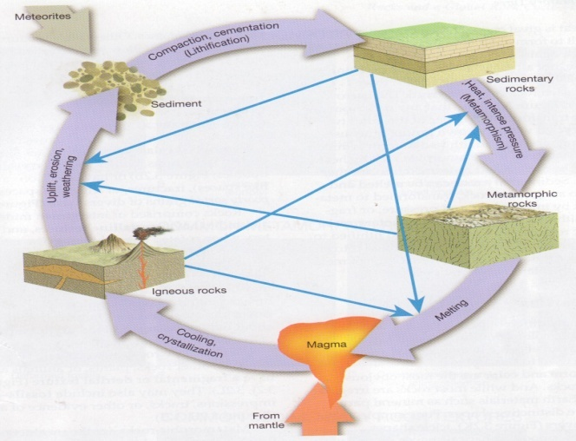

GGY 3020
MINERALOGY AND PETROLOGY
Part II: Introduction to Petrology
Dr. A. H. Ahmed

INTRODUCTION

Petros is the Greek word for rock. So, petrology is the science that concerns the genesis of rocks that is the origin and the formation processes of rocks. The word petrography is normally used if only descriptions of rocks are dealt with.

Rocks occur only in a fraction of the earth's volume that is the crust which is about 6 km thick under the oceans up to about 20 km at a maximum under the continents. The top layer of the crust, only found on the continents is often called the SIAL layer (Sllicon-ALuminium) and the lower part, the only part present under the oceans, the SIMA layer (Sllicon-Magnesium).

The continental crust and the oceanic crust form plates that float on the mantle underneath them. Through convection movements in the upper mantle, the floating plates collide and on ocean-continent borders the oceanic crust plunges under the continental crust. In the centre of the ocean new oceanic crust is continuously formed at the mid-oceanic ridges. The rate of movement at these so-called sea floor spreading centres is in the order of a few centimetres per year.

When rocks are observed a few things are immediately apparent:

- Rocks have variable chemical and mineralogical composition
- Rocks occur in different ways and environments
- Rocks may have different origins

Because of all these variables involved, there is a need for classification. The first division made is on the basis of origin, and the three main rock types distinguished are:

Igneous rocks: Solidification from a molten magma

Sedimentary rocks: Accumulation of loose particles on the earth's crust

Metamorphic rocks: Adaptation of igneous or sedimentary rocks to physical/chemical conditions different from those under which the rock was originally formed

PETROLOGY

\
\
CHAPTER ONE
Igneous petrology

OBJECTIVES
On completion of the course, students should be able to:
- Understand the basic concepts of igneous rock formation
- Identify, describe and classify the major igneous rocks both in hand specimen and under a microscope
- Recognize, identify and describe textures of igneous rocks
- Interpret how igneous rocks originated
- Relate the various igneous rocks to tectonic settings

Introduction
An igneous rock is any crystalline or glassy rock that forms from cooling of magma.
Igneous rocks are formed by solidification of magma-molten rock matter, usually carrying some amounts of crystals and containing small admixture of dissolved gases. Magma has the general composition of the complex silicate melt: it is composed of a discontinuous, fluctuating matrix of variously linked Si⁴⁺, Al³⁺, and O²⁻ ions which held the main metallic ions (Fe²⁺, Fe³⁺, Mg²⁺, Ca²⁺, Na⁺, K⁺) and other elements (Ti⁴⁺, Mn²⁺, Ni²⁺, S²⁻, Cl⁻, F⁻, OH⁻, etc).

The ultimate sources of all magmas lie in the mantle and their crystallization takes place within the crust or on the surface due to the cooling or decreasing the pressure. The first minerals to crystallize are those formed at high temperatures from almost anhydrous melt
Igneous process provides some of the most spectacular geologic activity visible at Earth’s surface. Igneous rocks also form deep inside Earth, so they provide information on a host of topics including Earth’s antiquity, deep composition, and past and present tectonic events. Thus, understanding igneous rocks is important to understanding Earth itself
In this exercise emphasis is placed on recognition and interpretation of igneous rocks. Because these rocks solidify from hot molten material (magma), direct observation of igneous rock formation is limited to extrusive igneous materials such as those associated with volcanic activity. Significant knowledge of the environments and conditions under which magmas form and eventually solidify has been achieved, however, based upon studies of composition and texture of igneous rocks, considerable attention will be focused on these two properties in this exercise. Once one develops the ability to correctly use them, recognition and interpretation of igneous rocks can be achieved
A magma consists mostly of liquid rock matter, but may contain crystals of various minerals, and may contain a gas phase that may be dissolved in the liquid or may be present as a separate gas phase.

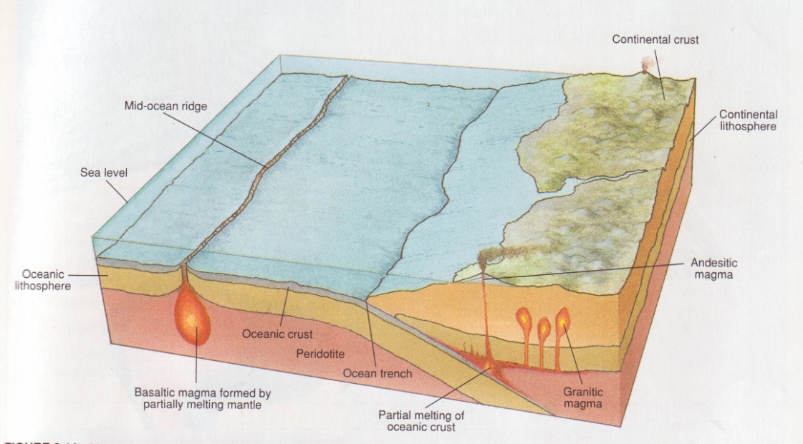
Fig Magma generation in different geologic environments

Magma can cool to form an igneous rock either on the surface of the Earth - in which case it produces a volcanic or extrusive igneous rock, or beneath the surface of the Earth, - in which case it produces a plutonic or intrusive igneous rock.
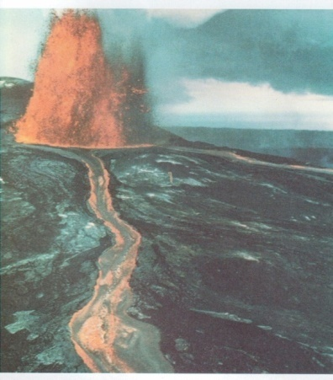

Gases in Magmas
At depth in the Earth nearly all magmas contain gas dissolved in the liquid, but the gas forms a separate vapor phase when pressure is decreased as magma rises toward the surface. This is similar to carbonated beverages which are bottled at high pressure. The high pressure keeps the gas in solution in the liquid, but when pressure is decreased, like when you open the can or bottle, the gas comes out of solution and forms a separate gas phase that you see as bubbles. Gas gives magmas their explosive character, because volume of gas expands as pressure is reduced. The composition of the gases in magma are:
- Mostly H₂O (water vapor) with some CO₂ (carbon dioxide)
- Minor amounts of Sulfur, Chlorine, and Fluorine gases
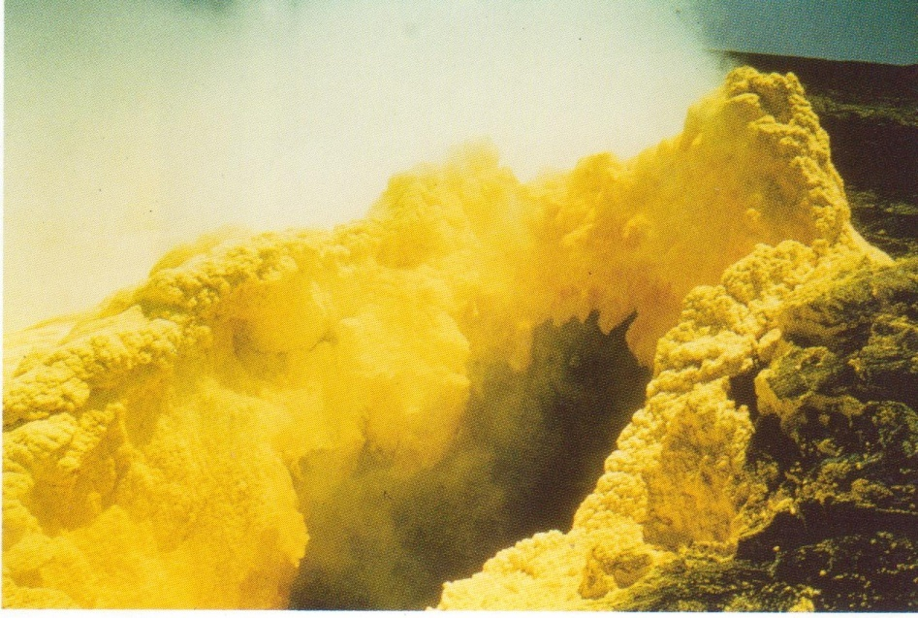
Figure 3 A fumaroles ( volcanic gas vent) in Kilauea caldera Deposits sulphur as the gases cool and mix with air

The amount of gas in a magma is also related to the chemical composition of the magma. Rhyolitic magmas usually have higher dissolved gas contents than basaltic magmas.

Temperature of Magmas
Temperature of magmas is difficult to measure (due to the danger involved), but laboratory measurement and limited field observation indicate that the eruption temperature of various magmas is as follows:
- Basaltic magma - 1000 to 1200ºC
- Andesitic magma - 800 to 1000ºC
- Rhyolitic magma - 650 to 800ºC.
Viscosity of Magmas
Viscosity is the resistance to flow (opposite of fluidity). Viscosity depends on primarily on the composition of the magma, and temperature.
- Higher SiO₂ (silica) content magmas have higher viscosity than lower SiO₂ content magmas (viscosity increases with increasing SiO₂ concentration in the magma).
- Lower temperature magmas have higher viscosity than higher temperature magmas (viscosity decreases with increasing temperature of the magma).
Thus, basaltic magmas tend to be fairly fluid (low viscosity), but their viscosity is still 10,000 to 100,0000 times more viscous than water. Rhyolitic magmas tend to have even higher viscosity, ranging between 1 million and 100 million times more viscous than water. (Note that solids, even though they appear solid have a viscosity, but it is very high, measured as trillions time the viscosity of water). Viscosity is an important property in determining the eruptive behavior of magmas.

Summary Table
Magma Type | Solidified Rock | Chemical Composition | Temperature | Viscosity | Gas Content
Basaltic | Basalt | 45-55 SiO₂ %, high in Fe, Mg, Ca, low in K, Na | 1000 - 1200 ºC | 10 - 10³ PaS | Low
Andesitic | Andesite | 55-65 SiO₂ %, intermediate in Fe, Mg, Ca, Na, K | 800 - 1000 ºC | 10³ - 10⁵ PaS | Intermediate
Rhyolitic | Rhyolite | 65-75 SiO₂ %, low in Fe, Mg, Ca, high in K, Na. | 650 - 800 ºC | 10⁵ - 10⁹ PaS | High

A magma crystallizes as a result of its cooling in the crust or on the surface, reduction of the pressure or separating out of its gaseous components. In the course of crystallization minerals can react with the melt, changing its composition or the composition of melt may be changed by assimilation of the surrounding rocks. The phenomenon of crystallization is very complex. The components of a silicate melt mutually lower than another’s freezing temperatures to a considerable degree. Further, the order of crystallization depends also upon the concentration of a given component in the melt and a mineral can crystallize if the melt is saturated with it under the existing conditions. These processes may be traced, however, in the simplified experimental runs which enable to recognize the behavior of the more complex multicomponent systems of magmas during their solidification

However more complicated, the crystallization of magma follows generally the patterns described above with the tendency for equilibrium to be maintained between the solid and liquid phases. To achieve it, the early formed crystals may react with liquid and change their composition. This reaction may be continuous to produce the homogenous solid solution as it is for plagioclases (when temperature falls the crystals become progressively more sodic). For ferromagnesian minerals their reactions with the liquid phase form completely new minerals with different crystal structure (olivines -- pyroxenes -- amphiboles). Both types of
transformations, known respectively as Bowen’s continuous and discontinous series point out for the coexistence of certain groups of minerals which in due course of magma cooling crystallize out together within a given range of p/T conditions (e.g. olivine + Mg-pyroxene, mica + alkali feldspar + quartz) and also those which tend to be antI achetic quartz – bytownite, orthoclase-labi diorite). If the reactions are incomplete (e.g. due to the rapid cooling, the early formed members of both series may persist in the final rock (e.g. as zoned crystals).
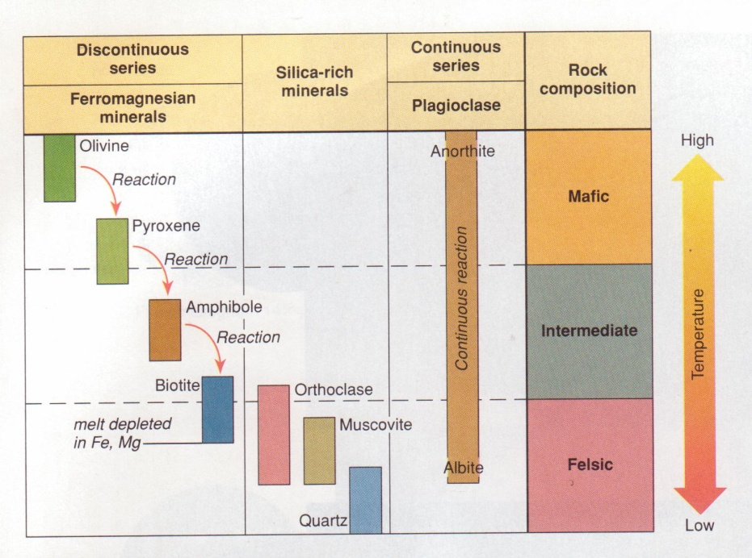
This described above differentiation of magma is known as its fractionation resulting from crystallization. The following processes are also of some importance: Liquid immiscibility – the separation of liquid sulphide from the liquid silicate fraction, gravitational settling and flotation of the crystals and filter-press action of the residual liquids. Eventually, the composition of magma may also be influenced by its reaction with the wall rock in the process of assimilation or contamination. The other factors of magma differentiation – ionic migration within magma and gaseous transport of some volatile components play the minor role
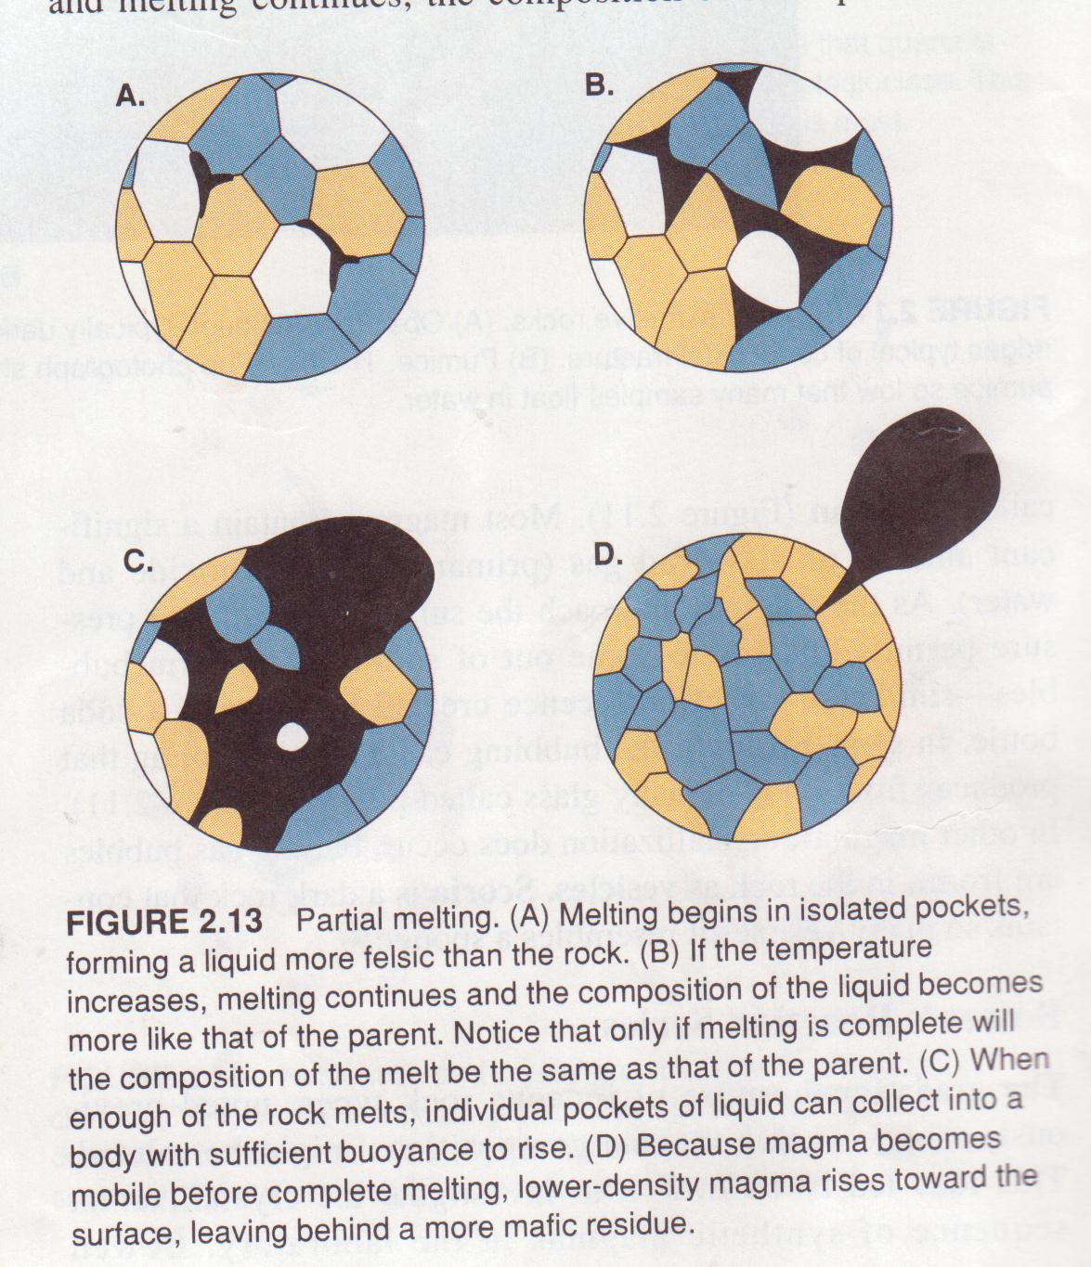

MINERALOGICAL COMPOSITION OF IGNEOUS ROCKS
The common igneous rocks are composed usually of three to six-phase combinations of a few widely distributed minerals. These essential constituents are: feldspars, quartz, pyroxenes, amphiboles, micas, olivines, felspathoides and glass. The accessory minerals occurring in amounts less 5% contain the elements excluded from on not completely accommodated in the principal phases (apatite, sphene, zircon, rutile, etc.).
The other division is based on colour of minerals. Felsic minerals are light and of relatively low density, about 2.5 – 2.7 (quartz, feldspars, feldspehoids). Mafic minerals are dark and with densities mostly from 3.0 to 3.6 (olivines, pyroxnes, amphiboles, biotite).
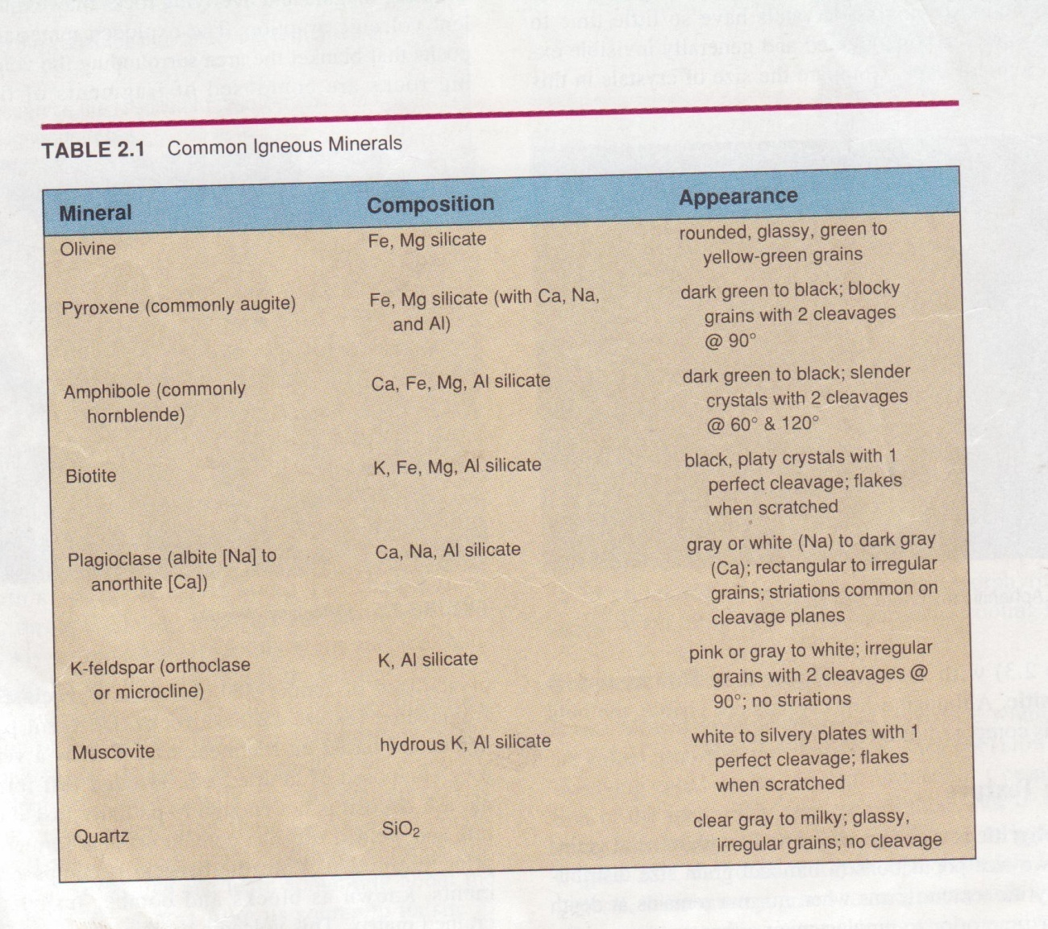

Apart from the above mentioned primary minerals, crystallizing directly during the magmatic processes, there is the group of the secondary minerals, formed during the postmagmatic deuteric processes or simply during the weathering. Their list includes: sericite, kaolinite, chlorite, epidote, chalcedony, calcite, Fe-hydroxides, etc.
There is the short list of more important minerals below, together with their chemical formulas and short characteristic:

Quartz SiO₂
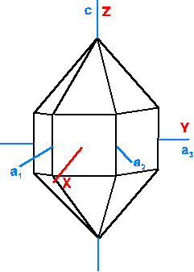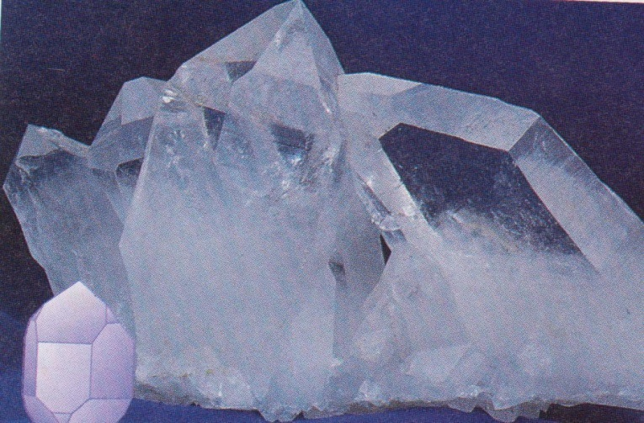
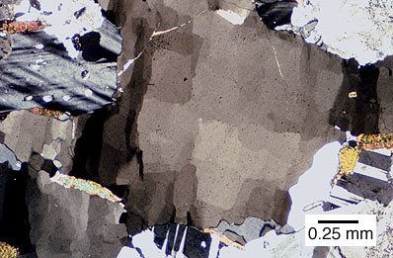
Figure 37 Quartz

Feldspars
K-feldspars and Na/Ca-feldspars (plagioclases) sanidine – anorthoclase (K, Na) (AlSi₃O₈) – (Na, K) (Si₃O₈) disordered high-temperature varieties, monoclinic at the potassic and triclinic towards the sodic end,
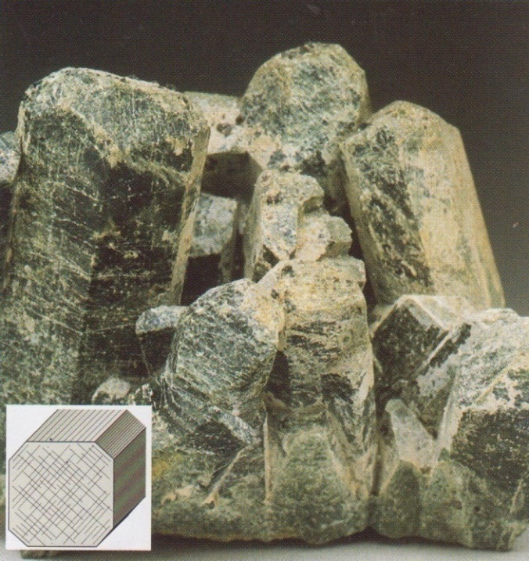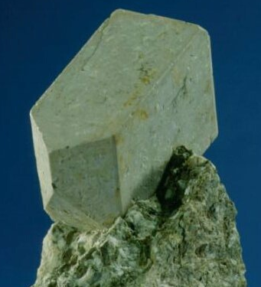
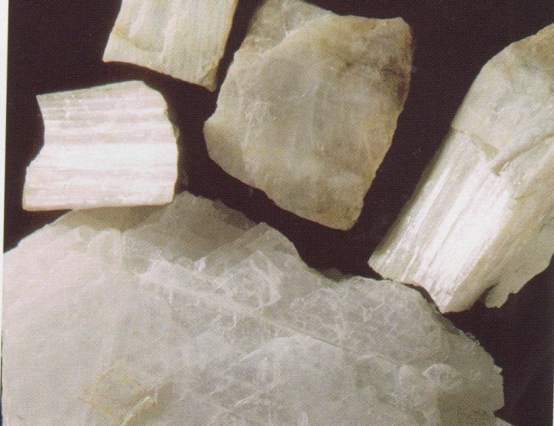
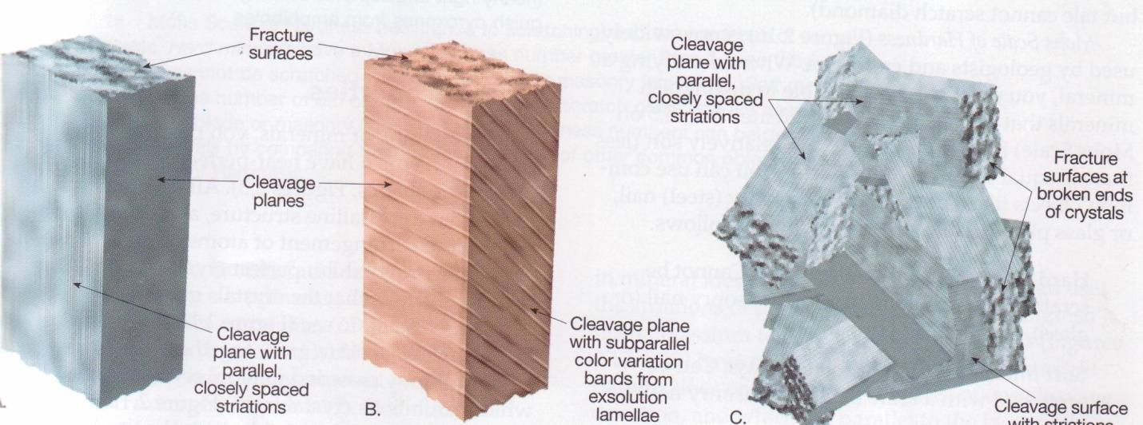
Figure 38 Feldspars

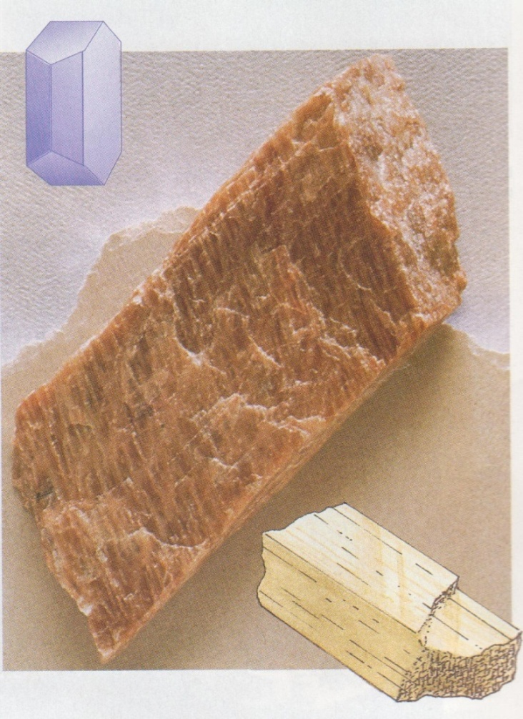
Figure 39 Potassium (K) feldspar exhibiting two directions of cleavage at 90⁰

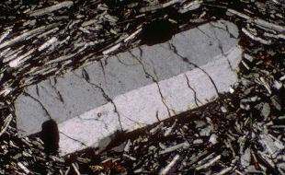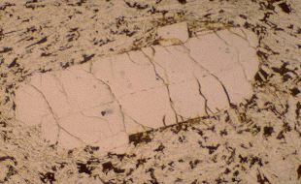
Figure 40 Plagioclase feldspar showing twining

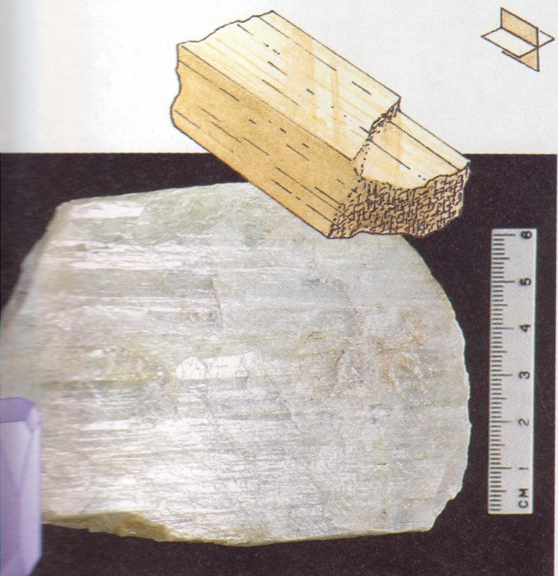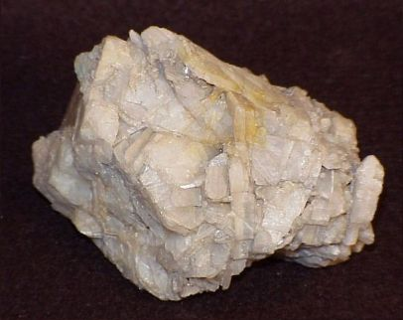
Figure 41 Plagioclase feldspar

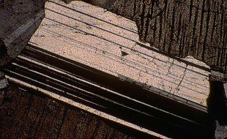
Figure 42 Plagioclase feldspar showing twining

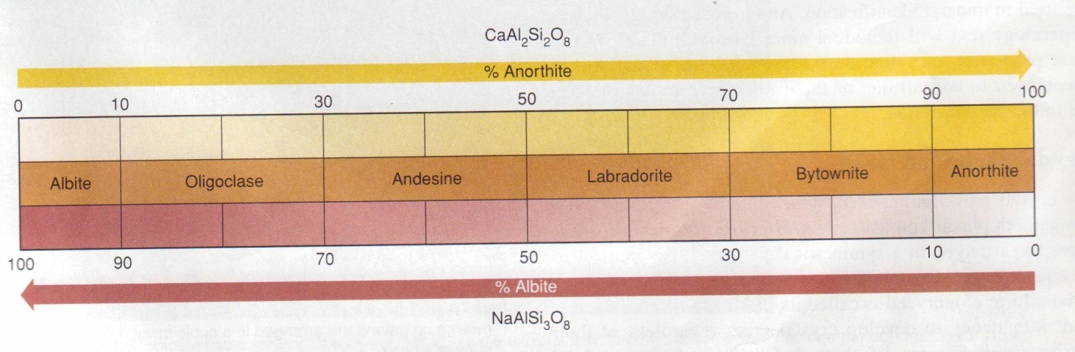
Figure 43 Plagioclase series

Feldspathoids

Olivines
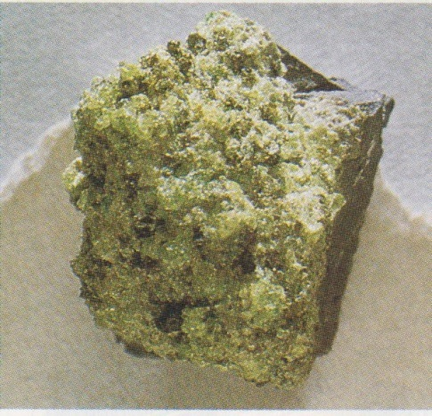
Figure 44 Olivine

Pyroxenes
orthopyroxenes (Mg,Fe)₂(Si₂O₆), namely enstatite, bronzite, hypersthene, up to 50% of Fe-molecule.
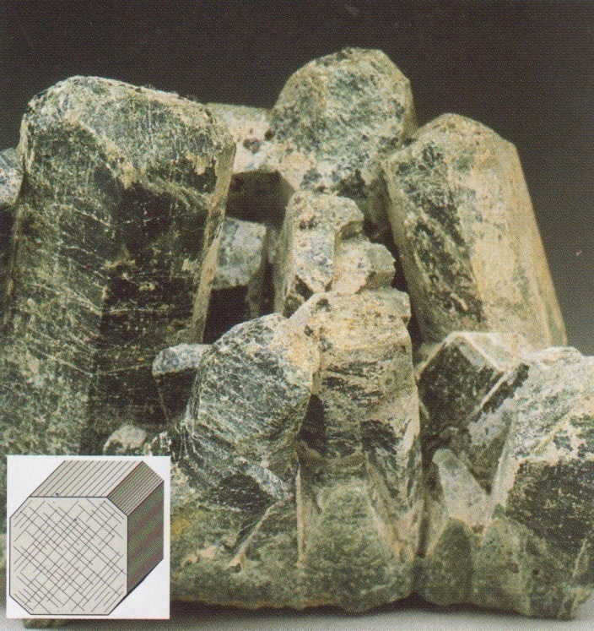
Figure 44 Pyroxene

clinopyroxenes of mainly augite-pigeonite group (Ca-Mg-Fe, sometimes also with Ti), sometimes aegirines (Na-Fe bearing).
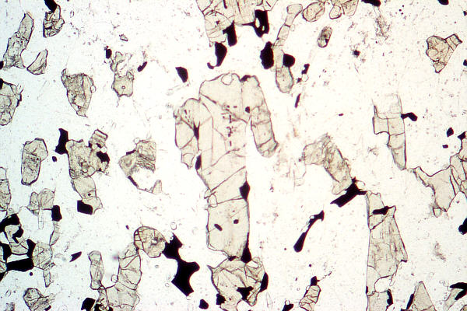
Figure 45 Augite in thin section

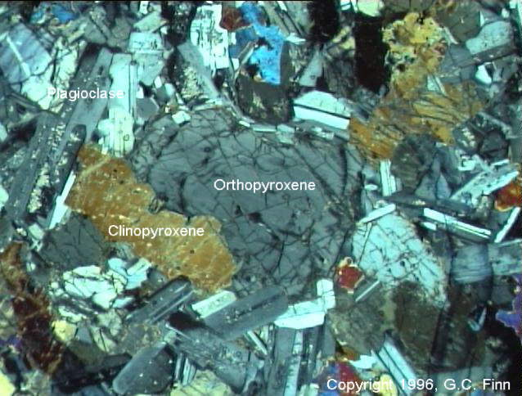
Figure 46 Pyroxenes in thin section

Amphiboles
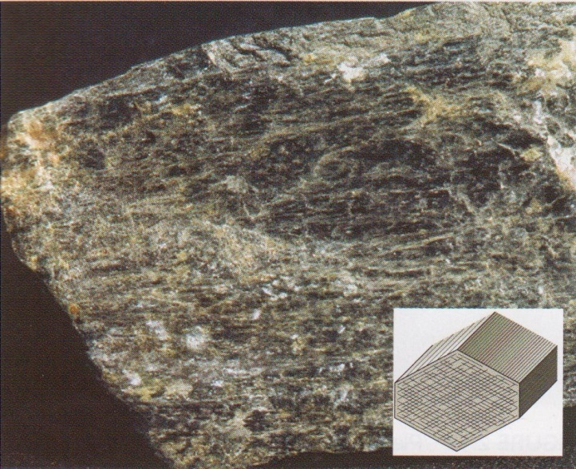
Figure 47 Amphibole
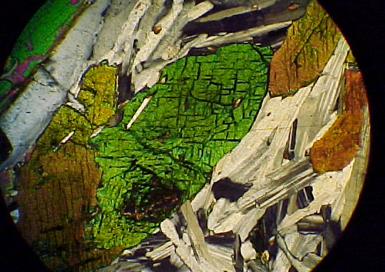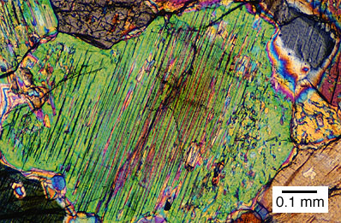
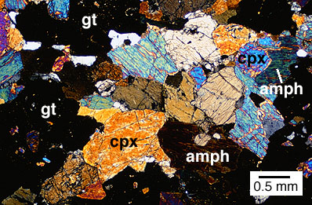
Figure 48 Amphibole in thin section

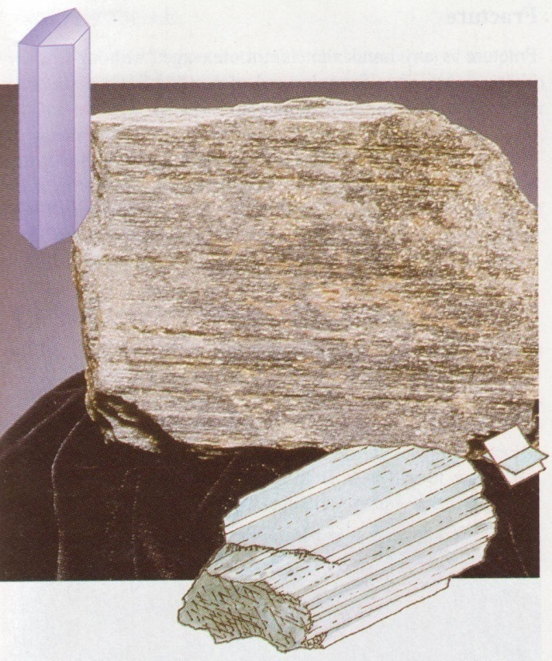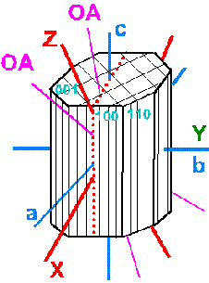
Figure 49 Hornblende specimen and crystal

hornblendes Na = Ca = Mg = Fe bearing and Ti-rich variety kaersutite

Micas
biotite K(Fe,Mg)₃(AlSi₃O₁₀) (OH)₂
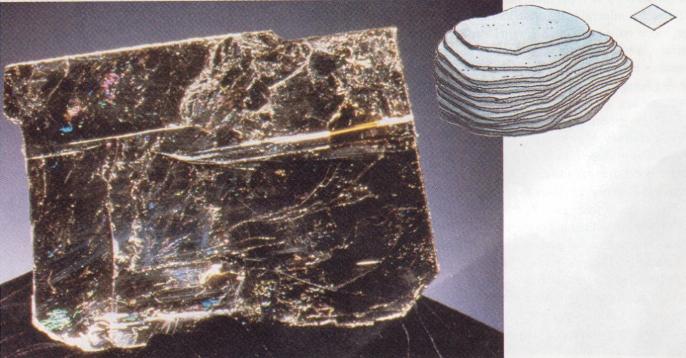
Figure 50 Biotite specimen
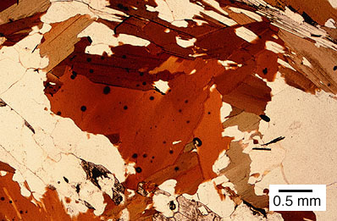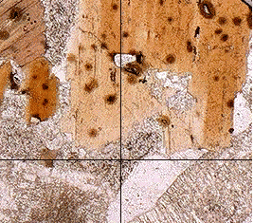
Figure 51 Biotite in thin section

Muscovite KAl₂(AlSi₃O₁₀) (OH)₂
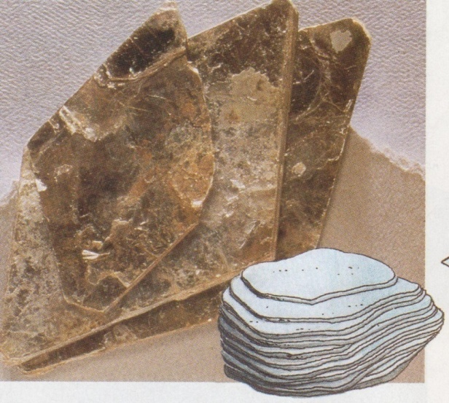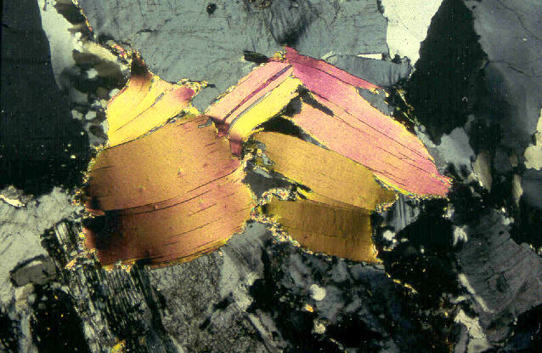
Figure 52 Muscovite specimen and in thin section

Glass
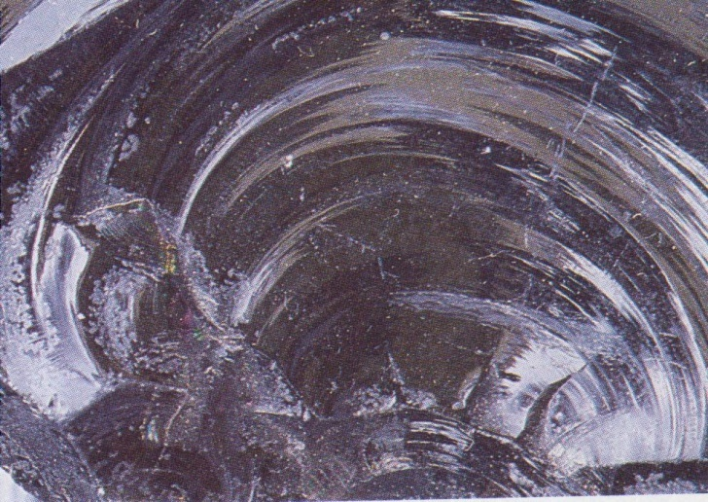
Figure 53 Glass

Modes of Occurrence of Igneous Rocks

One of the first things to determine about an igneous rock is the place of its formation: whether below or at the ground level. Extrusive (volcanic) rocks are formed by the flow of lava on the preexisting surfaces and the intrusive (plutonic) rocks crystallized within the preexisting rocks beneath the earth’s surface. Sometimes, on the basis of field studies, the third category of hypabyssal rocks can be added. They were formed in the shallow parts of the crust either being closely associated with the true volcanic rocks or forming of-shoots from the bigger plutons. From the point of view of petrographer there are not distinctive criteria to recognize the hypabyssal rocks under the microscope: most of them (wide spread basalts) fell within the volcanic rocks, some of them (diabases, lamprophyres, kimberlites) reveal textures characteristic rather for plutonic rocks. Thus, combining the field and microscopic observations one can deal with three groups of igneous rocks (coarse, medium, fine grained or plutonic, hypabyssal and volcanic), whereas for the microscopist only two groups (volcanic and plutonic rocks) exist.

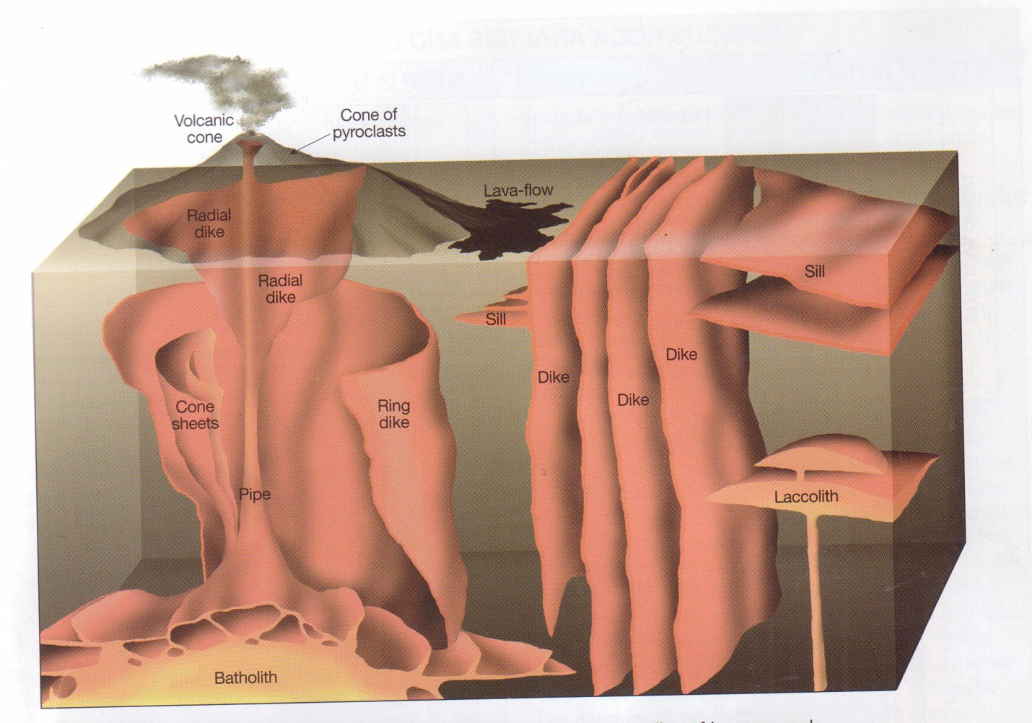
Main types of intrusive and extrusives bodies of igneous rocks\

Taking into consideration the shape of intrusive bodies and their relationship with the surrounding (country) rocks the following types of intrusions can be distinguished:

A. sheet intrusions,
B. lens-shaped intrusions
C. subjacent plutons.

Ad A. Within this group there are dikes and sills respectively discordant and concordant bodies against country rocks.

1. Dikes - they are tabular discordant masses that cut across
foliation or bedding of the surrounding rocks. Usually
they are emplaced into preexisting joint system,
occurring singly or in swarms. Occassionally, vertical or
outward dipping ring-dikes or inward dipping cone-
sheets may be found in oval or circular patterns over
an intrusion, being related to the doming action of the
igneous body. The thickness, length and the
composition of dikes vary in broad ranges.

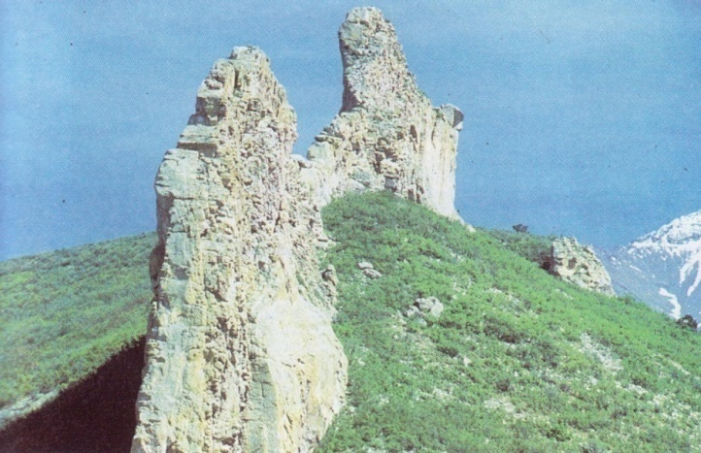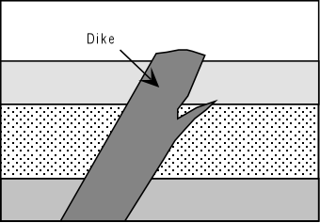
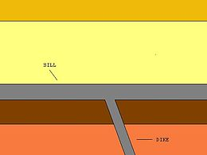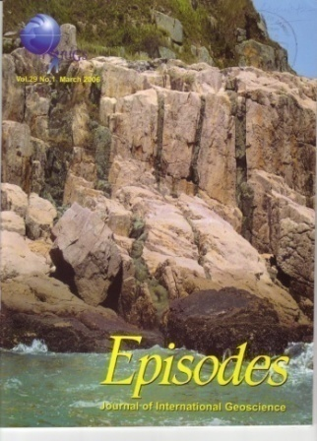

2. Sills - they are tabular bodies, emplaced essentially parallel
to the foliation or bedding of the country rocks. They
are usually of basic composition (basaltic), because
such magmas are less viscous and can spread laterally.
The thickness of sills may vary from a few to several
hundred metres.
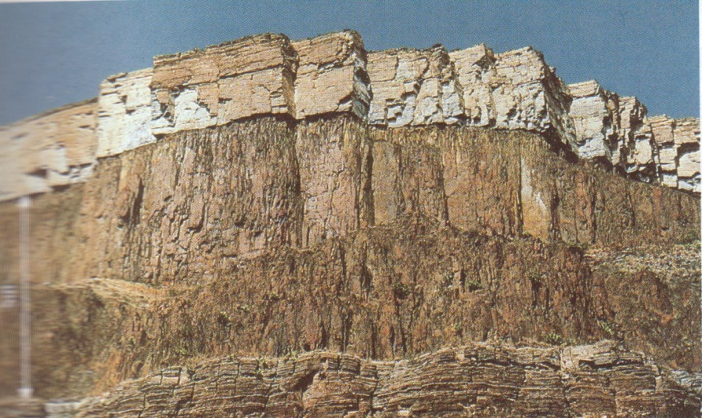

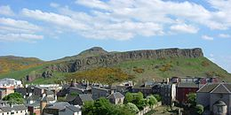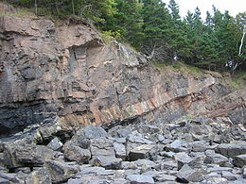

Ad B. The division is based mainly on the shape of intrustions:

1. Laccoliths - they are concordant, mushroom – shaped intrustions,
formed when magma rising up spreads out laterally
under more resistant layer. Most laccoliths are silicic or
intermediate in composition and they may grade
outwards into sill. Usually they are 1-8 km in diameter
with thickness of 1/3 of their diameter.
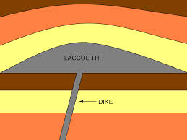

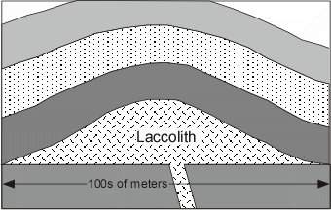

2. Lopoliths - they are lenticular, centrally sunken, generally
concordant, basin – or funnel-shaped intrusive masses.
The thickness is ** to ** of the width, and diameter
ranges from tens to hundreds of kilometers. They are
mafic to ultramafic in composition and a few have
upper layers differentiated even to silicic derivates.
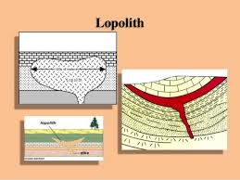

3. Phacoliths - lenticular concordant intrusions in the core of anticline
or syncline (doubly convex upwards or downwards
respectively). Emplaced after folding, with variable
rock composition and extent up to tens of kilometers.

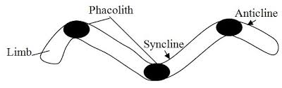

Ad C. Within this category fell only:

1. Batholiths - the large intrusive plutons with steeply dipping walls,
typically without any known floor. They range in size to
several thousand square kilometers and are usually
silicic in composition. Smaller bodies, about 100 km²,
are called stocks and if they are circular in cross-section
the name boss is used.

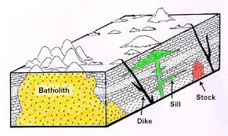

When the volcanic rocks are concerned, the type of their eruptions is governed by the viscosity of magma: the higher the silica content the higher viscosity. It means that basaltic magmas tend to erupt as fluid lavas with the formation of well-defined flows, whereas andesitic and especially rhyolitic magmas are so viscous that often erupt violently with formation of ejectamenta (ashes, blocks, bombs, etc). Those ejectamenta – pyroclastic rocks – will be discussed later as the group intermediate between the igneous and sedimentary rocks (igneous source of material with subsequent transport and deposition)

Under the subaerial conditions three main varieties of lavas can be distinguished:

1. block lava – composed of fragments relatively smooth, broken into
pieces up to several meters in size and showing the signs of flow
with tendency for some layers to shear over others,
am

2. aa lava – with rough surfaces resembling the furnace clinkers. The
clinker fragments are usually less than 15cm in diameter’

3. pahoehoe (ropy) lava – with rather smooth, glassy appearance,
showing often the snaky folds.

Lava flows may vary from a few cm in thickness to about 200m and they cover the areas of hundred thousands of km². A complete gradation between different varieties of lavas may exist.

The submarine extrusions give:

1. pillow lava – it consists of ellipsoidal masses (10cm to 6m in size),
piled one upon another, the intervening spaces being filled with the
material of sedimentary origin. The structure of each pillow is
composed of a glass crust and inside the composition is basaltic,
andesitic or spilitic (altered sodic basalt).

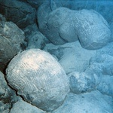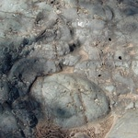

The lavas, especially towards the top of the flow, display often the gas bubbles, trapped during the degassing of lava flow. They should
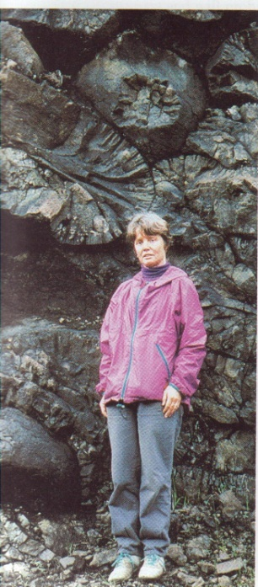
Figure 20 A dome of viscous lava squeezed up from the dome

Volcanic Landforms
Shield Volcanoes  - A shield volcano is characterized by gentle upper slopes (about 5º) and somewhat steeper lower slopes (about 10º). | 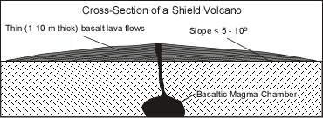  Figure 22 Shield volcano

- Shield volcanoes are composed almost entirely of thin lava flows built
- up over a central vent.
- Most shields are formed by low viscosity basaltic magma that flows easily down slope away form a summit vent.
- The low viscosity of the magma allows the lava to travel down slope on a gentle slope, but as it cools and its viscosity increases, its thickness builds up on the lower slopes giving a somewhat steeper lower slope.
- Most shield volcanoes have a roughly circular or oval shape in map view.
- Very little pyroclastic material is found within a shield volcano, except near the eruptive vents, where small amounts of pyroclastic material accumulate as a result of fire fountaining events.
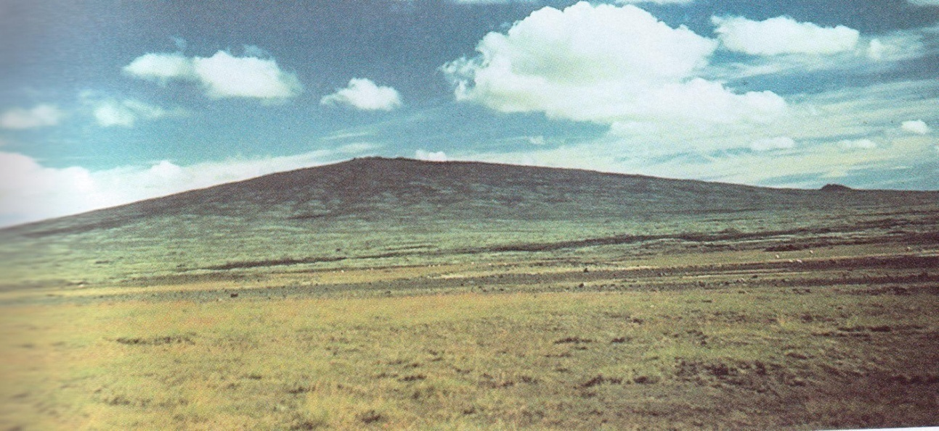
Figure 23 Shield volcano

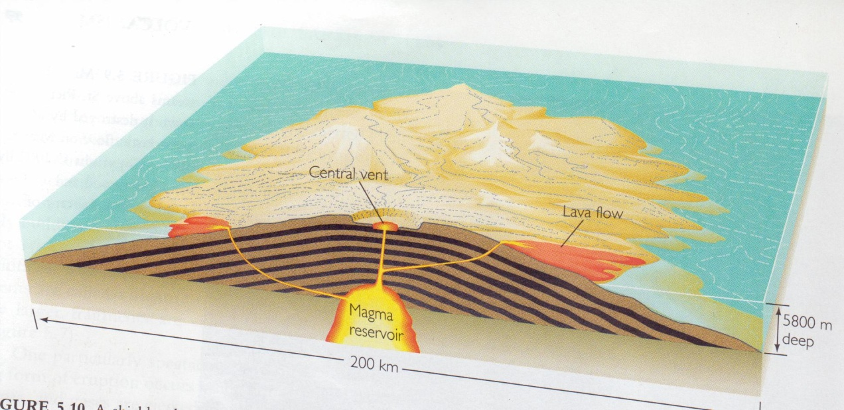
Figure 24 A shield volcano is built up of thousands of thin basaltic lava flows that spread widely and cools as gentle sloping sheets

Stratovolcanoes (also called Composite Volcanoes)

- Have steeper slopes than shields, with slopes of 6 - 10º low on the flanks to 30º near the summit.
- Steep slope near the summit result from thick, short viscous lava flows that don't travel far from the vent.
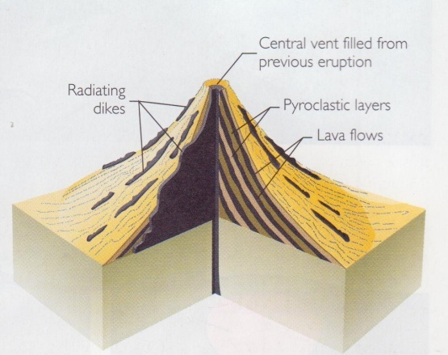
Figure 25 A composite volcano
volcano is built up of alternating layers of pyroclastic material and lava flows

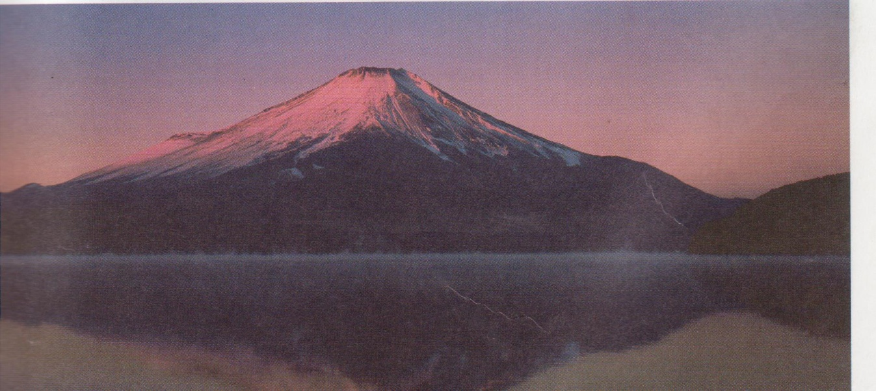
Figure 26 Fujiyama a composite volcano, Japan
The gentler slopes near the base are due to accumulations of material eroded from the volcano and to the accumulation of pyroclastic material.
- Stratovolcanoes show inter-layering of lava flows and pyroclastic material, which is why they are sometimes called composite volcanoes. Pyroclastic material can make up over 50% of the volume of a stratovolcano.
- Lavas and pyroclastics are usually andesitic to rhyolitic in composition.
- Due to the higher viscosity of magmas erupted from these volcanoes, they are usually more explosive than shield volcanoes.
- Stratovolcanoes sometimes have a crater at the summit, that is formed by explosive ejection of material from a central vent. Sometimes the craters have been filled in by lava flows or lava domes, sometimes they are filled with glacial ice, and less commonly they are filled with water.
- Long periods of repose (times of inactivity) lasting for hundreds to thousands of years, make this type of volcano particularly dangerous, since many times they have shown no historic activity, and people are reluctant to heed warnings about possible eruptions.

UNIT 3

MINERALOGICAL COMPOSITION OF IGNEOUS ROCKS
The common igneous rocks are composed usually of three to six-phase combinations of a few widely distributed minerals. These essential constituents are: feldspars, quartz, pyroxenes, amphiboles, micas, olivines, felspathoides and glass. The accessory minerals occurring in amounts less 5% contain the elements excluded from on not completely accommodated in the principal phases (apatite, sphene, zircon, rutile, etc.).
The other division is based on colour of minerals. Felsic minerals are light and of relatively low density, about 2.5 – 2.7 (quartz, feldspars, feldspehoids). Mafic minerals are dark and with densities mostly from 3.0 to 3.6 (olivines, pyroxnes, amphiboles, biotite).
Apart from the above mentioned primary minerals, crystallizing directly during the magmatic processes, there is the group of the secondary minerals, formed during the postmagmatic deuteric processes or simply during the weathering. Their list includes: sericite, kaolinite, chlorite, epidote, chalcedony, calcite, Fe-hydroxides, etc.
There is the short list of more important minerals below, together with their chemical formulas and short characteristic:

Quartz SiO₂
Figure 37 Quartz

Feldspars
K-feldspars and Na/Ca-feldspars (plagioclases) sanidine – anorthoclase (K, Na) (AlSi₃O₈) – (Na, K) (Si₃O₈) disordered high-temperature varieties, monoclinic at the potassic and triclinic towards the sodic end,
Figure 38 Feldspars

Figure 39 Potassium (K) feldspar exhibiting two directions of cleavage at 90⁰

Figure 40 Plagioclase feldspar showing twining

Figure 41 Plagioclase feldspar

Figure 42 Plagioclase feldspar showing twining

Figure 43 Plagioclase series

Feldspathoids

Olivines
Figure 44 Olivine

Pyroxenes
orthopyroxenes (Mg,Fe)₂(Si₂O₆), namely enstatite, bronzite, hypersthene, up to 50% of Fe-molecule.
Figure 44 Pyroxene

clinopyroxenes of mainly augite-pigeonite group (Ca-Mg-Fe, sometimes also with Ti), sometimes aegirines (Na-Fe bearing).
Figure 45 Augite in thin section

Figure 46 Pyroxenes in thin section

Amphiboles
Figure 47 Amphibole
Figure 48 Amphibole in thin section

Figure 49 Hornblende specimen and crystal

hornblendes Na = Ca = Mg = Fe bearing and Ti-rich variety kaersutite

Micas
biotite K(Fe,Mg)₃(AlSi₃O₁₀) (OH)₂
Figure 50 Biotite specimen
Figure 51 Biotite in thin section

Muscovite KAl₂(AlSi₃O₁₀) (OH)₂
Figure 52 Muscovite specimen and in thin section

Glass
Figure 53 Glass

UNIT 4

Textures of Igneous Rocks
The main factor that determines the texture of an igneous rock is the cooling rate (dT/dt).
Other factors involved are:
- The diffusion rate - the rate at which atoms or molecules can move (diffuse) through the liquid.
- The rate of nucleation of new crystals - the rate at which enough of the chemical constituents of a crystal can come together in one place without dissolving.
- 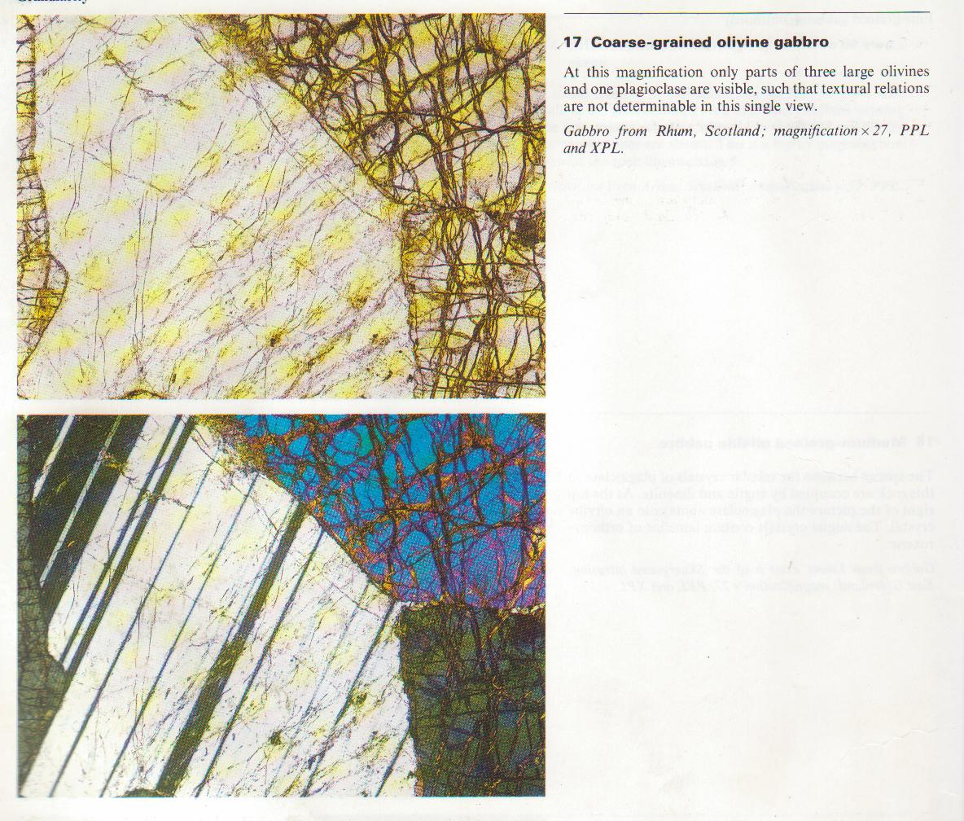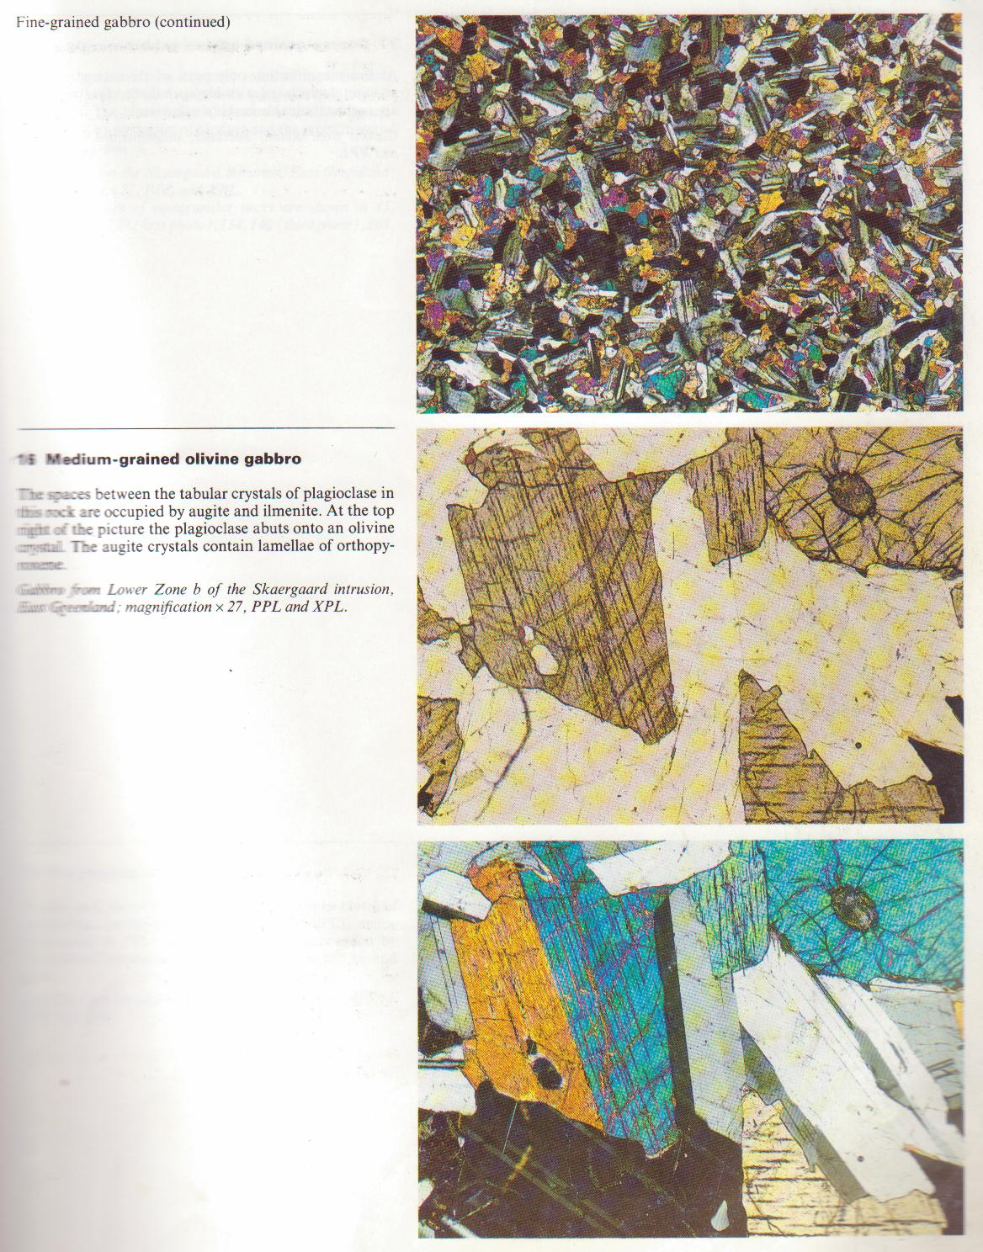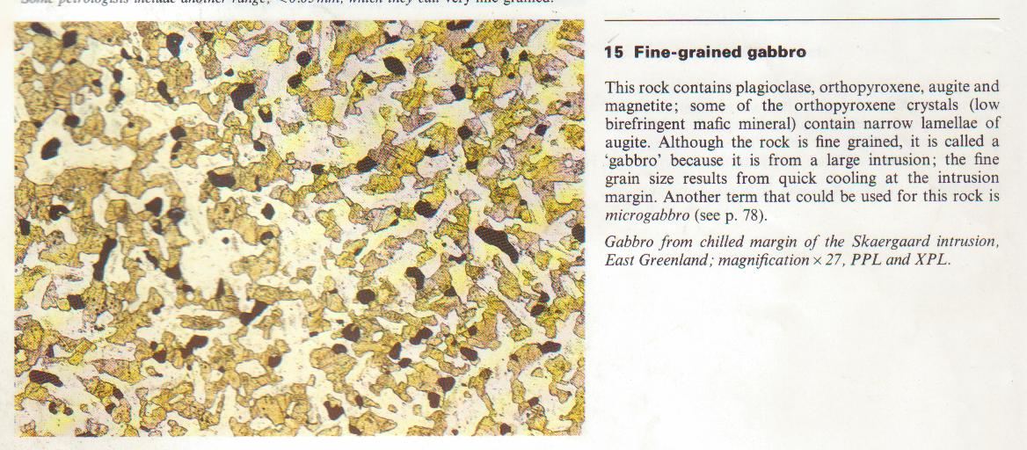The rate of growth of crystals - the rate at which new constituents can arrive at the surface of the growing crystal. This depends largely on the diffusion rate of the molecules of concern.

Figure 54 Grain size, from left to right,coarse grain, medium grain and fine grain
In order for a crystal to form in a magma enough of the chemical constituents that will make up the crystal must be at the same place at the same time to form a nucleus of the crystal. Once a nucleus forms, the chemical constituents must diffuse through the liquid to arrive at the surface of the growing crystal. The crystal can then grow until it runs into other crystals or the supply of chemical constituents is cut off.

All of these rates are strongly dependent on the temperature of the system. First, nucleation and growth cannot occur until temperatures are below the temperature at which equilibrium crystallization begins. Shown below are hypothetical nucleation and growth rate curves based on experiments in simple systems. Note that the rate of crystal growth and nucleation depends on how long the magma resides at a specified degree of undercooling (DT = T_{m} - T), and thus the rate at which temperature is lowered below the the crystallization temperature. Three cases are shown.

- For small degrees of undercooling (region A in the figure to the right) the nucleation rate will be low and the growth rate moderate. A few crystals will form and grow at a moderate rate until they run into each other. Because there are few nuclei, the crystals will be able to grow to relatively large size, and a coarse grained texture will result. This would be called a phaneritic texture. | 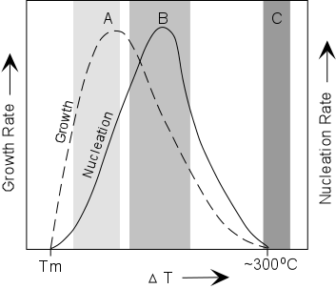

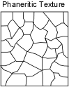

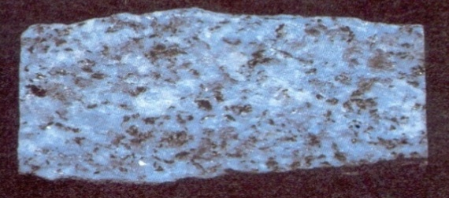
Figure 55 Phaneritic texture ,coarse grained
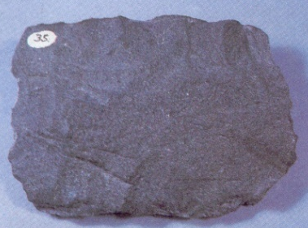
- At larger degrees of undercooling, the nucleation rate will be high and the growth rate also high. This will result in many crystals all growing rapidly, but because there are so many crystals, they will run into each other before they have time to grow and the resulting texture will be a fine grained texture. If the size of the grains are so small that crystals cannot be distinguished with a handlens, the texture is said to be aphanitic.

Figure 56 Aphanitic texture, fine grained
- At high degrees of undercooling, both the growth rate and nucleation rate will be low. Thus few crystals will form and they will not grow to any large size. The resulting texture will be glassy, with a few tiny crystals called microlites. A completely glassy texture is called holohyaline texture.

Two stages of cooling, i.e. slow cooling to grow a few large crystals, followed by rapid cooling to grow many smaller crystals could result in a porphyritic texture, a texture with two or more distinct sizes of grains. Single stage cooling can also produce a porphyritic texture. In a porphyritic texture, the larger grains are called phenocrysts and the material surrounding the the phenocrysts is called groundmass or matrix  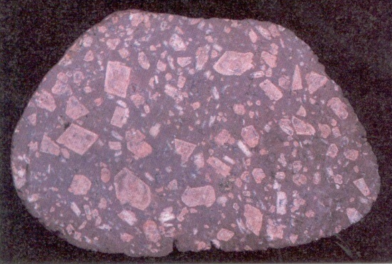  Figure 57 Porphyritic texture | 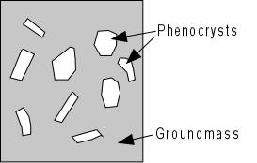

In a rock with a phaneritic texture, where all grains are about the same size, we use the grain size ranges shown to the right to describe the texture:
  <1 mm | fine grained
  1 - 5 mm | medium grained
  5 - 3 cm | coarse grained
  > 3 cm | very coarse grained

In a rock with a porphyritic texture, we use the above table to define the grain size of the groundmass or matrix, and this table to describe the phenocrysts:
  0.03 - 0.3 mm | microphenocrysts
  0.3 - 5 mm | phenocrysts
  > 5 mm | megaphenocrysts

Another aspect of texture, particularly in medium to coarse grained rocks is referred to as fabric. Fabric refers to the mutual relationship between the grains. Three types of fabric are commonly referred to:
- If most of the grains are euhedral - that is they are bounded by well-formed crystal faces. The fabric is said to be idomorphic granular.
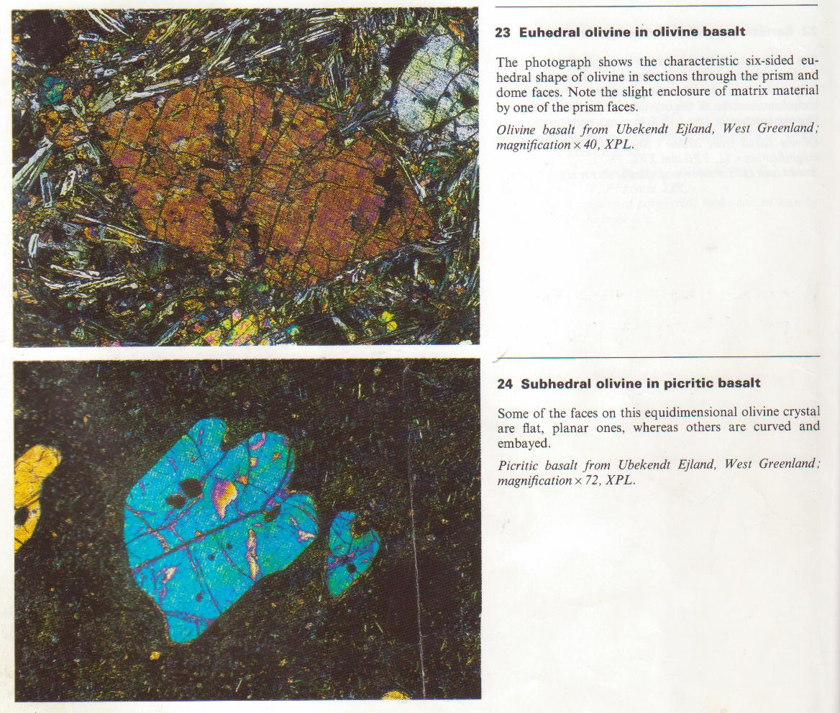
Figure 58 Euhedral crystal

- If most of the grains are subhedral - that is they bounded by only a few well-formed crystal faces, the fabric is said to be hypidiomorphic granular.
Figure 59 Subhedral crystal
- If most of the grains are anhedral - that is they are generally not bounded by crystal faces, the fabric is said to be allotriomorphic granular.
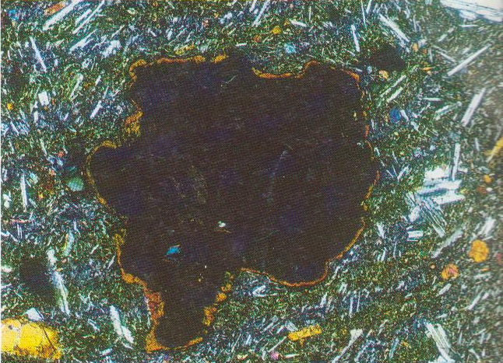
Figure 60 Anhedral crystal

If the grains have particularly descriptive shapes, then it is essential to describe the individual grains. Some common grain shapes are:
- Tabular - a term used to describe grains with rectangular tablet shapes.
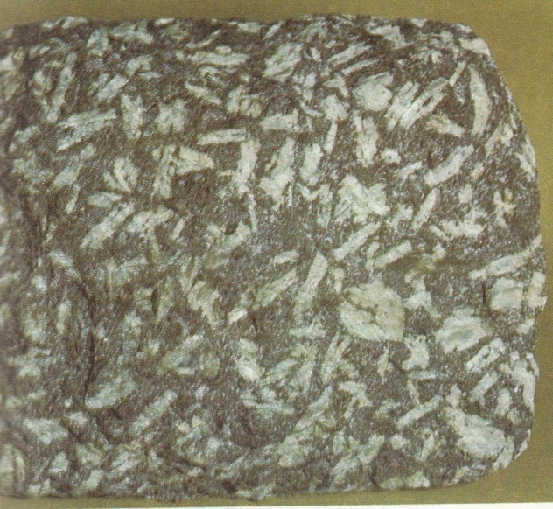
Figure 61 Tabular crystal

- Equant - a term used to describe grains that have all of their boundaries of approximately equal length.
- Fibrous - a term used to describe grains that occur as long fibers.
- Acicular - a term used to describe grains that occur as long, slender crystals.
- Prismatic - a term used to describe grains that show an abundance of prism faces.

CLASSIFICATION OF IGNEOUS ROCKS
Because of the limitations of the various criteria that can used to classify igneous rocks, geologists use an approach based on the information obtainable at various stages of examining the rocks.
- In the field, a simple field based classification must be used. This is usually based on mineralogical content and texture. For plutonic rocks, the IUGS system of classification can be used. For volcanic rocks, the following table can be used.

Simple Field Classification of Volcanic Rocks
Rock Name | Essential Minerals* | Other Minerals (may or may not be present)
Basalt | Olivine | Cpx, Opx, Plag.
Basanite | Olivine + Feldspathoid (Nepheline/ Leucite) | Cpx, Plag.
Andesite | No olivine, abundant Plagioclase | Cpx, Opx, Hornblende
Trachyte | Sanidine + Plagioclase | Na-Cpx, Hornblende, Biotite
Dacite | Plagioclase + Hornblende | Cpx, Opx, Biotite
Rhyolite | Quartz | Sanidine, Biotite, Plag., Hornblende, Cpx, Opx
* The amount of glass in the groundmass increases, in general, from the top to the bottom of the chart.

- Once the rocks are brought back to the laboratory and thin sections can be made, these are examined, mineralogical content can be more precisely determined, and refinements in the mineralogical and textural classification can be made.
- Chemical analyses can be obtained, and a chemical classification, such as the LeBas et al., IUGS chemical classification of volcanic rocks (based on total alkalies [Na₂O + K₂O] vs. SiO₂ diagram shown below)

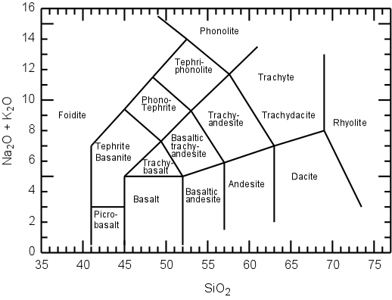
Figure 83 IUGS chemical classification of volcanic rocks

Note that at each stage of the process, the classification may change, but it is important to keep in mind that each stage has limitations, and that classification at each stage is for the purposes of describing the rock, not only for the individual investigator, but anyone else. Thus, the classification scheme should be employed in a consistent manner so that later investigators can understand what you are talking about at each stage of the process.

General Chemical Classifications
SiO₂ (Silica) Content
> 66 wt. % - Acid
52-66 wt% - Intermediate
45-52 wt% - Basic
< 45 wt % - Ultrabasic
This terminology is based on the onetime idea that rocks with a high % SiO₂ were precipitated from waters with a high concentration of hyrdosilicic acid H₄SiO₄. Although we now know this is not true, the acid/base terminology is well entrenched in the literature.

Silica Saturation Classification of igneous rocks
Classification of igneous rocks is one of the most confusing aspects of geology. This is partly due to historical reasons, partly due to the nature of magmas, and partly due to the various criteria that could potentially be used to classify rocks.
- Early in the days of geology there were few rocks described and classified. In those days each new rock described by a geologist could have shown characteristics different than the rocks that had already been described, so there was a tendency to give the new and different rock a new name. Because such factors as cooling conditions, chemical composition of the original magma, and weathering effects, there is a potential to see an infinite variety of igneous rocks, and thus a classification scheme based solely on the description of the rock would eventually lead to a plethora of rock names. Still, because of the history of the science, many of these rock names are firmly entrenched in the literature, so the student must be aware of all of these names, or at least know where to look to find out what the various rocks names mean.
- Magmas, from which all igneous rocks are derived, are complex liquid solutions. Because they are solutions, their chemical composition can vary continuously within a range of compositions. Because of the continuous variation in chemical composition there is no easy way to set limits within a classification scheme.
- There are various criteria that could be used to classify igneous rocks. Among them are:
  - Minerals Present in the Rock (the mode). The minerals present in a rock and their relative proportions in the rock depend largely on the chemical composition of the magma. This works well as a classification scheme if all of the minerals that could potentially crystallize from the magma have done so - usually the case for slowly cooled plutonic igneous rocks. But, volcanic rocks usually have their crystallization interrupted by eruption and rapid cooling on the surface. In such rocks, there is often glass or the minerals are too small to be readily identified. Thus a system of classification based solely on the minerals present can only be used.
We can easily the inadequacy of a mineralogical classification based on minerals present if you look at the classification schemes for volcanic rocks given in introductory geology textbooks. For example, most such schemes show that a dacite is a rock that contains small amounts of quartz, somewhat larger amounts of sanidine or alkali feldspar, plagioclase, biotite, and hornblende, In all the years I have been looking at igneous rocks (since about the mid-cretaceous) I have yet to see a dacite that contains alkali feldspar. Does this mean that the intro geology textbooks lie? Not really, these are the minerals that should crystallize from a dacite magma, but don't because the crystallization history is interrupted by rapid cooling on the surface.
  - Texture of the Rock. Rock texture depends to a large extent on cooling history of the magma. Thus rocks with the same chemical composition and same minerals present could have widely different textures. In fact we generally use textural criteria to subdivide igneous rocks in to plutonic (usually medium to coarse grained) and volcanic (usually fine grained, glassy, or porphyritic.) varieties.
  - Color. Color of a rock depends on the minerals present and on their grain size. Generally, rocks that contain lots of feldspar and quartz are light colored, and rocks that contain lots of pyroxenes, olivines, and amphiboles (ferromagnesium minerals) are dark colored. But color can be misleading when applied to rocks of the same composition but different grain size. For example a granite consists of lots of quartz and feldspar and is generally light colored. But a rapidly cooled volcanic rock with the same composition as the granite could be entirely glassy and black colored (i.e. an obsidian). Still we can divide rocks in general into felsic rocks (those with lots of feldspar and quartz) and mafic rocks (those with lots of ferromagnesium minerals). But, this does not allow for a very detailed classification scheme.
  - Chemical Composition. Chemical composition of igneous rocks is the most distinguishing feature.
  - The composition usually reflects the composition of the magma, and thus provides information on the source of the rock.
  - The chemical composition of the magma determines the minerals that will crystallize and their proportions.
  - A set of hypothetical minerals that could crystallize from a magma with the same chemical composition as the rock (called the Norm), can facilitate comparison between rocks.
  - Still, because chemical composition can vary continuously, there are few natural breaks to facilitate divisions between different rocks.
  - Chemical composition cannot be easily determined in the field, making classification based on chemistry impractical.

If a magma is oversaturated with respect to Silica then a silica mineral, such as quartz, cristobalite, tridymite, or coesite, should precipitate from the magma, and be present in the rock. On the other hand, if magma is undersaturated with respect to silica, then a silica mineral should not precipitate from the magma, and thus should not be present in the rock. The silica saturation concept can thus be used to divide rocks in silica undersaturated, silica saturated, and silica oversaturated rocks. The first and last of these terms are most easily seen.
- Silica Undersaturated Rocks - In these rocks we should find minerals that, in general, do not occur with quartz. Such minerals are:

Nepheline- NaAlSiO₄ | Leucite - KAlSi₂O₆
Forsteritic Olivine - Mg₂SiO₄ | Sodalite - 3NaAlSiO₄.NaCl
Nosean - 6NaAlSiO₄.Na₂SO₄ | Haüyne - 6NaAlSiO₄.(Na₂,Ca)SO₄
Perovskite - CaTiO₃ | Melanite - Ca₂Fe⁺³Si₃O₁₂
Melilite - (Ca,Na)₂(Mg,Fe⁺²,Al,Si)₃O₇
Thus, if we find any of these minerals in a rock, with an exception that we'll see in a moment, then we can expect the rock to be silica undersaturated.
If we calculate a CIPW Norm (we'll see how to do this in lab) the normative minerals that occur in silica undersaturated rocks are nepheline and/or leucite.
- Silica Oversaturated Rocks. These rocks can be identified as possibly any rock that does not contain one of the minerals in the above list.
If we calculate a CIPW Norm, silica oversaturated rocks will contain normative quartz.
- Silica Saturated Rocks. These are rocks that contain just enough silica that quartz does not appear, and just enough silica that one of the silica undersaturated minerals does not appear. In the CIPW norm, these rocks contain olivine, or hypersthene + olivine, but no quartz, no nepheline, and no leucite.
To get an idea about what silica saturation means, let's look at a simple silicate system - the system Mg₂SiO₄ - SiO₂

Note how compositions between Fo and En will end their crystallization with only Fo olivine and enstatite. These are SiO₂-undersaturated. compositions. All compositions between En and SiO₂ will end their crystallization with quartz and enstatite. These are SiO₂ - oversaturated compositions.  Note also that this can cause some confusion in volcanic rocks that do not complete their crystallization due to rapid cooling on the surface. Let's imagine first a composition in the silica-undersaturated field. Cooling to anywhere on the liquidus will result in the crystallization of Fo-rich olivine. If this liquid containing olivine is erupted and the rest of the liquid quenches to a glass, then this will produce a rock with phenocrysts of olivine in a glassy groundmass. | 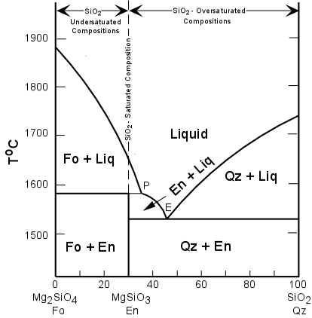  Figure 84 The system Mg₂SiO₄ - SiO₂

Applying the criteria above for identifying silica undersaturated rocks would tell us that this is a silica-undersaturated rock, which we know to be correct. Next, let's look at a silica oversaturated composition, such as one just to the left of the point labeled 'P' in the diagram. If this liquid is cooled to the liquidus and olivine is allowed to crystallize, and is then quenched on the surface, it will contain phenocrysts of Fo-rich olivine in a glassy groundmass. Applying the criteria above would suggest that this rock is also silica undersaturated, but we know it is not. This illustrates one of the difficulties of applying any criteria of classification to volcanic rocks where incomplete crystallization/reaction has not allowed all minerals to form.

Alumina (Al₂O₃) Saturation
After silica, alumina is the second most abundant oxide constituent in igneous rocks. Feldspars are, in general, the most abundant minerals that occur in igneous rocks. Thus, the concept of alumina saturation is based on whether or not there is an excess or lack of Al to make up the feldspars. Note that Al₂O₃ occurs in feldspars in a ratio of 1 Al to 1 Na, 1K, or 1 Ca:
KAlSi₃O₈ -- 1/2K₂O : 1/2Al₂O₃
NaAlSi₃O₈ -- 1/2Na₂O : 1/2Al₂O₃
CaAl₂Si₂O₈ -- 1CaO : 1Al₂O₃
Three possible conditions exist
- If there is an excess of Alumina over that required to form feldspars, we say that the rock is peraluminous. This condition is expressed chemically on a molecular basis as:
Al₂O₃ > (CaO + Na₂O + K₂O)
In peraluminous. rocks we expect to find an Al₂O₃-rich mineral present as a modal mineral - such as muscovite [KAl₃Si₃O₁₀(OH)₂], corundum [Al₂O₃], topaz [Al₂SiO₄(OH,F)₂], or an Al₂SiO₅- mineral like kyanite, andalusite, or sillimanite.
Peraluminous rocks will have corundum [Al₂O₃] in the CIPW norm and no diopside in the norm.
- Metaluminous rocks are those for which the molecular percentages are as follows:
Al₂O₃ < (CaO + Na₂O + K₂O) and Al₂O₃ > (Na₂O + K₂O)
These are the more common types of igneous rocks. They are characterized by lack of an Al₂O₃-rich mineral and lack of sodic pyroxenes and amphiboles in the mode.
- Peralkaline rocks are those that are oversaturated with alkalies (Na₂O + K₂O), and thus undersaturated with respect to Al₂O₃. On a molecular basis, these rocks show:
Al₂O₃ < (Na₂O + K₂O)
Peralkaline rocks are distinguished by the presence of Na-rich minerals like aegerine [NaFe⁺³Si₂O₆], riebeckite [Na₂Fe₃⁺²Fe₂⁺³Si₈O₂₂(OH)₂], arfvedsonite [Na₃Fe₄⁺²(Al,Fe⁺³)Si₈O₂₂(OH)₂ ], or aenigmatite [Na₂Fe₅⁺²TiO₂Si₆O₁₈] in the mode.
In the CIPW norm, acmite [NaFe⁺³Si₂O₆ ] and/or sodium metasilicate Na₂SiO₃ will occur as normative minerals.

Alkaline/Subalkaline Rocks
One last general classification scheme divides rocks that alkaline from those that are subalkaline. Note that this criteria is based solely on an alkali vs. silica diagram, as shown below. Alkaline rocks should not be confused with peralkaline rocks as discussed above. While most peralkaline rocks are also alkaline, alkaline rocks are not necessarily peralkaline. On the other hand, very alkaline rocks, that is those that plot well above the dividing line in the figure below, are also usually silica undersaturated.

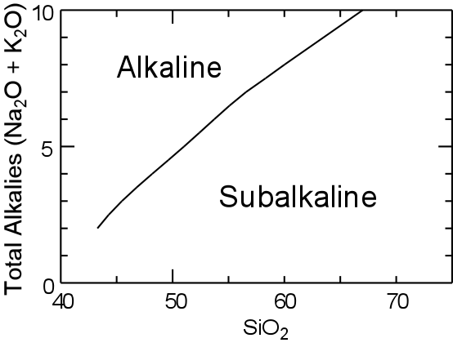
Figure 85 Alkaline/Subalkaline Rocks

Global Distribution of Igneous Rocks

Seismic data, studies of geothermal gradient, observations of xenoliths within igneous rocks and composition of meteorites have revealed that the earth is a layered body. A thin layer present at the earth’s surface is called the crust and its thickness changes from 6-8 km beneath the oceans to 30-40 km beneath the continents. Seismic velocities and densities within the oceanic crust correspond to its basaltic composition. The same observations under continents point out its twofold division: the upper layer is of granitic composition (dial) and the lower layer is of basaltic one (sima). The Mohorovicic discontinuity below the crust marks the beginning of mantle which continues to the depth of 2.900 km. Within the mantle, at a depth of about 70 km from the earth’s surface, there is commonly found another drop of seismic velocities and this low-velocity zone or asthenosphere is 50-75 km thick. The whole crust and the topmost part of the mantle are collectively called lithosphere. The earth’s core extends from 2.900 km to 6.370 km with the liquid outer layer (2.900 – 5.000 km) and solid inner part.

The mantle is composed of hypothetical pyrolite. Plagioclase pyrolite (olivine, Al-poor pyroxene, plagioclase), spinel pyrolite (olivine, Al-rich pyroxene, spinel) and garnet pyrolite (olivine, Al-poor pyroxene, garnet) are stable at increasing P/T conditions. The mantle is known to contain some water (in phlogopite, amphiboles, titanoclinohumite) but it is essentially solid. Therefore, magmas originated in the crust or mantle were formed by melting or partial melting of pre-existing rocks and the following melting processes may be mentioned:

1. the decrease of pressure (release of lithostatic pressure or migration
of rocks towards the areas of lower lithostatic pressure),

2. the increase of temperature (transport of rocks into hotter zones,
addition of heat due to the radioactive decay, friction or
convective transfer),

3. addition of fluids.

All these processes can be involved in different scale simultaneously and the generation of magmas will be discussed shortly in terms of the main tectonic environments, i.e. considerting divergent (accretional) plate junctions, convergent (destructive) plate margins and the interiors of the continents.

Igneous rocks within ocean basins

Basaltic lavas are dominating in the global scale and basalts are almost the sole component of volcanic rocks in the ocean basins (trachytes and related are very subordinate). Evidences from many sources show that volcanically active rift zones extend along the crest of mid-oceanic ridges. The oceanic crust is being formed in this area by permanent addition of basaltic intrusions or eruptions of submarine lavas. These zones of relatively high volcanic and seismic activity are under tension and the oceanic crust on either side of the ridge moves away at a rate of 1-6 cm/year, forming the uppermost part of the lithospheric plate.

Beneath the mid-ocean ridges one can assume the presence of vertically rising hot solid material from upper mantle. Continued rising brings this “diaper” to levels of more and more pronounced melting and magmas, of general basaltic composition, can reach eventually the surface. The sequence going downwards from the ocean bottom is (Fig. 11): pillow lavas, sheets of diabase dikes, structureless gabbro, layered cumulates (olivine, clinopyroxene, spinel) and the mantle peridotite of harzburgite composition (olivine + orthopyroxene).

Igenous rocks at continental margins

Continental margins have been not only the places of sedimentation but also of extensive igneous and metamorphide activity. The present continental margins may be regarded as modern geosynclines. The Andean type (W border of South America) contains a mountain belt bordered by a submarine trench. The island arc and Japan Sea types are similar, consisting of an island chain with an adjacent submarine trench. The difference is that the island arc may be remote from the continental border, but the Japan Sea type is separated from the continent only by a small ocean basin. The Atlantic geosyncline (North American and both African coasts) is without typical trench and does not show igneous activity (fig. 12).

Volcanism and plutonism in the orogenic belts and island arcs are governed by completely different tectonic regime than it is with the oceanic crust. These are areas of compression and the crust is thickened and shortened as lithospheric plates converge on one another. Movement of the plates does not finish by head-on collision, but after it an oceanic plate reaching the position marked by one of the trenches is bent downwards and passes beneath the opposing continental plate. The two plates grind in the subduction zone, producing numerous earthquakes and melting subsequently they yield different types of magmas.

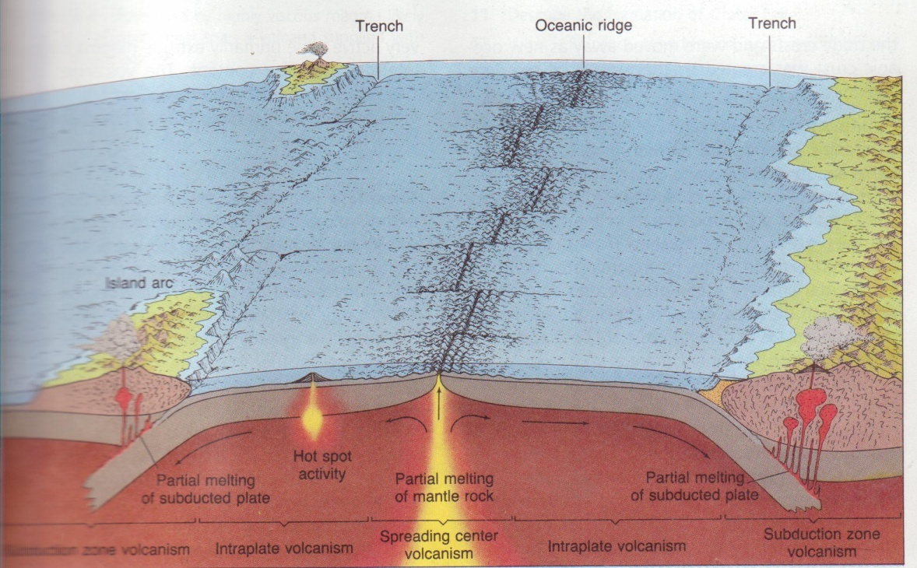
FIG Three zones of volcanism. Two of these zones are plate boundaries and third includes areas within the plate themselves

Head-on collisions of initial stage may give so-called ophiolitic suite. It is a distinctive rock assemblage, composed of ultramafic and basaltic rocks, often overlaid by deep sea sediments. They represent the part of oceanic plate, tectonically risen and emplaced in subaerial conditions (obduction of the oceanic plate which is thrust over the continental one). No melting was present and the process took place in the solid state. Ophiolite complexes are rare.
The tectonic environment in subduction zones favours the formation of new magmas. They are formed by complex processes related to increase of temperature with depth and progressive dehydration of the subducting plate; melting occurs at several depths both within and above it (fig. 13). It generates the calc-alkaline series of volcanic rocks (high Al basalt – dominant andesite – rhyolite) and their plutonic equivalents (with the most abundant granite), also subordinate tholeiitic series (basalt with augite and pigeonite, some andesites, a few silicic rocks). The formation of tholeiitic magmas is often followed by lavas with calc-alkaline trend and the spatial distribution of rocks is significant. The region of non-volcanic rocks represents the arc trench gap. Going of ocean there is the sequence of tholeiitic and calc-alkaline rocks, calcalkaline rocks, calcalkaline and sodic rocks, eventually sodic-alkalic rocks. The width of their geographical position indicates the dip of the subduction zone: the wider distribution of igneous rocks the smaller angle of this dip (fig. 13).

The plutonic equivalents are mainly composed of granitic plutons. The melt composition is a function of source rock types, depth and temperature of melting, kind and amount of fluids. The first melt, forming at lowest temperatures, tend to be granitic and when temperature rises – it becomes more basic.

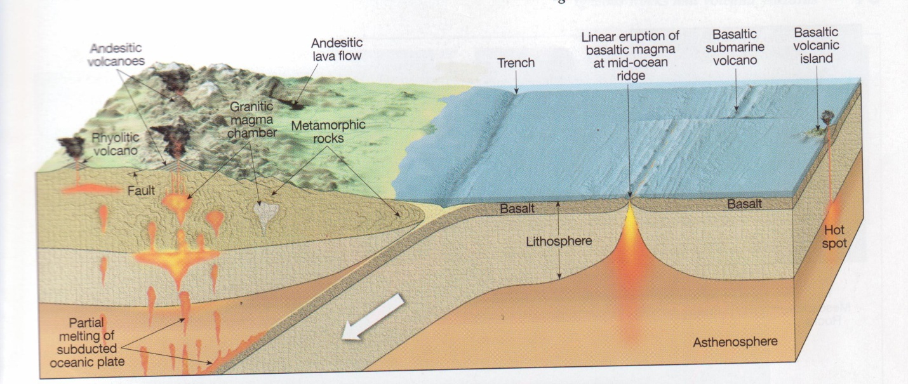

FIGURE

Continental igneous rocks

Igneous rocks found in the inner parts of continents include tholeiitic basalts, mafic layered complexes, anorthosites, peridotites and alkali-rich rocks.

Of the continental lavas, tholeiitic basalts are the most common, forming extensive lava flows (basalt traps, plateau basalts). Tholeiitic melts may also be emplaced at shallow depths in sills and dike swarms. Usually they follow the main fracture zones.

Emplacement of tholeiitic magmas at greater depths leads towards the formation of layered igneous complexes, strongly differentiated. Their composition is gabbroic in average, but some parts may be even silicic and ultramafic cumulates may be encountered at the bottom.

Anorthosites, limited in occurrence to bhe pre-cambrian, represent the unique geological event. They were formed by differentiation of basaltic magma, but the mafic minerals are now not exposed and only the uppermost part of plutons is visible.

Alkali basalts and foid-rich rocks can be found mainly in continental zones of rifting, sometimes they form provinces not related to subsidence.

Carbonatites often coexist with nephelinitic rocks (geosynclinal type) and with ultramafic to alkali rocks – peridotites and nepheline syenites (platform type).

Kimberlites represent the explosive, vertical ascent of magma of definitely mantle origin (presence of minerals stable under high pressure only).

SEDIMENTARY ROCKS

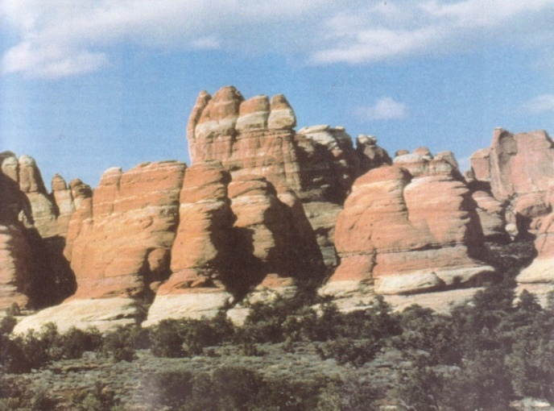

OBJECTIVES
This chapter focuses on sedimentary rocks, one of the three basic rock groups. The objectives are:
-To learn to identify minerals that are common in sedimentary.
-To identify textures in sedimentary rocks
-To use sedimentary rocks to interpret the history of Earth environments

INTRODUCTION

The term “sediment” means any solid material, settled down from a suspension in a liquid. However in geological sense, “sedimentary rocks” enclose not only such accumulations, formed by material derived from the abrasion of pre-existing rocks and transported by waters, but also chemical precipitates, organic debris, residual deposits, materials of glacial and eolian deposits and also volcanic ejectamenta. They cover about 90% of the Earth’s surface (including bottoms of oceans) and their thickness may reach 20km in some subsiding basinal areas.

What are the reasons to deal with sedimentary rocks? Environments and processes of deposition can be deduced from studies of this group of rocks, hence paleogeography and paleoclimate. Also the development of life has been recorded as fossils in sediments. A last, sedimentary rocks carry much of the world’s mineral wealth: oil, coal, natural gas, nuclear fuels, ores of Al, Mn, Fe, Cu, Zn, Pb, Au and other elements, they form ceramic raw materials, building materials, etc.

Sedimentary rocks are linked with igneous ones through the group of pyroclastic rocks, which are of igneous origin but were deposited and advanced diagenetic processes lead sedimentary rocks towards metamorphism.

Sedimentary rocks reveal very often the transitional nature, being frequently made up of several different components. Marls, occupying the position between limestones and argillaceous rocks or the gradation from a limestone via a sandy limestone and a calcareous sandstone to a sandstone can be mentioned as examples. This fact complicates more detailed classifications of sedimentary rocks. They are formed by rather limited selection of minerals and quartz, feldspars, clay minerals and carbonates are the most important. Thus, the classification of sedimentary rocks employs besides the mineral composition also other factors, such as textural features and the genetic relationships. The following major groups may be distinguished:

1) pyroclastic (or volcaniclastic) rocks,
2) detrital (or fragmental) rocks,
3) argillaceous rocks,
4) rocks of chemical and organic origin

The most abundant are rocks belonging to the argillaceous family (65-75%), then sandstones (10-20%) and carbonate rocks (10-15%), with all others – however also important – totaling less than 5%.

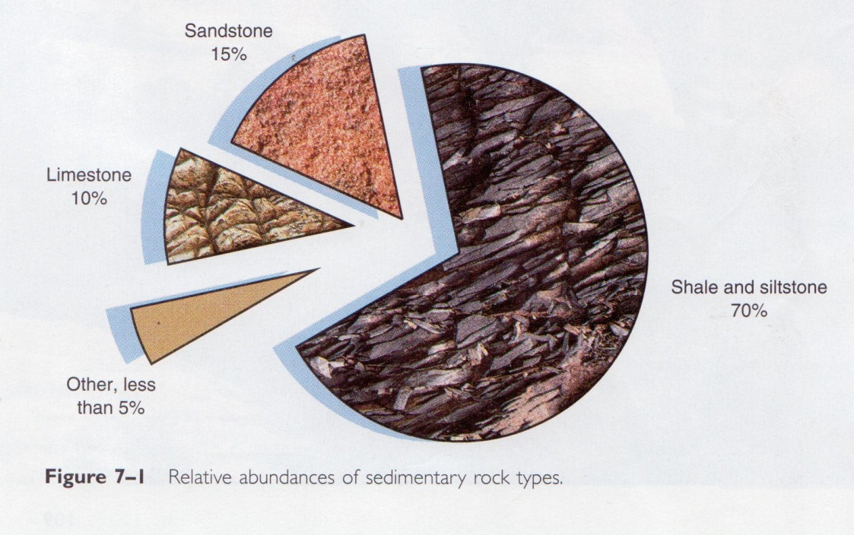

SEDIMENTARY PROCESSES

The rock-forming processes leading to the formation of sedimentary rocks include:

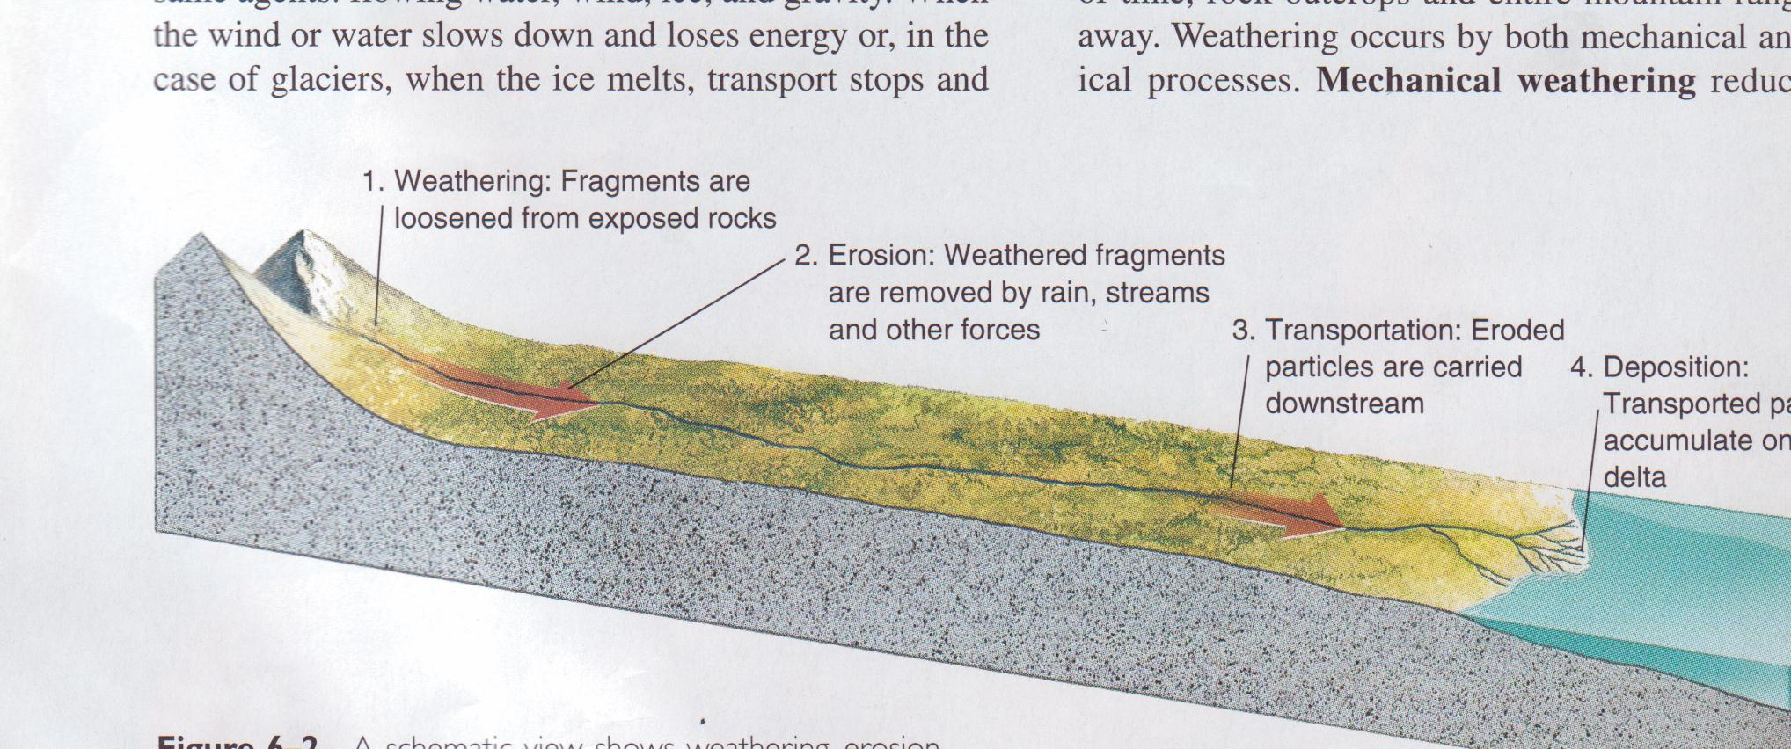
Showing weathering, erosion, transportation, and deposition of sediments

- weathering,
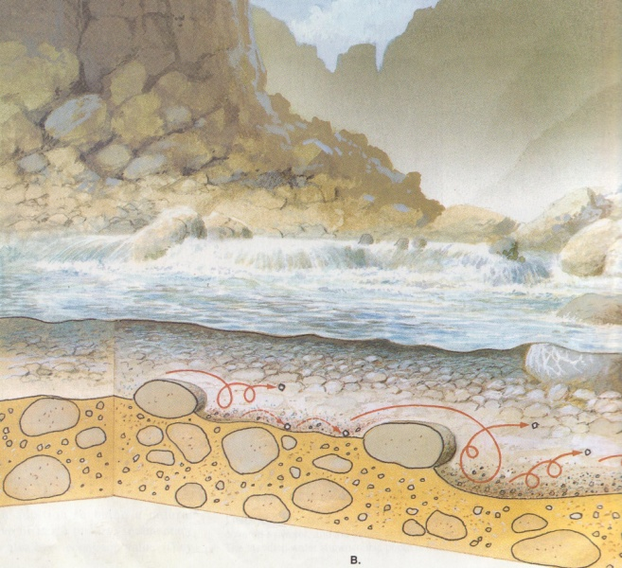

2) transportation,

3)deposition (sedimentation),

4)diagenesis (lithifications),

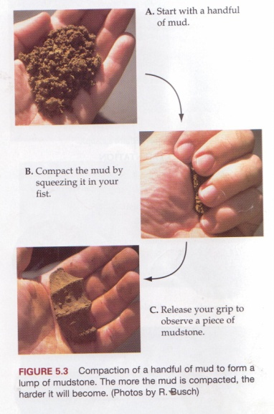

and each of the resulting rocks passed through at least one or two of these processes.

Weathering. All rocks exposed to the action of atmosphere, ground waters and organic life undergo more or less advanced physical and chemical alteration.

The physical weathering is caused by:

1) Changes in temperatures (daily and seasonal), leading to repeated
expansion and contraction of minerals and sometimes to freezing
and thawing of interstitial waters. These processes disintegrate rocks, producing residuum of mineral grains (mineral disintegration) and rock fragments (block disintegration);
2) action of organisms, especially roots of plants, loosening of rocks;
3) mechanical abrasion of particles during their transportation by
waters, glaciers and wind.

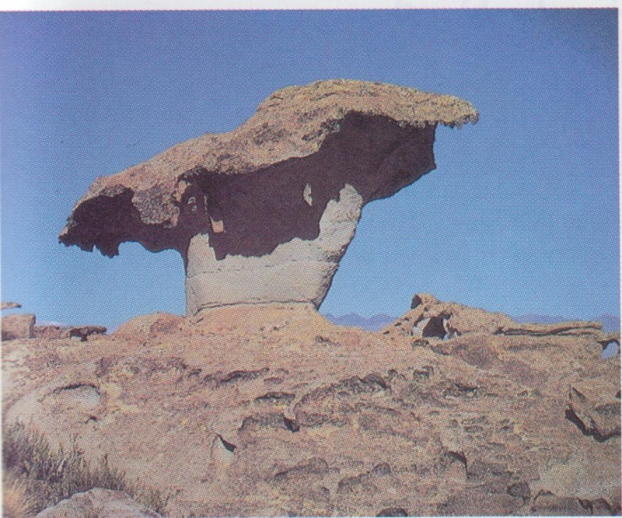
Wind abrasion

The chemical weathering leads to more profound changes, especially in the case of crystalline rocks, whose minerals are not stable under atmospheric and ground-water conditions. Waters with dissolved oxygen and carbon dioxide react eventually with minerals, liberating at first alkalia (mainly by decomposition of feldspars). Alkaline waters dissolve consequently other silicates and eventually even quartz. The organic life produces the humic acids which further accelerate processes of decomposition. Major chemical changes may be identified as:

1) hydrolysis
2) hydration
3) oxidation
4) carbonation
5) dissolving

During chemical and physical weathering of crystalline rocks, the end products are found to be of four kinds:
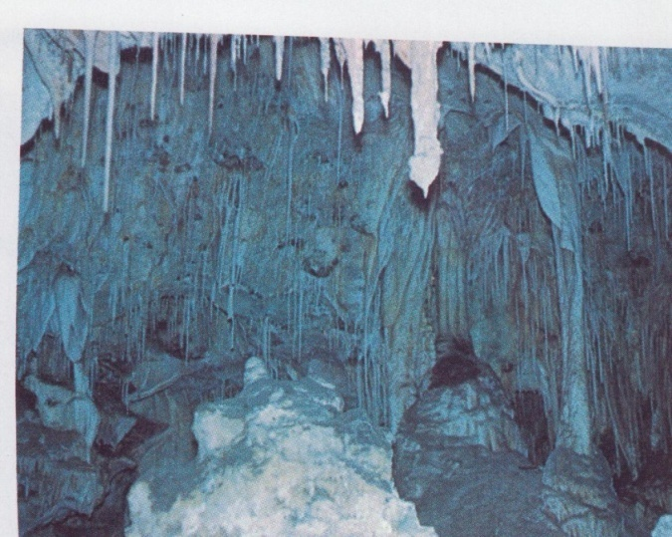
1) soluble salts (of Na, Ca, K, Mg)
2) colloidal substances (hydroxides of Fe, Al, Mn, colloidal silica)
3) insoluble decomposition products (clay minerals)
4) chemically resistant constituents (mainly quartz but in some extent
rock fragments, feldspars, micas, heavy minerals).

Transportation. Running waters are the major transporting agent but also the action of sea currents, waves, sediment plus water flows, glaciers and wind must be considered. The solid grains may be transported by saltation and rolling and these of the smallest size – in suspension. The velocity of current and degree of its turbulence have the strongest influence on the type of transportation. A part of the weathered material is carried away in the form of colloidal solutions and soluble salts are removed as true solutions.

Deposition (sedimentation). Sediments are laid down in one of the following environments:

1) continental

- fluviatile
- lacustrine (fresh-water lake, salt lake)
- glacial
- eolian
- swampy

2) intermediate

- deltaic
- castuarine

3) marine

a. literal (shoreline areas – tidal flats, sabkhas, beaches, barriers,
lagoons)
b. neritic (shallow waters – continental shelves, epeiric seas)
c. bathyal (the continental slope to a depth approx. 2000 m)
d. abyssal (deep waters)

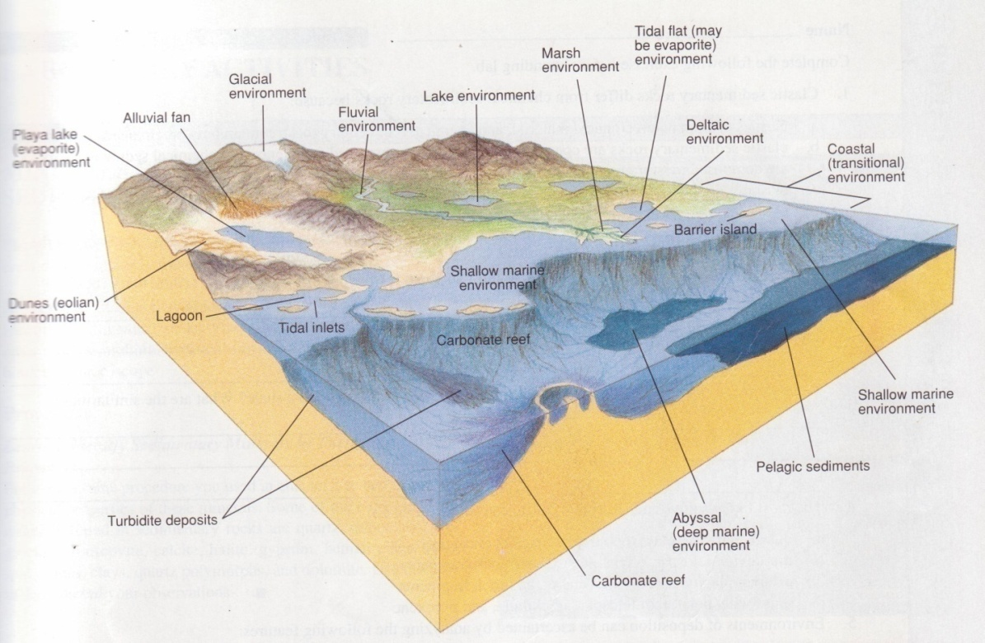
Common terrestrial and marine sedimentary enviroments

Many environmental factors influence the structure, texture and composition of sediments. On the dry land they include mainly climate and topography, as well as the cover of vegetation. In aqueous environments the bottom topography, depth of water, its temperature, salinity, alkalinity – acidity (pH), redox potential (Eh), freedom of circulation, turbulence, presence of organic life must be considered. Many of these factors result again from the climatic conditions. The tectonic factor controls the depositional setting (a stable craton, intracratonic basin or rift, continental margin, trench, any of arc-basins, etc).

A facies is a body or packet of sedimentary rocks with features that distinguish it form other facies. Lithofacies are based on sedimentary characteristics: mineral composition, grain size, texture, structure, colour. Biofacies rely on paleontological differences (fossil content). Facies can be described in terms of:

1) the sediment itself
2) the depositional process
3) the depositional environment
In the course of deposition one can observe so-called sedimentary differentiation: the subsequent deposition at first coarser then finer material or precipitation at first less and then – more soluble components. Dynamically evolving processes may, however, change this basic succession.

Diagenesis (lithification). Burial and compaction of soft sediments harden them into a massive rock. The major physical changes are caused by compaction, the squeezing of mineral grains closer to each other by the weight of overburden; it results in the decrease of porosity. The chemical changes are expressed by dissolution of certain minerals and after it – by reaction between water in pore spaces and minerals. It forms cement, binding the grains together. Other chemical changes include recrystallization, replacement and authigenesis.

Diagenesis may occur immediately after the deposition of a sedimentary rock (when it is still in the loose state) or long after that (it affects a rock already hardened).

MINERALOGICAL COMPOSITION
The most important from the genetical point of view is the division of rock-forming minerals of sedimentary rocks into authigenic and allogenic ones.

Authigenic
Authigenic constituents are these which were formed by chemical processes and subsequently deposited at the same basin. The most important among them are:

Clay Minerals
Kaolinite Al₄(Si₄O₁₀) (OH)₈
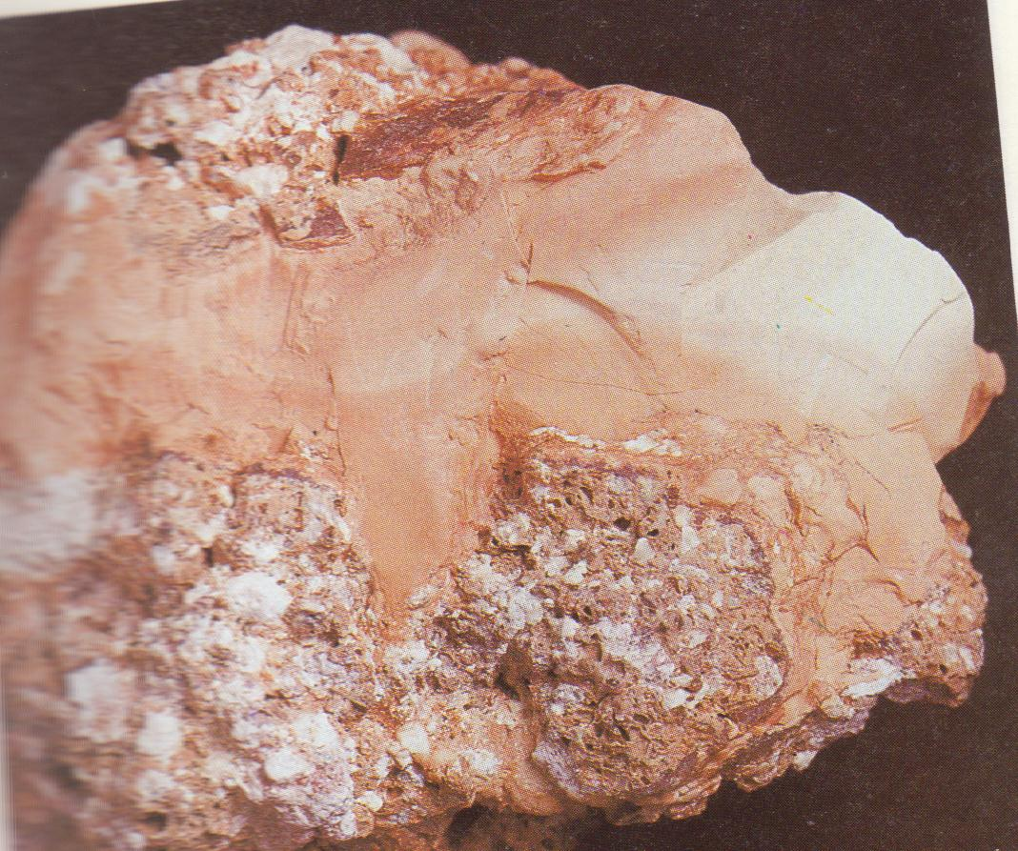
Figure 5. Kaolinite specimen

Montmorillonite Al₂(AlSi₃O₁₀) (OH)₂ . x H₂O; Mg may partly replace Al; interlayer cations (Na, Ca, K, etc.) always present
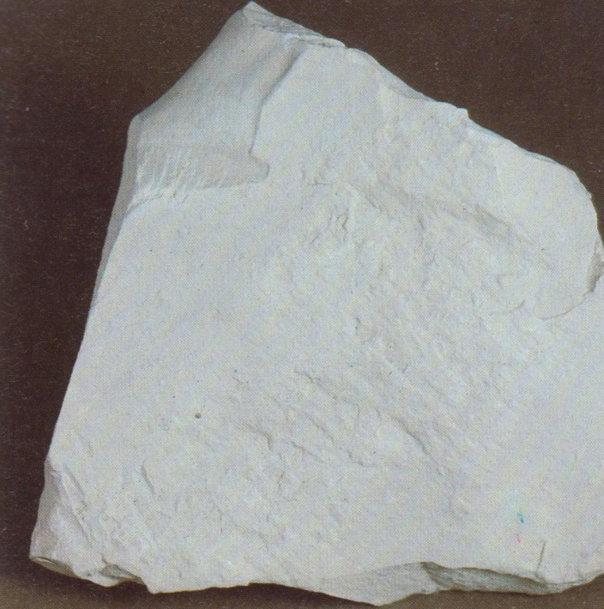
Figure 6. Montmorillonite specimen

Illite-sericite KAl₂ (AlSi₃O₁₀) (OH)₂
Chlorite Mg₅ (Al,Fe) ((Al,Si)₄O₁₀) (OH)₈
Chamosite Fe₃ (Al₂Si₂O₁₀) . 3H₂O
Clauconite (K, Na) (Fe, Al, Mg)₂ ((Al, Si)₄O₁₀) (OH)₂

2. Carbonates
Calcite CaCO₃ Siderite FeCO₈

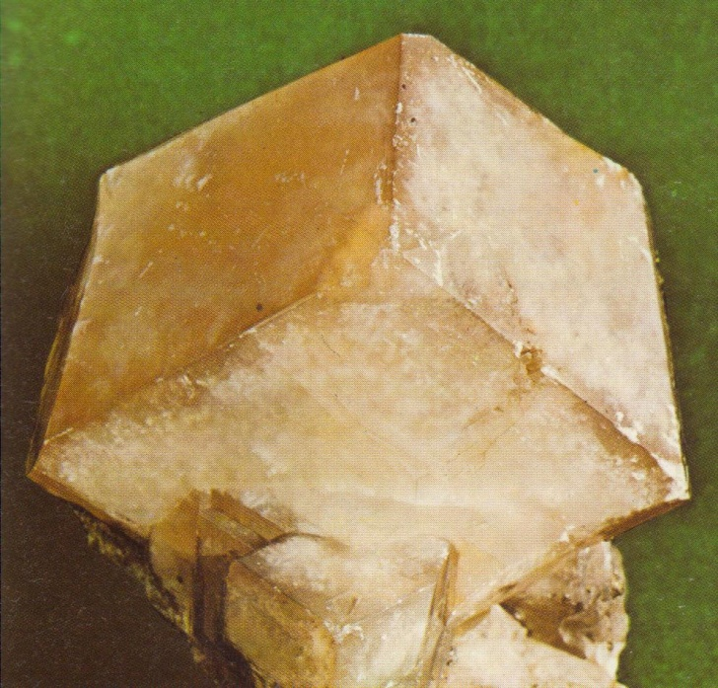
Figure 7. Calcite specimen

Dolomite CaCo₃ . MgCO₃
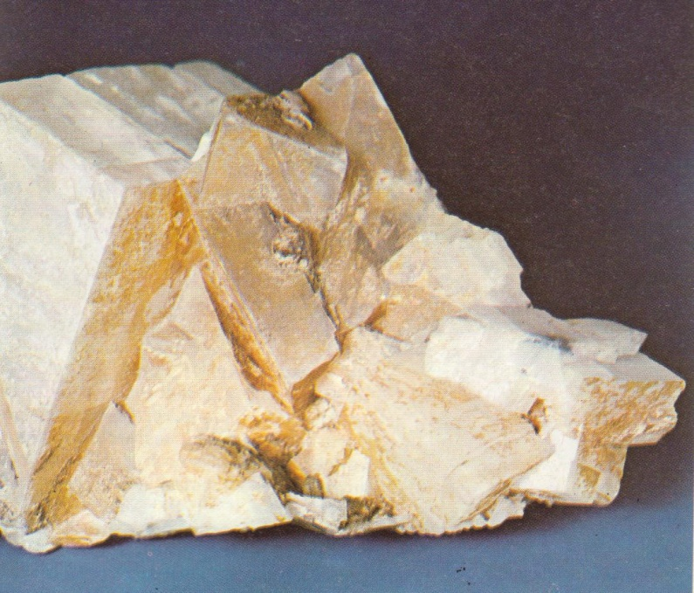
Figure 8. Dolomite specimen

Rhodochrosite MnCO₂
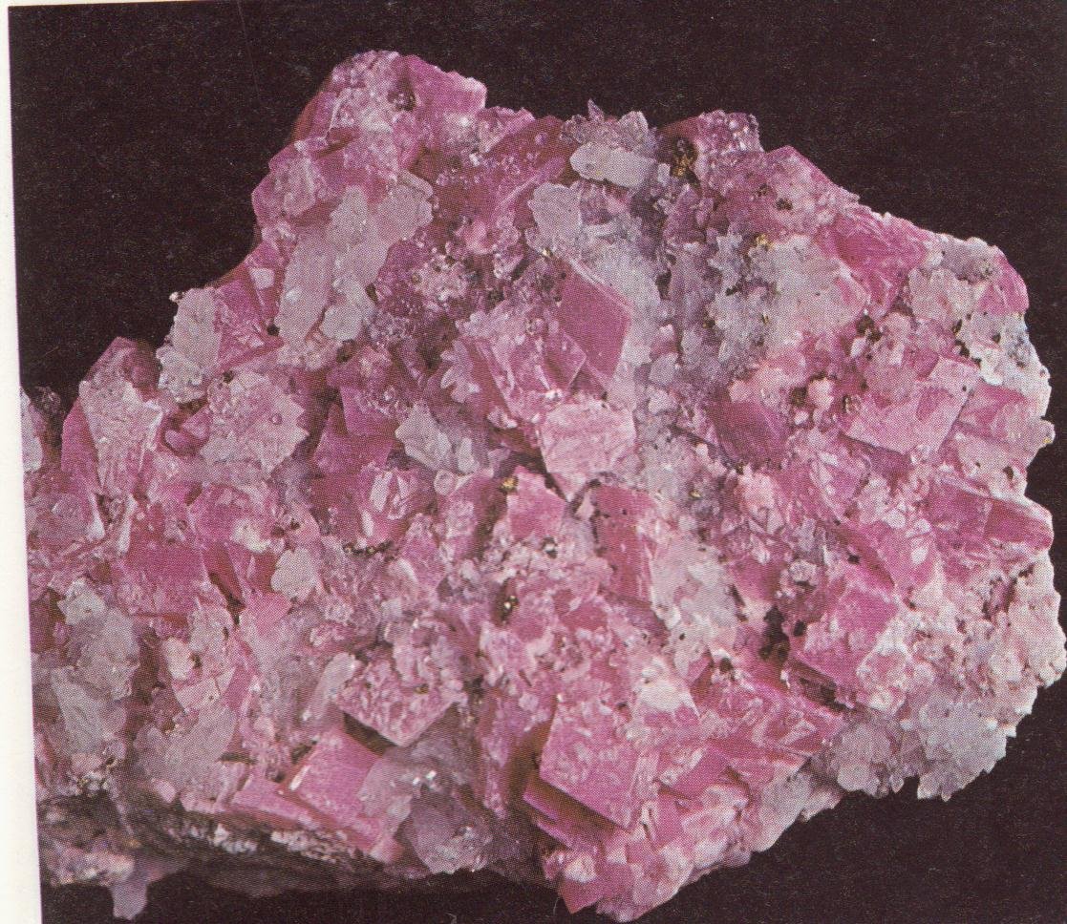
Figure 9. Rhodochrosite specimen

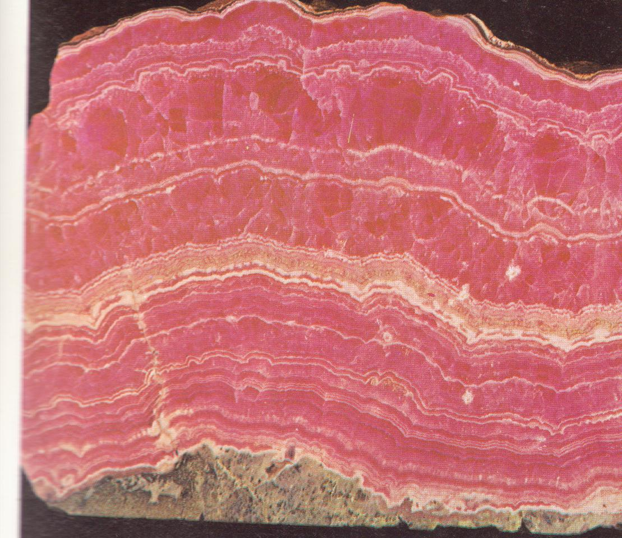
Figure 10. Bedded Rhodochrosite specimen

Ankerite CaCO₃ . (Mg,Fe)CO₃

3. Silica group
Quartz
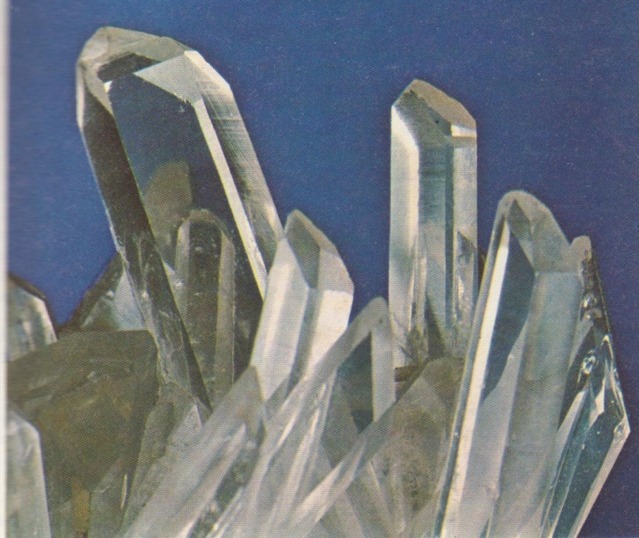
Figure 11. Bedded Rhodochrosite specimen

Chalcedony SiO₂
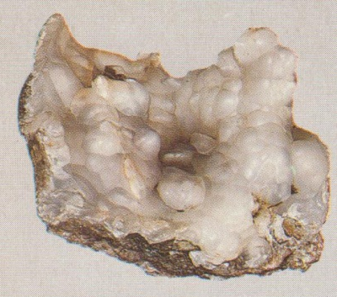
Figure 12. Chalcedony specimen

Opal SiO₂ . nH₂O
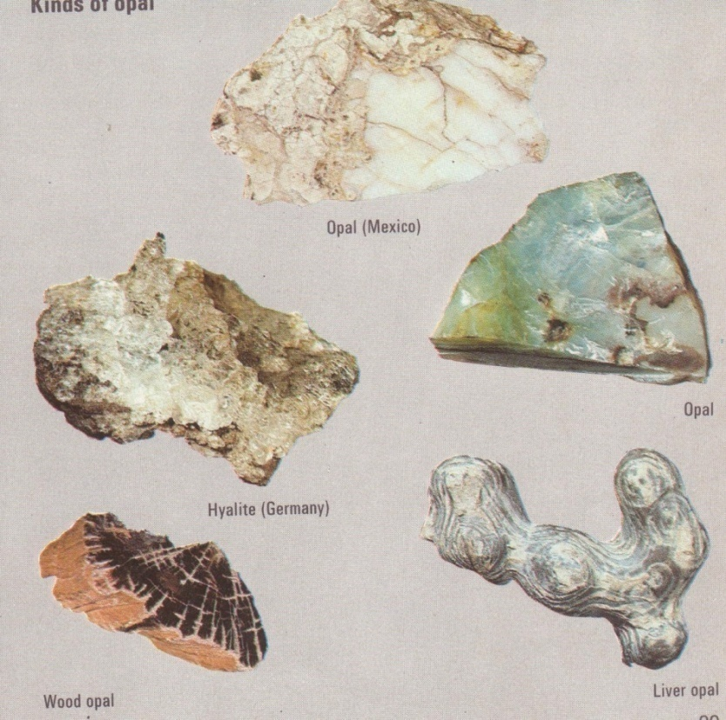
Figure 13. Opal minerals specimen

4. Minerals of Evaporites
Halite NaCl
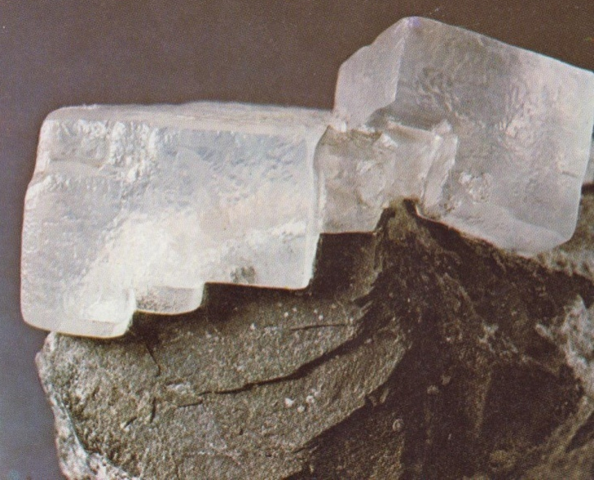
Figure 14. Halite specimen

Gypsum CaSO₄ . 2H₂O
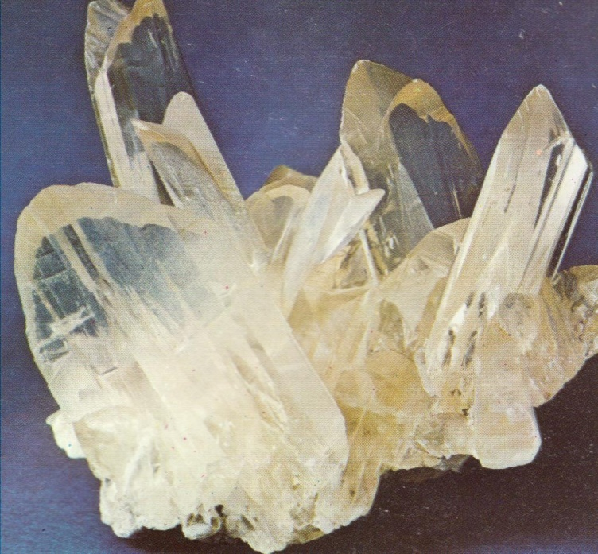
Figure 15. Gypsum specimen

Sylvite KCl
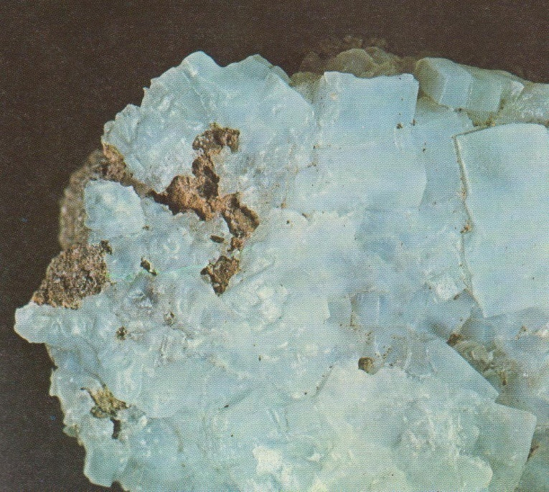
Figure 16. Sylvite specimen

Anhydrite CaSO₄, etc.
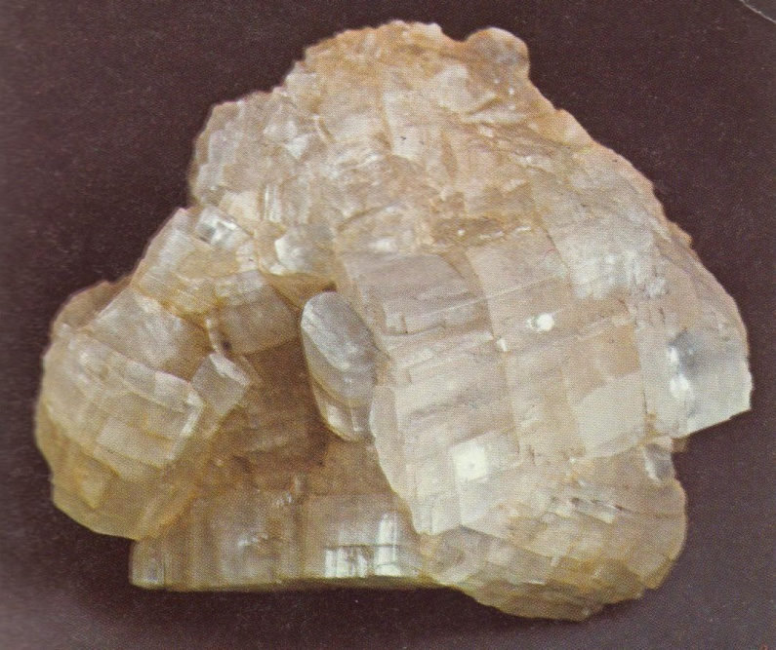
Figure 17. Anhydrite specimen

Carnallite KCl . MgCl₂ . 6H₂O
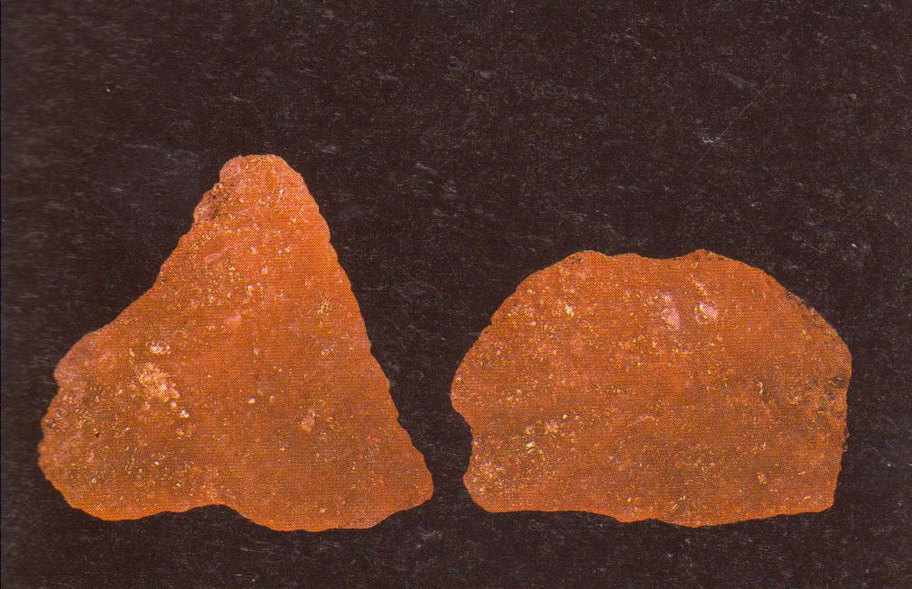
Figure 18. Carnallite specimen

Polyhalite K₂SO₄ . 2SO₄ . MgSO₄ . 2H₂O

5. Phosphates
Cellophane Ca₅ (PO₄)₃ (F, OH, Cl)

6. Hydroxides
Goethite/lepidocrokite α/γ . FeO.OH
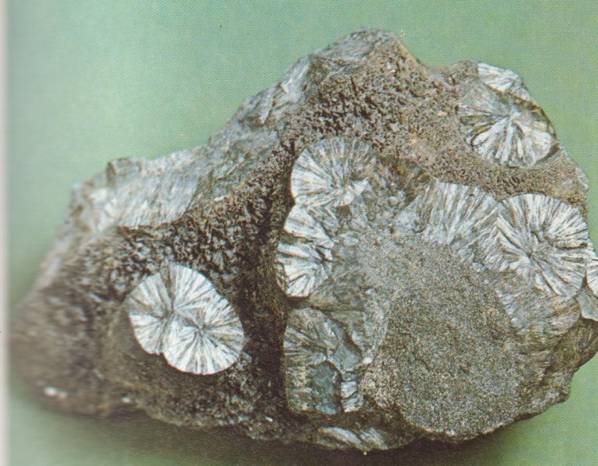
Figure 19. Goethite specimen

Hydrargillite Al(OH)₃
Boehmite/diaspar α/γ . AlO.OH
Manganite MnO . OH
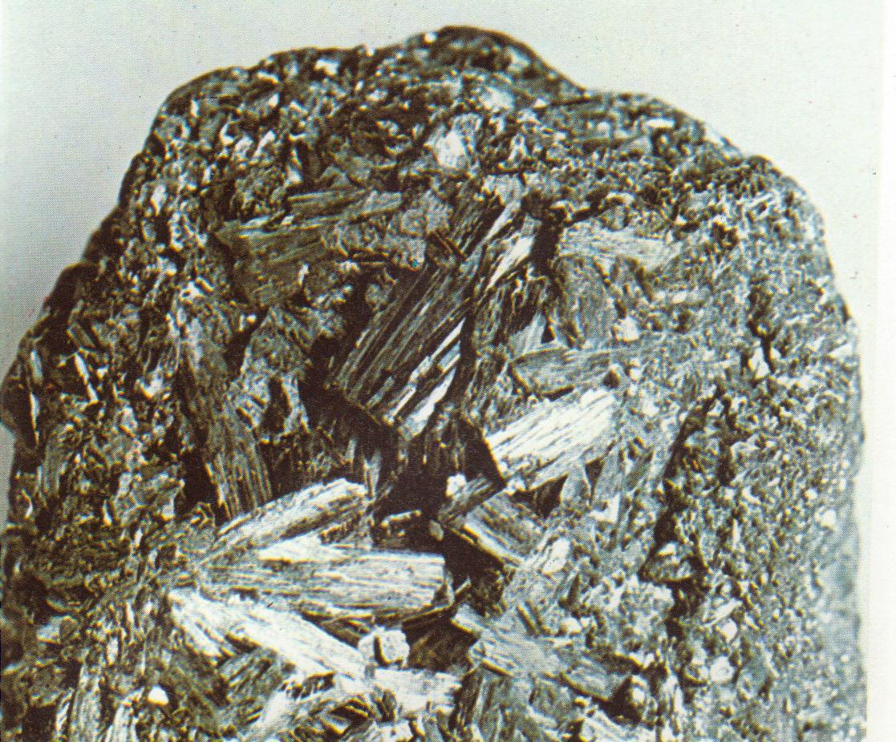
Figure 20. Manganite specimen

7. Others
Pyrite FeS₂
Hematite Fe₂O₃
Sulphur S
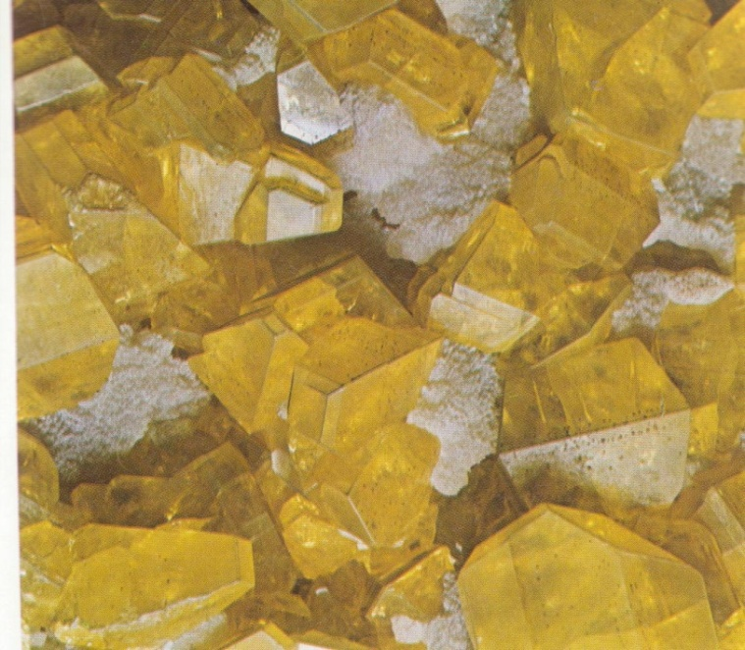
Figure 21. Sulphur specimen
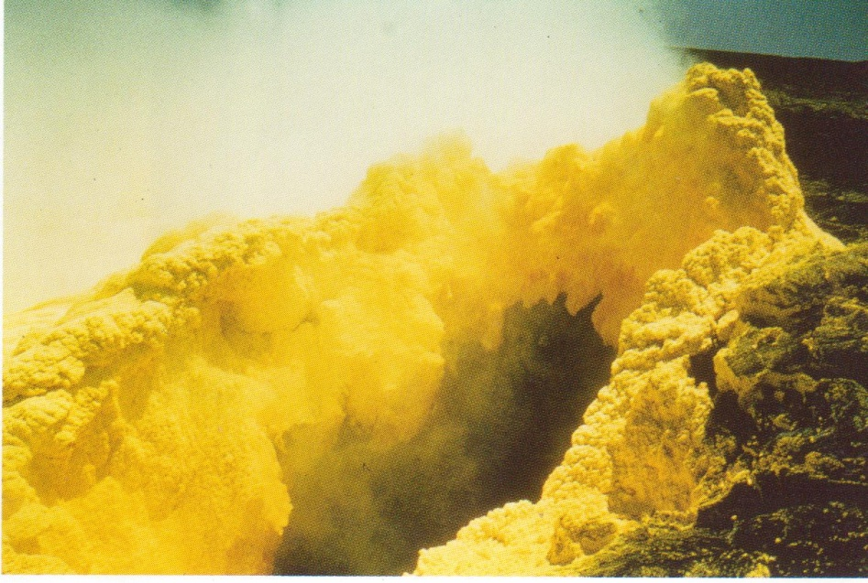
Figure 22. Volcanic gas vent ( a fimarole) deposits sulphur as gases cool and mix with air

Organic matter (carbonaceous and bituminuous)

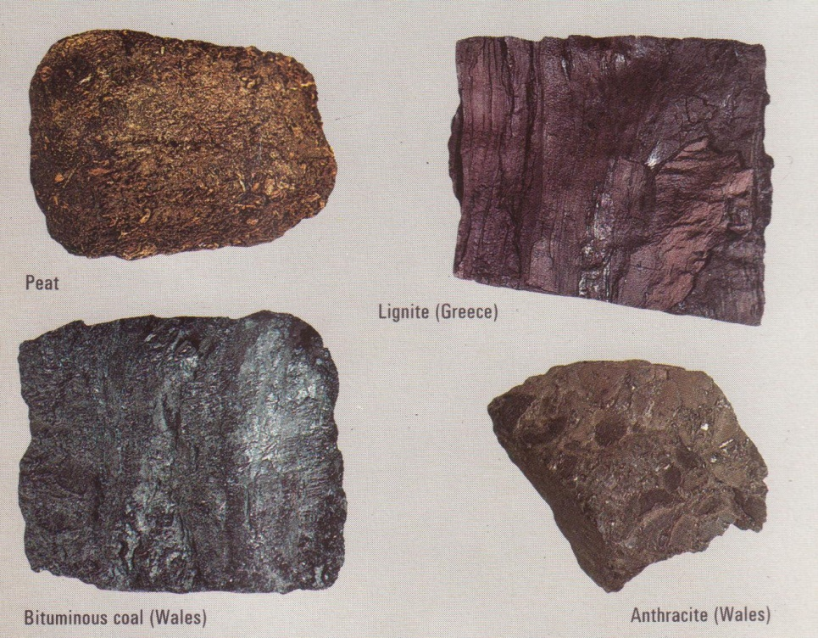
Figure 23. Organic specimen

Allogenic
Allogenic constituents are these which had been formed beyond the place of their deposition, into which they were subsequently transported (mechanical processes). The following must be mentioned:

1) Quartz SiO₂
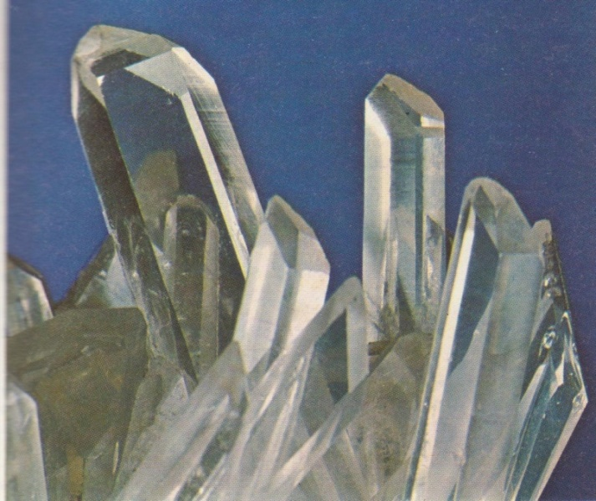
Figure 24. Quartz specimen

2) Feldspars
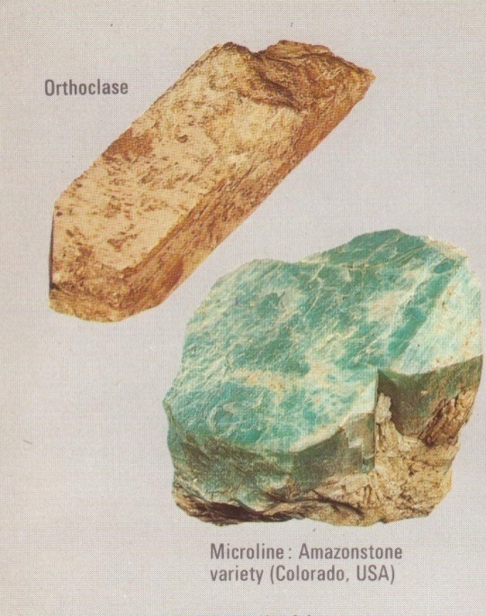
Figure 25. Feldspar specimen
Orthoclase – microcline K(AlSi₃O₈)
Sodium-rich plagioclase Na(AlSi₃O₈)
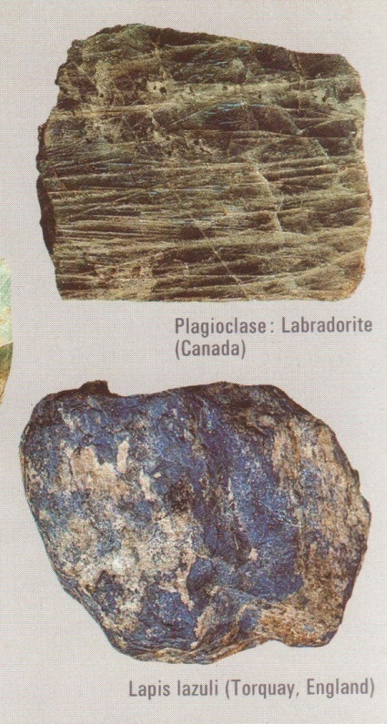
Figure 26. Plagioclase Feldspar specimen

3) Micas
Muscovite KAl₂ (AlSi₃O₁₀) (OH)₂
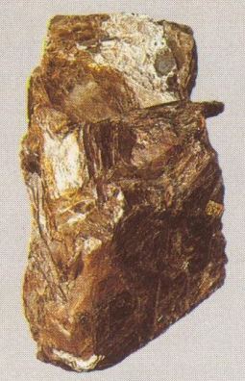
Figure 27. Muscovite specimen

4) Heavy minerals
Garnet, zircon, staurolite, kyanite, etc
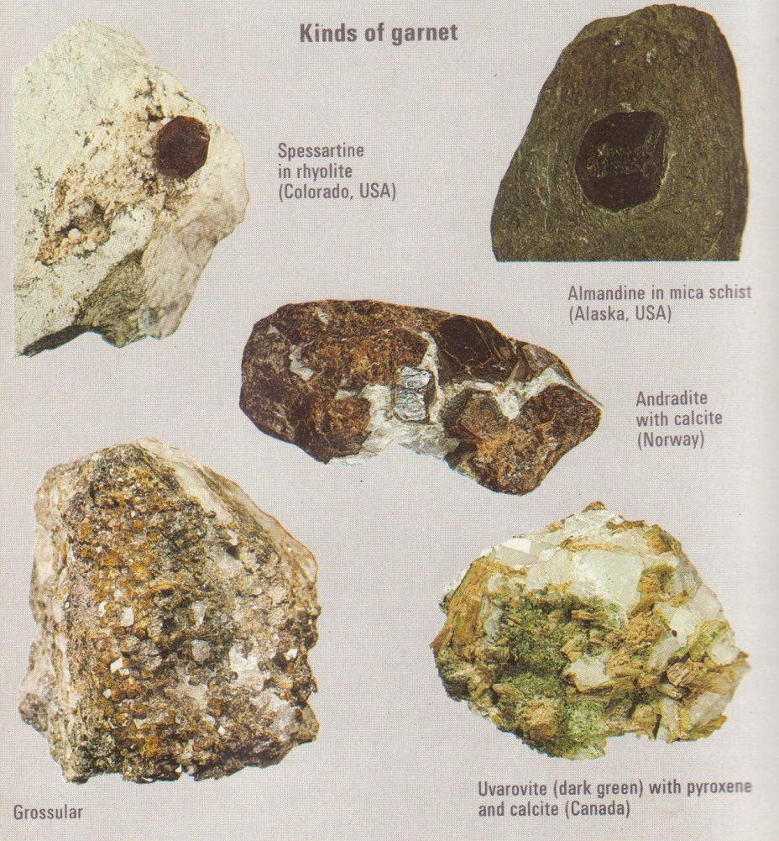
Figure 28. Muscovite specimen

5) Rock fragments
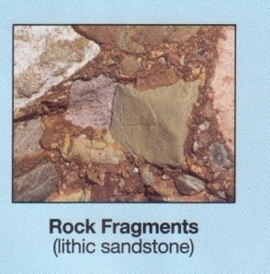Figure 29. Rock Fragments specimen

Sedimentary Structures
One of the most obvious sedimentary structure is stratification ( layering of sediments). Most layers of sediments, or strata (plural of stratum, a single layer), accumulate in nearly horizontal sheets. Strata less than 1 cm thick is called lamination; strata 1 cm thick or more are called beds.
Surfaces between strata are called bedding planes. These represent surfaces of exposure that occurred between sedimentary depositional events.
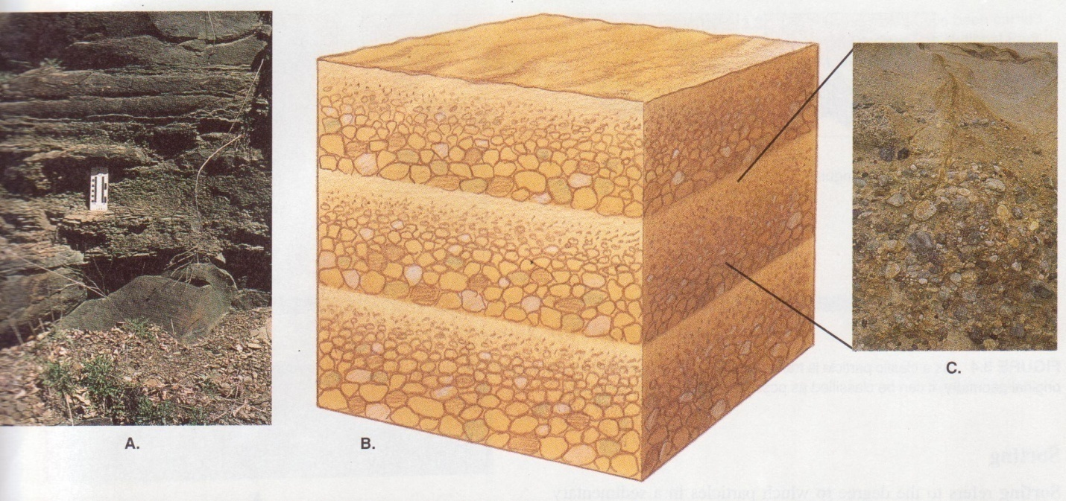
Figure 34. Horizontal strata
Most strata are deposited in nearly horizontal sheets. However, some stratification inclined is inclined and referred to as cross-stratification or cross bedding. E.g. sediments transported in a single direction by water or air currents commonly forms current ripple marks
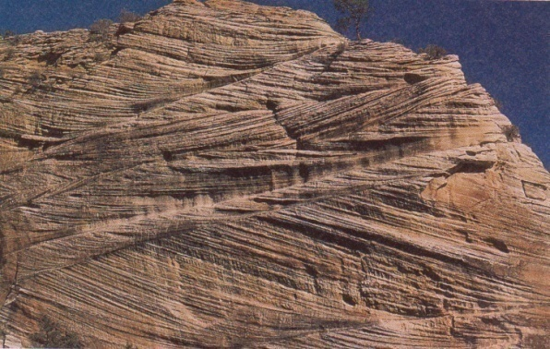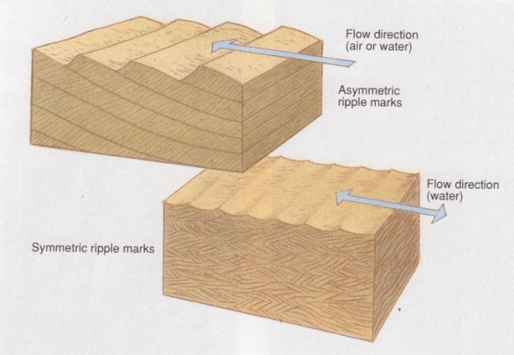
Figure 35. Cross bedding Figure 36. Ripple marks
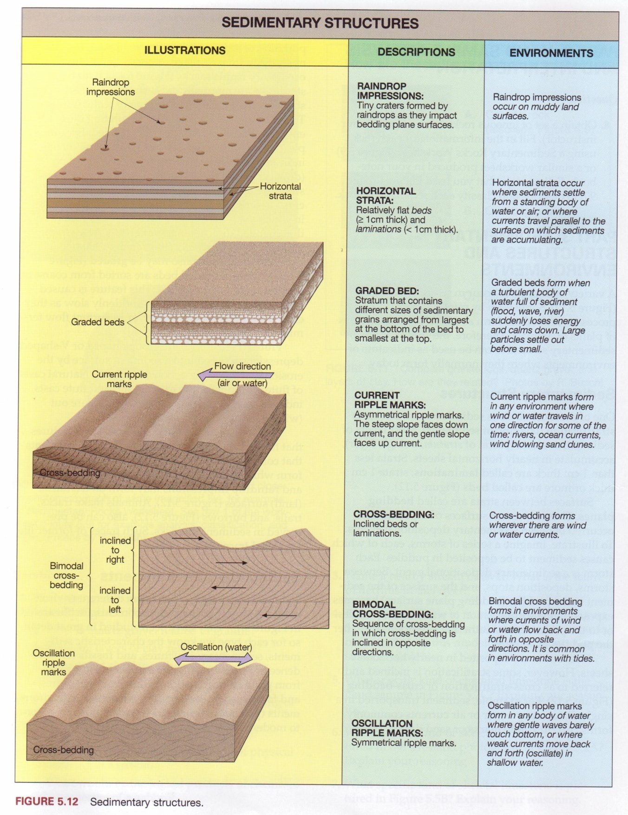
Figure 37. Sedimentary structures
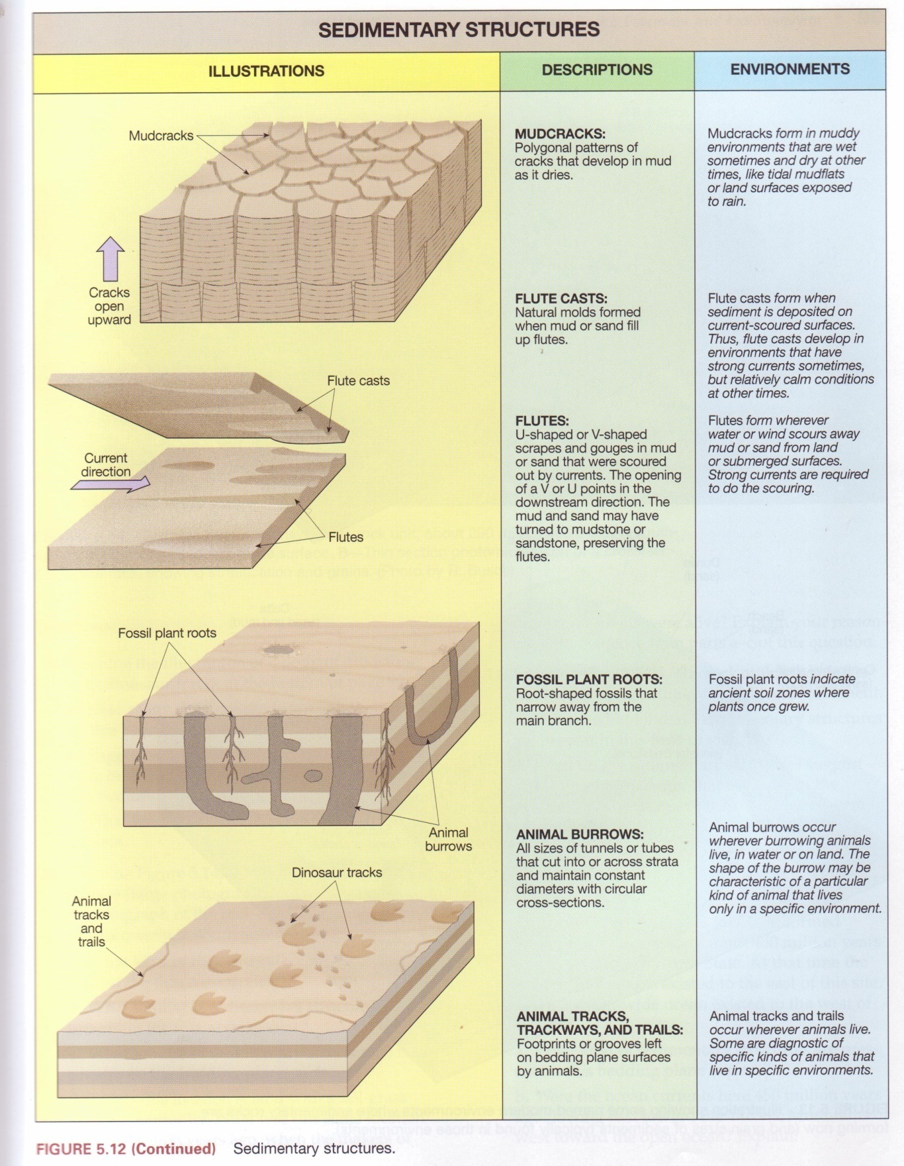
Figure 38. Sedimentary structures (continued)

Sedimentary Environments
Sediments are deposited in many different environments. A variety of these environments are illustrated in figure above. They have been studied in great detail, so for each type we know the characteristic sediments, sedimentary structures, and fossils (any evidence of prehistoric life). The information gained from grain characteristics, sedimentary structures, and fossils can be used to infer what ancient environments (pale environments) were like in comparison to modern ones
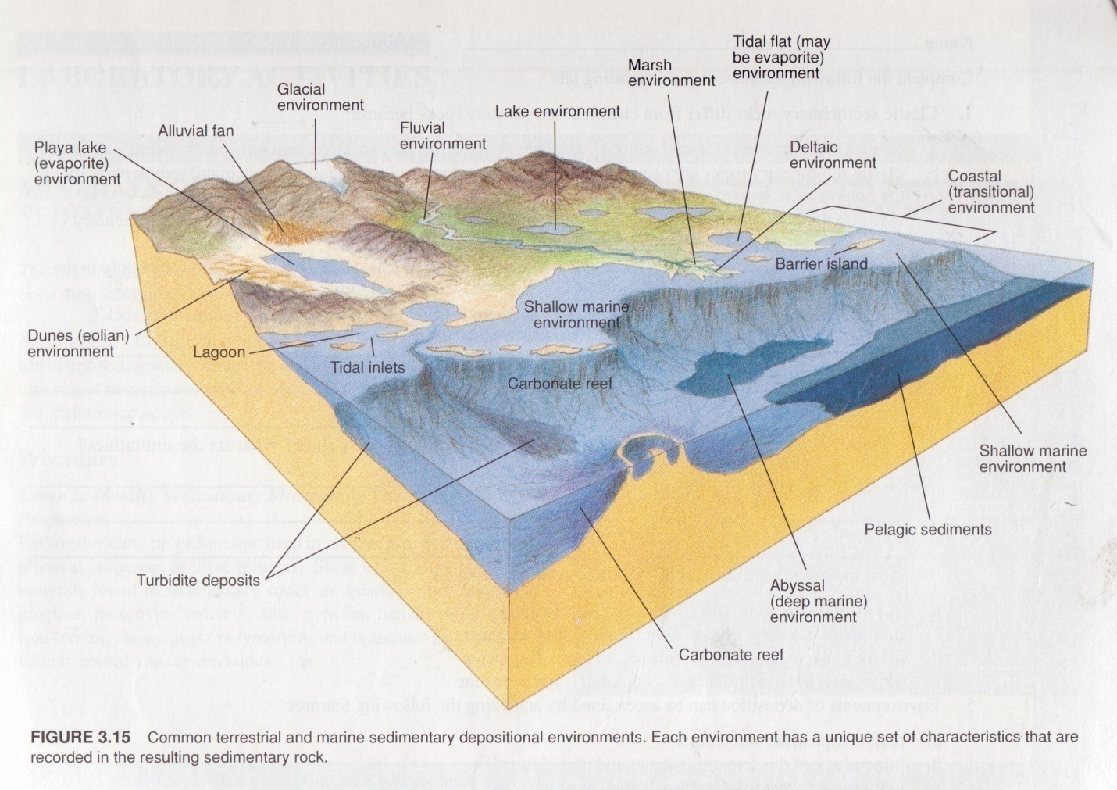

TEXTURES
Textures in sedimentary rocks are significant in that they provide important clues concerning distance of transportation and environments of deposition. Two basically different types of textures are recognized: (1) clastic textures (fragments of rock debris) and (2) crystalline textures (crystals which have grown from solutions).
Clastic Textures. The basic criterion for classifying clastic textures is grain size, with subordinate subdivisions made on the basis of rounding, sorting and cementation. The size of clastic particles ranges from large blocks, many feet in diameter, to fine dust.

Particle Size
Usually grain size of sedimentary rocks is expressed in Wentworth classes after C.K. Wentworth (1922). Wentworth grain size classes commonly used by sedimentologists in describing sediments:
Gravel includes grains larger than 2mm in diameter (granules, pebbles, cobbles, and boulders).
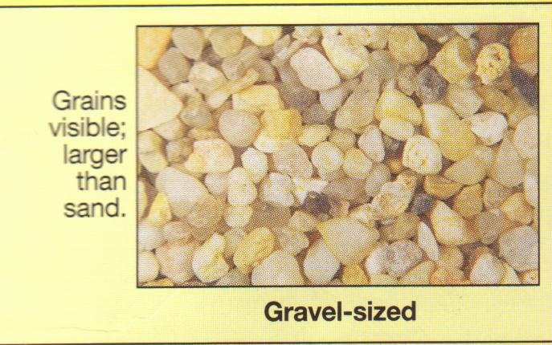
Sand includes grains from 1/16 mm to 2mm in diameter. This is the size range of grains in a sandbox. He grains are visible and feel very gritty when rubbed between the fingers.
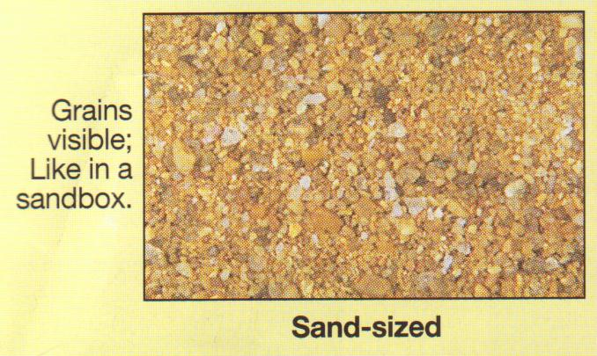
Silt includes grains from 1/256 mm to 1/16 mm in diameter. Grains of silt are usually too small to see but can be felt as very tiny gritty grains when they are rubbed between the fingers and the teeth.

Clay includes grains less than 1/256 mm in diameter. Clay- sized grains are too small to see and they feel smooth ( like chalk dust ) when rubbed between the fingers or teeth. Note that the word clay is used not only to denote a grain size but also a clay mineral.
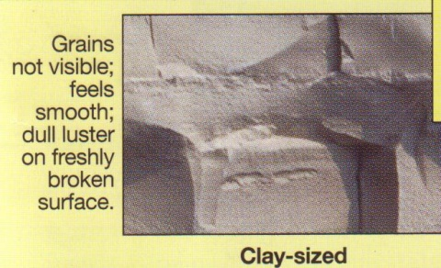

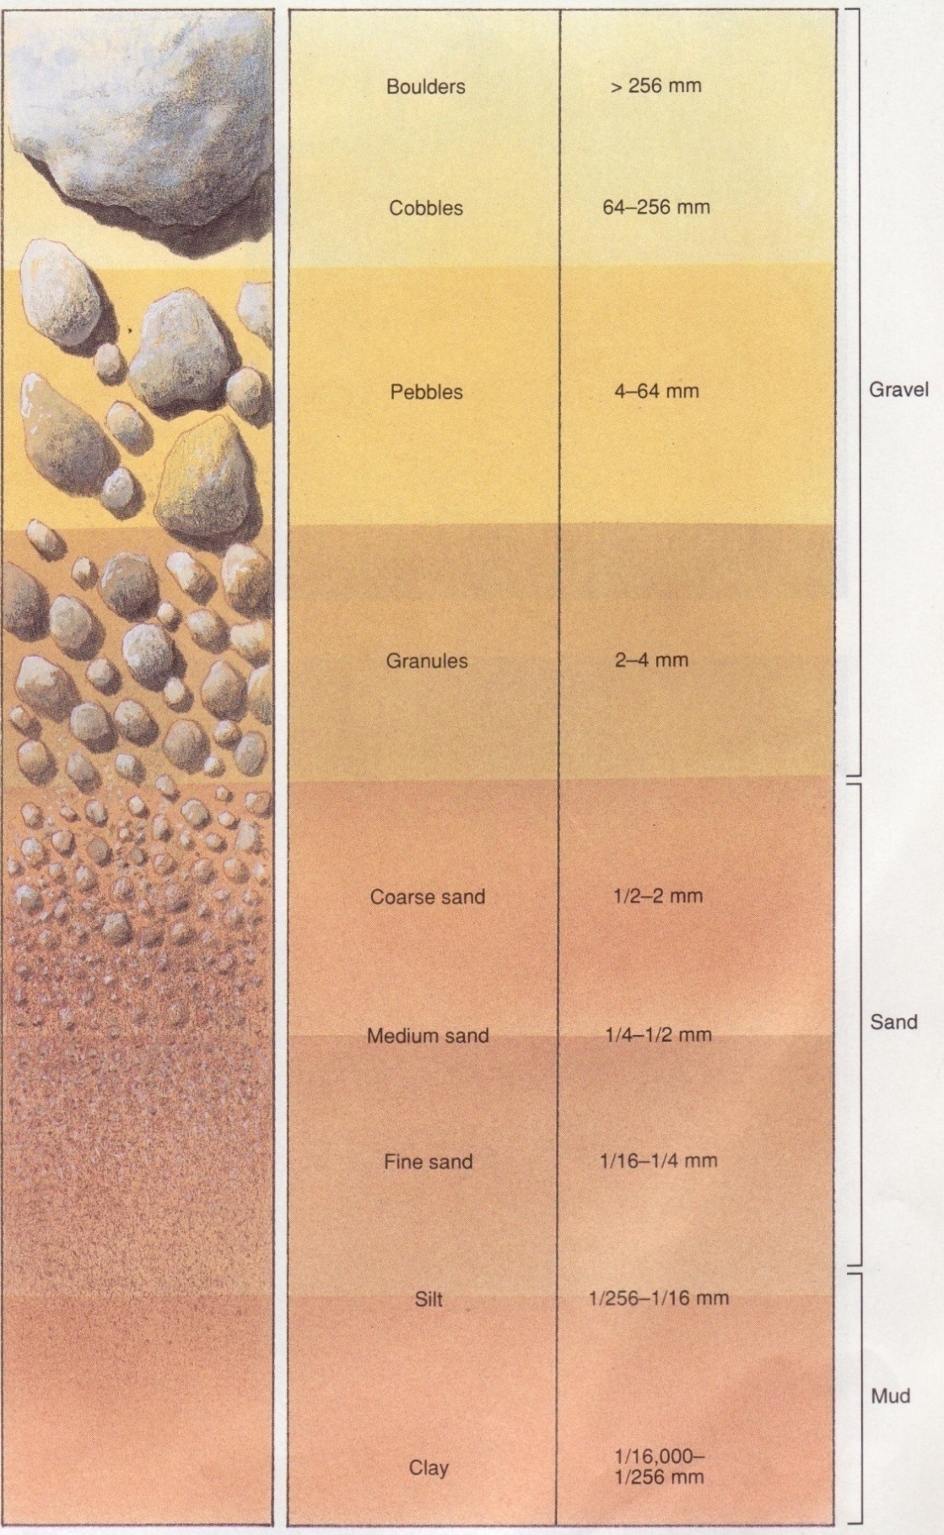
Figure 30. Grain size

Particle shape
Once formed, clastic sediment is removed and transported by running water, wind,, ice, or gravity. During transportation, particles that are initially angular tend to become more rounded by abrasion of sharp edges and corners. The further a particle is transported, the more its shape is changed. Grain carried a long distance by water or wind may become very smooth and rounded.
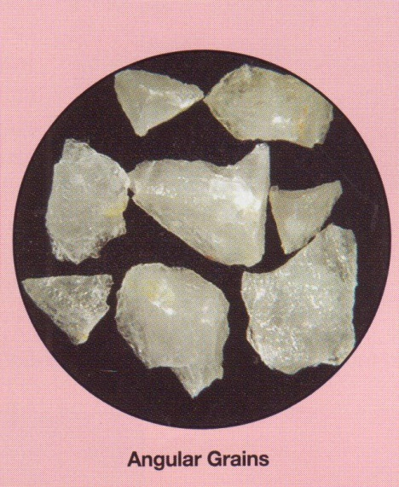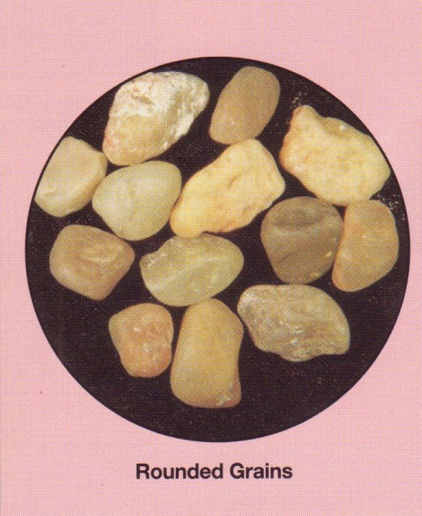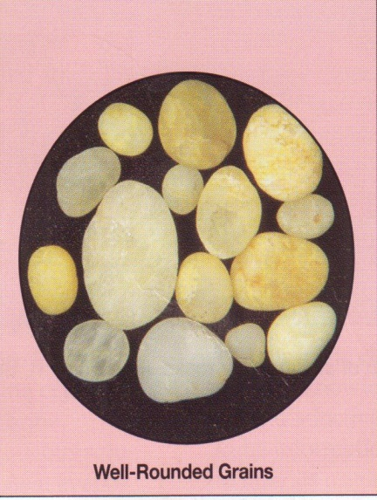
The degree of rounding can be used as indication of how far a grain has travelled e-g a conglomerate composed of rounded gravel probably formed far from the sediment source area. On the other hand, breccia which has angular particles probably formed near source of the gravel.
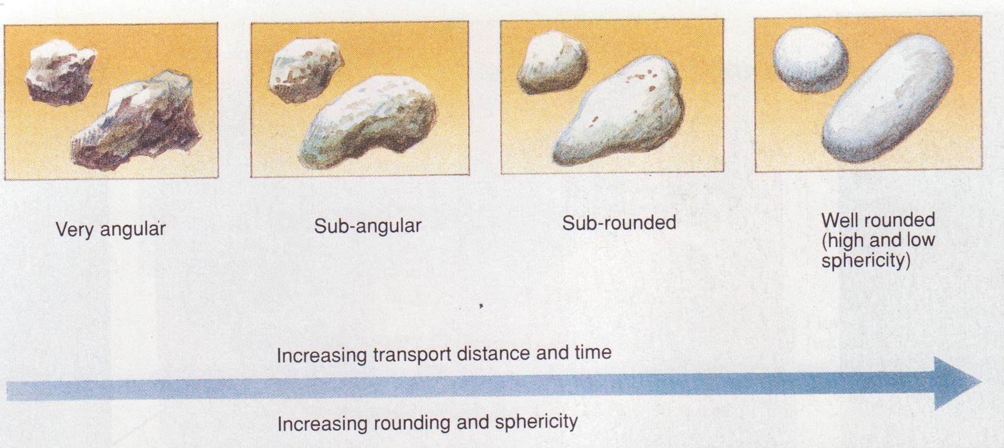
Figure 30. Grain shape

Sorting
Sorting refers to the range of various sizes of particles. It is a very important textural characteristic since it may provide clues concerning the history of transportation and the environment in which the sediment accumulated. Well-sorted material (Figure 30) is composed of one dominant size and usually one type of material. It results only after considerable transportation, during which particles similar in size and density are concentrated by prolonged washing and winnowing by current action. Poorly sorted material (Figure 30) contains several different sizes. Glaciers do not sort materials but deposit coarse and fine particles together. Mudflows do the same. Wind and water are the best sorting agents; they usually concentrate materials of one dominant grain size in dunes, beaches, bars and mud flats.

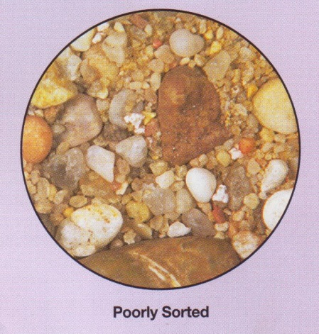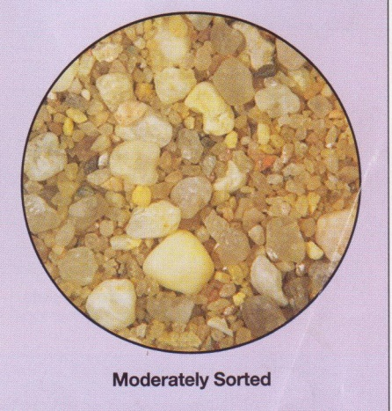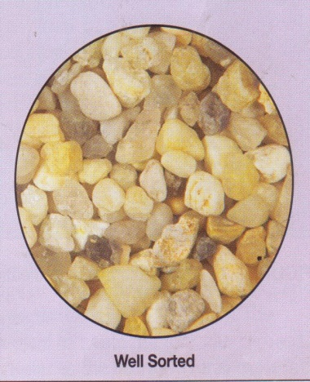
After a sediment is deposited, it may become tightly cemented together to form a solid rock. The dominant cementing materials are calcite, quartz, iron and chert which may be carried by ground water from a foreign source or derived within or very near the site of sedimentation by solution activity. The degree to which a sediment is cemented is thus an important textural characteristic in clastic rocks.
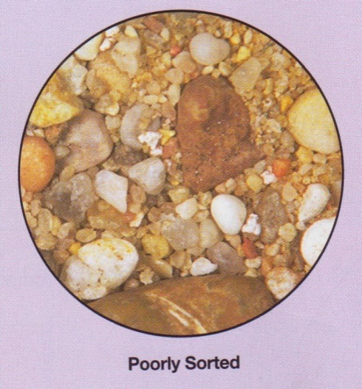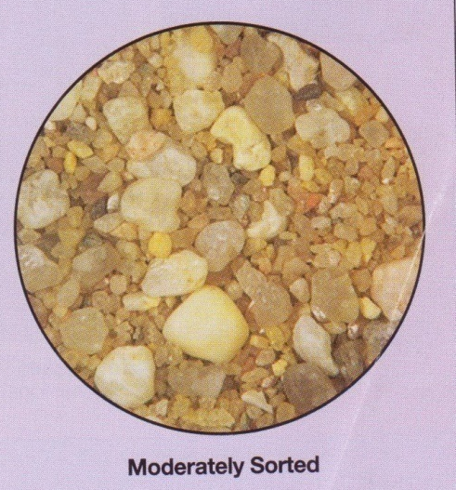
Figure 31. Sorting

Crystalline Textures. (Figures 31) In contrast to the clastic texture described above, minerals precipitated from sea water or lakes develop a texture consisting of a network of interlocking crystals. Such textures are similar to those found in igneous rocks but generally consist of one dominant mineral.
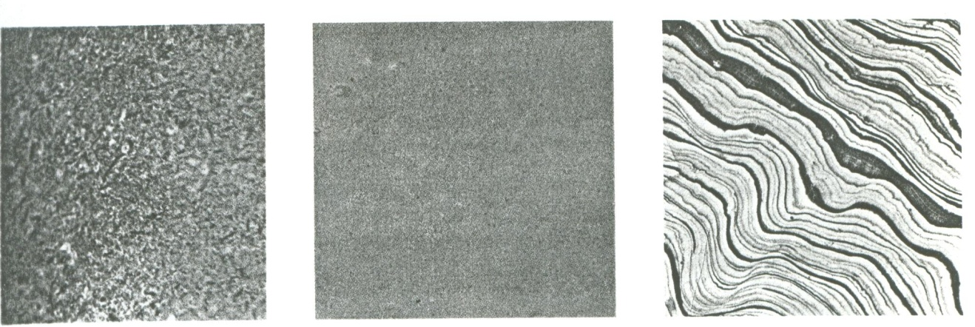
Figure 32 . Limestone textures

The individual crystals are usually about the same size and interlock to form a dense rock. Crystalline textures are described as coarse (greater than 2mm), medium (1/16mm to 2mm, Figure 32) and fine or microcrystalline (less than 1/16mm, Figure 32) deposits from springs and caves are commonly microcrystalline but have a banded structure (Figure 32) resulting from chemical variations and impurities during deposition.
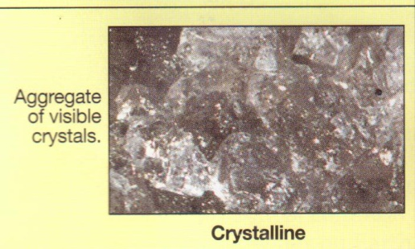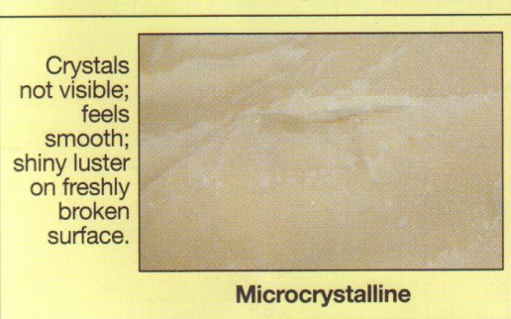
Oolitic Texture. Calcium carbonate precipitated on a sea floor and agitated by wave or current action commonly accumulates around a tiny shell fragment or grain or silt. As the particle moves to and fro, small spheres called oolites are built up by accretion and form a limestone texture which superficially resembles a well-rounded sandstone. Close examination of an oolitic texture reveals a concentric structure around a nucleus and generally minor amounts of associated shell debris (Figure 88C).
Skeletal Textures. Calcium carbonate may also be removed from sea water by organisms to make their shells and other hard parts. When the organisms die, the shell material will settle to the sea floor and may be concentrated as shell fragments on a beach or near a reef. The texture of the resulting rock is similar to a clastic texture, but the material is unique in that it consists of the skeletal fragments of organisms. Such a texture is referred to as skeletal (Figure 32) and is of fundamental importance in many limestones.
The samples shown above illustrate a variety of coarse clastic textures. All are composed of fragments greater than 2mm in diameter. In specimen A, large rounded pebbles composed mostly of quartzite are surrounded by a matrix of red sand and silt. The material is poorly sorted but a crude stratification is present. In Specimen B, two grain sizes are preserved – a fine sand-size matrix and coarse-grained pebbles. The angularity of the pebbles is an important textural characteristic of this rock and serves to distinguish it from the other coarse-grained sediments. In Specimen C, the grains are moderately well sorted and subangular and represent the border line between a medium and coarse grained texture.
Specimen A is typical of a medium-grained clastic texture. The grains are less than 2mm and are well rounded and well sorted. A fine-grained clastic texture is shown in Specimen B. individual grains are too small to be distinguished with the unaided eye but are well sorted. A microscopic view of this texture is shown in Figure 31. redistribution of these silt-sized particles by burrowing organisms is common and is evident in the lower left corner of the photo.
The finest-grained clastic texture is illustrated in C. Individual particles are less than 1/256mm and cannot be seen without high magnification. Lamination like that shown in C is common in fine-grained clastic rocks. (See photomicrograph of this texture in Figure 31).
Calcium carbonate precipitated from the sea or lakes may form a texture of interlocking crystal. The crystal size ranges from large crystals greater than one inch long to small submicroscopic grains. In Specimen A, the texture is coarse, crystalline and equigranula. Micro crystalline material, such as shown in B, forms a very dense, structureless rock. Even under the microscope the crystal material is difficult to distinguish. With extremely high magnification, discrete crystals can be identified. Some microcrystalline material is characteristically banded due to variations in conditions during deposition, such as illustrated by Specimen C.
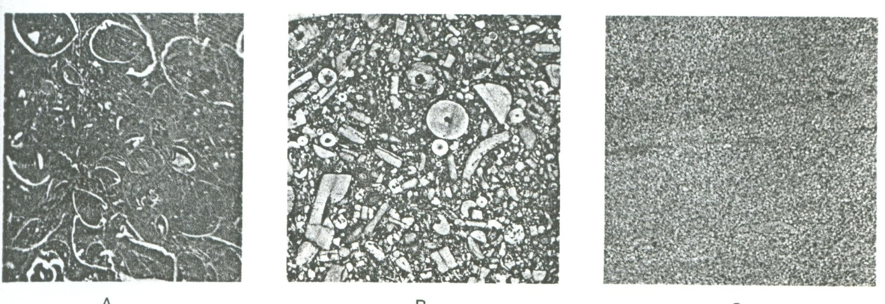
Figure 33. Examples of Limestone textures (actual size)

Organisms play an important role in many limestone textures. Shells and shell fragments accumulate after the organisms die and may dominate the textural aspect of the rock. In Specimen A, cross sections of shells of clamlike organisms are shown in white. Crinoid stem fragments are shown in Specimen B. Oolitic textures, such as are shown in Specimen C, develop when a silt particle or shell fragment is shifted to and fro by waves and picks up newly precipitated calcium carbonate. A microscopic view of oolites is shown in Figure 33.

TYPES OF SEDIMENTARY ROCKS
Materials accumulating as sediments have two principles sources. First sediments may be accumulations of materials that originate and transported as solid particles derived from both mechanical and chemical weathering. Deposits of this type are termed detrital and the sedimentary rocks that they form are called detrital sedimentary rocks. The second major source of sediment is soluble material produced largely by chemical weathering. When these dissolved substances are precipitated by either inorganic or organic processes, the material is known as chemical sediments and the rock formed from it are called chemical sedimentary rock

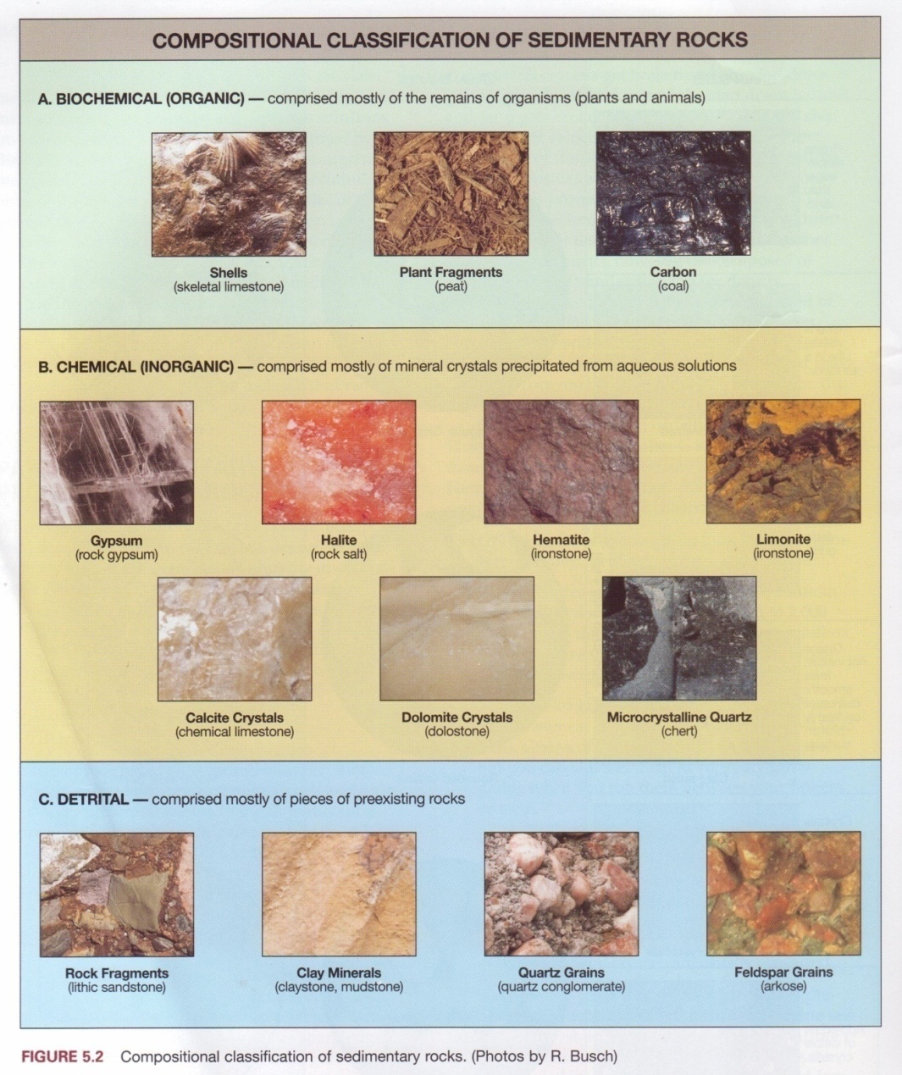
Figure 39. Composition classification of sedimentary rocks

CLASTIC ROCKS
Clastic rocks consist predominatly of fragments and debris of other rock material. These deposits are familiar as gravel, sand and mud when unconsolidated and are referred to as conglomerate, sandstone, and shale when indurated. Most of the material in the sedimentary record is sorted and stratified, and shows the effects of abrasion. Classification of classic rocks is made on the basis of texture and composition.
Table: Clastic sedimentary rocks
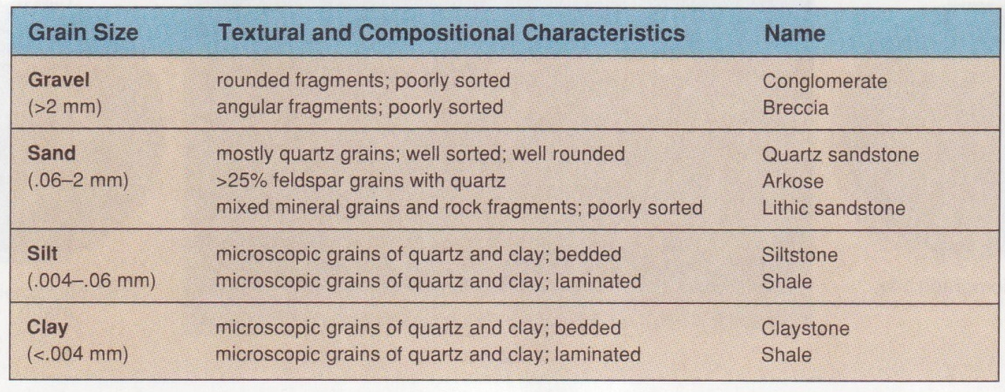

CONGLOMERATE
Conglomerates consists of coarse rock fragements(greater than 2 mm in diameter], held together by a matrix of sand, clay, and cement. The individual pebbles are usually well rounded and moderately well sorted{Figure 40].
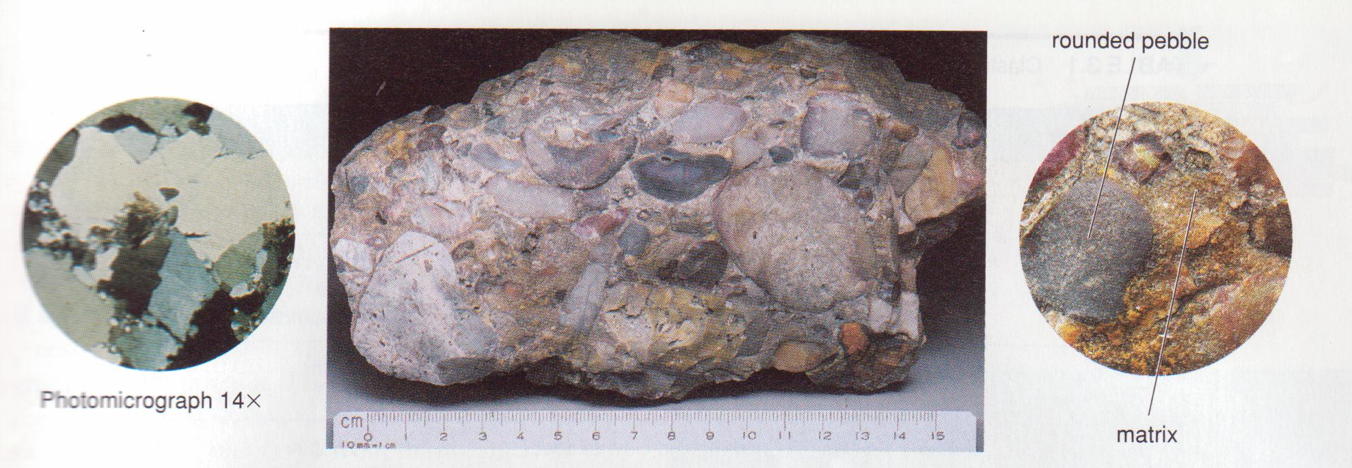
Figure 40. Conglomerate thin section and hand specimens
Pebbles in conglomerates may consist of any mineral or rock, but resistant materials such as quartz, quartzite, and chert are especially common. Fragments of limestone, granite, or other rock types may predominate in some deposits.
The only agents capable of transporting gravels and large fragments are swift-moving water, ice and gravity. The most important environments for conglomerate deposition are alluvial fans, river channels, and beaches.

BRECCIA
A breccia is a course-grained clastic rock in which the fragments are angular and show little evidence of abrasion (Figure 41). The material is commonly poorly sorted, with a fine-grained matrix.
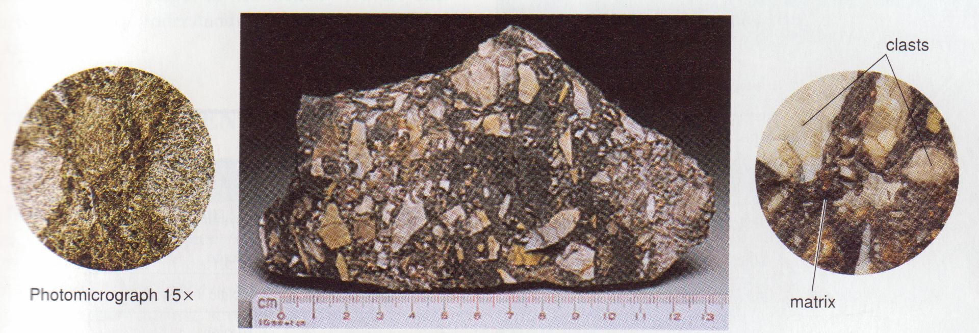
Figure 41. Breccia in thin section and hand specimen
The most significant breccia deposits result from glaciation, landslide, and other types of mass movement. Movement along fault planes will also produce a breccia zone, as will collapse in caves.

AKROSES
An arkrose (Figure 42) is a clastic rock which is composed of at least 25 percent feldspar. Quartz is the other major constituents. Arkose is generally coarse grained angular, and moderately well sorted. In most arkoses the grain size is commonly in the sand range, but some arkoses are coarse enough to be termed conglomerates.
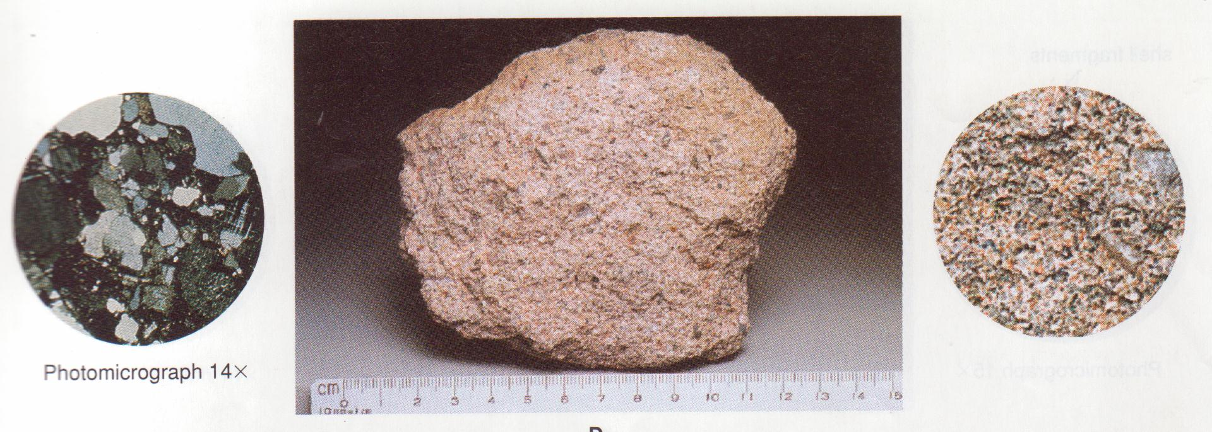
Figure 42. Arkose in thin section and hand specimen

In fugure 35, the feldspar is pink, and close inspection will reveal that it is very abundant. In thin section the feldspar grains, which have a plaid pattern, are nearly as abundant as quartz (gray). Calcite cement appears brown in the thin section.
Arkoses form by rapid erosion of a granitic terrain and rapid deposition. They are common in alluvial fans.

SANDSTONES
Sandstone are clastic sedimentary rocks consisting mostly of grains ranging from 1/16 to 2 mm in diameter. The grains are generally rounded and show other effects of abrasion. Quartz is usually the dominant mineral, although feldspar, garnet, mica, and other minerals may be present in varying amounts. Poorly sorted, dirty sandstones containing over 20 percent clay are called greywacke. Calcite, quartz, and iron oxide are the dominant cementing materials. Sandstones are generally stratified and are colored buff, red, brown, yellow, or green, depending on impurities’ and cementing agents.
Grit or Lithic sandstone consists of a mixture of angular, sand- sized grains including quartz, feldspar, mica, and rock fragments in a poorly sorted matrix.

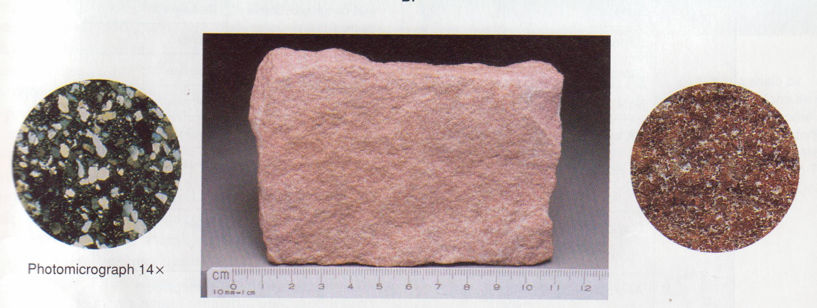
Figure 43. Sandstone in thin section and hand specimen

Sandstones may accumulate in a wide variety of environments, such as beaches, deserts, flood plains and deltas.

SILTSTONES
Siltstones are fine-grained clastic rocks in which at least 50 percent of material is 1/16 to 1/256 mm in diameter. They are commonly laminated (Figure 44), but burrowing organism may destroy or obscure evidences of stratification. Silt particles, when viewed under the microscope, appear to be angular rather than rounded like sand. They are composed of quartz grains, with an abundance of mica and clay minerals.
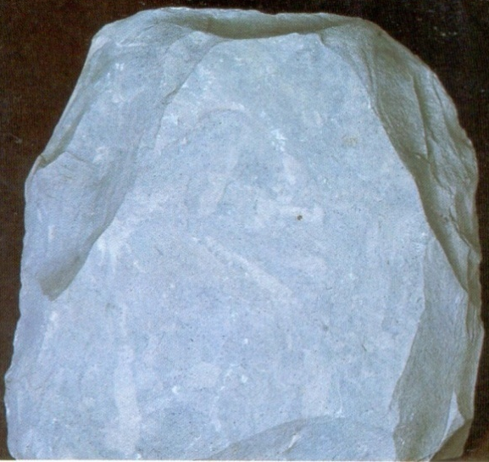
Figure 44. Siltstone
Silt is common material deposited by most streams in deltas and flood plains. It rarely forms thick beds and is characteristically interstratified with shales and sandstones.

SHALES
Shales are fine grained clastic rocks consisting of particles less than 1/256 mm in diameter. They are characteristically laminated or thin bedded, as is well expressed in both hand specimen and thin section. Quartz, mica, and the clay minerals are the dominant constituents, but, as is shown in Figure 85, particles are too small to be seen without a high magnification. Calcite may be present – usually as cement – in amounts ranging up to 50 percent. Eighty percent of exposed sedimentary rocks are shales. They accumulate in an environment of low mechanical energy such as lagoons, quite offshore waters, flood plains, and lakes.
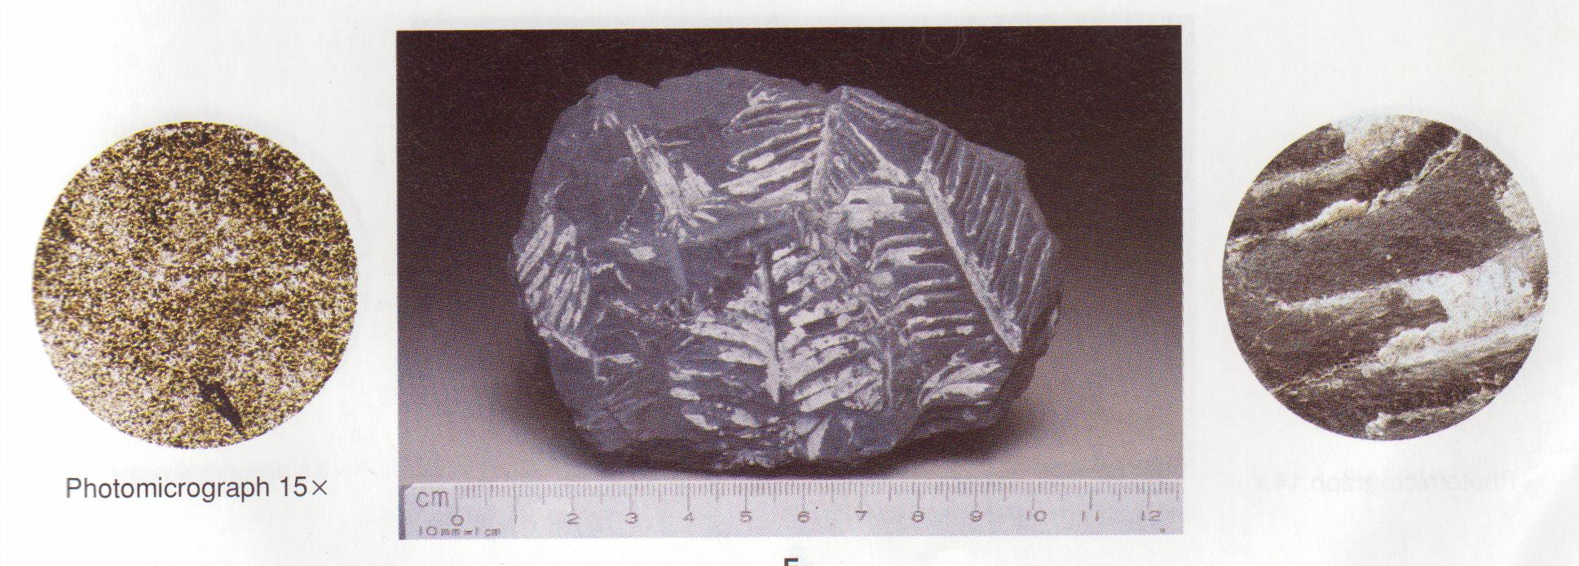
Figure 45. Shale in thin section and hand specimen

Chemical Sedimentary Rocks
Table: Chemical Sedimentary Rocks
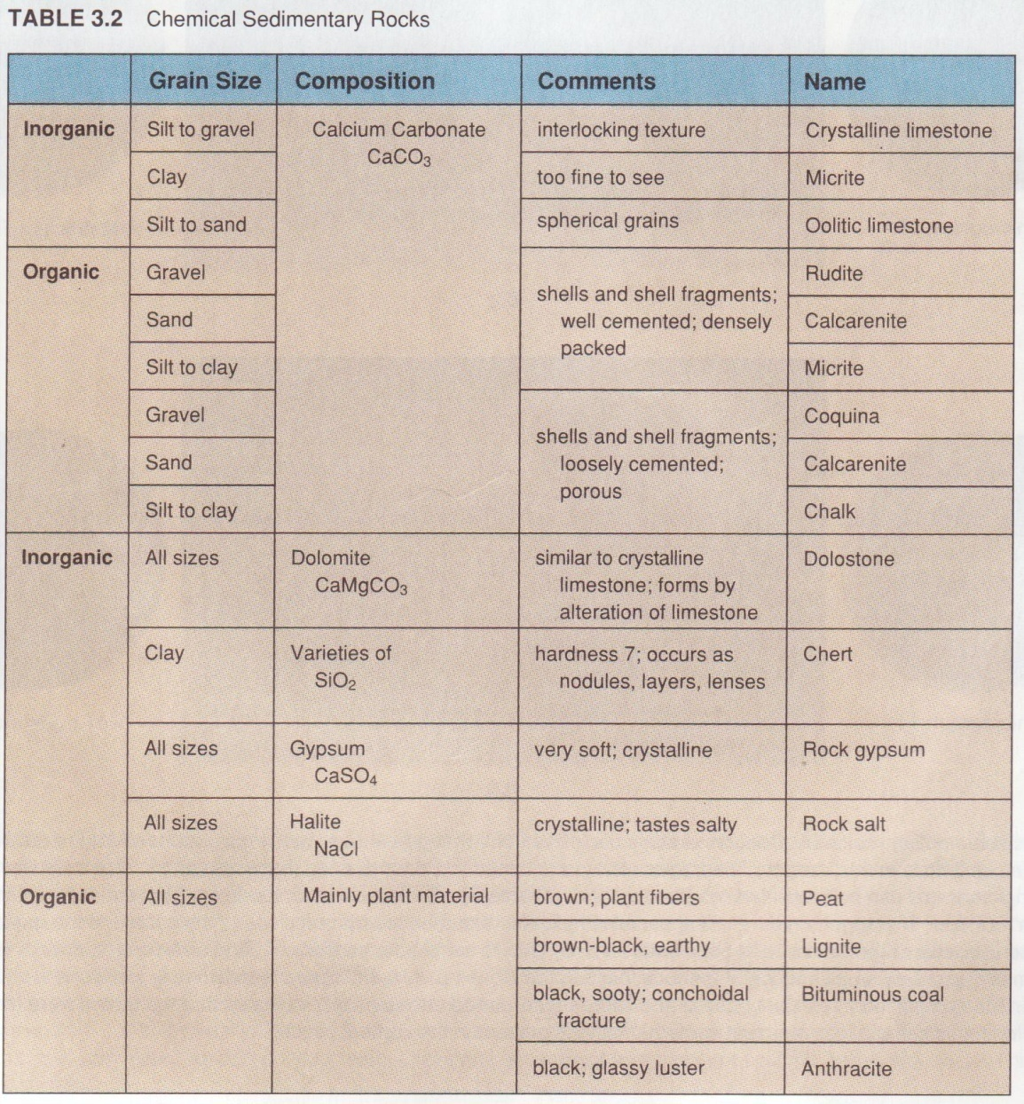

LIMESTONE
Limestones are sedimentary rocks that contain more than 50 percent calcium carbonate. Impurities, which may range in amount to 50 percent, include clay, quartz, iron oxide, rock fragements, and othe material. The calcite may be precipitated chemically or organically or may be of detrital origin. The many varieties of limestones are classified on the basis of texture or some other significant property.
All limestones are similar in that they are composed mostly of calcite and effervesce in hydrochloric acid.

CRYSTALLINE LIMESTONE (Sparite)
Crystalline limestone (Figure 46) is composed of interlocking crystals of calcite which can be seen with the unaided eye or with low power magnification.
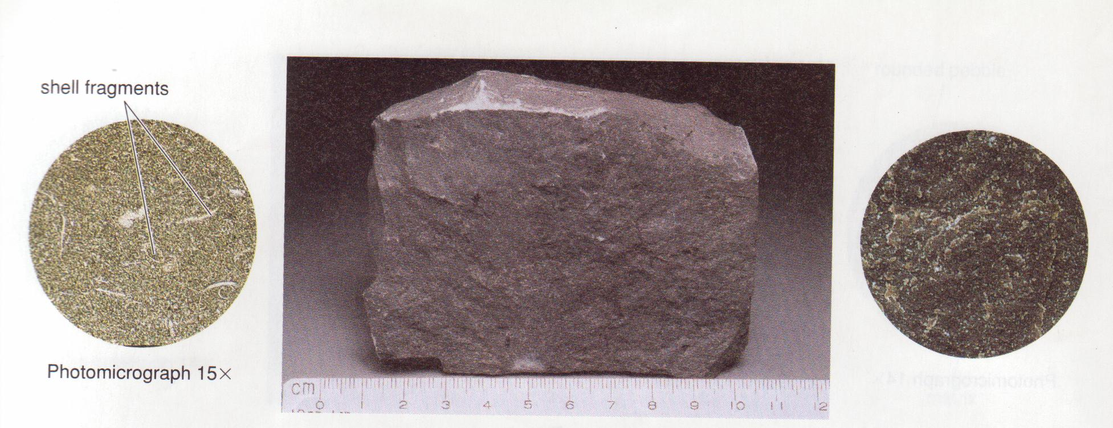
Figure 46. Crystalline limestone in thin section and hand specimen

In many respects it is similar to a marble, but it shows no evidence of pressure or flowage. Well-preserved fossils are common, and bedding planes are generally distinct. Good rhombohedral cleavage is commonly well expressed in thin sections of crystalline limestone.
Large crystals in limestone may grow after deposition if ground-water solutions migrate through the rock and precipitate calcite.
Dolomite or dolostone closely resembles crystalline limestone but is composed of the mineral dolomite. It can be distinguished by its reaction to dilute hydrochloric acid it must be powdered to exhibit effervescent (dolomite will react weakly if the hydrochloric acid is too concentrated. It is typical colour is buff to brown.
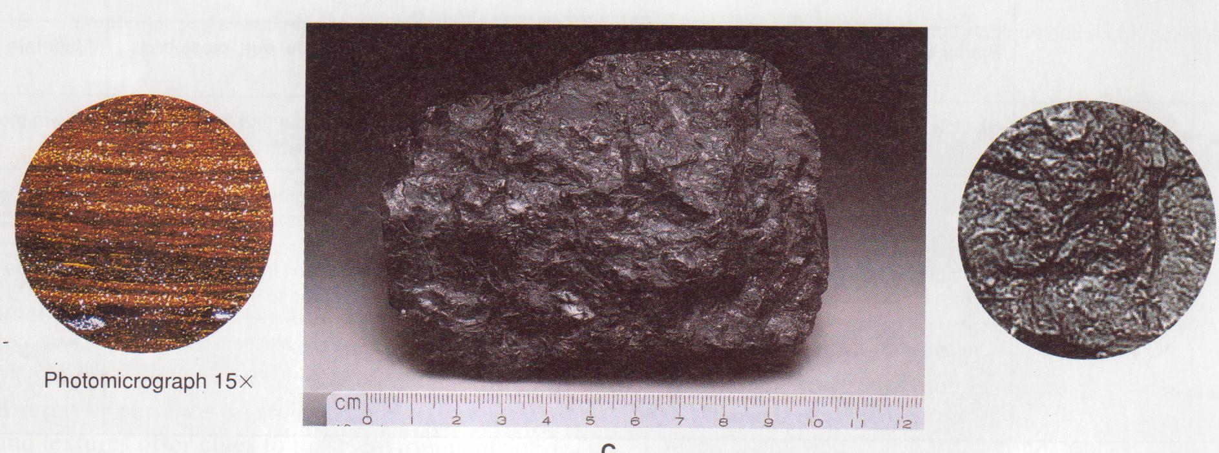
Figure 47. Dolomite in thin section and hand specimen

MICROCRYSTALLINE LIMESTONE (Micrite)
Micricrystalline limestone is composed almost entirely of microscopic crystals of calcite so small that they are difficult to discriminate even under the microscope. The rock has uniform texture, is very dense, and characteristically breaks with a conchoidal fracture. It is commonly buff or light yellow but may range in colour to dark gray or black if organic material is abundant.
Microcrystalline limestone forms in warm, quite, shallow seas.

OOLITIC LIMESTONE
Oolitic limestone is composed of small spheres of calcite concretions called oolites. The grains range up to 2 mm in diameter and consists of a sequence of concentric layers built around a nucleaus of fine silt, clay, or shell fragments. Calcite commonly cement the oolites together into a rock which closely resemble a well-rounded quartz sandstone. Stratification, sorting, cross-bedding, and other features characteristic of a sand stone are also common in oolitic limestone.

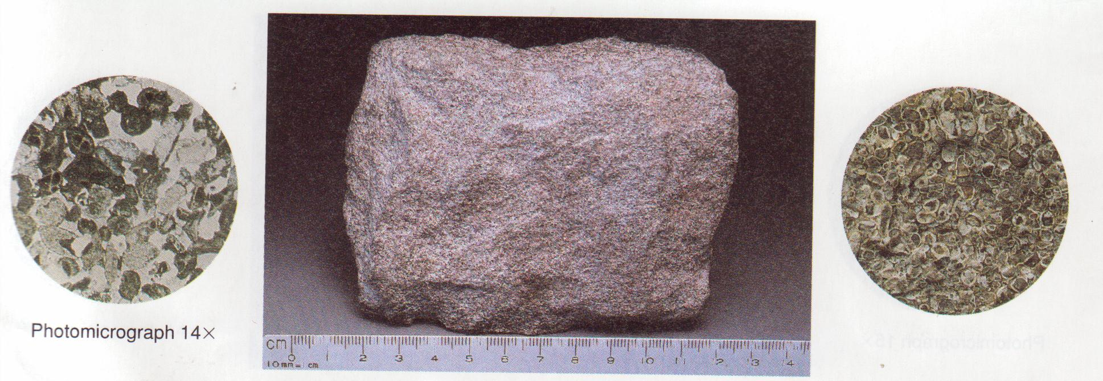
Figure 48. Oolitic limestone in thin section and hand specimen

Oolites originate in shallow water where the nucleus, agitated by current and waves, rolls along the bottom and picks up calcite that adheres to its surface.

COQUINA
Coquina [Figure 49] is the name given to a weak, porous, poorly cemented limestone composed almost exclusively of shells and shell fragments. The shell material in a coquina is commonly broken into platy fragments which are rounded, abraded, and well sorted, as is shown in the thin section.
Coquina is thus a particular type of clastic rock in which the fragmental material originated within the sedimentary environment rather than being transported to it from an eroded landmass. Coquinas are forming today along the southern Atlantic coast and in the Bahamas Islands where shell material is wished up on the shore and accumulates as calcareous sand on a beach or in shallow marine water.
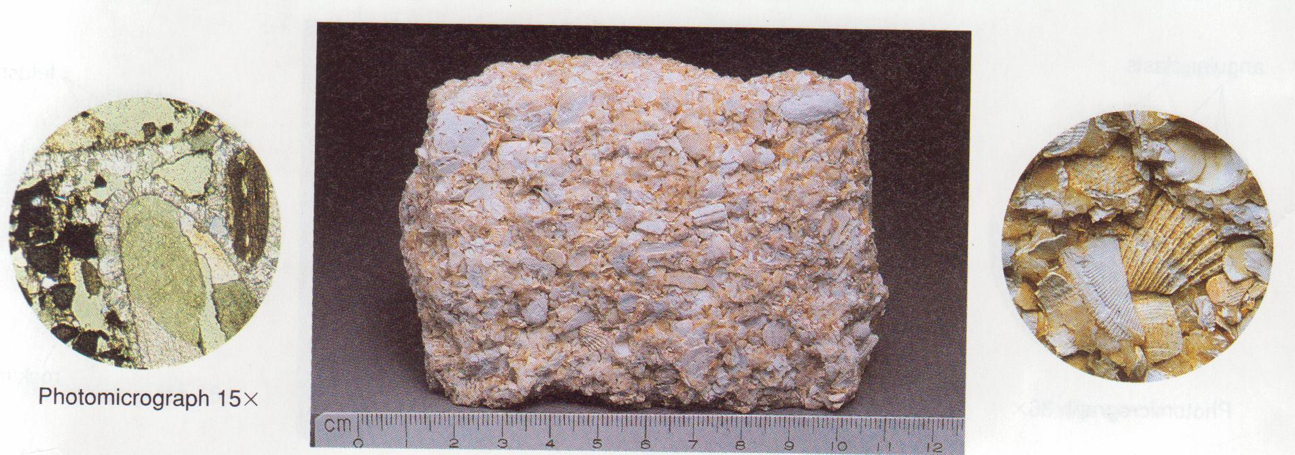
Figure 49. Coquina in thin section and hand specimen

SKELETAL OR FOSSILIFEROUS LIMESTONE
Skeletal limestone (Figure 50) is composed primarily of hard parts of invertebrate organisms such as molluscs, corals, crinoids, and other invertebrates. This material is commonly cemented with calcite and forms a dense rock. Fossils may weather out in relief, however, and reveal minute details of rock textures. In thin section, details of fossil shell structure are clearly expressed.
Fossiliferous limestone forms in warm, shallow seas where marine life is abundant.
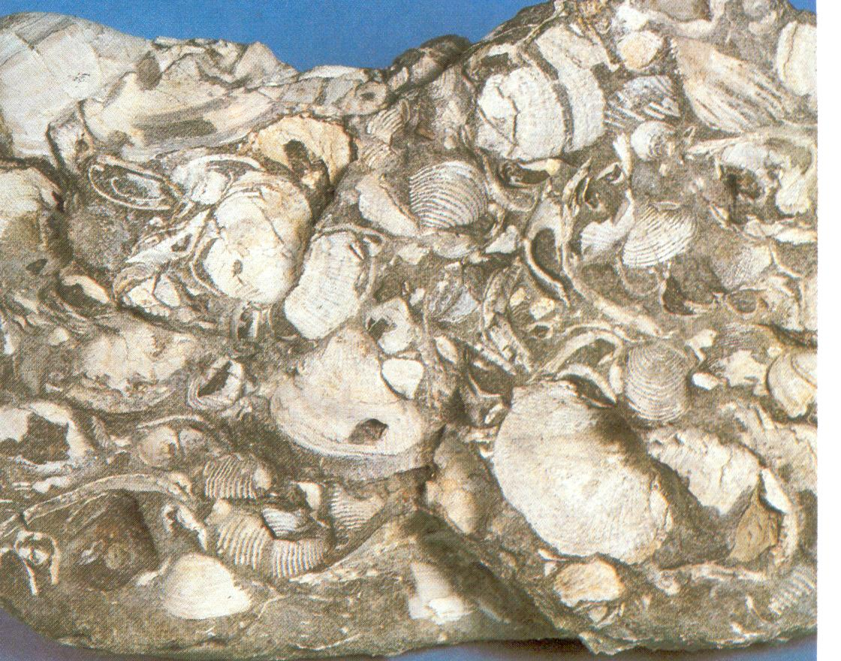
Figure 50. Fossiliferous limestone

CHALK
Chalk is a soft, porous, fine-textured limestone composed of shells of microscopic organisms, mostly foraminifera. It is normally white or buff and may contain varying amounts of mud (Figure 51).
The best-known chalks are of Cretaceous age, such as the famous white chalk cliffs on both sides of the English Channel, the Selma Chalk of the Gulf coast, and the Niobrara Chalk of Kansas. Chalk is considered to be a shallow water deposit formed by the accumulation of shells of floating organisms.

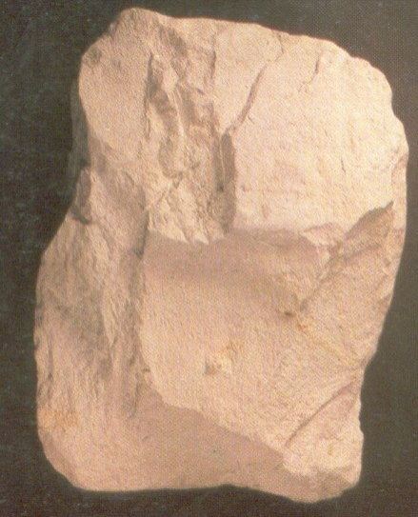

Figure 51. Chalk

TRAVERTINE
Travertine (Figure 52) is a calcium carbonate deposit formed in caves and springs. It is characteristically banded with alternating light and dark layers resulting from minor amounts of iron oxide which accumulate during successive periods of deposition.
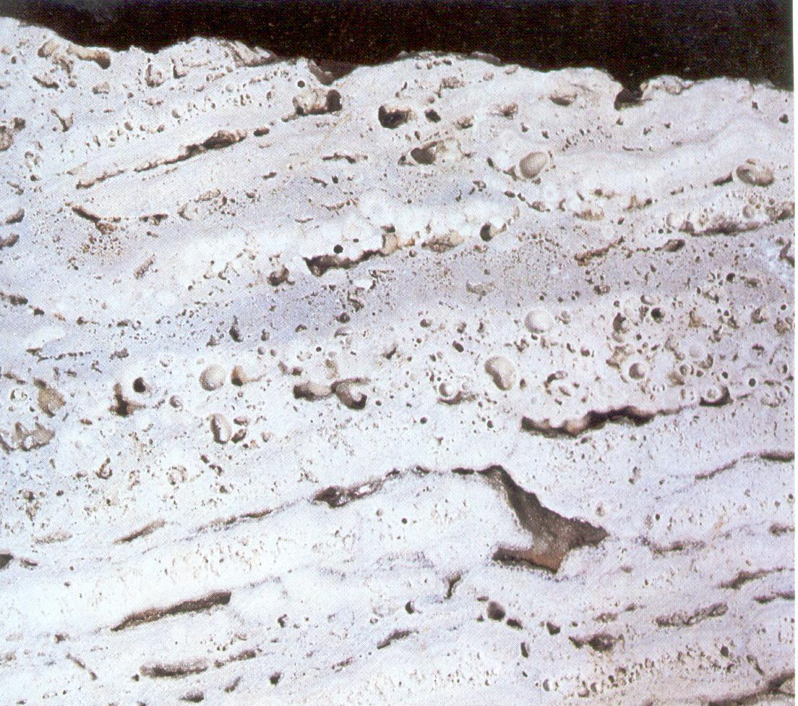
Figure 52. Travertine

The well-known flowstone, dripstone, stalagmites, and stalactites of caves are all varieties of travertine. In as much as traverstine forms relatively small deposits, mostly recent in age, it is of no great geologic importance, but it is of interest because of its beauty and the variety of forms in which it may occur.

ROCK GYPSUM
Rock gypsum is a chemical precipitate composed almost exclusively of aggregates of the mineral gypsum (Figure 53). It is normally white or is delicately coloured in various shades of yellow or light red. One of its most distinctive characteristics is that it can be scratched with the fingernail. Gypsum is commonly massive, but thin, delicate laminae formed by seasonal influxes of clay are found in some deposits.
Gypsum originates from evaporation of saline lakes or sea water in restricted bays and thus indicates an arid or semi arid climate at the time of formation.

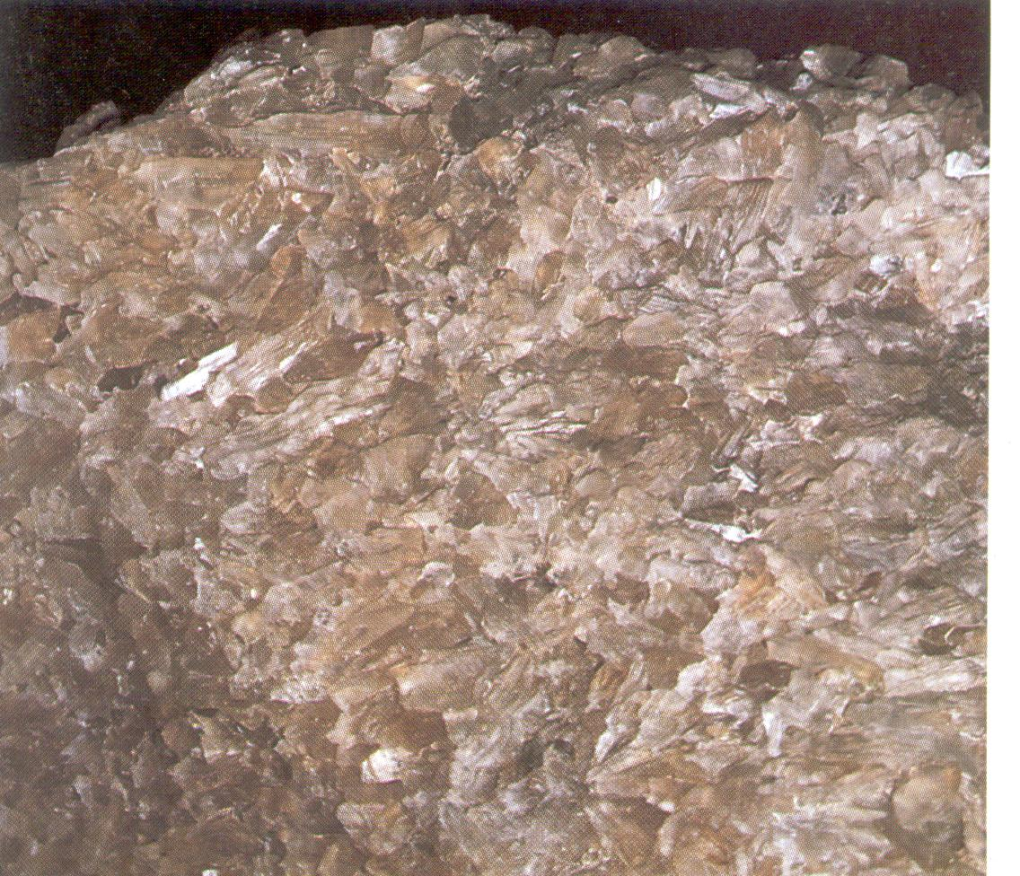
Figure 53. Gypsum

ROCK SALT
Rock salt is a rock composed of the mineral halite. Crystals may be fine, medium, or coarse and are generally colourless, unless modified with impurities of iron oxide or clay to various shades of red (Figure 54).

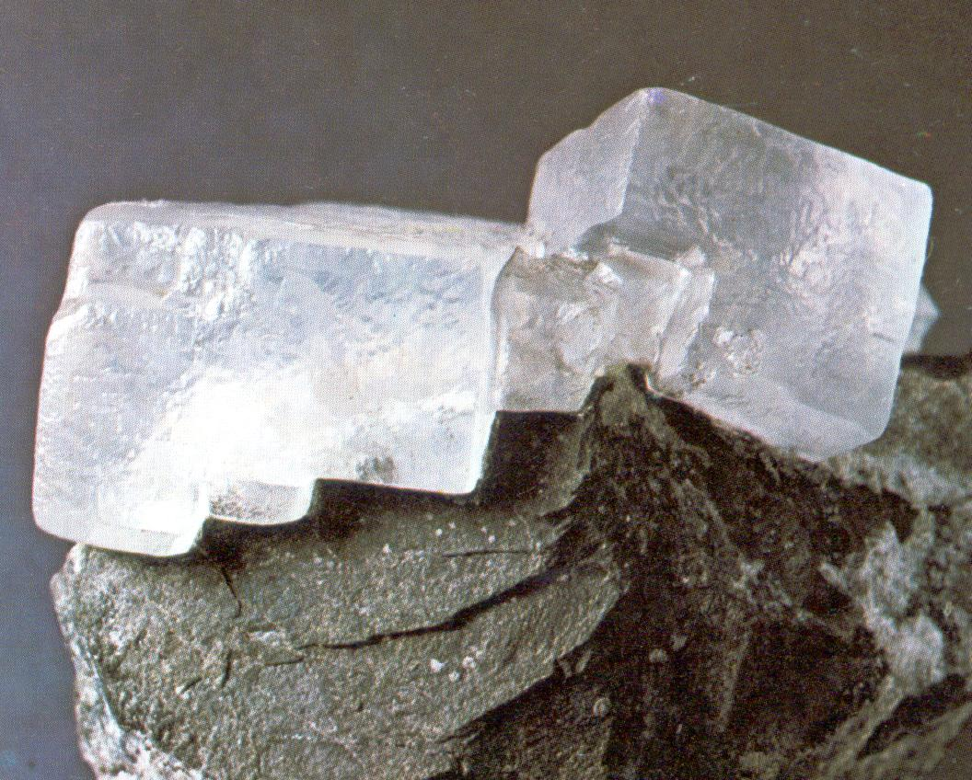
Figure 54. Rock salt
The origin of rock salt is similar to that of gypsum. Thick salt deposits are found in Michigan, New York, and Kansas and in relatively recent deposits of the western states. One of the interesting and important characteristics of salt is that it flows at relatively low temperatures and pressures. Salt from deeply buried strata may rise as piercement plugs or salt domes.

CHERT AND FLINT
Chert and flint (Figure 55) are common chemical siliceous sediments. The colour may be white or various shades of gray, green, blue, red, yellow, or black. Under high magnification, they have a fibrous or granular texture. Chert and flint commonly occur as nodules in limestone and may be coated white. Like other varieties of quartz, chert and flint are characterised by a hardness of 7 and a conchoidal fracture.
A large amount of chert is deposited in limestones by ground water but some appears to be deposited in shallow seas with limestone.
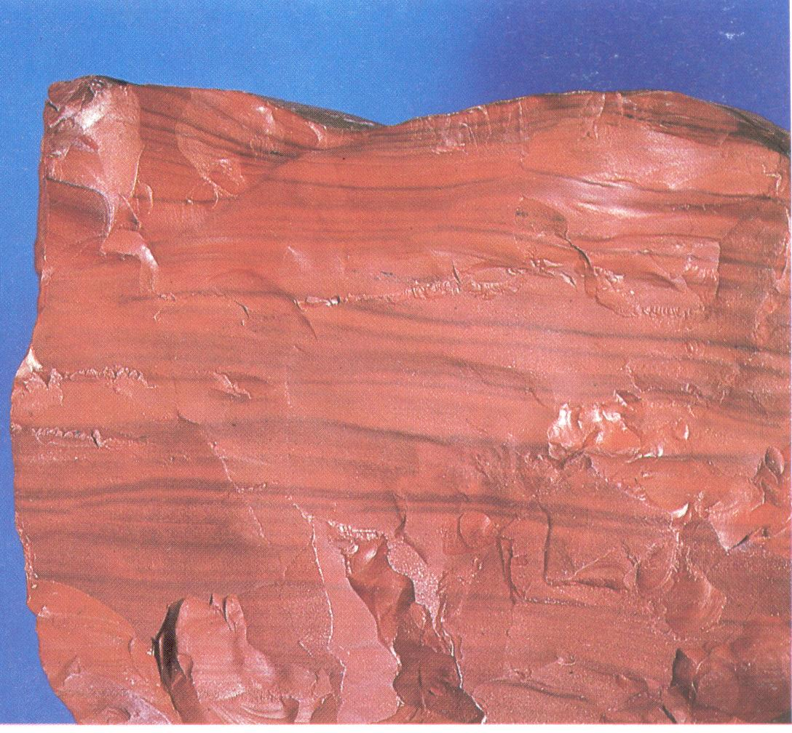
Figure 55. Flint

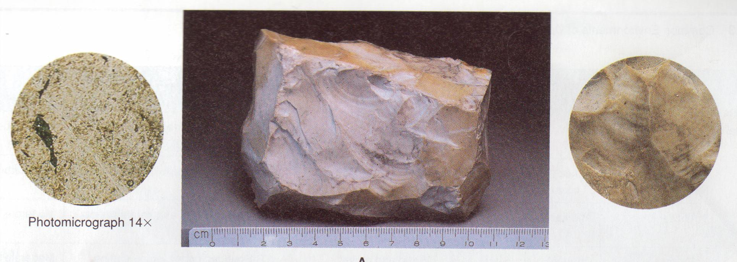
Figure 56. Jesper/Chert in thin section and hand specimen

PEAT
Peat is a dark brown or black residuum produced by partial decomposition and disintegration of plants (Figure 47). It represents the initial step in the formation of coal and forms in bogs and swamps. The organic residues constitute from 70 to 90 percent of the total accumulation. Mineral compounds are insignificant. The development of peat requires rapid growth and reproduction of plants and a minimum of life activity of micro-organisms. Peat deposits may be tens of feet thick and cover many square miles.
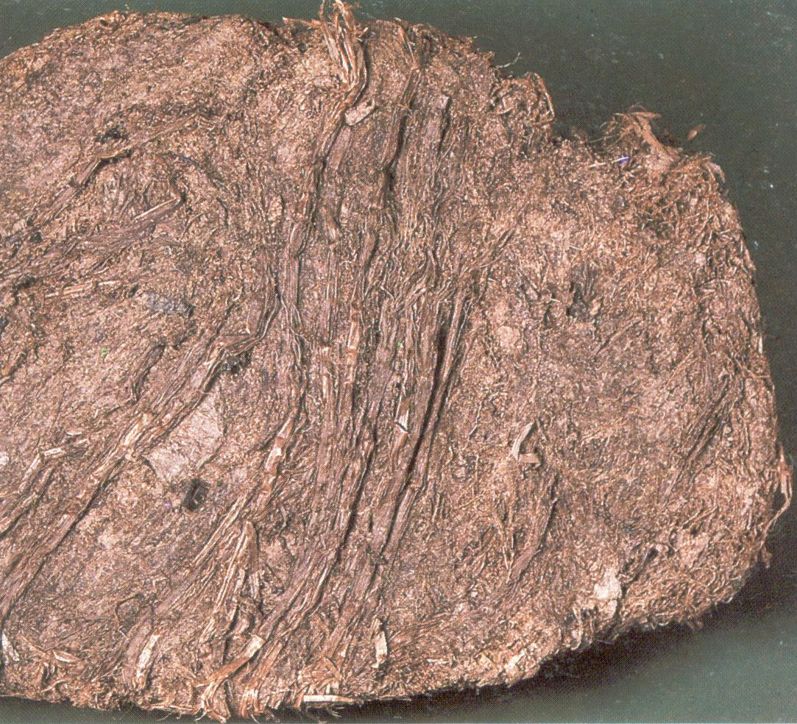
Figure 57. Peat

COAL
Coal (Figure 58) is composed of highly altered plant remains and various amounts of clay. It is opaque and noncrystalline, with colours ranging from light brown to black. Coalification results from the burial of peat and is classified according to the degree of change. Prolonged heat and pressure produce lignite (brown coal), bituminous (soft) coal, and anthracite (hard) coal.

Figure 58. Coal (Anthracite) in thin section and hand specimen

THE ORIGIN OF SEDIMENTARY ROCKSS
The various types of sedimentary rocks described in this manual may be formed in a number of sedimentary environments. The term “sedimentary environment” refers to the place where the sediment is deposited and to the physical, chemical, and biological conditions which exist in that place. The diagram in Figure 49 shows in a general way the regional setting of some of the major environments, and the following brief summary outlines some of the important characteristics of sedimentary rocks which form in each environment.

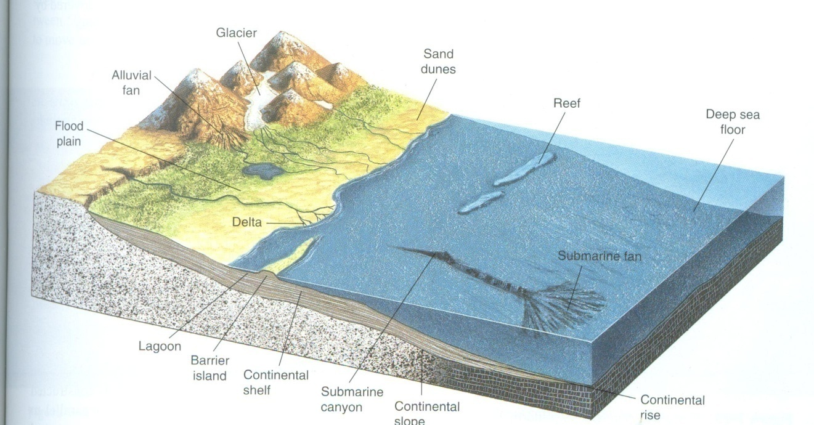
Figure 59. Depositional environments

Alluvial Fans
Alluvial fans are deposits of sediment in a dry basin. They typically contain coarse boulders and gravels and are poorly sorted. Fine-grained sand and silt may be deposited near the margin of the fan out in the valley.

Flood Plains
The great rivers of the world commonly meander across a flat flood plain before reaching the sea and depositing a considerable amount of sediment. Rocks formed in a flood plain environment are commonly lenses of sandstone deposited in the meander channel enclosed in a shale deposited on the flood plain.

Eolian
Wind is an effective sorting agent and will selectively transport sand. Gravel is left behind and dust-sized particles are lifted high into the atmosphere and transported thousands of miles before accumulating as a thin blanket of loess. Windblown sand accumulates in dunes and is characterized by fine grains which are well sorted and by large-scale cross-bedding.

Glacial
Glaciers do not effectively sort the material they transport, so the resulting deposit is an unstratified accumulation of boulders, gravel, sand, and fine silt.

Delta
Deltas are large accumulations of sediment which are deposited at the mouth of a river. They are one of the most significant environments of sedimentation and include a number of subenvironments such as stream channels, flood plain beaches, bars, and tidal flats. The deposit as a whole consist of a thick accumulation of silt, mud, and sand.

Shoreline
Beaches, bars, and spits commonly develop along low coasts and partly enclose quiet-water lagoons. The sediment in the beaches and bars is well washed by wave action and is typically clean, well-sorted quartz sand. Behind the bars and adjacent to the beaches, tidal flats may occur where fine silt and mud are deposited.

Organic Reef
An organic reef is a solid structure of shells and secretions of marine organisms. The framework is typically built by corals and algae but many types of organisms contribute to the reef community. These organisms produce a highly fossiliferous limestone.

Shallow Marine
Shallow seas are widespread along the margins of the continents and in the past were even more extensive. Sediments deposited in these shallow marine waters form extensive layers of well-sorted sand, shale, and limestone, which typically occur in a cyclic sequence as a result of shifting environments from changes in sea level.

Deep Ocean
The deep ocean adjacent to the continents receives a considerable amount of sediment transported from the continental margins by turbidity currents. As the current moves across the deep-ocean floor its velocity gradually decreases and sediment carried in suspension settles out. The resulting deposit is a widespread layer of sediment in which the size of grains grade from coarse at the base to fine at the top. The deep-sea deposits are characterized by a sequence of graded beds.
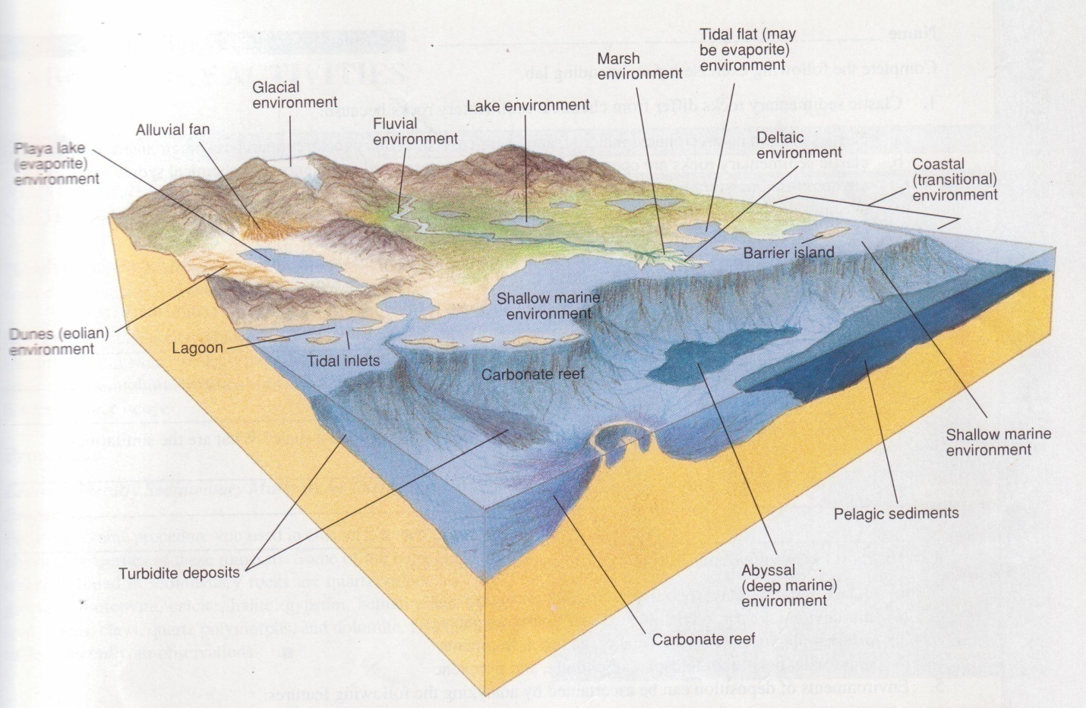
Figure 60. Depositional environments

