SEDIMENTARY ROCKS
THEIR PROPERTIES, DESCRIPTION AND CLASSIFICATION FOR THE HANDSPECIMEN
SECTION A: TEXTURE
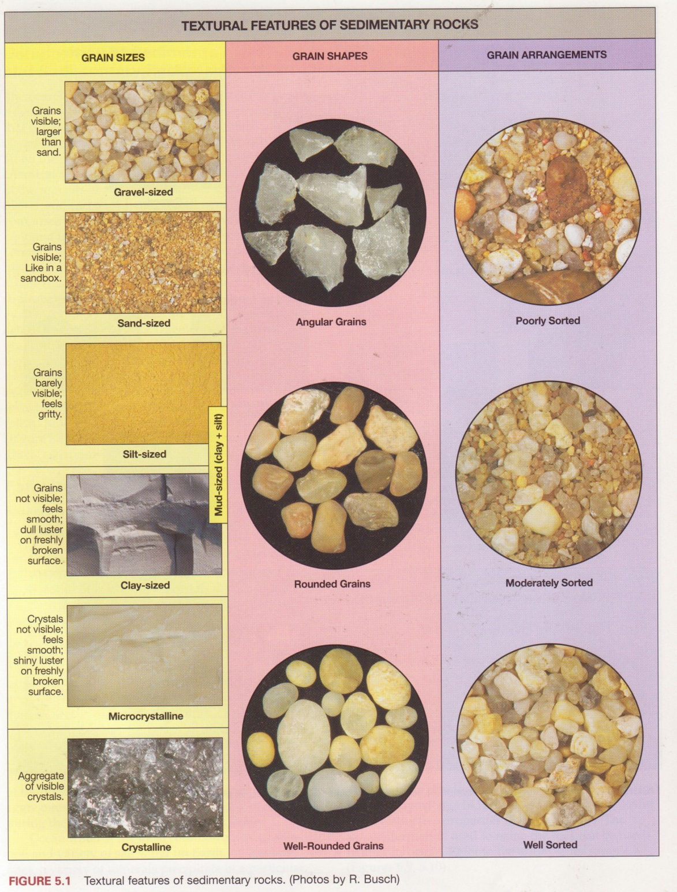

AI. grain Size:
The main categories of grain size and the names attached to them are as follows: All categories are based on diameter, in millimetres:

>2 coarse grained (granules, pebbles, cobbles and boulders).
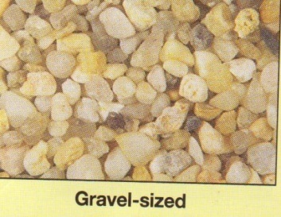
½ 56 – 2 Medium grained (silt and sand).
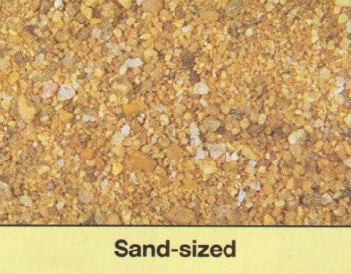
< ½ 56 Fine grained (clay)
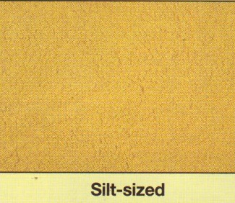
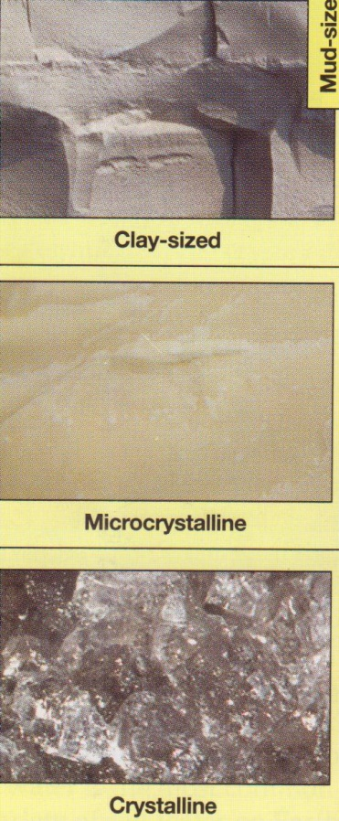
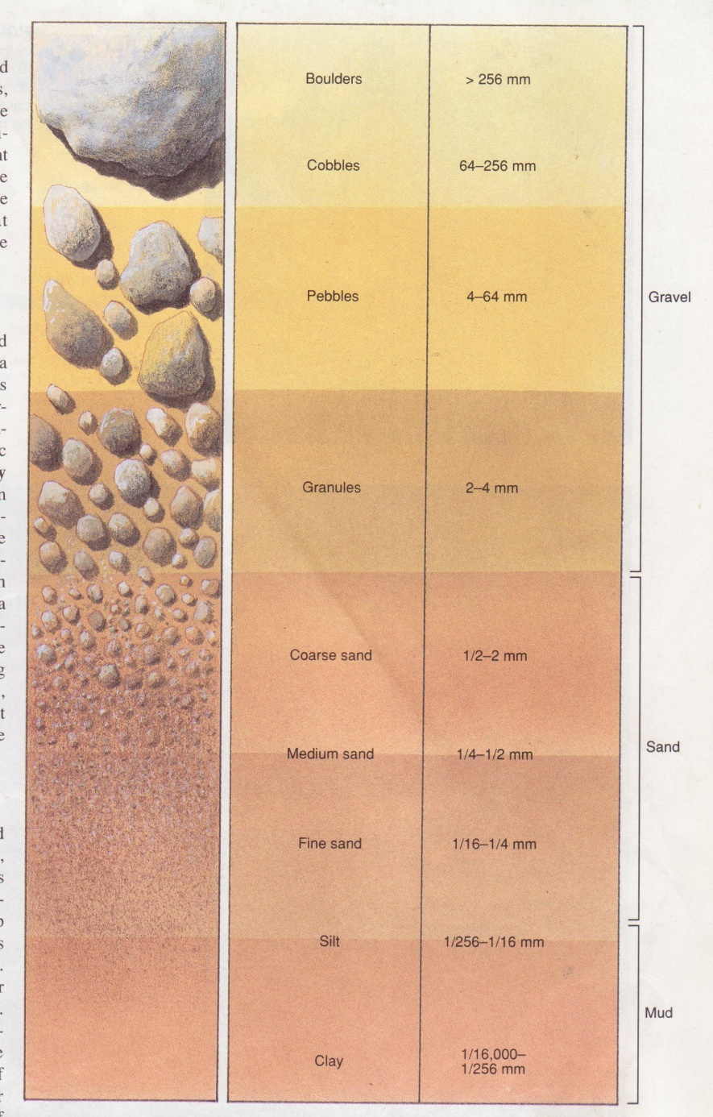
Particle Size

Note that silt is finer than sand. There is no upper limit to the coarse grained category – the largest grains (cobbles – 64 – 256mm, and boulders - >256mm) are quite common.

AII. Sorting and Grading:
- A well sorted rock consists of grains which are all more or less one size.
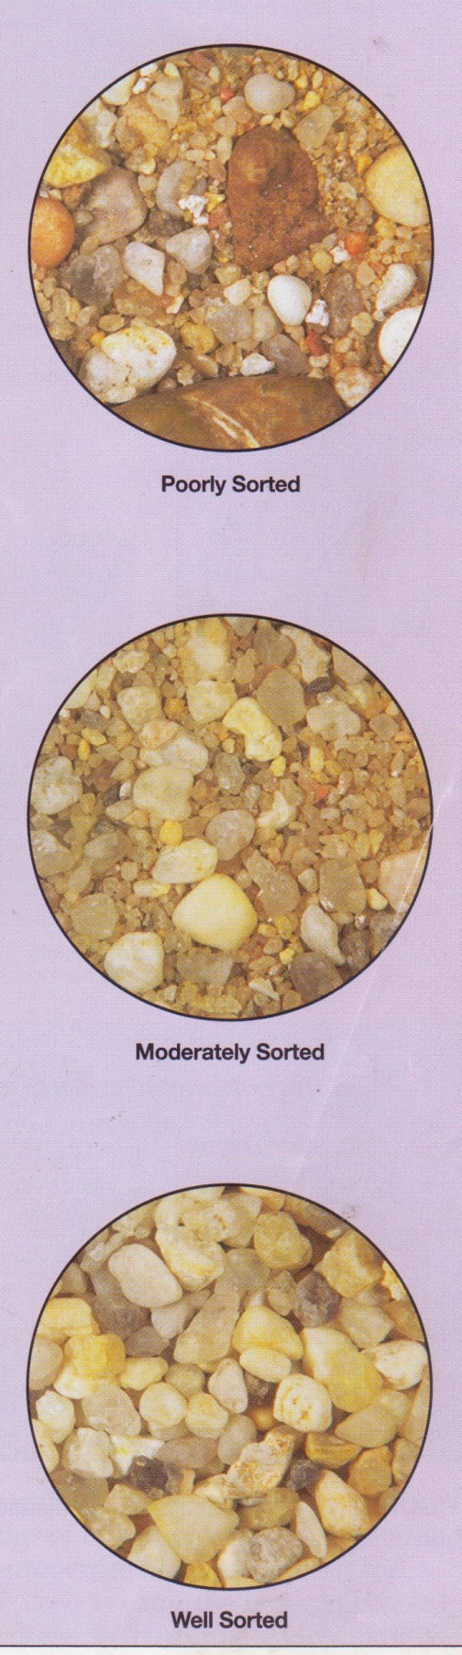
- A poorly sorted rock consists of grains which vary widely in size, all sizes being randomly distributed.

- A granded rock is a sedimentary unit which displays a sorting effect with the coarsest material at the base and the finest unit at the top (the unit may be a bed or a lamination – see below, AV)
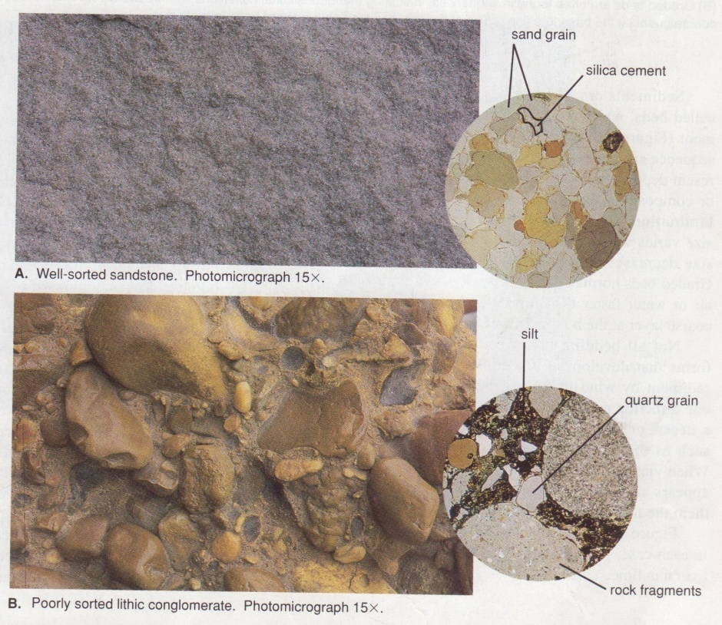
A) Well sorted A) Poorly sorted
AIII. Grain Shape:
The most important characteristic is the degree of either roundness or angularity. High angularity may reflect the preserved shapes of crystalline, mineral grains, while high rounding may indicate the advanced erosion of individual grains during their period of transportation. An idealised classification of grain shape is given below:

Angular Subangular Subrounded Rounded
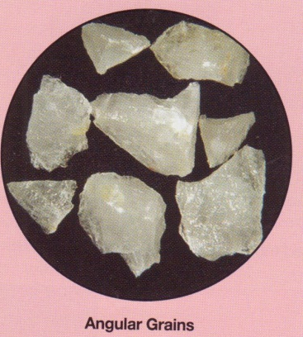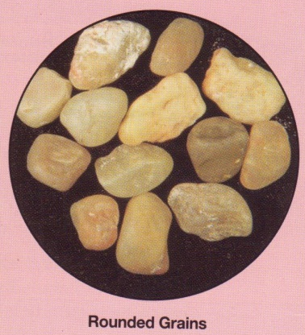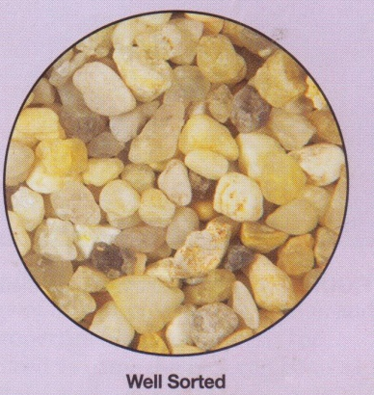
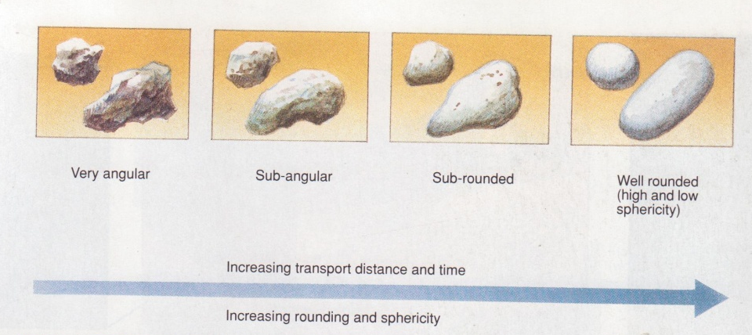

NOTE: that the two rock – types, CONGLOMERATE and BRECCIA are identical, except that conglomerate consists dominantly of subrounded or rounded grains, while breccia consists dominantly of subangular or angular grains.
AIV. Other Textural Terms:
CLASTIC – fragmental, composed of discrete grains; that is, each grain has its own boundary. Compare with “crystalline” texture.
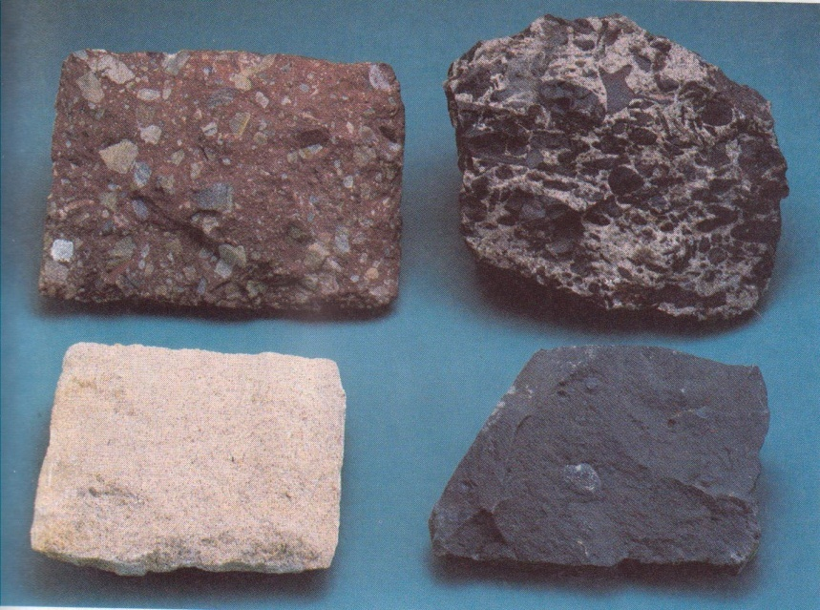
Clastic sedimentary rocks ( clockwise from top to left); breccias, conglomerate, sandstone, shale
BIOCLASTIC – Same as clastic, but all or most of the grains are fragments of fossils.
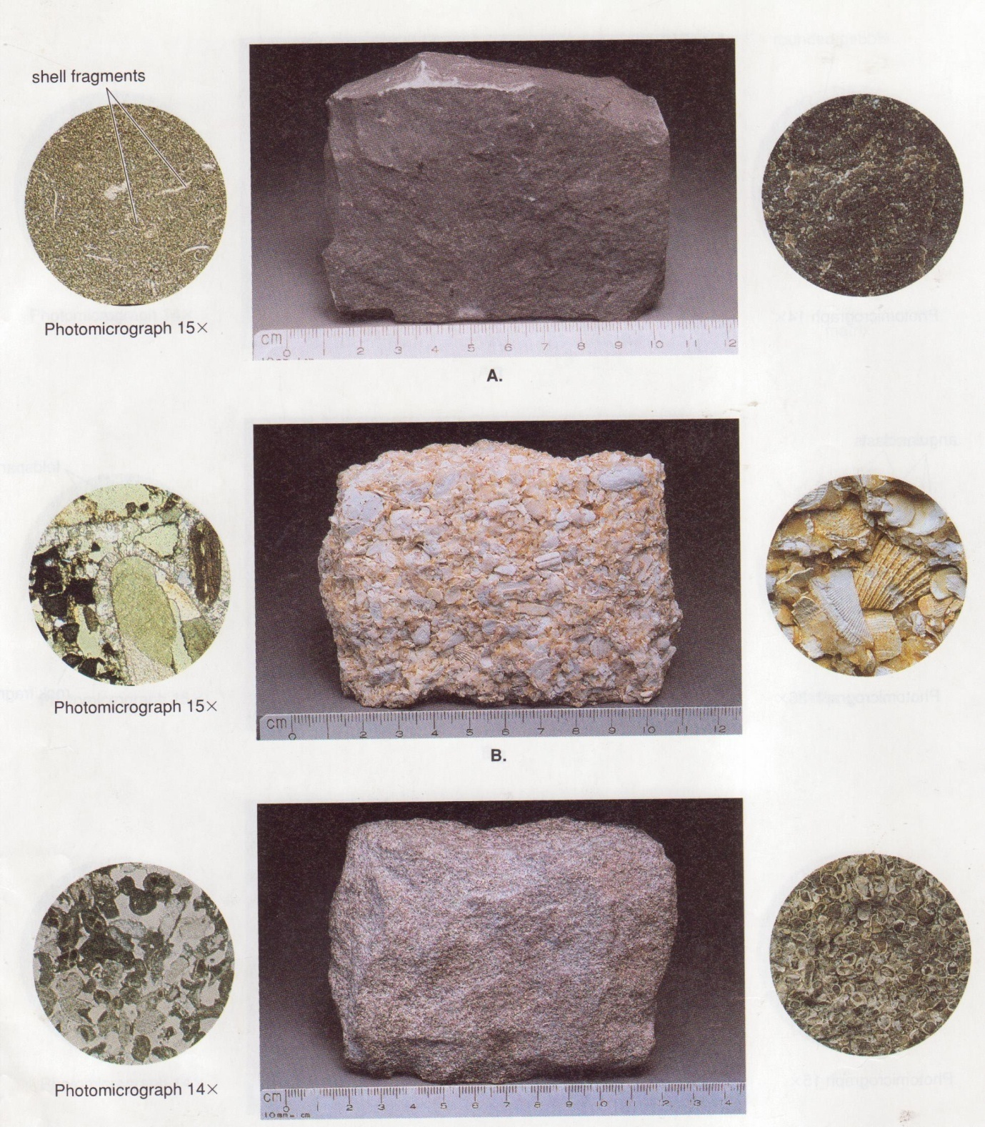
CRYSTALLINE – Composed of interlocking grains which are usually individual crystals. Each grain shares its boundary (often a Crystal face) with adjacent grains, forming a mosaic. Take care to distinguish between “crystalline” and “angular, Clastic” textures.
AMORPHOUS -Composed or noncrystalline, ‘glassy’ material
OOLITIC – composed of spheroids less than 2mm in diameter

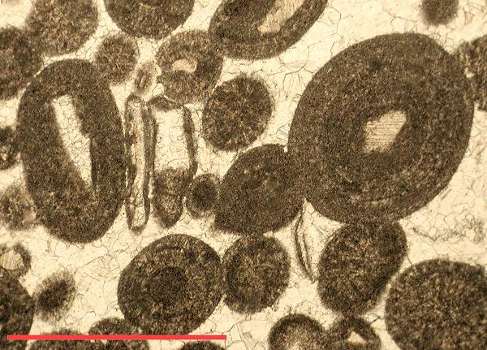

FISSILE - a rock capable of being split into parallel sheets
AV: SOME USEFUL ‘STRUCTURAL’ TERMS:
BED – a single discrete layer of sediment which has compacted and hardened to form a sedimentary rock. Its upper and lower surfaces (bedding planes) are …………., but not always parallel or sub parallel
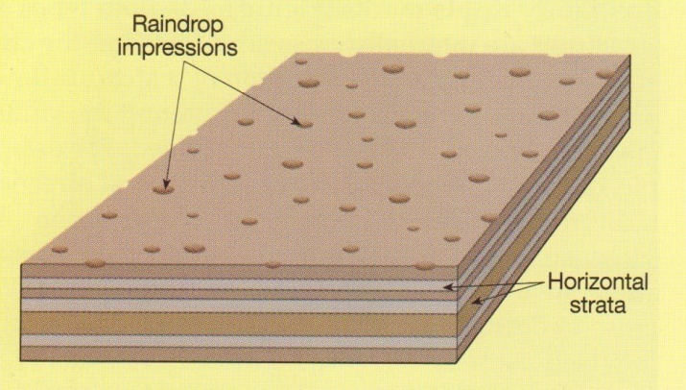
.
LAMINATION (Plural: LAMINAE) – discrete layers of sedimentary rock, similar to beds, but much thinner. Laminae are usually less than 5 mm thick.
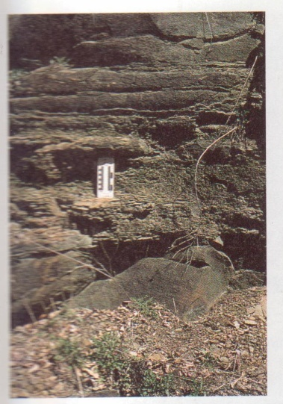
Bedding or stratification( laminated shale)

GRADED BEDDING OR LAMINATION –
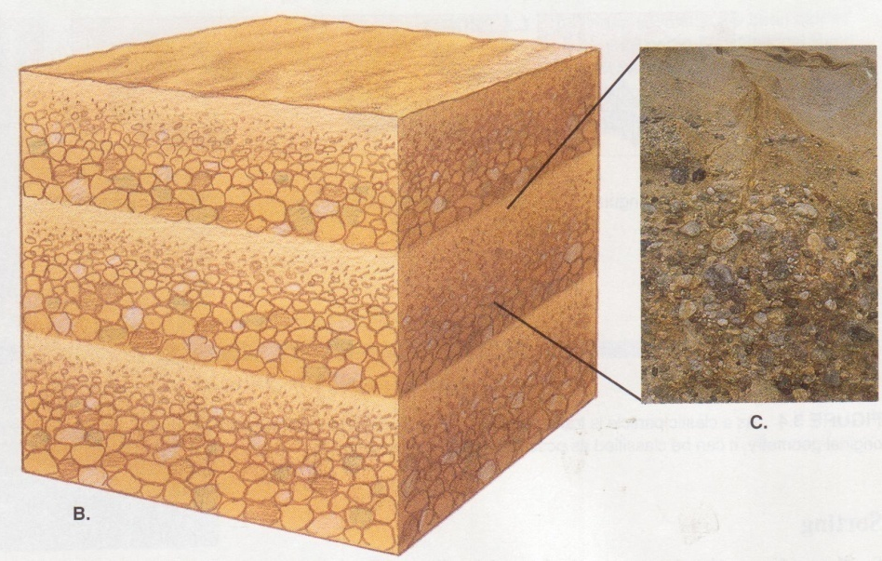
Graded bedding

CROSS –BEDDING –sets of thin beds or laminae orientated in different directions and abruptly terminating each other within one rock.
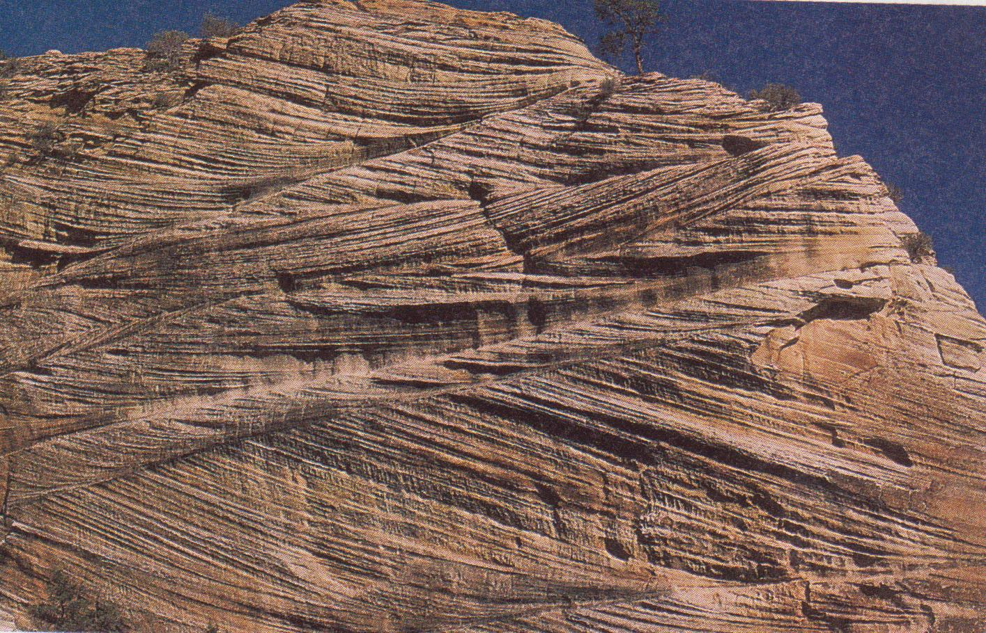
SECTION B:COMPOSITION
BI. DETRITAL AND CHEMICAL COMPONENTS:
DETRITAL – term applied to any particles of minerals or rocks which have been derived from pre-existing by weathering or erosion. The accumulation of detritus to form a sedimentary rock is generally associated with clastic and bioclastic textures (see AIV).
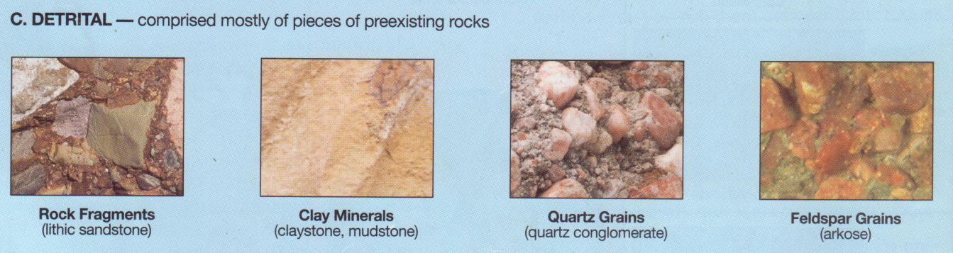

CHEMICAL - term applied to rock or part of rock which has been formed in place as the result of some chemical process. Such processes result in crystalline or amorphous textures (see AIV)
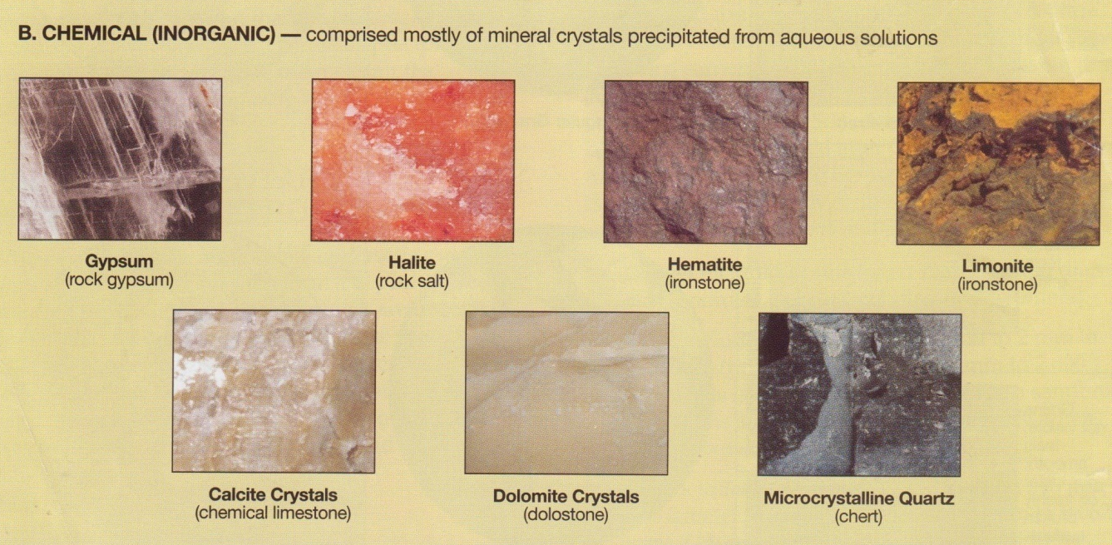
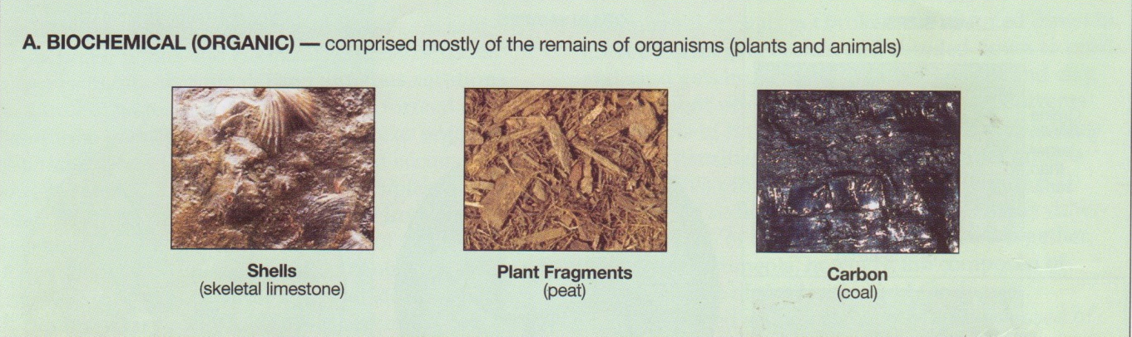

CEMENT – material, usually chemical, which binds the clastic grains of a sediment together. Its presence is not necessary for the consolidation (hardening) of a sedimentary rock.

Most sediments are composed of mixtures of a detrital and chemical fraction. However, one or other fraction is usually dominant and this must be used as a guide for classification and naming of the rock.
BII. DETRITAL MATERIALS:
The most important constituents of the detrital fraction are as follows:
- Minerals – quartz, feldspar, clay minerals, mincas and calcite.
- Rock Fragments of any kind and VOLCANIC BEBRIS (see below, DIII).
- Fossil debris
BIII. AIDS IN DISTINGUISING SOME DETRITAL MATERIALS:
Feldspar – Alteration of feldspar to white or grey earthy material in many sandstones and arkoses serves to distinguish it from quartz.
Rock fragments – Small grains of the rock, orthoquartzite, may be difficult to distinguish from the mineral, quartz. Otherwise, chart, volcanic rocks, shale and fine-grained metamorphic rocks are the normal varieties of rock fragments.
Volcanic debris isrecognised by the presence of ‘shards’ (angular fragments) of glass, pumice fragments or abundant, angular volcanic rock fragments.
BIV. VARIATION of the kinds of DETRITAL MATERIAL in any one rock may be described by the following terms:
POLYMICT – rocks consisting of fragments of many different kinds of material.
OLIGOMICT- rocks consisting of fragments of only one kind of material.
Note that these two terms are only useful for the coarse grained, clastic rocks, conglomerates, fanglomerates, tills and breccias (see note AIII and table of classification).
BV. Materials of the CHEMICAL FRACTION:
- COMMON MINERALS are calcite, dolomite, amorphous silica, evaporate minerals (rock salt and gypsum) and iron oxides.
- LESS COMMON as chemical precipitates are, for example, quartz and feldspar.

SECTION C: DESCRIPTIVE PROCEDURE
The object is to gather and organise information from the rock so that it can be used, first, to find a name from the classification table provided and, second, use the information and the name to find out as much as possible about the origin of the rock.
Inspect and describe the rock in the following order:
C1: Determine whether the TEXTURE of the rock is clastic, bioclastic, crystalline or amorphous (see AIV). As far as possible use this information to decide whether the rock is DETRITAL, ORGANIC or CHEMICAL in origin (see BI, and the classification table).
C2: If the rock is detrital: First determine the grain size (AI) and, if the rock is coarse grained, the grain shape (AIII). Next determine the composition of the clastic grains (BII, BIII,BIV). You should now have enough information to name the rock from the classification table.
Modify the name by refence to important details of its texture and structure (for examples, see sections AII, AIV and AV) and by simple refence to its COLOUR (for example “pink”, “yellow”, “mottles green”etc).
C3: If the rock is organic or chemical: If the rock is a bioclastic (fossiliferous) limestone (calcium carbonate rock), follow the same procedure as in C2, above. In all other cases, information gained in stage CI must be supplemented by the COMPOSITION of the rock. COLOUR and MINERALOGY may be important clues. For example, coal is black or brownish black. Name the rock accordingly.
C4: NOTES:
- It is not early to distinguish between organic or chemical chart. Do not try.

- Calcium carbonate rocks may form as a result of either organic, chemical or detrital processes, or as any two or all these processes. Sometimes the origin of, say, a limestone is obvious. If it is not obvious, it is not helpful or necessary to try to distinguish its orgin.

