

THE UUNIVERSITY OF ZAMBIA

SCHOOL OF MINES

DEPARTMENT OF GEOLOGY

GGY 3031: STRATIGRAPHY AND PALEONTOLOGY

NAME: TEBUHO WHENDE

COMPUTER NUMBER: 2021538451

TITLE: SYSTEM TRACTS

DUE DATE: 21/ 04/ 2024

SYSTEM TRACTS

CONTENTS:

- INTRODUCTION
- HIGHSTAND SYSTEM TRACT
- LOWSTAND SYSTEM TRACT
- TRANSGRESSIVE SYSTEM TRACT
- REFERENCES

INTRODUCTION

Sequence stratigraphy is based on the premise that sedimentary successions can be divided into unconformity-bounded units (sequences) that form during a single, major cycle of sea-level change. Sequences can be split into smaller units, which are genetically linked and which form during different stages of a single sea-level cycle. The entire three-dimensional assemblage of lithofacies enclosed within sequence boundaries is referred to as a depositional system. Depositional systems, in turn are made up of smaller stratigraphic units which are system tracts and parasequences. Sequence stratigraphy sets out to place these strata units into a predictable, chronostratigraphic framework by demonstrating how their generation is related to accommodation space.
Sediments deposited during particular parts of a sea level cycle are called sequence tracts. This concept is used to describe the relative timing and nature of sedimentary deposits. System tracts represent different stages of relative sea level change and are characterize by their specific sedimentary facies and stacking patterns. System tracts may lie immediately above or below a sequence boundary or in the middle part of a sequence. The three main system tracts are highstand system tract (HST), lowstand system tract (LST), transgressive system tract (TST)
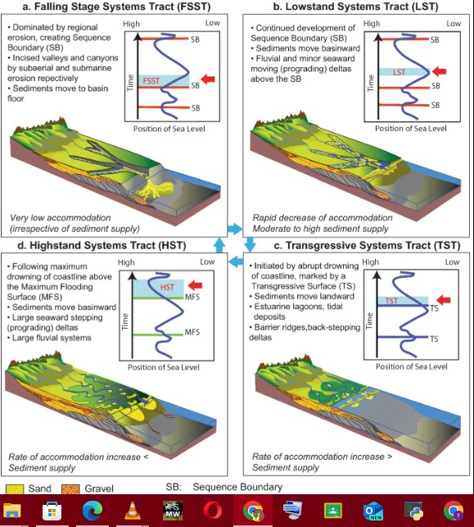
This image shows the complete cycle of sea level change which is made up of eustatic sea level rise, highstand system tract, and eustatic sea level fall and lowstand system tract. Understanding of the system tracts is crucial for interpreting sedimentary deposits and reconstructing past environments and landscapes.

- HIGSTAND SYSTEM TRACT
It is found immediately below a system boundary formed during late sea level rise, sea level standstill or early sea level fall. During this phase, sedimentation patterns typically involve progradation or aggradation of sedimentary facies. Sediment deposition happens on the shelf areas resulting in accumulation of shoreline deposits and shallow marine facies. At the beginning of HST there is often a transgressive surface marking transition from a LST to a HST. Highstand system tracts are found in alluvial and coastal plain sediments which grade seaward into shallow marine and offshore marine deposits.

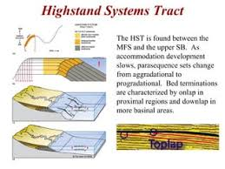

- LOWTAND SYSTEM TRACTS
They form after relative sea level falls to its minimum and begins to rise creating a small amount of accommodation space. As sea level continues to rise marine sediments are deposited and the fluvial ceases to incise. This concept describes a phase of sediment deposition within a sedimentary basin during a period of falling relative sea levels. Lowstand system tracts involve progradation (outward extension) of sedimentary systems. Progradation results in the deposition of coarser grained sediments towards the basin margins. Lowstand system tracts usually happen in nearshore or shallow marine environments

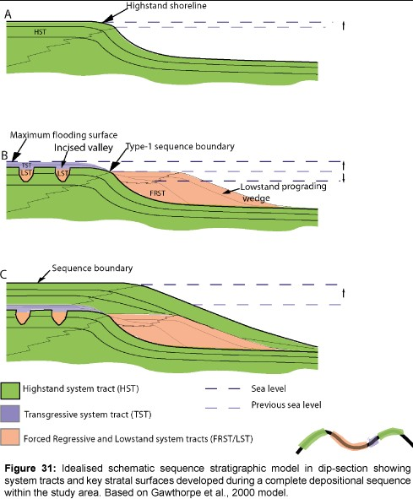

- TRANSGRESSIVE SYSTEM TRACTS

TST is a concept in sequence stratigraphy that represents the continued rise in relative sea level resulting in deposition of marine sediments over previously shallow marine environments. This creates conditions whereby the rate at which accommodation space created is greater than the rate of sediment supply, which brings on transgression. The site of deposition shifts in a landward direction, generating retrogradational parasequence. Transgressive system tract sediments may contain alluvial and coastal plain sediments, shallow-marine sediments, and offshore marine sediments, but they generally do not include submarine-fan sediments. Transgressive system tracts end with a maximum flooding surface marking the peak of transgression, before transitioning into HST as relative sea level stabilizes or begins to fall.
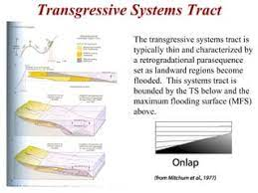

3. REFERENCES

- Sam Boggs Jr (2005), Principles of Sedimentology and Stratigraphy, fourth edition, Prentice hall.
- O. Cateneanu et al (2011), Sequence stratigraphy: Methodology and Nomenclature.

