BUSINESS ETHICS & SOCIAL RESPONSIBILITY
Defining Ethics
The term ethics is defined as a set of moral principles that governs the actions of an individual or a group. Ethics vary greatly from person to person and situations to situation, as well as from culture to culture. They are based on society's ideas of what is considered right and wrong. Family, friends and experiences influence individual's ethics and behaviour. Ethics provide the basic rules or parameters for conducting any activity in an “acceptable” manner.
Families especially parents have the first chance to influence a child's ethics. Parents usually put a high priority on teaching their children certain values, which include religious principles. Most parents also try to teach their children to obey society's rules and to behave well toward other people. As children grow and are exposed more to other children, these friends begin to have more and more influence on ethical behaviour. Indeed, the values of the group may become far more important than those of the larger society. Such behaviour also applies to the business world.
Many unethical business behaviours are fostered by a company's environment in which such practices are acceptable. Experiences can increase or decrease certain types of ethical behaviour and beliefs about what is right and wrong. A child punished for telling lies learns that telling lies is wrong.
Business ethics
Are moral principles that guide the way business professionals conduct their business activities.
Managerial ethics
Are standard of conduct or moral judgement used by managers in carrying out their businesses
Ethics and Law
Laws and ethics should not be viewed as synonyms. Laws are codified rules of behaviour
Enforced by courts. Laws do not cover every area requiring ethical guidance. A body of
Law that covers every possible area of behaviour would be unworkable. There always will be a need to complement compliance with the law with ethical judgement. Slavery, for example, was legal; it was however later abolished based on ethical grounds. Another more recent example involves Wal-Mart, and an employee named Deborah, refer below;

Wal-Mart-Lack of compassion
Tip of the iceberg can describe the story below. Wal-Mart is company No. 1 in the world. It has the most revenue over any other company ($421 Billion). But its riches equal its controversies. This story is probably the most apt at describing the unethical treatment of its workers, because of the sheer senselessness of it.
In 2000, a collision with a semi-trailer left 52-year-old Deborah Shank with permanent brain damage and in a wheelchair. Her husband and three sons were fortunate for a $700,000 accident settlement from the trucking company. After legal costs and other expenses, the remaining $417,000 was put in a special trust to care for Mrs Shank. However, six years later the providers of Mrs Shank’s health plan, Wal-Mart, sued the Shanks for the $470,000 it had spent on her medical care.
Wal-Mart was fully entitled to the money; in the fine print of Mrs Shank’s employment contract it said that money won in damages after an accident belonged to Wal-Mart. A federal judge had to rule in favour of Wal-Mart, and the family of Mrs Shank had to rely on Medicaid and social-security payments for her round-the-clock care. Wal-Mart may be reversing the decision after public outcry.
However this case pinpoints Wal-Mart’s often criticized treatment of employees as a commodity and its sometimes inhuman business ethics.
Look for more cases on link below;
http://listverse.com/2011/09/13/top-10-unethical-business-actions/

Classifying Decisions Using a Conceptual Framework
Managers and Business owners need to be conscious of the nature of decision they make, and how it will affect society, as well as the reputation of the company. The conceptual framework on page 17 can assist them evaluate their decision, by finding out in which quadrant their decision can be categorized. This will assist companies make rational, ethical and legal decisions that not only benefit the company but its stakeholders and society at large. Additionally, to avoid making unethical decisions managers should avoid rationalizing in this manner before making any decision. The four rationalizations believing;

- That the activity is not “really” illegal or immoral;
- That it is in the individual’s or the corporation’s best interest;
- That it will never be found out; and
- That because it helps the company, the company will condone it.

The following ethical guidelines can also assist managers make ethical decisions;
Ethical guidelines for managers by James Otoole
1. Tell the Truth - telling the truth is important in building trust with relevant stakeholders
2. Show respect for people - respect for the individual should be a guiding principle in all organisations
3. Stick to the Golden Rule - the Golden Rule, "Do unto others as you would have them do unto you", provides a benchmark for evaluating the ethical dimensions of business decisions.
4. Above all do no harm. This is the bottom-line ethical consideration, which should be adopted by business.
5. Practice participation, not paternalism - This principle is aimed at learning about the needs of relevant stakeholders, rather than deciding what best benefits the shareholders only.
Ethical Approaches
Deciding which actions are ethical and which are not is an extraordinary difficult task. Many
People in society are claiming that some business practices traditionally considered morally
acceptable are no longer considered. Ethics philosophers recognise "four fundamental approaches of ethical reasoning for business managers.

- Utilitarian approach (teleological) - Jeremy Bentham
This approach judges the effects of a particular action on the people directly involved and does so in terms of what provides the greatest good, for the greatest number of people. Utilitarian holds that an action is ethical if it produces the greatest good for the greatest number of people. Its premise is that ethical actions maximise happiness.

In other words, Bentham's principal of utility (Utilitarian) states that an action is moral if it produces the greater balance of pleasure over pain for the widest community affected by the action. John Stuart Mill adds that the purpose of ethical action is to achieve the greatest happiness for the greatest number of people. Modern utilitarianism argues that each individual has a personal set of preferences, and ethical behaviour is that behaviour which maximizes or optimises everyone's preferences.

Essential features of utilitarianism
- Maximisation of the Good
Utilitarianism asserts that it is always important to produce the greatest possible balance of value for all persons affected. The obvious means to maximization or optimal productivity is efficiency. Efficiency is a means to higher profits and to lower prices and the goods and services produced are intended to promote the greatest good for the greatest number.
- Intrinsic Goodness
Utilitarian believe that some things are good in themselves and not merely good as a means to something else. What we really ought to seek in life are certain experiences and conditions that are good in them without reference to their further consequences, and all values are ultimately to be gauged in terms of these intrinsic goods. Health, friendship, and freedom from pain would be included among such values. An intrinsic value, then, is a value in life that we wish to possess and enjoy just for its own sake and not for something else that it brings.
- The Measurement of Goods
Utilitariabnhn are committed to the measurement and comparison of goods, and emphasises the need to measure pleasurable and painful states and to compare one person's pleasures with another's in order to decide which is greater.
The utilitarian approach has two branches, the Act and the Rule Utilitarian
(i) Act Utilitarian - argues that in all situations one ought to perform that act which leads to the greatest good for the greatest number. Rules or practices are simply rules of thumb; they are guides to the actions that generally lead to the public good. An act utilitarian would not hesitate to violate such rules if he or she thought that in the circumstances such a violation would actually lead to the greatest good for the greatest number. Act utilitarian consider every circumstance open to any cause of action, and thus no case is closed by rules

(ii) Rule Utilitarianism - states that ethical actions and judgments should conform to firm and publicly advocated moral rules. Rules thus have a central role to play in determining correct behaviour. Rule utilitarian argue that allegiance to the rules enables us to avoid acts of industrial injustice.

Criticisms of utilitarianism
- The utilitarianism leads to an "end justifies the means" mentality. If any valuable end can justify the means to attain it, a true ethical basis is lost. But we all know that the end does not justify the means. If that were so, then Hitler could justify the Holocaust because the end was to purify the human race. We however all know that the end never justifies the means. The means must justify themselves. A particular act cannot be judged as good simply because it may lead to a good consequence. The means must be judged by some objective and reliable standard of morality.
- One major criticism of utilitarianism centres on the commitment to the quantification and measurement of goodness. It is difficult to measure truth, goodness, and virtue. A related problem is the comparison problem. It is difficult to quantify and compare individual pleasures or units of happiness.
- Utilitarianism has also been challenged on the grounds that it can lead to injustice. The tyranny of the majority can allow injustice for a small minority.
- Another criticism is that utilitarianism provides no guidelines for the ordering of preferences or for dealing with conflicts between preferences.
- Another problem with utilitarianism is predicting the consequences. If morality is based on results, then we would have to have omniscience in order to accurately predict the consequence of any action. But at best we can only guess at the future, and often these educated guesses are wrong.
- Consequences themselves must be judged. When results occur, we must still ask whether they are good or bad results. Utilitarianism provides no objective and consistent foundation to judge results because results are the mechanism used to judge the action itself.
- Moral rights approach - Immanuel Kant
Kant, unlike , Jeremy and Mills believed that certain types of activities such as murder, theft, and lying were absolutely prohibited, even in cases where the action would bring about more happiness than the alternative. For Kantians, there are two questions that we must ask ourselves whenever we decide to act: (i) Will everyone act as I propose to act? If the answer is no, then we must not perform the action. (ii) Does my action respect the goals of human beings rather than merely using them for my own purposes? Again, if the answer is no, then we must not perform the action. Kant’s theory is an example of a deontological moral theory–according to these theories, the rightness or wrongness of actions does not depend on their consequences but on whether they fulfil our duty.

To be specific, this approach holds that an action is good if it is done for the sake of what is right. It is argued that every person has a duty to do what is right, to respect others, and treat them as free, rational beings. Moreover it is often argued that employers stand in special relationships to employees or to their customers and that, as a result corporations have special moral obligations to their employees or customers, independent of the general good. Advocates of this model; identify several rights that individuals have in their work environments. These rights include;

- Life and Safety - the individual has the right not to have her or his life endangered.
- Truthfulness - the individual has a right not to be intentionally deceived by another, especially on matters about which the individual has the right to know.
- Privacy - the individual has the right to do whatever he or she chooses to do outside working hours and-to control information about his or her private life.
- Freedom of conscience - the individual has the right to refrain from carrying out any order that violates those commonly accepted moral or religious norms to which the person adheres.
- Free speech - the individual has the right to criticise the ethics or legality of corporate actions so long as the criticism does not violate the rights of other individuals within the organisation.
- Private property - the individual has a right to hold private property, this right enables the individual to be sheltered and to have the basic necessities in life.
According to this view, an ethical duty of managers is to ensure respect of these rights.
- Individualism approach
This approach states that acts are moral when they promote the individual's best long-term interests. If an action promotes individual's interests, it is ethical, if it does not, it is unethical. Each individual is held to have potentialities. Each person has a right and a responsibility to develop, those potentialities. Actions that help achieve that purpose are ethical, assuming the actions do not infringe on the rights of others. Individualism approach holds that human beings have a right and responsibility to become all they are capable of becoming. It is argued that human nature is good, but individuals can become bad if their right and responsibility to fulfil their potential is blocked.
Criticisms
1. It is difficult to demonstrate and recognise that every human being has some potentialities.
2. In view of man's inhumanity to man, it is not credible to argue that human nature is
basically good

- Justice Approach by Just Locke
This approach argues that managers have a duty to be guided by equity, fairness, and impartiality in their interactions with others. Lock tried to establish universal principles of a just society. He argued that individuals have certain natural rights and a just society must respect those rights. Advocates of this approach identified the following principles of justice that can be applied in work environments:
1. Fair treatment: - (distributive Justices) persons who are similar to each other in relevant respects should be treated similarly; persons who differ in some respect relevant to the job they perform should be treated differently, in proportion to the difference between them.
2. Fair administration of rules - (procedural justice) rules should be administered
consistently, fairly and impartially.
3. Fair compensation (compensatory justice) individuals should be compensated for the cost of their injuries by the party that is responsible for those injuries
4. Fair blame: - individuals should not be held responsible for matters over which they have no control
5. Due process - individuals have a right to a fair and impartial hearing when they believe that their personal rights are being violated.

Managing ethics
Given the increasing concern about ethics in organisations, a growing number of companies are attempting to provide guidance for their managers.
- At the core of many corporate efforts is the development of a corporate code of ethics (often called a code of conduct) A code of ethics is a written statement of a company's beliefs, values and norms of expected behaviour; ideally a code of ethics should.
(a) Give employees direction in dealing with ethical dilemmas
(b) Clarify the organisation's position regarding areas of ethical uncertainty
(c) Overall help achieve and maintain on-going conduct that the organisation views as
Ethical and proper.
- Training, top management involvement, knowledge of the Law, and self-analysis are all needed to properly deal with ethical issues. As more global competitors and business transactions in other countries increase, more ethical dilemmas will appear. What's considered corruption in Zambia may be perfectly acceptable in Nigeria. Managers must be aware of the legal aspects of business, social responsibility expectations and ethics. Failing to be aware of the law, to be socially responsible, and to make ethical decisions could result in lost market share, fines, imprisonment or inability to conduct business.
- Companies can use a variety of techniques to improve their ethical performance these techniques include;
(i) Whistle Blowing: Whistle blowing occurs when an employee discloses an illegal, immoral, or unethical action committed by a member of an organisation. Whistle blowing should be encouraged.
(ii) Establishing Committees or Groups to oversee programs for encouraging ethical behaviour, reviewing violations of codes of ethics and taking action on whistle-blowers, observations of illegal, immoral, or unethical actions.
'
(iii) Training Programs
Organisations must provide training for managers, professionals and other employees at all levels, especially for those in sensitive portions such as purchasing, waste disposal, personnel Research and Development, sales and manufacturing where social responsibility issues could be involved.
(iv) Establishing hotlines, and registering ethical behaviour anonymously

Four Main Themes of Ethical Dilemmas for business people and Managers
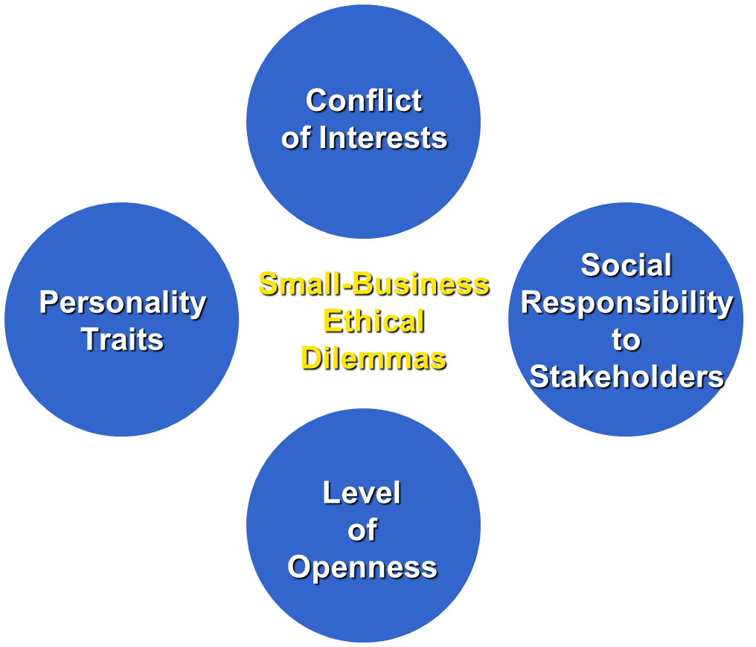
Major management dilemma
Of the four, management's major ethical dilemma centres on the potential conflict between economic and social performance. Can the good of society be served and management still operate at a profit? The firm's obligations to employees, customers, stockholders and the general public are part of the social performance. In certain instances unproved economic performance, such as increased sales, can occur only if one or more groups suffer a loss. How can the managerial dilemma of balancing economic and social performances be resolved? Managers must reconcile competing values in making decisions since their decisions have consequences for;
(1) Themselves
(2) The organisation that employs them and
(3) The society in which they and the organisation exists
One writer proposes that the following principles can guide managers in making socially responsible decisions;
- Place the interests of society before the interests of the organisation
- Place the interests of the organisation before manager’s private interests
- Reveal the truth in all instances of organisational and personal involvement.
However, the three principles provide guidelines but not answers. The manager must determine the relative benefits to society, company, and self. The advantage of a pluralistic approach to ethical decision-making is that the decision maker, with intentions to do right, has the basis for evaluating decisions.
Social responsibility
Business is normally conducted within a social network, which is found outside, and inside a business. The organisation interacts with a large number of parties such as customers, competitors, employees, suppliers, creditors and stockholders in its environment. Each of the various groups may be affected by the organisation's actions and the parties in turn may also take actions that will affect the organisation. For example, customers seek fair prices and satisfaction from their purchases, while governments, levy taxes on business. Within the business employers want to be treated humanely and with dignity. In addition they look for a work place that is safe and healthy, that respects their privacy, that provides meaningful work and that offers some security for retirement years.
Business cannot escape from society, and society cannot exist without business. All business decisions have a social impact.

Social responsibility is the obligations of the organisation's management to make decision, and take actions that will increase the welfare and interests of society as well as the organisation.
Evolution of social responsibility
The concept of social responsibility has evolved in conjunction with the following crises or major transformations in industry;
- The first was the entrepreneurial era of the late (19th C). The enormous business empires of some successful entrepreneurs had tremendous economic power. But abuses of that power brought public outcries. It was during this era of labour kickbacks, discriminatory pricing and bad business practices that ordinary citizens and governments first became concerned about business methods. This concern manifested itself in the nation’s laws forbidding certain ways of doing business.
- The second crisis occurred during the world's great economic depression, which resulted into many people losing employment and Banks failing in the 1930s. People blamed business greed, and out of the economic crisis emerged new laws that outlined a social agenda for business.
- Finally, the social unrest of the 1960s - 1970s which resulted from harmful products and harm caused to the environment brought new changes of business as a negative force in our society, Government regulation again increased, forcing health warnings on cigarettes, stricter environmental protection standards and a host of other restrictions.
Approaches to social responsibility
There are three major contrasting perspectives on corporate social responsibility; the
Traditional, Stakeholder and Affirmative social responsibility,
- Traditional social responsibility
This view is associated with economist Milton Friedman and others who believe that society creates firms to pursue two primary purposes; to produce goods and services efficiently arid maximise profits, so long as business stay within the rules of the game. Friedman favours the free market system, which in his view is the best system for regulating the conduct of a business, and it is up to society to establish the rules within which it operates. Proponents of this view offer the following major argument against social responsibility; they state that businesses are accountable to their shareholders, the owners of the corporation, thus management's sole responsibility is to serve the shareholder’s interests by managing the company to produce profits from which shareholders benefit.
- Stakeholder social responsibility
According to this philosophy, managers must be responsible to certain groups that are
affected by, or can affect, the company's objectives and interests. Such groups include
shareholders, customers, government agencies, competitors, unions, employees, trade
associations, important suppliers, protest groups and others. What is good for the company, it is argued, is good for society. The stakeholder philosophy also makes the
accumulation of capital a management priority. Capital accumulation is seen as the basis of social responsibility because it is essential for the creation of future jobs. Focusing on the customer helps a company protect its corporate image and economic interests. Protecting the interests of stakeholder groups reduces conflict between business and government regulatory agencies. The following are some of the stakeholders managers/businesses are socially responsible to;

- Shareholders - there is a general agreement that the primary role of management in corporations is to earn profits and dividends for shareholders. The shareholder plays a crucial role of providing the capital that allows the corporation to survive and grow. As a result, shareholders expect management to operate the business in such a way that the shareholders are provided with the largest possible return on their investment.
- Community - An organisation's community is its area of local business influence. Most communities have social needs that extend beyond the available resources. As a result, businesses are likely to receive more requests for assistance than it is reasonable to honour, necessitating priorities in giving. At the same time, businesses need various forms of support from communities, including an adequate transportation system, taxes that are equitable and do not discriminate for or against business, adequate school and recreational facilities and complete public services, such as police, fire protection, sewage, water, gas, electric services etc. Hence, because of these complementary needs, businesses and the communities in which they operate are somewhat interdependent and both can function more effectively with a high level of mutual support.
- Customers - Social responsibility toward customers fall into three categories; providing quality and safe products, pricing these products fairly and being truthful in advertising. Much of the current interest in business responsibility toward customers can be traced to the rise of consumerism. Consumerism is a form of social activism dedicated to protecting the rights of consumers in their dealings with businesses. The first formal declaration of consumer - rights protection came in the early 1960s. At that time, president John F. Kennedy (USA) identified four basic rights that consumers could draw on when dealing with business. These rights have now been backed by state Laws.
(i) Consumers have the right to safe products. For example, when you buy a new paint sprayer, it must be safe for use in spraying paint. It must come with complete instructions on how to use it. And it must have been properly tested by its manufacturer
(ii) Consumers have the right to be informed about all relevant aspects of a product. Food products must list their ingredients. And banks must tell you exactly how much interest you are paying on a loan.
(iii) Consumers have the right to be heard. Today, many companies have complaint offices. When companies refuse to respond, consumer protection agencies and consumer interest groups may intervene.
(iv) Consumers have the right to choose what they buy. There should be free and open competition among manufacturers. Any attempts by business to block this competition will affect the variety of products available. Interfering with competition can also result in illegal pricing practices. Collusion among companies - i.e. getting together to agree on prices is against the Law.

- Employees - a company that provides its employees with equal opportunities without regard to race, sex etc is meeting its social responsibilities. Other activities such as recruiting, hiring, training, promoting and compensating are also the basis for social responsibility toward employees. In addition to their responsibility to employees as resources of the company, firms have a social responsibility to their employees as people. Firms that accept this responsibility make sure that the work place is safe, both physically and emotionally.
They do not tolerate an abusive manager. Firms that ignore their responsibility to employees leave themselves open for Lawsuits.
- Society - It is argued that society is entitled to more than mere provision of goods and services. The following arguments are advanced in favour of social responsibility to society.
- Business exist at society's pleasure; so for their own legitimacy and survival businesses should meet the expectations' of the public otherwise, they are likely to eventually suffer financially and go out of business. This is related to the iron Law of responsibility which states that in the long run, those who do not use power in a manner that society considers responsible will tend to lose it.
- While government organisations stretch their budgets to limit, many large businesses often have surplus revenues that could potentially be used to help solve social problems. Business is considered to be the institution with the financial and human resources to solve social problems.
- Organisations that make clear and visible contributions to society can achieve
Enhanced reputations and gain greater market share for their products.
- Affirmative social responsibility
This philosophy holds that managers have a responsibility to promote the mutual best interests of the firm and its various stakeholders, including the general public. It encourages managers to anticipate changes in the social environment in which they operate, and it requires them to blend the goals of the company with the general and diverse interests of society as a whole. Management that adopts this philosophy must address the concerns of a wide range of groups as well as plan for the future needs of society. Some managerial obligations under the affirmative philosophy include;
- Maintaining and improving current standards for protecting the physical and social environments, compensating victims of pollution and other corporate - related activities; evaluating possible negative effects of the firm's planned actions on the public and attempting to eliminate or reduce negative effects prior to implementation.
- Accepting responsibility for solving current problems; willingly discussing activities with outside groups; making information freely available to the public, accepting formal and informal inputs from outside groups in decision making, and be willing to be publicly evaluated for its various activities.
- Showing willingness to work with outside groups for good environmental laws,
Promoting honesty and openness in government and in the firm's own lobbying activities.
- Taking a definite stand on issues of public concern, advocating ethical norms for all, in the firm.
Arguments for social responsibility
Agitators of business involvement in social affairs argue their case on the following grounds, among others:
- Business enterprises contribute to many of society's social problems. They, for Example, pollute water and air and distort the natural beauty of society's landscapes. As such, they should accept to work with other societal members to correct these problems
- Although short-run costs of social responsibility may be high, the long-run benefit will usually be greater. Long-run profit is normally the result of improved business image that accompany socially responsible behaviour.
- Social involvement by businesses can greatly help in solving some of society's pressing problems and improve the general quality of life. Business, too, can benefit from improved social and economic welfare since this will result in a better community in which to conduct business operations.
- An enhanced public image can, among other things, help a business gain more
customers, better employees, and society's approval of its existence - but public image, and the benefits that go with it, can only be gained through active participation in social programmes.
- Society's needs and expectations are continually changing as a result of socio-cultural, political, and other changes. This places an obligation on business concerns to adjust the variety and nature of their outputs (social and economic) in order to pace up with the changing needs and expectations of society.
- Business enterprises are members of society in the same way that all persons and other institutions are members. As such, they should accept the obligation to act responsibly in order to maintain and preserve the values, rights, freedoms, and interests of other members.
- Businesses have large amounts of power; they affect society's cultural, social, economic and other environments. As such, they should exhibit great amounts of responsibility to society that should match their power.
- Socially responsible behaviour may induce the government to scale down, or even eliminate, strict regulatory laws designed to police business activities. But if businesses choose to be socially irresponsible, society may be prompted to press for even stricter government surveillance of their activities.

Arguments against social responsibility
Those who argue against business participation in social programmes do so, on the following accounts, among others:
- Businesses are more socially responsible when they attend strictly to the profit objective and leave other activities to other institutions because, compelled by competitive forces, they will strive to reduce costs and prices and increase the assortment and quality of products - all to the benefit of society.
- Businesses are very likely to add the costs incurred on social programmes to the prices of their products, thereby hurting society.
- Involvement in social programmes is very likely to lead to higher costs and prices, making local businesses less competitive and sell less in international markets. This may lead to a weakened international balance of payments in the home countries of the socially responsive businesses.
- Combining economic and social actions may breed internal conflict and confusion of gaols within businesses.
- Emphasis on social programmes may cause the public to harbour unrealistic expectations that may be impossible for businesses to accomplish.
- Many business people lack the perceptions and skills to work effectively with social issues because their abilities are primarily economic.
- Combining social activities with economic activities will give business firms excessive power.

Classifying Decisions Using a Conceptual Framework

Unethical
Legal
Illegal
Corporate
Decisions
Quadrant I:
Ethical and Legal
Quadrant III:
Unethical and Legal
Quadrant IV:
Unethical and Illegal
Quadrant II:
Ethical and Illegal

