MALE REPRODUCTIVE ORGAN- 2021
The male reproductive system consists of a number of sex organs that play a role in the process of human reproduction. These organs are located on the outside of the body and within the pelvis. 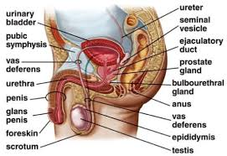

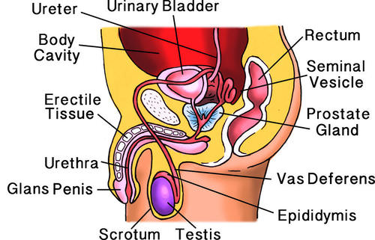

The purpose of the organs of the male reproductive system is to perform the following functions:
- To produce, maintain, and transport sperm (the male reproductive cells) and protective fluid (semen)
- To discharge sperm within the female reproductive tract during sex
- To produce and secrete male sex hormones responsible for maintaining the male reproductive system
Unlike the female reproductive system, most of the male reproductive system is located outside of the body. These external structures include the penis, scrotum, and testicles.
- Penis: This is the male organ used in sexual intercourse. It has three parts: the root, which attaches to the wall of the abdomen; the body, or shaft; and the glans, which is the cone-shaped part at the end of the penis. The glans, also called the head of the penis, is covered with a loose layer of skin called foreskin. This skin is sometimes removed in a procedure called circumcision. The opening of the urethra, the tube that transports semen and urine, is at the tip of the penis. The glans of the penis also contains a number of sensitive nerve endings.
The body of the penis is cylindrical in shape and consists of three circular shaped chambers. These chambers are made up of special, sponge-like tissue. This tissue contains thousands of large spaces that fill with blood when the man is sexually aroused. As the penis fills with blood, it becomes rigid and erect, which allows for penetration during sexual intercourse. The skin of the penis is loose and elastic to accommodate changes in penis size during an erection.
Semen, which contains sperm (reproductive cells), is expelled (ejaculated) through the end of the penis when the man reaches sexual climax (orgasm). When the penis is erect, the flow of urine is blocked from the urethra, allowing only semen to be ejaculated at orgasm.
- Scrotum: This is the loose pouch-like sac of skin that hangs behind and below the penis. It contains the testicles (also called testes), as well as many nerves and blood vessels. The scrotum acts as a "climate control system" for the testes. For normal sperm development, the testes must be at a temperature slightly cooler than body temperature. Special muscles in the wall of the scrotum allow it to contract and relax, moving the testicles closer to the body for warmth or farther away from the body to cool the temperature.
- Testicles (testes): These are oval organs about the size of large olives that lie in the scrotum, secured at either end by a structure called the spermatic cord. Most men have two testes. The testes are responsible for making testosterone, the primary male sex hormone, and for generating sperm. Within the testes are coiled masses of tubes called seminiferous tubules. These tubes are responsible for producing sperms
The internal organs of the male reproductive system, also called accessory organs, include the following:
- Epididymis: The epididymis is a long, coiled tube that rests on the backside of each testicle. It transports and stores sperm cells that are produced in the testes. It also is the job of the epididymis to bring the sperm to maturity, since the sperm that emerge from the testes are immature and incapable of fertilization. During sexual arousal, contractions force the sperm into the vas deferens.
- Vas deferens: The vas deferens is a long, muscular tube that travels from the epididymis into the pelvic cavity, to just behind the bladder. The vas deferens transports mature sperm to the urethra, the tube that carries urine or sperm to outside of the body, in preparation for ejaculation.
- Ejaculatory ducts: These are formed by the fusion of the vas deferens and the seminal vesicles (see below). The ejaculatory ducts empty into the urethra.
- Urethra: The urethra is the tube that carries urine from the bladder to outside of the body. In males, it has the additional function of ejaculating semen when the man reaches orgasm. When the penis is erect during sex, the flow of urine is blocked from the urethra, allowing only semen to be ejaculated at orgasm.
- Seminal vesicles: The seminal vesicles are sac-like pouches that attach to the vas deferens near the base of the bladder. The seminal vesicles produce a sugar-rich fluid (fructose) that provides sperm with a source of energy to help them move. The fluid of the seminal vesicles makes up most of the volume of a man's ejaculatory fluid, or ejaculate.
- Prostate gland: The prostate gland is a walnut-sized structure that is located below the urinary bladder in front of the rectum. The prostate gland contributes additional fluid to the ejaculate. Prostate fluids also help to nourish the sperm. The urethra, which carries the ejaculate to be expelled during orgasm, runs through the center of the prostate gland.
- Bulbourethral glands: Also called Cowper's glands, these are pea-sized structures located on the sides of the urethra just below the prostate gland. These glands produce a clear, slippery fluid that empties directly into the urethra. This fluid serves to lubricate the urethra and to neutralize any acidity that may be present due to residual drops of urine in the urethra.
The entire male reproductive system is dependent on hormones, which are chemicals that regulate the activity of many different types of cells or organs. The primary hormones involved in the male reproductive system are follicle-stimulating hormone, luteinizing hormone, and testosterone.
Follicle-stimulating hormone is necessary for sperm production (spermatogenesis), and luteinizing hormone stimulates the production of testosterone, which is also needed to make sperm. Testosterone is responsible for the development of male characteristics, including muscle mass and strength, fat distribution, bone mass, facial hair growth, voice change, and sex drive.

Anatomy of the Female Reproductive System
The human female reproductive system contains two main parts: the uterus and the ovaries, which produce a woman’s egg cells.

Learning Objectives
Outline the anatomy of the female reproductive system from external to internal

Key Takeaways

Key Points
- A female’s internal reproductive organs are the vagina, uterus, fallopian tubes, cervix, and ovary.
- External structures include the mons pubis, pudendal cleft, labia majora and minora, vulva, Bartholin’s gland, and the clitoris.
- The female reproductive system contains two main parts: the uterus, which hosts the developing fetus, produces vaginal and uterine secretions, and passes the anatomically male sperm through to the fallopian tubes; and the ovaries, which produce the anatomically female egg cells.
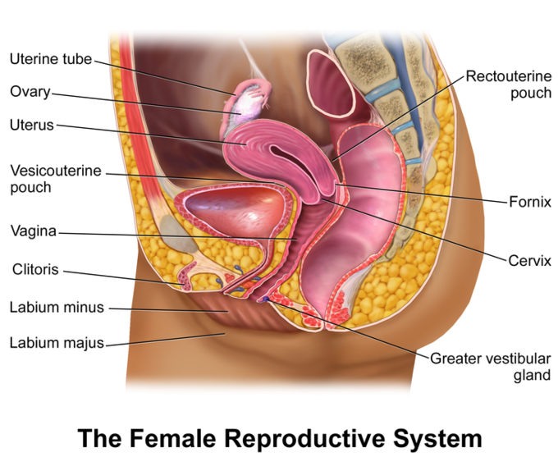

Key Terms
- ovary: A female reproductive organ, often paired, that produces ova and in mammals secretes the hormones estrogen and progesterone.
- oviduct: A duct through which an ovum passes from an ovary to the uterus or to the exterior (called fallopian tubes in humans).
- vulva: The consists of the female external genital organs.
- oogenesis: The formation and development of an ovum.
The human female reproductive system (or female genital system) contains two main parts:
- Uterus
  - Hosts the developing fetus
  - Produces vaginal and uterine secretions
  - Passes the anatomically male sperm through to the fallopian tubes
- Ovaries
  - Produce the anatomically female egg cells.
  - Produce and secrete estrogen and progesterone
These parts are internal; the vagina meets the external organs at the vulva, which includes the labia, clitoris, and urethra. The vagina is attached to the uterus through the cervix, while the uterus is attached to the ovaries via the fallopian tubes. At certain intervals, the ovaries release an ovum, which passes through the fallopian tube into the uterus.
If, in this transit, it meets with sperm, the sperm penetrates and merges with the egg, fertilizing it. The fertilization usually occurs in the oviducts, but can happen in the uterus itself. The zygote then implants itself in the wall of the uterus, where it begins the process of embryogenesis and morphogenesis. When developed enough to survive outside the womb, the cervix dilates and contractions of the uterus propel the fetus through the birth canal (vagina).
The ova are larger than sperm and have formed by the time an anatomically female infant is born. Approximately every month, a process of oogenesis matures one ovum to be sent down the fallopian tube attached to its ovary in anticipation of fertilization. If not fertilized, this egg is flushed out of the system through menstruation.
An anatomically female’s internal reproductive organs are the vagina, uterus, fallopian tubes, cervix, and ovary. The external components include the mons pubis, pudendal cleft, labia majora, labia minora, Bartholin’s glands, and clitoris
The ovaries and female reproductive tract lie within the pelvic cavity. It consists of the following components
- Two oviducts or fallopian tubes associated with two ovaries
- Uterus, a thick-walled hollow uterus primarily responsible for the maintenance of the foetus to develop.
- The vagina, a muscular expandable tube connected to the uterus to the external environment
- Cervix goes into the vagina containing small opening that is known as, cervical canal. It serves as a pathway for sperms and for delivering a baby.
TASK 2
- Explain the difference between adolescence and puberty.
- Discuss secondary characteristics of males and females.
- Describe the female and male reproductive organs with help of the diagram
- Explain how the baby is produced from inception to birth.

