Clinical Skills Lumbar Puncture Procedure
Student Name: ID #: Group:

Examiners Name: Final Score: /30 Percentage:

 | STEPS | NOT DONE (0) | INCOMPLETE/ INCORRECT  (1) | COMPLETE/ CORRECT  (2)
1 | Introduction (Self Intro, Capacity, Pt full name)
2 | Explains Procedure and obtains Consent
3 | Notes allergies to cleaning solution and anesthetic
4 | Gathers supplies required (Local Anesthetic solution, needle, syringe,  2 pairs sterile gloves, cleaning solutions, cotton swabs, spinal needle, CSF collection bottles, sterile drapes, strapping, lab form)
5 | Washes Hand
6 | Positions Pt, Identifies Landmarks (Tuffier’s line) and marks it.
7 | Wears sterile gloves
8 | Cleanses skin (savlon, iodine then spirit last) and Drapes Pt
9 | Change gloves. Anesthetize the skin at point of entry.
10 | Advances spinal needle slowly, with bevel parallel to fibers, directed towards umbilicus while checking for fluid return.  Upon fluid return, withdraws stylet slowly - noting colour and clarity.
11 | Connects 3 way stop cock and measures opening pressure using a manometer
12 | Obtains 3-4 tubes of 1-2ml (adult) and labels them.
13 | Removes Needle and Discards Immediately in a sharps container.  GIVE ZERO for procedure for failure to discard
14 | Places cotton with strapping and instructs Pt to lie down still in supine postion for 15 to 30 mins
15 | Thanks Pt, cleans up area, takes samples to the lab and documents procedure.

TOTAL = /30
Further reading:

- Anatomy of site and layers penetrated by spinal needle
- Indications of LP (therapeutic and diagnostic)
- Contraindications – absolute and relative
- Complications – Early, intermediate and late
- Types of spinal needles – cutting vs non cutting
- CSF analysis findings (normal vs bacterial/viral/fungal/TB meningitis)
- Order of cleaning skin
- Investigations to be performed in 4 tubes
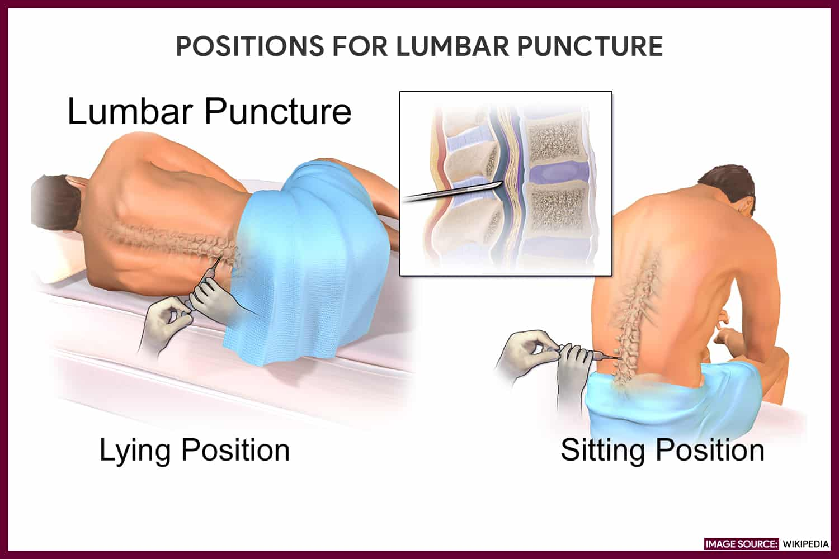

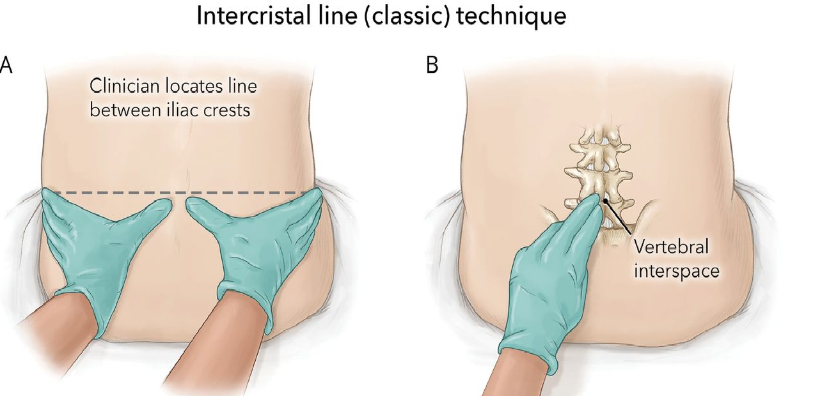

3 way stop cock
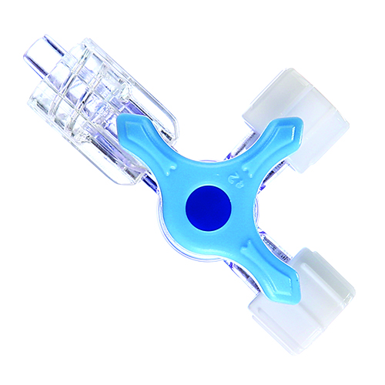

Spinal manometer
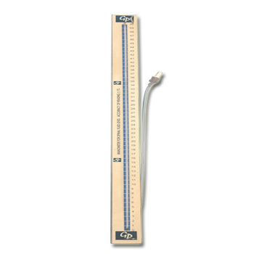

Measuring opening pressure
