A PLACE TO BELONG AND A PLACE TO BECOME

NOTICE

TAKE NOTICE THAT PWC MUNALI EXTRA ORDINARY LOCAL CHURCH CONFERENCE WILL BE HELD ON SUNDAY 29th October, 2023 AT CHURCH SOON AFTER THE MAIN CHURCH SERVICE

Per: 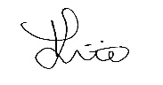
Church Secretary
26th October,2023

