

The university of Zambia
School of medicine
Department of public health
Community based education and community medicine 3009 group report
Supervisor ; Mrs Mununkila L.K
Coordinator ; Dr Moses Simuyemba
Title ; A community health diagnosis of M’tendere township in Lusaka
Date ; 4th January,2016 to 29th January,2016.
team members;
- Siamoomba Oscar -13173430
- Phiri Mabvuto -13017021
- Munthali Wezi -13012916
- Mooka Edinah-13023489
- Phiri Rashid -1321828
- Muyombu Andrew -1316407
- Anse chintu Kalombo -10029508
- Maimbolwa Pumulo -13196944
- Nyirenda David -13015095
- Habasimbi Caroline -13016334
- Kahula Chiteta-13187678
- Chibwe Paul -13083031
- Martin Chikwanka-11118156
- Habachela Moonga -13053019
- Aarthi Booplal -15094928
- Surekha Singh -15094936

Table of contents ……………………………………………………………………………………..page number
TITLE PAGE………………………………………………………………………………………………...1
DEFINITIONS……………………………………………………………………………………………. 3
1 INTRODUCTION……………………………………………………………………………………….4
- BACKGROUND ……………………………………………………………………………………..5
1.1 RELIGION …………………………………………………………………………………………….5
1.2 POLITICAL STRUCTURE……………………………………………………………………………6
1.3 EDUCATION …………………………………………………………………………………………..7
1.4 SOCIAL ECONOMY………………………………………………………………………………….7
1.5 PHYSICAL ENVIRONMENT……………………………………………………………………….8
1.6 HEALTH SERVICES ……………………………………………………………………………………8
1.7 RECREATION……………………………………………………………………………………………9
1.8 COMMUNICATION…………………………………………………………………………………..9
2.0 MAIN BODY………………………………………………………………………………………………10
2.1 AIM…………………………………………………………………………………………………………..10
2.2 OBJECTIVES……………………………………………………………………………………………….10
2.3 METHODOLOGY…………………………………………………………………………………………10
2.4 RESULTS……………………………………………………………………………………………………..11
2.4.1 PHYSICAL ENVIRONMENT ……………………………………………………………………….11
2.4.2 SANITATION……………………………………………………………………………………………..11
2.4.3 INFRASTRUCTURE …………………………………………………………………………………….11
2.4.4 EDUCATION ……………………………………………………………………………………………..12
2.4.5 SOCIAL AND ECONOMIC STATUS………………………………………………………………12
2.4.6 HEALTH STATUS ……………………………………………………………………………………….12
2.5 DISCUSSION …………………………………………………………………………………………………14
3.0 CONCLUSION AND RECOMMENDATIONS………………………………………………………18
3.1 CONCLUSIONS………………………………………………………………………………………………18
3.2 RECOMMENDATIONS…………………………………………………………………………………….18
4.0 REFRENCES …………………………………………………………………………………………………….19

DEFINITION OF APPROPRIATE TERMS
COMMUNITY; THIS IS A CLUSTER OF PEOPLE WHO HAVE AT LEAST ONE CHARACTERISTIC IN COMMON
SURVEY; THIS IS A NON-EXPERIMENTAL DESCRIPTIVE RESEARCH METHOD
HEALTH; A STATE OF COMPLETE MENTAL, PHYSICAL AND SOCIAL WELL-BEING-CHURCHILL MEDICAL DICTIONARY 16TH EDITION
COMMUNITY DIAGNOSIS ; THE IDENTIFICATION AND QUANTIFICATION OF HEALTH PROBLEMS IN A COMMUNITY AS A WHOLE IN TERMS OF MORTALITY AND MORBIDITY RATES AND RATIOS , AND IDENTIFICATION OF THEIR CORRELATES FOR THE PURPOSE OF DEFININGTHOSE AT RISK AND THOSE IN NEED OF HEALTH CARE.
MORTALITY RATE; THE DEATH RATE; THE RATIO OF NUMBER OF DEATHS TO THE TOTALPOPULATION
MORBIDITY; THE STATE OF BEING DISEASED
SANITATION; CONDITIONS RELATING TO PUBLIC HEALTH
HYGIENE; THOSE CONDITIONS THAT PROMOTE AND PRESERVE HEALTH
1. INTRODUCTION
This report intends to give an outline of community health survey carried out in a specific community. A community being defined as a cluster of people with at least one common characteristic (geographical location, ethnicity, and occupation, housing condition…) .A survey is a non-experimental descriptive research method. The community health survey was carried out in the community of M’tendere. The program was aimed at assessing and identifying the determinants of health in the community via interactive sessions with the members of the community and evaluation of it’s the eight subsystems. It involved personal contact with the members of the community and experience of their day to day activities, challenges and accomplishments. It was first-hand experience centered education with an aspect of problem learning. This report will outline the findings of the team that consisted of 16 medicals students in their third year. It will strive to present the determinants of health in M’tendere based on the Population structures, Environmental factors affecting health and Disease patterns, Organization of Human society, The genetic and home environment. This report will also propose some measures that can help alleviate some of the problems and challenges the community is currently facing with regards to their health.

1.0 BACKGROUND
M’tendere , meaning peace, was formerly known as chainama hills ,is a township of Lusaka , Zambia that was founded in 1967 as a site and service resettlement scheme , where services were provided but resident s themselves produced the majority of the dwelling . The peri-urban area is situated 3675km on the eastern of the Lusaka with a population of 99,833. It comprises of ten zones with four basic government schools, four community schools and one health care center. The township is characterized by overcrowding, poor waste disposal, inadequate access to safe water, poor sanitation, poor hygiene practices and poverty.
Figure 1.map of M’tendere
  - RELIGION
M’tendere has one dominant religion, Christianity. There are several different denominations of Christians in M’tendere some of which include, Pentecostals, Catholics, and Baptists, Salvation Army, the United Church of Zambia and new apostolic church. These all had church structures distributed throughout the ten zones that M’tendere. Also present in M’tendere is a group of people that hold to traditional beliefs and superstitions, though this group is not very significant in number. The more popular practice in M’tendere is to merge traditional beliefs and Christian values. There were no structures to evidence the presence of other religions like Islam and Buddhism. The people of M’tendere all have different levels of devotion to their religious beliefs though there is a general sense of spirituality.
Figure 2; members of team M’tendere in front of one of the said religious structures.
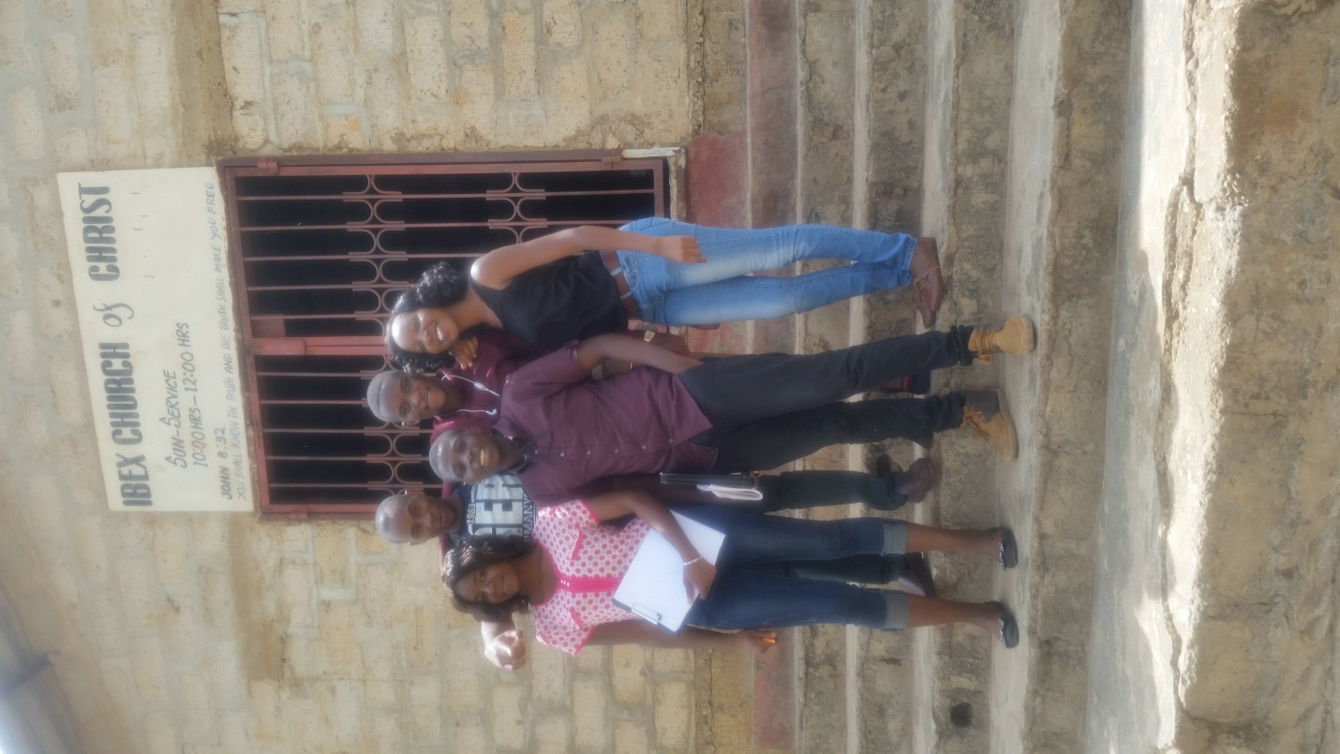
1.2 Political structure
The political structure in order of descending seniority is given by the following flow chart;
National level (president)
↓
Provincial level (minister)
↓
District level (chairman)
↓
Constituency level (Member of Parliament)
↓
Ward level (councilor)
↓
Branch level (chairman)
↓
Section level (chairman)
1.3EDUCATION
The township currently has 5 primary schools with one being upgraded to a secondary school. These include M’tendere basic school, Chitukuko basic school, new M’tendere primary school and Mahatma Gandhi basic. The attendance in these schools is poor and not consistent, probably due to the fact that these schools are not easily accessed by most students in the zones that not close to the schools. The average age ranges of pupils in these schools are 7-19 years .though this schools are government owned and operated, they are not free. There is a mandatory fee that is supposed to be paid by the pupils at the beginning of each academic year. This also contributes to the poor attendance in the schools. This region does not have institutes that provide tertiary level education like colleges and universities. Most of the population has no formal training, with most possessing basic skills in trades like carpentry and bricklaying.
Figure 3; one of the schools in M’tendere
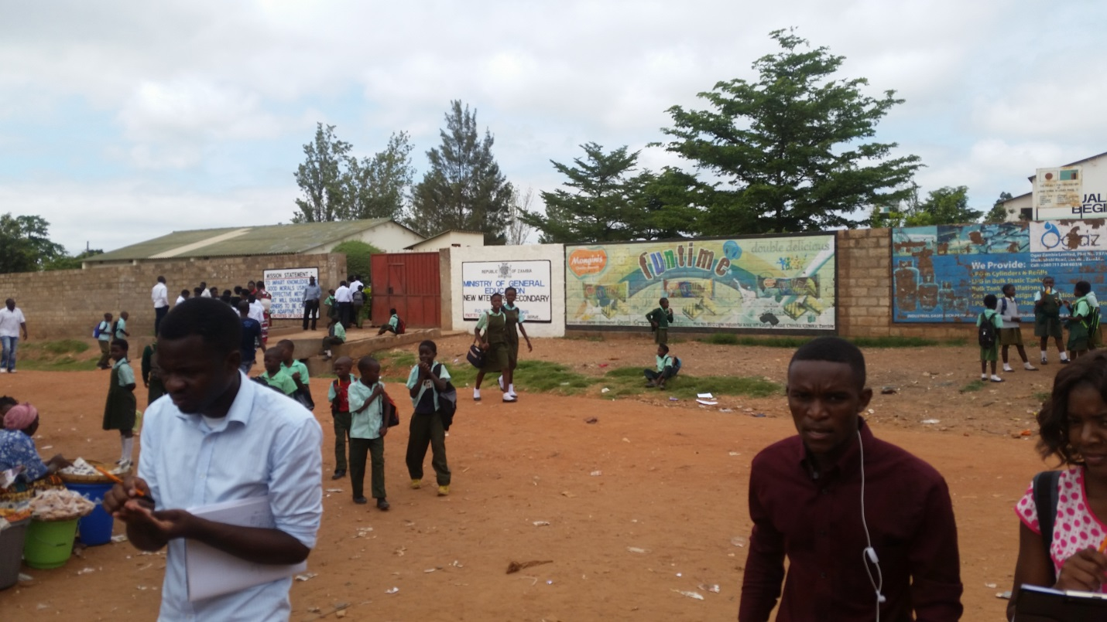
  - SOCIAL ECONOMY
Most of the people are self-employed and engaged in various business ventures such as the selling of salaula, bakeries, hardware stores, bars, vegetable vendors and others are landlords. Some members of this community are formally employed as teachers, nurses and accountants to mention but a few of the available occupations. Not all sources income in M’tendere are legal, some people are engaged in several illegal businesses like prostitution. M’tendere community has a mixture of low-income households, middle-income households and high-income households.
Figure 4; some of the economic activities in the community
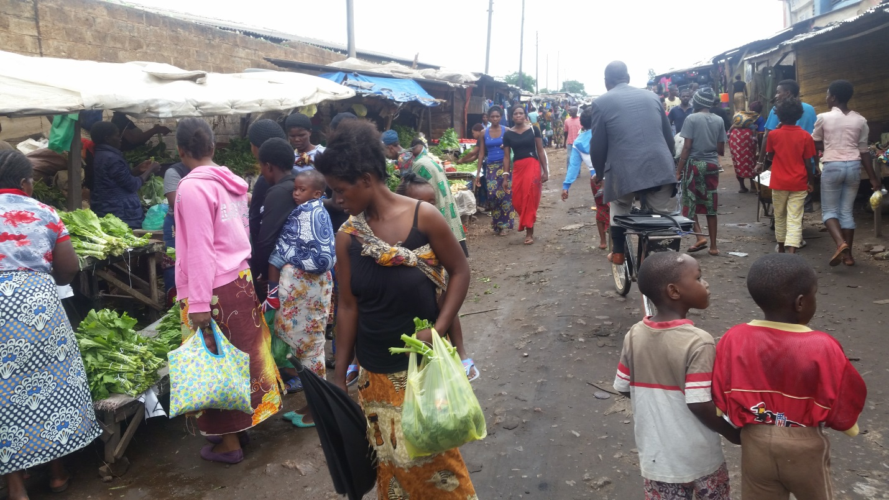
1.5 PHYSICAL ENVIRONMENT
Water; of the population of 99,833, only 16% have direct access to safe water supply by Lusaka Water and Sewerage Company and the other 84% use other sources such as shallow wells and streams.
Sanitation: the area has poor sewer system and little or no drainage; this is compounded by the high levels of littering. The structures for human waste disposal consist of 4% of the population use flushable toilets, 80% use pit latrines and 16% of the population use other means like defecating in the bush.
Waste disposal: mainly it is by done randomly disposing of the waste in undesignated areas, a few people use council bins. Some households have a system were they pack their waste in sacks and these sacks are later collected by young boys paid to do so.
Structures: 80 % of the houses are made of bricks and 20% are made of mud .of the 80% bricked houses, 60% are roofed with iron sheets and 40 % asbestos.
  - HEALTH SERVICES
health services in the area are provided by the existing M’tendere Healthcare Center located 12 km east of district health office , has boundary with kalingalinga on the west , chainama on the north , chainda on the east , bauleni on the southern side and St Agness on the south east .it started as an out-patient service in 1976 through community initiative . With the increase in population, the health center extended its services to maternal and child health and delivery services. With help from the Irish aid, the maternal child health and maternity department was constructed in 1992.later in 2005, the out-patient department was extended with help from American Corps.
Currently the health center carters for populations of 99,833 from 10 zones .the health center provides the following services;
- CURATIVE
- ART/VCT
- LABORATORY
- TB SERVICES
- MATERNAL SERVICES
- MALE CIRCUMCISION
- RESEARCH PROGRAM
- DENTAL SERVICES
The following is the administrative structure at M’tendere clinic;
Staff -Levels
Specialty | Number
Nutritionist | 0
Doctors | 2
Nursing sister | 0
Lab technicians | 1
Registered mid-wives | 3
Counselors
Clinical Officers | 7
Enrolled nurses | 9
C.mid-wives | 1
EHTs | 2
Dentists | 2
Physiotherapist | 2
Pharmacists | 1
  - RECREATION
80 % of recreation consists of extracurricular activities in the schools and 5% takes the form of church activities. 15 % is taken up by beer-drinking.
  - COMMUNICATION ;
This was considered at the health center level. The landline is installed but not functional. The mode of communication is through CIRDZ phone and VOIP (radio).in case of an emergency, the health center has no car but just bicycles which are used for out-reach areas.

2.1 Aim: understand the system of M’tendere Community and the challenges faced in relation to health
2.2 Objectives
To identify determinants of health in M’tendere community by evaluating
- Physical environmental factors such as water , sanitation, drainage and infrastructure
- Personal factors such income , behavior, sex
To assess the services provided by the health center
- Inquire about health indicators such as mortality , morbidity , disability rate , nutrition status and health care delivery
To identify challenges faced by the community and the health center and propose possible solutions to the same.
2.3 METHODOLOGY
Community and health diagnosis was conducted as follows;
- By inspection of the health care center
This involved a tour of the health center, visiting each department, interviewing some of the health personnel and accessing health records.
- Attachment to households. Involved having a concrete conversation for most part of the day with the members, with part of the conversation consisting of questioning them on the activities that characterize their daily routines .it also involved making observations. This was done for 2 days.
- Survey of the community via observations at the market, schools and entire community and interviewing random individuals in the community. This was done for 3 days.

2.4 RESULTS

Total population of the catchment area: 99,833

2.4.1Physical environment
Water source
Source | Piped(council water) | Shallow wells | Streams | Boreholes
Respondent | 84% | 10% | 4% | 2%

Quality of water
Quality | Safe water | Unsafe water
Respondent | 12 % | 88 %

Treatment of water

Treatment | Boiling | Chlorination | No treatment
Respondent | 20% | 5% | 75%

2.4.2 SANITATION
Types of toilets

Toilets | Flush toilets | Pit latrines | Bushes/ others
Respondent | 4% | 80% | 16%

Waste disposal
Method | Random damping | Bins | Unknown NGO collection
Respondent | 80% | 4% | 16%

2.4.3 INFRASTRUCTURE
Quality | Bricked | Mud
Respondent | 80% | 20%

2.4.4 EDUCATION
Education levels offered
Level | Primary | Secondary | Tertiary
Respondent | 98% | 2% | 0%

Levels attained
Level | Primary | Secondary | Tertiary | None
Respondent | 60% | 4% | 1% | 35%

2.4.5 SOCIAL AND ECONOMIC STATUS
Sources of electricity
Source | Electricity | Solar energy | Charcoal | Firewood
Respondent | 50% | 2% | 48% | 0%

Employment status
Status | Unemployed | Self employed | Formal employment
Respondent | 34% | 60% | 6%

Social activity
Activity | Drinking beer | Sport | Prostitution
Respondent | 60% | 4% | 36%

Meals partaken per day
Number of meals | Percentage of consumers
1 | 40%
2 | 50%
3 | 8%
More than 3 | 2%

2.4.6 HEALTH STATUS
Top 5 causes of morbidity
Disease | Incidence /1000 total
Diarrhea (non bloody) | 30280
Malaria | 3134
ENT(infections) | 2138
Skin (infections) | 605
Eye infection | 1960

HIV/AIDS Services (based on 2013 records)
- Proportional of clients counseled for the HIV who took an HIV
 | Number
Counseled &tested | 3.6%
Not counseled | 96.4%
- Cumulative number of the patients enrolled on ART

Status | Number | Percentage | Total
Male | 7164 | 36.4% | 7164
Female | 12541 | 63.6% | 12541
 |  |  | 19709

- Maternal and child health
Prevention of mother to child transmission
Proportion of pregnant women testing HIV positive
Number of women that tested for HIV | 2842
Number of women that tested positive for HIV | 319
Percentage of HIV positive women: 11.2%

2.5 DISCUSSION
Physical environment.
Water source and treatment: deducing from the obtained results, water was supplied by 84% council, 10% shallow wells, 4% streams and 2% boreholes. Despite piped water being the most supplied, it was diagnosed that 80% of this water is actually unsafe for drinking and only 12 % was safe. This was attributed to the occurrence of leakages in the pipes due to vandalism. Most of the wells do not have proper protection, they are not sufficiently far from sources of infection like pit latrines, and are not properly covered and are consequently susceptible to contamination from outside sources. The region has a stream from which children play, however, the water in this stream is highly contaminated due to reception of effluent from the drainage system .owing to 75% of the water being consumed without treatment and the high levels of contamination at the sources of water, cases of water borne diseases such as bilharzia and diarrhea are frequently encountered at the health center. This is compounded by the fact that only 20% was boiled and 5% treated with chlorine.
Figure 5; contaminated water sources
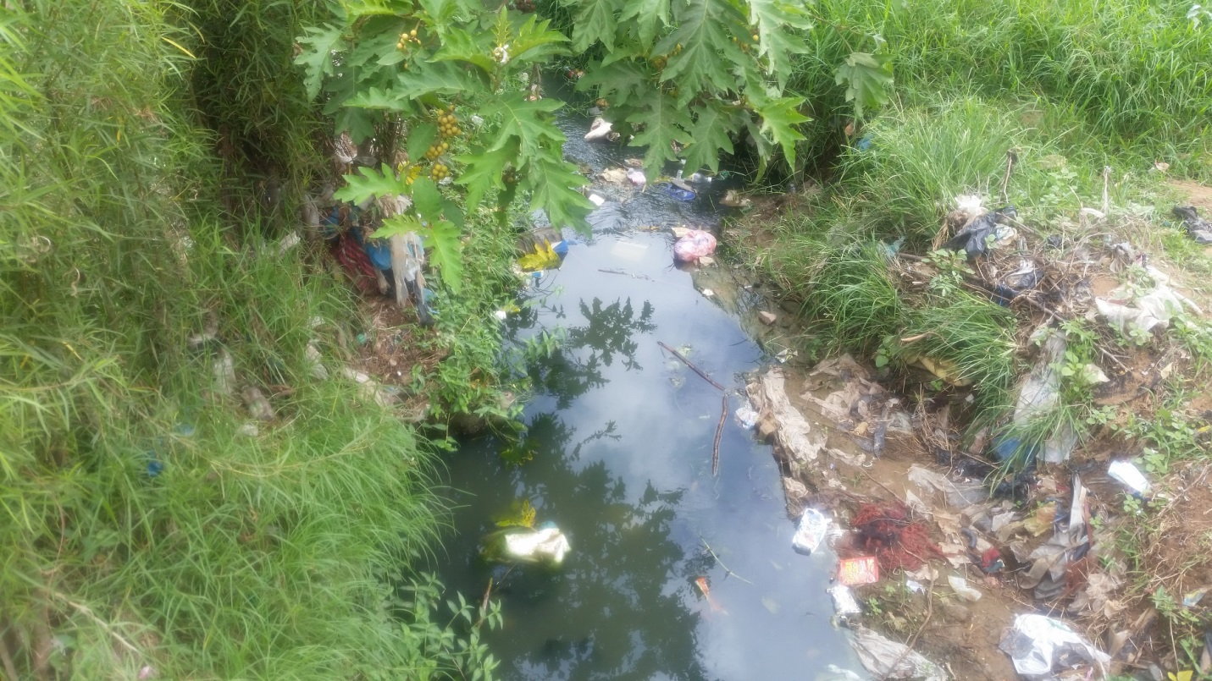
Infrastructure: was poor despite most homes being quality material such as bricks (80% cemented) and 20% mud. Most of these homes have leakages in their roofs and cracked walls. This becomes a problem in the rainy season when puddles of water accumulate in the hidden places in these households and provide conducive conditions for the growth of microbes and hence become a source of infection. The houses are in close proximity to each other and this increases the risk of transmission of some communicable diseases between members of households. The area does not have a well-developed road network, this makes it difficult to deliver and access health services.
Types of toilets and garbage disposal: 4% flush toilets, 80 % pit latrines and 16 % bushes/others are the types of toilets present in M’tendere Township. Most of the pit latrines did not have any covering and were close to the water wells, increasing the risk of contamination of the water in the wells. The residents were also observed to conduct a certain unsanitary practice of boring holes “breathers” in the sides of pit latrines that were fully filled. This allowed the outflow of the excess human excreta into the surrounding areas and consequent development of sites of infection. All these factors are thought to contribute to the high prevalence of diarrheal cases at the clinic.
Moreover, waste disposal is practically a challenge for the entire community. Waste is not disposed of in specifically designated areas rather it is randomly damped in various areas in the market , schools and the general surroundings of the community .this causes a lot of air pollution due to the unpleasant odors emanating from the accumulated piles of garbage in the streets M’tendere .In addition, the drainage system is poorly constructed leading to areas with stagnant water which act as breeding sites for malaria causing invertebrates, that is , mosquitoes which in turn leads to the high occurrence of malaria in the area.
Figure 5; garbage disposal along the streets of M’tendere
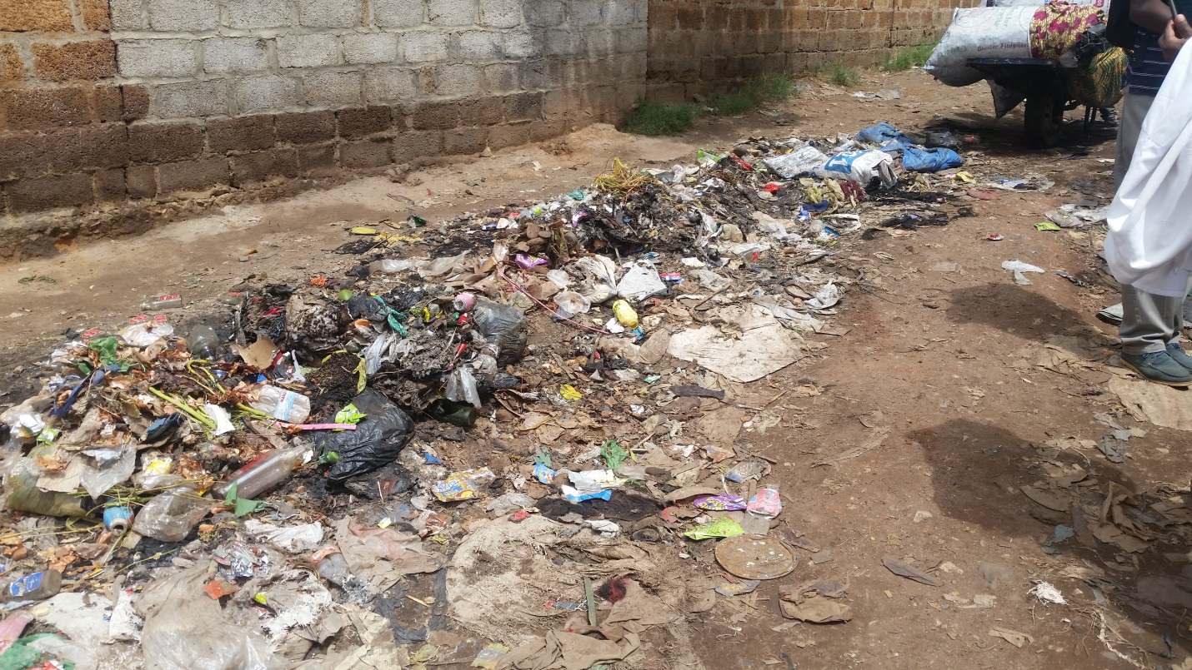
Education
The community had 5 primary schools with one undergoing an upgrade to secondary school status; hence 98% of the education is primary level education with 2% privately run secondary schools and 0% tertiary education. This is thought to be the reason behind only 60 % of the population having primary level education, 4 % secondary, and 1 % tertiary and 35% having no education at all. There is little health education in these schools and this leads to ignorance of practices that prevent disease and promote good health among the students and the general population at large. However, there is a modest level of literacy even in the low income populace of M’tendere which has enabled them to acquire knowledge about HIV and testing as well as maternal and child health. The low levels of education have limited access by the general populace of M’tendere to certain well-paying jobs. This limits the M’tendere community member’s ability to afford certain drugs and health services.

Social and Economic Status
Economic status: the findings show that 34% were unemployed , 60 % self-employed engaged in various business ventures such as the selling of salaula , street vending of various goods , hardware stores ,bars , carpentry to mention but a few and 6% were formally employed . The increase in the dollar has resulted in only 50% managing to have 2 meals in a day, 40% only afford 1 meal, 8 % have 3 meals in a day and 2% are able to afford more than 3 meals in a day. In most of these households, the diet was not well balanced due to inability to afford fruits and meats, which compromised the immunity of the individual and made them susceptible to opportunistic infections like colds which are rife in most areas of M’tendere community.

Social activities : as a result of lack of recreation centers, 60 % of the population engaged in beer drinking leading to alcohol related diseases like cirrhosis as well as the high prevalence of unprotected sex due to reduced judgment when drunk thus the high number of STIs in the area.36% of the population ,mainly female , is engaged in prostitution . This is also thought to have contributed to the high prevalence of STIs.
Health status
Morbidity : top 5 cases at the health center were diarrhea(non bloody)-30,280, malaria -3134, ENT(infection)-2138, skin infection – 605 and eye infection 1,960.diarrhea being the highest due to poor water supply, low access to safe drinking water and poor sanitation .
The health facility only offers out-patient treatment and services and hence no records of mortality rates are kept .
HIV/AIDS services : based on 2013 records , the proportion of clients counseled for HIV after taking an HIV test were 3.6% and 96.4% did not attempt.In terms of the cumulative number of patients enrolled on ART was 36% male and 63.6% female. Of the pregnant women that tested for HIV , 11% were found to be positive
The clinic faces challenges in the form of being under staffed and having shortages of drugs . this has prevented the clinic from efficiently treating the overwhelming population of patients.
Figure 7; physiotherapy department at clinic
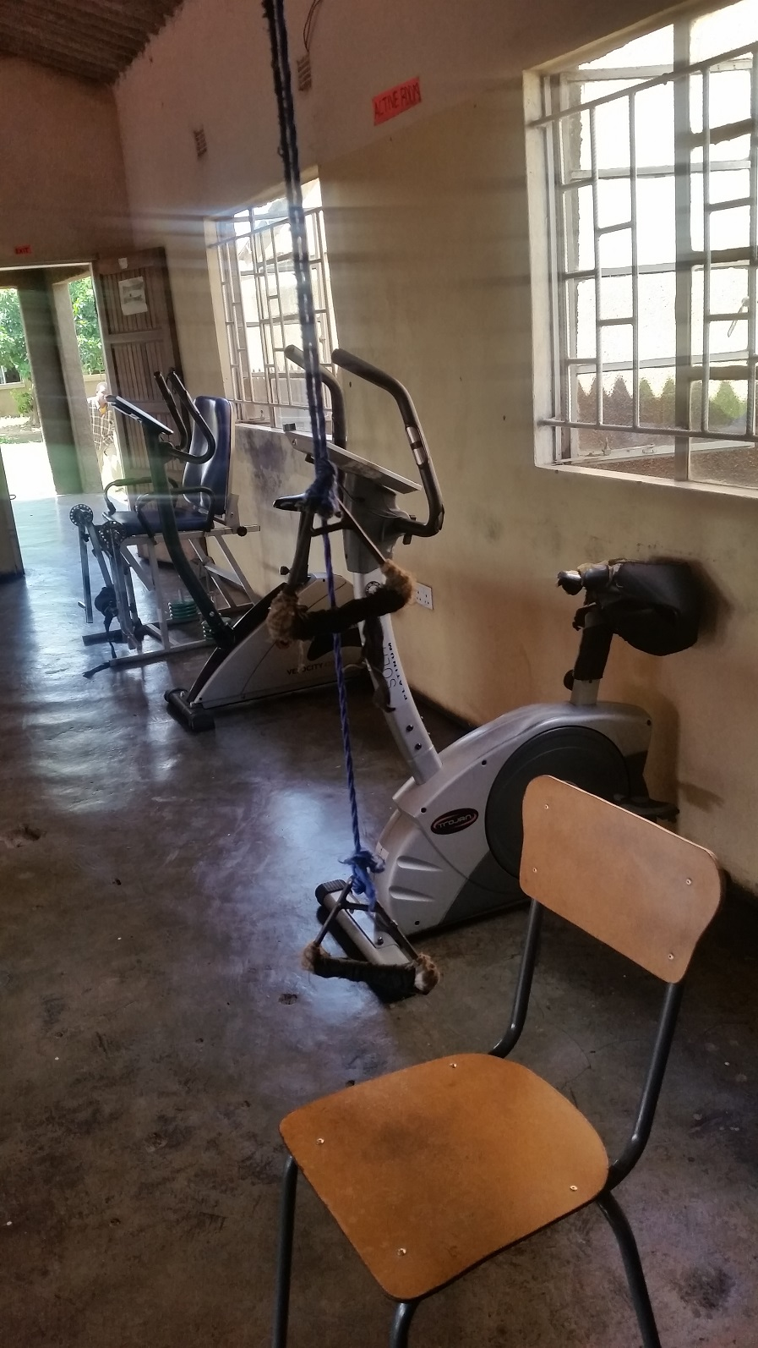
Figure 8; maternity ward at the clinic
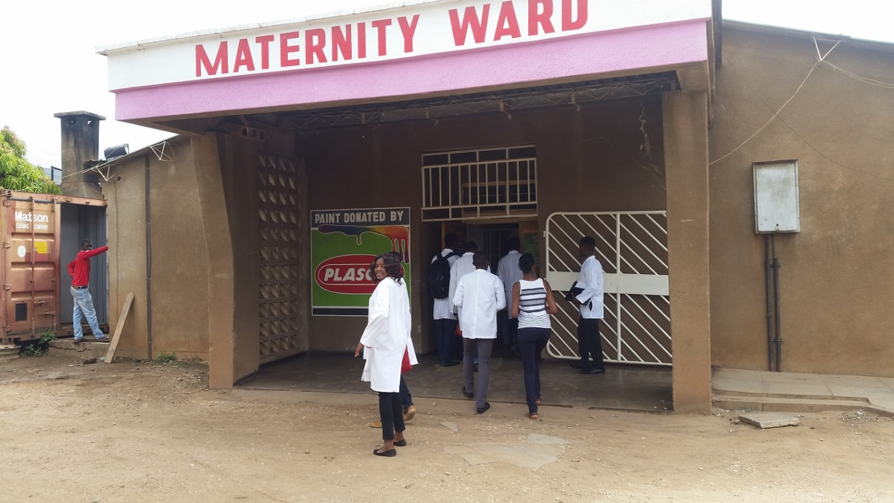
3 Conclusion and recommendations
3.1 Conclusion
The community of M’tendere was studied through field work activity and research and the determinants of health were identified and some were quantified. During community diagnosis poor sanitation ,particularly due to indiscriminate garbage disposal and lack of hygienic practices at both community and household level were pinpointed as the major problem. Community and individual attitude towards environmental cleanliness and personal health were identified as the primary source of these problems. The community mostly did not feel responsible for “keeping its environment clean”, it felt that that was the responsibility of the existing political structures. The team was expected to provide and implement a solution to at least one of the problems encountered in M’tendere. The identified the unsanitary state of the patients toilet at the clinic as a problem that it could immediately address. This was addressed by purchasing some cleaning reagents and equipment for the toilet which the clinic did not have in supply as well as by sticking posters on the walls of the toilet admonishing the users to “keep the toilet clean”. Refer

ANNEX
Figure (i)
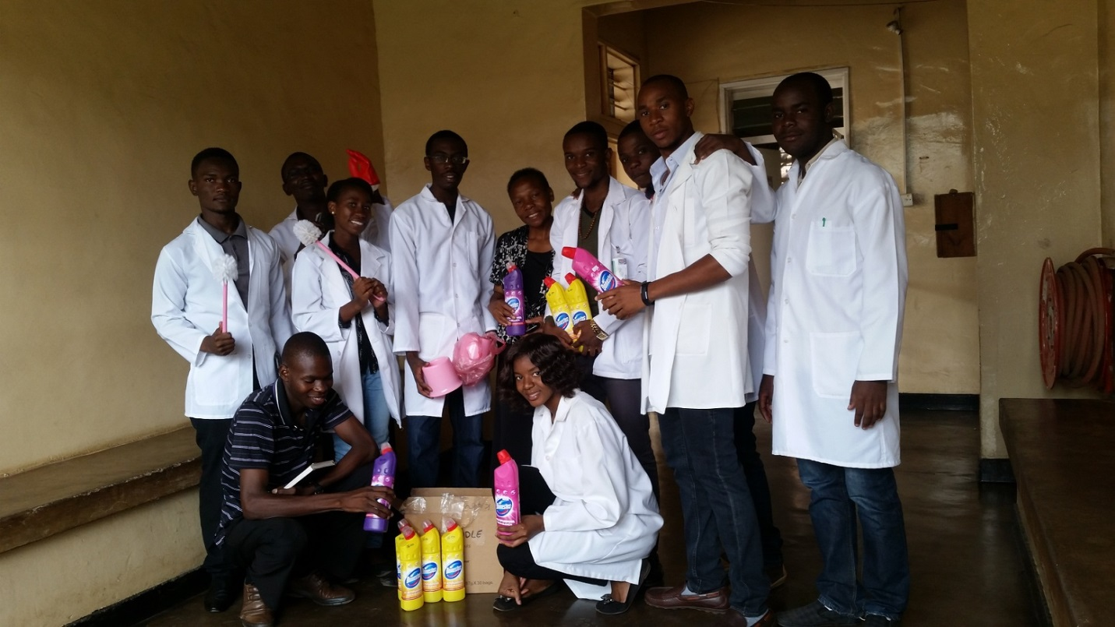
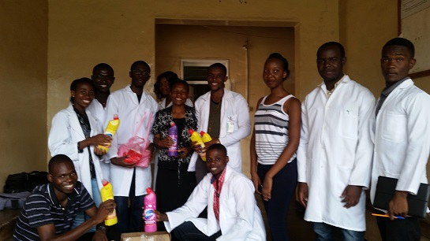
Figure (ii)
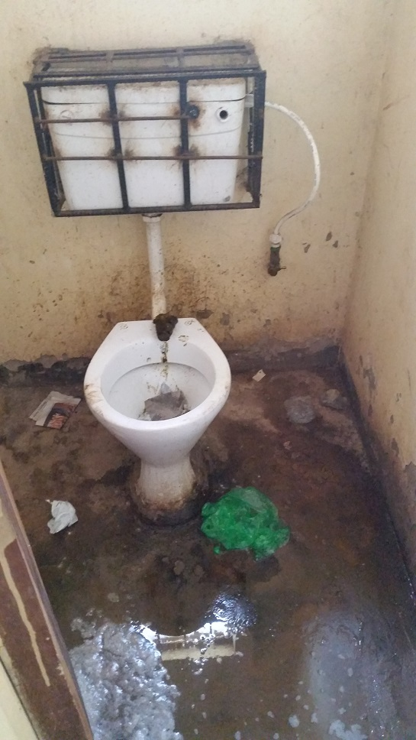

to figure (i) in annex.
3.2 Recommendations
a meeting was held with some members of the the council ,clinic administration and community to present some recommendations that the team thought would help in addressing and alleviating some of the challenges facing the community with regards to public health.the following are some of the suggestions that were given by the M’tendere team;
- Sensitization and public health training for church ,school and community leaders.
- Issue some community behavior reform communication campaigns.
- School outreach for health awareness and disease prevention measures.
- Building of better and bigger market to deal with overcrowding and street vending.
- Building of more public toilets.
- Adequate stocking of the clinic with necessary drugs.
- Employment of more staff at the clinic.
- Distribute bins at regular intervals throughout the market and streets to curb on littering
- Issuance of more liquor licenses and closely regulate the activities of the bars.
- Engage the Lusaka Water and Sewerage Company in providing safe water to the community as well as repairing and replacing the vandalized pipes.
- Creation of better and health friendly recreation activities like libraries and sports center to curb on health-risky activities by the youth like excessive drinking of alcohol.
- Regular collection of garbage by the city council.
- Use of CDF to empower more youth and the families to start sustainable business. This will go a long way in giving these family the financial capability to afford good nutrition and medical services like cancer screening.
- Strictly enforce regulations that require industries and private businesses to put in place environmental safe guards as well as health friendly practices.
- Subsidize the local pharmacies to enable the average resident of M’tendere better afford the prescribed drugs.
- Build better drainage systems.
4 REFERENCES
1. M’tendere health center action plan of 2015 and council records of 2015
2. Rasha Salama .PhD , COMMUNITY HEALTH SURVEY ,Suez Canal University, Egypt.
3.CHURCHILL LIVINGSTONE ,MEDICAL DICTIONARY 16TH EDITION , ELSEVIER , NORFOLK ,UK.
4. Boaden, N., & John, B. (1999). Community Based Medical Education 1st Edition.
5. Ogunbode, O. (2004). Community Based Medical Education. Evans Brother Publication.

