METHODOLOGY
Research Design
This study used a descriptive survey design. Descriptive studies are not only restricted to fact findings, but may equally lead to formulation of important principles of knowledge and coming up with solutions to significant problems. Therefore, this study utilized a descriptive design because the study intended to identify and prioritize community health problems as well as describe disease prevention methods in Kabwata community. Both qualitative and quantitative approaches were used in this study. Otieno (2013) pointed out that quantitative and qualitative methods could be combined at different stages of the research process in the study of the same phenomena. The study used both qualitative and quantitative methods because several researchers advocate the combination of the two methods not only for the purpose of triangulation but also for the purpose of drawing from the strengths of both methods since both have their own pros and cons.

Target Population
The study was undertaken in Kabwata constituency, particularly with focus on the community which falls within the catchment area of Kabwata Urban Clinic, of Lusaka district, Lusaka Province, Zambia.

Variables
The major variables of interest were, family structure, religion and culture, highest level of education, general health status and practices; sanitation, economic status and social life/well-being.

Sampling Procedures
The researcher used the simple random sampling technique. This is where the researcher selected sampling units in an attempt to attain a sample that appeared to be representative of the population. Ideally, it was preferable to collect data from nurses at the facility over a minimum period of 2 weeks. However, several challenges were met such as time availability to the researchers, the nurses, the facility health workers and the research time, among other contingent factors. Furthermore, the study employed simple random sampling in selecting the sample of the study.

Data Collection
In the collection of data for this research, Structured observation checklist was used. This study used both quantitative instrument (checklist) and qualitative instruments (registers and files of patients) as well of recorded data from screening rooms, in order to extend the breadth and range of enquiry by using different methods. By using random sampling method, data from 6 families was extracted on variables of interest, as well as data for a minimum of 130 patients to establish community health problems.
Additionally, HIV infection status was also be sourced from the Antiretroviral Therapy (ART) center, particularly from the data office.

Data Analysis Techniques
The collected data was critically analyzed by use of tables, pie charts and graphs.

ETHICAL CONSIDERATIONS

Prior to the study, the researcher sought permission for medical approval from the University of Zambia School of Medicine undergraduate Research Ethics Committee. The information obtained from patients’ files and registers was strictly confidential and was used specifically and solely for the purpose of this study. To enhance confidentiality, names of patients and dates of birth on the checklist during data collection were not included.
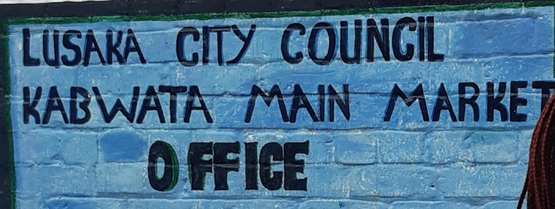
Additionally, prior to surveying the community, particularly at the Kabwata main market, permission was sought and granted by the Lusaka City Council Kabwata Main Market Office.

During field work, respect of autonomy, beneficence and right of consent of individual were carefully observed and adhered to. The respondent was given respect in an appropriate manner; autonomy was ensured by not forcing individuals to give information they considered very confidential. The respondent was given enough information, for the purpose of the visit, the use of the information they were disclosing to ensure they made an informed decision. This, therefore, ensured justice on the part of respondent.

CONCLUSION
The community of Kabwata was studied through field work activity research and the determinants of health were identified and some were quantified. During community diagnosis, poor sanitation, particularly due to indiscriminate garbage disposal and lack of hygienic practices at both community and household level were pinpointed as a major problem. Community and individual attitude towards environmental cleanliness and personal heath were identified as the primary source of these problems. The community mostly did not feel responsible for keeping its environment clean; it felt that it was the responsibility of the existing political structures. The team was expected to provide and implement a solution to at least one of the problems encountered in Kabwata community. The identified unsanitary state of the toilets

REFERENCES
1. 2010 Census of population and Housing, Zambia
2. Donfouet, Hermann & Mohamed, Shukri & Otieno, Peter & Wambiya, Elvis & Mutua, Martin & Danaei, Goodarz. (2020). Economic valuation of setting up a social health enterprise in urban poor-resource setting in Kenya. Social Science & Medicine. 266. 113294. 10.1016/j.socscimed.2020.113294.

