
THE UNIVERSITY OF ZAMBIA
SCHOOL OF MEDICINE
DEPARTMENT OF PUBLIC HEALTH AND COMMUNITY MEDICINE

NAME: MAZALA CHANDA
COMPUTER NUMBER: 13169882
COURSE: COMMUNITY BASED EDUCATION AND FIRST AID
COURSE CODE: DPH 3009
TITLE: REPORT ON HOUSEHOLD EXPERIENCE WITH THE CHIPAILA’S
CATCHMENT AREA: MAAMBA
FACILITATOR: Mr. Chisoso
COURSE COODINATOR: Dr. M. SIMUYEMBA
DUE DATE: 29TH FEBRUARY, 2016

Table of Contents

CONTENT PAGE NUMBER
I. Definition of Appropriate terms 3
ii. Introduction 4
iii. Objectives and Aims 5
iv. Problem Statement 6
v. Questions 6
vi. Methodology 7
- Interviews 7
- Observations 7
- Ethical consideration 7
vii. Household experience 8
- Family background and education 8
- House structure, composition and sanitation 9
- Income and nutrition 10
- Health, religion and recreation 11
viii. Discussion 12
ix. Limitations and Difficulties 15
x. Family tree 16
xi. Recommendations 18
xii. Conclusion 18
xiii. References 19

DEFFINATION OF APPROPRIATE TERMS AND ABBREVIATIONS

1. SWASCO - Southern Water and Sewerage Company.
2. TCB - Training Center B
3. TCA - Training center A
4. MALENDE - Shrine in Tonga.
5. ZESCO - Zambia Electricity supply corporation
6. UTH - University teaching hospital
7. ZIT - Zambia Institute of technology
8. ZIMCO - Zambia Industrial and Mining Corporation
9. UCZ - United Church of Zambia
10. HAHC - Hospital Affiliated Health Center
11. CBE - Community Based Education
12. UPND - United party for national development
13. DPH - Department of Public health
15. Epidemic - Disease that is continually present in the community.
16. Mayadi - An area in Maamba catchment area were most rich people stay
17. Beneficence - A noun of the adjective; beneficent meaning doing well or resulting in good
18. Topography - The arrangement of natural and artificial physical features of an area
19. Socio-economic - Relating to or concerned with the interaction of social and economic factors
20. Family tree - A chart of information that shows relationships of family members over time
21. Autonomy - Having the right for self-governance, the freedom of choice or action
22. Kapaso - Chiefs personal messengers
23. Musca Sorbens - A form of green flies that causes eye infections

INTRODUCTION
Maamba, home to the indigenous Tonga speaking people of Zambia is located in the southern province of Zambia in sinazongwe district, it is situated approximately 85 kilometers from batoka, off the Lusaka Livingstone road. Bordered by Choma, Gwembe, Mapatizya, Zimbabwe to the north, east, west and south respectively,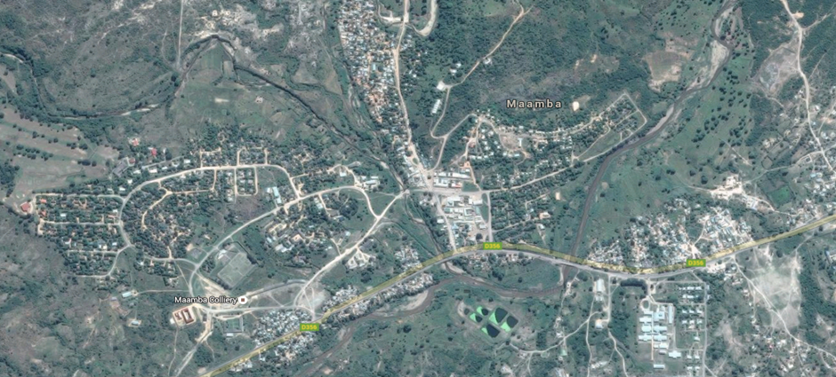 according to the statistical values collected from the environmental healthy department of Maamba hospital Maamba is home to over 16,388 people 3,643 households. It is also home to the famous Maamba collieries coal mine. Maamba town has a hilly topography.
The Catchment area has a total of four (4) learning institutions, which include four (4) government schools and one (1) private school. Maamba private school is the only private school in the catchment area while the government schools include: Maamba secondary school, Maamba basic school and mamba special school which offers education to the less privileged and the disabled
The entire catchment area has two health centers, Maamba general hospital and a hospital affiliated healthy Centre (HAHC) which is cleverly placed inside the hospital premises. At the time of CBE, healthy facility was under construction in the peripherals of the catchment area. Maamba hospital is staffed by two doctors who take shifts in servicing the people, and despite it being a hospital, Maamba hospital has no ambulance.
Maamba community falls in the sinazongwe district and represented by Hon Richwell Siamunene, the community is under the umbrella of the provincial minister MR Nathaniel Mubukwanu. The district is further divided into smaller towns headed by town clerks who are elected by the other councilors within the council chamber. The towns are further divided into 8 wards which are run by area councilors who are elected by ward residents. Ward councilors together form a local council which ensures checks and balances on councilors. The council is led by a council secretary elected by member councilors. The wards are further divided into zones which are headed by chairpersons. The catchment area was located in training centers A and B in the core of ward 15 pioneered by chairman Bombe.
According to the chief advisor who is also headman Sikalonzo, the whole Tonga tribe originated from Maamba. In an exclusive interview with him, we leant that Maamba is under the chiefdom Mweemba which is run by the senior chief Mweemba, chiefdom Mweemba extends beyond Maamba to Sinazongwe and Kalomo. When the chiefdom is considered at large it has 300 and more headmen but when the chiefdom is considered only on the Maamba part, it has 14 headmen. At village level of administration, the village is headed by a village headman who is followed by the vice headman who is not from the family tree to give checks and balances to the leadership. This followed by a 6 membered committee and then in addition to the 6-member committee there is a 4 membered structure of king’s men kapaso’s
The people of Maamba are also known for their famous traditional practices, these are locally known as the Amalende, and the Amalende practitioners have special designated places of worship known as the shrines, in the exclusive interview with the headman, it was revealed that the people turn to these shrines in times droughts, epidemics and hunger among other things.
Another quality worth mentioning about the people of Maamba is their warm heart, kindness and tenderness.
During household attachment, I was attached to the Chipaila’s family, more information us given in the household attachment section of this report.

OBJECTIVES AND AIMS
- To access characteristics of the household in terms of age of head of household, level of education, the marital status, and the number of occupants of the house.
- To access the socio-economic status of the household with respect to average income, recreational activities, and nutrition.
- To make observation of the physical environment with regards to sanitation, water source and storage, and water treatment.
- To access the accommodation with respect to the number of rooms, the general structural integrity, and the ventilation of the accommodation
- To evaluate the most common diseases experienced by the household, and whether they seek medical attention at local health facility.
- To evaluate water and sanitation challenges in the area
- To find out how traditional beliefs affect the health of the community
- To determine how economic status affects the health of the area
- To evaluate how recreational facilities, affect the health of the community members
- To analyze the general levels of education and how this affect health
- To assess attitudes toward community health community health services and issues.

Main Goal:
To understand the way of life of the local people with respect to their social and economic activities, political and religious affiliations, income and expenditure amenities, and other day to day activities by spending a complete day with them.
To achieve these objectives and the main goal, a community diagnosis was carried out via observation, taking of photographs and question asking to understand and document general characteristics of the mamba community including administrative structures, environmental factors, transport system, recreation, religious structures and social amenity structures. Further more information was obtained from literature which was previously reviewed and documenting evidence as appropriate. This was achieved with the help of environmental health technician of mamba hospital Mr. Chilomo and head man Sikalonzo. Also a household attachment was done with a view of obtaining precise and accurate information.

PROBLEM STATEMENT
Maamba community being an unplanned settlement has several challenges, including but not limited to, low to no monthly income per household, indiscriminate waste disposal, cow dung, erratic water supply, under-treated water, unstable housing, soil which is semi coal, pollution from the mine, and low sanitary conditions. All of the challenges plus many others pose a health risk to members of the community, particularly those in overcrowded zones and to the people that live close to the mine. Household attachment thus saves to understand how the physical environment, socio-economic aspects and customs and belief of individual households affect their health.
QUESTIONS
Household attachment saves to address the following questions:
- How does the level of education of the head of the household affect the socio-economic status of the family?
- What impact does the house design and general infrastructure including ventilation have on the health on the occupants?
- What influences nutrition of the household and what impact does this have on their health?
- Where is the source of water for the household, and how does the storage of the water affect the health?
- How does the cultural belief affect the status of the family and what possible impact this has on health?

METHODOLOGY
Two (2) methods where used to collect data, these are personal interview with householder and observations of the household and occupants.

- INTERVIEW
The interview with the householder concentrated on the following:
- Education of the respondent and that of other occupants of the household.
- Background of respondent.
- Social life particularly the marital status, employment and average monthly income.
- Nutrition with respect to the number of meals afforded per day, where the food is purchased and content of the average meal, is it a balanced meal?
- Sanitation, with respect to the drainage system around household, number of toilets, the general cleanness of the toilets and possibility of cross contamination.
- Water supply with regards to source of water, conditions required to obtain the water, how the water is treated and how it is stored.
- Health with respect to any chronic disease among occupants of the household, common diseases among occupants, general awareness of services offered by local health provider and other health matters.
- Structural integrity of the household, ventilation and number of rooms and occupants.

- OBSERVATIONS
Concentrate on the daily behavior of the household, structure observation, possible health risk, such as personal hygiene of the householder and toilet location was also observed with respect to hygiene. Also the topography of the area was observed.

- ETHICAL CONSIDERATION
Ethical consideration relates to moral principles considered right within the community. Several ethics where observed during field work, with respect to respect for person, respect of autonomy, beneficence, justice, right of consent of individual. The respondent was given respect in an appropriate manner, the autonomy was respect by not forcing individual to give information they considered very confidential. The respondent was given enough information, for the purpose of the visit, the use of the information they were giving to ensure they made informed choice. This therefore ensured justice on the part of respondent. In respect for the respondent request names have been withheld

HOUSEHOLD EXPERIENCE
Maamba catchment area has 8 compounds among which is the ‘mayadi’ compound where I did my house hold attachment. 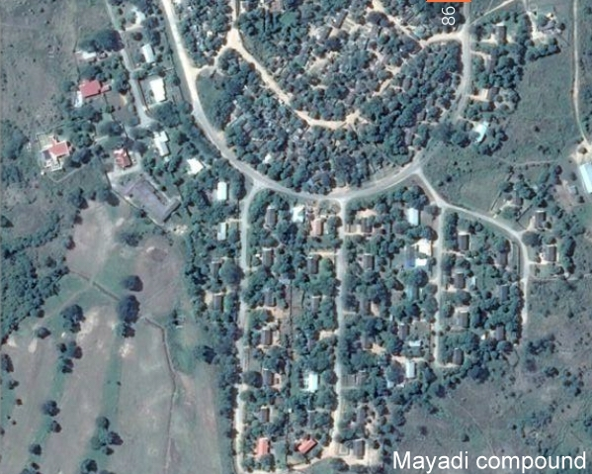 I spent a complete day at one of the hose holds in the mayadi compound, particularly at the Chipaila’s household which is headed by Mr. Isaac Chipaila who is married to Mrs. Judith Chipaila.
- FAMILY BACKGROUND AND EDUCATION
Mr. Chipaila was born 60 years ago in 1956 In a family of nine (9), his mom was a Nsenga from Petauke (she died in 1996 from diabetes) while his dad was from Ndola, his wife turns 59 this year in September and was born in 1957, and together they had 5 children, sadly in 2010 one of their daughters passed away. Of the remaining 4, the eldest is a medical surgeon working at the university teaching hospital UTH, following him is an agriculturist doing his practice in Ndola and then next in line a son studying Bachelor of Economics at Cavendish University in Lusaka, Zambia.
Mr. Chipaila did his primary education in Ndola at Chiwala primary school, he went on to do his secondary (grades 8 – 10) at Chiwala secondary school I the same town. In 1972, his family moved to Matero in Lusaka, he then joined and completed his Grade 12 at Matero boys that preceding year. From 1974 to 1977 he was at the Zambia Institute of technology (ZIT) now called The Copperbelt University where he studied surveying and obtained a degree in surveying. It was the Zambia industrial and Mining Corporation limited (ZIMCO) that brought him to Maamba where he worked for Maamba collieries for 25 year before he retired as a surveyor. His last post was Chief Surveyor
His wife, Mrs. Chipaila went up to Grade Eleven (11) at Matero girls.
- HOUSE STRUCTURE,COMPOSITION AND SANITATION
The family owns a 3 bedroomed house in the mayadi compound of Maamba Catchment area which is about 2 kilometers away from the township. The house is bricked and properly plastered, roofing was done using Asbestos and the main source of electricity is the Zambia electricity supply corporation (ZESCO), among the bedrooms is the master bedroom which is air conditioned. The toilets and bathroom are inside the house, amazingly I noticed is a pit latrine toilet that is about 12 meters away from the nearest corner of the house. The windows of the house are standard and so are the air vents. Most of the yard is dominated by a garden of tomatoes and rape. 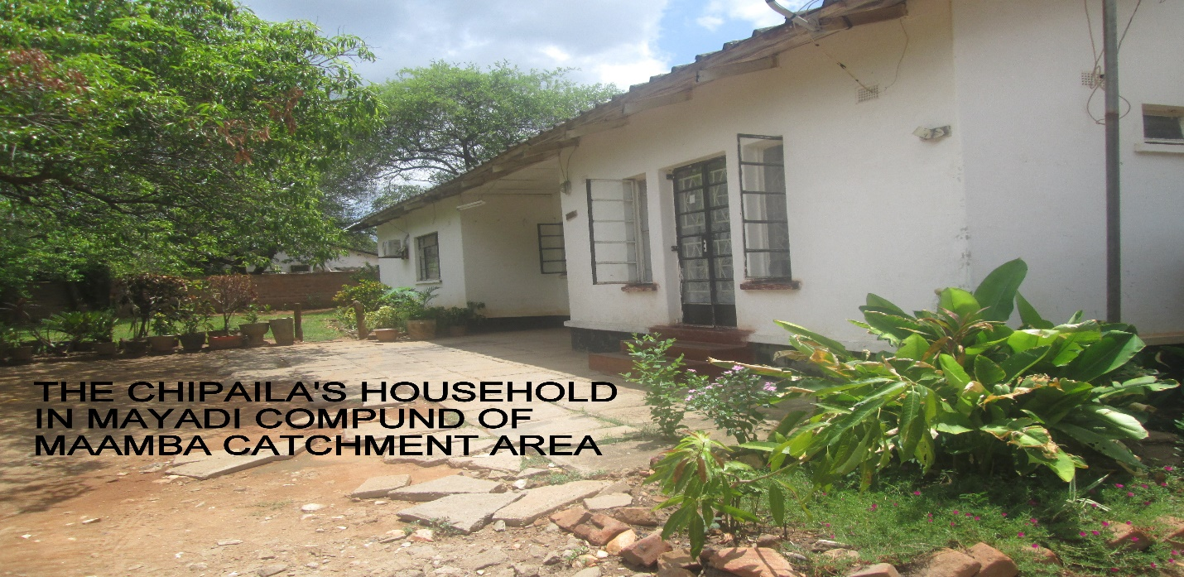
There is a rubbish bin outside the house just near to the pit latrine toilet.80 percent of the water they use is tap water. During my visit at the house, I noticed that the water from the tap was brown with macroscopic particles in it. Mr. Chipaila said that the water is not good for human consumption as ii is contaminated by the mines as such other measures such as boiling and chlorinating the water are a must. He added that water from the taps is periodic as it is only available during in the following hours: 05 – 08, 11 – 14 and 16 – 21.Despite the contamination in the water I noticed that it was used for cooking, bathing, and other purposes.
During their life time, Mr. and Mrs. Chipaila have adopted 3 children (2 girls and 1 boy) thus the house is home to Mr. and Mrs. Chipaila, the three children plus an occasional maid. 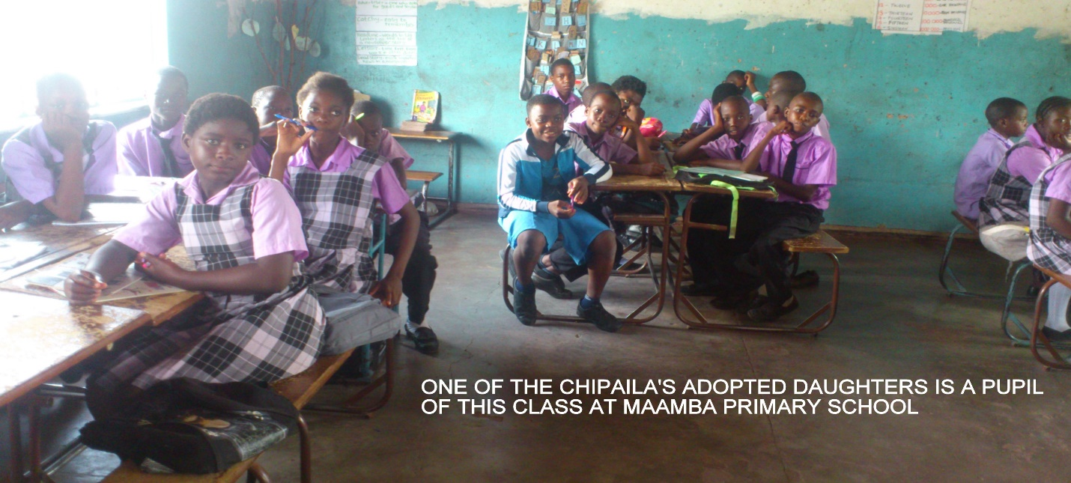
- INCOME AND NUTRITION
Mr. Chipaila retired in 2003, however, together with his wife he manages a shop (Chipaila shop), butchery, bar, restaurant and a lodge. Mrs. Chipaila informed me that she is a full time farmer and does her farming in Kalomo district and harvests on average per season a total of 400 bags of maize which is sold to the food reserve agency and thus contributes to the income of the family together with the money obtained from the other businesses mentioned above. 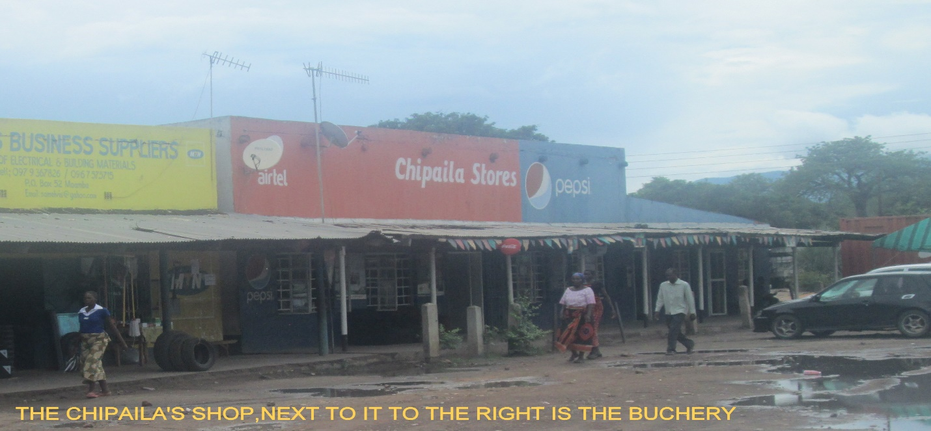
The Chipaila’s manage to have 3 balanced meals in a day.
When I enquired about he manages his finances, Mr. Chipaila informed me that they never make a budget but he confirmed with me that the income comes from the businesses he runs and that the profit money is directed toward the education of his children and nutrition plus managing of day to day house expenditure

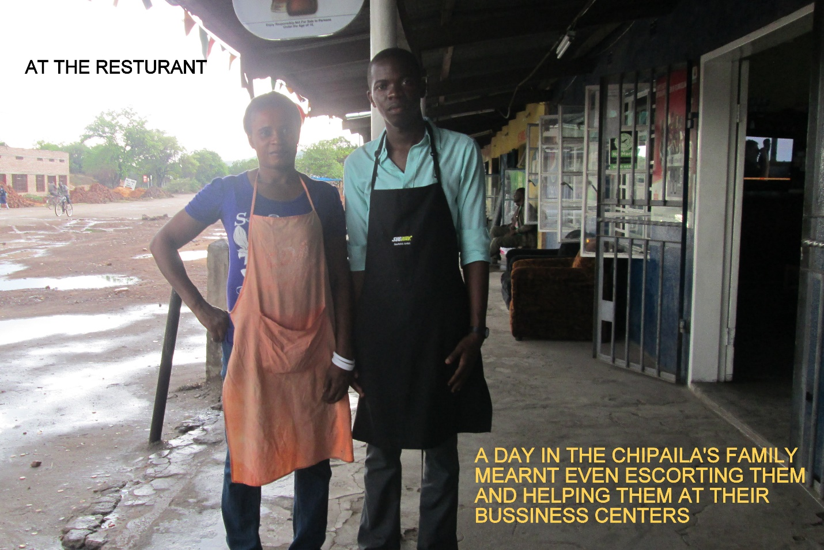
- HEALTH,RELIGION AND RECREATION
Mr. Chipaila revealed to me that he was diagnosed with diabetes 2 years ago, he further added that it’s a family thing as his elder sister and brother were diagnosed with diabetes. During the time of the interviews I noticed that his feet had become rigid due to the disease. He also complained of occasional numbness. I also learnt that he goes to the UTH every month for tablets and insulin injections.
Because of the disease, Mr. Chipaila’s nutrition is different from the rest of the family as it contains more roughage.
Mrs. Chipaila on the other hand told me that she is health and that there is no history of any genetic disease at her side of the family.The family is a Christian family and they go to the united church of Zambia (UCZ) 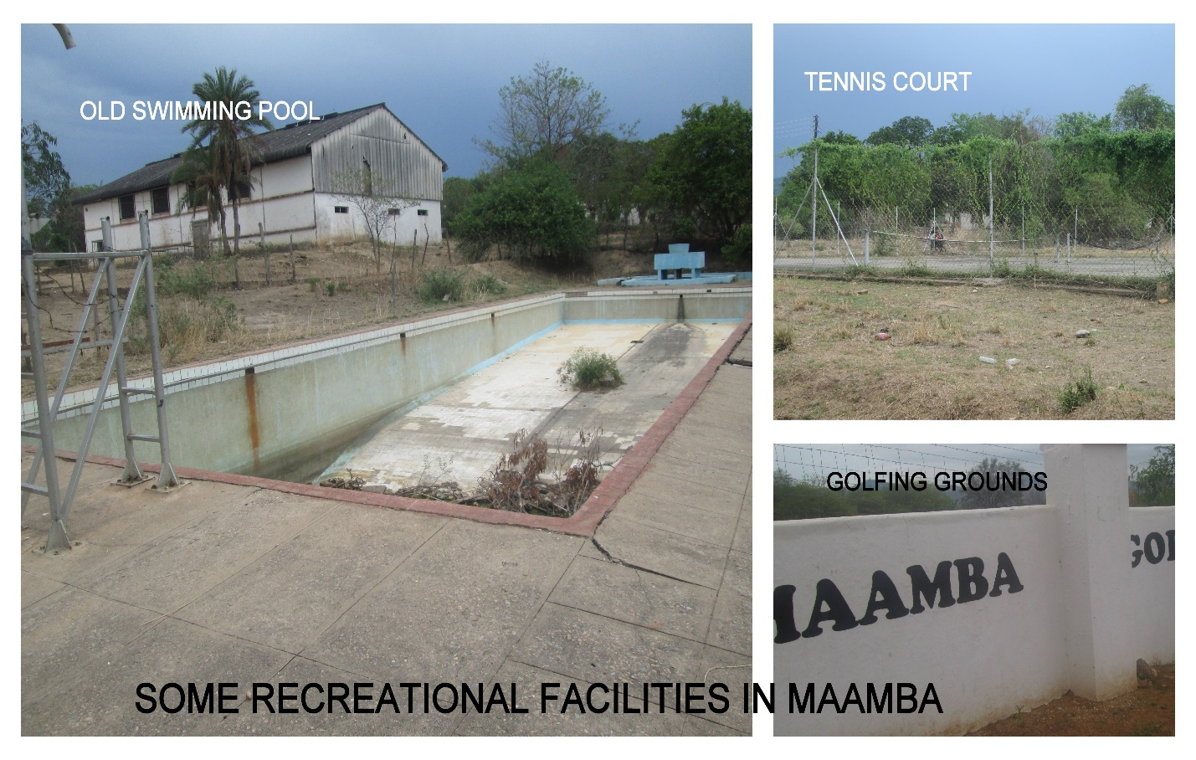
During his free time, Mr. Chipaila used to engage in Beer drinking (stopped due to diabetes), he now uses that time for playing gold at Maamba golf club and squash. Occasionally he watches television with is children.

DISCUSSION

A household was assigned from Maamba community. Much of the day was spend with the family in the hopes of learning their daily activities and life style. And initial interview was conducted to obtain the essential information of the household as aforementioned in the methodology above. Many observation where made and will be outlined herein. In view of ethical consideration and request of the respondent, all names of the siblings and pictures of the house have been withheld
Based on observations, the area had no stagnant water, even after rain fall, due to slight inclination of the topography, thus all water flows to nearby drainages. This reduces breeding grounds for mosquitoes which would explain the why the family has not recorded malaria in recent history. The householders seldom washed their hands after using the toilet and thus this could increase risk of diarrheal diseases. Due to load shedding the family is forced to spend on other means of fuel which financial strain on their income.
Overall it was discovered that the high education level on the guardian had an impact on the socio-economic status of the family. This had affected the family positively as most of his siblings and the people staying at his home are educated and well vest with the issues of health such as washing of hands after using the toilets
The family does afford to have at least 3 balanced meals in a day, this was seen in the meal I was served as I joined them for lunch, 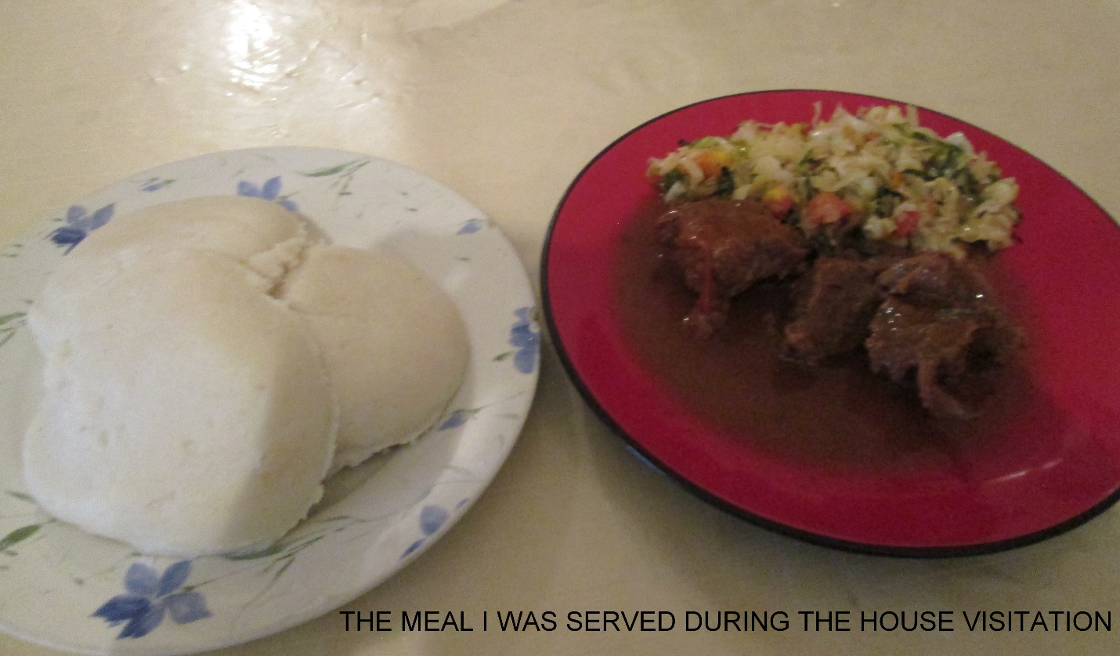and this explains the absence of malnutrition in the family. The house is properly ventilated, this could explain why the members under the house last recorded pneumonia and other respiratory diseases way back in June 2014. The wife demonstrated high awareness of health matters despite her low educational background, she have more than average information on cervical cancer and other viral diseases like Aids and Ebola, she explained further that she was involved with an health committee at the church. Otherwise it seemed all members of the house had access to health care within the means of the family.
I noticed that the outside toilet was not covered and produced a fail which caused air pollution to some extent. The uncovered pit latrine was a source of Musca sorbens, a form of flies that causes eye problems. The other form of flies could be were also a risk to the family as they could be a source for diarrhea diseases like typhoid and dysentery.
Among the adopted children were kids, in another interview with the maid, she informed me of the precautions that were put in place to ensure safety in the house, the measures include: proper handling and disposal of sharps like knives, kerosene and other dangerous substances like drugs were out of reach to the kids.
The family showed intense knowledge in the processing of the dirty water that was supplied by the SWASCO, they informed me that they were aware that the water unclean and that they either boil or chlorinate the water. This is to avoid water borne diseases. The family disposed most of their rubbish waste in the rubbish bin, however when full I was informed that the water is taken to the designated bins that the town council collects periodically.
The Chipaila compound mayadi is close to the Maamba coal mine, this means that the people there are subjected to many sorts of pollutants ranging from gases and chemicals both of which can cause respiratory infections, 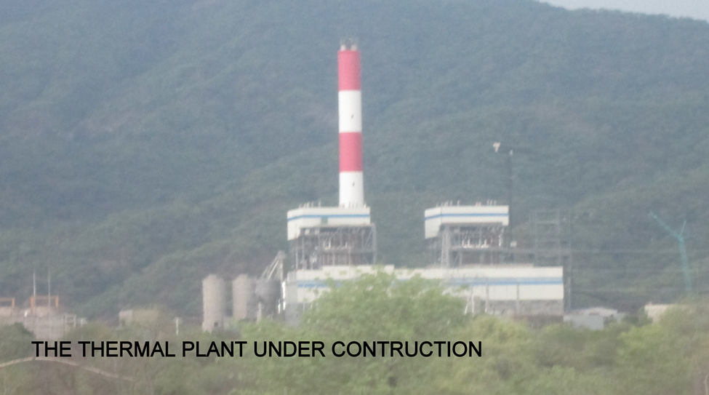this together with the Maamba thermal plant that is under construction (due to the incomplete combustion of coal will release carbon monoxide) will pose a serious threats not only to the miners but to the residents of the mayadi township.
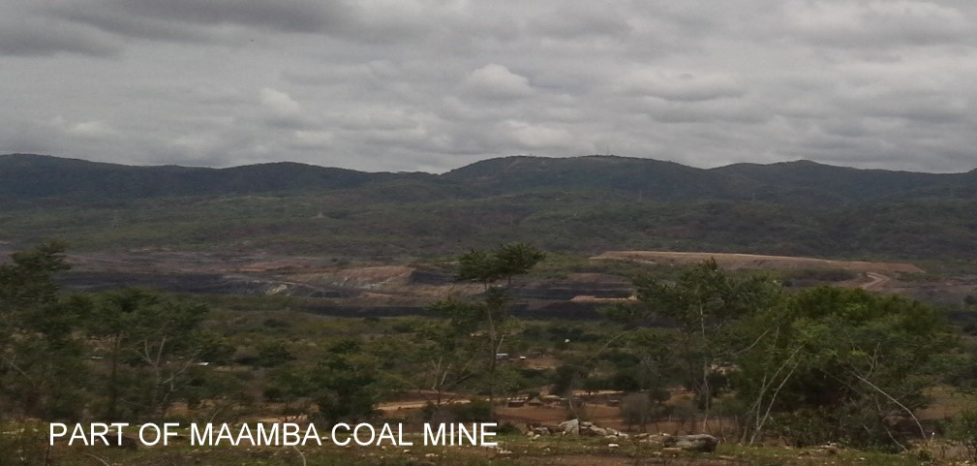
Generally the mayadi compound of the catchment area is habited by most of the well to do people in Maamba, it is because of this reason that the standard of living in that area of Maamba is high and so are the moral and cultural values.

LIMITATIONS AND DIFFICULTIES
A lot of challenges were faced, the main ones include:
- The amount of time spent with the household possibly limited the amount of data gathered.
- Language barrier was also a major limitation. Most of the locals spoke the native Tonga language which made it hard to interpolate and explain fully to them certain parameters such as getting a consent.
- Some medical terms could not be explained to the fullest meaning as they do not have local language equivalents or such terms are considered obscene language in a local sense.
- Due to the sex of respondent full information of the husband could not be obtained as giving such information of the husband is considered a sign of disrespect.
- Some information given by respondent could also be limited, particularly health information as such information may be regarded as strictly confidential
- The distance from the lodging facility to both the hospital and the catchment areas TCA and TCB were long, as such student had to cover long distances on foot which made them tire and partially disabled their activity
- Natural limitations like the hilly topography and the famous scorching sun of Maamba made it impossible to reach to areas in the peripherals of the catchment area.
Other challenges include the disclosure of information from some residents and the unwillingness of the locals to join in on the sensitization activities of the locals

FAMILY TREE
The Next page gives a proper and succinct analytical Family tree of the Banda Vaida.
The tree goes up to six (4) generations

RECCOMMENDATIONS
More information could be obtained if the household attachment was allocated more time 3 days to a week because it was noticed that certain activities like farming and church going were done on special days which unfortunately were not done the day we went for the attachments, thus it is recommended that this part of field work should be allocated more time as it would help in better understand the community.
Limited resources particularly transport reduced amount of households interviewed, thus the information obtained is not a good presentation of the whole community. It is thus recommended that the Department of Public Health consider increasing funding towards field work.
In order to reach more place and beat the long distances, it is recommended that prior to CBE arrangements should be made with the local office and other involved stake holders to provide transport and lodging facilities which are near to the catchment townships.

CONCLUSION
The household attachment offered insight into the daily lives of average household of Maamba community. The major finding was the low socio-economic status of the household, which forces the family to compromise on quality of food purchased. The poor accommodation with poor ventilation that explain the high number on non-pneumonia cases in the household as well as the community at large as revealed by Maamba hospital. The poor sanitary conditions such as the high number of householder accessing a pin latrine could also explain the high number of diarrheal diseases reported to the local health post. The household showed good awareness of health matters and thus accessed these health services. However, cultural belief and possibly background affects the low levels of education among the children in the household. All in all, the poor educational background and low socio-economic status of the family affected their general livelihood

REFERENCES

- Center Statistical Office (CSO)
- Center for Disease Control and prevention (CDC)
- http://www.cdc.gov/flu/
- http://www.cdc.gov/healthywater/global/diarrhea.burden.html
- http://www.cdc.gov/hpv/
- Center for Infectious Diseases Research in Zambia (CIDRZ)
- http://www.cirdrz.org/publications
- Environmental health Department at Maamba Hospital
- Mr. and Mrs. Chipaila +260979152055
- Family tree builder: Family Echo
- http://www.familyecho.com/
- http://www.avert.org
- National Communication Disease Center (NCDC)
- http://www.ncdc.gov.in/index1.asp?linkid=258
- Chief Advisor-Headman Sikalonzo
- The University of Zambia, School of Medicine, Department of public health,
- Lecture notes on Bio-ethics
- Lecture notes on Community Diagnosis, Dr. Rasha Salama
- Lecture notes on Environmental Health, (Mr.) Luke. J. Banda
- Lecture notes on Epidemiology
- Lecture notes on Genetic Disorders, Dr. M. Simuyemba
- Lecture notes on First Aid, Dr. katowa Mukwato .P.
- World Health Organization (WHO)
- http://www.who.int/trade/glossary/story076/en/
- Zambia Demography and Health survey 2007
- Mr. Chisoso Maamba team facilitator.

