
THE UNIVERSITY OF ZAMBIA
SCHOOL OF MEDICINE
DEPARTMENT OF PUBLIC HEALTH AND COMMUNITY MEDICINE

GROUP REPORT ON FEILD EXPERIENCE AND COMMUNITY DIAGNOSIS IN GARDEN COMPOUND.

 | NAME | COMP NUMBER | GENDER
1 | CHIYAYIKA DOREEN | 2017008706 | F
2 | CHOOBE DIANA | 2016144547 | F
3 | DHRUV DARJI | 15020932 | M
4 | FIKWAMO ANTONY | 15008339 | M
5 | FUMPA VINCENT | 14042371 | M
6 | HAKETA M MELISSA | 2016133217 | F
7 | HAMBILIKI REBECCA | 2016136659 | F
8 | HAMUYUNI CHISAMBA | 15008983 | M
9 | KABUNGO PETER B.MS | 15066282 | M
10 | HANEMBO VILLEO | 15014860 | M
11 | CHISHA MEMORY | 15019225 | F
12 | SHAWA NYANYIWA | 15009441 | F
13 | NZAYISENGA S. THERESA | 2016140964 | F
14 | KABUNGO MARSHAL | 15012417 | M
15 | CHISULO MEDSON | 15029492 | M
16 | CHIYAKA LUPANDU | 15053717 | M

OBJECTIVES
To study the public health of Garden compound by surveying selected households with respect to demography, social economic status, environment, sanitation, health and hygiene.
To get an early interaction with families in the community and all categories of health workers at the health center in Chipata compound.
To get acquainted with the skill of data collection, interpretation and research skills.
To learn the importance of teamwork as one of the most important and key ethics of the medical profession.
To find out and evaluate the disease prevalence in the area
To understand environmental factors affecting the community's health
To learn about the various health-related activities taking part in the area both governmental and non-governmental.
To understand the works carried out at the Health Post.
To determine the community’s attitude towards various health services by various people in the health sector as well as those from the private sector.

GARDEN SETTLEMENT

Garden Settlement is an improvement area. It was granted the legal status on 16th
February, 1999 under the Statutory and Improvement Areas Act of 1999.
LOCATION
Garden Settlement lies 5 kilometres north-west of the city centre about 1 kilometre on the
right hand side of the Great East Road towards the city centre. It shares its boundaries
with the following settlements; Northmead to the south, Thorn Park to the south-east,
Olympia Park to the east and Chaisa and Mandevu to the West. The settlement covers a
total surface area of about 3,844,517.78 square meters of flat land. Parts of the settlement
are water logged and is subject to regular flooding.
ORGANISATION
Garden Settlement falls under Ngwerere Ward 19. It operates under the Ward Development Council (WDC), whose major role is to facilitate development and implement developmental projects in the ward. These include security, community sensitizing on health matters, writing
project proposals and delivering ground rental notices to the community. It is divided into 9 zones.
COMMUNITY ORGANISATIONS
These are civil society organizations formed voluntarily by residents with a common
interest and a specific purpose. They include church organizations e.g. SADA, Catholic, UPC Truth Turbanacle Church and many others, women’s clubs/groups, youth clubs/groups and market committees. Red Cross is also a known prominent group in this area.
HISTORY
The name Garden originated from a farmland that belonged to a white lady called Mrs
Emma, where they grew vegetables and fruits, hence the name Garden.
The Settlement started as workers compounds. It consisted of three areas; Garden,
Muntonio and Mutengo (big trees). The areas were farmlands for Mrs Emma, Antonio
(Portuguese farmer) and Mrs Jeffrey referred. The name Garden became prominent
when the United Bus Company (UBZ) introduced a bus to this area and it named the
route as Garden.
Upgrading of the settlement started in 1977 under the Housing Project Unit (HPU) of
LCC. The project was funded by the World Bank. Upgrading meant de-densification of
the area and relocation of residents for infrastructure improvement such as roads and
water system. Residents who were given loans in form of materials worth K700.00 to
improve their houses or building a two-roomed house.

POPULATION
The total population of Garden Settlement was estimated at 42,506, the number of
households is approximately 7,829 and the average household size is 5.4 (LCC, 2006).
The population of the settlement is increasing rapidly due to high birth rates and
immigration of people from other areas (compare CSO 2000 census, appendix ii). The current population stands at 66, 505. The distribution according to the CSO census of 2010 was as shown below:

Gender (C 2010)
Males | 32,911
Females | 33,294

Age Groups (C 2010)
0-14 years | 26,067
15-64 years | 39,311
65+ years | 827

Age Distribution (C 2010)
0-9 years | 17,908
10-19 years | 15,782
20-29 years | 14,676
30-39 years | 10,052
40-49 years | 4,231
50-59 years | 2,068
60+ years | 1488

Urbanization (C 2010)
Urban | 66,205

INFRASTRUCTURE
Due to its unplanned status, the housing infrastructure in Garden Settlement is informal
without layout plans. The yards are very small and the houses are constructed very close
to each other in a poor environment. Though the houses are made of concrete blocks and
iron roofing sheets, most of them are poorly built.
The main roads liking the settlement to the city centre are Garden Road, Manchinchi Road and Katima Mulilo Road. The roads are tarred and are in good conditions, though in some
parts the drainage is blocked with sand and garbage. The inner-settlement roads are
gravel and are in a deplorable state; they are narrow and impassable during the rainy
season.
Water in the settlement is provided by the LWSC and the Garden Water Trust (GWT).
LWSC which is the licensed provider, supplies water through the distribution network of
Lusaka. LWSC supplies site and service areas such as Chilulu, Luangwa and Garden Site
3 and 4. This water supply in the areas under the LWSC distribution network is erratic. According to a survey by DTF (2005) Chilulu hardly receives water; only a few individual connections of initial connections receive water in the evening up to the following day aroud 08:00. Luangwa area also has the same problem although all the taps receive the water in the evening. GWT supplies Old Garden and the water comes from a borehole which also supplies Chaisa Settlement (DTF, 2005). This part of the settlement has fairly continuous supply. The infrastructure is good, but pipes and taps leak because they have been vandalised. Water is supplied through individual taps and communal taps. Individual shallow wells are also common in Garden Settlement due to inadequate water in the area. The wells have water throughout the year, but it is contaminated. The community facilities found in the settlement include Dzithandizene Trades School, two Government Basic Schools, Private Primary and basic Schools, police post, a market and a health post.
The health facility only used to offer antenatal and under five services but as at now, it also offers other medical services such as a vaccination program under the District Health Office and Out Patients Department Services. However, most residents go to Chipata, Mandevu, Chainama and/or University Teaching Hospital (UTH) for further medical services.
The settlement has famous bars and night clubs such as Cork Pit night club. It also has a bank, a market and service stations.

INCOME VENTURES
Most residents of Garden Settlement are involved in informal activities; women are
mainly involved in selling vegetables and groceries in the market and along the street,
working as maids, washing clothes for money, shop keeping and prostitution; men are involved in carpentry, bricklaying, plumbing, water vending, selling groceries, block making,
renting houses and welding.
A few residents are involved in semi-formal employment works such as security guards, mini-bus drivers, teachers, police officers, council workers, health workers, secretaries and clerks.
Some of the common occupations are shown below:

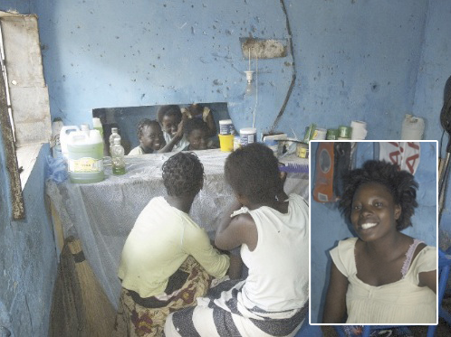
Fig. 1: Local Saloon

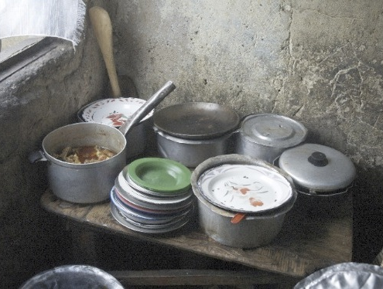
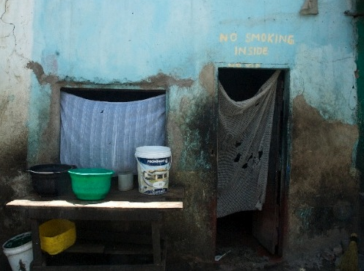
Fig. 2&3: Restaurant

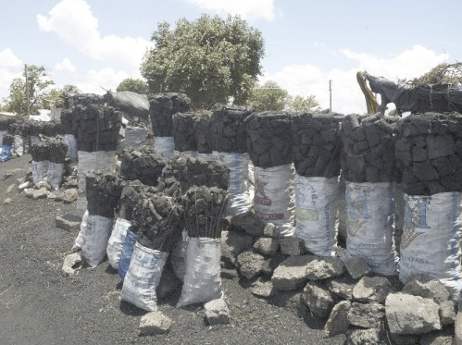
Fig. 4. Charcoal Vending
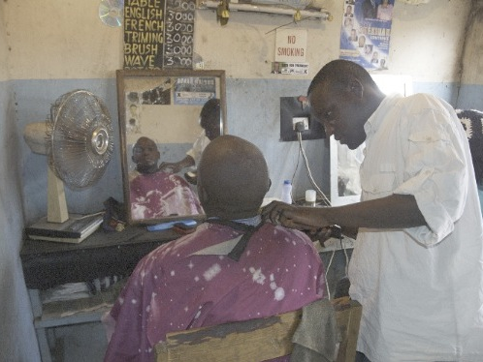
Fig. 5. Barbing Business

ENVIRONMENT AND SANITATION
Most residents of Garden Settlement use pit latrines which are in a poor condition and are shared by many households. A few households have flush toilets connected to the sewer system or individual septic tanks.
Pit latrines are generally shallow and poorly constructed. Some of the residents do not have toilet facilities because they lack space in their yard and some landlords do not provide the facility for their tenants. Residents without toilets use their neighbours or toilets at the nearby taverns and bars. Others use shake-shake packs or plastics for defecation.
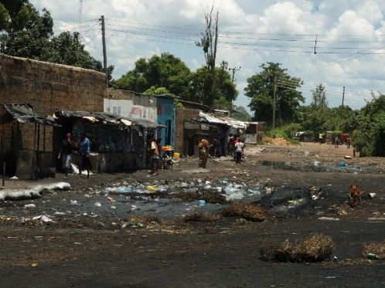
Fig. 6. Surroundings

Solid waste is a big problem in Garden Settlement. Residents dump their garbage in undesignated places like drains, roadside and markets. The garbage blocks the drains and
is also breeding ground for rats and cockroaches. It is also a source of ground water
contamination through leachate.
This compounded with poor drainages subject settlement to regular flooding during the rainy season. This situation causes pit latrines to overflow, emptying its contents in the surrounding areas and water sources, thereby causing serious health and environmental problems. Flooding also causes pit latrines and houses to collapse thus endangering the lives of the residents.
The settlement is situated near sewerage ponds which emit a bad smell. The ponds are also a breeding place for mosquitoes and dead bodies have found floating on many occasions. Children have also fallen into the same ponds.
Houses in Garden Settlement are congested and most of them are poorly built with no
proper ventilation. The room occupancy rate is also very high. Some houses are not
connected to electricity; residents depend on charcoal and firewood for cooking. Thus the
residents are susceptible to hazards such as fire and respiratory diseases.
The residents complain of noise coming from bars, bottle stores and night clubs. Loud
noise from the music played from these places can be heard 24 hours a day. This has
resulted in lack of sleep for residents especially those staying near the bars.
They also complain of the air pollution from the sewage dams in the area. These are waste dump ponds for Lusaka Sewerage Company. Due to these ponds, Garden is home of mosquitos, and burdened with an unpleasant odour continuously.

RECREATION
For recreation, most people spend their time playing sport, clubbing, etc. They benefit from the nearby Red Cross club within the area where they play board games and field games. Others due to lack of activity, occupy themselves with beer drinking, smoking and prostitution. The common beers taken is usually opaque beer and some are locally brewed. Drug abuse and early marriages remain a biggest challenge that parents in the area face.

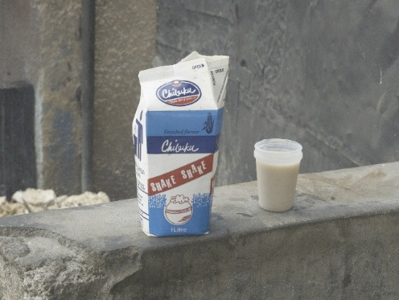
Fig. 7. Opaque Beer.

HOUSEHOLD EXPERIENCE

Various households were visited during the entire period of the CBE with the basic aim to understand and document the characteristics of that household and the challenges they face relating to health. Focusing on day to day budgeting, nutrition, waste disposal, water supply, leisure, work and religion.

METHODOLOGY OF HOUSEHOLD STUDY
Students in groups of 3 were assigned to one household of a day. During the household visit, the data represented below was obtained. The survey was a verbal one, asking questions to household members. The rest of the day of the household experience was spent in helping the house with daily chores and taking part in the average day at that household.

The following data about various aspects of a household was obtained from the households visited;
- SEX OF HEAD OF HOUSEHOLD

- ADEQUACY OF INCOME

- TYPES OF FAMILY

- AVERAGE NUMBER OF MEALS PER DAY

- NUTRITIONAL CONTENTS OF AN AVERAGE DAY’S MEAL

Carbohydrates : Nshima, cassava, sweet potatoes, millet, sorghum
Vegetables : rape, Chinese cabbage, pumpkin leaves , okra, bean leaves
Protein : kapenta, chicken, beef, soya pieces,
- WATER SUPPLY

- SANITATION: WATER DRAINAGE
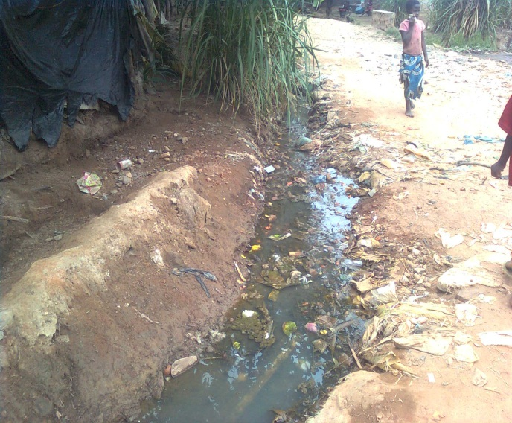
From the various households visited, two examples were taken to demonstrate the various citizens of Garden Settlement.
THE KUNDAS
It was observed that majority of the households in Garden compound are low income households. One of the many households of such kind was that of the Kundas. Their house had three bedrooms and consisted of a family with seven members. Upon the visit, the deployed group of students had an interaction with the head of the house, Mrs Kunda, an elderly lady, living with her grandchildren, who was suffering from high blood pressure and hypertension which had taken a toll on her eyesight. She relied on other family members to assist her with basic mobility around the house.
At first glance, the major challenge the family experienced was a source of clean, running water to the household. Water had to be drawn every day in numerous buckets from the nearest water source. The family’s major source of income was a couple of rentable structures within the premises of the household. Majority of her grandchildren had to pull out of school or pause there studies due to financial reasons, however, the eldest of her grandchildren is currently enrolled at Evelyn Hone College.
After performing some basic chores for the household, it was realized that there was no proper facility for garbage disposal which led to the accumulation of waste, from the household, into a heap just around the corner of the house.

THE BANDAS
On the other hand, among the handful of health conscious families in Garden Compound is Mrs Banda’s.
Mrs Banda is 41 years old, she completed her Ordinary Level of education (grade 12). She is catholic and has 4 children who she has managed to put through school. The first born is working, the second is in college and the last two are still in primary school. She lives with the last 2 children in her house.
Mrs Banda’s family is a middle class family. She has 3 small houses on rent giving her an income of K2000-K2500 per month. She also has a shop on rent for K1000 per month. With these monthly earnings Mrs Banda is able to have three meals per day.
Water and waste disposal are not a problem at her home; she has a direct water supply from Lusaka Water and Sewerage Company. As for the waste there is a special area where she heaps the bags of waste which are collected every Tuesday by the Waste Management Company.
Just like many other residents of Garden Compound, Mrs Banda has observed the following evils in the area;
- High levels of unemployment: It is unarguable that most of the youths in the area have nothing to do but drinking. The high unemployment level has been exacerbated by the fact that whenever there’s a project in the area, workers from other areas are employed while locals are neglected. It was also observed that Garden Compound is one of the areas in Zambia with a high number of drunkard women- indeed women in the area have nothing to do, their plea to the government is that the government should introduce women empowerment programmes.
- Unreliability of the health post: the only health post in the area is unreliable; the only medicine one is sure to find is paracetamol. Most of the times, there is no medicine and the residents feel discouraged to go there when they are unwell as a result, many have resorted to seek healing from the traditional healers who seem to be mushrooming in the area.
- Cold mannerisms of the workers at the health post: There is a loud cry in the area about the unwelcoming manners of the workers at the health post. Residents feel better in the tents of traditional healers than at the health post.
Although it is impossible to depict the diverse types of people found in Garden Settlement using only 2 such examples, it is fair to say that the CBE household experience did given the following general picture about the households of Garden Settlement; Generally the houses visited were in poor state of infrastructure and the number of people living per unit area of the household was too high (on average, 12 people in an average 2-3 bedroomed house. Levels of education are generally low, owing largely to the low level of income. Most households tend to survive on a day to day way of budgeting for their food and necessities due to an unstable source of income.

GARDEN HEALTH POST
Garden Health Post is a primary health care facility located on Manchinchi Road. It is the primary referral and provides basic clinical care for the people of Garden Township.
Garden Health Post caters for Zone 11 and falls under Chipata Level 1 Clinic.

Garden Health Post has the following departments which carry out their respective functions;
- Outpatient Department
- Pharmacy
- Mother-Child Health centre
- Vaccination center under District Health Office(DHO)

OUTPATIENT DEPARTMENT
The outpatient department at garden health post follows basic routine involving the following steps
Registry > waiting > screening > collection of drugs

Registry
The patient first goes to the registry to obtain a book if one was not previously obtained the book itself costs about 5 kwacha, the records of the book number are kept in the ministry of health log book for garden compound and the patient is given a card on which the patients name, age and log book number are recorded.
For returning patients they present a card and the books are pulled out from the archives. The books are then taken to the clinical officer’s office or the nurse on duty.
Waiting
The patients wait in the waiting room for their names to be called out in a systematic manner based on a first come first served basis.
Screening
During screening the temperature of the patient is first recorded and then the patient is told to present their symptoms, these details are recorded in the patients book and a prescription is then given.
It is important to note that screening is done separately for the children under five and the adults.
Collection of drugs
The patient then takes the prescription to the pharmacy and the drugs can be obtained. In the case where a patient has to obtain their own drugs they are given an official transcript with a stamp.
The book is then returned to the registry and the treatment and diagnosis are the ministry of health book.
From the outpatients department, the following data about the patients was received:

PHARMACY

Garden health post pharmacy is structurally not independent as it shares the small space available with the ART department due to lack of infrastructural development and it is also not functionally independent as it is under Chipata level 1 hospital hence the availability of drugs at this facility is dependent on the hospital’s supply of drugs from the government which in most instances is not adequate as the hospital also carters for a large population.
Due to indirect supply of drugs to the pharmacy by the government, the facility from time to time as a shortage of drugs sometimes for a few hours and other times even few days. This was observed during the time spent at the pharmacy, about 4 out of every series of 5 people who were referred to the pharmacy to get drugs had at least one drug they had to get on their own. This poses a big challenge on the people of the community most people even opt to stay home than visiting the facility because of this challenge.
The facility almost entirely depends on the government except for a few times when drugs are donated by non-governmental organizations (NGOs) but this is not consistent and only happens once in a while.
Despite the challenges faced in this department there is a very good work culture and the personnel are always gladly serve people with the limited resources they have. There are two health personnel managing this department. It has very good ventilation and moderate temperatures for drug storage. The two health personnel are enough as they deal with a very small population or a small turn out of people at the facility.

MOTHER CHILD HEALTH (MCH) CENTRE
The MCH at Garden Health Post is a very active department. It carries of the following activities;
- Antenatal Checkouts
- Postnatal Checkouts
- Under 5 care
- Family planning
- Male circumcision
The MCH is headed by 2 nurses that a vastly experienced in the field of mother cold health. The working relationship observed by the nurses towards their patients was excellent and very interactive. They were very welcoming and taught the group of students all they could in such a brief period.
One of the few problems that was noted affecting not only the MCH but also the entirety of Garden Health Post was the environment. As stated earlier, the facility is located within a semi-industrial car park, there are many cars, car spare parts and junk metal pieces from the surrounding welders that prove to be a health hazards, particularly to pregnant women. These factors are especially dangerous during under 5 sessions which are attended by several women and young children.
VACCINATION CENTER
Of the three buildings belonging to the health centre, one is a vaccination centre. This centre is actually an individual clinic reporting directly to Lusaka District Health Board. It is known as Lusaka District Health clinic. The clinic has 3 employees; 2 nurses and 1 cashier. With these numbers, the workers are comfortable with the man-power that is available. The clinic is mostly supported by Lusaka District Medical Office and Rotary Club of Nkhwazi.
The clinic offers vaccination for Yellow fever, Hepatitis A, Hepatitis B, Typhoid, Rabies and Meningococci (disease causing meningitis). Of all these vaccines, Yellow fever and Rabies receive most clients. The patients that come for these vaccines are of equal genders and the numbers vary according to the time of the year. Usually there is a hike in numbers during the last quarter of the year when students desire to study go for studies abroad. The patients get the Yellow Fever at the clinic for K300 but these other vaccines must be bought from somewhere else and administered at the clinic. Anyone from Lusaka district that requires these services is entitled as there is only one clinic of its kind in the district.
We discovered that there isn’t much sensitization of this to the clinic as it has been left to the district and people only come to its knowledge when they need to travel or have been bitten by a dog. We also discovered that there is no sign post to direct people to the location of this clinic hence, everyone that came would ask if they were at the right location.
We were told of a few challenges by the workers of this clinic. One was that many patients come with expired vaccines and have to repurchase the vaccine. There is also a challenge in storage of vaccines as there is only one refrigerator. Many patients also tend to throw the ice designed to preserve the vaccines so they come with ineffective vaccines at times. Another challenge was insufficient space in the clinic resulting in only a sitting space of 2 people at a time. This has also led to lack of privacy for the clients/patients. Further, most of the vaccines here are expensive and hence the low income and poor families do not usually access them. The mostly accessed vaccine is the yellow fever vaccine. This is mostly by individuals who would want to travel abroad to countries where it is a requirement.

PROBLEMS FACED BY GARDEN HEALTH POST
Apart from the very obvious environmental problem that was discussed above, there were a few other problems that were noticed during our visit to the facility.
Garden Health Post only has 2 functional toilets for the public with are actually a very poor sanitary state. The facility receives on average 50 patients (not including the persons that my accompany patients) and in such a case, these toilets are actually a health hazard to the people. Furthermore, water availability is a problem at the facility. The health post does have a well and hand pump system but this remains closed most of the times, reason being that people misuse and break the hand pump system when availed for public use. Thus, general workers full up a drum near the toilets for water use, a practice not performed adequately well, resulting in water unavailability for people who need it after using the already hazardous toilets.
The health post has limited space and this is a challenge to health workers and patients as there is no space to conduct private examinations and if need arises, there is a lot of moving of furniture to create the private room. This deters patients and sometimes discourages workers to freely converse with patients as their privacy is compromised.
Lack of reagents and chemicals used in various texts has also been a serious issue for the health post. Most tests cannot be conducted in this place as they lack most reagents. The only tests conducted are malaria, syphilis, HIV and urine analysis. These however still quickly run out and patients are usually referred to Chipata first level hospital.
Another problem that was observed at the facility was the complete lack of Methylated Spirit, a basic need for clinics. The implications of this problem were that the staff could not sterilize instruments such as thermometers that were used from one patient to another (this could easily lead to transmission of certain infections). Furthermore, tests involving drawing blood e.g. HIV testing, could not be performed.
The issue of Methylated spirit unavailability was addressed by the student group as we donated 5lts of Methylated spirit.
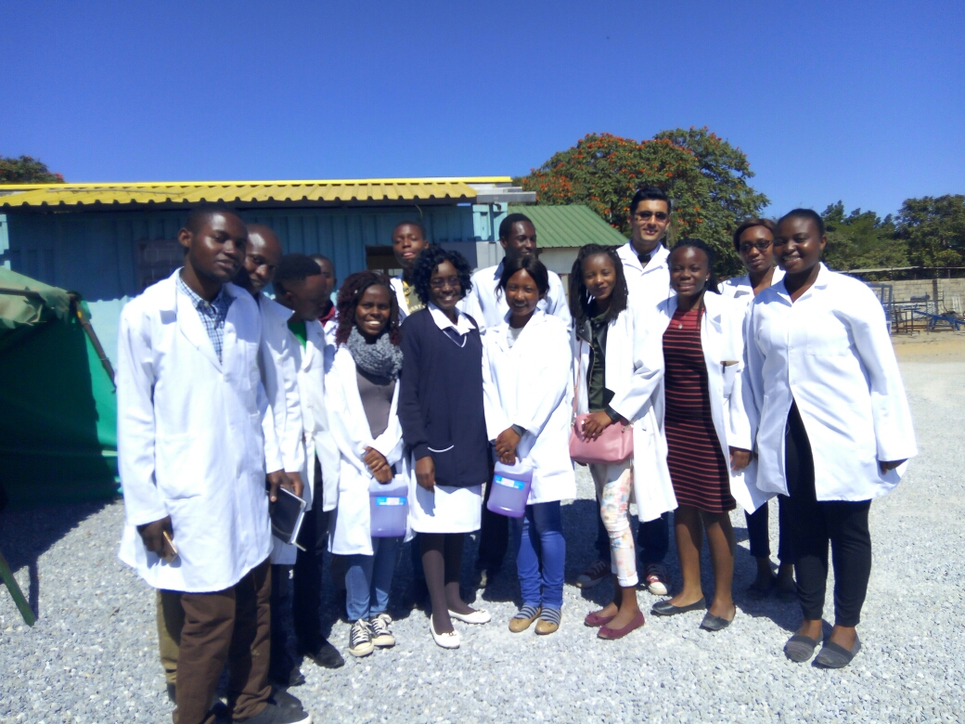
Fig. 8 Garden township group donated Methylated spirit to the Health Post

PROBLEM IDENTIFICATION AND SOLVING

Divided into two groups, we paired up and collected data from individuals on the street, market place, household, bars and barbershops. There was no particular pattern of navigation during this process of data collection. Basically, we headed in one general direction and randomly asked questions from individuals in aforementioned places.
However, there was a general pattern that emerged in regard to the questions asked that pertain to things such as sanitation, employment levels, job opportunities, family planning and common disease and also the life style.
To start with, employment levels were found to be critically low. For example, only 40 percent of the population was employed and the majority of these were women. When we asked for the causes of the low employment levels, lack of job opportunities and low minimum wage were the common answers. Others also complained about prolonged unpaid days, need for a recommendation in order to get a job and also short term employment.
Based on observation and also according to the answers given by individuals, the common disease found was upper respiratory infection, which is true and correlates well with the poor sanitation levels along the roads and in individual yards and households.

      - CONDOM DISTRIBUTION

Condom promotion and distribution is one of the key intervention areas for the national HIV response as part of its commitment to reducing new infections. This intervention area will promote an increase in distribution of both male and female condoms and in the intensification of education and awareness-raising. The priority is wide-scale information sharing about the benefits of using condoms and their correct use every time a person has casual sex or has multiple concurrent sexual partners.
This also promotes the condom as a family planning method and for use in stable relationships among sero-discordant couples. Based on evidence and programme experience, there are significant disparities in access and condom use among sexually active age groups. The condom use has been relatively low amongst the age group 15 – 24 years and sex workers. This highlights an important challenge that requires improving condom programming to reach these population groups.
The efforts to increase condom availability, accessibility and use, which is key towards HIV prevention in Zambia. According to the National AIDS Council of Zambia. Provinces with the highest HIV prevalence rates, including Lusaka (16.1%), Western (16.0%), Copperbelt (14.2%), Southern (13.4%) and Central (13.4%).
Although Zambia has demonstrated that the HIV epidemic has been stabilized - as noted in the decrease in HIV prevalence rates from 15.6% in 2002 to 11.6% in 2016, as well as reduction in the rate of new infections by 41% - Zambia still ranks among the 10 countries globally with the highest number of people living with HIV and AIDS with 46,000 new HIV infections in 2016 alone. The prevalence of HIV among women aged 15-59 remains unacceptably high at 14.9% compared to their male counterparts at 9.5%, with disparities being most pronounced among young adults aged 20-24, where it is 4 times as high among females (8.6%) than males (2.1%).
The low condom use is among the key drivers of HIV infections in Zambia, especially among young people where only 40% of girls and 49% of boys aged 15-24 used a condom at last high risk sex according to the 2014 Zambia Demographic and Health Survey. Increasing condom availability, accessibility and use is therefore critical in a comprehensive and sustainable approach to the prevention of HIV and other sexually transmitted infections (STIs), and are effective for preventing unintended pregnancies respectively.
With regard to the above information, the crew was compelled to communicate to the community about condoms, primarily aimed at,

- To see the knowledge garden people have on condom usage and proper application

- To educate garden community how to properly wear a condom

- To evenly distribute condoms to the community and sex workers at large

Knowledge about condom usage
Generally the knowledge people expressed was good but a little bit misaligned in that the application was abused. Majority of people talked to expressed abuse of condom usage. Among men many said that they put on more than one condom during sexual intercourse. This is because in case one bursts another can still hold the semen .Some even claimed that if two condoms are worn it reduces the chances of getting in infected. The majority of females did not know how to wear a female condom this is because female condoms are rare in community chemists and general distribution.

PROBLEM SOLVING

The community was properly educated on how to wear a male condom and how to put on a female condom. People talked to was the general public and sex workers who surprisingly showed utmost interest and were eager to learn. The crew made it a point to the community on the following;
- To check the expiry date before use
- To note the side that should be inside or outside
- To hold the tip of the condom when rolling backwards as to prevent air bubbles which might cause bursting resulting in unwanted pregnancy.
- Not to abuse condoms by putting on two or double, both sexual partners putting on condoms.
- Condoms were distributed at last.
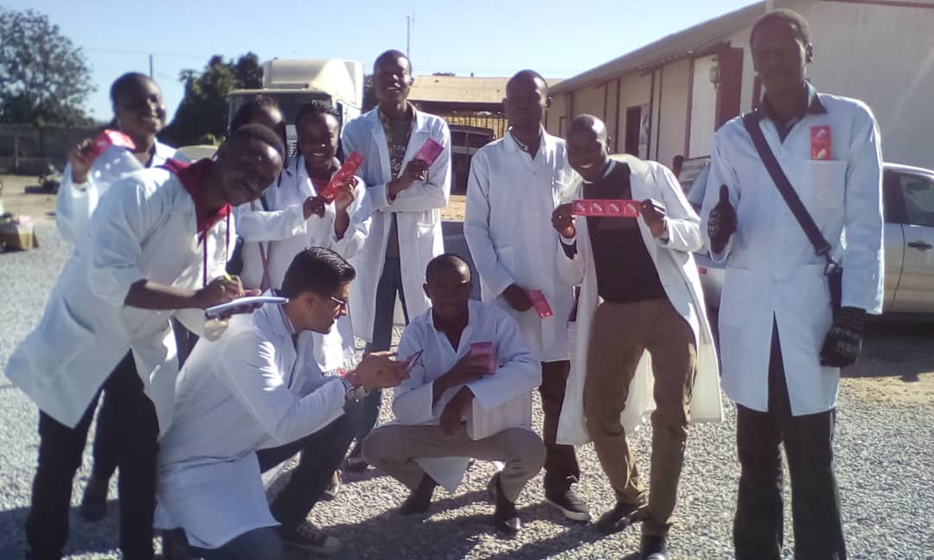
Fig. 9. Condom distribution team

Outcomes of the condom distribution;
- The people appreciated that condoms can not only be used in disease prevention but also in unwanted pregnancy prevention and in reducing abortion rates.
- People now understands that it’s not condom incompetence that causes bursting of a condom but lack of proper use, expired ones and abuse of condoms.
- The community now appreciate the use of condoms since some shunned that condoms were painful during intercourse.
- The community is now fully aware that disposing of used condoms in flashing toilets cause blockage resulting in sewer linkage. 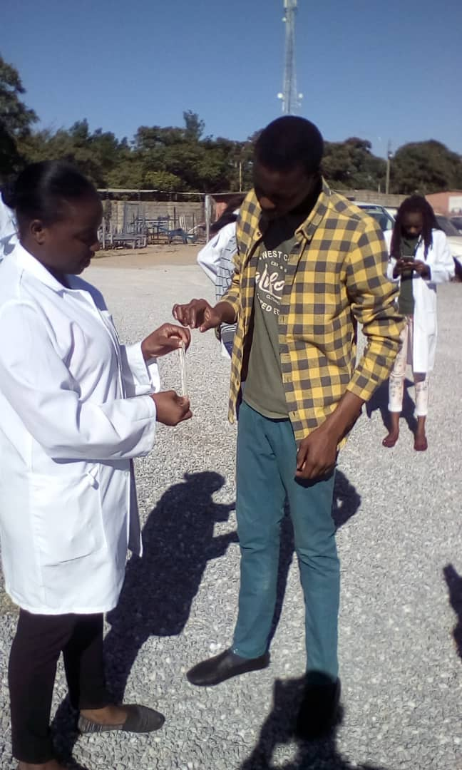

During condom distribution, educational talks on the usage and a campaign for male circumcision was done. Both men and women showed a genuine interest in learning about condom use and receiving the condoms but women showed keen interest in learning on female condoms. It was noticed that most women complained of the complicated nature of the female condoms. During the distribution and education exercise, it was noticed again that the majority of the residents had little or no information on how to properly use and dispose the condoms. This is a health hazard which could contribute to spread of many STIs. Most of the young pregnant women found were interviewed and most confessed that they were not in schools due to pregnancy and lack of funds. Most of them did not know the men responsible. This is because most of the women starting from an early age indulged in premarital sex and some used it as a source of income. To curb this problem, our team carried out talks with the ladies on how to avoid unplanned pregnancies and other STIs that could arise from the casual sex. Residents were seen to have had no information on the availability of the condoms at the clinic and some opted to buying when there was need. This was a challenge for those who could not afford hence leading to problems such as unwanted pregnancies, spread of STIs, and many others.

      - CERVICAL CANCER
It was responsibility of the group during community assessment to carry out a survey about the knowledge of cervical cancer amongst the people of Garden Settlement.
The basis of the survey was an article by the Centre for Infectious Diseases Research in Zambia (CIDRZ). One of the studies carried out by CIDRZ in 2005 at UTH was pertaining the prevalence of cervical cancer in HIV+ women and it was found that a fifth of the women had cervical cancer and almost a third had precancerous lesions.
Addressing to these problems, CIDRZ established the Cervical Cancer Prevention Programme in Zambia. It included a rapid screen and test method with involved inspection with Acetic Acid digital cervicography, a low cost and nurse led procedure. Treatment (cryography) was also available on site while advanced lesions were referred to the nearest General Hospital for Loop Electrosurgical Excision (LEEP).
The above were a few of the ideas from CIDRZ that triggered the survey about cervical cancer knowledge amongst people of Garden Township.
The survey was a very interactive and verbal one, carried off with the aim of finding out the following;
- Knowledge of cervical cancer
- Knowledge about the relation between HIV status and cervical cancer susceptibility
- Knowledge about the various practices that lead to cervical cancer
- Knowledge about cervical cancer screening and treatment methods.
The following data was obtained from the general survey.

Knowledge about cervical cancer
Most men and women didn’t know what cervical cancer exactly was, a decent number had, however, heard about it.
Generally, women didn’t know what exactly cervix is, neither did they know the implications of cancers. The general lack of knowledge could be associated with the low levels of education as 80% of the people talked to were school dropouts.

Knowledge about the relation between HIV status and cervical cancer susceptibility
HIV was a universal problem that was brought up in almost all conversations held with the people talked to. The rates of HIV/AIDS were very high and people had a very bad mentality about the disease, as quoted from a young man who was interviewed ‘HIV is just like Malaria.’ It was observed that the people of the township, especially the youths were very unbothered by their HIV status and its effects to the community.
This problem puts women at a much higher risk of contracting cervical cancer (as shown by the research of CIDRZ in 2005, relating HIV to cervical cancer). Furthermore, women were involved in many unhealthy practices that also lead to the cancer, a few are;
- Use of snuffs like ‘nsunko’ (used to arouse sexual feelings) which have been proven to have direct effects on the cancer of cervix and other cancers (e.g. of the lung)
- Multiple and early pregnancies due to poor family planning.
Not only women, but also the men of Garden Settlement have mentalities and practices which influence the rates of cervical cancer:
- High rates of unemployment, leading high levels of sexual abuse
- Unhealthy sexual practices. These include not using condoms or using condoms incorrectly, as well as not indulging in foreplay prior to sex which brings the risk of condom breakage.
- Men also have a bad perspective about Male circumcision (MC). Men feel they will become totally immune and thus tend to start abusing sex. On the other hand, many men have ill-view about the MC such as, it will reduce fertility and their sexual dominance and thus do not go for MC.

Knowledge about cervical cancer screening
It was generally poor. This is likely due to the general lack of knowledge of the cancer. Not a single woman interacted with had ever gone for cervical cancer screening, despite there being free screening offered at Chipata level one clinic.
This problem is likely due to the sensitisation programmes. People of the community had never before been sensitised about cervical cancer.

PROBLEM SOLVING
The issue about the lack knowledge of cervical cancer amongst the people of Garden Settlement was addressed by us as we organised a 3hour session about cervical cancer sensitisation in the OPD at Garden Health Post. Almost 50 people were thoroughly sensitized about the disease.
The following issues were strongly emphasized during the talk:
- Definition of cervical cancer
- How it is contracted e.g. description of the Human papilloma virus (HPV)
- Relation of cervical cancer to HIV
- Practices among men and women that lead to cervical cancer i.e. causes other than HPV
- Signs, symptoms and general implications of the cancer
- Knowledge about screening, vaccination and treatment.

Outcomes of the cervical cancer sensitisation talk:
- Men and women were had a thorough understanding of the cancer
- Many women turned out very interactive, especially with the signs and symptoms of cervical cancer. The asked many questions relating to issues like pain during/after sexual intercourse, abnormal bleeding etc. which are typical signs of the disease.
- Methods of avoiding and treating the disease.
- Most women said that they will go for at least one screening session per year and it was emphasised that they spread the message to other women.
- Men were encourage to go for MC, to use safe sex practices (e.g. appropriate use of condoms) as well as to encourage women in their families and communities to go for cervical cancer screening.
- Women were encouraged to go for cervical cancer vaccination.
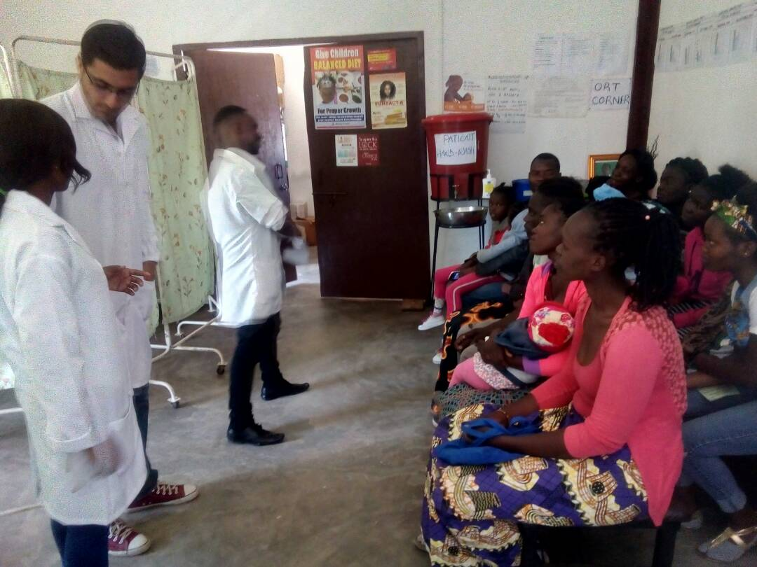
Fig. 10. Cervical cancer sensitisation talk.

Other health related problems in Garden Settlement

From the demographic information at Garden Health Post (Data Table OPD), it was noted that women are the ones who frequently access the clinic from the age group of 15 – 35 years old. This kind of reckless conduct exhibited by women such as excessive alcohol drinking and multiple sexual partners as mentioned on the onset, accounts for the high ratio of clinic access of women to men.
Among the problems identified, condom distribution, educational use on usage and a fervent male circumcision campaign was the only solutions offered effectively by our team. Thus, a proper garbage disposal and collection mechanism would go a long way in restoring sanity to the cleanliness of the community and lessen the health hazards causing diseases such as upper respiratory disease.
Construction of decent drainages and a well organised allocation of space can be of meaningful importance to this area and the people at large because it would not only contribute to the general cleanliness of the environment but also the health hazards would be alleviated because the community lacks drainages and garbage disposal was very poor as it was done in the roads. In addition, the houses were too close to each other with very small yards, hence it was difficult for individuals no to catch flus or airborne diseases easily. The poor roads observed were also a contributor to upper respiratory diseases because each time wind blew or when people were moving, dust was being released.
Building of roads and a proper market place or infrastructure would also be a solution to prevent people from stalling along the road side and it would also stop people from doing businesses within their homes because this made roads smaller and it was also observed that houses were very close to the market place or almost within the market place.
It can be concluded that most problems encountered by this community are due to failed parenting strategy, poor family planning and lack of self-actualization by individuals. People do not really have a good understanding of the benefits of good health and a clean surrounding and how the two are related. If the moral fibre of the society can be restored by encouraging women to abide in their homes unlike beer drinking early in the morning, the values, dignity and better health of the community can be re-established.

RECOMMENDATIONS.
There are quite a good number of things which the relevant authorities can work on to help improve the state of the environment
The government should build more schools in the area to reduce the illiteracy levels. This would also help reduce levels of drug and alcohol abuse by youths and early pregnancies.
Also putting up more sensitization and awareness programs to ensure that residents have enough information on how to prevent and manage most of the common diseases.
The Government should introduce empowerment programs in the area aimed at improving the economic status of members of the community which in turn would help improve their access to health care.
Setting up of empowerment programmes fpor women.This would also reduce poverty as most women would be able to benefit hence support their families
Setting up of recreational facilities which would occupy the youths hence reduce on the careless drinking and prostitution hence reduce spread of STIs and reduce dependence on drinking for recreation
The local council must get more involved in controlling the construction of houses in these areas so that there can be a proper pattern less overcrowding.
Also the council can help them set up proper drainage system sin the community.
The Government, through the Ministry of Health must supply the health post with more chemicals and drugs which will make it safer and cheaper for members of this community to access medical care.
In order to increase community's knowledge on diseases such as STIs, cervical cancer and many others and on family planning, community awareness programmes can be carried out regularly in order to reduce their spread and encourage family planning.
Increase availability of running water to reduce spread of water born diseases through contaminated drinking water.

REFERENCES

      - Markovic, N. and Markovic, O., (2008), What Every Woman Should Know About Cervical Cancer, 1st Edition, Springer Science and Business Media, Maryland, U.S.A.
      - Centre for Infectious Diseases Research in Zambia (CIDRZ), (2018). Cervical Cancer. [online] Available at: https://www.cidrz.org/cervical-cancer/ [Accessed on 14th June, 2018].
      - Central Statistical Office (CSO) (2018), 2010 Census of Population and Housing: Analytical Report, Central Statistical Office, Lusaka Zambia.
      - Devolution Trust Fund (2005), Baseline Study for Water Supply and Sanitation in Lusaka, DTF, Lusaka
      - Lusaka City Council (2006), A Report on the Status of Unplanned Settlements in Lusaka, LCC, Lusaka
      - University of Zambia (1999), A study on the Environmental Improvement of Unplanned Settlements in Lusaka, JICA, Lusaka

