INTRODUCTION
Kabwata community is located in Lusaka, the capital city of Zambia. It is located southeast of the city center. Kabwata community is a medium-to-densely populated residential area. Kabwata is popular with tourists because of the Kabwata cultural village which has old traditional grass-thatched huts where craftsmen and their families converge from all over the country to make crafts goods to sell to tourists. Kabwata since the last census has a population of about 120,875, and the majority of them are in the youth or middle-age categories. The mean household size is six people. Almost half of the houses are female-headed, and these generally represent the poor proportion of the population. The majority of the population has attended school but only two-thirds of that group completes secondary school. Education up to this level is rarely sufficient to obtain entry to formal employment.
The population of Kabwata is comprised of civil servants, other employed people, retired, retrenched, unemployed and traders. Households living in the Kabwata rely on incomes from employment and trade but the majority of households are involved in informal employment, with a significant number involved in informal trading activities. Informal employment activities consist of traders, small producers and a range of casual jobs which include vendors of vegetables, fruit, meat, fish, snack foods and non-perishable items such as clothing, soaps and cosmetics and electronic goods. Others have small workshops and repair bicycles and motorcycles, recycle scrap metal, make furniture, stitch shoes, weave cloth, and make and embroider garments. The majority of women sell or produce goods from their homes; stitching garments, weaving cloth, embroidering textile goods, making crafts, processing food or running a salon. Other informal employment common in Kawabata includes casual workers in restaurants, security guards and gardeners, and temporary office helpers. Household income for almost 70 per cent of households is less than ZMK500, 000.00 per month. Approximately 45 per cent of household expenditure is on food and 12 per cent on housing.
Kabwata has fairly modern residential buildings that were built soon after independence in 1964. They include high-rise flats built by the National Housing Authority and residential houses. The population of Kabwata is high due to public amenities such as a market, major tarred roads, cheaper housing accommodation, piped water and sanitation facilities. This set-up offers opportunities for informal employment and trading. The most common and visible services offered through the local council authority include maintenance of markets, periodic maintenance of roads, cleaning and maintenance of drains, maintenance of bus shelters, and refuse collection. The community has piped water serviced by the Lusaka Water and Sewerage Company, but the source is erratic. The community also has a sewerage system used in liquid waste disposal, although it requires some attention or maintenance most of the time. There is fairly good public transport. The major roads linking to the community are tarred; however, the residential roads are quite poor, making certain areas of the community such as Kabwata site and service inaccessible, especially during the rainy season. There is enough installed electric power capacity such that any household can be connected without problems.
There is a government clinic called Kabwata clinic. Located along Burma Road, P.O Box 37136, Kabwata, Lusaka, Zambia. The healthy center offers services such as:
- Maternal and Child Health(MCH)
- Antiretroviral Therapy (ART)
- Outpatient Department Treatment(OPD)
The quality of services is adequate, but the biggest challenge is that the clinic is understaffed. The supply of drugs has been satisfactory; the kit supply has been supplemented by district purchase through grant funding. Mortality rates are low, the main causes of death being malaria and AIDS-related conditions.

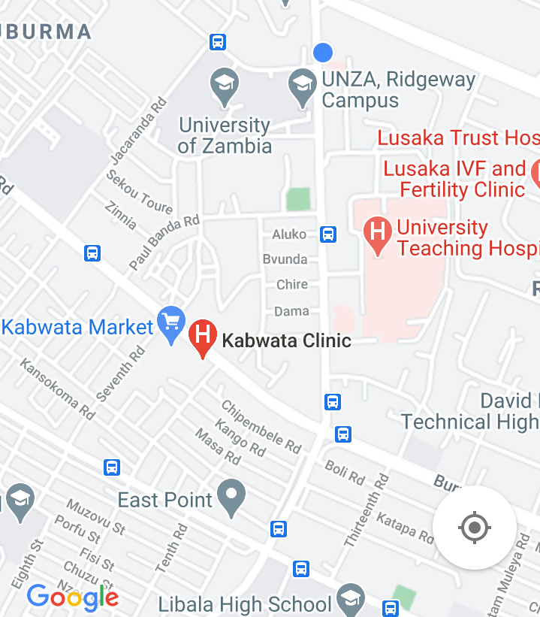

Kabwata is a constituency of the National Assembly of Zambia. It covers the Lusaka suburb of Kabwata, Libala and Chilenje in Lusaka Province. The Member of Parliament (MP) for Kabwata constituency is Honorable Given Lubinda and a councilor is Mr Longa G Chiboboka.
REFERENCES
1. Simon, David J.; Pletcher, James R.; Siegel, Brian.,eds. (2008). “National Citizen’s Coalition (NCC)”. Historical Dictionary of Zambia. African Histological Dictionaries. 106(3rd edition). Metuchen, New Jersey: Scarecrow Press. Pg. 333.
2. FEWS NET (2011) Zambia, http://www.fews.net/docs/Publications/Zambia_OL_2011_10.pdf
(Accessed 20 May 2013).
3. Ministry of Health (2005) ‘National HIV/AIDS/STI/TB Policy’, June 2005.

