EEE3352 ASSIGNMENT 3
(Where appropriate, assume μ₀ =4π×10⁻⁷ H/m)
- From the magnetisation curve for mild steel, derive the curve of relative permeability against magnetic field strength. From your graph determine (a) the value of μ_{r} when the magnetic field strength is 1200 A/m, and (b) the value of the magnetic field strength when μ_{r} is 500.
- A mild steel closed magnetic circuit has a mean length of 75 mm and a cross-sectional area of 320.2 mm².A current of 0.40 A flows in a coil wound uniformly around the circuit and the flux produced is 200 μWb. If the relative permeability of the steel at this value of current is 400, find (a) the reluctance of the material and (b) the number of turns of the coil.
- Figure Q3 shows a ring formed with two different materials— cast steel and mild steel. The dimensions are:
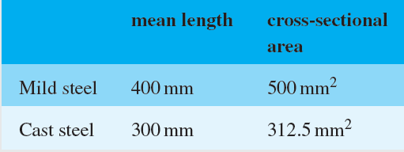
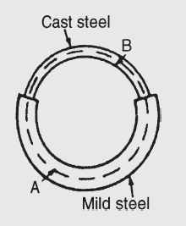
Figure Q3
Find the total m.m.f. required to cause a flux of 500 μWb in the magnetic circuit. Determine also the total circuit reluctance.
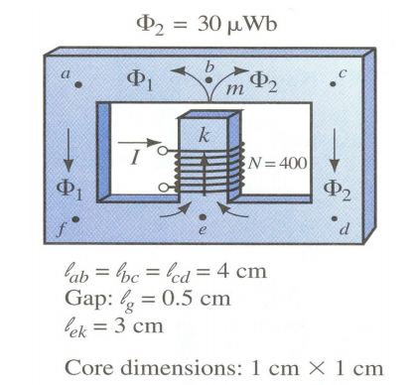
- The core of the magnetic device as shown in the figure below is made of cast-iron and it is symmetrical both left and right arms. Find the current I that is needed to establish a flux density of 30 $μ$Wb at the right arm of the core.

- Figure Q5 shows the magnetic circuit of a relay. When each of the air gaps are 1.5 mm wide, find the m.m.f. required to produce a flux density of 0.75 T in the air gaps.
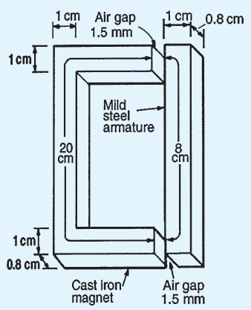

Figure Q5
- A square of side a carries a current I as shown in figure Q6. Show that the magnetic flux density at a point on the axis of the coil and distance z from its plane is given by:
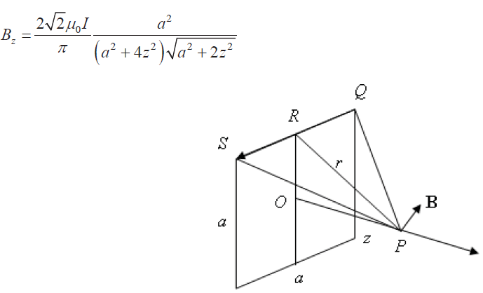

Figure Q6

Note: Assignment is due in a week’s time.

