Introduction
So you're shopping for a new computer in an electronics store and you're trying to make sense of the technical specifications. One computer that looks pretty cool has a 64-bit quad-core Intel i7 3.5 GHz processor. Sounds impressive, but what does it really mean?
The last computer you bought a few years ago had a sticker on it that said Pentium 4, but you don't remember the details. The computer was getting sort of slow, but why would you need a 64-bit quad-core? Why exactly is this better than the processor in your old computer? To understand what the specifications mean, we first have to look at how the processor is designed and how it functions.

Definitions
The central processing unit (CPU) of a computer is a piece of hardware that carries out the instructions of a computer program. It performs the basic arithmetical, logical, and input/output operations of a computer system. The CPU is like the brains of the computer - every instruction, no matter how simple, has to go through the CPU. So let's say you press the letter 'k' on your keyboard and it appears on the screen - the CPU of your computer is what makes this possible. The CPU is sometimes also referred to as the central processor unit, or processor for short. So when you are looking at the specifications of a computer at your local electronics store, it typically refers to the CPU as the processor.
When we start to look at the various components of a CPU and how they function, remember that this is all about speed. When we use a computer, we want the instructions to be carried out very fast. As the instructions become more complicated (for example, creating a 3D animation or editing a video file), we demand more from the CPU. Thus, the technological advances we have seen in processor technology have largely been driven by the need for speed.

Components
A typical CPU has a number of components. The first is the arithmetic logic unit (ALU), which performs simple arithmetic and logical operations. Second is the control unit (CU), which manages the various components of the computer. It reads and interprets instructions from memory and transforms them into a series of signals to activate other parts of the computer. The control unit calls upon the arithmetic logic unit to perform the necessary calculations.
Third is the cache, which serves as high-speed memory where instructions can be copied to and retrieved. Early CPUs consisted of many separate components, but since the 1970s, they have been constructed as a single integrated unit called a microprocessor. As such, a CPU is a specific type of microprocessor. The individual components of a CPU have become so integrated that you can't even recognize them from the outside. This CPU is about two inches by two inches in size.
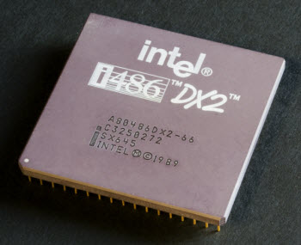
Top-view of an Intel CPU - because it is a single integrated unit, the components are not visible from the outside

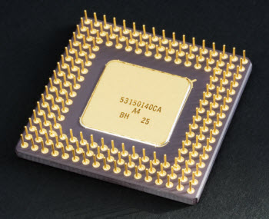
Bottom-view of an Intel CPU - the gold plated pins provide the connections to the motherboard
CPUs are located on the motherboard. Motherboards have a socket for this, which is specific for a certain type of processor. A CPU gets very hot and therefore needs its own cooling system in the form of a heat sink and/or fan.
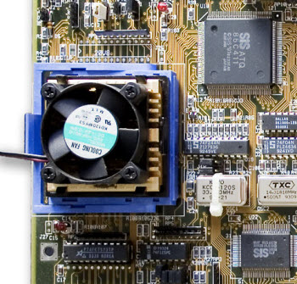
CPU located on a motherboard with a heat sink and fan directly on top
The ALU is where the calculations occur, but how do these calculations actually get carried out? To a computer, the world consists of zeros and ones. Inside a processor, we can store zeros and ones using transistors. These are microscopic switches that control the flow of electricity depending on whether the switch is on or off. So the transistor contains binary information: a one if a current passes through and a zero if a current does not pass through.
Transistors are located on a very thin slice of silicon. A single silicon chip can contain thousands of transistors. A single CPU contains a large number of chips. Combined, these only cover about a square inch or so. In a modern CPU, however, that square inch can hold several hundred million transistors - the very latest high-end CPUs have over one billion! Calculations are performed by signals turning on or off different combinations of transistors. And more transistors means more calculations. You may be interested to know that the material, silicon, used in chips is what gave the Silicon Valley region of California its name.
Early CPUs were quite bulky and did not contain as many transistors as they do today. Chip manufacturers, such as Intel and AMD, have invested a lot of research into making everything smaller and fitting more transistors inside a single processor. So when there is a new generation of chips, it typically means they have come up with a smarter way to pack more processing power into a single CPU. The general name of the processor, such as Intel Pentium 4, Intel i7, AMD Athlon, and AMD 870, refers to the underlying architecture of the CPU. There are so many different ones that it can be hard to figure out what you really need in a new computer. The best way is to go with the latest processor type that falls within your budget.

Clock Rate
The clock rate of a processor is the speed at which instructions are executed. This speed is regulated using an internal clock and is expressed as the number of clock cycles per second. Modern CPUs can process billions of calculations per second. The unit used to express the clock rate is hertz, abbreviated as Hz. So when a processor has a clock speed of 3.5 GHz that means 3.5 gigahertz, or 3.5 billion clock cycles per second

