Feb. 2019
Tutorial Problems for Lecture1- EEE3131
- Name two advantages of digital data as compared to analog data.
- Name an analog quantity other than temperature and sound.
- Define the sequence of bits represented by each of the following sequences of levels.
- High, High, low, High, Low, Low , Low, High
- Low, Low, Low High, Low Low, High, Low , High, Low, High, Low
- List the sequence of levels that represent each of the following.
(1011101) (b) 11101001
- For the pulse shown in Fig1 graphically determine the following
- Rise time (b) fall time (c) Pulse width (d) aptitude

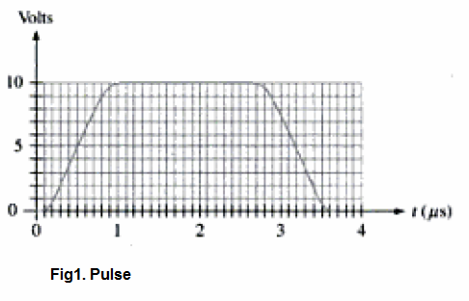
- Determine the period of the digital waveform shown in fig2. Indicate whether the wave form is periodic or non-periodic.
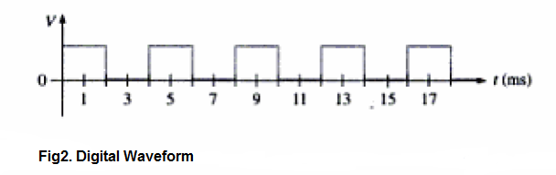
- Determine the bit sequence represented by the wave form in figure 3. A bit time is 1 micro second. What is the total time needed to transfer all the bits.
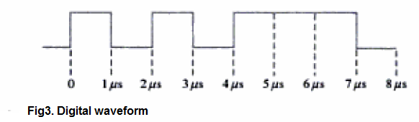
- What is meant by an IC
- Explain the term DIP.
- Label the pin number on the IC package whose view is shown in figure4.
