

THE UNIVERSITY OF ZAMBIA
SCHOOL OF ENGINEERING
DEPARTMENT OF ELECTRICAL AND ELECTRONICS
ENGINEERING

LAB 3 REPORT

NAME: NTALASHA MWANSA
COMPUTER NUMBER: 2019109646
COURSE: EEE 3131
LECTURER: MR GEORGE ZIBA
DUE DATE: 25TH MAY, 2021

1.0 TITLE:
The J K Flip-Flop

2.0 OBJECTIVE
- To study the logical development of the JK flipflop and its various forms.

3.0 EQUIPMENT REQUIRED
- Multisim software
- Hp ENVY laptop

4.0 PROCEDURE
Practical 6.1
Set up the circuit as instructed in the lab manual and simulate on multism software

Practical 6.2
Set up the circuit as instructed in the lab manual and simulate on multism software

Practical 6.3
Set up the circuit as instructed in the lab manual and simulate on multism software

Practical 6.4
Set up the circuit as instructed in the lab manual and simulate on multism software

Practical 6.5
Set up the circuit as instructed in the lab manual and simulate on multism software
Practical 6.6
Set up the circuit as instructed in the lab manual and simulate on multism software

6.0 RESULTS
Practical 6. 1, 2 ,3
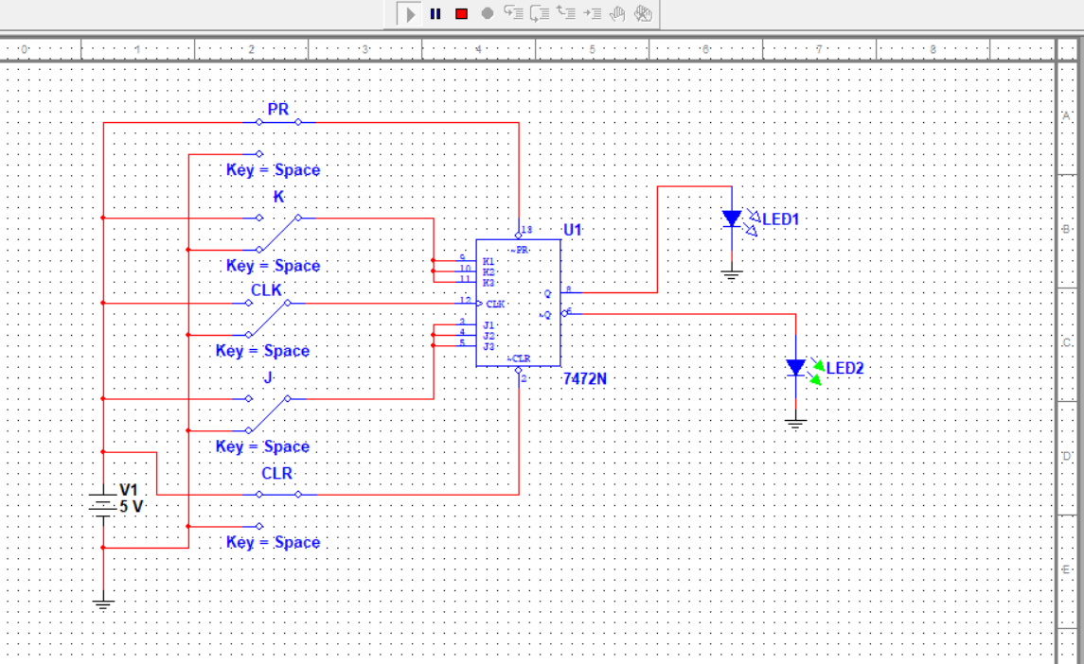
TRUTH TABLE
STEP | J | K | Qn | Qn+1
1 | 1 | 0 | 0 | 0
2 | 0 | 0 | 0 | 0
3 | 1 | 1 | 0 | 1
4 | 0 | 0 | 1 | 0
5 | 1 | 1 | 0 | 1
6 | 1 | 0 | 1 | 0
7 | 0 | 1 | 0 | 1
8 | 0 | 1 | 1 | 1
9 | 1 | 0 | 1 | 0

STEP | J | K | Qn+1
2,4 | 0 | 0 | Qn
7,8 | 0 | 1 | 1
6,9 | 1 | 0 | 0
3,5 | 1 | 1 | T

Practical 6.4
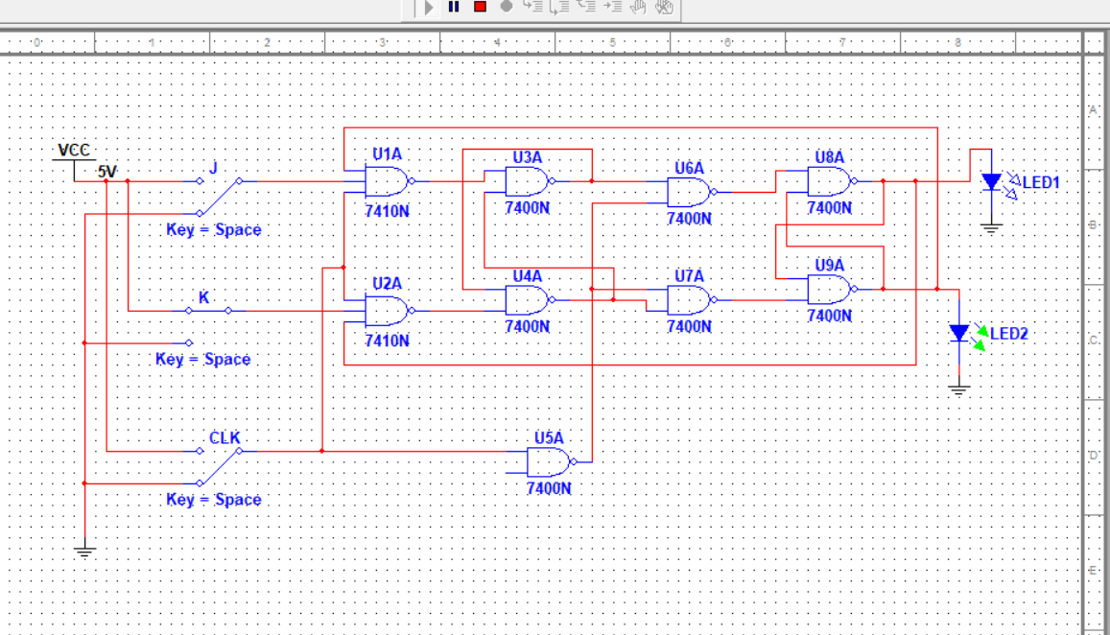

Practical 6.5
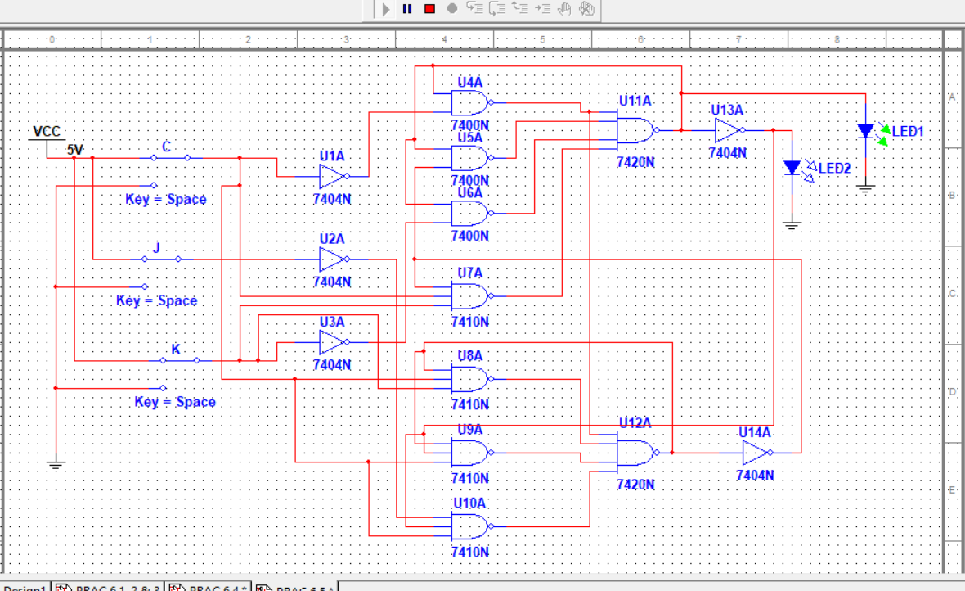

Practical 6.6
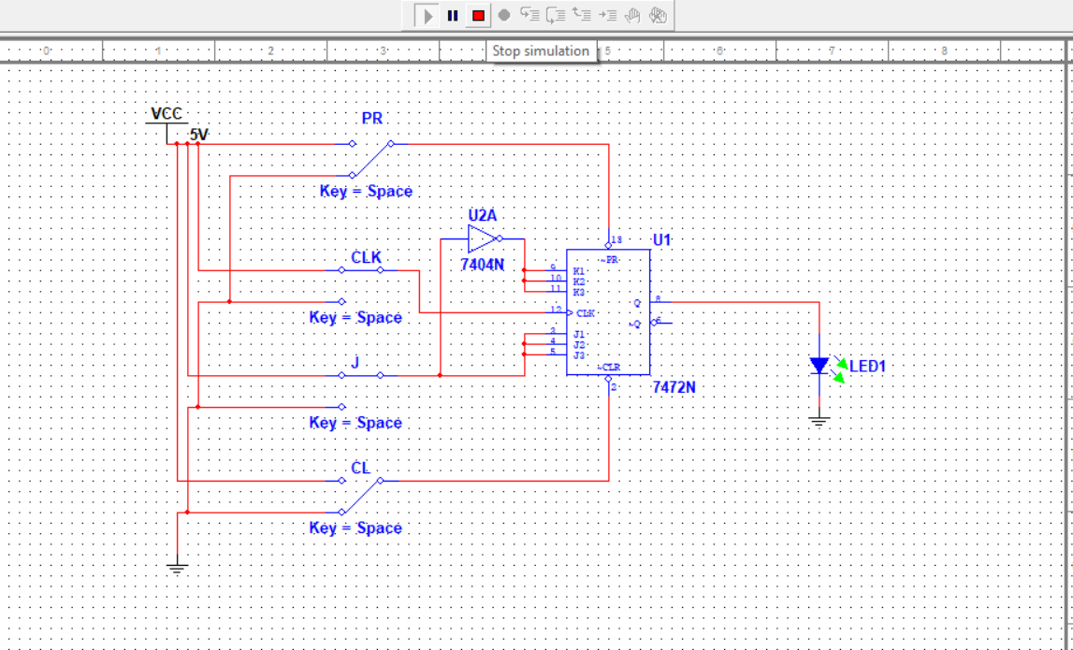

EXERCISE 6.1

FLIP FLOP | LEADING EDGE TRIGGER | TRAILING EDGE TRIGGER | LEVEL TRIGGER | INPUT EFFECT WHEN CLOCK IS HIGH
CLOCKED SR LATCH |  |  | X | YES
D TYPE LATCH |  |  | X | YES
EDGE TRIGGERED D TYPE | X |  |  | YES
MASTER SLAVE JK |  | X |  | NO
EDGE TRIGGERED JK | X |  |  | YES

7.0 CONCLUSION
All circuits were successfully connected.
But it should be noted that due to the so many connections made on the multism software, the circuit osf 6.5 did not respond as it should.its outputs did not quite correspond with its truthtable. This was due to the fact that the software was overwhelmed with so many interconnections between components of the cicuit.
However, all circuits were connected in accordance with the lab manual instructions.

8.0 APPLICATIONS
Being the most flexible type available, the JK flip-flop can be put to virtually any use in control circuits, counters and shift registers.
It is, however, quite rare to find its facilities being used fully and where this is so it will often be more economic to choose a flip-flop of another kind, especially if multiple circuits are needed, when simpler circuits such as the D type latch are packaged in fours or eights instead of ones or twos as are JK flip-flops.
One area of design in which the JK facilities are fully used is in the construction of synchronous and asynchronous counters to perform non-binary counting, where the use of JK flip flops often eliminates a considerable amount of gating which would otherwise be necessary.

9.0 REFERENCES
[1] William Kleitz, 2006, Digital Electronics with VHDL, Prentice Hall ISBN-100131714902 [Practical 1]
[2] Maini Anil K., Digital Electronics: Principles, Devices and Applications, 2007, John Wiley and Sons Ltd, ISBN 978-0-470-03214-5. [Theory 1]
[3] Thomas L. Floyd, 2006, Digital Fundamentals with PLD Programming, Prentice Hall ISBN-10: 0131701886 [Practical 2]
[4] Sedha R.S, A textbook of Digital Electronics, S. Chand, 2010 [Theory 2]
[5] Alan C. Diixon, JamesL. Antonakos, 2000, A Practical Approach To Digital Electronics, Prentice Hall ISBN-10: 0137275 951.

