

THE UNIVERSITY OF ZAMBIA
SCHOOL OF ENGINEERING
DEPARTMENT OF ELECTRICAL AND ELECTRONICS
ENGINEERING

LAB 4 REPORT

NAME: NTALASHA MWANSA
COMPUTER NUMBER: 2019109646
COURSE: EEE 3131
LECTURER: MR GEORGE ZIBA

1.0 TITLE:
EQUIVALENCE, NON-EQUIVALENCE AND OTHER CIRCUITS

2.0 OBJECTIVE
- To introduce a group of important circuits based upon two inputs to perform equivalence, non-equivalence, equality, inequality and half-adder functions.
3.0 EQUIPMENT REQUIRED
- Multisim software
- Hp ENVY laptop

4.0 PROCEDURE
For Practicals 7.1 to 7.6:
Set up the circuit as instructed in the lab manual and simulate on multism software

5.0 RESULTS
Practical 7.11 A greater than B
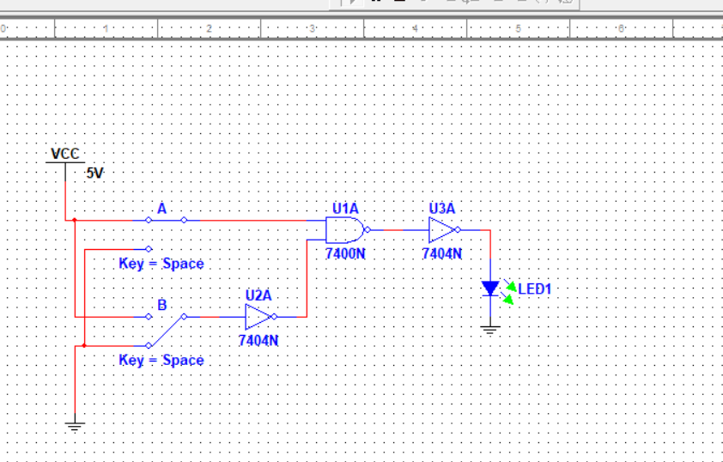
7.12 A less than or equal to B
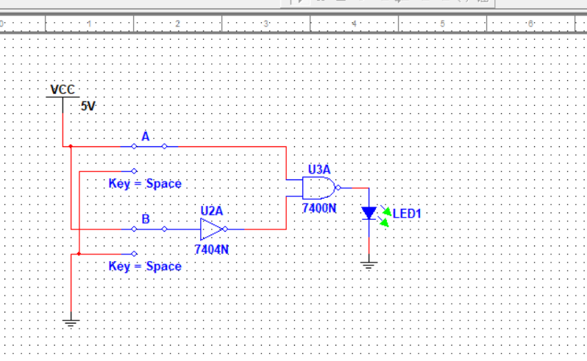
7.13 A less than B
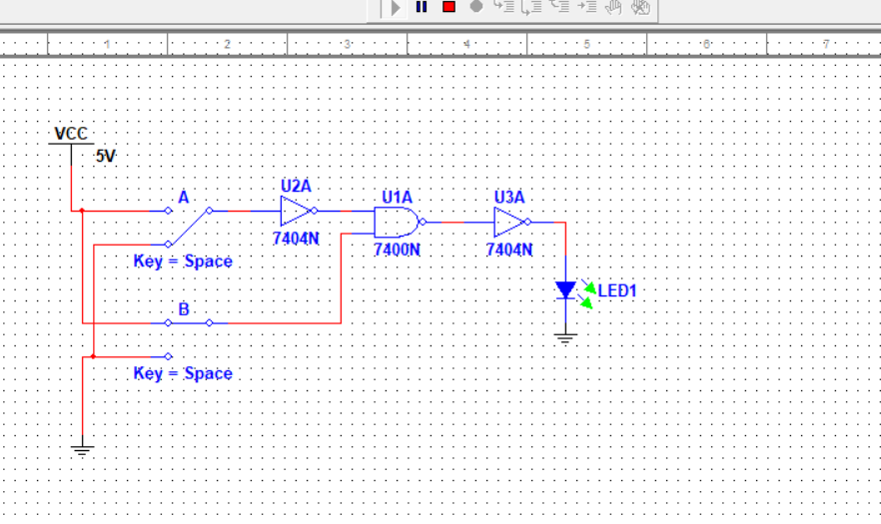
7.14 A greater or equal to B
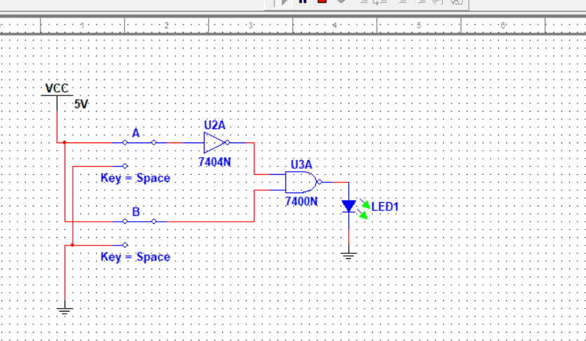

Practical 7.2
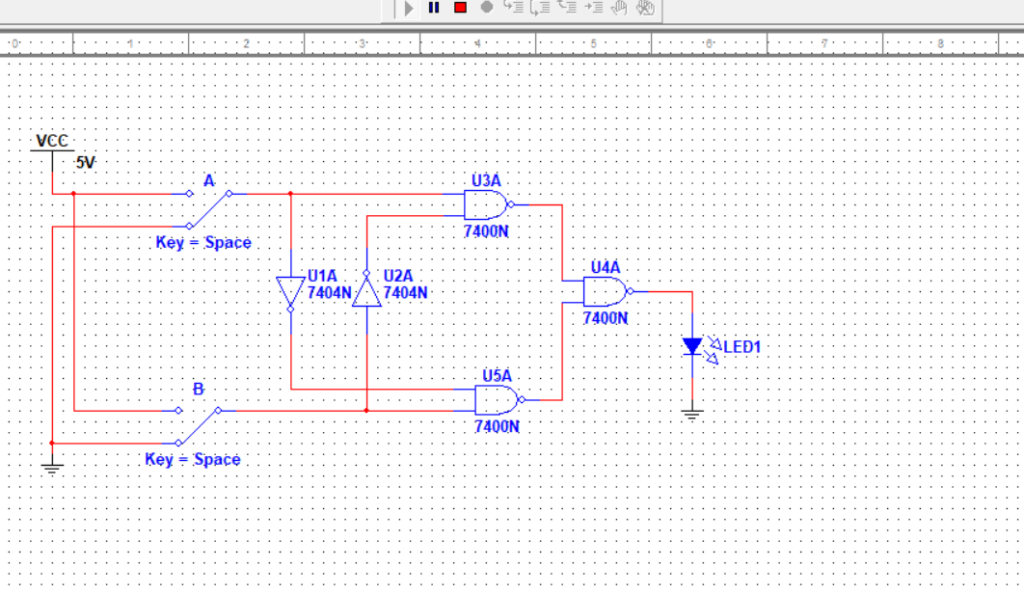
Practical 7.3
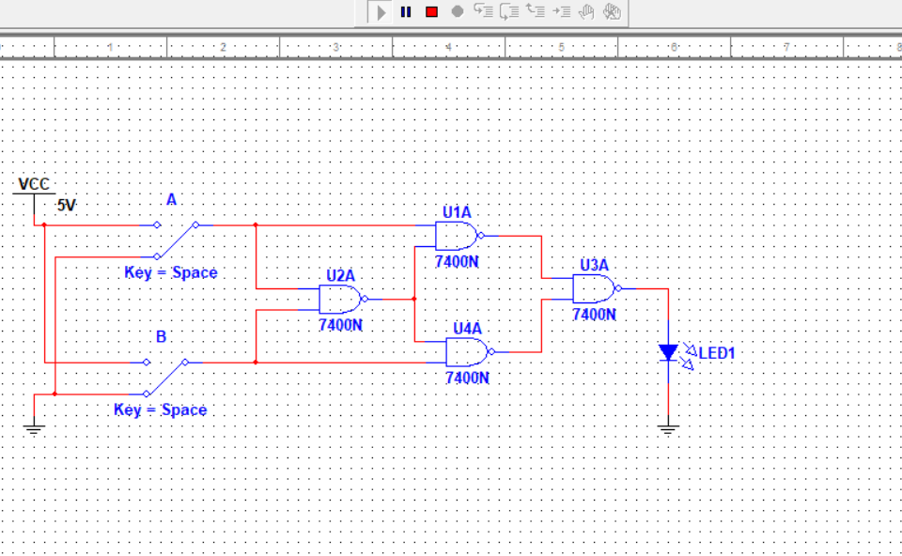

Practical 7.4
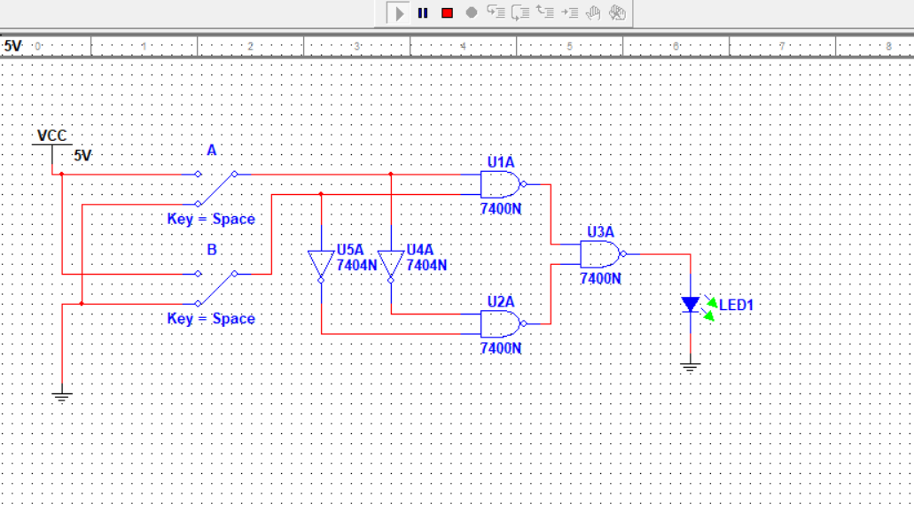

A | B | Z
0 | 0 | 1
0 | 1 | 0
1 | 0 | 0
1 | 1 | 1

PRACTICAL 7.5
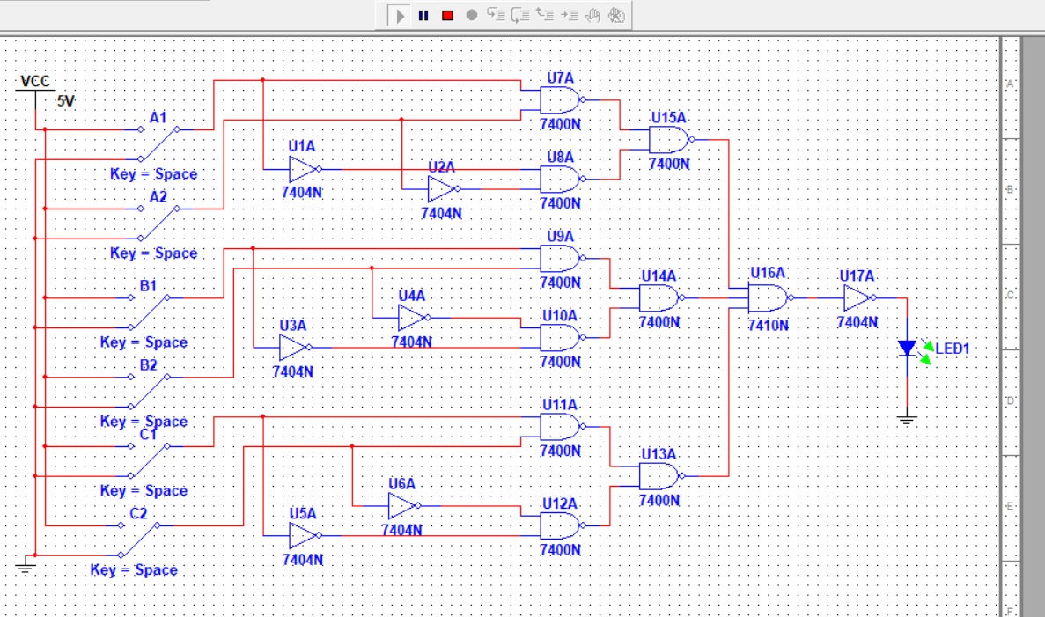

PRACTICAL 7.6
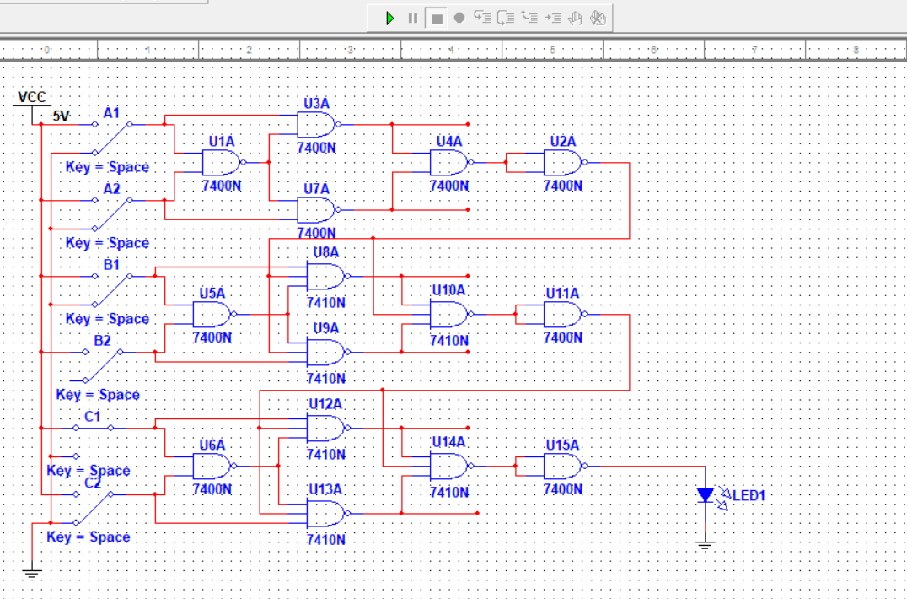

ANSWERS TO EXERCISES
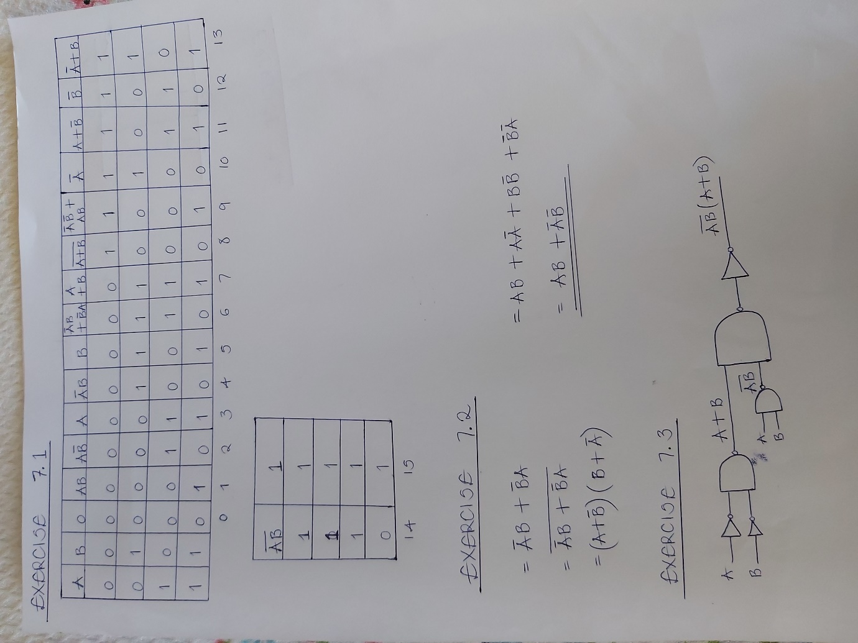

EXERCISE 7.5
X | Y | OUTPUT
000 | 001 | 0
010 | 010 | 0
111 | 000 | 1
100 | 101 | 0
101 | 110 | 1
100 | 011 | 1
110 | 000 | 1

EXERCISE 7.6 : In relation to diagram 7.6 above
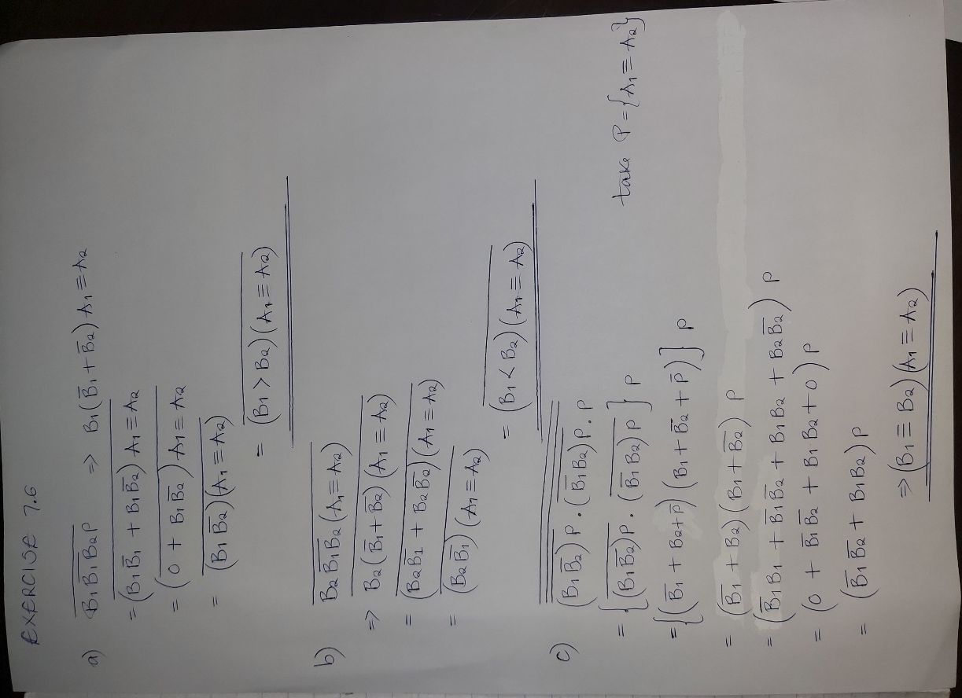
7.0 CONCLUSION
All circuits were successfully connected.
The experiment was successfully done as the objectives were met. All connected circuits responded in accordance with their respective truth tables
A better understanding of logic circuits was attained simply by observing the outputs produced by several different logic circuit connections. The output was observed on an LED which lit up upon a “HIGH” output and was off when output was “LOW” once the software was simulated.

8.0 APPLICATIONS

The NAND gate is widely used in integrated circuit logic since just about all types of operation can be obtained, although usually at greater cost. However, in designing logic systems, as we shall see later, the design tools and techniques are mostly better adapted to the use of the three fundamental operations of AND, OR, NOT so methods of converting the resulting expressions to the exclusive use of NAND have to be used.
Some formal methods do exist but in most practical cases but these are heavy-handed and cumbersome and have little advantage over simple experience. The fact that multi-input gates can be used for operations requiring fewer inputs than are available by leaving inputs disconnected means that when designing a large logic system it is easier to ensure that the number of modules (or packages) can be kept to a minimum. This is usually the most important economic factor nowadays.

9.0 REFERENCES
[1] William Kleitz, 2006, Digital Electronics with VHDL, Prentice Hall ISBN-100131714902 [Practical 1]
[2] Maini Anil K., Digital Electronics: Principles, Devices and Applications, 2007, John Wiley and Sons Ltd, ISBN 978-0-470-03214-5. [Theory 1]
[3] Thomas L. Floyd, 2006, Digital Fundamentals with PLD Programming, Prentice Hall ISBN-10: 0131701886 [Practical 2]
[4] Sedha R.S, A textbook of Digital Electronics, S. Chand, 2010 [Theory 2]
[5] Alan C. Diixon, JamesL. Antonakos, 2000, A Practical Approach To Digital Electronics, Prentice Hall ISBN-10: 0137275 951.

