

THE UNIVERSITY OF ZAMBIA
SCHOOL OF ENGINEERING
DEPARTMENT OF ELECTRICAL AND ELECTRONICS
ENGINEERING

ASSIGNMENT 5 SOLUTIONS

NAME: NTALASHA MWANSA
COMPUTER NUMBER: 2019109646
COURSE: EEE 3131
LECTURER: MR GEORGE ZIBA

Question 1
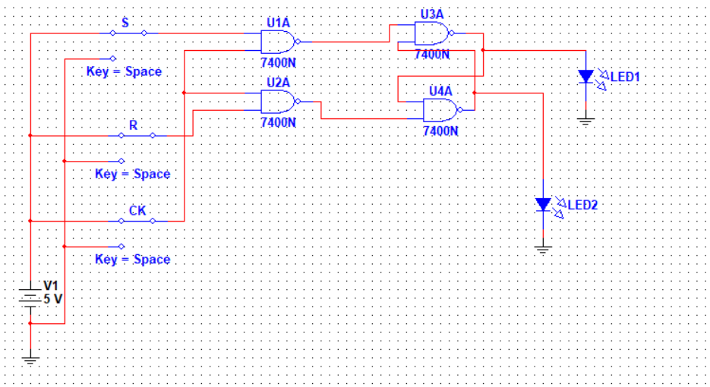
Clock | R | S | Q
1 | 0 | 0 | Qn
1 | 0 | 1 | 1
1 | 1 | 0 | 0
1 | 1 | 1 | invalid

Question 2
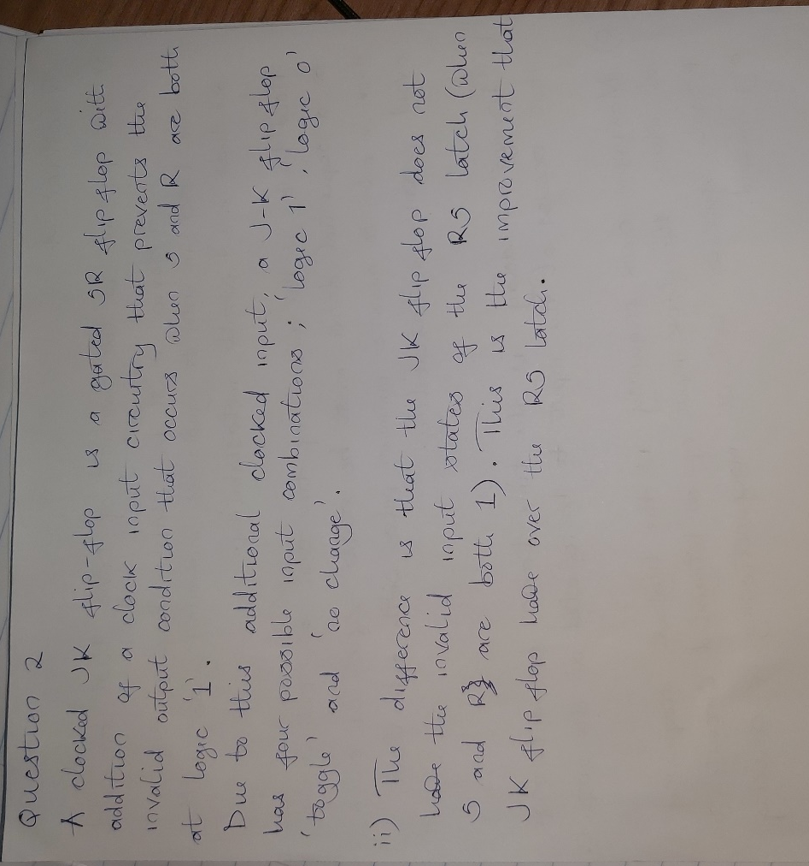

Question 3
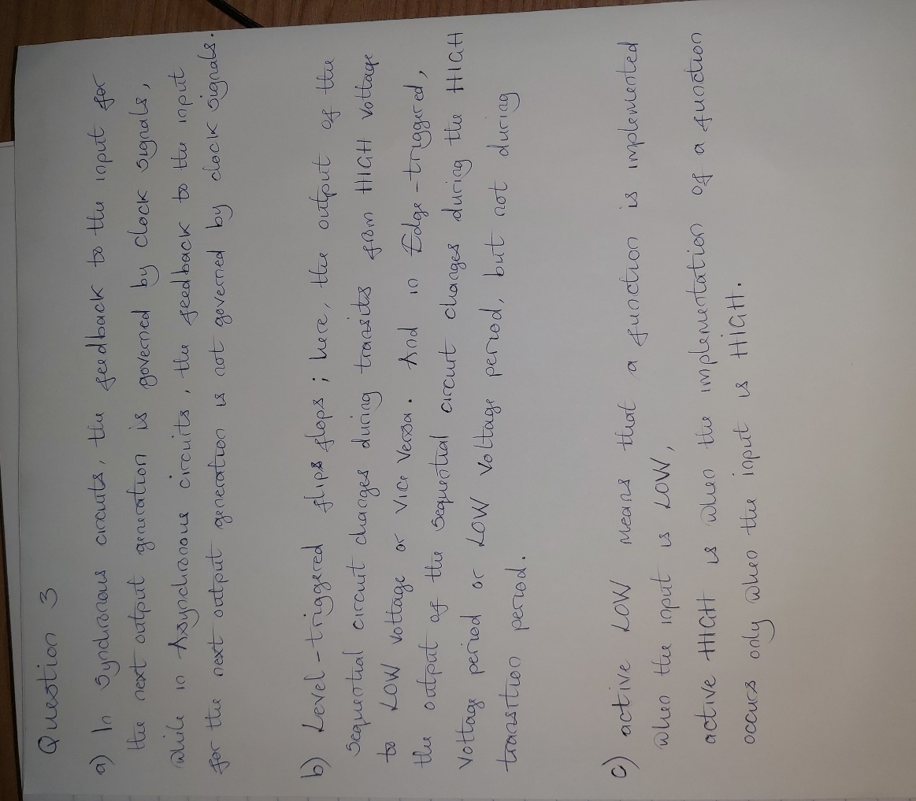

Question 4
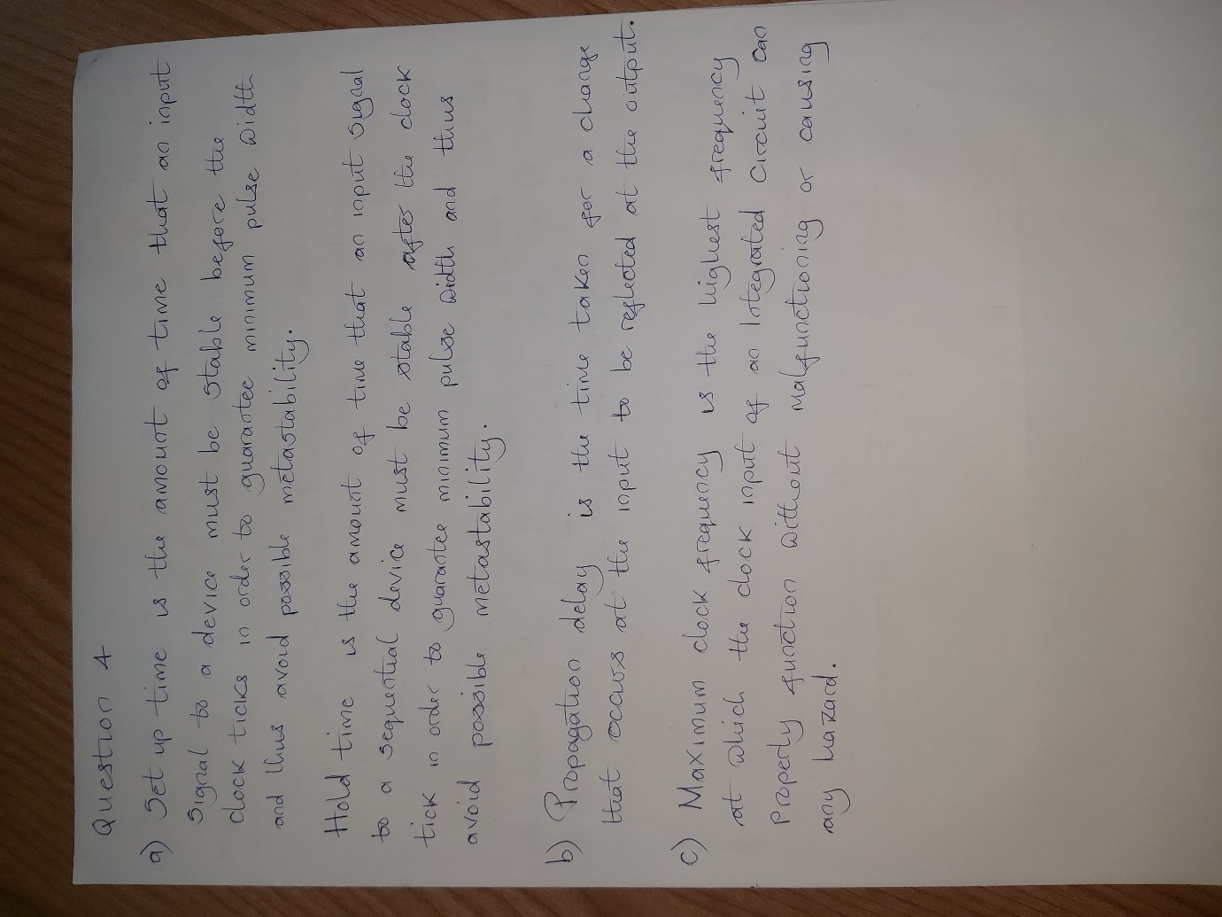

Question 5
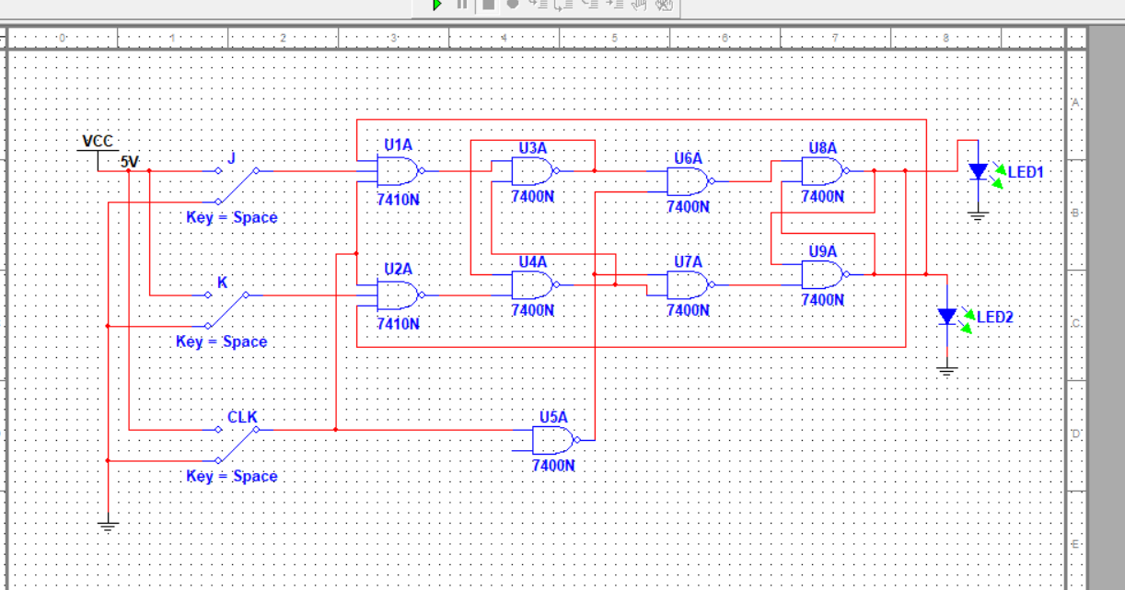
j | k | Qn | Qn+1
0 | 0 | 0 | 0
0 | 0 | 1 | 1
0 | 1 | 0 | 0
0 | 1 | 1 | 0
1 | 0 | 0 | 1
1 | 0 | 1 | 1
1 | 1 | 0 | 1
1 | 1 | 1 | 0

 | 00 | 01 | 11 | 10
0 | 0 | 0 | 1 | 1
1 | 1 | 0 | 0 | 1
Qn JK

Qn+1= J’.Qn + K’.Qn

Question 6

Output

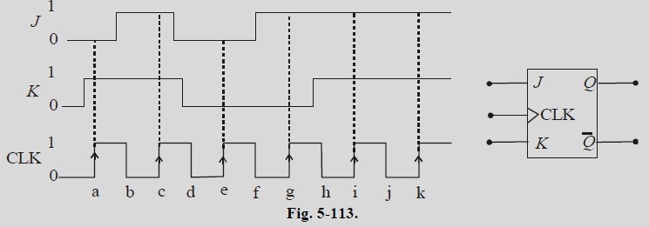

Question 7

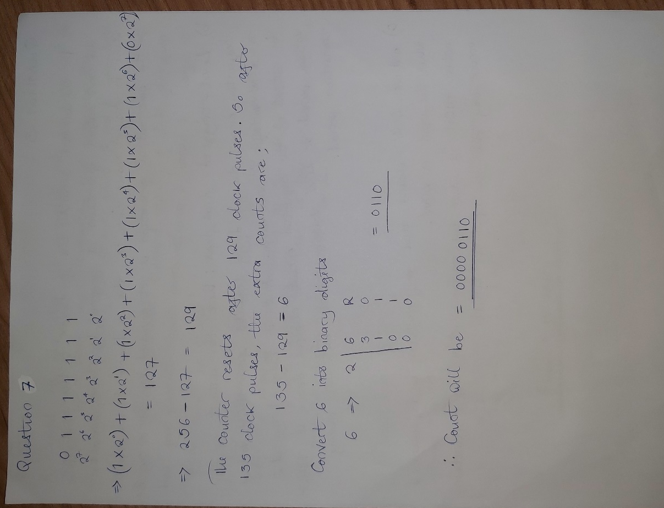

Question 8

