THE UNIVERSITY OF ZAMBIA
SCHOOL OF ENGINEERING
Department of Electrical and Electronic Engineering

EEE3112: ENGINEERING PRACTICE

TITLE: OSCILLOSCOPES
LAB #: 4

NAME: DISMAS BANDA
COMPUTER #: 14051664
ATTENTION: MR. HIMUNZOWA

1.PROCEDURE
Experiment 1
- Connect the output of the Unilab signal generator to one of the channel input and set it on sine wave, full amplitude.
- Several frequencies were set on signal generator and their values were checked by the use of the oscilloscope to check whether the frequencies of signal generator were the same with those obtained from the oscilloscope.

Experiment 2
The input switch was set to AC and the Unilab signal generator was set to square wave, 25Hz and connected to the oscilloscope.
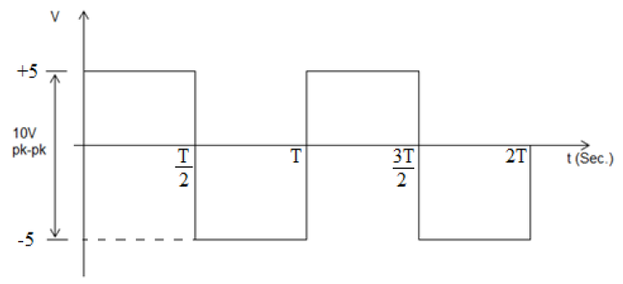

The oscilloscope was triggered to make a steady picture on the screen and the Input was switched to DC.

Experiment 3
The feedback 459 +kit 461 was used to make a high pass filter circuit with capacitor and resistor values of $1μF and 1000Ω$ respectively as shown in figure 1 below.
Figure 1.1: High pass filter circuit
The high level output from the Unilab oscillator, sine wave, 100Hz was used and the output was coupled to the input of the filter and to channel A (or Ch 1).
- Both channels, A and B were selected in order to have both signals o n the screen at the same time and the gain of each channel was adjusted so that the signal have almost the same amplitude on the screen.
- The phase difference between input and output of the filter was measured on the screen.
- Keeping the connections, and changing the settings so as to obtain the X –Y display, with the input to the filter as Y and the output as X.
- An ellipse was seen on the oscilloscope as shown below. The phase differnce between the two signals is given by the formula;
$$Sinϕ=\frac{A}{B}$$

- The phase measurement was repeated directly by using the ellipse for 200Hz and 400Hz.

Experiment 5
A band pass filter shown in figure 3 below was build and sweep generator with frequencies between 10Hz and 20KHz was used to feed the filter.
Figure 1.2: Band pass filter

The output of the filter was coupled to channel A on an oscilloscope and the deflection output from the sweep generator to the X – input of the oscilloscope and the frequency response of the filter were gotten directly on the screen.

Figure 1.3: Signal as a result of Change of frequency output with time

The sweep generator changes the frequency of its output with time, and at the same time outputs a signal as shown in figure 4 above to the X – deflection of the oscilloscope.

3.DISCUSSION
An oscilloscope is an instrument that is commonly used to display and analyze the waveform of electronic signals. A typical oscilloscope can display AC or pulsating DC waveforms having a frequency as low as 1 hertz (Hz) or as high as several megahertz (MHz). high end oscilloscopes can display signals having frequencies up to several hundred gigahertz (GHz). The display is broken up into so-called horizontal divisions and vertical divisions Time is displayed from left to right on the horizontal scale. Instantaneous voltage appears on the vertical scale, with positive values going upward and negative values going downward.
In any oscilloscope, the horizontal sweep is measured in seconds per division (s/div), milliseconds per division (ms/div), microseconds per division (s/div), or nanoseconds per division (ns/div). The vertical deflection is measured in volts per division (V/div), millivolts per division (mV/div), or microvolts per division (V/div). Virtually all oscilloscopes have adjustable horizontal sweep and vertical deflection settings.

4.APPLICATIONS
Oscilloscopes are used in a wide variety of different industries and applications.
- Power analysis- Oscilloscope can be used to measure and analyse the operating characteristics of power conversion devices, circuits and line power harmonics. Differential amplifier probes are needed to this, and special software is also offered to make analysis of data easier.

- Data storage devices - Oscilloscope are used to test CD/DVD and disc drive designs by measuring disk performance, media noise and optical recording characteristic such data.

- Serial data analysis – Digital data signals are moving to ever – increasing serial data Oscilloscopes are used to analyse and characterise such data as USB, SCSI, Ethernet, Serial ATA, Fibre channel, firewall, etc.

- Jitters Analysis – Today, high – bandwidth circuits have extremely fast clocks and signals. Oscilloscopes are used to characterise and debug signal jitters as well as timing for clocks, clock – to – data and data stream analysis.

- Time domain reflectometry (TDR) is a way to measure impedance values and variations such as faults along transmission cables, cable connector or micro strips on a circuit board.

5.CONCLUSION
The lab could be said to be a success for the objectives were met i.e. practical training in the use of the oscilloscope, use of delayed sweep and use sweep generator and oscilloscope to get frequency was gained.

6.REFERENCES
University of Zambia: School of Engineering (Department of Electrical and Electronic Engineering) Lab Manual.

