
THE UNIVERSITY OF ZAMBIA
SCHOOL OF ENGINEERING
DEPT. OF ELECTRICAL AND ELECTRONICS ENGINEERING

[EEE 3112]
LAB NO 1: VOLTMETERS AND WAVEFORMS

NAME: MOSES MULILO
COMPUTER NO: 2020989611
DATE OF LAB: 05.10.23
DUE DATE: 11.11.23

1. OBJECTIVE
To establish the connection between AC wave form and readings on different voltmeters. How interpret the reading and how to make circuits to widen the measurement range.

2. EQUIPMENT
- Unilab signal generator with low impedance (1 Ohm) output
- Feedback 603 signal generator
- Dual beam oscilloscope. Preferably Philips 3208
- Digital Voltmeter Fluke 45
- AVO analogue voltmeter ( to be used on 3V and 10V AC only)
- Feedback trainer 459
- Feedback trainer kit 461 with
- Capacitor 100nF
  - Resistor 470R
  - Resistor 470K
- Diode BYX36 or similar

3. BACKGROUND THEORY
Analogue and digital multi-meters are aimed at measuring currents and voltages varying sinusoidal with time. When using multi-meters for measuring on non-sinusoidal periodic currents and voltages we have to be careful when interpreting the readings.
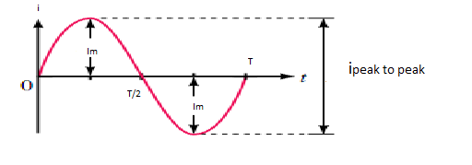

Fig 1 Periodic Signal

To describe this time varying current we have several quantities
- Average Value
The average value (mean value) of a time varying current on a time interval is the DC current that will carry the same amount of charge during that time interval. A signal as in fig 1 (a pure AC signal) will have an average value equal to zero if taken over a one or more complete periods. In order to have an average value attached to a pure AC signal, we calculate the average value on half a period.

$$i_{av }=\frac{1}{\frac{T}{2}}\int_{0}^{\frac{T}{2}}{i\left(ωt\right)dt}$$
When i is a sine wave $i_{av}=\frac{2}{π}i_{max}$

- RMS Value
The rms value of a time varying current on a time interval is the DC current that dissipate the same amount of heat in a resistor during this time interval. Usually we calculate this using a full time period as the time interval. The formula for calculating the rms value is:
$$i_{rms }=(\frac{1}{\frac{T}{2}}\int_{0}^{\frac{T}{2}}{i{(ωt)}^{2}dt)^{\frac{1}{2}}}$$
When i is a sine wave $i_{rms}=\frac{1}{\sqrt{2}}i_{max}$
- Form factor
The form factor is the ratio of rms value to mean value.
When i is a sine wave, the form factor is $=\frac{i_{rms}}{i_{av}}=1.11$
- The connection between scaling and reading
Some Ac instruments have a reading proportional to the average value, some have a reading proportional to the rms value, and some have a reading proportional to the peak value. Usually all these different meters are scaled in sine wave rms, so that if you use these different instruments to measure on a pure sine wave, they will all show the same reading. If the signal is not pure sine wave, the readings will differ.

- Frequency limitations
All instruments have an upper frequency limit, which may vary from some KHz to some hundred kHz for ordinary multi-meters. Usually they are all capable of handling 400Hz, which is widely used frequency for power supply.
In order to measure on signals above the cut-off frequency of the meters, we use special high frequency probes. A passive high frequency probe rectifies the signal and gives out a DC voltage that can easily be measured by the multi-meter. We are then able to use ordinary DC instruments to measure on signals up to 1 GHz.
- Decibel
Decibel is a way of taking the ratio between two signal levels. Therefore the dB value of a signal is a number relating it to another signal level, a reference level. The basic definition of dB relates power levels:
dB value = 10 log (Actual power level/ reference power level)
When used to relate voltage levels we often use the formula:
dB value = 20 log (Actual voltage level/ reference voltage level)
If you want to express how many dB your signal has dropped from a certain level, this becomes your reference level. This level has a dB value = 0 dB.

4. PREPARATION QUESTIONS
Q1 Calculate the rms value and the average value (half period) for a triangle formed wave and a square wave with a peak voltage of 10V.
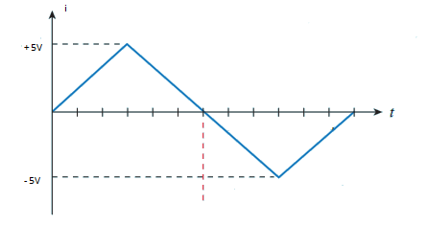
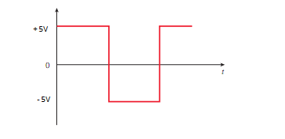
- Triangle wave form (peak to peak = 10V)
$V_{mean}=\frac{2}{T} \int_{0}^{T/4}{\frac{20t}{T}} dt+ \int_{T/4}^{T/2}{10.20t dt}$Q
$$=\frac{2}{T}[\frac{20t^{2}}{2T}|_{0}^{\frac{T}{4}}+ 10t- \frac{20}{2T}t^{2}|_{\frac{T}{4}}^{\frac{T}{2}}]$$
$$=\frac{2}{T}\left(\frac{20(\frac{T}{4})}{2T}+ 10{\left(\frac{T}{2}\right)- 20{(\frac{T}{2})}^{2}-10\left(\frac{T}{4}\right)+ 10(\frac{T}{4})}_{}\right)$$
$$=\frac{2}{T} ( \frac{5T}{8}+\frac{5T}{2}-\frac{15T}{8})$$
$$=\frac{5T}{4}. \frac{2}{T}$$
$$=\frac{5}{2}=2.5 V$$
$${{(V_{rms})}^{2}}_{r}= \frac{2}{T}\int_{0}^{T/2}{{12.T v}^{2}}dt$$
$$=\frac{2}{T}(12.96|_{0}^{\frac{T}{2}})$$
$$=12.96$$
$V_{rms}= \sqrt{12.97}$ = 3.6V
- Square wave form (peak to peak = 10V)
$$V_{mean}= \frac{2}{T}\int_{0}^{T/2}{v\left(t\right)dt}$$
$$=\frac{2}{T}\int_{0}^{T/2}{5dt}$$
$$=\frac{10}{T}(\frac{T}{2})$$
$$=5V$$
$$Vrms=\frac{2}{T}\int_{0}^{T/2}{{v(t)}^{2}dt}$$
$$= \frac{2}{T}\int_{0}^{T/2}{25dt}$$
$$=\frac{50}{T}(\frac{T}{2})$$
$$=25V$$
Q2 If you have a meter with both reading and scale proportional to rms value (sine), what would the reading be if you measured on:
a) Square wave with max value of 6V?
b) Triangle wave with max value of 6V?
c) Pure sine wave with max value of 6V?

Q3 You have a meter with reading proportional to average (mean) value and scaled in rms (sine). What would your meter read if you measured on the same 3 signals as in Q2?

5. PROCEDURE
1. Checked that the oscilloscope is correctly calibrated by using the 1 Vp-p calibrating signal.. In order to get useful results in the lab, one had to be accurate in the oscilloscope measurements. Then Calibrated the AVO meter to show 0 with no input. (The screw just below the centre of the scale)
2. Set the output from the Unilab generator to 1 kHz and 10V peak to peak (Vp-p) sinusoidal signal, using the low impedance 1 ohm output (TAKING NOTE NOT SHORT THE OUTPUT). Controlled the frequency with the frequency counter function of the Fluke Digital Voltmeter. Coupled the oscilloscope, the Digital Voltmeter (DVM) and the AVO- meter in parallel directly on the output of the signal generator. Used the oscilloscope to control the output is exactly 10V peak to peak. Took note of the reading on the DVM and the AVO-meter.
3. Set the output to square wave, 10V peak to peak (using the oscilloscope). Noted the readings on the DVM and the AVO-meter.
4. Set the output to triangle wave, 10V peal to peak (using the oscilloscope). Noted the reading on the DVM and the AVO-meter.
5. Made a high pass filter using the 100nF capacitor and the 470 Kilo-ohm resistor
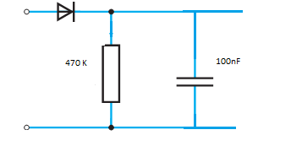
Using the signal generator to feed the filter with 1 kHz square wave signal. Coupled the oscilloscope, the DVM and the AVO-meter in parallel across the output of the filter. USING THE 3V RANGE OF THE AVO-METER. Adjusted the output level of the signal generator until the signal from the filter is 10V peak to peak. Noted the reading of the DVM and the AVO-meter.
6. Used the diode, the 0.1$μF$ capacitor and the 470K resistor to create a peak value measuring circuit.
7. In order to determine the frequency characteristics of the fluke voltmeter, used the feedback SS0603 signal generator with sinusoidal output. Use the oscilloscope to keep the output at a constant 5Vp-p over the whole frequency range and measure this voltage by using the fluke voltmeter on the AC. The generator should be loaded with the peak value circuit while doing these measurements.
Do the same with the peak value circuit, monitoring the output with the Fluke Voltmeter on DC
5. RESULTS
 | DVM | AVO | V peck | V mean | V rms
Sine | 3.804 | 3.4 | 10
Square | 5.41 | 5.6 | 10
Triangle | 3.19 | 2.8 | 10
Square through filter | 1.126 | 0.65 | 10

- Half a period of the output from the filter as seen on the oscilloscope screen.
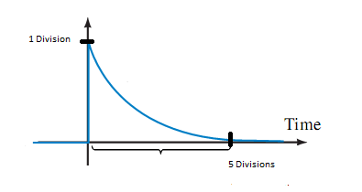
Time = 5 divisions X 0.1ms/divisions = 0.5 ms
Amplitude = 1 division X 5 V/division = 5V
You should now be able to fill in the columns marked DVM and AVO with the voltage readings from the experiment.
- V mean and V rms for all the waveforms.

  - Sine Wave (Peak to peak = 10V)
$$V_{mean }=\frac{2}{π}V_{max}$$
$$=\frac{2}{π}X 5$$
$$=3.182V$$

- Plot these two frequency responses in the same axis system on a Lin-log- paper, using dB as the vertical scale, with 0 dB at the plateau of each curve.

