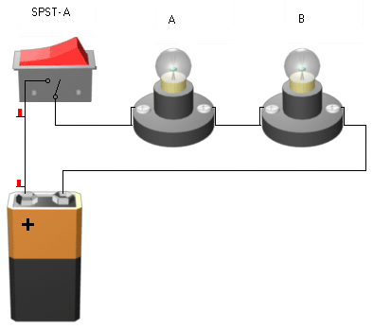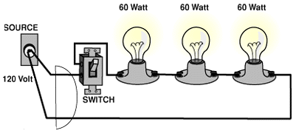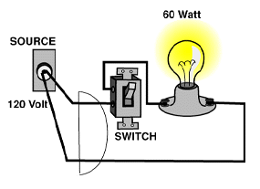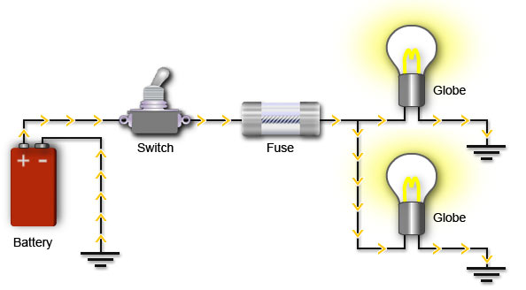
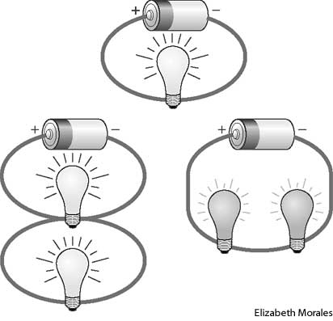

Solar Charger for 6V 4.5Ah Battery
Here is a solar charger circuit that is used to charge Lead Acid or Ni-Cd batteries using the solar energy power. The circuit harvests solar energy to charge a 6 volt 4.5 Ah rechargeable battery for various applications. The charger has Voltage and Current regulation and Over voltage cut off facilities.

The circuit uses a 12 volt solar panel and a variable voltage regulator IC LM 317.
The solar panel consists of solar cells each rated at 1.2 volts.
12 volt DC is available from the panel to charge the battery. Charging current passes through D1 to the voltage regulator IC LM 317. By adjusting its Adjust pin, output voltage and current can be regulated.

Solar Charger Circuit Schematic
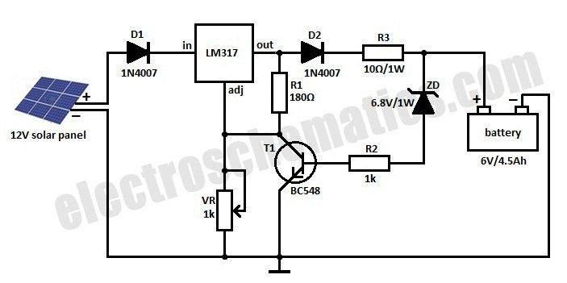
Solar charger with current regulation and cut off.
VR is placed between the adjust pin and ground to provide an output voltage of 9 volts to the battery. Resistor R3 Restrict the charging current and diode D2 prevents discharge of current from the battery.
Transistor T1 and Zener diode ZD act as a cut off switch when the battery is full. Normally T1 is off and battery gets charging current. When the terminal voltage of the battery rises above 6.8 volts, Zener conducts and provides base current to T1. It then turns on grounding the output of LM317 to stop charging.

Solar Inverter Battery Charger
Here is an energy saving solar inverter battery charger. It harvests solar energy to replenish 12 volt Inverter battery. It has auto cut off facility to stop charging when the battery attains full charge. The charger uses a 24 volt solar panel as input.
The circuit uses a variable voltage regulator IC LM 317 to set the output voltage steady around 16 volts. Variable resistor VR controls the output voltage. When the solar panel generates current, D1 forward biases and Regulator IC gets input current. Its output voltage depends on the setting of VR and the output current is controlled by R1. This current passes through D2 and R3. When the output voltage is above (as set by VR) 16volts, Zener diode ZD2 conducts and gives stable 15 volts for charging.
Charging current depends on R1 and R3. Around 250 to 300 milli ampere current will be available for charging. Green LED indicates charging status. When the battery attains full voltage around 13 volts, Zener diode ZD1 conducts and T1 forward biases. This drains the output current from the regulator IC through T1 and charging process stops. When the battery voltage reduces below 12 volts, ZD1 turns off and battery charging starts again.

Solar Inverter Battery Charger Circuit Schematic
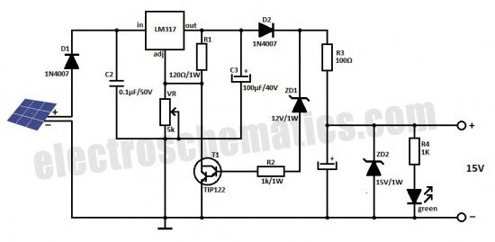
Connect the circuit to the solar panel and measure the input voltage. Make sure that it is above 18 volts. Connect the circuit to the battery with correct polarity and adjust VR till LED lights. This indicates the conduction of ZD2 and output voltage. Use heat sinks for LM317 and TIP 122 to dissipate heat.
Note : The same circuit can be modified for charging different types of batteries. The only modification required is the change of ZD1 and ZD2. Select ZD2 value for the required output voltage and ZD1 for cut off voltage level. For example for 6 volt battery, ZD1 should be 6.1 volts and ZD2 6.8 volt. For Mobile battery, ZD1 should be 4.7 volts and ZD2 5.1 volts. All the other components remain same.

Cellphone Charger Using Bike Battery
Posted by D Mohankumar
This is the simple and easy way to tap current from a Motor Bike battery to charge the Mobile Phone. Most of the Mobile Phone battery pack has three 1.2 volt cells making the voltage to 3.6 volts. For fast charging of the battery pack, each cell requires more than 1.2 volts and sufficient current. This circuit can deliver 5 volts at 300 mA to charge the battery quickly. The circuit is Voltage and Current regulated and with Polarity and Surge protection components.

Mobile Charger using Bike Battery Circuit Schematic
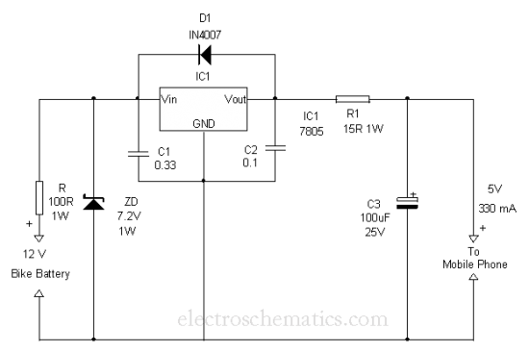
The circuit uses a Positive Voltage regulator IC 7805 to give 5 volt regulated output. The components around IC1 are meant for protecting the IC so as to give smooth output power. Zener diode ZD act as the Input Surge protecting diode. It provides 7.2 volts to the input of the regulator IC from the 12 volt bike battery. Diode D1 is the Output Surge and Input Short protecting diode.
When a surge voltage exceeding maximum voltage rating of the regulator is applied to the input or when a voltage in excess of the input voltage is applied to the output, the regulator will be destroyed. If the input terminal shorts with the ground, the output voltage increases above the input voltage(ground potential)and the charge in the capacitor connected to the output flows into the input side which is also fatal to the regulator. Both these situations can be avoided by using the Zener at the input and the diode D1 across the regulator. Capacitor C1 and C2 provide stability to the regulator and these should be soldered close to the legs of the regulator. Capacitor C3 act as a buffer to give constant voltage in the output.
7805 Datasheet
7805 IC can tolerate maximum 35 volts and its current rating is 1 Amps maximum. Resistor R1 restricts the charging current to around 330 mA as per the Ohms law. Even if the current is low, charging process will not be affected. Slow charging with 80 to 100 mA current is generally advised. But in case of an emergency, quick charging can be done with high current
Assemble the circuit on a Perfboard and enclose in a small case that can be fitted near the Bike battery. Use suitable pins to connect with the Mobile phone. Charging current can be tapped from the battery using Alligator Clips. Before using the circuit, double check the connections especially the polarity of connectors and measure output voltage and current using a Digital Multi Meter. The same circuit can be used for charging Mobile battery from 12 volt Car battery or from a 12 volt Solar panel.

IC 7805 Pin connection and Alligator Clips
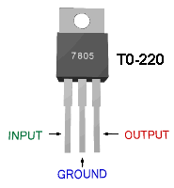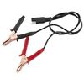

DIY Solar Tracker System
Posted by Popescu Marian
The solar panels are operating at optimal parameters when they are at the perfect right angle to the sun. Unfortunately this is accomplished only if solar panels are rotated by the sun. This is the purpose of this diy solar tracker system.
The solar tracker circuit uses a window comparator to maintain the motor in a idle state as long as the two LDRs are under the same illumination level. In this case, half the voltage is applied to the noninverting input of A1 and to the inverting input of A1.

Solar Tracker Circuit Schematic
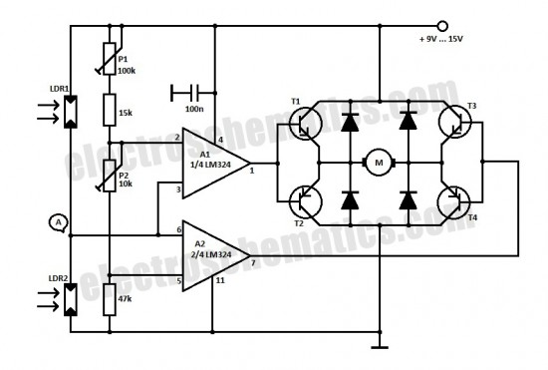
simple diy solar tracker system schematic
solar tracking components
- T1, T3 = BD239, BD139
- T2, T4 = BD240, BD140
- A1, A2 = 1/2 of LM324
- Diodes = 1N4001
When the sun position is changing so does the illumination level on the LDRs and the input voltage for the window comparator is no longer half of the supply voltage thereby the output of the comparator generates informations for the motor that rotates the panels for tracking the sun.
diy sun tracking sensor
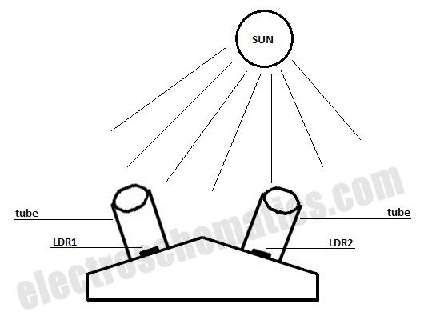
diy sun tracking sensor
P1 and P2 are adjusted in such way that the motor stands still when the LDRs get the same amount of solar light. If less light reaches LDR2 than LDR1, the voltage in point A increases to more than half of the power supply voltage. As a result the output of A1 is HIGH and T1 and T4 transistors conduct. In this situation the motor is starting.
If the angle of the solar light is changing again and the voltage in point A decreases at less than power supply voltage, the output of A2 goes HIGH and T3 and T2 transistors conduct. As a result the motor is rotating in opposite direction.
For solar panels control is best to use small motors with a suitable voltage and a maximum working current of 300 mA. This solar tracker system is used for tracking the sun only in one plane, the horizontal one. If you want to track the solar light in the vertical plane you need to build a separate sun tracker circuit.
Analog Solar Panel Tracker Circuit by Bien Fallaria
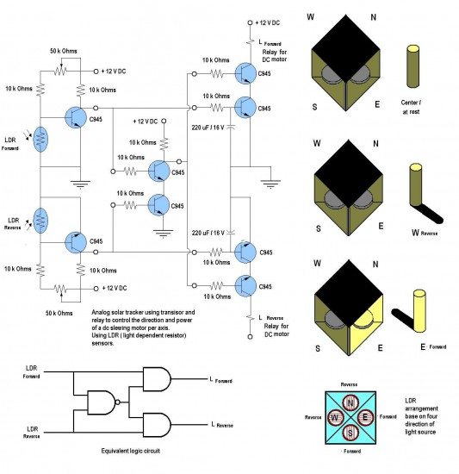
analog solar tracker circuit schematic by Bien
This is a simple and practical analog solar panel tracker circuit. Using four LDR (light dependent resistor) as a sensor in detecting the light source arranged as illustrated. When the light hit the LDR in a certain position, it will activate the circuit and trigger the relay to turn the slewing motor in the right direction until the sensor is fully shaded under its cover stopping the motor to its rest condition.

Turn Off Battery Charging from Solar Panel at Nightfall
Posted by Popescu Marian
When loading a battery during the day from a solar panel it can be partially discharging through the panel after nightfall. This solar panel power switch circuit replaces the diode and connects the panel to battery through a relay contact.
When the power supply voltage is too low the relay is not ON, so the battery is not connected to the solar panel.
When the voltage is high enough to engage the relay and the LDR receives enough light in order to open T1, the relay will switch and the battery will charge.
The relay remains ON even when the solar panel voltage starts to decrease. A battery connected and charged can not action the relay when the light intensity decreases because R2 will block T1. The brightness at which this occurs is set by P1.
Because the power consumption is determined primarily by the relay, it is important that the relay should be a miniature one, with high coil resistance but also be capable to switch up to 10 Amps.

Solar panel power switch schematic
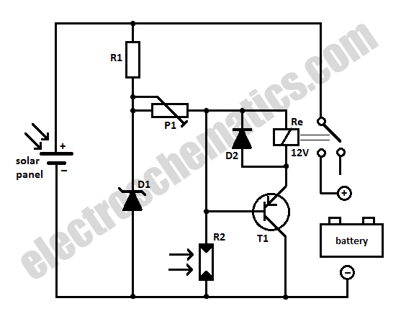
Components list for solar panel to battery switch
R1 = 100Ω
R2 = LDR05
P1 = 25K
D1 = zener diode 9.1V / 1W
D2 = 1N4148
T1 = BC557

Battery Charger using Solar Cells
Posted by D Mohankumar
Here are two battery chargers using solar cells to capture light energy for battery charging. It converts light energy into electrical energy. Simple and ideal energy savingdesigns.
Here are two battery chargers using solar cells to capture light energy for battery charging. It converts light energy into electrical energy. Simple and ideal energy saving designs
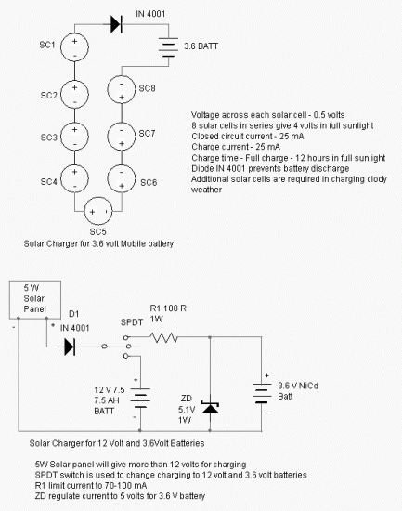

Portable Solar Power Inverter
Posted by T.K. Hareendran
A compact and portable 12V solar power inverter circuit that will keep away darkness. This tried and tested design converts 12V DC from the storage battery of any solar power system to 230V AC that is enough to power a number of energy saving CFLs. Just feed 12V DC input through input jack J1 (with right polarity) and flip switch S1 to ON position!
The solar powered inverter circuit, optimised for CFL loads, uses IC CD4047B (IC1) as a freerunning astable oscillator. Capacitor C2 and resistor R2 are timing components. The pulse repetition rate of IC1 is determined by the value of 4.4xC2xR2. IC1 generates cmplementary squarewave signals at its output pins 10 and 11. Power Mosfets T1 and T2 serve as drivers for the high-voltage generator,realised using step-up transformer (X1).
Note that an ordinary (AC 230V to 12-0-12/5Amp) step-down transformer is here used for reverse function (step-up) and its output is available at AC mains outlet J2. You can light up two to four low wattage (ie 11W at AC 230V) ready-made Compact Flourescent Lamps (CFLs) using this portable solar power inverter circuit. Two small, independent heatsinks are necessary for T1 and T2. Finally, you can try an AC 230V to 9-0-9/5Amp rated transformer as X1.

12V Solar Power Inverter Circuit Schematic
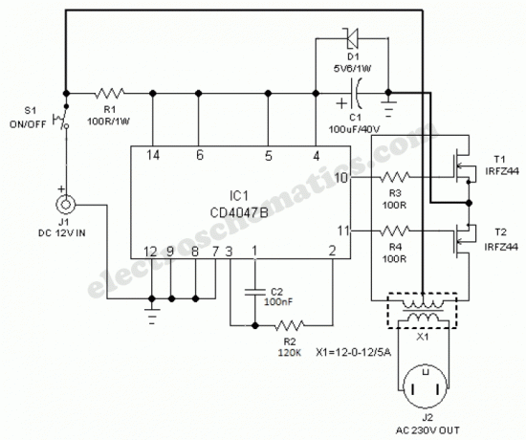

12V to 120V Voltage Inverter Circuit
Posted by Popescu Marian
Here is a simple 12 volt inverter circuit. This 120V AC power source is built with a simple 120V:24V center-tapped control transformer and four additional component. This circuit outputs a clean 200-V pk-pk square wave at 60 Hz and can supply up to 20W. The circuit is self-starting and free-running.
If Q1 is faster and has a higher gain than Q2 is will turn on first when you apply the input power and will hold Q2 off. Load current and transformer magnetizing current then flows in the upper half of the primary winding, and auto transformer action supplies the base drive until the transformer saturates. When that action occuts, Q1 loses its base drive. As it turns off, the transformer voltage reverse, turning Q2 on and repeating the cycle.

12VDC to 120AC Inverter Schematic
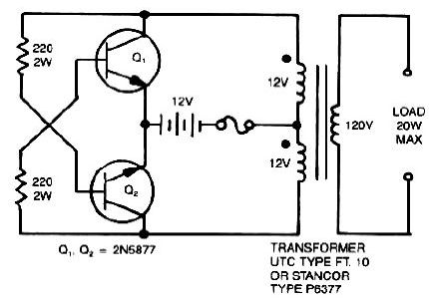
The output frequency depends on the transformer iron and input voltage but not on the load. The frequency range between 50 to 60 Hz with a 60-Hz transformer and car battery or equivalent source. The output voltage depends on turns ratio and the difference between input voltage and transistor saturation voltage. For higher power, use larger transformers and transistors.
This type of 12V inverter normally is used in radios, phonographs, hand tools, shavers and small fluorescent lamps. It will not work with reactive loads (motors) or loads with inrush currents, such as coffee pots, frying pans and heaters.

Infrared Headphones Receiver Circuit
Posted by Popescu Marian
Use this infrared headphones receiver with the ir headphones transmitter.
Use 600Ω headphones. BPW41N and BP104 have a filter for visible light and are centered on 950nm at 25⁰C.
At normal light illumination and 3 to 4 meters distance the audio distorsion were 1 – 2%, wich is not bad for such a simple ir headphones receiver schematic

IR headphone receiver circuit diagram
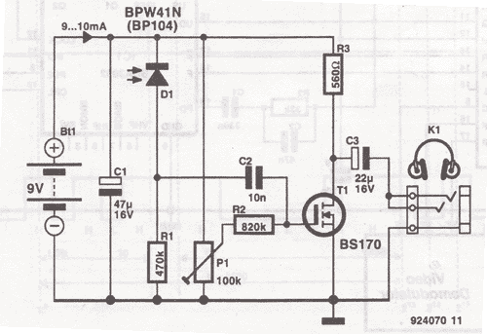

Infrared Headphones Transmitter Circuit
Posted by Popescu Marian
The transmitter offers a optical link (infrared) for headphones. Three infrared leds (ir) are polirised by T1 current, P1 is used to adjust the current level . Current consumption of this headphones infrared transmitter is about 60mA at 9V.
Maintain separated adapter ground and audio signal ground to prevent current reactions thru LED. The optical link is relative directional and can be improved by placing the leds in different angles and placing reflectors behind them.
The optimal input audio level is 100 – 200mV for 1.2 – 2.4 m coverage of this headphones ir transmitter. On the site we provide the infrared receiver schematic for this infrared headphones transmitter.

Infrared headphones transmitter circuit
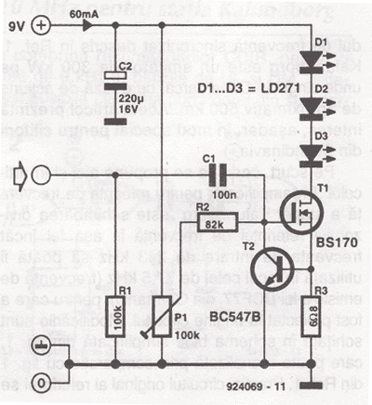

Basic Infrared Transmitter Circuit
Posted by Popescu Marian
This infrared tranmitter is intended for use with this infrared receiver.
It works with 2 – 1.5V batteries or a 3V lithium battery. To give a compact infrared device assembly and still a good frequency stability, the circuit uses a oscillator with outpashing network. Current consumption depends on power supply and duration as S1 remains pressed. When Ub = 2V, the frequency is 29.3 kHz, the LEDs top current is 25 mA and total current consumption is 27 mA.
When Ub = 3.2 V, freq is 30.4 kHz, the top current through each led is 64 mA and total current consumption is 67mA. At this voltage the distance between receiver and transmitter prototype was 13 meters.
Current consumption may be reduced by connecting with S1 in series a parallel group RC (R = 10 k Ω; C = 1000uF/6.3V).
By pressing S1 result only a short current impulse. Even if S1 remains pressed, the current can not exceed 300uA.

Infrared transmitter circuit schematic
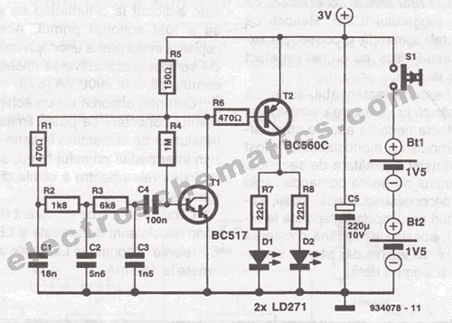

Infrared Switch Operated by Remote
Posted by Popescu Marian
SFH505A made by Siemens combine infrared diode receiver, amplifier, demodulator and a filter band pass for minimizing interferences. This circuit work together with this infrared transmitter.
The output signal of IC1 has the impulse duration limited to a maximum value. This fact is exploited by the associated transmitter for obtain a maximum radius action.
Most commercial remote controllers uses modulated data transfer, in which impulses width is smaller than that which can work IC1. Please note that remote transmitters from Sony or Philips have no effect on this circuit.
Diode D2 indicates that IC2a has received an release impulse. If interference occur due to other remotes, this is indicated by D2. The exit of IC3a acts one of the relay through T1. Meanwhile, it triggers monostable IC2b, which operates the second relay on the path IC3b and T2. In this way the second relay is operated from a half-second after the first has been operated. This allows coupling in two steps of some appliances. Diodes D3 and D4 dignals relays activation. The relays can switch up to 2000 VA (8A).
The circuit absorbs about 0.6mA when relays are disabled and LEDs are off. With relays and LEDs on, it grows to 125 mA.

Infrared switch circuit schematic
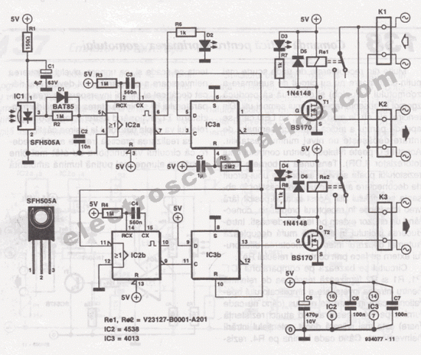

High Power IR Infrared Transmitter
Posted by D Mohankumar
This Infrared transmitter can activate IR based switching circuits from a distance of 10 meters or more. It is a high power IR transmitter driving two IR LEDs through a Darlington transistor BD 139 to increase range and directionality.
IC CD 4047 is wired as an Astable multivibrator and its output pulses depend on the values of C1 and VR1. By adjusting VR1 the output frequency can be adjusted from 10 KHz to 60 KHz. High output from IC1 is available from its Q output (Pin 10) which is used to drive the NPN Darlington transistor BD 139. Resistor R4 restricts the power of IR LEDs to a safer level. Q_ (Pin 11) is the complimentary output of IC1 which is used to connect the indicator LED which flashes in sympathy with the IR signals.

Infrared Transmitter Circuit Diagram
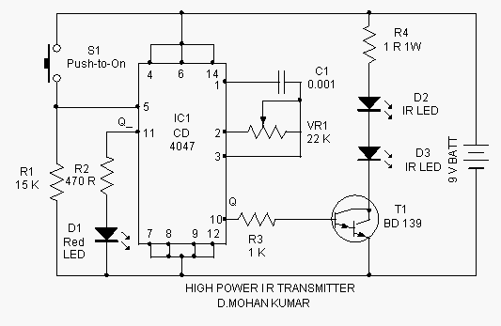

Shadow Sensor Alarm
Posted by T.K. Hareendran
Shadow sensors are widely used to detect the movement of a person in a confined area. Many circuits published earlier have a serious drawback that only one light dependent resistor (LDR) is used for shadow detection.
Needless to say, this is not a perfect solution!

Shadow Sensor Circuit Schematic
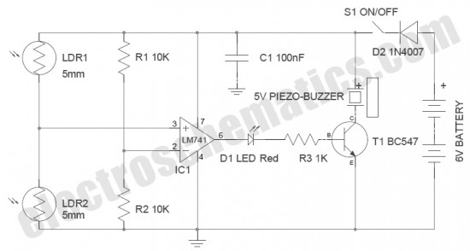
buy the components for this shadow sensor alarm project
- 741 IC
general purpose OP-Amp
- 5V Buzzers – wide range of 5 volts buzzers
Described here is a simple but improved circuit of a smart shadow sensor alarm, which can register a shadow when there is a light difference. Here two 5mm LDRs are used with the popular Op-amp LM741CN to drive an active piezo-sounder when a “valid” shadow is detected. The whole shadow sensor circuit can be powered from four 1.5V AA cells (6VDC), or similar dc supply sources.
Notes
- Place LDR1 & LDR2 1 inch apart (LDR1 —— 1 inch —— LDR2)
- Diode D2 is not a crucial component. It is for input supply polarity protection only
- Current consumption of the lab prototype is 2 to 3 mA (standby) & 20 to 30mA (Active). Major “current consuming” component is the Piezo-Buzzer!
- The Piezo-Buzzer can be replaced with a 6V low-current electro-magnetic relay to drive external loads like an electric hooter. Remember to add a freewheeling diode (in anti-parallel configuration) across the relay coil

Wire Break Sensor Alarm
Posted by T.K. Hareendran
Circuit of a loop sensor based simple security alarm is described here. The sensor loop is nothing but a short length of thin enamelled copper wire, which bridges two input points of the electronic alarm circuit. When the loop is opened the alarm circuit fires an active electric/electronic hooter to raise an ear-splitting audio alert signal. The circuit requires 12 volt dc supply for proper working.
When the loop is closed, anode terminal of diode D1 is at ground level and transistor T1 is off. When the loop opens, capacitor C1 is quickly charged via resistor R1 and diode D1, whereupon mosfet T1 comes on so that the hooter (BZ1) is switched on. If the loop is closed again, initial condition is maintained by grounding the anode of D1 and this stops the charging of C1. However, C1 is disharged fairly slowly via R2, so that T1 is not switched off immediately! This ensures that the alarm remains active for a little more time and then goes out slowly. This timeout can be changed by varying the value of R1,R2 and C1. Mosfet T1 may be one of many types of popular n-channel power mosfet, but it should be able to handle the selected 12V hooter of your choice.

Wire break alarm circuit schematic
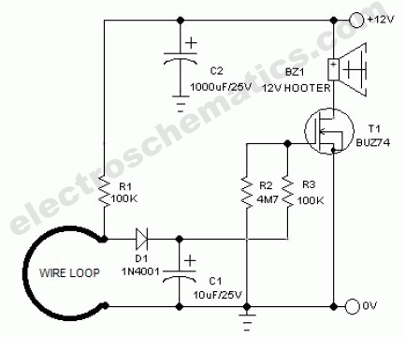

Tilt Sensor Alarm Circuit
Posted by T.K. Hareendran
Ultra simple circuit of the tilt sensor alarm presented here can be fabricated using readily available inexpensive components. The circuit is a true transistor based design. Home made Tilt sensor for this circuit is an ordinary little glass/plastic bottle with two metal needles inserted through its cap, and a small quantity of water inside.
You can also try your own ideas to make the tilt sensor. A 9V alkaline battery is enough for powering the whole circuit.

Tilt Sensor Circuit Schematic
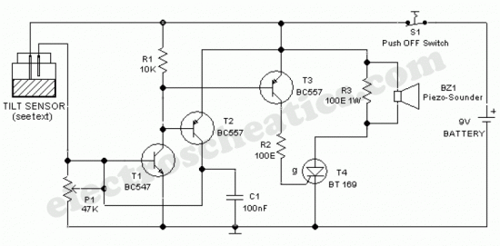
Usually, transistor T1 is in inactive state. When the sensor assembly is tilted, both needles inside the sensor (bottle) are short circuited by the water and a positive voltage is available at the base of T1 and it becomes active. Activation of T1 causes the activation of next transistors T2 and T3. After this, T2 supplies constant bias for T1 to make it latched and T3 triggers the SCR(T4) which inturn energises the active piezo-sounder(BZ1). Once activated the circuit can be deactivated by depressing the power/reset switch S1.
Preset pot P1 is deliberately added here to adjust the circuit sensitivity. This may become necessary if you are trying a different (readymade) tilt sensor. Similarly,SCR(T4) and piezosounder (BZ1) may be replaced with near equivalent parts. Resistor R3 (100-150 Ohm) is optional.

Water Switch Sensor Circuit

Posted by T.K. Hareendran
Possible applications for this water switch circuit: rain alarm, watertap leak detector, water level sensor for bathroom water heaters, wetness checker for flower pots and more. This circuit is nothing but a water activated solid-state switch (S201S02) capable of driving ac mains operated loads.
How does the water switch circuit works
Working principle of this circuit is very simple. When the sensor rings are bridged by water, an isolated electric switch turns on to activate the load (an alarm, for instance) connected through its switching contacts. Here, the renowned S201S02 solid-state relay (IC1) is wired as the electronic switch. Any low current 5VDC power unit can be used to feed input supply to the whole circuit.
As clearly indicated in the circuit diagram, two closely spaced metal rings are used as the water sensor mechanism. However, one can use two metal needles/injection needles to make the sensor.

Water Switch Circuit Schematic

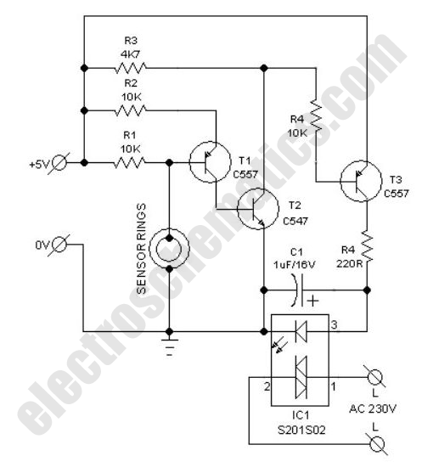

Water Level Sensor Circuit
Posted by Popescu Marian
This simple water level sensor circuit monitors the presence of water in a certain location or container. The circuit sends an acoustic alarm when it senses a drop of water leak. It is very simple to build and it is made of a single IC and some passive components. Check out the water level indicator circuit too!
The IC LM1801 is a low power comparator that can deliver high output current if needed. When water hits the sensor, the reference voltage is overshot and the IC drives the ceramic transducer to beep. It is also possible to connect several sensors to the water level monitor circuit. The sensor can be easibly made out of a small piece ofPCB that is etched with the proper pattern. The decoupling capacitor C3 is a 100uF/16V electrolytic capacitor.

Water Level Sensor Circuit Diagram

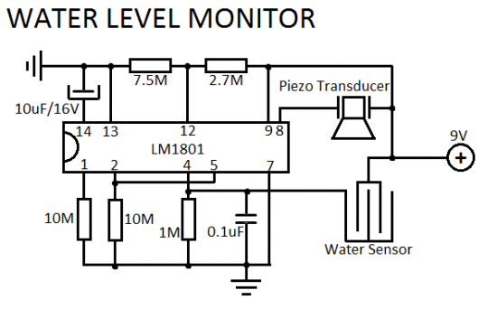

Logic State Indicator
Posted by D Mohankumar
Here is a simple logic state indicator to test whether the output of digital IC is in logic 1 or 0. The Bicolor LED lights Green when the logic state is 1 and lights Red when the logic state is 0.
The circuit uses only a few components and is based on the switching action of bipolar transistor. Normally the base of T1 is floating so that it will be off. This will allow T2 to conducts since its base gets bias through R2. The Red half of the bicolor LED lights indicating 0 logic. When the red probe connected to the base of T1 makes contact with a high signal output, T1 conducts and Green half of bicolor LED lights indicating logic 1. At the same time, T2 turns off and Red half of bicolor LED turns off. If the output is pulsating with alternate cycles, Red and Green LEDs lights alternately and if the transition is very fast both Red and Green LEDs lights giving yellow colour. The circuit can also be used as a continuity tester or Fuse tester.
Logic Stage Indicator Circuit Diagram

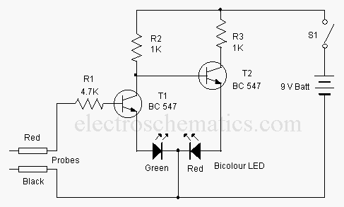

Battery Status Indicator Circuit
Posted by D Mohankumar
If an LED indicator is present in battery powered gadgets such as Emergency lamps, it will consume power even if the gadget is not using. This will reduce the battery voltage since the LED takes around 2 volts. So it is necessary to charge the battery continuously to keep the battery voltage level. This circuit eliminates this and the LEDs turn on only in two conditions. That is in the over charged and over discharged conditions only.
The circuit is basically a voltage controlled switch using Zener diodes. Two state LED indication is provided using a Bicolour LED. Zener diode ZD1 and the PNP transistor T1 forms the over discharge indicator switch. When the battery voltage is above the breakdown point of ZD1 (around 5 volts), it conducts and keeps T1 out of conduction. So the Red half of the bicolur LED remains off. When the battery voltage reduces below 5 volts, Zener turns off allowing T1 to conduct and Red LED turns on. This indicates that the battery is going to the over discharged state.
Zener diode ZD2 and NPN transistor T2 forms the Over charge indicator switch. When the battery voltage is below 6.8 volts (maximum voltage level), ZD cease to conduct and T2 remains off. So that the Green half of the LED also remains off. When the battery voltage increases above 7 volts due to overcharging, ZD2 conducts followed by T2 and Green LED turns on. This is the over charged state. In short, if the battery voltage is between 5 and 7 volts, both LEDs remain off. This reduces the chance of power consumption.

Battery Status Indicator Circuit

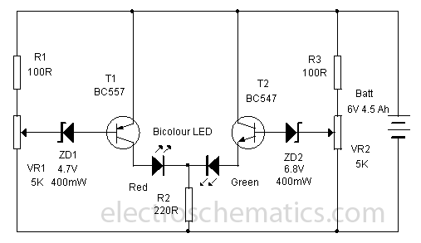

Setting
A variable power supply is necessary for the calibration. Provide 5 volts and adjust VR1 till Red LED turns on. At this point, Green LED remains off. Increase the voltage to 7volts and adjust VR2 till Green LED turns on. At this point, Red LED should remain off. Reduce the voltage to 6 volts. Both LEDs should be in the off state.Water Level Sensor PCB and Parts
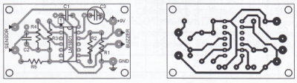
Water Level Indicator Circuit
Posted by Popescu Marian
This simple water level indicator will activate a buzzer in order to make a noise when a certain level of water is being reached. Because the water sensor and the command circuit are located on the same printed circuit board, indicator, together with its 9 V battery and the buzzer can be mounted in a compact case. Obviously the sensor, that is made by corossion, on the board, must not be mounted directly on iron or steel bathtubs but with a magnet atached on the case. Check out the new water level sensor circuit.

Water Level Indicator Circuit Diagram
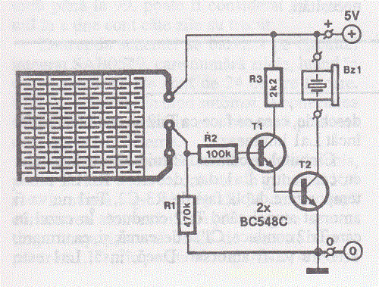
In order to avoid the scratching of the bathtub, the magnet can be covered with plastic or rubber. If the bathtub is made of polypropylene, the water indicator must be attached to it with two clamps or double adhesive tape.
When the water reaches the sensor T1 base is connected to the positive terminal. In consequence, T1 and T2 are opening and the buzzer it makes a buzz. The current consumption is now around 25 mA.
In order that the water level sensor circuit will not be put into operation by steam it may be necessary the reduction of the sensibility by increasing the value of R2. Is recommended to tin the PCB in order to avoid corossion.Water Level Indicator PCB Layout
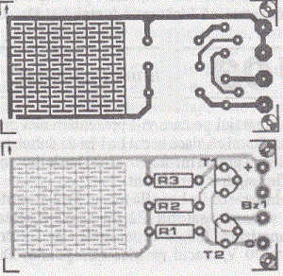

Simple Water Level Indicator
Posted by D Mohankumar
This is one of the simplest water level indicator that can give three indications –Full, Half and Low water levels in the overhead tank through LED indications. The circuit is too simple and uses a single IC and a few components.
The main part of the water level circuit is the 7 channel Darlington array IC ULN 2004. Its three inputs are connected to three probes to sense the water level and the corresponding outputs are connected to three LEDs through current limiting resistors R1 through R3. A common probe (probe A) is connected to the positive rail. When this probe gets electrical continuity through water with the probes B, C and D corresponding LEDs light.
Position of probe
Probe A Bottom of tank
Probe B Upper position of tank
Probe C Middle position of tank
Probe D Lower position of tank

Simple Water level Indicator Circuit diagram

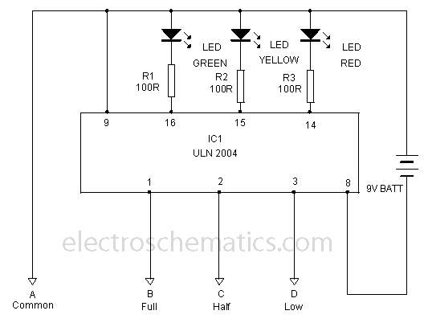

A very simple water level indicator using the ULN2004 Each pin rated at 500mA -600mA.

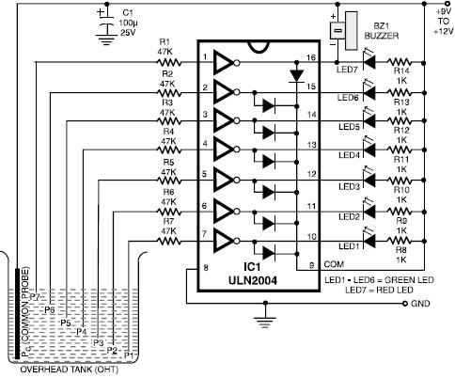
Settings
Assemble the circuit on a common PCB and enclose in a small box. This unit can be kept in a place for easy monitoring. Use brass or chromium plated pins as probes. Connect the probes with the unit using three core shield wire. Probes should be plugged into the tank through the side- Probe A and D in the lower position, Probe B in the upper position and Probe C in the middle position. If the tank is empty, only the probes A and D get current through water so that Red LED only lights. When the water level increases to half of the tank, Probe C gets continuity and Yellow LED also lights. When the tank becomes full, Probe B gets continuity and Green LED lights. In short, if Green, Yellow and Red LEDs light, tank is full. If Yellow and Red LEDs light, tank is half and if Red LED only lights, tank is empty.

TDA2030 Audio Amplifier Circuits
Posted by Popescu Marian
TDA2030 is a monolithic integrated circuit in Pentawatt package, intended for use as a low frequency class AB amplifier. It provides 14W output power (d = 0.5%) at 14V/4Ω at ± 14V or 28V, the guaranteed output power is 12W on a 4Ω load or 8W on a 8Ω
TDA2030 10W audio amplifier circuit
TDA 2030 audio amplifier can output 20 W but in this schematic we have reduced the power to 10W and we use 10w speakers.
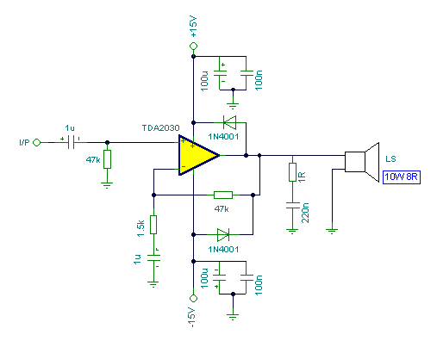

TDA2030 20W amplifier circuit
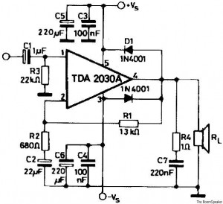
TDA2030 PCB layout
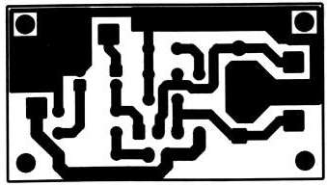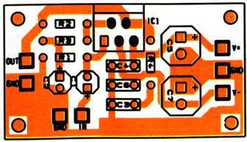
TDA2030 Assembly
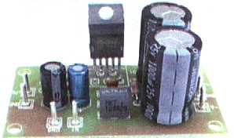

TDA2030 35W Bridged amplifier
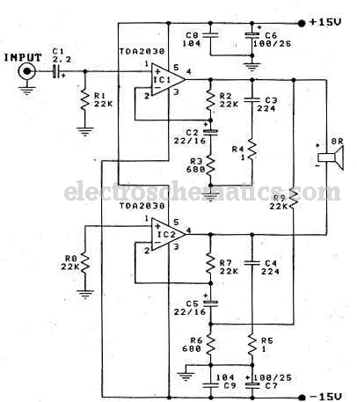

200W Hybrid Audio Amplifier Circuit
Posted by Popescu Marian
Connecting two TDA2030 thru cheap power transistors we can create a amplifier wich can deliver a higher power. With the components value from the schematic the total amplifier gain is 32 dB. The speaker can be 2 ohm instead of 4 ohm if we use the TIP transistors.
TDA 2030 is produced by SGS Ates and is a complete audio amplifier. AB class of the final amplifier cand deliver up to 14W on 4 ohm at a +-14V power supply. With a proper designed power supply this audio amplifier can output 200W.

200W audio amplifier circuit diagram
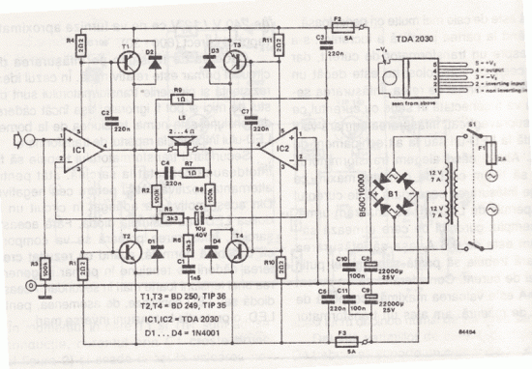
Active components:
IC1, Ic2 TDA 2030
T1, T3 = BD 250, TIP 36
T2,T4 = BD 249, TIP 35
D1 … D4 = 1N4001

RF Based Wireless Remote Control System
Posted by T.K. Hareendran
It is often required to switch electrical appliances from a distance without being a direct line of sight between the transmitter and receiver. As you may well know, an RF based wireless remote control system (RF Transmitter & RF Receiver) can be used to control an output load from a remote place. RF transmitter , as the name suggests, uses radio frequency to send the signals at a particular frequency and a baud rate.
The RF receiver can receive these signals only if it is configured for the pre-defined signal/data pattern. An ideal solution for this application is provided by compact transmitter and receiver modules, which operate at a frequency of 434 MHz and are available ready-made. Here, the radio frequency (RF) transmission system employs Amplitude Shift Keying (ASK) with transmitter (and receiver) operating at 434 MHz. The use of the ready-made RF module simplifies the construction of a wireless remote control system and also makes it more reliable.
RF Transmitter
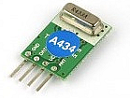This simple RF transmitter, consisting of a 434MHz license-exempt Transmitter module and an encoder IC , was designed to remotely switch simple appliances on and off. The RF part consists of a standard 434MHz transmitter module, which works at a frequency of 433.92 MHz and has a range of about 400m according to the manufacture. The transmitter module has four pins. Apart from “Data” and the “Vcc” pin, there is a common ground (GND) for data and supply. Last is the RF output (ANT) pin.
Pin Assignment of the 434MHz Transmitter module

Note that, for the transmission of a unique signal, an encoder is crucial. For this, I have used the renowned encoder IC HT12E from Holtek. HT12E is capable of encoding information which consists of N address bits and 12N data bits. Each address/ data input can be set to one of the two logic states. The programmed addresses/data are transmitted together with the header bits via an RF transmission medium upon receipt of a trigger signal. Solder bridges TJ1 and TJ2 are used to set the address and data bits.
The current consumption with a supply voltage of near 5.4V is about 10 mA. Since the current consumption is very little,the power can also be provided by standard button cells. Recommended antenna length is 17 cm for 433.92 MHz, and a stiff wire can be used as the antenna. Remember to mount the antenna (aerial) as close as possible to pin 4 (ANT) of the transmitter module.

RF Transmitter – Schematic Diagram
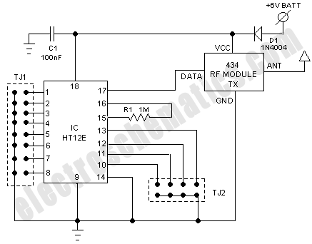

RF Receiver
This circuit complements the RF transmitter built aorund the small 434MHz transmitter module. The receiver picks up the transmitted signals using the 434Mhz receiver module. This integrated RF receiver module has been tuned to a frequency of 433.92MHz,exactly same as for the RF transmitter.
434MHz receiver module
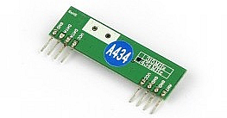
The miniature 434MHz RF receiver module receives On-Off Keyed (OOK) modulation signal and demodulates it to digital signal for the next decoder stage. Local oscillator is made of Phase Locked Loop (PLL) structure. Technically, this is an Amplitude Shift Keying (ASK) receiver module based on a single-conversion, super-heterodyne receiver architecture and incorporates an entire Phase-Locked Loop (PLL) for precise local oscillator (LO) generation. It can use in OOK / HCS / PWM modulation signal and demodulate to digital signal.
The receiver module has eight (4+4) pins. Apart from three “ground (GND) ” and two “Vcc” pins, there are two pins (one for Digital Data & other for Linear Data) for data output. Last is the RF input (ANT) pin.
Pin Assignment of the 434MHz Receiver module
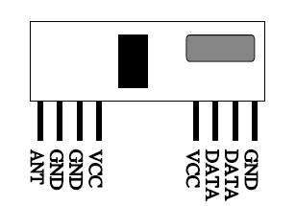
Pin Connections
- 1 Antenna
- 2 Ground
- 3 Ground
- 4 Vcc
- 5 Vcc
- 6 Linear Data (Normally NOT used)
- 7 Digital Data (Normally Used)
- 8 Ground
The “coded” signal transmitted by the transmitter is processed at the receiver side by the decoder IC HT12F from Holtek. VR1 and R1 are used to tweak the oscillator frequency of the decoder to that of the transmitter. Any possible variations due to component tolerences and/or a different supply voltage can be compensated by this arrangement. HT12F is capable of decoding informations that consist of N bits of address and 12N bits of data. HT12F decoder IC receives serial addresses and data from the HT12E encoder that are transmitted by the RF transmitter module. HT12D compare the serial input data three times continuously with the local addresses.
If no error or unmatched codes are found, the input data codes are decoded and then transferred to the output pins. The “Valid Transmission” (VT) pin also goes high to indicate a valid transmission.
For proper operation, a pair of HT12E/HT12F ICs with the same number of addresses and data format should be chosen. The data bits are set up using solder bridges RJ1 and RJ2. Output of the decoder is brought out on a pinheader K1 , making the logical signal available to circuits that need it. This output is also fed to the relay driver transitor T1. The RF Receiver circuit can be powered from a standard 5VDC supply. Just as for the RF Transmiitter, the aerial (17 cm for 433.92 MHz) has to be mounted as close as possible to the RF IN (ANT) pin of the 434MHz RF receiver module.

RF Receiver – Schematic Diagram
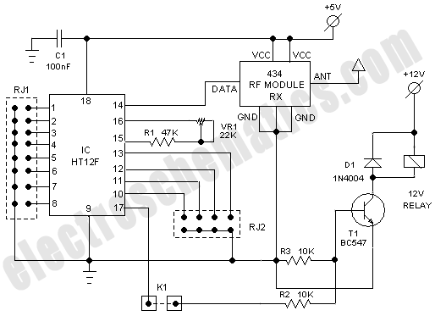
Notes
- RF transmitter circuit can be safely powered from DC 4.5V to 6V power supply. Here, diode D1 is added to introduce a 0.65V drop, but this is not very crucial
- The 434 MHz RF module (Tx &Rx) is available from many sources. Connection terminals are usually labelled on the PCB. In case of any doubt, refer datasheets of the RF modules
- In practice, the transmitter is usually powered by batteries. But you can power the receiver from an onboard /external dc supply too. In this case, make an optional “noise filter” arrangement , as shown here, to “clean” the 5V power rails of the 434MHz RF receiver module
optional “noise filter” circuit
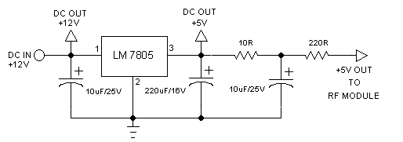

White LED Night Light
Posted by T.K. Hareendran
White Light Emitting Diodes recently available can be used as a powerful alternative to incandescent lamps in lighting applications. Today’s White LEDs are less expensive, draw much less current, and project a fairly well focused beam.
Described here is a simple circuit of an efficient White LED Night Light which can be directly powered from AC230V supply. First of all, note that a “capacitivetransformerless power supply” is used in this circuit.
Capacitive Transformerless Power Supply
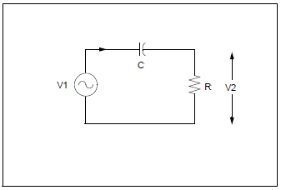
When a capacitor and resistor are connected in series to an AC source, as shown here, a constant current can be maintained through the resistor, so long as the reactance of the capacitors is much greater than the resistance. The current flow is dependent upon the value of the capacitor and assuming that V1 is much greater than V2, the value of the current can be assumed to be: I_{rms} = V₁/X_{C}, where X_{C} is the reactance of the capacitor. According to this, if we are using a 1uF capacitor , the current value is near 70mA at 230VAC/50Hz input. In order to get a DC voltage using this method, as usual, rectifiers and filter capacitors should be added.

Night LED Light Circuit Schematic
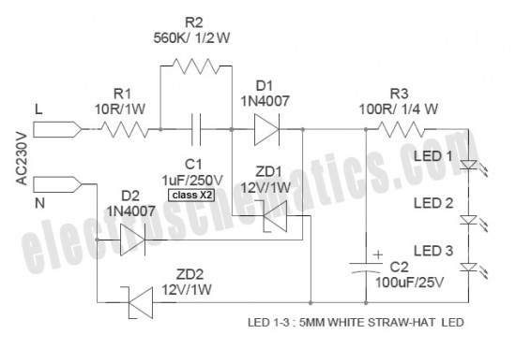
Here, a 12VDC /70mA (max) capacitive transformerless power supply is used to power three 5mm white straw-hat LEDs. One advantage of this circuit is that the output voltage will not climb to an unsafe level if the output load is absented by a fault in the white LED string. This safety mechanism is realized by adding two zener diodes (ZD1 & ZD2) as an integral part of the bridge rectifier unit. In an orthodox capacitive transformerless power supply based LED circuit, there is a risk of filter capacitor explosion in an open-load condition.
The circuit is straight forward and self-explanatory. Resistor R1 limits inrush current. The value of R1 is chosen so that it does not dissipate too much power, yet is large enough to limit inrush current. Needless to say, C1 is the important component. The maximum current flowing through the circuit components is controlled – almost exclusively – by the value of C1. Electrolytic capacitor C2 simply stores current for release to the load, and is rated at twice the voltage expected at output. Resistor R3 limits the operating current of the white LED string, comprising three white LEDs (LED 1 – 3) in series. This circuit is suitable for staircase, corridor, wardrobe, bedroom and bathroom lighting applications.
Notes
- An electrocution hazard exists during experimentation with this circuit. An isolation transformer (1:1) should be used when probing the circuit
- If the output load is increased, the behavior of the circuit changes in unexpected ways. So be careful while making your own modifications (not recommended) at the output load (white LEDs)
- Since the circuit is directly connected to the mains network, you naturally have to give adequate regard to safety when fitting it into a fixture. It is better to use a good quality water-proof plastic cabinet for enclosing the finished circuit

LED Night Lamp Circuit
Posted by T.K. Hareendran
The design of the LED night lamp circuit (bedroom light) is similar to that of many commercially available products. However, the light circuit does not use any kind of bulky and noisy stepdown transformers, but a capacitive potential divider is inserted in a simple manner to provide a constant current for driving the light source. Here a high-efficiency, low current blue LED is used as the light source. The design is safe, simple and stable!

Night Lamp Circuit Schematic
- 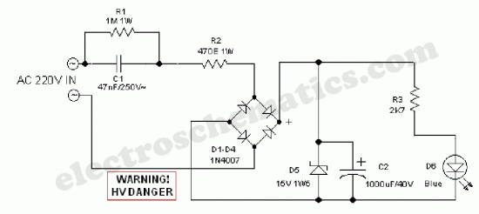
When input power (AC 220V) is available, capacitor C2 is charged through C1 and R2 and bridge rectifier assembly D1-D4. Zener diode D5 limits the voltage across C2 to a safe value of near 15V. This low voltage dc supply is then fed to the LED (D6) via current limiting resistor R3. When the input supply is removed, LED stays on unchanged for a short time and then diminishes gradually. No instant darkness when the supply is switched off!
After construction, enclose the circuit in a small plastic box. Drill a 5mm hole in the centre of the enclosure and fit the LED in a suitable LED holder in the 5mm hole. Finally fit a supply input socket and, optionally an on/off switch at the rear/side of the enclosure.
- WARNING! Great care should be taken when working with this led night lamp circuit since it is connected directly to the fatal mains supply.

White LED Flood Lamp Circuit
Posted by D Mohankumar
This White LED lights illuminates your porch with cool white light. The circuit is too simple and energy saving design. Its current consumption is practically nil but can provide light like a 20 watt CFL lamp. It is directly connected to AC lines to eliminate a bulk transformer.
Ultra White LED Lamps are now replacing the fluorescent lamps due to its energy saving property and simplicity of design. White LED emits 1000 to 6000 MCD light and easily works on 3 volts at 20 mA. White LEDs are available as spot light and diffuse type versions. Different sizes like 3mm, 5mm and 10 mm varieties are now common. High watt single white LED is also available. White LEDs was introduced in 1990 which uses Indium Gallium Nitride (InGaN) as the semiconductor. White LED contains a blue chip with white inorganic Phosphor.
When blue light strikes the phosphor, it emits white light. The circuit uses capacitive reactance to drop high volt AC to low volt AC. This reduces power loss due to heat dissipation. The value of the AC capacitor can be calculated using the formula X c= 1/ (2 π f C) where, Xc is the reactance in ohms, C the capacitance in farads and f the mains frequency. Xc = Vrms / I where Vrms is the input voltage and I is the current flowing through LEDs. The low volt AC (around 100 volts) dropped by C1 is then rectified by a full wave rectifier formed of D1-D4.
Capacitor C2 act as a ripple remover and buffer. Zener diode ZD regulates DC to 69 volts and prevents excess reverse voltage across the LEDs during the negative half cycles. R1 is a must in the circuit to bleed the stored current from C1 when the circuit in unplugged. C1 can store more than 400 volts for many days if R1 is not connected. This can give a lethal shock.
R2 reduces the inrush current. 20 LEDs are connected as a string to obtain luminance equal to 20W CFL. Enclose the circuit in a shock proof case. If a reflector is provided behind the LEDs, it will give a flood light appearance.
- Important! Do not touch any points or trouble shoot when the circuit is connected to mains.
- Caution This is an AC powered circuit and can give fatal shock if handled carelessly. Do not construct the circuit unless you are competent to handle high volt circuits.

LED Lights Circuit Schematic
- 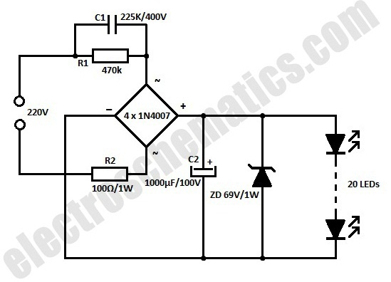

Automatic Night Lamp with Morning Alarm
Posted by Popescu Marian
This circuit project automatically turns on a night lamp when bedroom light is switched off. The lamp remains ON until the light sensor senses daylight in the morning. A super-bright white LED is used as the night lamp. It gives bright and cool light in the room. When the sensor detects the daylight in the morning, a melodious morning alarm sounds.
The automatic night lamp circuit utilises light-dependant resistors (LDRs) for sensing darkness and light in the room. The resistance of LDR is very high in darkness, which reduces to minimum when LDR is fully illuminated. LDR1 detects darkness, while LDR2 detects light in the morning.

Night lamp circuit how it works
When LDR1 is illuminated with ambient light in the room, its resistance remains low, which keeps trigger pin 2 of IC2 at a positive potential. As a result, output pin 3 of IC2 goes low and the white LED remains off. As the illumination of LDR1’s sensitive window reduces, the resistance of the device increases.
In total darkness, the specified LDR has a resistance in excess of 280 kiloohms. When the resistance of LDR1 increases, a short pulse is applied to trigger pin 2 of IC2 via resistor R2 (150 kiloohms). This activates the monostable and its output goes high, causing the white LED to glow.
LDR2 and associated components generate the morning alarm at dawn. LDR2 etects the ambient light in the room at sunrise and its resistance gradually falls and transistor T1 starts conducting. When T1 conducts, melody-generator IC UM66 (IC3) gets supply voltage from the emitter of T1 and it starts producing the melody. The musical tone generated by IC3 is amplified by single-transistor amplifier T2. Resistor R7 limits the current to IC3 and zener diode ZD limits the voltage to a safer level of 3.3 volts.
The night lamp with alarm circuit can be easily assembled on a general-purpose PCB. Enclose it in a good-quality plastic case with provisions for LDR and LED. Use a reflective holder for white LED to get a spotlight effect for reading. Place LDRs away from the white LED, preferably on the backside of the case, to avoid unnecessary illumination. The speaker should be small so as to make the gadget compact.

Night lamp with alarm circuit diagram
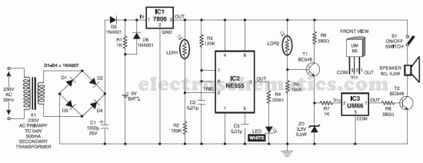

Automatic Street Light Circuit
Posted by Srihari Rao
There have been lot of problems in street lights. Major problem in some places is every evening a person has to come and switch ON the street light and it should be again switched off in morning. Yes, this may not be the situation in everywhere but exists in many places.
So this problem can be overcome by using a simple circuit. Below shown circuit will be automatically switched ON and OFF during night and morning times respectively.

Automatic light schematic
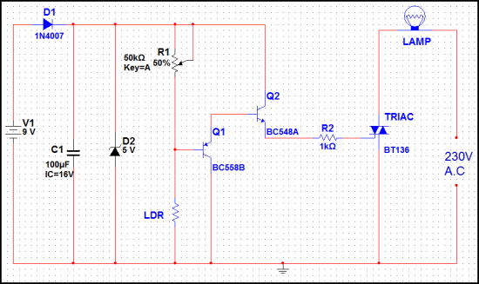
In above circuit R1 can be used to adjust the sensitivity. And the working of the circuit is very simple. The LDR will have very low resistance during day time so the transistor Q1 will be in OFF condition. And during night time the resistance will be very high so automatically the transistor Q1 will be ON.
The Q1 is PNP transistor and the emitter of Q1 is given to base of Q2. So the Q2 transistor will be ON only if the transistor Q1 is ON. The TRIAC is used in the circuit to make is circuit complete. As the TRIAC will allow voltage to pass from either directions only when there is a certain threshold voltage in gate terminal. And the gate of TRIAC is controlled by transistor Q2.
So totally the lamp will be ON during night time and will be again switched off during day light. To change the sensitivity of the circuit to light adjust R2.

Automatic Door Light Switch
Posted by Popescu Marian
This automatic door light switch circuit turns ON a lamp when a door is opened then turns it OFF when the door is opened again. The working principle of the light switch is quite simple. The bistables inside CMOS 4013 are conected in series. FF2 is configured as a R-S memory to store the state of the switch. S1 must switch as soon as the door opens that is why it will be mounted on the door jamb.
When the door will be opened FF2 is registered and its output (pin 13) will be 1.
This output, connected at the tact entry of FF1 (pin 3) will open T1 and activate the relay switching ON the light.
When the door is closed nothing will happen because FF2 is unregistered and its output (pin 13) passes in state “0″. Only when the door is opened again, FF1 will change its state and the output at pin 1 will block the transistor so the relay will be disconnected and the door light switch turns off the lamp.
The relay must operate at voltages between 5 V and 15 V.

Door Jamb Light Switch Circuit Schematic
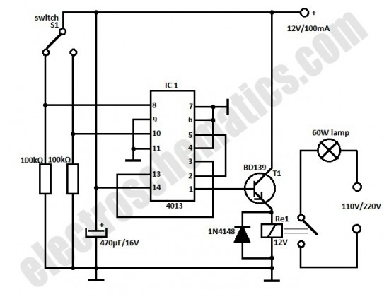
automatic door light switch circuit schematic

Solar Battery Charger Circuit
Posted by Jim Keith
This is the most simple and affordable solar battery charger that the hobbyist can make. It has a few drawbacks over other similar controls, but offers numerous advantages. It is intended for charging lead-acid batteries, but may also be used for charging any battery at a constant voltage. Voltage output is adjustable.
Advantages & Disadvantages of this solar charger
- + Simple, small & inexpensive
- + Uses commonly available components
- + Adjustable voltage
- + ZERO battery discharge when sun is not shining
- – High drop-out voltage—may be marginal for 6V application
- – Current limited to 1.5A
- – No LED indicators—no bells or whistles
Solar battery charger specifications
- Solar panel rating: 20W (12V) or 10W (6V)
- Output voltage range: 5 to 14V (adjustable) (may be reduced further by shorting R2)
- Max power dissipation: 10W (includes power dissipation of D1)
- Typical dropout voltage: 2 to 2.75V (depending upon load current)
- Maximum current: 1.5A (internally limits at about 2.2A)
- Voltage regulation: ±100mV (due to regulation of series rectifier)
- Battery discharge: 0mA (this control will not discharge the battery when the sun doesn’t shine)

Solar battery charger schematic
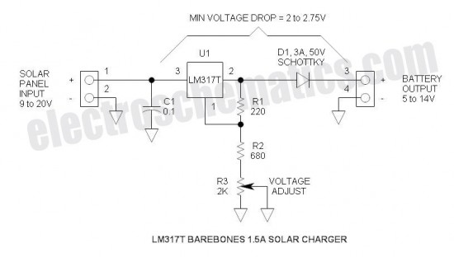
6V Applicaton
- Output Voltage: Set for 7V
- Input voltage:
  - Battery discharged (6V): 8.75V Min @ 1.5A (this is a little high for panels that are characterized for 6V applications)
  - Battery charged (7V): 9V Min @ 10mA (e.g.)
12V Application
- Output Voltage: Set for 14V
- Input voltage:
  - Battery discharged (12V): 14.75V Min @ 1.5A (Available from solar panel characterized for 12V operation)
  - Battery charged: (14V): 16V Min
Minimum Head Voltage
This is also referred to “drop-out voltage.” The input voltage must exceed the output voltage by about 2.75V @ 1.5A. Fortunately, when the battery discharged, the output voltage is lower so the solar panel voltage will also be lower.
When fully charged, the battery voltage will be high, but the current is very low—at this point, the drop-out voltage reduces to about 2V and the open circuit solar panel voltage also comes into play. The schottky rectifier was selected to reduce this head voltage requirement—the voltage drop of the schottky is about 0.5V @ 1.5A or about half that of a typical silicon rectifier.
More advanced controls have a much lower head voltage requirement and will function better under marginal conditions.
Maximum Power Dissipation
In this solar battery charger project the power is limited by the thermal resistances of both the LM317T and the heat sink. To keep the junction temperature below the 125°C Max, the power must be limited to about 10W. If a smaller or less effective heat sink is used, the maximum power dissipation must be de-rated. Fortunately, the LM317 has internal temperature limiting so that if it gets too hot, it shuts down thus protecting itself from damage. Max power comes into effect when charging a 12V battery @ 1.5A: e.g. battery voltage = 12V, solar panel = 18V. P = (18V – 12V) * 1.5A = 9W. So thermally, it is carefully matched to the current rating.
If a solar panel that is characterized for 12V is applied with a 6V battery, the maximum current must be reduced to about 0.7A: e.g. battery voltage = 6V, solar panel voltage = 18V. P = (18V – 6V) * 0.7A = 9.6W. In this case, the solar panel power may not exceed 10W.
When charging, the heat sink normally runs warm. When beginning to “top off” or completing the charge at maximum voltage, the heat sink runs hot. When fully charged, the heat sink runs cool. This heat is not exactly wasted power—it is excess power that is unneeded in the process of charging a battery.
Current Limiting
Current limiting is provided by the solar panel—it is not a commonly understood fact that the solar panel tends to be a constant current device. For this reason, a solar panel can withstand a short circuit.
Therefore, the control does not need current limiting.
Float Charge of Lead-Acid Batteries
This control charges the battery at a constant voltage and also maintains a charged battery (float charge). The float charge voltage specification is a little lower, so to accommodate both charge and float charge voltage, a compromise is reached by simply reducing the voltage slightly—that is how ALL automotive systems operate. To obtain maximum charge in a 12V battery, set the control to 14.6V. Automotive systems further reduce voltage to 13 to 13.5V in order to accommodate high temperature operation as the battery is usually located in the hot engine compartment—battery has a negative thermal coefficient of voltage.
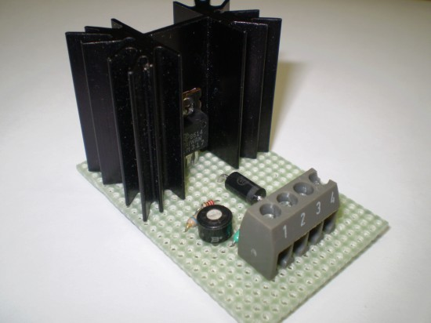
Application with other types of batteries
It is difficult to determine how to set the voltage in this case. The easiest way to do this is to charge the battery fully using other means and then transfer the charged battery to the control and connect an ammeter in series. Increase the voltage setting until there is significant current and then back off the potentiometer until the current drops to perhaps 10mA or so. Some types of batteries such as lithium ion types must be disconnected after charging to prevent degradation.
Solar Battery Charger Protection
C1 provides substantial protection against static discharge.
There is no protection against reverse polarity or mis-wiring. It is protected if solar panel is connected reverse without battery connected, or if battery is connected reverse without solar panel connected. However, if the battery or solar panel is misconnected simultaneously, who knows? anyone care to experiment?
TDA2822 is a audio amplifier IC available in 16 pin power DIP package. The operating voltage of the IC is from 3V to 15V DC. The IC can be operated in both BTL and stereo mode. TDA2822 IC can be used in for many purposes like as an amplifier in small radios, headphone amplifiers,
preamplifiers etc. The IC is able to deliver more audio output on the BTL mode on same voltage.

TDA2822 Amplifier

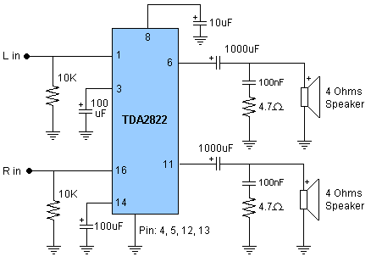

Transformer less Power Supply
Many times we want a simple power supply to operate our low power electronics or electronic circuits. Most of the power supplies use transformers but there is also some tricks to get voltage of your needs from transformerless power supplies. Transformerless power supplies are very

important and works well on the places where you have short place and low mA requirements. The circuit mentioned here is a simple and verastile power supply circuit which is capable of delivering any voltage from 3 to 12 volts by selecting suitable parts values you can obtain voltage of your needs.
Here are some details of part values you can change to get the required voltages.
For 3V Use R2 = 15K, D2 = 3V & C1 = 220µF
For 6V Use R2 = 12K, D2 = 6.2V & C1 = 220µF
For 9V Use R2 = 10K, D2 = 9V & C1 = 220µF
For 12V Use R2 = 10K, D2 = 12V & C1 = 470µF

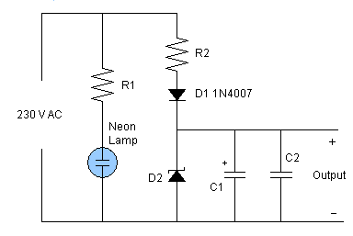
Lab Power Supply
This is a circuit of a lab power supply using LM7805, LM7806, LM7809& LM7812 ICs. The circuit is very simple to build and can be used for many purposes. The circuit is using LM 78xx series voltage regulator ICs which perform DC to DC converter or DC to DC step down tasks in electronic circuits. The circuit is ideal to use as a voltage source for different experiments in lab. The output current of these ICs are upto 1A. The input voltage can be any from 15 to 35 volt DC but it is better to apply 2 to 3 volt higher input voltage than output because the voltage difference will change in to heat dissipation from the IC. For more voltage difference between input and output use suitable heatsinks with the ICs. These ICs contain a built in overheat protection which will shutdown the IC automatically by overheat if heatsink is not sufficient. These ICs also contain short circuit protection which will protect it if there is any short circuit during experiment.

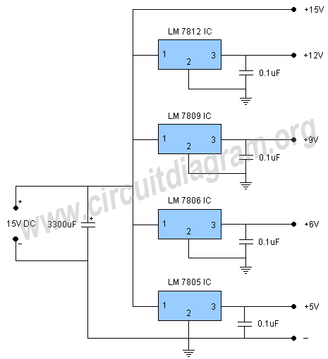
FM Stereo Transmitter
Schematic of a extremely well and crystal clear sound FM stereo transmitter circuit for broadcasting CD quality music on FM band. This circuit will perform variety of tasks like transmit your walkman, computer, iPod, discman, TV and other audio sources on FM receiver. The heart of the circuit is BA1404 FM transmitter IC, the circuit require only few external parts. The input voltage should be 1.5V to 3V DC, do not give more then 3 volt to the circuit it will damage the IC. Use 30cm copper wire as antenna, the L1 is 3-4 turns of 24 guage enameled wire wound on 5mm ferrite core or use ready made variable coil of 3.5 turns shown below.
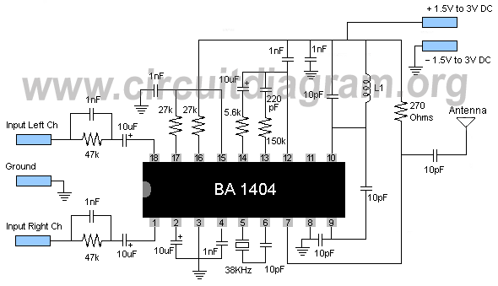
MP3 FM Transmitter
Here is a schematic which can be used as car mp3 FM transmitter circuit which can broadcast your mp3 player audio on your car FM radio so you can hear your favourite songs on your car FM radio. This circuit is very useful and can perform a variety of tasks for example you can broadcast your computer audio on your home stereo or any FM receiver, you can hear your tv audio on any FM walkman by putting the stereo plug of this circuit in the headphone jack so you can watch TV without disturbing to any one who is sleeping or taking rest. The preamplifier stage of this circuit is very good so it will broadcast good quality sound. L is equal of 2 turns of 24 guage enameled wire wound on 5mm former. Use 6 inch wire for antenna.

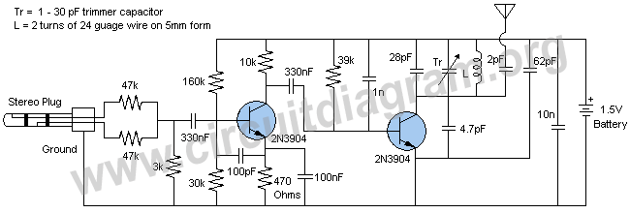
Simple AM Radio
In previous article abouthow to make a radio we have discussed a simplecrystal radio receiver circuit. The schematic mentioned here is also a simple AM radio circuit but it is not using a crystal, it is using high gain preamplifier stage of transistor BC 549. The circuit is using only few components to make a good quality am receiver. For making 200uH coil take a #26 enameled copper wire and wound 60 turns on a 1cm diameter and 7.6cm long ferrite rod. The circuit can be powered with a 9 volt battery.
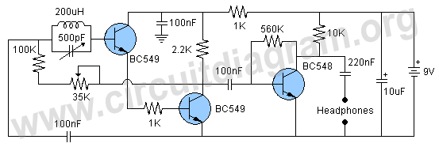

Simple AM Radio Circuit Using TA7642 IC
Here is a simple AM radio circuit using TA7642 IC which is similar to ZN414 IC. ZN414 IC was a very famous am radio IC among electronics enthusiasts few years ago but now it is no more available in the market because it has been discontinued several years ago and now TA7642 and MK484 ICs has taken its place and the performace of these ICs are similar to ZN414.
The circuit mentioned here is a simple am receiver which can be built in a short time if all parts are available with you. The Coil L1 is equal to 55 turns of 0.315mm (30 swg) enamelled copper wire wound on 10mm x 100mm long ferrite rod. You can also experiment with any am radio coil you have in scrap.
The antenna is not required with the circuit but you can use any wire as an antenna and a ground connection for further sensitivity. Using am loop antenna will also increase peformance greatly. The circuit can be operated with a 1.5 volt battery. Use crystal earphone with the circuit. If you want further audio amplification to drive a speaker use other circuits of am receivers in the Radio & RF circuits section.
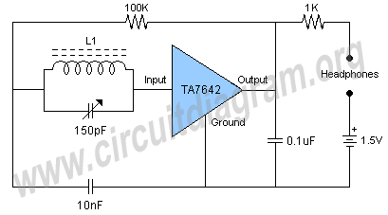
Solar Powered AM radio
Here is a project of a solar powered AM radio receiver circuit. The circuit is built around a MK484 AM radioIC. MK484 IC is a good quality am receiver IC comes in TO92 transistor package requires only few external components because all the necessary circuitry like RF detector, AGC, RF amplifier are incorporated inside the IC. The voltage source of this radio circuit is a 1.5 volt solar cell but you can also use a 1.5 volt battery in the place of solar cell if desired. The two 9014 transistors are used to amplify the audio output of the IC. The Coil L1 is equal to 55 turns of 0.315mm (30 swg) enameled copper wire wound on 10mm x 100mm long ferrite rod. You can also use any similar ICs like YS414 and TA7642 in the place of MK484. The sensitivity and selectivity can be further increased with the help of AM loop antenna.
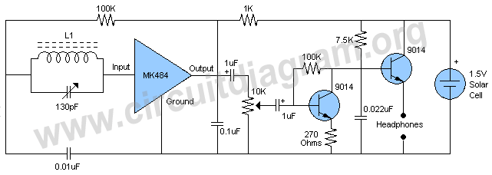
Temperature Sensor Using Diode
The figure below shows a project / schematic of a very sensitive, relaible and low cost temperature sensor using a 1N4007 diode. You might be thinking that how can a general diode perform a temperature sensing task? But it is true. A simple diode can sense temperature because their forward voltage change when the temperature change due to which you can make a good and working temperature sensor circuit with a low cost general purpose diode and without using a NTC thermistor or any other commercially available temperature or thermal sensors.
The Temperature Sensor Relay Switch Circuit shown here can also be very useful if you want to build a temperature sensor but you don't have an NTC thermistor in your hand.

In the place of relay you can also connect other load like you can make it atemperature alarm circuit by simply connecting a buzzer in the place of relay or you can also connect some LEDs to get visual indication. Also do not use the diode D2 if you are not using relay with the circuit.

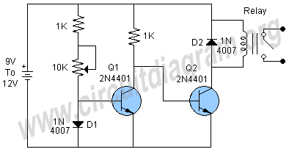

Temperature Sensor LED Meter
Here is a very easy and useful schematic of a temperature sensor LED meter circuit. The circuit can be used to sense high and low temperature levels and shows visual indications by lighting up the LEDs. The circuit is using four LEDs marked low, medium, high and very high temperature levels. You can also match the LED levels by a thermometer and write the number of centigrade or Fahrenheit with each LED.

By adjusting the 20K variable resistor you can match the circuit with your desire temperature level. For more accurate matching you can also experiment with other higher values thermistor like 100K, 500K or 1000K (1Meg) and also with higher values of variable resistor like 50K, 100K and 200K. You can also use a 3 volt piezo buzzer as sound indication in the place of LED 4.

For best results use same color and brand LEDs with same manufacturer because there is always some difference between LEDs from different manufacturers due to which they will not provide equal brightness on same current and hence the circuit will not provide accurate results. I have used 4 transparent green LEDs and they worked nicely.

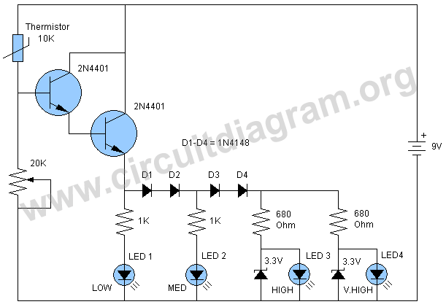

Water or Liquid Level Sensor Relay Switch
Here is a schematic of a simple water or liquid level sensor relay switch circuit, which can be used to switch on or off electronic appliances at the desired level of water. The circuit is ideal for automatically switch off the water pump when your water tank, pool or aquarium is filled. The circuit is very easy to build
and contains only few parts. The NPN transistor 2N2222 is working as a switch, when the two probes shown in the circuit will detect water the transistor become switch on and activates the six volts relay For operating the circuit with 12 volts use a 12 volt relay.

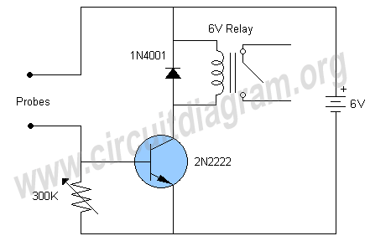
Rain Sensor Alarm
A rain sensor alarm circuit can be a very beneficial device for alerting when rainfall happens. The rain detector circuit shown here is very simple using only three components but is very sensitive to detect rain or moisture. The sensor part of the circuit can be easily made with verobaord or you can also make it in home by attaching thin metal strips on plastic or wood etc. The sensor can be made by several techniques, and performance of the circuit is also depends on the sensor. For better performance make sure to give no more than 1minimeter gap between the sensor strips.
Working of the Circuit:
Working of the circuit is simple the transistor BC547B is working as a switch in this circuit when the water droplets fall on the sensor the transistor will become switched on and the 9V will start passing through the transistor which will activate the Buzzer.

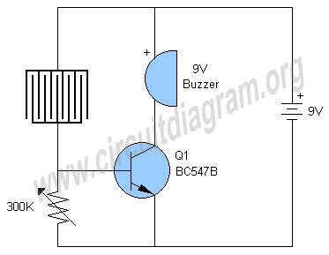

Telephone Amplifier Circuit
An easy to build circuit of telephone conversation amplifier. The circuit uses a common LM386 IC, the circuit require no power supply it will run by using the power from phone line.

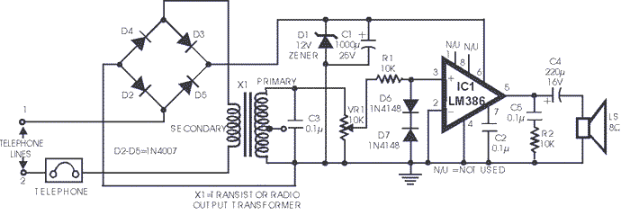
Moisture Level LED Meter
Here is a very simple and useful project of a moisture level LED Meter circuit that can be used as a sensor or detector to measure humidity or moisture level in plants, soil, wood, wall, floor etc. The interesting part of the circuit is four LEDs which will light up according to the moisture level and show low, medium, high and full level of moisture.
The circuit is using only one BC547 transistor that is working as a switch. The sensitivity of the circuit can be adjusted with 100K variable resistor. The operating voltage of the circuit is 12 volt DC but you can also operate it with 9 volt DC. For operating with 9V simply remove the D5 and D6 diodes and connect the 680 Ohm resistor near LED 4 directly with D4.

Note: Try to use all LEDs from a same manufacturer, same type and color because different manufacturers have different brightness LEDs and using them in the circuit will not show accurate results. I have used four green transparent LEDs and they worked very well.

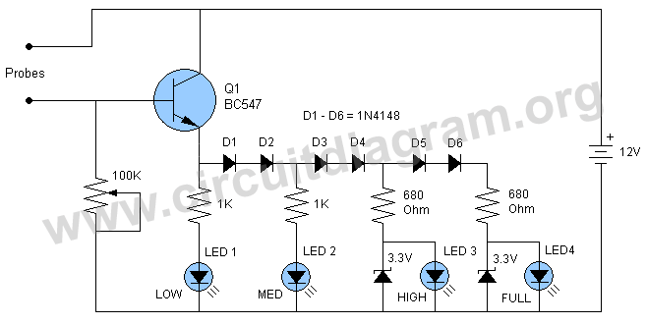

Wireless Water Level Indicator
This Here is a useful project of a wireless water level indicator circuit. The circuit can be used for many different water level indicator tasks for example you can use it as a water level alarm for water tanks, swimming pools, washing machines, aquariums or any type of liquid level detector task you want.
The good feature of the circuit is that it will detect your selected level of water and inform you wirelessly on a long distance by transmitting a beautiful melody on your fm radio. The circuit is ideal to use if you want to monitor the level of water from distance.
The project is using a UM66 CMOS melody IC and an FM transmitter circuit to transmit the melody on FM receiver. The 10K variable resistor is used to adjust the volume of transmitting melody. Coil L1 is equal to 2 turns of # 24 wire wound on 5mm form (Air Core) remove the form after winding the coil. TR is equal to 1to 30 pF trimmer capacitor which is used to adjust the transmitting frequency. For antenna use any 12 inch wire or for maximum range use 30 inch wire.
For tuning the circuit first of all connect the power and enter the two probes in water or use a 100 ohms resistor between them to switch-on the BC547B transistor to activate the melody and transmitter circuit (remember to remove this 100 ohms resistor after tuning the circuit) now tune your FM receiver on a blank dial and adjust the trimmer capacitor until you hear a melody.
Note: It is better to tune the circuit from a distance of 10 meters to make sure you have tuned a real frequency not harmonics.

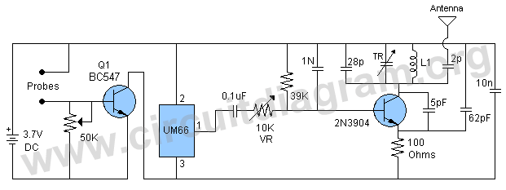

FM Receiver Circuit
Here is a portable good quality sensitive FM receiver circuit or FM tuner circuit. The circuit is build around the TDA 7021T IC which is a FM radio receiver IC. The IC requires only few external components and the required voltage is only 3 volts. The audio output is low so we have further further

amplified it with LM386 amplifier IC. You can also use other high power audio amplifier with it to increase the audio more. A high frequency tuned antenna amplifier circuit is used at the antenna input section of the circuit for increasing the sensitivity. You can change the frequency with the help of 25pF vairable capacitor. The Coil L1 is an air cored coil equal to 5 turns of 1mm silver plated wire wound on 4mm form.
This FM radio circuit is very portable and can be easliy fit in a small box with batteries.

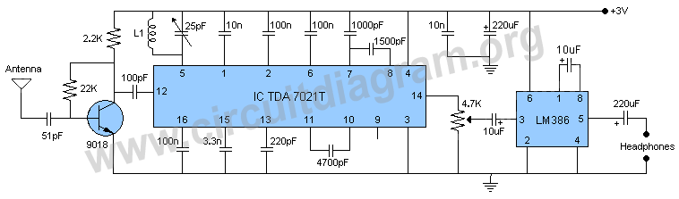
Rain Detector switch Using Relay
Here is a circuit of a rain detector switch using relay which can be used to switch off your electronic appliances outside the home when rainfall starts to prevent them from short circuit and damage and can also be used for many similar tasks. The circuit is using only few components and it can be operated with 6 volts DC. The sensor can be made by your own by simply attaching the thin metal strips on a piece of plastic or wood but make sure to give 1mm gap between the strips, you can also make it by using verobaord.
Working of the Circuit:
Working of the circuit is simple the transistor BC547B is working as a switch. When the sensor detects water the transistor become switch on and hence the 6 volts starts passing through the transistor, which activates the 6 volts relay.

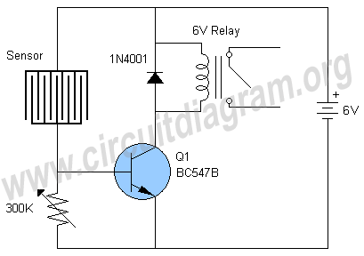

Dark Detecting Circuit
Here is a dark detecting circuit which will activate the relay in the circuit when there is no light on the surface of photoresistor. This dark detector circuit is very easy to build and using only few components. The photoresistor will switch on the transistor 2N2222 when there is no light on its surface. When transistor 2N2222 become in ON condition it will activate the relay. You can adjust the sensitivity of the circuit with the help of 50K variable resistor. Use 5-6 volt relay.

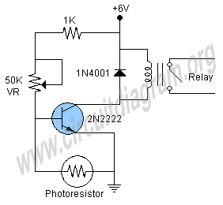

Water Level Alarm circuit
Here is the schematic of a water level alarm circuit. The circuit will work as awater level sensor and will give a melodious alarm sound when the two probes in the circuit will detect water. You can use this water level indicator circuit to detect the level of water in any place for example in swimming pool, water tank etc. The melody circuit is build around the famous CMOS Melody IC UM66 comes in TO-92 transistor package.
For using the circuit simply attach the two probes on the desired level of water on which you want the indication and make two to three inches gap between the two probes.

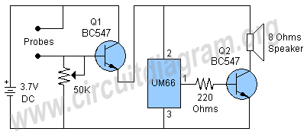

Understanding Small Signal NPN and PNP Transistors

Building virtually any electronic circuit from these small signal transistors and their complementary pairs may be feasible. This goes to show just how versatile and important these devices can be.
A BC547 transistor is a tiny three terminal device capable of converting small signal inputs into large amplified outputs, probably one of the greatest inventions of mankind so far. Even the most sophisticated chips to date have (millions of) transistors embedded within them and configured into complex circuits, assigned with many discrete and specific operations through different stages.
All transistors basically function in the same manner. They are broadly distinguished by their power ratings or power handling capacities. They may be also classified by their frequency handling capabilities and their amplification determining factor or hFE.
A BC547 is a general purpose, small signal transistor fit for almost all types of circuit applications and therefore extensively used for making an unlimited range of electronic gadgets today. Companies like NXP, PHILIPS, Micro Electronics, and FAIRCHILD, to name a few, are the leaders in manufacturing this device.
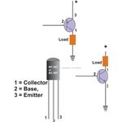
- The diagram shows the basic appearance of the transistor, which might differ slightly depending upon the particular make, however the technical specs and the pin-out assignments remain identical.

BC546, BC547, BC548, BC549, BC550, BC556, BC557, BC558, BC559, BC560 Transistors
