TITLE: PURE TORSION

OBJECTIVE

- To illustrate the theory of torsional stresses and twisting in a solid circular shaft

THEORY
Torsion test is a process that is used on materials to determine its properties such as the modulus of elasticity in shear, the torsion yield strength and the modulus of rupture. It is often used for testing if a materials is brittle or ductile according to way is fractures and can be tested in full-sized parts, i.e., shafts, axles and twist drills which are subjected to torsional loading in service.

For example,
Consider a cylindrical solid shaft of length l, and diameter d and having shear modulus G. Let this shaft be subjected to a pure torsion caused by a couple T applied so that the axis of the couple coincides with the axis of the shaft. The state of stresses at any point in the shaft, is one of pure shear, and strain is such that one cross-section of the shaft rotates to another.

If θ is the angle of twist through which one end of the shaft rotates relative to the other, it can be shown that:

where: T = Torque, Nm

J = Polar second moment of area,
τ = Shear stress,
G = Shear modulus,
θ = Angle of twist, rad
l = Length of shaft, m
d = Shaft diameter, m

EQUIPMENT/APPARATUS
The standard 1.7 kNm Torsion Testing Machine for manual or powered straining and with self-indicating Weighing Mechanism and Sliding Saddle was to be used.
The machine contained the following parts.
- The sliding saddle
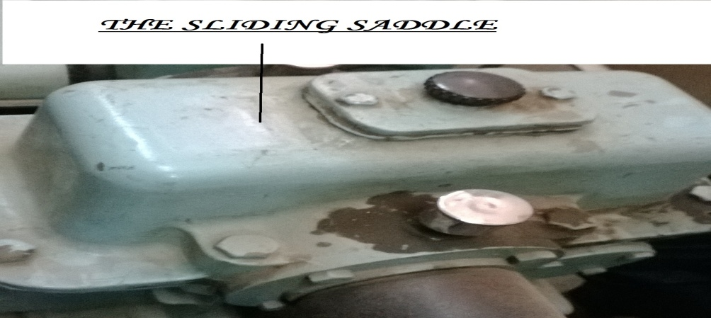

- Two clamp
- On of the clamps is fixed, and the other is in the driving end which rotates the specimen.
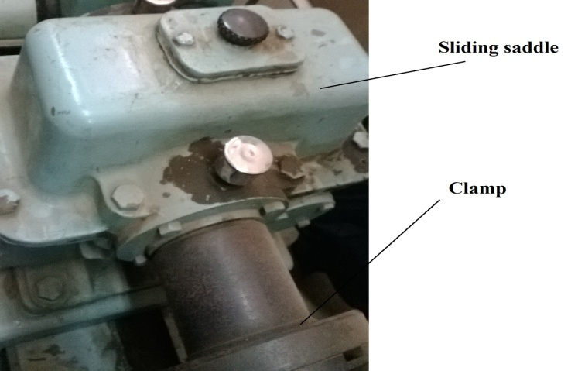
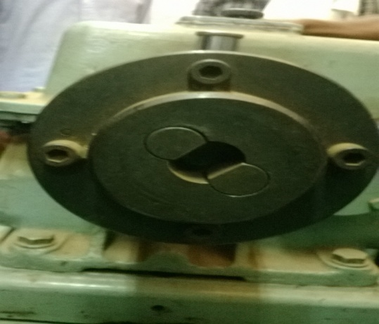

side view clamp

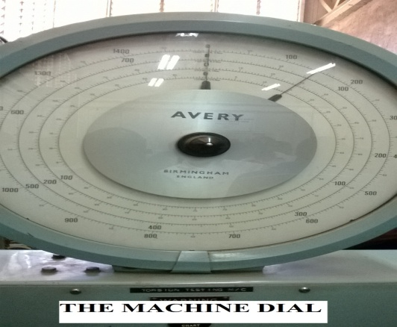
- The machine Dial or machine face

- The machine dial shows the amount of torque that is applied to the specimen during the test.

- The Gear box or the speed selector
- This is used for speed selection and the direction of the specimen.
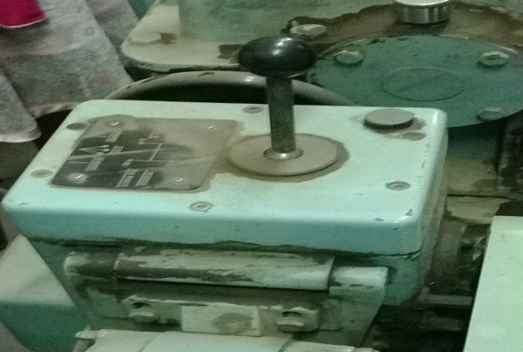

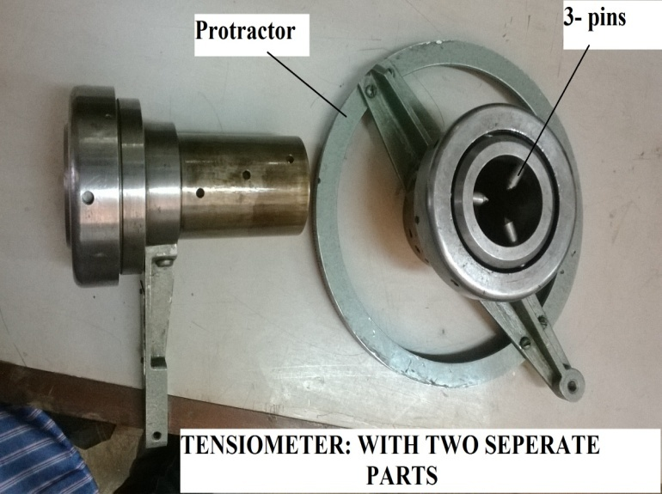
- The Tensiometer

- The tensiometer is consists of two separate parts that enables the twisting of the specime.
- Each part of the tensiometer has 3 pins the holds the specimen in place during the testing process.
- The tensiometer also has a protractor for easy reading of angle of twist.

- Specimens
A number of pre-prepared specimens were to used. The diameter of the specimens depend on the following factors:
- Available unit (apparatus)
- Material available which is to be tested.
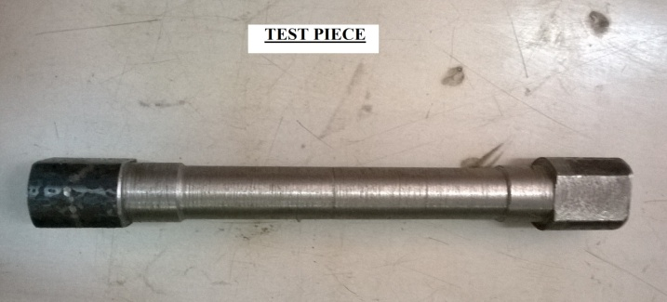
The machine which was to be used can accommodate 150mm, 175mm and 125mm diameter specimens. An example is shown below.

PROCEDURE

- Attach the angle indicator at the headstock of the machine.
- Mark out a suitable test length on the test piece, say 100 – 150 mm.
- securely clamp the specimen in two sets of jaws of the machine. Make sure the sliding saddle is securely locked on the machine bed.
- Clamp the moving jaws of the angle indicator to the test piece.
- Select a suitable load scale using the handle located below the dial face.
- Make sure the machine chuck is disengaged, start the machine
- Note the “zero” readings on the angle of twisdt and torque.
- Engage the chuck to rotate “forward”.
- At suitable load intervals (not exceeding 10Nm), take corresponding angle of twist readings.
- Continue until the specimen fails completely.
- Take particular note of the following:
- Torque and angle of twist around the yield point.
- Torque abd angle of rapture.
- Repeat the above procedure for other specimens of either different materials or dimensions.

DATA COLLECTION AND ANALYSIS

The experiment was not carried out. Hence no data was collected and to be analysed.

DISCUSSION
Since no data was collected the discussion was written based on the theory.

Considering a cylindrical bar with one end being twisted as shown in the figure below, the twisting moment M_{T} is resisted by the shear stress τ existing across the specimen section. This shear stress is zero at the center of the bar, increases linearly with its radius and finally reaches its maximum value at the peripheral of the bar. If the cylindrical bar with a length of L, the twisting moment can be related to the shear stress as follow
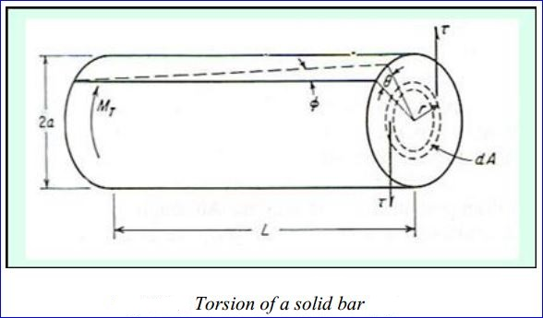

$$\frac{M_{T}}{J}=\frac{Gθ}{L} = \frac{τ}{r}$$
The shear strain, $γ$, can be calculated from the equation below
$$γ=tanθ= \frac{τθ}{L}$$

Where J is the polar moment of inertia, mm²
G is the shear modulus, N/mm²
$θ$ is the degree of rotation, rad
r is the radius of the cylindrical bar, mm
L is the length of the cylindrical bar, mm
$τ$ is the shear stress, N/mm²

Expected graph

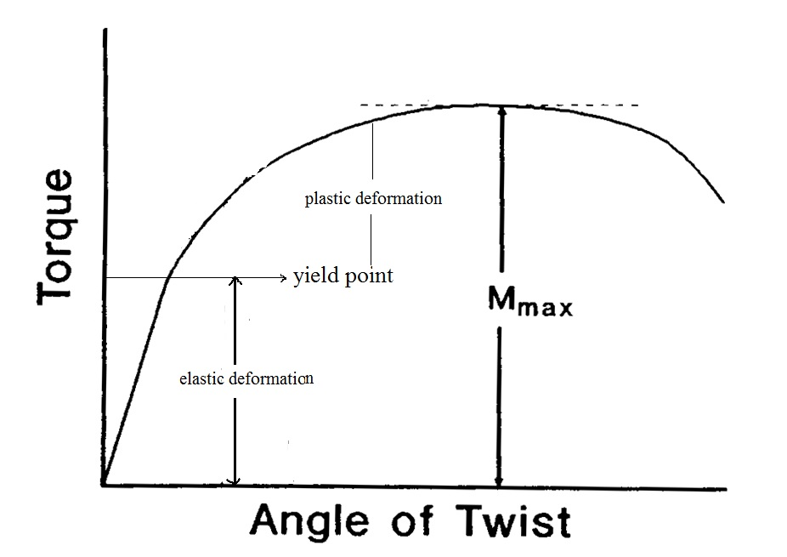

According to the graphical relationship of torque and degree of rotation, we can notice that the torsion specimen deformed elastically and then plastically similar to the case of the tension tested specimen. The initial stage of elastic behavior shows a linear relationship of torque and degree of rotation with its slope representing the shear modulus of the modulus of rigidity, G. The stress at the proportional limit is frequently determined at 0.04 rad.m of the gauge length. Beyond the proportional limit, specimen deformed in a plastic manner and the relationship between the torque and the degree of rotation is no longer linear.

Within the elastic range of deformation, the shear stress can be calculated according to equation given above.

For a solid cylindrical specimen
The polar moment $J= \frac{{πD}^{4}}{32}$, we can therefore determine the shear stress as shown in the equation below.
$τ= \frac{{M_{T}}_{2}^{D}}{\frac{{πD}^{4}}{32}}= \frac{16M_{T}}{{πD}^{3}}$

For a tube specimen
The maximum shear stress at the peripheral of the tube can be calculated from the equation below

$$τ= \frac{16M_{T}D_{1}}{π\left({D^{4}}_{1}- {D^{4}}_{2}\right)}$$

Where D₁ is the outer diameter of the tube
D₂ is the inner diameter of the tube

Types of torsion failures

Torsion failures are different from tension failures and normally provide little deformation or elongation. The characteristic of the fracture surface is related to the state of stress at the point on the bar surface, which can be described as shown in figure 2.

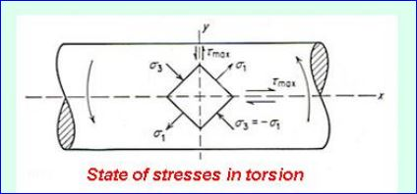

Figure 2.

It can be seen that the maximum shear stresses exist along two planes, which are perpendicular to each other. One is perpendicular to the longitudinal axis (yy) and another is aligned parallel to the longitudinal axis (xx). The principle stresses σ₁ and σ₃ are inclined at 45⁰ to the longitudinal axis and have their magnitudes equal to those of the shear stresses. The principle stress σ₁ is tensile while the principle stress σ₃ is compressive. The intermediate stress σ₂ is zero under torsion. As mentioned previously, the characteristics of torsion fractures are influenced by torsional and tensile forces. These result in two types of torsion failures; one is ductile failure due to the shear stresses and the other one is brittle failure due to the tensile stresses. The former produces the fracture surface along the plane of the maximum shear stress and more frequently normal to the longitudinal axis as shown in figure 3.

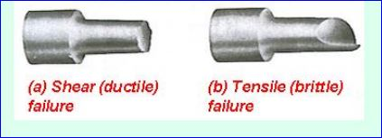

Figure 3.

The latter exhibits the fracture planes normal to the directions of the tensile stresses, which are 45⁰ to the longitudinal axis.

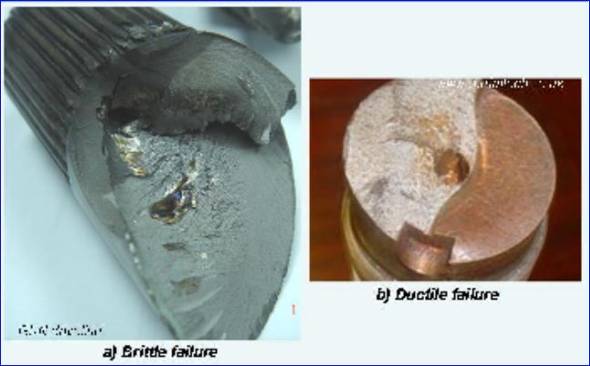

Figure 4.

The figure above (figure 4) shows brittle and ductile fracture surfaces observed from a driveshaft and a brass rod respectively failed under torsion. This means the driveshaft failed under a brittle manner influenced by the tensile stresses while the ductile failure of the brass rod was affected by the shear stresses. However, if the specimen fails into little pieces where the fracture plane cannot be determined, the fracture in this case is considered to start along the maximum shear stress parallel to the longitudinal axis of the specimen. In addition, it has also been shown in a study, which has indicated that the fracture characteristic is associated with the hardness of the tool steels. If the tool steel possesses the hardness values of higher than 720 VHN, failure is expected to be influenced by tensile stress. Conversely, if the hardness of the tool steel is lower than 720 VHN, the shear stress is responsible for such a failure.

CONCLUSION
The experiment wasn’t carried out, but according to the theoretical information the main objective of the experiment was achieved. The torsional and twisting stresses in cylindrical and circular shafts were illustrated.

REFERENCES
- EEE 3112, Laboratory manual; Torsion tests; The University of Zambia. 2014
- Dieter, G.E., Mechanical metallurgy, 1988, SI metric edition, McGraw-Hill, ISBN 0-07-100406-8.
- G. H Ryder., Strength of materials, 1969, Macmillan, London, UK

