
UNIVERSITY OF ZAMBIA
SCHOOL OF ENGINEERING

DEPARTMENT OF ELECTRICAL AND ELECTRONICS

EEE 3112 LAB REPORT 1

TITLE: PURE TORSION

NAME: KALIMANYONDO SIMWANZA
COMPUTER#: 27046184

ATTENTION OF: MR K MOONGA

1. OBJECTIVE
To illustrate the theory of torsional stresses and twisting in a solid circular shaft
2. EQUIPMENT/APPARATUS
- Standard 1.7 KNm Torsion Testing Machine for manual or powered straining and with self-indicating Weighing Mechanism and Sliding Saddle. Fig 1 shows the machine dial in for indicating the torsion force applied
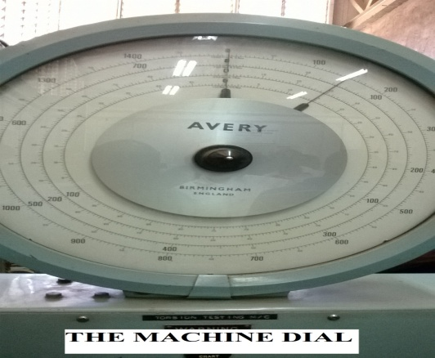

Fig 1
- 360Ο machine mountable angle of twist indicator/protractor

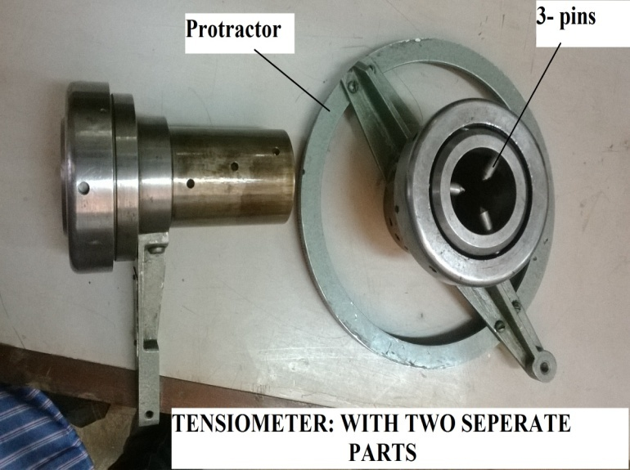

Fig 2

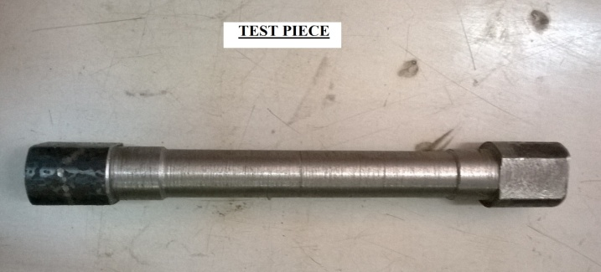
- A number of pre-prepared specimens. An example is shown in fig 3

Fig 3
3. THEORY
Torsion tests are made on materials to determine such properties as the shear modulus of elasticity, the torsion yield strength and the modulus of rupture.
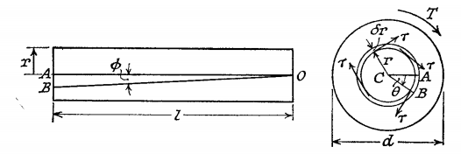
Consider a cylindrical solid shaft of length l, and diameter d and having shear modulus G. Let this shaft be subjected to a pure torsion caused by a couple T applied so that the axis of the couple coincides with the axis of the shaft. The state of stresses at any point in the shaft, is one of pure shear, and strain is such that one cross-section of the shaft rotates to another.
If θ is the angle of twist through which one end of the shaft rotates relative to the other, it can be shown that:
The left hand figure shows the shear strain Ø of elements at a distance r from the axis (Ø is constant T), so that a line originally OA twists to OB and ‹ABC = θ, the relative angle of twist of cross sections a distance l apart.
Arc AB =rθ =lØ approx.
But Ø =τ/r = Gθ/l (1)
The torque can be equated to the sum of the moments of the tangential stresses on the elements $2πrδr, i.e$
$$T=\int{τ\left(2πrdr\right)r}$$
$$=\left(Gθ/l\right)\int{\left(2πrdr\right)}r^{2} from (1)$$
$$=\left(\frac{Gθ}{l}\right)J$$
Where J is called the polar moment of inertia
Combining (1) and (2)
$$\frac{T}{J}=\frac{Gθ}{l}=\frac{2τ}{d}$$
Where: T = Torque, Nm
J = Polar second moment of area, m⁴
τ = Shear stress, N /m²
G = Shear modulus, N /m²
θ = Angle of twist, radian
l = Length of shaft, m
d = Shaft diameter, m

4. PROCEDURE
a) Attach the angle indicator at the headstock of the machine.
b) Mark out a suitable test length on the test piece, say 100 – 150 mm.
c) Securely clamp the specimen in two sets of jaws of the machine. Make sure the sliding saddle is securely locked on the machine bed.
d) Clamp the moving jaws of the angle indicator to the test piece.
e) Select a suitable load scale using the handle located below the dial face.
f) Make sure the machine chuck is disengaged, start the machine
g) Note the “zero” readings on the angle of twist and torque.
h) Engage the chuck to rotate “forward”.
i) At suitable load intervals (not exceeding 10Nm), take corresponding angle of twist readings.
j) Continue until the specimen fails completely.
k) Take particular note of the following:
(i) Torque and angle of twist around the yield point.
(ii) Torque abd angle of rapture.
l) Repeat the above procedure for other specimens of either different materials or dimensions.
5. RESULTS
The experiment was not conducted due to non operation of torsion testing machine.
6. DISCUSSION
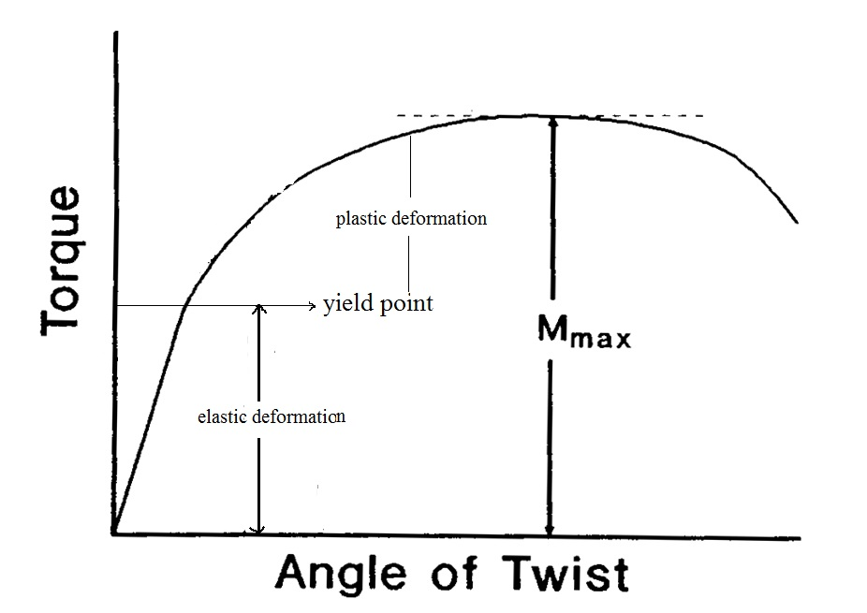
The torsion testing equipment was not working. However the expected toque-twist angle graph is shown below.

The angle of twist is measured in degrees and converted into radians $\left(θ X \frac{π}{180}\right)$ before plotting the graph. From the graph it can be seen that the specimen deforms elastically and then plastically in the same way as a tension tested specimen. The elastic region has a linear relationship with the slope indicating the shear modulus of rigidity (G). Beyond the proportional limit, specimen deformed in a plastic manner and the relationship between the torque and the degree of rotation is no longer linear.
- G – Strain Modulus can be calculated using the formula
$$G= \frac{Tl}{Jθ}$$
Where T is the torque reading on the machine, θ is the twist angle read from the twist indictor/ protractor and l is the gauge length of the specimen.
For a solid cylindrical specimen J the Polar second moment of area, m⁴ specimen is found using $J= \frac{π}{32}d^{4}$ with d diameter of specimen.
The shear modulus for cast iron is approximately 41,000 N/mm²

- The average total work done in twisting each shaft is found using
$$=\frac{1}{2}X\left(\frac{πD^{3}τ}{16}\right)X(\frac{2τl}{GD})$$
$$=\left(\frac{τ^{2}}{4G}\right)XπD^{2}l/4$$

$$=\left(\frac{τ^{2}}{4G}\right)X Volume of specimen$$
- Average energy per unit volume over the test length is calculated using

$$=\left(\frac{τ^{2}}{2G}\right)$$
- The maximum shear stress at yielding is calculated using
$$\hat{τ}=16T/πD^{3}$$
7. CONCLUSION
The experiment was unfortunately not conducted due to non operational of the torsion testing equipment. It is hoped that this equipment is repaired soon.
8. REFERENCES
- R.K RAJPUT, 2004, Strength of Material New Delhi: S CHAND & COMPANY LTD
- G H RYDER ,1969, Strength of Material, London :Macmillan and Company

