-Helps how Read circuit diagrams handy legend of common used on electrical diagrams it is not comprehensive
To troubleshoot electric ccts we use either a wiring diagram or schematic or both that come with the appliance
These diagrams are usually included with the tech sheet that’s carefully and clearly hidden inside the appliances, safety out of sight of owners who usually just end up losing it if they happen to stumble on it
If you are working on an electrical problem and you don’t have the wiring or schematic diagram, its like trying to drive around an unfamiliar city without a map
You have to know what the symbols mean in order to understand what the map is telling you same with wiring diagram or schematic
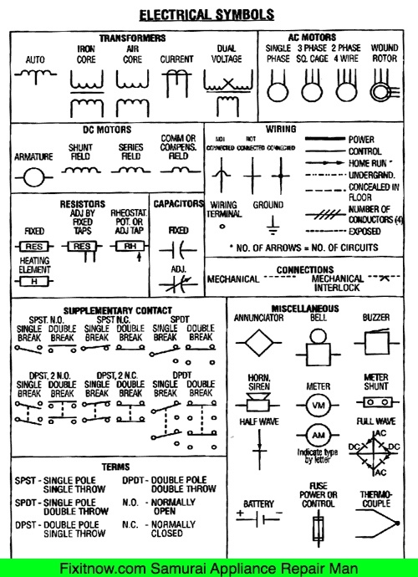
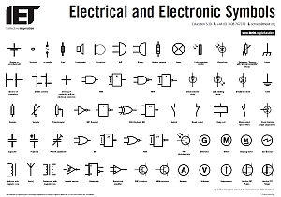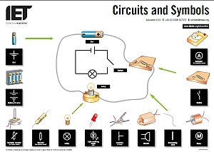

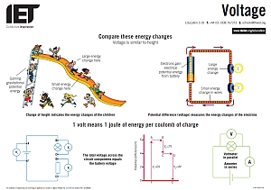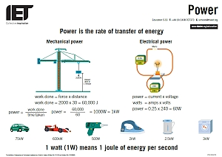

Electrical Power

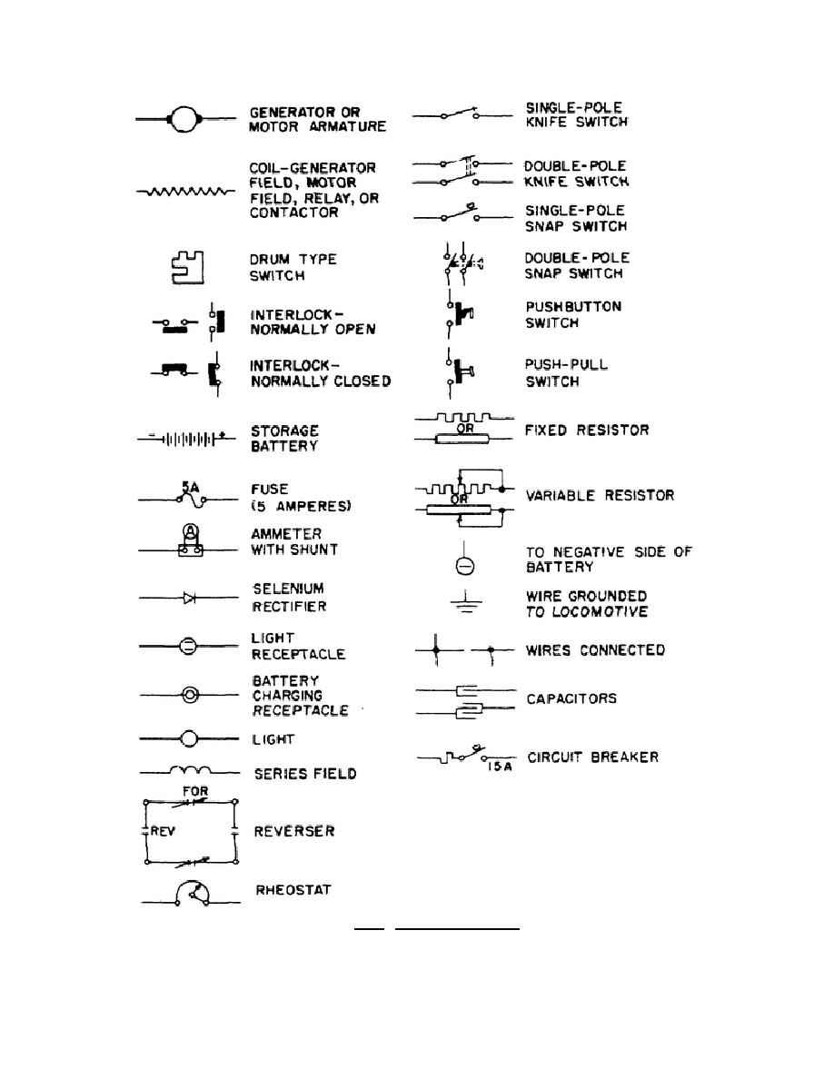
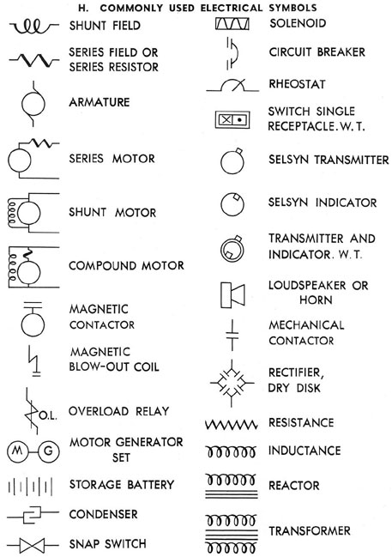
Submarine Electrical System

Wire Support and Protection

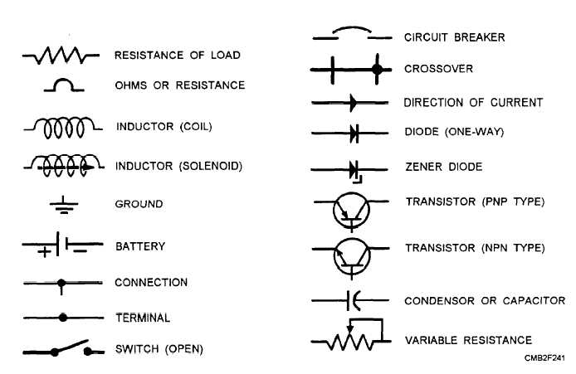
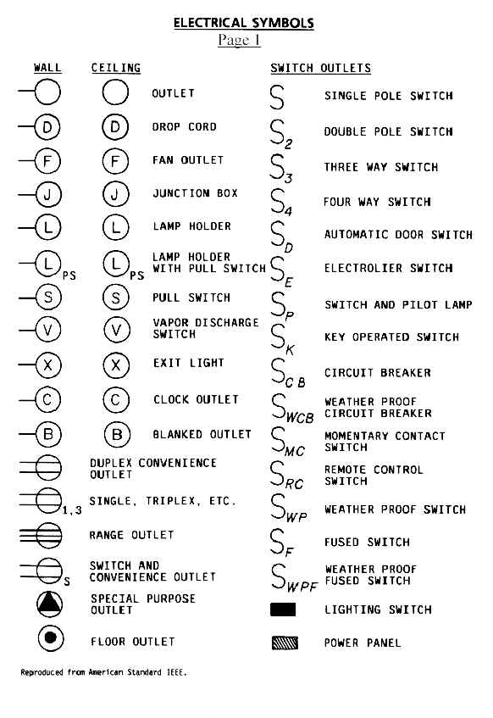
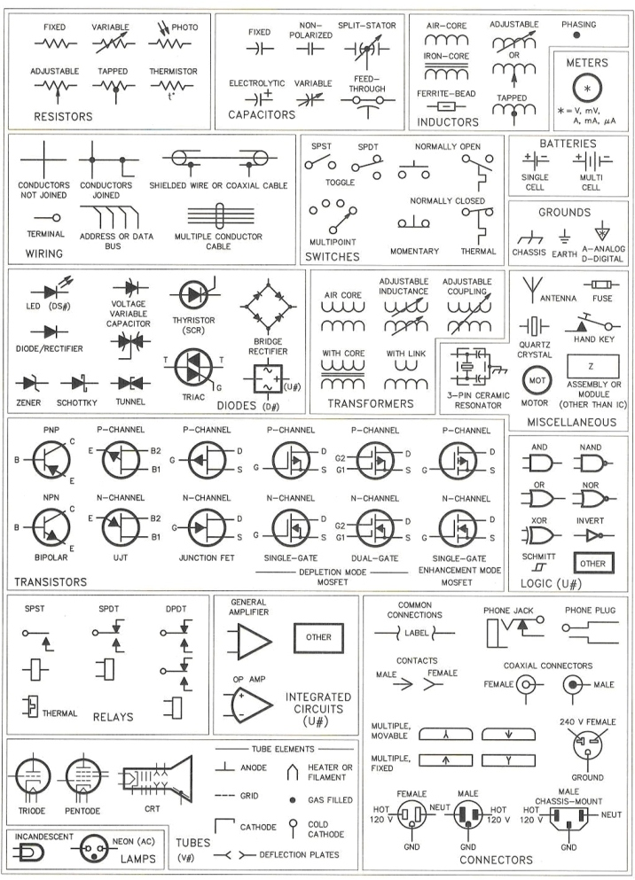
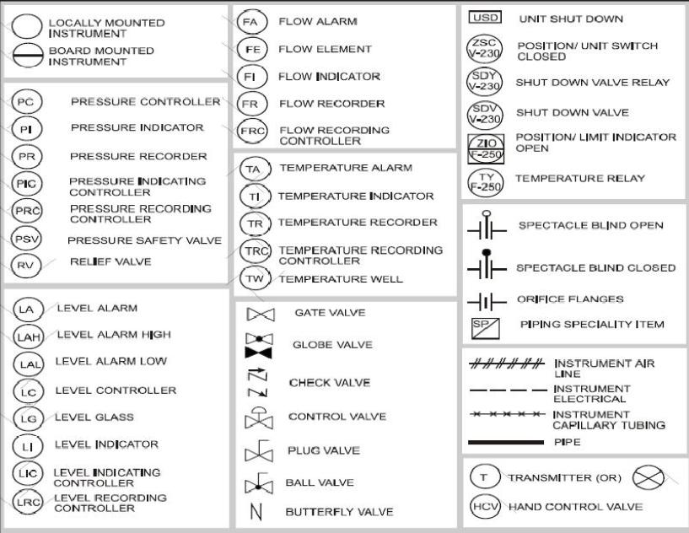
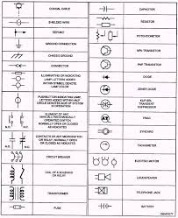

Electrical Symbols & Electronic Symbols
Electrical symbols and electronic circuit symbols are used for drawing schematic diagram.
The symbols represent electrical and electronic components.

Table of Electrical Symbols
Symbol | Component name | Meaning

Wire Symbols
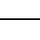 | Electrical Wire | Conductor of electrical current
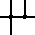 | Connected Wires | Connected crossing
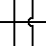 | Not Connected Wires | Wires are not connected

Switch Symbols and Relay Symbols
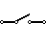 | SPST Toggle Switch | Disconnects current when open
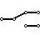 | SPDT Toggle Switch | Selects between two connections
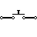 | Pushbutton Switch (N.O) | Momentary switch - normally open
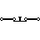 | Pushbutton Switch (N.C) | Momentary switch - normally closed
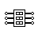 | DIP Switch | DIP switch is used for onboard configuration
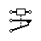 | SPST Relay | Relay open / close connection by an electromagnet
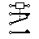 | SPDT Relay | Relay open / close connection by an electromagnet
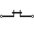 | Jumper | Close connection by jumper insertion on pins.
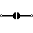 | Solder Bridge | Solder to close connection

Ground Symbols
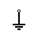 | Earth Ground | Used for zero potential reference and electrical shock protection.
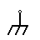 | Chassis Ground | Connected to the chassis of the circuit
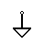 | Digital / Common Ground

Resistor Symbols
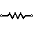 | Resistor (IEEE) | Resistor reduces the current flow.
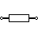 | Resistor (IEC) | Resistor reduces the current flow.
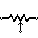 | Potentiometer (IEEE) | Adjustable resistor - has 3 terminals.
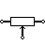 | Potentiometer (IEC) | Adjustable resistor - has 3 terminals.
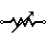 | Variable Resistor / Rheostat(IEEE) | Adjustable resistor - has 2 terminals.
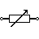 | Variable Resistor / Rheostat(IEC) | Adjustable resistor - has 2 terminals.
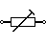 | Trimmer Resistor | Preset resistor
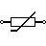 | Thermistor | Thermal resistor - change resistance when temperature changes
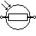 | Photoresistor / Light dependent resistor (LDR) | Photo-resistor - change resistance with light intensity change

Capacitor Symbols
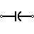 | Capacitor | Capacitor is used to store electric charge. It acts as short circuit with AC and open circuit with DC.
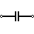 | Capacitor
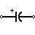 | Polarized Capacitor | Electrolytic capacitor
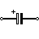 | Polarized Capacitor | Electrolytic capacitor
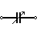 | Variable Capacitor | Adjustable capacitance

Inductor / Coil Symbols
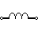 | Inductor | Coil / solenoid that generates magnetic field
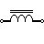 | Iron Core Inductor | Includes iron
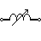 | Variable Inductor

Power Supply Symbols
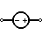 | Voltage Source | Generates constant voltage
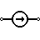 | Current Source | Generates constant current.
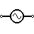 | AC Voltage Source | AC voltage source
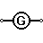 | Generator | Electrical voltage is generated by mechanical rotation of the generator
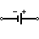 | Battery Cell | Generates constant voltage
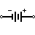 | Battery | Generates constant voltage
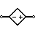 | Controlled Voltage Source | Generates voltage as a function of voltage or current of other circuit element.
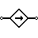 | Controlled Current Source | Generates current as a function of voltage or current of other circuit element.

Meter Symbols
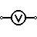 | Voltmeter | Measures voltage. Has very high resistance. Connected in parallel.
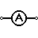 | Ammeter | Measures electric current. Has near zero resistance. Connected serially.
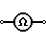 | Ohmmeter | Measures resistance
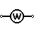 | Wattmeter | Measures electric power

Lamp / Light Bulb Symbols
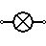 | Lamp / light bulb | Generates light when current flows through
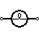 | Lamp / light bulb | Generates light when current flows through
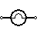 | Lamp / light bulb | Generates light when current flows through

Diode / LED Symbols
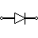 | Diode | Diode allows current flow in one direction only (left to right).
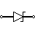 | Zener Diode | Allows current flow in one direction, but also can flow in the reverse direction when above breakdown voltage
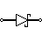 | Schottky Diode | Schottky diode is a diode with low voltage drop
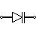 | Varactor / Varicap Diode | Variable capacitance diode
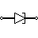 | Tunnel Diode
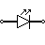 | Light Emitting Diode (LED) | LED emits light when current flows through
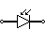 | Photodiode | Photodiode allows current flow when exposed to light

Transistor Symbols
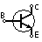 | NPN Bipolar Transistor | Allows current flow when high potential at base (middle)
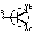 | PNP Bipolar Transistor | Allows current flow when low potential at base (middle)
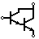 | Darlington Transistor | Made from 2 bipolar transistors. Has total gain of the product of each gain.
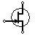 | JFET-N Transistor | N-channel field effect transistor
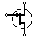 | JFET-P Transistor | P-channel field effect transistor
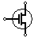 | NMOS Transistor | N-channel MOSFET transistor
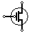 | PMOS Transistor | P-channel MOSFET transistor

Misc. Symbols
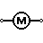 | Motor | Electric motor
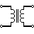 | Transformer | Change AC voltage from high to low or low to high.
 | Electric bell | Rings when activated
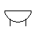 | Buzzer | Produce buzzing sound
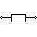 | Fuse | The fuse disconnects when current above threshold. Used to protect circuit from high currents.
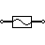 | Fuse
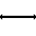 | Bus | Contains several wires. Usually for data / address.
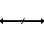 | Bus | Contains several wires. Usually for data / address.
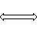 | Bus | Contains several wires. Usually for data / address.
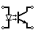 | Optocoupler / Opto-isolator | Optocoupler isolates onnection to other board
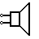 | Loudspeaker | Converts electrical signal to sound waves
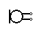 | Microphone | Converts sound waves to electrical signal
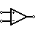 | Operational Amplifier | Amplify input signal
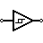 | Schmitt Trigger | Operates with hysteresis to reduce noise.
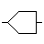 | Analog-to-digital converter (ADC) | Converts analog signal to digital numbers
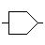 | Digital-to-Analog converter (DAC) | Converts digital numbers to analog signal
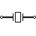 | Crystal Oscillator | Used to generate precise frequency clock signal

Antenna Symbols
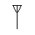 | Antenna / aerial | Transmits & receives radio waves
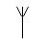 | Antenna / aerial | Transmits & receives radio waves
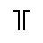 | Dipole Antenna | Two wires simple antenna

Logic Gates Symbols
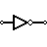 | NOT Gate (Inverter) | Outputs 1 when input is 0
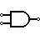 | AND Gate | Outputs 1 when both inputs are 1.
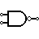 | NAND Gate | Outputs 0 when both inputs are 1. (NOT + AND)
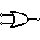 | OR Gate | Outputs 1 when any input is 1.
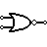 | NOR Gate | Outputs 0 when any input is 1. (NOT + OR)
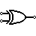 | XOR Gate | Outputs 1 when inputs are different. (Exclusive OR)
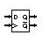 | D Flip-Flop | Stores one bit of data
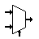 | Multiplexer / Mux 2 to 1 | Connects the output to selected input line.
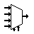 | Multiplexer / Mux 4 to 1 | Connects the output to selected input line.
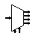 | Demultiplexer / Demux 1 to 4 | Connects selected output to the input line.

Circuit Symbols and Circuit Diagrams
Thus far, this unit of The Physics Classroom tutorial has focused on the key ingredients of an electric circuit and upon the concepts of electric potential difference, current and resistance. Conceptual meaning of terms have been introduced and applied to simple circuits. Mathematical relationships between electrical quantities have been discussed and their use in solving problems has been modeled. Lesson 4 will focus on the means by which two or more electrical devices can be connected to form an electric circuit. Our discussion will progress from simple circuits to mildly complex circuits. Former principles of electric potential difference, current and resistance will be applied to these complex circuits and the same mathematical formulas will be used to analyze them.
Electric circuits, whether simple or complex, can be described in a variety of ways. An electric circuit is commonly described with mere words. Saying something like "A light bulb is connected to a D-cell" is a sufficient amount of words to describe a simple circuit. On many occasions in Lessons 1 through 3, words have been used to describe simple circuits. Upon hearing (or reading) the words, a person grows accustomed to quickly picturing the circuit in their mind. But another means of describing a circuit is to simply draw it. Such drawings provide a quicker mental picture of the actual circuit. Circuit drawings like the one below have been used many times in Lessons 1 through 3.
Describing Circuits with Words  "A circuit contains a light bulb and a 1.5-Volt D-cell." | Describing Circuits with Drawings  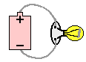
A final means of describing an electric circuit is by use of conventional circuit symbols to provide a schematic diagram of the circuit and its components. Some circuit symbols used in schematic diagrams are shown below.
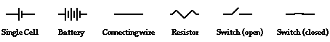
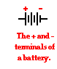
A single cell or other power source is represented by a long and a short parallel line. A collection of cells or battery is represented by a collection of long and short parallel lines. In both cases, the long line is representative of the positive terminal of the energy source and the short line represents the negative terminal. A straight line is used to represent a connecting wire between any two components of the circuit. An electrical device that offers resistance to the flow of charge is generically referred to as a resistor and is represented by a zigzag line. An open switch is generally represented by providing a break in a straight line by lifting a portion of the line upward at a diagonal. These circuit symbols will be frequently used throughout the remainder of Lesson 4 as electric circuits are represented by schematic diagrams. It will be important to either memorize these symbols or to refer to this short listing frequently until you become accustomed to their use.
As an illustration of the use of electrical symbols in schematic diagrams, consider the following two examples.

Example 1:
Description with Words: Three D-cells are placed in a battery pack to power a circuit containing three light bulbs.
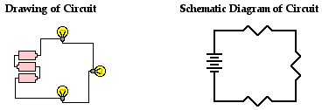
Using the verbal description, one can acquire a mental picture of the circuit being described. This verbal description can then be represented by a drawing of three cells and three light bulbs connected by wires. Finally, the circuit symbols presented above can be used to represent the same circuit. Note that three sets of long and short parallel lines have been used to represent the battery pack with its three D-cells. And note that each light bulb is represented by its own individual resistor symbol. Straight lines have been used to connect the two terminals of the battery to the resistors and the resistors to each other.

The above circuits presumed that the three light bulbs were connected in such a way that the charge flowing through the circuit would pass through each one of the three light bulbs in consecutive fashion. The path of a positive test charge leaving the positive terminal of the battery and traversing the external circuit would involve a passage through each one of the three connected light bulbs before returning to the negative terminal of the battery. But is this the only way that three light bulbs can be connected? Do they have to be connected in consecutive fashion as shown above? Absolutely not! In fact, example 2 below contains the same verbal description with the drawing and the schematic diagrams being drawn differently.

Example 2:
Description with Words: Three D-cells are placed in a battery pack to power a circuit containing three light bulbs.
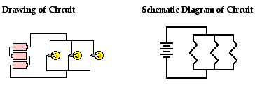
Using the verbal description, one can acquire a mental picture of the circuit being described. But this time, the connections of light bulbs is done in a manner such that there is a point on the circuit where the wires branch off from each other. The branching location is referred to as a node. Each light bulb is placed in its own separate branch. These branch wires eventually connect to each other to form a second node. A single wire is used to connect this second node to the negative terminal of the battery.

These two examples illustrate the two common types of connections made in electric circuits. When two or more resistors are present in a circuit, they can be connected in series or in parallel. The remainder of Lesson 4 will be devoted to a study of these two types of connections and the affect that they have upon electrical quantities such as current, resistance and electric potential. The next part of Lesson 4 will introduce the distinction between series and parallel connections.

Check Your Understanding
1. Use circuit symbols to construct schematic diagrams for the following circuits:
a. A single cell, light bulb and switch are placed together in a circuit such that the switch can be opened and closed to turn the light bulb on.

b. A three-pack of D-cells is placed in a circuit to power a flashlight bulb.

c.  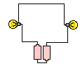 | d.  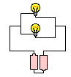

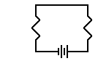
2. Use the concept of conventional current to draw an unbroken line on the schematic diagram at the right that indicates the direction of the conventional current. Place an arrowhead on your unbroken line.
Circuit symbols are used in circuit diagrams which show how a circuit is connected together. The actual layout of the components is usually quite different from the circuit diagram.
To build a circuit you need a different diagram showing the layout of the parts on stripboard or printed circuit board.
Temporary and trial circuits are often built on breadboardwhich does not require soldering.

Wires and connections
Component | Circuit Symbol | Function of Component
Wire |  | To pass current very easily from one part of a circuit to another.
Wires joined | 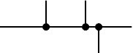 | A 'blob' should be drawn where wires are connected (joined), but it is sometimes omitted. Wires connected at 'crossroads' should be staggered slightly to form two T-junctions, as shown on the right.
Wires not joined | 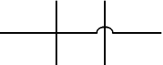 | In complex diagrams it is often necessary to draw wires crossing even though they are not connected. The simple crossing on the left is correct but may be misread as a join where the 'blob' has been forgotten. The bridge symbol on the right leaves no doubt!

Power Supplies
Component | Circuit Symbol | Function of Component
Cell | 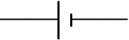 | Supplies electrical energy.  The larger terminal (on the left) is positive (+).  A single cell is often called a battery, but strictly a battery is two or more cells joined together.
Battery | 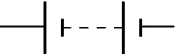 | Supplies electrical energy. A battery is more than one cell.  The larger terminal (on the left) is positive (+).
DC supply |  | Supplies electrical energy.  DC = Direct Current, always flowing in one direction.
AC supply |  | Supplies electrical energy.  AC = Alternating Current, continually changing direction.
Fuse |  | A safety device which will 'blow' (melt) if the current flowing through it exceeds a specified value.
Transformer | 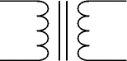 | Two coils of wire linked by an iron core. Transformers are used to step up (increase) and step down (decrease) AC voltages. Energy is transferred between the coils by the magnetic field in the core. There is no electrical connection between the coils.
Earth  (Ground) | 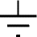 | A connection to earth. For many electronic circuits this is the 0V (zero volts) of the power supply, but for mains electricity and some radio circuits it really means the earth. It is also known as ground.

Output Devices: Lamps, Heater, Motor, etc.
Component | Circuit Symbol | Function of Component
Lamp (lighting) | 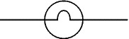 | A transducer which converts electrical energy to light. This symbol is used for a lamp providing illumination, for example a car headlamp or torch bulb.
Lamp (indicator) | 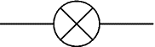 | A transducer which converts electrical energy to light. This symbol is used for a lamp which is an indicator, for example a warning light on a car dashboard.
Heater |  | A transducer which converts electrical energy to heat.
Motor | 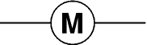 | A transducer which converts electrical energy to kinetic energy (motion).
Bell | 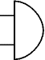 | A transducer which converts electrical energy to sound.
Buzzer | 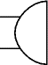 | A transducer which converts electrical energy to sound.
Inductor  (Coil, Solenoid) |  | A coil of wire which creates a magnetic field when current passes through it. It may have an iron core inside the coil. It can be used as a transducer converting electrical energy to mechanical energy by pulling on something.

Switches
Component | Circuit Symbol | Function of Component
Push Switch  (push-to-make) |  | A push switch allows current to flow only when the button is pressed. This is the switch used to operate a doorbell.
Push-to-Break Switch |  | This type of push switch is normally closed (on), it is open (off) only when the button is pressed.
On-Off Switch  (SPST) |  | SPST = Single Pole, Single Throw.  An on-off switch allows current to flow only when it is in the closed (on) position.
2-way Switch  (SPDT) | 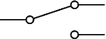 | SPDT = Single Pole, Double Throw.  A 2-way changeover switch directs the flow of current to one of two routes according to its position. Some SPDT switches have a central off position and are described as 'on-off-on'.
Dual On-Off Switch  (DPST) | 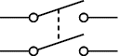 | DPST = Double Pole, Single Throw.  A dual on-off switch which is often used to switch mains electricity because it can isolate both the live and neutral connections.
Reversing Switch  (DPDT) | 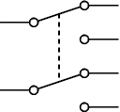 | DPDT = Double Pole, Double Throw.  This switch can be wired up as a reversing switch for a motor. Some DPDT switches have a central off position.
Relay | 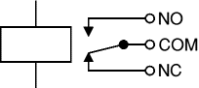 | An electrically operated switch, for example a 9V battery circuit connected to the coil can switch a 230V AC mains circuit.  NO = Normally Open, COM = Common, NC = Normally Closed.

Resistors
Component | Circuit Symbol | Function of Component
Resistor |  | A resistor restricts the flow of current, for example to limit the current passing through an LED. A resistor is used with a capacitor in a timing circuit.  Some publications still use the old resistor symbol:
Variable Resistor  (Rheostat) | 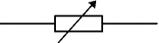 | This type of variable resistor with 2 contacts (a rheostat) is usually used to control current. Examples include: adjusting lamp brightness, adjusting motor speed, and adjusting the rate of flow of charge into a capacitor in a timing circuit.
Variable Resistor  (Potentiometer) | 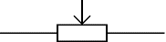 | This type of variable resistor with 3 contacts (a potentiometer) is usually used to control voltage. It can be used like this as a transducer converting position (angle of the control spindle) to an electrical signal.
Variable Resistor  (Preset) | 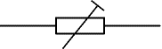 | This type of variable resistor (a preset) is operated with a small screwdriver or similar tool. It is designed to be set when the circuit is made and then left without further adjustment. Presets are cheaper than normal variable resistors so they are often used in projects to reduce the cost.

Capacitors
Component | Circuit Symbol | Function of Component
Capacitor | 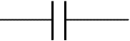 | A capacitor stores electric charge. A capacitor is used with a resistor in a timing circuit. It can also be used as a filter, to block DC signals but pass AC signals.
Capacitor, polarised | 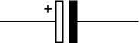 | A capacitor stores electric charge. This type must be connected the correct way round. A capacitor is used with a resistor in a timing circuit. It can also be used as a filter, to block DC signals but pass AC signals.
Variable Capacitor | 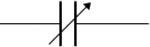 | A variable capacitor is used in a radio tuner.
Trimmer Capacitor | 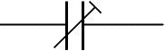 | This type of variable capacitor (a trimmer) is operated with a small screwdriver or similar tool. It is designed to be set when the circuit is made and then left without further adjustment.

Diodes
Component | Circuit Symbol | Function of Component
Diode | 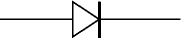 | A device which only allows current to flow in one direction.
LED  Light Emitting Diode | 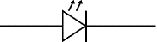 | A transducer which converts electrical energy to light.
Zener Diode | 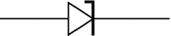 | A special diode which is used to maintain a fixed voltage across its terminals.
Photodiode | 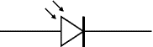 | A light-sensitive diode.

Transistors
Component | Circuit Symbol | Function of Component
Transistor NPN | 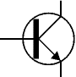 | A transistor amplifies current. It can be used with other components to make an amplifier or switching circuit.
Transistor PNP | 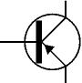 | A transistor amplifies current. It can be used with other components to make an amplifier or switching circuit.
Phototransistor | 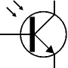 | A light-sensitive transistor.

Audio and Radio Devices
Component | Circuit Symbol | Function of Component
Microphone | 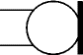 | A transducer which converts sound to electrical energy.
Earphone | 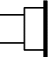 | A transducer which converts electrical energy to sound.
Loudspeaker | 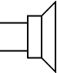 | A transducer which converts electrical energy to sound.
Piezo Transducer | 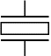 | A transducer which converts electrical energy to sound.
Amplifier  (general symbol) | 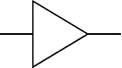 | An amplifier circuit with one input. Really it is a block diagram symbol because it represents a circuit rather than just one component.
Aerial  (Antenna) | 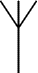 | A device which is designed to receive or transmit radio signals. It is also known as an antenna.

Meters and Oscilloscope
Component | Circuit Symbol | Function of Component
Voltmeter | 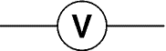 | A voltmeter is used to measure voltage.  The proper name for voltage is 'potential difference', but most people prefer to say voltage!
Ammeter | 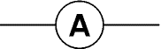 | An ammeter is used to measure current.
Galvanometer | 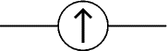 | A galvanometer is a very sensitive meter which is used to measure tiny currents, usually 1mA or less.
Ohmmeter | 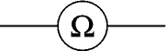 | An ohmmeter is used to measure resistance. Most multimeters have an ohmmeter setting.
Oscilloscope | 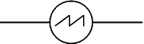 | An oscilloscope is used to display the shape of electrical signals and it can be used to measure their voltage and time period.

Sensors (input devices)
Component | Circuit Symbol | Function of Component
LDR | 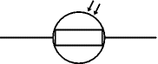 | A transducer which converts brightness (light) to resistance (an electrical property).  LDR = Light Dependent Resistor
Thermistor | 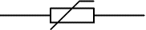 | A transducer which converts temperature (heat) to resistance (an electrical property).

Logic Gates
Logic gates process signals which represent true (1, high, +Vs, on) or false (0, low, 0V, off).
For more information please see the Logic Gates page.
There are two sets of symbols: traditional and IEC (International Electrotechnical Commission).
Gate Type | Traditional Symbol | IEC Symbol | Function of Gate
NOT | 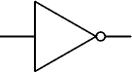 | 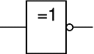 | A NOT gate can only have one input. The 'o' on the output means 'not'. The output of a NOT gate is the inverse (opposite) of its input, so the output is true when the input is false. A NOT gate is also called an inverter.
AND | 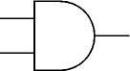 | 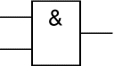 | An AND gate can have two or more inputs. The output of an AND gate is true when all its inputs are true.
NAND | 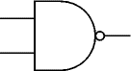 | 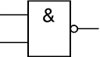 | A NAND gate can have two or more inputs. The 'o' on the output means 'not' showing that it is a Not ANDgate. The output of a NAND gate is true unless all its inputs are true.
OR | 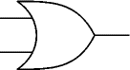 | 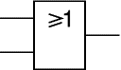 | An OR gate can have two or more inputs. The output of an OR gate is true when at least one of its inputs is true.
NOR | 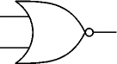 | 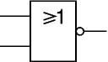 | A NOR gate can have two or more inputs. The 'o' on the output means 'not' showing that it is a Not OR gate. The output of a NOR gate is true when none of its inputs are true.
EX-OR | 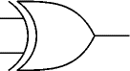 | 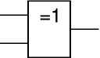 | An EX-OR gate can only have two inputs. The output of an EX-OR gate is true when its inputs are different (one true, one false).
EX-NOR | 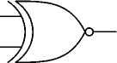 | 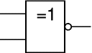 | An EX-NOR gate can only have two inputs. The 'o' on the output means 'not' showing that it is a Not EX-ORgate. The output of an EX-NOR gate is true when its inputs are the same (both true or both false).

Circuit Diagrams
Next Page: Circuit Symbols
Also see: Block Diagrams
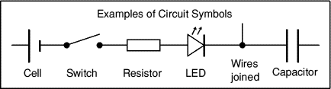
Circuit diagrams show how electronic components are connected together. Each component is represented by a symbol and a few are shown here, for other symbols please see theCircuit Symbols page.

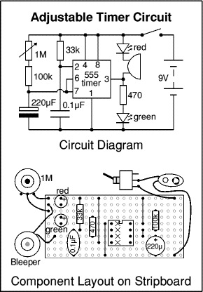
Circuit diagrams and component layouts
Circuit diagrams show the connections as clearly as possible with all wires drawn neatly as straight lines. The actual layout of the components is usually quite different from the circuit diagram and this can be confusing for the beginner. The secret is to concentrate on the connections, not the actual positions of components.
The circuit diagram and stripboard layout for theAdjustable Timer project are shown here so you can see the difference.
A circuit diagram is useful when testing a circuit and for understanding how it works. This is why the instructions for projects include a circuit diagram as well as the stripboard or printed circuit board layout which you need to build the circuit.
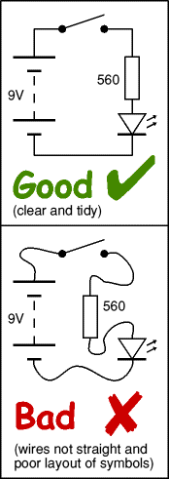

Drawing circuit diagrams
Drawing circuit diagrams is not difficult but it takes a little practice to draw neat, clear diagrams. This is a useful skill for science as well as for electronics. You will certainly need to draw circuit diagrams if you design your own circuits.
Follow these tips for best results:
- Make sure you use the correct symbol for each component.
- Draw connecting wires as straight lines (use a ruler).
- Put a 'blob' () at each junction between wires.
- Label components such as resistors and capacitors with their values.
- The positive (+) supply should be at the top and the negative (-) supply at the bottom. The negative supply is usually labelled 0V, zero volts.
If you are drawing the circuit diagram for science please see the section about drawing diagrams the 'electronics way'.
If the circuit is complex:
- Try to arrange the diagram so that signals flow from left to right: inputs and controls should be on the left, outputs on the right.
- You may omit the battery or power supply symbols, but you must include (and label) the supply lines at the top and bottom.

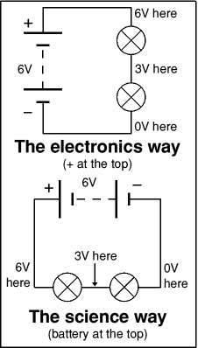

Drawing circuit diagrams the 'electronics way'
Circuit diagrams for electronics are drawn with the positive (+) supply at the top and the negative (-) supply at the bottom. This can be helpful in understanding the operation of the circuit because the voltage decreases as you move down the circuit diagram.
Circuit diagrams for science are traditionally drawn with the battery or power supply at the top. This is not wrong, but there is usually no advantage in drawing them this way and I think it is less helpful for understanding the circuit.
I suggest that you always draw your circuit diagrams the 'electronics way', even for science!
[I hope your science teacher won't mind too much!]
Note that the negative supply is usually called 0V (zero volts).
This is explained on the Voltage and Current page.
BLOCK DIAGRAMS
Block diagrams are used to understand (and design) complete circuits by breaking them down into smaller sections or blocks. Each block performs a particular function and the block diagram shows how they are connected together. No attempt is made to show the components used within a block, only the inputs and outputs are shown. This way of looking at circuits is called the systems approach.
Power supply (or battery) connections are usually not shown on block diagrams.

Audio Amplifier System
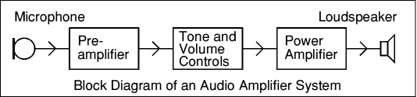
The power supply (not shown) is connected to the pre-amplifier and power amplifier blocks.
- Microphone - a transducer which converts sound to voltage.
- Pre-Amplifier - amplifies the small audio signal (voltage) from the microphone.
- Tone and Volume Controls - adjust the nature of the audio signal.
The tone control adjusts the balance of high and low frequencies.
The volume control adjusts the strength of the signal.
- Power Amplifier - increases the strength (power) of the audio signal.
- Loudspeaker - a transducer which converts the audio signal to sound.

Radio Receiver System
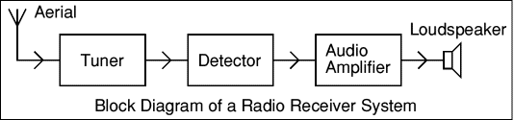
The power supply (not shown) is connected to the audio amplifier block.
- Aerial - picks up radio signals from many stations.
- Tuner - selects the signal from just one radio station.
- Detector - extracts the audio signal carried by the radio signal.
- Audio Amplifier - increases the strength (power) of the audio signal.
This could be broken down into the blocks like the Audio Amplifier System shown above.
- Loudspeaker - a transducer which converts the audio signal to sound.

Regulated Power Supply System
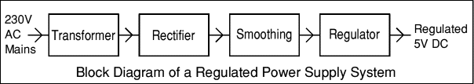
- Transformer - steps down 230V AC mains to low voltage AC.
- Rectifier - converts AC to DC, but the DC output is varying.
- Smoothing - smooths the DC from varying greatly to a small ripple.
- Regulator - eliminates ripple by setting DC output to a fixed voltage.
For futher information please see the Power Supplies page.

Feedback Control System
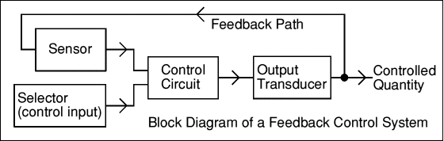
The power supply (not shown) is connected to the control circuit block.
- Sensor - a transducer which converts the state of the controlled quantity to an electrical signal.
- Selector (control input) - selects the desired state of the output. Usually it is a variable resistor.
- Control Circuit - compares the desired state (control input) with the actual state (sensor) of the controlled quantity and sends an appropriate signal to the output transducer.
- Output Transducer - converts the electrical signal to the controlled quantity.
- Controlled Quantity - usually not an electrical quantity, e.g. motor speed.
- Feedback Path - usually not electrical, the Sensor detects the state of the controlled quantity.

Types of Power Supply
There are many types of power supply. Most are designed to convert high voltage AC mains electricity to a suitable low voltage supply for electronics circuits and other devices. A power supply can by broken down into a series of blocks, each of which performs a particular function.
For example a 5V regulated supply:
Each of the blocks is described in more detail below:
- Transformer - steps down high voltage AC mains to low voltage AC.
- Rectifier - converts AC to DC, but the DC output is varying.
- Smoothing - smooths the DC from varying greatly to a small ripple.
- Regulator - eliminates ripple by setting DC output to a fixed voltage.
Power supplies made from these blocks are described below with a circuit diagram and a graph of their output:
- Transformer only
- Transformer + Rectifier
- Transformer + Rectifier + Smoothing
- Transformer + Rectifier + Smoothing + Regulator

Dual Supplies
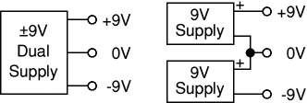
Some electronic circuits require a power supply with positive and negative outputs as well as zero volts (0V). This is called a 'dual supply' because it is like two ordinary supplies connected together as shown in the diagram.
Dual supplies have three outputs, for example a ±9V supply has +9V, 0V and -9V outputs.

Transformer only
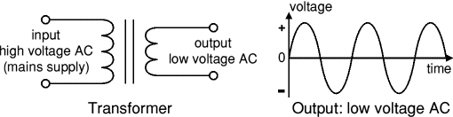
The low voltage AC output is suitable for lamps, heaters and special AC motors. It is not suitable for electronic circuits unless they include a rectifier and a smoothing capacitor.
Further information: Transformer

Transformer + Rectifier
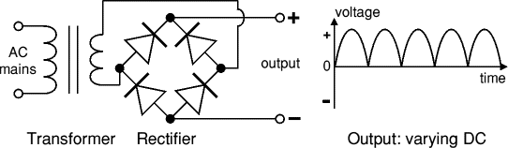
The varying DC output is suitable for lamps, heaters and standard motors. It is not suitable for electronic circuits unless they include a smoothing capacitor.
Further information: Transformer | Rectifier

Transformer + Rectifier + Smoothing
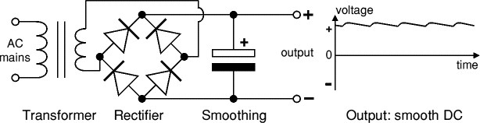
The smooth DC output has a small ripple. It is suitable for most electronic circuits.
Further information: Transformer | Rectifier | Smoothing

Transformer + Rectifier + Smoothing + Regulator
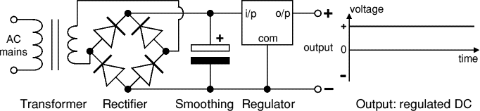
The regulated DC output is very smooth with no ripple. It is suitable for all electronic circuits.
Further information: Transformer | Rectifier | Smoothing | Regulator

Transformer
Transformer
circuit symbol
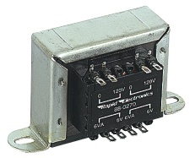
Transformer
Photograph © Rapid Electronics

There is more information
about transformers on the
Electronics in Meccano
website.

Transformers convert AC electricity from one voltage to another with little loss of power. Transformers work only with AC and this is one of the reasons why mains electricity is AC.
Step-up transformers increase voltage, step-down transformers reduce voltage. Most power supplies use a step-down transformer to reduce the dangerously high mains voltage (230V in UK) to a safer low voltage.
The input coil is called the primary and the output coil is called thesecondary. There is no electrical connection between the two coils, instead they are linked by an alternating magnetic field created in the soft-iron core of the transformer. The two lines in the middle of the circuit symbol represent the core.
Transformers waste very little power so the power out is (almost) equal to the power in. Note that as voltage is stepped down current is stepped up.
The ratio of the number of turns on each coil, called the turns ratio, determines the ratio of the voltages. A step-down transformer has a large number of turns on its primary (input) coil which is connected to the high voltage mains supply, and a small number of turns on its secondary (output) coil to give a low output voltage.
turns ratio = | Vp | = | Np | and | power out = power in
turns ratio = | Vs | = | Ns | and | Vs × Is = Vp × Ip

Vp = primary (input) voltage  Np = number of turns on primary coil  Ip = primary (input) current |  | Vs = secondary (output) voltage  Ns = number of turns on secondary coil  Is = secondary (output) current

Rectifier
There is more information
about rectifiers on the
Electronics in Meccano
website.
There are several ways of connecting diodes to make a rectifier to convert AC to DC. The bridge rectifier is the most important and it produces full-wave varying DC. A full-wave rectifier can also be made from just two diodes if a centre-tap transformer is used, but this method is rarely used now that diodes are cheaper. Asingle diode can be used as a rectifier but it only uses the positive (+) parts of the AC wave to produce half-wave varying DC.

Bridge rectifier
A bridge rectifier can be made using four individual diodes, but it is also available in special packages containing the four diodes required. It is called a full-wave rectifier because it uses all the AC wave (both positive and negative sections). 1.4V is used up in the bridge rectifier because each diode uses 0.7V when conducting and there are always two diodes conducting, as shown in the diagram below. Bridge rectifiers are rated by the maximum current they can pass and the maximum reverse voltage they can withstand (this must be at least three times the supply RMS voltage so the rectifier can withstand the peak voltages). Please see the Diodes page for more details, including pictures of bridge rectifiers.
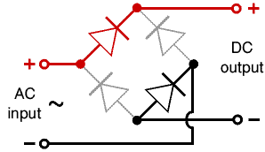 | 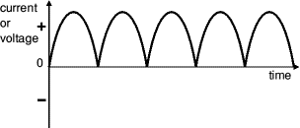
Bridge rectifier  Alternate pairs of diodes conduct, changing over  the connections so the alternating directions of  AC are converted to the one direction of DC. | Output: full-wave varying DC  (using all the AC wave)

Single diode rectifier
A single diode can be used as a rectifier but this produces half-wave varying DC which has gaps when the AC is negative. It is hard to smooth this sufficiently well to supply electronic circuits unless they require a very small current so the smoothing capacitor does not significantly discharge during the gaps. Please see the Diodes page for some examples of rectifier diodes.
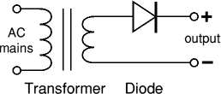 | 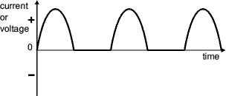
Single diode rectifier | Output: half-wave varying DC  (using only half the AC wave)

Smoothing
Smoothing is performed by a large value electrolytic capacitor connected across the DC supply to act as a reservoir, supplying current to the output when the varying DC voltage from the rectifier is falling. The diagram shows the unsmoothed varying DC (dotted line) and the smoothed DC (solid line). The capacitor charges quickly near the peak of the varying DC, and then discharges as it supplies current to the output.
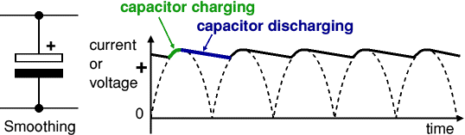
Note that smoothing significantly increases the average DC voltage to almost the peak value (1.4 × RMSvalue). For example 6V RMS AC is rectified to full wave DC of about 4.6V RMS (1.4V is lost in the bridge rectifier), with smoothing this increases to almost the peak value giving 1.4 × 4.6 = 6.4V smooth DC.
Smoothing is not perfect due to the capacitor voltage falling a little as it discharges, giving a small ripple voltage. For many circuits a ripple which is 10% of the supply voltage is satisfactory and the equation below gives the required value for the smoothing capacitor. A larger capacitor will give less ripple. The capacitor value must be doubled when smoothing half-wave DC.
There is more information
about smoothing on the
Electronics in Meccano
website.
Smoothing capacitor for 10% ripple, C = | 5 × Io
Smoothing capacitor for 10% ripple, C = | Vs × f
C = smoothing capacitance in farads (F)
Io = output current from the supply in amps (A)
Vs = supply voltage in volts (V), this is the peak value of the unsmoothed DC
f = frequency of the AC supply in hertz (Hz), 50Hz in the UK

Regulator
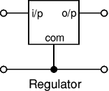 | 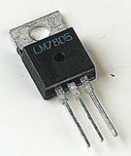
Voltage regulator
Photograph © Rapid Electronics

Voltage regulator ICs are available with fixed (typically 5, 12 and 15V) or variable output voltages. They are also rated by the maximum current they can pass. Negative voltage regulators are available, mainly for use in dual supplies. Most regulators include some automatic protection from excessive current ('overload protection') and overheating ('thermal protection').
Many of the fixed voltage regulator ICs have 3 leads and look like power transistors, such as the 7805 +5V 1A regulator shown on the right. They include a hole for attaching a heatsink if necessary.
Please see the Electronics in Meccano website for more information about voltage regulator ICs.
zener diode
a = anode, k = cathode
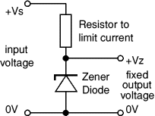

Zener diode regulator
For low current power supplies a simple voltage regulator can be made with a resistor and a zener diode connected in reverse as shown in the diagram. Zener diodes are rated by their breakdown voltage Vz andmaximum power Pz (typically 400mW or 1.3W).
The resistor limits the current (like an LED resistor). The current through the resistor is constant, so when there is no output current all the current flows through the zener diode and its power rating Pz must be large enough to withstand this.
Please see the Diodes page for more information about zener diodes.
Choosing a zener diode and resistor:
- The zener voltage Vz is the output voltage required
- The input voltage Vs must be a few volts greater than Vz
(this is to allow for small fluctuations in Vs due to ripple)
- The maximum current Imax is the output current required plus 10%
- The zener power Pz is determined by the maximum current: Pz > Vz × Imax
- The resistor resistance: R = (Vs - Vz) / Imax
- The resistor power rating: P > (Vs - Vz) × Imax
Example: output voltage required is 5V, output current required is 60mA.
There is more information
about regulators on the
Electronics in Meccano
website.
- Vz = 4.7V (nearest value available)
- Vs = 8V (it must be a few volts greater than Vz)
- Imax = 66mA (output current plus 10%)
- Pz > 4.7V × 66mA = 310mW, choose Pz = 400mW
- R = (8V - 4.7V) / 66mA = 0.05k = 50, choose R = 47
- Resistor power rating P > (8V - 4.7V) × 66mA = 218mW, choose P = 0.5W

AC, DC and Electrical Signals
Alternating Current (AC) | Direct Current (DC) | Properties of signals | RMS values
Next Page: Oscilloscopes (CROs)
Also See: Diodes | Power Supplies
AC means Alternating Current and DC means Direct Current. AC and DC are also used when referring to voltages and electrical signals which are not currents! For example: a 12V AC power supply has an alternating voltage (which will make an alternating current flow). An electrical signal is a voltage or current which conveys information, usually it means a voltage. The term can be used for any voltage or current in a circuit.

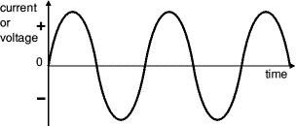
AC from a power supply
This shape is called a sine wave.
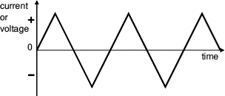
This triangular signal is AC because it changes
between positive (+) and negative (-).

Alternating Current (AC)
Alternating Current (AC) flows one way, then the other way, continually reversing direction.
An AC voltage is continually changing between positive (+) and negative (-).
The rate of changing direction is called the frequency of the AC and it is measured in hertz (Hz) which is the number of forwards-backwards cycles per second.
Mains electricity in the UK has a frequency of 50Hz.
See below for more details of signal properties.
An AC supply is suitable for powering some devices such as lamps and heaters but almost all electronic circuits require a steady DC supply (see below).

Direct Current (DC)
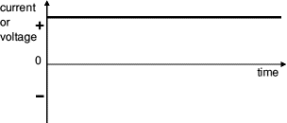
Steady DC
from a battery or regulated power supply,
this is ideal for electronic circuits.
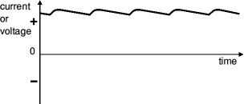
Smooth DC
from a smoothed power supply,
this is suitable for some electronics.
Varying DC
from a power supply without smoothing,
this is not suitable for electronics.
Direct Current (DC) always flows in the same direction, but it may increase and decrease.
A DC voltage is always positive (or always negative), but it may increase and decrease.
Electronic circuits normally require a steady DC supply which is constant at one value or a smooth DC supply which has a small variation called ripple.
Cells, batteries and regulated power supplies providesteady DC which is ideal for electronic circuits.
Power supplies contain a transformer which converts the mains AC supply to a safe low voltage AC. Then the AC is converted to DC by a bridge rectifier but the output isvarying DC which is unsuitable for electronic circuits.
Some power supplies include a capacitor to providesmooth DC which is suitable for less-sensitive electronic circuits, including most of the projects on this website.
Lamps, heaters and motors will work with any DC supply.
Please see the Power Supplies page for further information.
Power supplies are also covered by theElectronics in Meccano website.

Properties of electrical signals
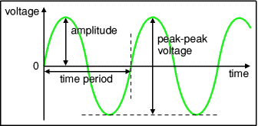
An electrical signal is a voltage or current which conveys information, usually it means a voltage. The term can be used for any voltage or current in a circuit.
The voltage-time graph on the right shows various properties of an electrical signal. In addition to the properties labelled on the graph, there is frequency which is the number of cycles per second.
The diagram shows a sine wave but these properties apply to any signal with a constant shape.
- Amplitude is the maximum voltage reached by the signal.
It is measured in volts, V.
- Peak voltage is another name for amplitude.
- Peak-peak voltage is twice the peak voltage (amplitude). When reading an oscilloscope trace it is usual to measure peak-peak voltage.
- Time period is the time taken for the signal to complete one cycle.
It is measured in seconds (s), but time periods tend to be short so milliseconds (ms) andmicroseconds (µs) are often used. 1ms = 0.001s and 1µs = 0.000001s.
- Frequency is the number of cycles per second.
It is measured in hertz (Hz), but frequencies tend to be high so kilohertz (kHz) and megahertz (MHz) are often used. 1kHz = 1000Hz and 1MHz = 1000000Hz.
frequency = | 1 | and | time period = | 1
frequency = | time period | and | time period = | frequency
- Mains electricity in the UK has a frequency of 50Hz,
so it has a time period of ¹/₅₀ = 0.02s = 20ms.

Root Mean Square (RMS) Values
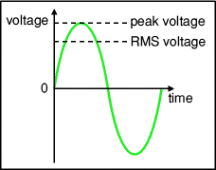
The value of an AC voltage is continually changing from zero up to the positive peak, through zero to the negative peak and back to zero again. Clearly for most of the time it is less than the peak voltage, so this is not a good measure of its real effect.
Instead we use the root mean square voltage (V_{RMS}) which is 0.7 of the peak voltage (V_{peak}):
V_{RMS} = 0.7 × V_{peak} and V_{peak} = 1.4 × V_{RMS}
These equations also apply to current.
They are only true for sine waves (the most common type of AC) because the 0.7 and 1.4 are different values for other shapes.
The RMS value is the effective value of a varying voltage or current. It is the equivalent steady DC (constant) value which gives the same effect.
For example a lamp connected to a 6V RMS AC supply will light with the same brightness when connected to a steady 6V DC supply. However, the lamp will be dimmer if connected to a 6V peak AC supply because the RMS value of this is only 4.2V (it is equivalent to a steady 4.2V DC).
You may find it helps to think of the RMS value as a sort of average, but please remember that it is NOT really the average! In fact the average voltage (or current) of an AC signal is zero because the positive and negative parts exactly cancel out!

What do AC meters show, is it the RMS or peak voltage?
AC voltmeters and ammeters show the RMS value of the voltage or current.

What does '6V AC' really mean, is it the RMS or peak voltage?
If the peak value is meant it should be clearly stated, otherwise assume it is the RMS value. In everyday use AC voltages (and currents) are always given as RMS values because this allows a sensible comparison to be made with steady DC voltages (and currents), such as from a battery.
For example a '6V AC supply' means 6V RMS, the peak voltage is 8.6V. The UK mains supply is 230V AC, this means 230V RMS so the peak voltage of the mains is about 320V!

So what does root mean square (RMS) really mean?
First square all the values, then find the average (mean) of these square values over a complete cycle, and find the square root of this average. That is the RMS value. Confused? Ignore the maths (it looks more complicated than it really is), just accept that RMS values for voltage and current are a much more useful quantity than peak values.

Diodes
Signal diodes | Rectifier diodes | Bridge rectifiers | Zener diodes
Also see: LEDs | AC and DC | Power Supplies


Examples: 
Circuit symbol:

Function
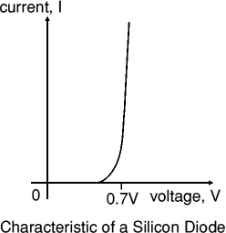
Diodes allow electricity to flow in only one direction. The arrow of the circuit symbol shows the direction in which the current can flow. Diodes are the electrical version of a valve and early diodes were actually called valves.

Forward Voltage Drop
Electricity uses up a little energy pushing its way through the diode, rather like a person pushing through a door with a spring. This means that there is a small voltage across a conducting diode, it is called the forward voltage drop and is about 0.7V for all normal diodes which are made from silicon. The forward voltage drop of a diode is almost constant whatever the current passing through the diode so they have a very steep characteristic (current-voltage graph).

Reverse Voltage
When a reverse voltage is applied a perfect diode does not conduct, but all real diodes leak a very tiny current of a few µA or less. This can be ignored in most circuits because it will be very much smaller than the current flowing in the forward direction. However, all diodes have a maximum reverse voltage(usually 50V or more) and if this is exceeded the diode will fail and pass a large current in the reverse direction, this is called breakdown.
Ordinary diodes can be split into two types: Signal diodes which pass small currents of 100mA or less andRectifier diodes which can pass large currents. In addition there are LEDs (which have their own page) and Zener diodes (at the bottom of this page).

Connecting and soldering
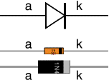
Diodes must be connected the correct way round, the diagram may be labelled aor + for anode and k or - for cathode (yes, it really is k, not c, for cathode!). The cathode is marked by a line painted on the body. Diodes are labelled with their code in small print, you may need a magnifying glass to read this on small signal diodes!
Small signal diodes can be damaged by heat when soldering, but the risk is small unless you are using a germanium diode (codes beginning OA...) in which case you should use a heat sink clipped to the lead between the joint and the diode body. A standard crocodile clip can be used as a heat sink.
Rectifier diodes are quite robust and no special precautions are needed for soldering them.

Testing diodes
You can use a multimeter or a simple tester (battery, resistor and LED) to check that a diode conducts in one direction but not the other. A lamp may be used to test a rectifier diode, but do NOT use a lamp to test a signal diode because the large current passed by the lamp will destroy the diode!

Signal diodes (small current)
Signal diodes are used to process information (electrical signals) in circuits, so they are only required to pass small currents of up to 100mA.
General purpose signal diodes such as the 1N4148 are made from silicon and have a forward voltage drop of 0.7V.
Germanium diodes such as the OA90 have a lower forward voltage drop of 0.2V and this makes them suitable to use in radio circuits as detectors which extract the audio signal from the weak radio signal.
For general use, where the size of the forward voltage drop is less important, silicon diodes are better because they are less easily damaged by heat when soldering, they have a lower resistance when conducting, and they have very low leakage currents when a reverse voltage is applied.

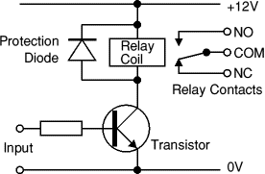
Protection diodes for relays
Signal diodes are also used to protect transistors and ICs from the brief high voltage produced when a relay coil is switched off. The diagram shows how a protection diode is connected 'backwards' across the relay coil.
Current flowing through a relay coil creates a magnetic field which collapses suddenly when the current is switched off. The sudden collapse of the magnetic field induces a brief high voltage across the relay coil which is very likely to damage transistors and ICs. The protection diode allows the induced voltage to drive a brief current through the coil (and diode) so the magnetic field dies away quickly rather than instantly. This prevents the induced voltage becoming high enough to cause damage to transistors and ICs.

Diode | Maximum  Current | Maximum  Reverse  Voltage
1N4001 | 1A | 50V
1N4002 | 1A | 100V
1N4007 | 1A | 1000V
1N5401 | 3A | 100V
1N5408 | 3A | 1000V

Rectifier diodes (large current)
Rectifier diodes are used in power supplies to convert alternating current (AC) to direct current (DC), a process called rectification. They are also used elsewhere in circuits where a large current must pass through the diode.
All rectifier diodes are made from silicon and therefore have a forward voltage drop of 0.7V. The table shows maximum current and maximum reverse voltage for some popular rectifier diodes. The 1N4001 is suitable for most low voltage circuits with a current of less than 1A.
Also see: Power Supplies

Bridge rectifiers
There are several ways of connecting diodes to make a rectifier to convert AC to DC. The bridge rectifier is one of them and it is available in special packages containing the four diodes required. Bridge rectifiers are rated by their maximum current and maximum reverse voltage. They have four leads or terminals: the two DC outputs are labelled + and -, the two AC inputs are labelled .
The diagram shows the operation of a bridge rectifier as it converts AC to DC. Notice how alternate pairs of diodes conduct.
Also see: Power Supplies
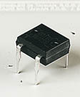 | 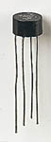 | 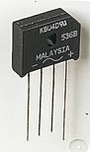 | 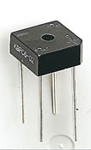 | 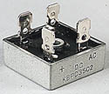
Various types of Bridge Rectifiers
Note that some have a hole through their centre for attaching to a heat sink
Photographs © Rapid Electronics

Zener diodes
Example: Circuit symbol:
a = anode, k = cathode
Zener diodes are used to maintain a fixed voltage. They are designed to 'breakdown' in a reliable and non-destructive way so that they can be usedin reverse to maintain a fixed voltage across their terminals. The diagram shows how they are connected, with a resistor in series to limit the current.
Zener diodes can be distinguished from ordinary diodes by their code and breakdown voltage which are printed on them. Zener diode codes begin BZX... or BZY... Their breakdown voltage is printed with V in place of a decimal point, so 4V7 means 4.7V for example.
Zener diodes are rated by their breakdown voltage and maximum power:
- The minimum voltage available is 2.4V.
- Power ratings of 400mW and 1.3W are common

Light Emitting Diodes (LEDs)
Colour | Sizes and shapes | Resistor value | LEDs in series | LED data | Flashing | Displays
Also see: Lamps
Example LED: 
Circuit symbol:

Function
LEDs emit light when an electric current passes through them.

Connecting and soldering
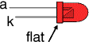
LEDs must be connected the correct way round, the diagram may be labelled a or + for anode and k or - for cathode (yes, it really is k, not c, for cathode!). The cathode is the short lead and there may be a slight flat on the body of round LEDs. If you can see inside the LED the cathode is the larger electrode (but this is not an official identification method).
LEDs can be damaged by heat when soldering, but the risk is small unless you are very slow. No special precautions are needed for soldering most LEDs.

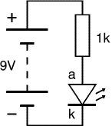
Testing an LED
Never connect an LED directly to a battery or power supply!
It will be destroyed almost instantly because too much current will pass through and burn it out.
LEDs must have a resistor in series to limit the current to a safe value, for quick testing purposes a 1k resistor is suitable for most LEDs if your supply voltage is 12V or less. Remember to connect the LED the correct way round!
For an accurate value please see Calculating an LED resistor value below.

Colours of LEDs
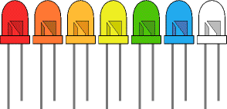
LEDs are available in red, orange, amber, yellow, green, blue and white. Blue and white LEDs are much more expensive than the other colours.
The colour of an LED is determined by the semiconductor material, not by the colouring of the 'package' (the plastic body). LEDs of all colours are available in uncoloured packages which may be diffused (milky) or clear (often described as 'water clear'). The coloured packages are also available as diffused (the standard type) or transparent.

Tri-colour LEDs
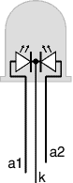
The most popular type of tri-colour LED has a red and a green LED combined in one package with three leads. They are called tri-colour because mixed red and green light appears to be yellow and this is produced when both the red and green LEDs are on.
The diagram shows the construction of a tri-colour LED. Note the different lengths of the three leads. The centre lead (k) is the common cathode for both LEDs, the outer leads (a1 and a2) are the anodes to the LEDs allowing each one to be lit separately, or both together to give the third colour.

Bi-colour LEDs
A bi-colour LED has two LEDs wired in 'inverse parallel' (one forwards, one backwards) combined in one package with two leads. Only one of the LEDs can be lit at one time and they are less useful than the tri-colour LEDs described above.

Sizes, Shapes and Viewing angles of LEDs
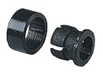
LED Clip
Photograph © Rapid Electronics
LEDs are available in a wide variety of sizes and shapes. The 'standard' LED has a round cross-section of 5mm diameter and this is probably the best type for general use, but 3mm round LEDs are also popular.
Round cross-section LEDs are frequently used and they are very easy to install on boxes by drilling a hole of the LED diameter, adding a spot of glue will help to hold the LED if necessary. LED clips are also available to secure LEDs in holes. Other cross-section shapes include square, rectangular and triangular.
As well as a variety of colours, sizes and shapes, LEDs also vary in their viewing angle. This tells you how much the beam of light spreads out. Standard LEDs have a viewing angle of 60° but others have a narrow beam of 30° or less.

Rapid Electronics stock a particularly wide selection of LEDs and their website is a good guide to the extensive range available including the latest high power LEDs.

Calculating an LED resistor value
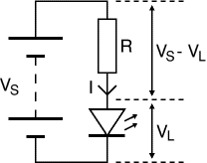
An LED must have a resistor connected in series to limit the current through the LED, otherwise it will burn out almost instantly.
The resistor value, R is given by:
R = (V_{S} - V_{L}) / I
V_{S} = supply voltage
V_{L} = LED voltage (usually 2V, but 4V for blue and white LEDs)
I = LED current (e.g. 10mA = 0.01A, or 20mA = 0.02A)
Make sure the LED current you choose is less than the maximum permitted and convert the current to amps (A) so the calculation will give the resistor value in ohms ().
To convert mA to A divide the current in mA by 1000 because 1mA = 0.001A.
If the calculated value is not available choose the nearest standard resistor value which is greater, so that the current will be a little less than you chose. In fact you may wish to choose a greater resistor value to reduce the current (to increase battery life for example) but this will make the LED less bright.

For example
If the supply voltage V_{S} = 9V, and you have a red LED (V_{L} = 2V), requiring a current I = 20mA = 0.020A,
R = (9V - 2V) / 0.02A = 350, so choose 390 (the nearest standard value which is greater).

Working out the LED resistor formula using Ohm's law
Ohm's law says that the resistance of the resistor, R = V/I, where:
V = voltage across the resistor (= V_{S} - V_{L} in this case)
I = the current through the resistor
So R = (V_{S} - V_{L}) / I
For more information on the calculations please see the Ohm's Law page.

Connecting LEDs in series
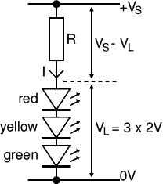
If you wish to have several LEDs on at the same time it may be possible to connect them in series. This prolongs battery life by lighting several LEDs with the same current as just one LED.
All the LEDs connected in series pass the same current so it is best if they are all the same type. The power supply must have sufficient voltage to provide about 2V for each LED (4V for blue and white) plus at least another 2V for the resistor. To work out a value for the resistor you must add up all the LED voltages and use this for V_{L}.
Example calculations:
A red, a yellow and a green LED in series need a supply voltage of at least 3 × 2V + 2V = 8V, so a 9V battery would be ideal.
V_{L} = 2V + 2V + 2V = 6V (the three LED voltages added up).
If the supply voltage V_{S} is 9V and the current I must be 15mA = 0.015A,
Resistor R = (V_{S} - V_{L}) / I = (9 - 6) / 0.015 = 3 / 0.015 = 200,
so choose R = 220 (the nearest standard value which is greater).

Avoid connecting LEDs in parallel!
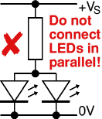
Connecting several LEDs in parallel with just one resistor shared between them is generally a bad idea.
If the LEDs require slightly different voltages only the lowest voltage LED will light and it may be destroyed by the larger current flowing through it. Although identical LEDs can be successfully connected in parallel with one resistor this rarely offers any useful benefit because resistors are very cheap and the current used is the same as connecting the LEDs individually. If LEDs are in parallel each one should have its own resistor.

Reading a table of technical data for LEDs
Suppliers' websites and catalogues usually provide tables of technical data for components such as LEDs. These tables contain a good deal of useful information in a compact form but they can be difficult to understand if you are not familiar with the abbreviations used.
The table below shows typical technical data for some 5mm diameter round LEDs with diffused packages (plastic bodies). Only three columns are important and these are shown in bold. Please see below for explanations of the quantities.
Type | Colour | I_{F}  max. | V_{F}  typ. | V_{F}  max. | V_{R}  max. | Luminous  intensity | Viewing  angle | Wavelength
Standard | Red | 30mA | 1.7V | 2.1V | 5V | 5mcd @ 10mA | 60° | 660nm
Standard | Bright red | 30mA | 2.0V | 2.5V | 5V | 80mcd @ 10mA | 60° | 625nm
Standard | Yellow | 30mA | 2.1V | 2.5V | 5V | 32mcd @ 10mA | 60° | 590nm
Standard | Green | 25mA | 2.2V | 2.5V | 5V | 32mcd @ 10mA | 60° | 565nm
High intensity | Blue | 30mA | 4.5V | 5.5V | 5V | 60mcd @ 20mA | 50° | 430nm
Super bright | Red | 30mA | 1.85V | 2.5V | 5V | 500mcd @ 20mA | 60° | 660nm
Low current | Red | 30mA | 1.7V | 2.0V | 5V | 5mcd @ 2mA | 60° | 625nm

I_{F} max. | Maximum forward current, forward just means with the LED connected correctly.
V_{F} typ. | Typical forward voltage, V_{L} in the LED resistor calculation.  This is about 2V, except for blue and white LEDs for which it is about 4V.
V_{F} max. | Maximum forward voltage.
V_{R} max. | Maximum reverse voltage  You can ignore this for LEDs connected the correct way round.
Luminous intensity | Brightness of the LED at the given current, mcd = millicandela.
Viewing angle | Standard LEDs have a viewing angle of 60°, others emit a narrower beam of about 30°.
Wavelength | The peak wavelength of the light emitted, this determines the colour of the LED.  nm = nanometre.

Flashing LEDs
Flashing LEDs look like ordinary LEDs but they contain an integrated circuit (IC) as well as the LED itself. The IC flashes the LED at a low frequency, for example 3Hz (3 flashes per second). Flashing LEDs are designed to be connected directly to a particular supply voltage such as 5V or 12V without a series resistor. Check with the supplier to find the safe supply voltage range for a particular flashing LED. The flash frequency is fixed so their use is limited and you may prefer to build your own circuit to flash an ordinary LED, for example the Flashing LED project which uses a 555 astable circuit.

LED Displays
LED displays are packages of many LEDs arranged in a pattern, the most familiar pattern being the 7-segment displays for showing numbers (digits 0-9). The pictures below illustrate some of the popular designs:
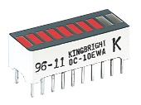 | 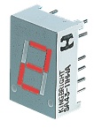 | 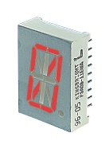 | 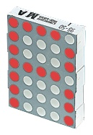
Bargraph | 7-segment | Starburst | Dot matrix
Photographs © Rapid Electronics

Pin connections of LED displays
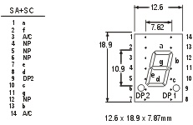
Pin connections diagram
© Rapid Electronics
There are many types of LED display and a supplier's catalogue or website should be consulted for the pin connections. The diagram on the right shows an example from Rapid Electronics. Like many 7-segment displays, this example is available in two versions: Common Anode (SA) with all the LED anodes connected together and Common Cathode (SC) with all the cathodes connected together. Letters a-g refer to the 7 segments, A/C is the common anode or cathode as appropriate (on 2 pins). Note that some pins are not present (NP) but their position is still numbered.

Lamps
Function | Symbols | Selecting | Types of lamp | Connecting
Also see: LEDs

Function and Construction

Lamps emit light when an electric current passes through them. All of the lamps shown on this page have a thin wire filament which becomes very hot and glows brightly when a current passes through it. The filament is made from a metal with a high melting point such as tungsten and it is usually wound into a small coil. Filament lamps have a shorter lifetime than most electronic components because eventually the filament 'blows' (melts) at a weak point.

Circuit symbols
There are two circuit symbols for a lamp, one for a lamp used to provide illumination and another for a lamp used as an indicator. Small lamps such as torch bulbs can be used for both purposes so either circuit symbol may used in simple educational circuits.
Lamp used for lighting  (for example a car headlamp or torch bulb) | Lamp used as an indicator  (for example a warning light on a car dashboard)

Selecting a Lamp
There are three important features to consider when selecting a lamp:
- Voltage rating - the supply voltage for normal brightness.
- Power or current rating - small lamps are usually rated by current.
- Lamp type - please see the table below.
The voltage and power (or current) ratings are usually printed or embossed on the body of a lamp.

Voltage rating
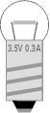
This is the supply voltage required for normal brightness. If a slightly higher voltage is used the lamp will be brighter but its lifetime will be shorter. With a lower supply voltage the lamp will be dimmer and its lifetime will be longer. The light from dim lamps has a yellow-orange colour.
Torch lamps pass a relatively large current and this significantly reduces the output voltage of the battery. Some voltage is used up inside the battery driving the large current through the small resistance of the battery itself (its 'internal resistance'). As a result the correct voltage rating for a torch lamp is lower than the normal voltage of the battery which lights it!
For example: a lamp rated 3.5V 0.3A is correct for a 4.5V battery (three 1.5V cells) because when the lamp is connected the voltage across the battery falls to about 3.5V.

Power or current rating
This is the power or current for the lamp when connected to its rated voltage. Low power lamps are usually rated by their current and high power lamps by their power. It is easy to convert between the two ratings:
P = I × V  or  I = P / V | where: | P = power in watts (W)  I = current in amps (A)  V = voltage in volts (V)
Examples:
- A lamp rated 3.5V 0.3A has a power rating P = I × V = 0.3 × 3.5 = 1.05W
- A lamp rated 6V 0.06A has a power rating P = I × V = 0.06 × 6 = 0.36W
- A lamp rated 12V 2.4W has a current rating I = P / V = 2.4 / 12 = 0.2A

Lamp Type
Type of Lamp | Example
MES Miniature Edison Screw  These are the standard small lamps. The bulb diameter is usually about 10mm, but tubular bulbs are also available. MES lamps have one contact on the base and the body forms the other contact. They are available with a good range of voltage and power (or current) ratings. Lens ended versions are available to produce a focused beam of light.  LES Lilliput Edison Screw  Smaller than MES, these have a bulb diameter of about 5mm.  Photograph © Rapid Electronics | 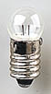
MCC Miniature Centre Contact  These have a bayonet style fitting, like a standard mains lamp in the UK. They have one contact on the base and the body forms the other contact. The bulb diameter is about 10mm.  Photograph © Rapid Electronics | 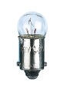
SBC Small Bayonet Cap  These have a bayonet style fitting, like a standard mains lamp in the UK. They have two contacts on the base so the metal body is not connected in the circuit. SBC lamps have high power ratings (24W for example) and their bulbs are large with a diameter of up to about 40mm. Note the two filament arrangements in the lamps shown, horizontal on the left, vertical on the right.  Photograph © Rapid Electronics | 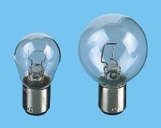
Pre-focus  This type of lamp is used in torches and lanterns. The flange at the top of the metal body is used to hold the lamp in place. Lampholders are not readily available so this type is unsuitable for most projects.  Photograph © Rapid Electronics | 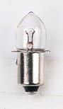
Wire ended  These are very small lamps with a bulb about 3mm diameter and 6mm long. Take care to avoid snapping the wires where they enter the glass bulb.  Photograph © Rapid Electronics | 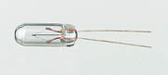
Grain of Wheat  These are similar to the wire ended lamps above but they have stranded wire leads usually about 150mm long. The bulb is about 3mm diameter and 6mm long - the size of a grain of wheat!  Photograph © Rapid Electronics | 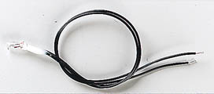
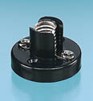 | 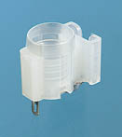
screw terminals | solder tags
Lampholders
Photographs © Rapid Electronics

Connecting and soldering
Lamps may be connected either way round in a circuit and the supply may be AC or DC.
Most lamps are designed to be used in a lampholder but the small 'wire ended' and 'grain of wheat' lamps have wires which may be soldered directly onto a circuit board.
Lampholders usually have screw terminals or solder tags to attach wires. Some small holders have contacts which may be soldered directly to a circuit board.

Lamps in Series
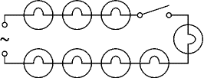
Several lamps can be successfully connected in series provided they all have identical voltage and power (or current) ratings. The supply voltage is divided equally between identical lamps so their voltage rating must be suitable for this. For example Christmas tree lights may have 20 lamps connected in series to a 240V supply, so each lamp will have 240V ÷ 20 = 12V across it.
A disadvantage of connecting lamps in series is that if one lamp blows all of them will go out because the circuit is broken. Christmas tree lamps have a special feature to overcome this problem; they are designed to short circuit (conduct like a wire link) when they blow, so the circuit is not broken and the other lamps remain lit, making it easier to locate the faulty lamp. Sets also include one 'fuse' lamp which blows normally.
WARNING! The Christmas tree lamps may seem safe because they use only 12V but they are connected to the mains supply which can be lethal. Always unplug from the mains before changing lamps. The voltage across the holder of a missing lamp is the full 240V of the mains supply! (Yes, it really is!)

Capacitors
Polarised (> 1µF) | Unpolarised (< 1µF) | Real Values | Variable & trimmers
Also see: Capacitance and Uses of Capacitors

Function
Capacitors store electric charge. They are used with resistors intiming circuits because it takes time for a capacitor to fill with charge. They are used to smooth varying DC supplies by acting as a reservoir of charge. They are also used in filter circuits because capacitors easily pass AC (changing) signals but they block DC (constant) signals.

Capacitance
This is a measure of a capacitor's ability to store charge. A large capacitance means that more charge can be stored. Capacitance is measured in farads, symbol F. However 1F is very large, so prefixes are used to show the smaller values.
Three prefixes (multipliers) are used, µ (micro), n (nano) and p (pico):
- µ means 10⁻⁶ (millionth), so 1000000µF = 1F
- n means 10⁻⁹ (thousand-millionth), so 1000nF = 1µF
- p means 10⁻¹² (million-millionth), so 1000pF = 1nF
Capacitor values can be very difficult to find because there are many types of capacitor with different labelling systems!
There are many types of capacitor but they can be split into two groups, polarised andunpolarised. Each group has its own circuit symbol.

Polarised capacitors (large values, 1µF +)
Examples: 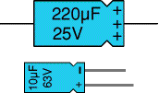 Circuit symbol:

Electrolytic Capacitors
Electrolytic capacitors are polarised and they must be connected the correct way round, at least one of their leads will be marked + or -. They are not damaged by heat when soldering.
There are two designs of electrolytic capacitors; axial where the leads are attached to each end (220µF in picture) and radial where both leads are at the same end (10µF in picture). Radial capacitors tend to be a little smaller and they stand upright on the circuit board.
It is easy to find the value of electrolytic capacitors because they are clearly printed with their capacitance and voltage rating. The voltage rating can be quite low (6V for example) and it should always be checked when selecting an electrolytic capacitor. If the project parts list does not specify a voltage, choose a capacitor with a rating which is greater than the project's power supply voltage. 25V is a sensible minimum for most battery circuits.

Tantalum Bead Capacitors
Tantalum bead capacitors are polarised and have low voltage ratings like electrolytic capacitors. They are expensive but very small, so they are used where a large capacitance is needed in a small size.
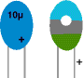
Modern tantalum bead capacitors are printed with their capacitance, voltage and polarity in full. However older ones use a colour-code system which has two stripes (for the two digits) and a spot of colour for the number of zeros to give the value in µF. The standard colour code is used, but for the spot, grey is used to mean × 0.01 and white means × 0.1 so that values of less than 10µF can be shown. A third colour stripe near the leads shows the voltage (yellow 6.3V, black 10V, green 16V, blue 20V, grey 25V, white 30V, pink 35V). The positive (+) lead is to the right when the spot is facing you: 'when the spot is in sight, the positive is to the right'.
For example: blue, grey, black spot means 68µF
For example: blue, grey, white spot means 6.8µF
For example: blue, grey, grey spot means 0.68µF

Unpolarised capacitors (small values, up to 1µF)
Examples: 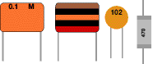 Circuit symbol:
Small value capacitors are unpolarised and may be connected either way round. They are not damaged by heat when soldering, except for one unusual type (polystyrene). They have high voltage ratings of at least 50V, usually 250V or so. It can be difficult to find the values of these small capacitors because there are many types of them and several different labelling systems!
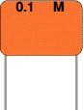
Many small value capacitors have their value printed but without a multiplier, so you need to use experience to work out what the multiplier should be!
For example 0.1 means 0.1µF = 100nF.
Sometimes the multiplier is used in place of the decimal point:
For example: 4n7 means 4.7nF.

Capacitor Number Code

A number code is often used on small capacitors where printing is difficult:
- the 1st number is the 1st digit,
- the 2nd number is the 2nd digit,
- the 3rd number is the number of zeros to give the capacitance in pF.
- Ignore any letters - they just indicate tolerance and voltage rating.
For example: 102 means 1000pF = 1nF (not 102pF!)
For example: 472J means 4700pF = 4.7nF (J means 5% tolerance).
Colour Code
Colour | Number
Black | 0
Brown | 1
Red | 2
Orange | 3
Yellow | 4
Green | 5
Blue | 6
Violet | 7
Grey | 8
White | 9

Capacitor Colour Code
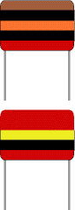
A colour code was used on polyester capacitors for many years. It is now obsolete, but of course there are many still around. The colours should be read like the resistor code, the top three colour bands giving the value in pF. Ignore the 4th band (tolerance) and 5th band (voltage rating).
For example:
brown, black, orange means 10000pF = 10nF = 0.01µF.
Note that there are no gaps between the colour bands, so 2 identical bands actually appear as a wide band.
For example:
wide red, yellow means 220nF = 0.22µF.

Polystyrene Capacitors

This type is rarely used now. Their value (in pF) is normally printed without units. Polystyrene capacitors can be damaged by heat when soldering (it melts the polystyrene!) so you should use a heat sink (such as a crocodile clip). Clip the heat sink to the lead between the capacitor and the joint.

Real capacitor values (the E3 and E6 series)
You may have noticed that capacitors are not available with every possible value, for example 22µF and 47µF are readily available, but 25µF and 50µF are not!
Why is this? Imagine that you decided to make capacitors every 10µF giving 10, 20, 30, 40, 50 and so on. That seems fine, but what happens when you reach 1000? It would be pointless to make 1000, 1010, 1020, 1030 and so on because for these values 10 is a very small difference, too small to be noticeable in most circuits and capacitors cannot be made with that accuracy.
To produce a sensible range of capacitor values you need to increase the size of the 'step' as the value increases. The standard capacitor values are based on this idea and they form a series which follows the same pattern for every multiple of ten.
The E3 series (3 values for each multiple of ten)
10, 22, 47, ... then it continues 100, 220, 470, 1000, 2200, 4700, 10000 etc.
Notice how the step size increases as the value increases (values roughly double each time).
The E6 series (6 values for each multiple of ten)
10, 15, 22, 33, 47, 68, ... then it continues 100, 150, 220, 330, 470, 680, 1000 etc.
Notice how this is the E3 series with an extra value in the gaps.
The E3 series is the one most frequently used for capacitors because many types cannot be made with very accurate values.

Variable capacitors
Variable Capacitor Symbol
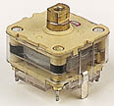
Variable Capacitor
Photograph © Rapid Electronics
Variable capacitors are mostly used in radio tuning circuits and they are sometimes called 'tuning capacitors'. They have very small capacitance values, typically between 100pF and 500pF (100pF = 0.0001µF). The type illustrated usually has trimmers built in (for making small adjustments - see below) as well as the main variable capacitor.
Many variable capacitors have very short spindles which are not suitable for the standard knobs used for variable resistors and rotary switches. It would be wise to check that a suitable knob is available before ordering a variable capacitor.
Variable capacitors are not normally used in timing circuits because their capacitance is too small to be practical and the range of values available is very limited. Instead timing circuits use a fixed capacitor and a variable resistor if it is necessary to vary the time period.

Trimmer capacitors
Trimmer Capacitor Symbol
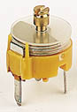
Trimmer Capacitor
Photograph © Rapid Electronics
Trimmer capacitors (trimmers) are miniature variable capacitors. They are designed to be mounted directly onto the circuit board and adjusted only when the circuit is built.
A small screwdriver or similar tool is required to adjust trimmers. The process of adjusting them requires patience because the presence of your hand and the tool will slightly change the capacitance of the circuit in the region of the trimmer!
Trimmer capacitors are only available with very small capacitances, normally less than 100pF. It is impossible to reduce their capacitance to zero, so they are usually specified by their minimum and maximum values, for example 2-10pF.
Trimmers are the capacitor equivalent of presets which are miniature variable resistors.

Capacitance and Uses of Capacitors
Capacitance | Charge & Energy | Reactance | Series & Parallel | Charging | Time constant |Discharging | Uses | Capacitor Coupling
Next Page: Impedance and Reactance
Also See: Capacitors | Power Supplies
unpolarised capacitor symbol
polarised capacitor symbol

Capacitance
Capacitance (symbol C) is a measure of a capacitor's ability to store charge. A large capacitance means that more charge can be stored. Capacitance is measured in farads, symbol F. However 1F is very large, so prefixes (multipliers) are used to show the smaller values:
- µ (micro) means 10⁻⁶ (millionth), so 1000000µF = 1F
- n (nano) means 10⁻⁹ (thousand-millionth), so 1000nF = 1µF
- p (pico) means 10⁻¹² (million-millionth), so 1000pF = 1nF

Charge and Energy Stored
The amount of charge (symbol Q) stored by a capacitor is given by:
Charge, Q = C × V | where: | Q = charge in coulombs (C)  C = capacitance in farads (F)  V = voltage in volts (V)
When they store charge, capacitors are also storing energy:
Energy, E = ½QV = ½CV² where E = energy in joules (J).
Note that capacitors return their stored energy to the circuit. They do not 'use up' electrical energy by converting it to heat as a resistor does. The energy stored by a capacitor is much smaller than the energy stored by a battery so they cannot be used as a practical source of energy for most purposes.

Capacitive Reactance Xc
Capacitive reactance (symbol Xc) is a measure of a capacitor's opposition to AC (alternating current). Like resistance it is measured in ohms, , but reactance is more complex than resistance because its value depends on the frequency (f) of the electrical signal passing through the capacitor as well as on the capacitance, C.
Capacitive reactance, Xc = | 1 | where: | Xc = reactance in ohms ()  f = frequency in hertz (Hz)  C = capacitance in farads (F)
Capacitive reactance, Xc = | 2fC | where:
The reactance Xc is large at low frequencies and small at high frequencies. For steady DC which is zero frequency, Xc is infinite (total opposition), hence the rule that capacitors pass AC but block DC.
For example a 1µF capacitor has a reactance of 3.2k for a 50Hz signal, but when the frequency is higher at 10kHz its reactance is only 16.
Note: the symbol Xc is used to distinguish capacitative reactance from inductive reactance X_{L} which is a property of inductors. The distinction is important because X_{L} increases with frequency (the opposite of Xc) and if both X_{L} and Xc are present in a circuit the combined reactance (X) is the difference between them. For further information please see the page on Impedance.

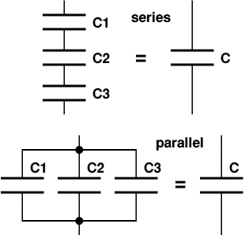
Capacitors in Series and Parallel
Combined capacitance (C) of  capacitors connected inseries: | 1 | = | 1 | + | 1 | + | 1 | + ...
Combined capacitance (C) of  capacitors connected inseries: | C | = | C1 | + | C2 | + | C3 | + ...

Combined capacitance (C) of  capacitors connected inparallel: | C = C1 + C2 + C3 + ...
Two or more capacitors are rarely deliberately connected in series in real circuits, but it can be useful to connect capacitors in parallel to obtain a very large capacitance, for example to smooth a power supply.
Note that these equations are the opposite way round for resistors in series and parallel.

Charging a capacitor
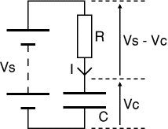
The capacitor (C) in the circuit diagram is being charged from a supply voltage (Vs) with the current passing through a resistor (R). The voltage across the capacitor (Vc) is initially zero but it increases as the capacitor charges. The capacitor is fully charged when Vc = Vs. The charging current (I) is determined by the voltage across the resistor (Vs - Vc):
Charging current, I = (Vs - Vc) / R (note that Vc is increasing)
At first Vc = 0V so the initial current, Io = Vs / R
Vc increases as soon as charge (Q) starts to build up (Vc = Q/C), this reduces the voltage across the resistor and therefore reduces the charging current. This means that the rate of charging becomes progressively slower.
time constant = R × C | where: | time constant is in seconds (s)  R = resistance in ohms ()  C = capacitance in farads (F)
For example:
If R = 47k and C = 22µF, then the time constant, RC = 47k × 22µF = 1.0s.
If R = 33k and C = 1µF, then the time constant, RC = 33k × 1µF = 33ms.
A large time constant means the capacitor charges slowly. Note that the time constant is a property of thecircuit containing the capacitance and resistance, it is not a property of a capacitor alone.
Graphs showing the current and
voltage for a capacitor charging
time constant = RC
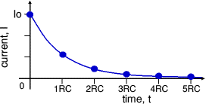
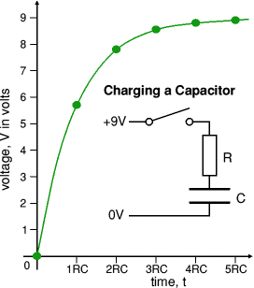
The time constant is the time taken for the charging (or discharging) current (I) to fall to ¹/e of its initial value (Io). 'e' is the base of natural logarithms, an important number in mathematics (like ). e = 2.71828 (to 6 significant figures) so we can roughly say that the time constant is the time taken for the current to fall to ¹/₃ of its initial value.
After each time constant the current falls by ¹/e (about ¹/₃). After 5 time constants (5RC) the current has fallen to less than 1% of its initial value and we can reasonably say that the capacitor isfully charged, but in fact the capacitor takes for ever to charge fully!
Time | Voltage | Charge
0RC | 0.0V | 0%
1RC | 5.7V | 63%
2RC | 7.8V | 86%
3RC | 8.6V | 95%
4RC | 8.8V | 98%
5RC | 8.9V | 99%

The bottom graph shows how thevoltage (V) increases as the capacitor charges. At first the voltage changes rapidly because the current is large; but as the current decreases, the charge builds up more slowly and the voltage increases more slowly.
After 5 time constants (5RC) the capacitor is almost fully charged with its voltage almost equal to the supply voltage. We can reasonably say that the capacitor is fully charged after 5RC, although really charging continues for ever (or until the circuit is changed).

Discharging a capacitor
Graphs showing the current and
voltage for a capacitor discharging
time constant = RC
The top graph shows how the current (I) decreases as the capacitor discharges. The initial current (Io) is determined by the initial voltage across the capacitor (Vo) and resistance (R):
Initial current, Io = Vo / R.
Note that the current graphs are the same shape for both charging and discharging a capacitor. This type of graph is an example of exponential decay.
Time | Voltage | Charge
0RC | 9.0V | 100%
1RC | 3.3V | 37%
2RC | 1.2V | 14%
3RC | 0.4V | 5%
4RC | 0.2V | 2%
5RC | 0.1V | 1%

The bottom graph shows how thevoltage (V) decreases as the capacitor discharges.
At first the current is large because the voltage is large, so charge is lost quickly and the voltage decreases rapidly. As charge is lost the voltage is reduced making the current smaller so the rate of discharging becomes progressively slower.
After 5 time constants (5RC) the voltage across the capacitor is almost zero and we 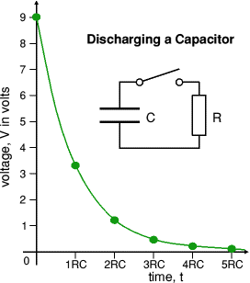
can reasonably say that the capacitor is fully discharged, although really discharging continues for ever (or until the circuit is changed).

Uses of Capacitors
Capacitors are used for several purposes:
- Timing - for example with a 555 timer IC controlling the charging and discharging.
- Smoothing - for example in a power supply.
- Coupling - for example between stages of an audio system and to connect a loudspeaker.
- Filtering - for example in the tone control of an audio system.
- Tuning - for example in a radio system.
- Storing energy - for example in a camera flash circuit.

Capacitor Coupling (CR-coupling)
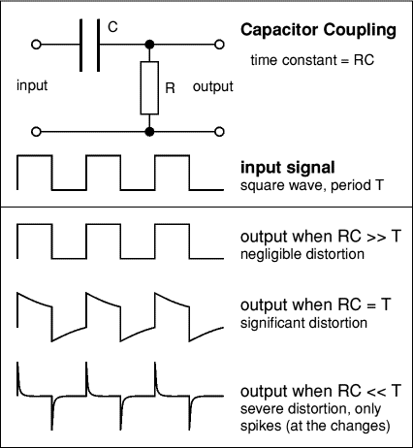
Sections of electronic circuits may be linked with a capacitor because capacitorspass AC (changing) signals but block DC(steady) signals. This is called capacitor coupling or CR-coupling. It is used between the stages of an audio system to pass on the audio signal (AC) without any steady voltage (DC) which may be present, for example to connect a loudspeaker. It is also used for the 'AC' switch setting on anoscilloscope.
The precise behaviour of a capacitor coupling is determined by its time constant (RC). Note that the resistance (R) may be inside the next circuit section rather than a separate resistor.
For successful capacitor coupling in anaudio system the signals must pass through with little or no distortion. This is achieved if the time constant (RC) is larger than the time period (T) of the lowest frequency audio signals required (typically 20Hz, T = 50ms).
Output when RC >> T
When the time constant is much larger than the time period of the input signal the capacitor does not have sufficient time to significantly charge or discharge, so the signal passes through with negligible distortion.
Output when RC = T
When the time constant is equal to the time period you can see that the capacitor has time to partly charge and discharge before the signal changes. As a result there is significant distortion of the signal as it passes through the CR-coupling. Notice how the sudden changes of the input signal pass straight through the capacitor to the output.
Output when RC << T
When the time constant is much smaller than the time period the capacitor has time to fully charge or discharge after each sudden change in the input signal. Effectively only the sudden changes pass through to the output and they appear as 'spikes', alternately positive and negative. This can be useful in a system which must detect when a signal changes suddenly, but must ignore slow changes

Impedance and Reactance
Impedance | Reactance | Input Impedance | Output Impedance | Voltage Divider
Next Page: 555 and 556 Timer Circuits
Also See: Capacitance | Resistance | Ohm's Law | Voltage Dividers

Impedance
Impedance, Z = | V
Impedance, Z = | I

Resistance, R = | V
Resistance, R = | I

V = voltage in volts (V)
I = current in amps (A)
Z = impedance in ohms ()
R = resistance in ohms ()
Impedance (symbol Z) is a measure of the overall opposition of a circuit to current, in other words: how much the circuit impedes the flow of current. It is like resistance, but it also takes into account the effects of capacitance and inductance. Impedance is measured in ohms, symbol .
Impedance is more complex than resistance because the effects of capacitance and inductance vary with the frequency of the current passing through the circuit and this means impedance varies with frequency! The effect of resistance is constant regardless of frequency.
The term 'impedance' is often used (quite correctly) for simple circuits which have no capacitance or inductance - for example to refer to their 'input impedance' or 'output impedance'. This can seem confusing if you are learning electronics, but for these simple circuits you can assume that it is just another word for resistance.
Four electrical quantities determine the impedance (Z) of a circuit:
resistance (R), capacitance (C), inductance (L) and frequency (f).
Impedance can be split into two parts:
- Resistance R (the part which is constant regardless of frequency)
- Reactance X (the part which varies with frequency due to capacitance and inductance)
For further details please see the section on Reactance below.
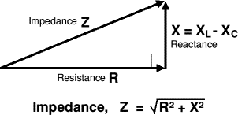
The capacitance and inductance cause a phase shift* between the current and voltage which means that the resistance and reactance cannot be simply added up to give impedance. Instead they must be added as vectorswith reactance at right angles to resistance as shown in the diagram.
* Phase shift means that the current and voltage are out of step with each other. Think of charging a capacitor. When the voltage across the capacitor is zero, the current is at a maximum; when the capacitor has charged and the voltage is at a maximum, the current is at a minimum. The charging and discharging occur continually with AC and the current reaches its maximum shortly before the voltage reaches its maximum: so we say the current leads the voltage.

Reactance, X
Reactance (symbol X) is a measure of the opposition of capacitance and inductance to current. Reactance varies with the frequency of the electrical signal. Reactance is measured in ohms, symbol .
There are two types of reactance: capacitive reactance (Xc) and inductive reactance (X_{L}).
The total reactance (X) is the difference between the two: X = X_{L} - Xc
- Capacitive reactance, Xc
Xc = | 1 | where: | Xc = reactance in ohms ()  f = frequency in hertz (Hz)  C = capacitance in farads (F)
Xc = | 2fC | where:
- Xc is large at low frequencies and small at high frequencies.
For steady DC which is zero frequency, Xc is infinite (total opposition),
hence the rule that capacitors pass AC but block DC.
- For example: a 1µF capacitor has a reactance of 3.2k for a 50Hz signal,
but when the frequency is higher at 10kHz its reactance is only 16.
- Inductive reactance, X_{L}
X_{L} = 2fL | where: | X_{L} = reactance in ohms ()  f = frequency in hertz (Hz)  L = inductance in henrys (H)
- X_{L} is small at low frequencies and large at high frequencies.
For steady DC (frequency zero), X_{L} is zero (no opposition),
hence the rule that inductors pass DC but block high frequency AC.
- For example: a 1mH inductor has a reactance of only 0.3 for a 50Hz signal,
but when the frequency is higher at 10kHz its reactance is 63.

Input Impedance Z_{IN}
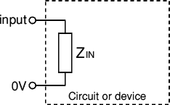
Input impedance (Z_{IN}) is the impedance 'seen' by anything connected to the input of a circuit or device (such as an amplifer). It is the combined effect of all the resistance, capacitance and inductance connected to the input inside the circuit or device.
It is normal to use the term 'input impedance' even for simple cases where there is only resistance and the term 'input resistance' could be used instead. In fact it is usually reasonable to assume that an input impedance is just resistance providing the input signal has a low frequency (less than 1kHz say).
The effects of capacitance and inductance vary with frequency, so if these are present the input impedance will vary with frequency. The effects of capacitance and inductance are generally most significant at high frequencies.
Usually input impedances should be high, at least ten times the output impedance of the circuit (or component) supplying a signal to the input. This ensures that the input will not 'overload' the source of the signal and reduce the strength (voltage) of the signal by a substantial amount.

Output Impedance Z_{OUT}
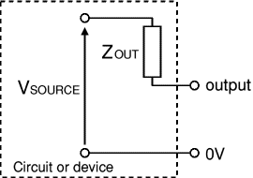
The equivalent circuit of any output

The output of any circuit or device is equivalent to an output impedance (Z_{OUT}) in series with a perfect voltage source (V_{SOURCE}). This is called the equivalent circuit and it repesents the combined effect of all the voltage sources, resistance, capacitance and inductance connected to the output inside the circuit or device. Note that V_{SOURCE} is usually not the same as the supply voltage Vs.
It is normal to use the term 'output impedance' even for simple cases where there is only resistance and the term 'output resistance' could be used instead. In fact it is usually reasonable to assume that an output impedance is just resistance providing the output signal has a low frequency (less than 1kHz say).
The effects of capacitance and inductance vary with frequency, so if these are present the output impedance will vary with frequency. The effects of capacitance and inductance are generally most significant at high frequencies.
Usually output impedances should be low, less than a tenth of the load impedance connected to the output. If an output impedance is too high it will be unable to supply a sufficiently strong signal to the load because most of the signal's voltage will be 'lost' inside the circuit driving current through the output impedance Z_{OUT}. The load could be a single component or the input impedance of another circuit.
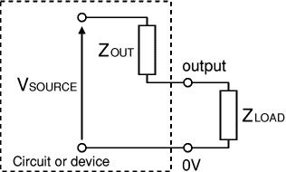
The load can be a single component or
the input impedance of another circuit

- Low output impedance, Z_{OUT} << Z_{LOAD}
Most of V_{SOURCE} appears across the load, very little voltage is 'lost' driving the output current through the output impedance. Usually this is the best arrangement.
- Matched impedances, Z_{OUT} = Z_{LOAD}
Half of V_{SOURCE} appears across the load, the other half is 'lost' driving the output current through the output impedance. This arrangement is useful in some situations (such as an amplifier driving a loudspeaker) because it delivers maximum power to the load. Note that an equal amount of power is wasted driving the output current through Z_{OUT}, an efficiency of 50%.
- High output impedance, Z_{OUT} >> Z_{LOAD}
Only a small portion of V_{SOURCE} appears across the load, most is 'lost' driving the output current through the output impedance. This arrangement is unsatisfactory.

The output resistance of a voltage divider
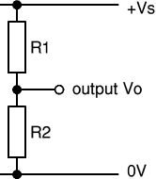
Voltage divider
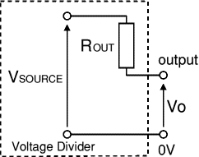
Equivalent circuit of a voltage divider
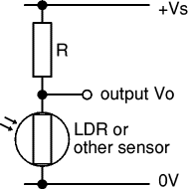
Voltage divider with an LDR
Voltage dividers are widely used in electronics, for example to connect an input transducer such as an LDR to a circuit input.
For successful use the output impedance of the voltage divider should be much smaller than the input impedance of the circuit it is connected to. Ideally the output impedance should be less than a tenth of the input impedance.
In the equivalent circuit of a voltage divider the output impedance is just a resistance and the term 'output resistance' could be used. R_{OUT}is equal to the two resistances (R1 and R2) connected in parallel:
Output impedance, R_{OUT} = | R1 × R2
Output impedance, R_{OUT} = | R1 + R2
The voltage source V_{SOURCE} in the equivalent circuit is the value of the output voltage Vo when there is nothing connected to the output (and therefore no output current). It is sometimes called the 'open circuit' voltage.
Voltage source, V_{SOURCE} = | Vs × R2
Voltage source, V_{SOURCE} = | R1 + R2
In most voltage dividers one of the resistors will be aninput transducer such as an LDR. The transducer's resistance varies and this will make both V_{SOURCE} and R_{OUT} vary too. To check that R_{OUT}is sufficiently low you should work out its highest value which will occur when the transducer has its maximum resistance (this applies wherever the transducer is connected in the voltage divider).
For example: If R1 = 10k and R2 is an LDR with maximum resistance 1M, R_{OUT} = 10k × 1M / (10k + 1M) = 9.9k (say 10k). This means it should be connected to a load or input resistance of at least 100k.

Series and Parallel Connections
Next Page: Voltage and Current
Also see: Circuit Symbols and Circuit Diagrams

Connecting Components
There are two ways of connecting components:
In series  so that each component has the same current.  The battery voltage is divided between the two lamps  Each lamp will have half the battery voltage if the lamps are identical. | 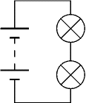
In parallel  so that each component has the same voltage.  Both lamps have the full battery voltage across them.  The battery current is divided between the two lamps. | 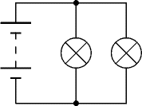

Most circuits contain a mixture of series and parallel connections
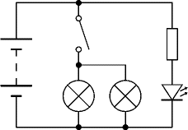
The terms series circuit and parallel circuit are sometimes used, but only the simplest of circuits are entirely one type or the other. It is better to refer to specific components and say they are connected in seriesor connected in parallel.
For example: the circuit on the right shows a resistor and LED connected in series (on the right) and two lamps connected in parallel (in the centre). The switch is connected in series with the two lamps.
See Lamps in Parallel below for another example.

Lamps in Series
If several lamps are connected in series they will all be switched on and off together by a switch connected anywhere in the circuit. The supply voltage is divided equally between the lamps (assuming they are all identical). If one lamp blows all the lamps will go out because the circuit is broken.

Christmas Tree Lights
The lamps on a Christmas tree are connected in series.
Normally you would expect all the lamps to go out if one blew, but Christmas tree lamps are special! They are designed to short circuit (conduct like a wire link) when they blow, so the circuit is not broken and the other lamps remain lit, making it easier to locate the faulty lamp. Sets also include one 'fuse' lamp which blows normally.
If there are 20 lamps and the mains electricity voltage is 240V, each lamp must be suitable for a 12V supply because the 240V is divided equally between the 20 lamps: 240V ÷ 20 = 12V.
WARNING! The Christmas tree lamps may seem safe because they use only 12V but they are connected to the mains supply which can be lethal. Always unplug from the mains before changing lamps. The voltage across the holder of a missing lamp is the full 240V of the mains supply! (Yes, it really is!)

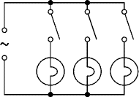
Lamps in Parallel
If several lamps are connected in parallel each one has the full supply voltage across it. The lamps may be switched on and off independently by connecting a switch in series with each lamp as shown in the circuit diagram. This arrangement is used to control the lamps in buildings.
This type of circuit is often called a parallel circuit but you can see that it is not really so simple - the switches are in series with the lamps, and it is these switch and lamp pairs that are connected in parallel.

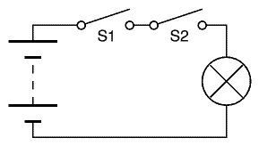
Switches in Series
If several on-off switches are connected in series they must all be closed (on) to complete the circuit.
The diagram shows a simple circuit with two switches connected in series to control a lamp.
Switch S1 AND Switch S2 must be closed to light the lamp.

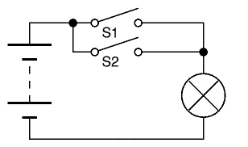
Switches in Parallel
If several on-off switches are connected in parallel only one needs to be closed (on) to complete the circuit.
The diagram shows a simple circuit with two switches connected in parallel to control a lamp.
Switch S1 OR Switch S2 (or both of them) must be closed to light the lamp.

Voltage and Current
This Page: Voltage | Current | ... in Series and Parallel
Next Page: Meters
Also See: Multimeters | Ohm's Law
Voltage and Current are vital to understanding electronics, but they are quite hard to grasp because we can't see them directly.

Voltage is the Cause, Current is the Effect
Voltage attempts to make a current flow, and current will flow if the circuit is complete. Voltage is sometimes described as the 'push' or 'force' of the electricity, it isn't really a force but this may help you to imagine what is happening. It is possible to have voltage without current, but current cannot flow without voltage.
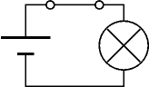 | 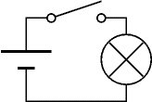 | 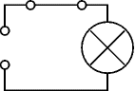
Voltage and Current  The switch is closed making a complete circuit so current can flow. | Voltage but No Current  The switch is open so the circuit is broken and current cannot flow. | No Voltage and No Current  Without the cell there is no source of voltage so current cannot flow.

Voltage, V
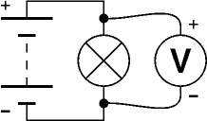
Connecting a voltmeter in parallel
- Voltage is a measure of the energy carried by the charge.
Strictly: voltage is the "energy per unit charge".
- The proper name for voltage is potential difference or p.d. for short, but this term is rarely used in electronics.
- Voltage is supplied by the battery (or power supply).
- Voltage is used up in components, but not in wires.
- We say voltage across a component.
- Voltage is measured in volts, V.
- Voltage is measured with a voltmeter, connected in parallel.
- The symbol V is used for voltage in equations.

Voltage at a point and 0V (zero volts)
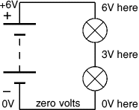
Voltage is a difference between two points, but in electronics we often refer to voltage at a point meaning the voltage difference between that point and a reference point of 0V (zero volts).
Zero volts could be any point in the circuit, but to be consistent it is normally the negative terminal of the battery or power supply. You will often see circuit diagrams labelled with 0V as a reminder.
You may find it helpful to think of voltage like height in geography. The reference point of zero height is the mean (average) sea level and all heights are measured from that point. The zero volts in an electronic circuit is like the mean sea level in geography.

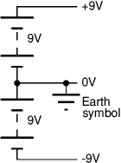
Zero volts for circuits with a dual supply
Some circuits require a dual supply with three supply connections as shown in the diagram. For these circuits the zero volts reference point is the middle terminal between the two parts of the supply.
On complex circuit diagrams using a dual supply the earth symbol is often used to indicate a connection to 0V, this helps to reduce the number of wires drawn on the diagram.
The diagram shows a ±9V dual supply, the positive terminal is +9V, the negative terminal is -9V and the middle terminal is 0V.

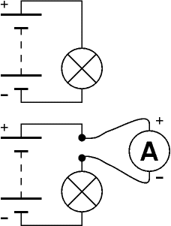
Connecting an ammeter in series

Current, I
- Current is the rate of flow of charge.
- Current is not used up, what flows into a component must flow out.
- We say current through a component.
- Current is measured in amps (amperes), A.
- Current is measured with an ammeter, connected in series.
To connect in series you must break the circuit and put the ammeter acoss the gap, as shown in the diagram.
- The symbol I is used for current in equations.
Why is the letter I used for current? ... please see FAQ.
1A (1 amp) is quite a large current for electronics, so mA (milliamps) are often used. m (milli) means "thousandth":
1mA = 0.001A, or 1000mA = 1A
The need to break the circuit to connect in series means that ammeters are difficult to use on soldered circuits. Most testing in electronics is done with voltmeters which can be easily connected without disturbing circuits.

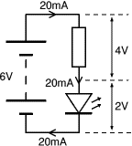
Voltage and Current for components in Series
Voltages add up for components connected in series.
Currents are the same through all components connected in series.
In this circuit the 4V across the resistor and the 2V across the LED add up to the battery voltage: 2V + 4V = 6V.
The current through all parts (battery, resistor and LED) is 20mA.

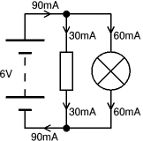
Voltage and Current for components in Parallel
Voltages are the same across all components connected in parallel.
Currents add up for components connected in parallel.
In this circuit the battery, resistor and lamp all have 6V across them.
The 30mA current through the resistor and the 60mA current through the lamp add up to the 90mA current through the battery.

Meters
Analogue | Digital | Voltmeters | Ammeters | Galvanometers | Ohmmeters
Next Page: Multimeters
Also See: Voltage and Current

Analogue display
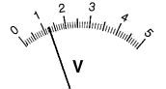
Analogue displays have a pointer which moves over a graduated scale. They can be difficult to read because of the need to work out the value of the smallest scale division. For example the scale in the picture has 10 small divisions between 0 and 1 so each small division represents 0.1. The reading is therefore 1.25V (the pointer is estimated to be half way between 1.2 and 1.3).
The maximum reading of an analogue meter is called full-scale deflection or FSD (it is 5V in the example shown).
Analogue meters must be connected the correct way round to prevent them being damaged when the pointer tries to move in the wrong direction. They are useful for monitoring continously changing values (such as the voltage across a capacitor discharging) and they can be good for quick rough readings because the movement of the pointer can be seen without looking away from the circuit under test.
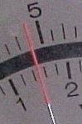 | 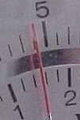
Correct  reflection hidden | Wrong  reflection visible

Taking accurate readings
To take an accurate reading from an analogue scale you must have your eye in line with the pointer. Avoid looking at an angle from the left or right because you will see a reading which is a little too high or too low. Many analogue meters have a small strip of mirror along the scale to help you. When your eye is in the correct position the reflection of the pointer is hidden behind the pointer itself. If you can see the reflection you are looking at an angle.
Instead of a mirror, some meters have a twisted pointer to aid accurate readings. The end of the pointer is turned through 90° so it appears very thin when viewed correctly. The meter shown in the galvanometers section has a twisted pointer although it is too small to see in the picture.

Digital display
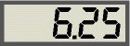
Values can be read directly from digital displays so they are easy to read accurately. It is normal for the least significant digit (on the right) to continually change between two or three values, this is a feature of the way digital meters work, not an error! Normally you will not need great precision and the least significant digit can be ignored or rounded up.
Digital meters may be connected either way round without damage, they will show a minus sign (-) when connected in reverse. If you exceed the maximum reading most digital meters show an almost blank display with just a 1 on the left-hand side.
All digital meters contain a battery to power the display so they use virtually no power from the circuit under test. This means that digital voltmeters have a very high resistance (usually called input impedance) of 1M or more, usually 10M, and they are very unlikely to affect the circuit under test.
For general use digital meters are the best type. They are easy to read, they may be connected in reverse and they are unlikely to affect the circuit under test.

Connecting meters
It is important to connect meters the correct way round:
- The positive terminal of the meter, marked + or coloured red should be connected nearest to + on the battery or power supply.
- The negative terminal of the meter, marked - or coloured black should be connected nearest to - on the battery or power supply.

Voltmeters
Connecting a voltmeter in parallel
- Voltmeters measure voltage.
- Voltage is measured in volts, V.
- Voltmeters are connected in parallel across components.
- Voltmeters have a very high resistance.

Measuring voltage at a point
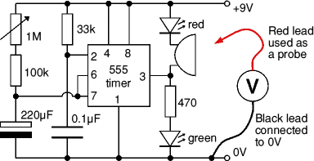
When testing circuits you often need to find the voltages at various points, for example the voltage at pin 2 of a 555 timer IC. This can seem confusing - where should you connect the second voltmeter lead?
- Connect the black (negative -) voltmeter lead to 0V, normally the negative terminal of the battery or power supply.
- Connect the red (positive +) voltmeter lead to the point you where you need to measure the voltage.
- The black lead can be left permanently connected to 0V while you use the redlead as a probe to measure voltages at various points.
- You may wish to use a crocodile clip on the black lead to hold it in place.
Voltage at a point really means the voltage difference between that point and 0V (zero volts) which is normally the negative terminal of the battery or power supply. Usually 0V will be labelled on the circuit diagram as a reminder.
Analogue meters take a little power from the circuit under test to operate their pointer. This may upset the circuit and give an incorrect reading. To avoid this voltmeters should have a resistance of at least 10 times the circuit resistance (take this to be the highest resistor value near where the meter is connected).
Most analogue voltmeters used in school science are not suitable for electronics because their resistance is too low, typically a few k. 100k or more is required for most electronics circuits.

Connecting an ammeter in series

Ammeters
- Ammeters measure current.
- Current is measured in amps (amperes), A.
1A is quite large, so mA (milliamps) and µA (microamps) are often used. 1000mA = 1A, 1000µA = 1mA, 1000000µA = 1A.
- Ammeters are connected in series.
To connect in series you must break the circuit and put the ammeter across the gap, as shown in the diagram.
- Ammeters have a very low resistance.
The need to break the circuit to connect in series means that ammeters are difficult to use on soldered circuits. Most testing in electronics is done with voltmeters which can be easily connected without disturbing circuits.

Galvanometers
Galvanometers are very sensitive meters which are used to measure tiny currents, usually 1mA or less. They are used to make all types of analogue meters by adding suitable resistors as shown in the diagrams below. The photograph shows an educational 100µA galvanometer for which various multipliers and shunts are available.
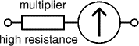 | 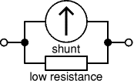 | 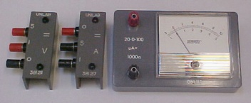
Making a Voltmeter  A galvanometer with a high resistance multiplier in series to make a voltmeter. | Making an Ammeter  A galvanometer with a low resistance shunt in parallel to make an ammeter. | Galvanometer with multiplier and shunt  Maximum meter current 100µA (or 20µA reverse).  This meter is unusual in allowing small  reverse readings to be shown.

Ohmmeters
An ohmmeter is used to measure resistance in ohms (). Ohmmeters are rarely found as separate meters but all standard multimeters have an ohmmeter setting.
1 is quite small so k and M are often used.
1k = 1000, 1M = 1000k = 1000000.

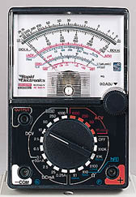 | 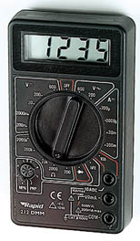
Analogue Multimeter | Digital Multimeter
Multimeter Photographs © Rapid Electronics

Multimeters
Multimeters are very useful test instruments. By operating a multi-position switch on the meter they can be quickly and easily set to be a voltmeter, an ammeter or anohmmeter. They have several settings (called 'ranges') for each type of meter and the choice of AC or DC.
Some multimeters have additional features such as transistor testing and ranges for measuring capacitance and frequency.
Analogue multimeters consist of a galvanometer with various resistors which can be switched in as multipliers (voltmeter ranges) and shunts (ammeter ranges).
For further information please see the Multimeters page.

Multimeters
Choosing | Digital | Analogue | Voltage & Current | Resistance | Diode | Transistor

Next Page: Resistance
Also See: Meters | Voltage & Current
Multimeters are very useful test instruments. By operating a multi-position switch on the meter they can be quickly and easily set to be a voltmeter, an ammeter or an ohmmeter. They have several settings (called 'ranges') for each type of meter and the choice of AC or DC. Some multimeters have additional features such as transistor testing and ranges for measuring capacitance and frequency.

I recommend:

Choosing a multimeter
The photographs below show modestly priced multimeters which are suitable for general electronics use. A digital multimeter is the best choice for your first multimeter, even the cheapest will be suitable for testing simple projects.
If you are buying an analogue multimeter make sure it has a high sensitivity of 20k/V or greater on DC voltage ranges, anything less is not suitable for electronics. The sensitivity is normally marked in a corner of the scale, ignore the lower AC value (sensitivity on AC ranges is less important), the higher DC value is the critical one. Beware of cheap analogue multimeters sold for electrical work on cars because their sensitivity is likely to be too low.

Digital Multimeter
Photograph © Rapid Electronics

Digital multimeters
All digital meters contain a battery to power the display so they use virtually no power from the circuit under test. This means that on their DC voltage ranges they have a very high resistance (usually called input impedance) of 1M or more, usually 10M, and they are very unlikely to affect the circuit under test.
Typical ranges for digital multimeters like the one illustrated:
(the values given are the maximum reading on each range)
- DC Voltage: 200mV, 2000mV, 20V, 200V, 600V.
- AC Voltage: 200V, 600V.
- DC Current: 200µA, 2000µA, 20mA, 200mA, 10A*.
*The 10A range is usually unfused and connected via a special socket.
- AC Current: None. (You are unlikely to need to measure this).
- Resistance: 200, 2000, 20k, 200k, 2000k, Diode Test.
Digital meters have a special diode test setting because their resistance ranges cannot be used to test diodes and other semiconductors.

Top of page | Choosing | Digital | Analogue | Voltage & Current | Resistance | Diode | Transistor

Analogue Multimeter
Photograph © Rapid Electronics

Analogue multimeters
Analogue meters take a little power from the circuit under test to operate their pointer. They must have a high sensitivity of at least 20k/V or they may upset the circuit under test and give an incorrect reading. See the section below onsensitivity for more details.
Batteries inside the meter provide power for the resistance ranges, they will last several years but you should avoid leaving the meter set to a resistance range in case the leads touch accidentally and run the battery flat.
Typical ranges for analogue multimeters like the one illustrated:
(the voltage and current values given are the maximum reading on each range)
- DC Voltage: 0.5V, 2.5V, 10V, 50V, 250V, 1000V.
- AC Voltage: 10V, 50V, 250V, 1000V.
- DC Current: 50µA, 2.5mA, 25mA, 250mA.
A high current range is often missing from this type of meter.
- AC Current: None. (You are unlikely to need to measure this).
- Resistance: 20, 200, 2k, 20k, 200k.
These resistance values are in the middle of the scale for each range.
It is a good idea to leave an analogue multimeter set to a DC voltage range such as 10V when not in use. It is less likely to be damaged by careless use on this range, and there is a good chance that it will be the range you need to use next anyway!

Sensitivity of an analogue multimeter
Multimeters must have a high sensitivity of at least 20k/V otherwise their resistance on DC voltage ranges may be too low to avoid upsetting the circuit under test and giving an incorrect reading. To obtain valid readings the meter resistance should be at least 10 times the circuit resistance (take this to be the highest resistor value near where the meter is connected). You can increase the meter resistance by selecting a higher voltage range, but this may give a reading which is too small to read accurately!
On any DC voltage range:
Analogue Meter Resistance = Sensitivity × Max. reading of range
e.g. a meter with 20k/V sensitivity on its 10V range has a resistance of 20k/V × 10V = 200k.
By contrast, digital multimeters have a constant resistance of at least 1M (often 10M) on all their DC voltage ranges. This is more than enough for almost all circuits.

Top of page | Choosing | Digital | Analogue | Voltage & Current | Resistance | Diode | Transistor

Measuring voltage and current with a multimeter
- Select a range with a maximum greater than you expect the reading to be.
- Connect the meter, making sure the leads are the correct way round.
Digital meters can be safely connected in reverse, but an analogue meter may be damaged.
- If the reading goes off the scale: immediately disconnect and select a higher range.
Multimeters are easily damaged by careless use so please take these precautions:
- Always disconnect the multimeter before adjusting the range switch.
- Always check the setting of the range switch before you connect to a circuit.
- Never leave a multimeter set to a current range (except when actually taking a reading).
The greatest risk of damage is on the current ranges because the meter has a low resistance.

Measuring voltage at a point
When testing circuits you often need to find the voltages at various points, for example the voltage at pin 2 of a 555 timer IC. This can seem confusing - where should you connect the second multimeter lead?
Measuring voltage at a point.
- Connect the black (negative -) lead to 0V, normally the negative terminal of the battery or power supply.
- Connect the red (positive +) lead to the point you where you need to measure the voltage.
- The black lead can be left permanently connected to 0V while you use the redlead as a probe to measure voltages at various points.
- You may wish to fit a crocodile clip to theblack lead of your multimeter to hold it in place while doing testing like this.
Voltage at a point really means the voltage difference between that point and 0V (zero volts) which is normally the negative terminal of the battery or power supply. Usually 0V will be labelled on the circuit diagram as a reminder.
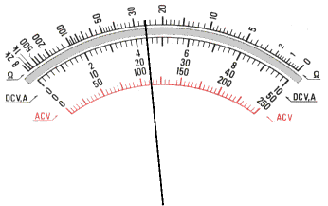
Analogue Multimeter Scales
These can appear daunting at first but remember
that you only need to read one scale at a time!
The top scale is used when measuring resistance.

Reading analogue scales
Check the setting of the range switch and choose an appropriate scale. For some ranges you may need to multiply or divide by 10 or 100 as shown in the sample readings below. For AC voltage ranges use the red markings because the calibration of the scale is slightly different.
Sample readings on the scales shown:
DC 10V range: 4.4V (read 0-10 scale directly)
DC 50V range: 22V (read 0-50 scale directly)
DC 25mA range: 11mA (read 0-250 and divide by 10)
AC 10V range: 4.45V (use the red scale, reading 0-10)
If you are not familiar with reading analogue scales generally you may wish to see the analogue display section on the general meters page.

Top of page | Choosing | Digital | Analogue | Voltage & Current | Resistance | Diode | Transistor

Measuring resistance with a multimeter
To measure the resistance of a component it must not be connected in a circuit. If you try to measure resistance of components in a circuit you will obtain false readings (even if the supply is disconnected) and you may damage the multimeter.
The techniques used for each type of meter are very different so they are treated separately:

Measuring resistance with a DIGITAL multimeter
- Set the meter to a resistance range greater than you expect the resistance to be.
Notice that the meter display shows "off the scale" (usually blank except for a 1 on the left). Don't worry, this is not a fault, it is correct - the resistance of air is very high!
- Touch the meter probes together and check that the meter reads zero.
If it doesn't read zero, turn the switch to 'Set Zero' if your meter has this and try again.
- Put the probes across the component.
Avoid touching more than one contact at a time or your resistance will upset the reading!

Measuring resistance with an ANALOGUE multimeter
The resistance scale on an analogue meter is normally at the top, it is an unusual scale because it readsbackwards and is not linear (evenly spaced). This is unfortunate, but it is due to the way the meter works.
- Set the meter to a suitable resistance range.
Choose a range so that the resistance you expect will be near the middle of the scale. For example: with the scale shown below and an expected resistance of about 50k choose the × 1k range.
- Hold the meter probes together and adjust the control on the front of the meter which is usually labelled "0 ADJ" until the pointer reads zero (on the RIGHT remember!).
If you can't adjust it to read zero, the battery inside the meter needs replacing.
- Put the probes across the component.
Avoid touching more than one contact at a time or your resistance will upset the reading!
Analogue Multimeter Scales
The resistance scale is at the top, note that it reads
backwards and is not linear (evenly spaced).

Reading analogue resistance scales
For resistance use the upper scale, noting that it reads backwards and is not linear (evenly spaced).
Check the setting of the range switch so that you know by how much to multiply the reading.
Sample readings on the scales shown:
× 10 range: 260
× 1k range: 26k
If you are not familiar with reading analogue scales generally you may wish to see the analogue displaysection on the general meters page.

Top of page | Choosing | Digital | Analogue | Voltage & Current | Resistance | Diode | Transistor

Testing a diode with a multimeter
The techniques used for each type of meter are very different so they are treated separately:
Diodes
a = anode
k = cathode

Testing a diode with a DIGITAL multimeter
- Digital multimeters have a special setting for testing a diode, usually labelled with the diode symbol.
- Connect the red (+) lead to the anode and the black (-) to the cathode. The diode should conduct and the meter will display a value (usually the voltage across the diode in mV, 1000mV = 1V).
- Reverse the connections. The diode should NOT conduct this way so the meter will display "off the scale" (usually blank except for a 1 on the left).

Testing a diode with an ANALOGUE multimeter
- Set the analogue multimeter to a low value resistance range such as × 10.
- It is essential to note that the polarity of analogue multimeter leads is reversed on the resistance ranges, so the black lead is positive (+) and the red lead is negative (-)! This is unfortunate, but it is due to the way the meter works.
- Connect the black (+) lead to anode and the red (-) to the cathode. The diode should conduct and the meter will display a low resistance (the exact value is not relevant).
- Reverse the connections. The diode should NOT conduct this way so the meter will show infinite resistance (on the left of the scale).
For further information please see the diodes page.
You may find it easier to test a diode with the simple tester project.

Top of page | Choosing | Digital | Analogue | Voltage & Current | Resistance | Diode | Transistor

Testing a transistor with a multimeter
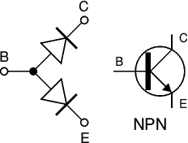
Testing an NPN transistor
Set a digital multimeter to diode test and an analogue multimeter to a low resistance range such as × 10, as described above for testing a diode.
Test each pair of leads both ways (six tests in total):
- The base-emitter (BE) junction should behave like a diode and conduct one way only.
- The base-collector (BC) junction should behave like a diode and conduct one way only.
- The collector-emitter (CE) should not conduct either way.
The diagram shows how the junctions behave in an NPN transistor. The diodes are reversed in a PNP transistor but the same test procedure can be used.
For further information please see the transistors page.
You may find it easier to test a transistor with the simple tester project.
Some multimeters have a 'transistor test' function, please refer to the instructions supplied with the meter for details.

Resistance
Resistance | Series | Parallel | Conductors and Insulators
Next Page: Ohm's Law
Also See: Voltage and Current | Resistors | Series and Parallel | Impedance

Resistance
Resistance is the property of a component which restricts the flow of electric current. Energy is used up as the voltage across the component drives the current through it and this energy appears as heat in the component.
Resistance is measured in ohms, the symbol for ohm is an omega .
1 is quite small for electronics so resistances are often given in k and M.
1 k = 1000 1 M = 1000000 .
Resistors used in electronics can have resistances as low as 0.1 or as high as 10 M.

Resistors connected in Series
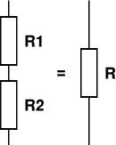
When resistors are connected in series their combined resistance is equal to the individual resistances added together. For example if resistors R1 and R2 are connected in series their combined resistance, R, is given by:
Combined resistance in series: R = R1 + R2
This can be extended for more resistors: R = R1 + R2 + R3 + R4 + ...
Note that the combined resistance in series will always be greater than any of the individual resistances.

Resistors connected in Parallel
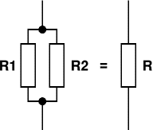
When resistors are connected in parallel their combined resistance is less than any of the individual resistances. There is a special equation for the combined resistance of two resistors R1 and R2:
Combined resistance of  two resistors in parallel: | R = | R1 × R2
Combined resistance of  two resistors in parallel: | R = | R1 + R2
For more than two resistors connected in parallel a more difficult equation must be used. This adds up the reciprocal ("one over") of each resistance to give the reciprocal of the combined resistance, R:
1 | = | 1 | + | 1 | + | 1 | + ...
R | = | R1 | + | R2 | + | R3 | + ...
The simpler equation for two resistors in parallel is much easier to use!
Note that the combined resistance in parallel will always be less than any of the individual resistances.

Conductors, Semiconductors and Insulators
The resistance of an object depends on its shape and the material from which it is made. For a given material, objects with a smaller cross-section or longer length will have a greater resistance.
Materials can be divided into three groups:
- Conductors which have low resistance.
Examples: metals (aluminium, copper, silver etc.) and carbon.
Metals are used to make connecting wires, switch contacts and lamp filaments. Resistors are made from carbon or long coils of thin wire.
- Semiconductors which have moderate resistance.
Examples: germanium, silicon.
Semiconductors are used to make diodes, LEDs, transistors and integrated circuits (chips).
- Insulators which have high resistance.
Examples: most plastics such as polythene and PVC (polyvinyl chloride), paper, glass.
PVC is used as an outer covering for wires to prevent them making contact.

Resistors
Colour Code | Colour Code Calculator | Tolerance | Real Values (E6 & E12 series) | Power Rating
Also see: Resistance | Ohm's Law | Variable Resistors

Example:
Circuit symbol:

Function
Resistors restrict the flow of electric current, for example a resistor is placed in series with a light-emitting diode (LED) to limit the current passing through the LED.

Connecting and soldering
Resistors may be connected either way round. They are not damaged by heat when soldering.

The Resistor
Colour Code
Colour | Number
Black | 0
Brown | 1
Red | 2
Orange | 3
Yellow | 4
Green | 5
Blue | 6
Violet | 7
Grey | 8
White | 9

Resistor values - the resistor colour code
Resistance is measured in ohms, the symbol for ohm is an omega .
1 is quite small so resistor values are often given in k and M.
1 k = 1000 1 M = 1000000 .
Resistor values are normally shown using coloured bands.
Each colour represents a number as shown in the table.
Most resistors have 4 bands:
- The first band gives the first digit.
- The second band gives the second digit.
- The third band indicates the number of zeros.
- The fourth band is used to shows the tolerance (precision) of the resistor, this may be ignored for almost all circuits but further details are given below.
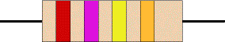
This resistor has red (2), violet (7), yellow (4 zeros) and gold bands.
So its value is 270000 = 270 k.
On circuit diagrams the is usually omitted and the value is written 270K.
Find out how to make your own Colour Code Calculator.

Small value resistors (less than 10 ohm)
The standard colour code cannot show values of less than 10. To show these small values two special colours are used for the third band: gold which means × 0.1 and silver which means × 0.01. The first and second bands represent the digits as normal.
For example:
red, violet, gold bands represent 27 × 0.1 = 2.7
green, blue, silver bands represent 56 × 0.01 = 0.56

Resistor Colour Code Calculator
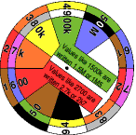
The Resistor Colour Code Calculator can be used to identify resistors. It consists of three card discs showing the colours and values, these are fastened together so you can simply turn the discs to select the value or colour code required. Simple but effective!
There are two pdf versions to download and print on A4 white card (two per sheet):
- Colour (for a colour printer)
- Black and White (for a black only printer)
This version must be coloured manually, it is easiest to do this before cutting out.
To make the calculator, carefully cut out the three discs and fasten them together with a small brass paper fastener.
The calculator design is copyright but it may be copied for educational purposes.

Tolerance of resistors (fourth band of colour code)
The tolerance of a resistor is shown by the fourth band of the colour code. Tolerance is the precision of the resistor and it is given as a percentage. For example a 390 resistor with a tolerance of ±10% will have a value within 10% of 390, between 390 - 39 = 351 and 390 + 39 = 429 (39 is 10% of 390).
A special colour code is used for the fourth band tolerance:
silver ±10%, gold ±5%, red ±2%, brown ±1%.
If no fourth band is shown the tolerance is ±20%.
Tolerance may be ignored for almost all circuits because precise resistor values are rarely required.

Resistor shorthand
Resistor values are often written on circuit diagrams using a code system which avoids using a decimal point because it is easy to miss the small dot. Instead the letters R, K and M are used in place of the decimal point. To read the code: replace the letter with a decimal point, then multiply the value by 1000 if the letter was K, or 1000000 if the letter was M. The letter R means multiply by 1.
For example:
560R means 560
2K7 means 2.7 k = 2700
39K means 39 k
1M0 means 1.0 M = 1000 k

Real resistor values (the E6 and E12 series)
You may have noticed that resistors are not available with every possible value, for example 22k and 47k are readily available, but 25k and 50k are not!
Why is this? Imagine that you decided to make resistors every 10 giving 10, 20, 30, 40, 50 and so on. That seems fine, but what happens when you reach 1000? It would be pointless to make 1000, 1010, 1020, 1030 and so on because for these values 10 is a very small difference, too small to be noticeable in most circuits. In fact it would be difficult to make resistors sufficiently accurate.
To produce a sensible range of resistor values you need to increase the size of the 'step' as the value increases. The standard resistor values are based on this idea and they form a series which follows the same pattern for every multiple of ten.
The E6 series (6 values for each multiple of ten, for resistors with 20% tolerance)
10, 15, 22, 33, 47, 68, ... then it continues 100, 150, 220, 330, 470, 680, 1000 etc.
Notice how the step size increases as the value increases. For this series the step (to the next value) is roughly half the value.
The E12 series (12 values for each multiple of ten, for resistors with 10% tolerance)
10, 12, 15, 18, 22, 27, 33, 39, 47, 56, 68, 82, ... then it continues 100, 120, 150 etc.
Notice how this is the E6 series with an extra value in the gaps.
The E12 series is the one most frequently used for resistors. It allows you to choose a value within 10% of the precise value you need. This is sufficiently accurate for almost all projects and it is sensible because most resistors are only accurate to ±10% (called their 'tolerance'). For example a resistor marked 390could vary by ±10% × 390 = ±39, so it could be any value between 351 and 429.

Resistors in Series and Parallel
For information on resistors connected in series and parallel please see the Resistance page,

Power Ratings of Resistors
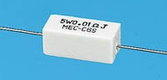
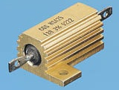
High power resistors
(5W top, 25W bottom)
Photographs © Rapid Electronics
Electrical energy is converted to heat when current flows through a resistor. Usually the effect is negligible, but if the resistance is low (or the voltage across the resistor high) a large current may pass making the resistor become noticeably warm. The resistor must be able to withstand the heating effect and resistors have power ratings to show this.
Power ratings of resistors are rarely quoted in parts lists because for most circuits the standard power ratings of 0.25W or 0.5W are suitable. For the rare cases where a higher power is required it should be clearly specified in the parts list, these will be circuits using low value resistors (less than about 300) or high voltages (more than 15V).
The power, P, developed in a resistor is given by:
P = I² × R  or  P = V² / R | where: | P = power developed in the resistor in watts (W)  I = current through the resistor in amps (A)  R = resistance of the resistor in ohms ()  V = voltage across the resistor in volts (V)
Examples:
- A 470 resistor with 10V across it, needs a power rating P = V²/R = 10²/470 = 0.21W.
In this case a standard 0.25W resistor would be suitable.
- A 27 resistor with 10V across it, needs a power rating P = V²/R = 10²/27 = 3.7W.
A high power resistor with a rating of 5W would be suitable.

Ohm's Law
Next Page: Power and Energy
Also See: Voltage and Current | Resistance | Resistors
To make a current flow through a resistance there must be a voltage across that resistance. Ohm's Law shows the relationship between the voltage (V), current (I) and resistance (R). It can be written in three ways:
V = I × R | or |  | or
  I = | V
  I = | R
  R = | V
  R = | I

where: | V = voltage in volts (V)  I = current in amps (A)  R = resistance in ohms () | or: | V = voltage in volts (V)  I = current in milliamps (mA)  R = resistance in kilohms (k)
For most electronic circuits the amp is too large and the ohm is too small, so we often measure current in milliamps (mA) and resistance in kilohms (k). 1 mA = 0.001 A and 1 k = 1000 .
The Ohm's Law equations work if you use V, A and , or if you use V, mA and k. You must not mix these sets of units in the equations so you may need to convert between mA and A or k and .

The VIR triangle
V
I R
Ohm's Law
triangle
You can use the VIR triangle to help you remember the three versions of Ohm's Law.
Write down V, I and R in a triangle like the one in the yellow box on the right.
- To calculate voltage, V: put your finger over V,
this leaves you with I R, so the equation is V = I × R
- To calculate current, I: put your finger over I,
this leaves you with V over R, so the equation is I = ^{V}/_{R}
- To calculate resistance, R: put your finger over R,
this leaves you with V over I, so the equation is R = ^{V}/_{I}

Ohm's Law Calculations
Use this method to guide you through calculations:
V
I R
- Write down the Values, converting units if necessary.
- Select the Equation you need (use the VIR triangle).
- Put the Numbers into the equation and calculate the answer.
It should be Very Easy Now!
- 3 V is applied across a 6 resistor, what is the current?
  - Values: V = 3 V, I = ?, R = 6
  - Equation: I = ^{V}/_{R}
  - Numbers: Current, I = ³/₆ = 0.5 A

- A lamp connected to a 6 V battery passes a current of 60 mA, what is the lamp's resistance?
  - Values: V = 6 V, I = 60 mA, R = ?
  - Equation: R = ^{V}/_{I}
  - Numbers: Resistance, R = ⁶/₆₀ = 0.1 k = 100
(using mA for current means the calculation gives the resistance in k)

- A 1.2 k resistor passes a current of 0.2 A, what is the voltage across it?
  - Values: V = ?, I = 0.2 A, R = 1.2 k = 1200
(1.2 k is converted to 1200 because A and k must not be used together)
  - Equation: V = I × R
  - Numbers: V = 0.2 × 1200 = 240 V

Power and Energy
Power | Calculations | Overheating | Energy
Next Page: AC, DC and Electrical Signals
Also See: Voltage and Current | Resistance | Ohm's Law


What is power?
Power is the rate of using or supplying energy:
Power = | Energy |  | Power is measured in watts (W)  Energy is measured in joules (J)  Time is measured in seconds (s)
Power = | Time
Electronics is mostly concerned with small quantities of power, so the power is often measured in milliwatts (mW), 1mW = 0.001W. For example an LED uses about 40mW and a bleeper uses about 100mW, even a lamp such as a torch bulb only uses about 1W.
The typical power used in mains electrical circuits is much larger, so this power may be measured in kilowatts (kW), 1kW = 1000W. For example a typical mains lamp uses 60W and a kettle uses about 3kW.

Calculating power using current and voltage
There are three ways of writing an equation for power, current and voltage:
Power = Current × Voltage so P = I × V | or |  | or
  I = | P
  I = | V
  V = | P
  V = | I

where: | P = power in watts (W)  V = voltage in volts (V)  I = current in amps (A) | or: | P = power in milliwatts (mW)  V = voltage in volts (V)  I = current in milliamps (mA)

P
I V
You can use the PIV triangle to help you remember the three versions of the power equations. Use it in the same way as the Ohm's Law triangle. For most electronic circuits the amp is too large, so we often measure current in milliamps (mA) and power in milliwatts (mW). 1mA = 0.001A and 1mW = 0.001W.

Calculating power using resistance and current or voltage
Using Ohm's Law V = I × R we can convert P = I × V to:
P  I² R |  | V²  P R
PI²R triangle |  | V²PR triangle
P = I² × R  or  P = V² / R | where: | P = power in watts (W)  I = current in amps (A)  R = resistance in ohms ()  V = voltage in volts (V)

Wasted power and overheating
Normally electric power is useful, making a lamp light or a motor turn for example. However, electrical energy is converted to heat whenever a current flows through a resistance and this can be a problem if it makes a device or wire overheat. In electronics the effect is usually negligible, but if the resistance is low (a wire or low value resistor for example) the current can be sufficiently large to cause a problem.
You can see from the equation P = I² × R that for a given resistance the power depends on the currentsquared, so doubling the current will give 4 times the power.
Resistors are rated by the maximum power they can have developed in them without damage, but power ratings are rarely quoted in parts lists because the standard ratings of 0.25W or 0.5W are suitable for most circuits. Further information is available on the Resistors page.
Wires and cables are rated by the maximum current they can pass without overheating. They have a very low resistance so the maximum current is relatively large. For further information about current rating please see the Connectors and Cables page.

Energy
The amount of energy used (or supplied) depends on the power and the time for which it is used:
Energy = Power × Time
A low power device operating for a long time can use more energy than a high power device operating for a short time. For example:
- A 60W lamp switched on for 8 hours uses 60W × 8 × 3600s = 1728kJ.
- A 3kW kettle switched on for 5 minutes uses 3000W × 5 × 60s = 900kJ.
The standard unit for energy is the joule (J), but 1J is a very small amount of energy for mains electricity so kilojoule (kJ) or megajoule (MJ) are sometimes used in scientific work. In the home we measure electrical energy in kilowatt-hours (kWh). 1kWh is the energy used by a 1kW power appliance when it is switched on for 1 hour:
1kWh = 1kW × 1 hour = 1000W × 3600s = 3.6MJ
For example:
- A 60W lamp switched on for 8 hours uses 0.06kW × 8 = 0.48kWh.
- A 3kW kettle switched on for 5 minutes uses 3kW × ⁵/₆₀ = 0.25kWh.
Automatic Solar Garden Lights with LEDs
Efficient automatic solar garder lights circuit with minimum components the best deal is that is completely auto and the Solar panel acts as a light detector. Switches the Lamp off at Dawn, charges the battery during daytime and switches the LED lights ON at dusk providing 100 Lumens illumination during the night.
The solar panel must provide 5.5V and 150mA. Assuming a 3.7V/1500mAh battery the charging will be complete in 8 hours at 200% capacity @ 180 mA. With 10 LEDs the power consumption would be 90 mA/hour providing a 10 hours illumination with light levels of 50 lumens to 60 lumens. With 20 LEDs the light intensity will be 100 to 120 lumens.
You can use any number of LEDs and battery capacity too. This would directly provide you the amount of illumination and time for illumination. If you use higher capacity battery than that recommended the solar panel current should be increased proportionately. Current provided by solar panel should be 10% of battery capacity.

Solar garden lights circuit schematic
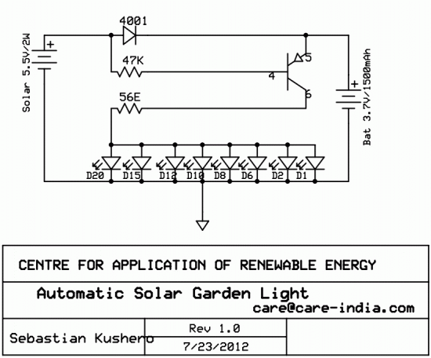
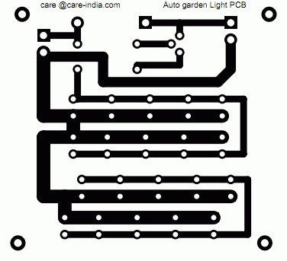
Bill of material for the solar garden lights
- Resistor (1) 4K7 or 5K6
- Resistor (1) 47E or 56E or any value ( Current Limiting )
- Transistor 2N3906
- Diode 1N4001/7/ 1N4148 (Any)
- Solar Panel 5.5v/200mA
- Battery 3.7v/1500mAh
- Switch SPST

Solar Charger for 6V 4.5Ah Battery
Here is a solar charger circuit that is used to charge Lead Acid or Ni-Cd batteries using the solar energy power. The circuit harvests solar energy to charge a 6 volt 4.5 Ah rechargeable battery for various applications. The charger has Voltage and Current regulation and Over voltage cut off facilities.
The circuit uses a 12 volt solar panel and a variable voltage regulator IC LM 317.
The solar panel consists of solar cells each rated at 1.2 volts.
12 volt DC is available from the panel to charge the battery. Charging current passes through D1 to the voltage regulator IC LM 317. By adjusting its Adjust pin, output voltage and current can be regulated.

Solar Charger Circuit Schematic
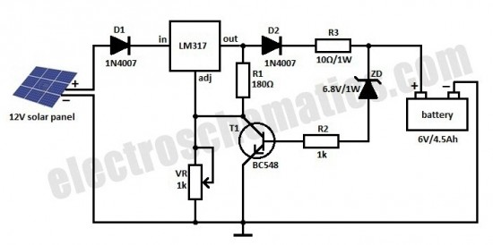
Solar charger with current regulation and cut off.
VR is placed between the adjust pin and ground to provide an output voltage of 9 volts to the battery. Resistor R3 Restrict the charging current and diode D2 prevents discharge of current from the battery.
Transistor T1 and Zener diode ZD act as a cut off switch when the battery is full. Normally T1 is off and battery gets charging current. When the terminal voltage of the battery rises above 6.8 volts, Zener conducts and provides base current to T1. It then turns on grounding the output of LM317 to stop charging.

Solar Inverter Battery Charger
Here is an energy saving solar inverter battery charger. It harvests solar energy to replenish 12 volt Inverter battery. It has auto cut off facility to stop charging when the battery attains full charge. The charger uses a 24 volt solar panel as input.
The circuit uses a variable voltage regulator IC LM 317 to set the output voltage steady around 16 volts. Variable resistor VR controls the output voltage. When the solar panel generates current, D1 forward biases and Regulator IC gets input current. Its output voltage depends on the setting of VR and the output current is controlled by R1. This current passes through D2 and R3. When the output voltage is above (as set by VR) 16volts, Zener diode ZD2 conducts and gives stable 15 volts for charging.
- Charging current depends on R1 and R3. Around 250 to 300 milli ampere current will be available for charging. Green LED indicates charging status. When the battery attains full voltage around 13 volts, Zener diode ZD1 conducts and T1 forward biases. This drains the output current from the regulator IC through T1 and charging process stops. When the battery voltage reduces below 12 volts, ZD1 turns off and battery charging starts again.
- Solar Inverter Battery Charger Circuit Schematic
- 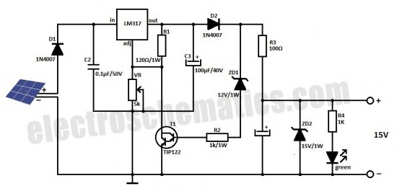
- Connect the circuit to the solar panel and measure the input voltage. Make sure that it is above 18 volts. Connect the circuit to the battery with correct polarity and adjust VR till LED lights. This indicates the conduction of ZD2 and output voltage. Use heat sinks for LM317 and TIP 122 to dissipate heat.
- Note : The same circuit can be modified for charging different types of batteries. The only modification required is the change of ZD1 and ZD2. Select ZD2 value for the required output voltage and ZD1 for cut off voltage level. For example for 6 volt battery, ZD1 should be 6.1 volts and ZD2 6.8 volt. For Mobile battery, ZD1 should be 4.7 volts and ZD2 5.1 volts. All the other components remain same.

Solar Charger Monitor Circuit
This add on circuit can be attached to the solar charger to see whether the battery is charging or not. It lights a Red LED to indicate that the battery is not accepting charge. It gives a warning indication if there is any loose connection with the charger and battery.
The Solar charger monitor circuit uses two PNP transistors T1 and T2 to give a warning indication if there is any loose connection with the charger and battery. If the connection is intact and current is flowing into the battery, diodes D2 and D3 forward bias and drops around 1.2 volts. This forward voltage drop across the diodes causes T2 to conducts. The collector current from T2 keeps the base of T1 high and it remains off. Red LED connected to the emitter of T1 remains off indicating that current is flowing to the battery and the connections are intact. When there is any break in the connecting cables or any loose contacts in the terminals, no more current passes and D2 and D3 reverse biases. This turns off T2 and T1 conducts .LED lights indicating that battery is not getting charging current.

Solar Charger Monitor Circuit Diagram
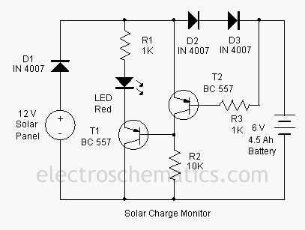

Solar Based Multipurpose Charger Circuit

Here is an ideal solution to harvest Solar energy for charging purpose. This charger can replenish almost all types of batteries including Mobile phone battery. It uses a Solar Module to convert light energy into electrical energy

Solar Charger Circuit Schematic
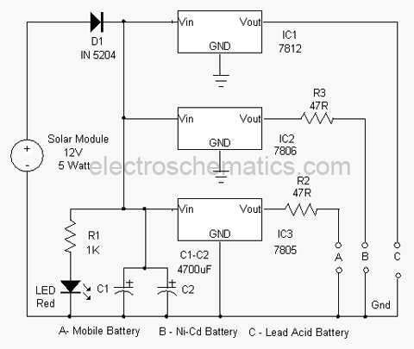
The circuit is self explanatory. A 12 volt 5 Watt solar panel is used as the source of current. The cells in the panel are made up of semiconductor material which transforms light energy into electrical energy. When the sunlight is maximum, the solar module can generate around 16.5 volts at 400 mA. This current is used to charge the battery. Diode D1 allows current into three regulator ICs to provide regulated voltage to the load. IC1 7812 gives 12 volts and 400 mA current to charge a Lead Acid battery.
The battery can be connected to point C and ground. IC2 7806 gives regulated 6 volts to charge NiCd battery. Resistor R3 restricts the charging current. IC3 7805 provides regulated 5 volts to charge all types of Mobile phone batteries which are rated at 3.6 volts. Resistor R2 restricts charging current to a safer level. Point A can also used to charge Lithium ion and NiMh batteries. High value capacitors C1 and C2 act as current buffers so that a short duration interruption in current flow from the panel will not affect the charging process. Red LED indicates the charging process.

Solar Powered Lamp Circuit
Here is the simple solution to make an automatic Solar powered lamp. It automatically switches on two high power White LEDs in the evening and stays on for 6 hours using a 6 volt 4.5 Ah rechargeable battery.
A 12 volt solar panel is used to charge the battery during day time. The battery is connected to the input line through the NO and Common contacts of the relay. Diodes D1 and D2 drops 1.4 volts and charge indicator LED uses 1.8 volts. Relay also drops some voltage so that around 8 volts will be available for charging the battery. The high value (4700uF) Capacitor C1 act as a “buffer” for the clean switching of the relay and also prevents “relay clicking” when the input voltage reduces momentarily.

Simple Solar Lamp Circuit diagram
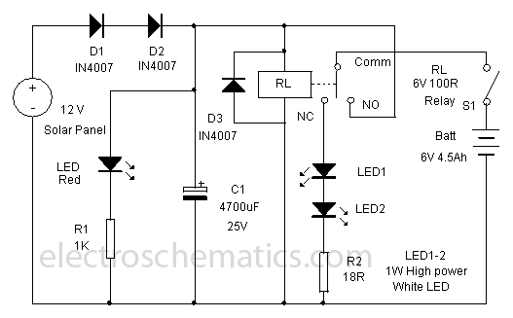
During day time, the solar panel generates 12 volt DC which makes the relay active and the NO (Normally Open) contact makes connection with the common contact. This completes the current path to the battery. Two 1 Watt power LEDs are connected to the NC (Normally Connected) contacts of the relay. When the relay energize, the NC contact breaks and LEDs do not get power. Resistor R2 (18 Ohms 1 Watt) drops the LED current to 330 mA. The LEDs are rated 350 mA at 3.6 volts. With 3 volts and 250 mA current, these LEDs can give adequate brightness.
1 Watt Power LED
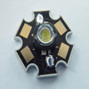
In the evening, current from the solar panel stops and relay de-energize. At the same time, the NC contact of the relay gets power from the battery through the common contact and LEDs turn on. Theoretically, the battery can power 12 hours with 350 mA current, but the battery voltage and current reduces drastically. So it is better to turn off the lamp after 5 or 6 hours using the switch S1.
Use a small 6 volt 100 Ohms PCB relay to make the lamp unit compact. The Solar Lamp circuit including the relay can be enclosed in a small box. If a reflector is fixed behind the White LEDs, intensity of light can be increased. Use jack and socket to connect the solar panel with the circuit.

DIY Solar Bird House Light
This solar birdhouse light is an economical circuit of a mini solar lighting system circuit is presented here. At the heart of the circuit is a mini 6V/2W solar panel. Here, this solar panel is used to charge a 4V/800mAh rechargeable battery through a charge current limiter circuit built around an adjustable 3-pin regulator LM317T (IC1).
Resistor R1 sets the output current. The lighting circuit comprising 20 white LEDs are directly powered the battery. Swich S1 is a simple on/off switch. Assemble the circuit on a small PCB and enclose in a suitable cabinet. Fix the solar panel on the top of the cabinet and power switch and LEDs on the front side.
Specification of a typical 6V/2W solar panel:
- Maximum Power (Pm) :2W
- Working Voltage (Vmp):9V
- Working Current (Imp) :220mA
- Open Circuit Voltage (Voc) :10.5V
- Power Tolerance:-3% to +5%
Assuming a 6 hour sunlit day, a 2 watt panel (near 150mA current set by the regulator IC1+R1) will pump about 900mAh into the battery. Solar charging current can be reduced by increasing the value of R1 ,say from 8.2 Ohm to 10 Ohm.

Solar Birdhouse Circuit Schematic
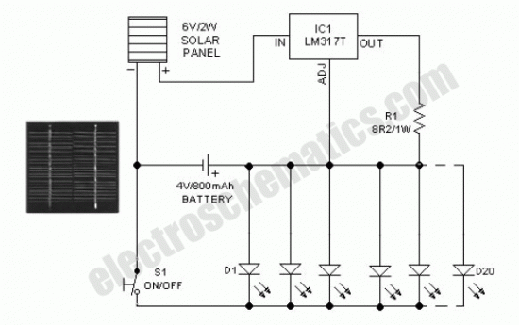

Portable Solar Lanten Schematic
This portable solar lantern circuit uses 6 volt/5 watt solar panels are now widely available. With the help of such a photo-voltaic panel we can construct an economical, simple but efficient and truly portable solar lantern unit. Next important component required is a high power (1watt) white LED module.
When solar panel is well exposed to sunlight, about 9 volt dc available from the panel can be used to recharge a 4.8 volt /600 mAh rated Ni-Cd batterypack. Here red LED (D2) functions as a charging process indicator with the help of resistor R1. Resistor R2 regulates the charging current flow to near 150mA.
Assuming a 4-5 hour sunlit day, the solar panel (150mA current set by the charge controller resistor R2) will pump about 600 – 750 mAh into the battery pack. When power switch S1 is turned on, dc supply from the Ni-Cd battery pack is extended to the white LED (D3). Resistor R3 determines the LED current. Capacitor C1 works as a buffer.
Note: After construction, slightly change the values of R1,R2 and R3 up/down by trial&error method, if necessary.

Solar Lantern Circuit Schematic
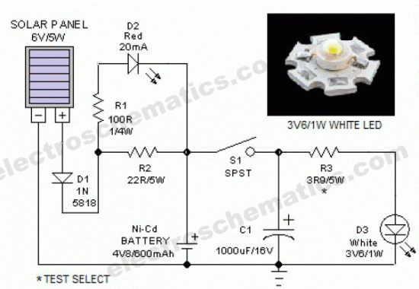
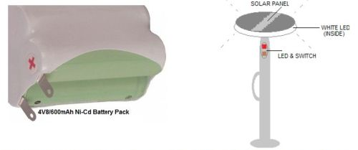

LED Solar Lantern Lights
Circuit of the LED solar lantern lights presented here is built around one 6V/1W Solar Panel (PhotoVoltaic Panel) and a 4V/800mAh Lead-Acid Battery. Here, commonly available 5mm White Straw Hat LEDs are used as the light source
how does the solar lantern circuit works
DC 6V supply from the solar panel is fed to the rechargeable battery through diode D1 (1N4007) and resistor R1 (15R). Diode D1 functions as a reverse current protector and resistor R1 limits the battery charging current to a safe value. Transistor T1 (BC548) is here wired as an automatic switch to control the LED driver transistor T2 (SL100). T1 disables T2 when the circuit receives sufficient power output from the solar panel.

Solar Lantern Lights Circuit Schematic
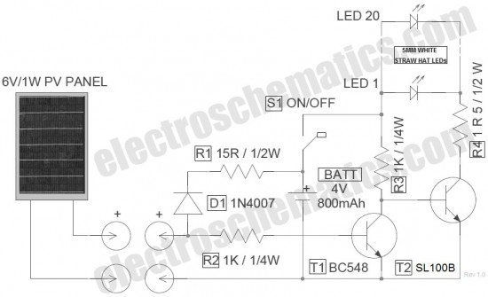
LED solar powered lantern lights schematic
Switch S1 is an ordinary power on/off switch. Finally, resistor R4 determines the operating current of the white LED (LED 1 – LED 20) assembly. No-load voltage of the solar panel is near 7.2Volt. When connected with the circuit, the PV panel gives around 170mA of current at 6VDC output in middling sunlight, which is more than enough for this circuit. When fully charged, no-load output voltage of the 4V lead-acid battery is near 4.6Volt. According to datasheet, Forward Voltage of the 5mm (actually 4.8mm) White Straw Hat LED (used here) is 3 to 3.2volt, and maximum Continuous Current is about 20mA (Peak Current 30mA).
LED Solar Powered Lantern Notes
- The design of this solar powered lantern is flexible! So, you can modify it as per your requirement & taste. However if you wish to change the PV panel and/or the re-chargeable battery, keep an eye on resistor R1. This also applies to resistor R4 when you are playing with the number of white LEDs
- In the LED solar lights prototype, medium-power transistor SL100B (fitted with a small heatsink) was used as T2. This part number is not very crucial. You can try near-similar transistors as well
- This solar lantern can also be charged from any 6VDC power source, capable of delivering the demanded current output

3 Volts Car Adapter Circuit
This 3 volts Car Adapter circuit is based on a standard LT1074CT switching regulator IC. The schematic shows the LT1074CT used as a positive step-down or ‘buck’ converter. The ‘switcher’ is used to convert a +12-volt car battery voltage down to +3 volts for use with the personal hi-fi’s and handheld games for the author’s two boisterous children on long car journeys. Note at under ten years of age, children will rarely be hi-fi aficionado’s and are generally not concerned with any noise generated by the ‘switcher ‘circuit.

3 volts car adapter circuit schematic
- 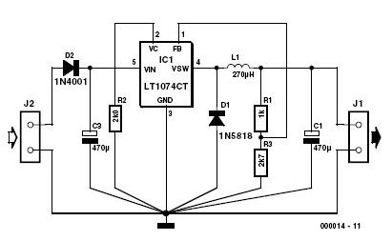
- The circuit is connected to the car +12-V system via the cigarette lighter socket — is advisable to use a fused version of the cigarette lighter plug. The +12-V arrives on theboard via screw- terminal block J2. Diode D2 provides a reverse voltage protection, while C3 decouples the input to the switcher IC.
- The LT1074CT briskly switches the supply voltage on and off in response to the signal applied to its F/B input, to the extent that the average output voltage is at the required level. The values of potential divider resistors R1-R3 have been chosen to attenuate the output voltage so that there is 2.5 V at the F/B pin. The difference between the attenuated output voltage and the internal 2.5-V reference is used to control the modulation effect of the switcher.
- Components R2 and C2 provide frequency stabilisation for the feedback loop. Inductor L1 along with the LT1074CT form the main switching components, while C1 provides decoupling for the output load. The 3-V output voltage is taken from screw terminal J1. With this circuit built, boxed up and installed in your car, you can look forward to possibly your first ‘quiet’ long car journey.

SAFE 12V CAR ADAPTER
Safe 12V car adapter described here can be used to limit a +12 volt car battery current, available from the in-dash cigar lighter power port, to below 2.6 Amperes for use with portable electronic gadgets and travel chargers on long car journeys. This circuit will protect the car electric system against possible short circuits across the cigar power port.
The 12 volts car adapter circuit is connected to the car +12V electric system via the cigar lighter plug J1. The +12V arrives on the board via a reverse voltage protection diode D1. Capacitor C1 decouples the input to the circuit. The current limited 12V output can be taken from the cigar lighter socket J2.Red LED (D2) is a simple power status indicator. After construction,boxed up the unit using a suitable ABS enclosure.
- Working of this electronic fuse is very simple. Usually,the mosfet switch T1 is driven via resitor R2 and the 12V from the car battery is available at the output jack J2. The current flow through sense resistor R1 produces a voltage drop,which is at a certain level will force transistor T2 to switch on. This in turn switches off T1 somewhat and the output supply current to the connected electrical load is reduced to prevent costly disasters.
- Note: Use a good quality heatsink for T1. Only for cars with negative ground only!
- 12 volts car adapter circuit diagram
- 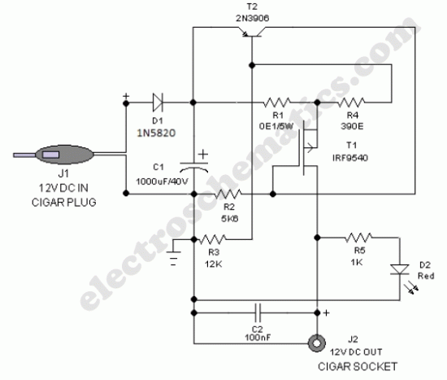

The DC supply available from the cigar lighter socket is fed to an adjustable, three-pin regulator LM317L (IC1). Capacitor C1 buffers any disorder in the input supply. Resistors R1 and R2 regulate the output of IC1 to steady 5V, which is available at the ‘A’ type female USB socket. Red LED1 indicates the output status and zener diode ZD1 acts as a protector against high voltage.

General Purpose Power Supply
This general purpose power supply can e used for supply output voltages from 1 to 35V. The line transformer should be selected to give about 1.4 times the desired output voltage from the positive side of filter capacitor C1 to ground. Potentiometer R2 sets the output voltage to the desired value by adjusting the reference input.
Rsc is the current limit set resistor. Its value is calculated as:
Rsc = 0.65V/I_{L}
For example, if the maximum current output is to be 1A, Rsc = 0.65/1 = 0.65Ω
The 1kΩ resistor, Rs, is a light-loaded resistor designed to improve the no-load stability of the supply.
This power supply deliver a cc voltage adjustable between 0 and 30V , a current intensity of 1A and has a built in programmable current limitation.
The output current can be adjusted with P3.
Power supply first use adjustment
Load the output with a 1k / 1W resistor, rotate P3 at minimum and adjust P2 untill his cursor is next to the + output voltage line. With P1 bring the output voltage to 0. If the adjustment domain of the P2 potentiometer does not reach 30V, lower R6 value.

Adjustable voltage supply circuit schematic
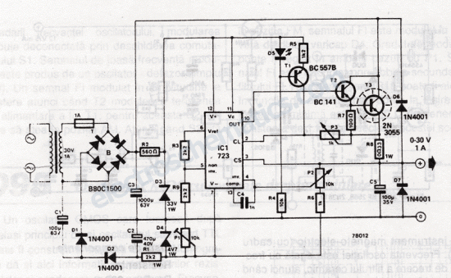

General power supply circuit schematic
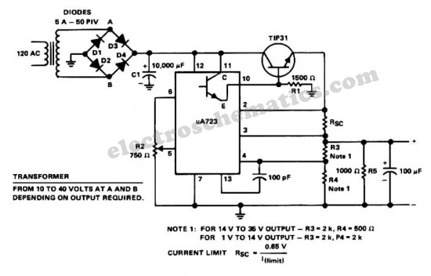

USB DC Power Supply from Cigar Lighter Socket

The diagram shows the circuit of a versatile USB power socket that safely converts the 12V battery voltage into stable 5V. This circuit makes it possible to power/recharge any USB power-operated device, using in-dash board cigar lighter socket of your car.

USB Power Socket Circuit Diagram
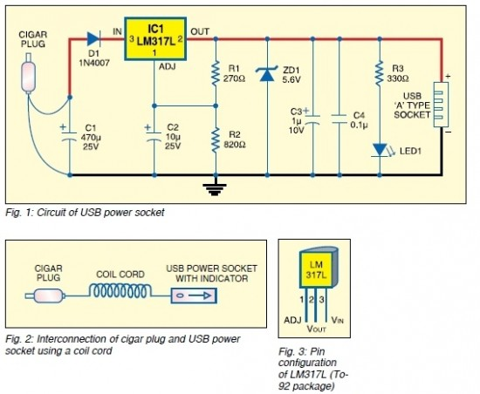
Assemble the circuit on a general-purpose PCB and enclose in a slim plastic cabinet along with the indicator and USB socket. While wiring the USB outlet, ensure correct polarity of the supply. For interconnection between the cigar plug pin and the device, use a long coil cord as shown in Fig. 2. Pin configuration of LM317L is shown in Fig. 3.

Desktop PC power supply circuit diagram

Useful for electronics hobbyists, this linear workbench desktop power supply circuit converts a high input voltage (12V) from the SMPS of a PC into low output voltage (1.25 to 9 volts). An adjustable three-pin voltage regulator chip LM317T (IC1) is used here to provide the required voltages. The LM317T regulator, in TO-220 pack, can handle current of up to 1 amp in practice.
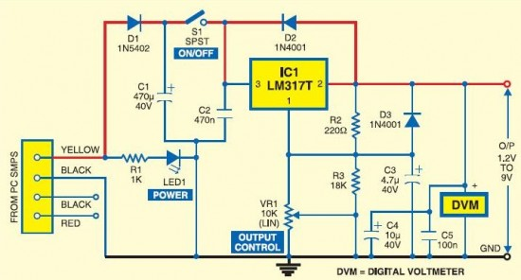
The diagram shows the circuit of the desktop power supply. Regulator IC LM317T is arranged in its standard application. Diode D1 guards against polarity reversal and capacitor C1 is an additional buffer. The green LED (LED1) indicates the status of the power input. Diode D2 prevents the output voltage from rising above the input voltage when a capacitive or inductive load is connected at the output. Similarly, capacitor C3 suppresses any residual ripple.
Connect a standard digital voltmeter in parallel with the output leads to accurately set the desired voltage with the help of variable resistor VR1. You can also use your digital multimeter if the digital voltmeter is not available. Switch on S1 and set the required voltage through preset VR1 and read it on the digital voltmeter.
Now the power supply is ready for use.
The circuit can be wired on a common PCB. After fabrication, enclose the circuit in a metallic cover. Then open the cabinet of your PC and connect the input line of the gadget to a free (hanging) four-pin drive power connector of the SMPS carefully.

Optocoupler
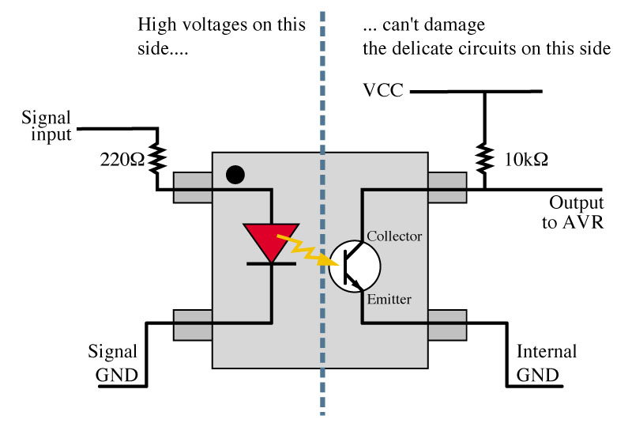
This linear optocoupler is built with MOC5010 and can be used to isolate a circuit from main grid, audio interface, in medical electronics and many other applications. Because of its high isolation resistance (10¹¹ Ω), MOC5010 is used in applications where a circuit is powered directly from main power. With a bandwidth from 5 Hz to 100 kHz you have no reason to complain about audio signal response.
MOC5010 transforms an input current variation into an output voltage variation. The linear optocoupler circuit presented here has an amplification factor of 0.75. The input must not overcome 2 Vef while bandwidth is 118 kHz at -3 dB.
Amplifier A has a transfer resistance of 200 mV/mA resulting in a total amplification of 0.6 … 0.8 (-4.5 … -2 dB). The output impedance is not higher than 200 Ω so you can connect an external amplifier at pin 4. If the input voltages are higher than 2 Vef then connect a potentiometer as voltage divider like showing below optocoupler circuit diagram.
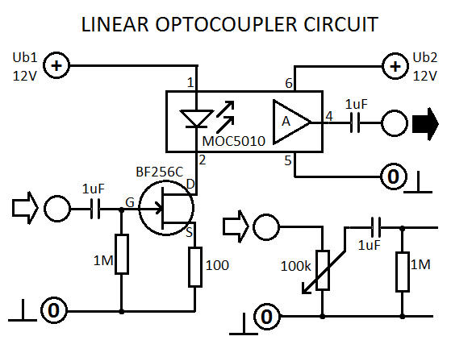
If the global amplification is too small use a regular transistor instead of FET T1. It is important to mention that 2 separate power supplies are required: both the +12 V terminals as well the 0V (ground) must be isolated from one another. In many cases it is possible to use a 12V voltage for the transmitter part from the connected device.

The three-phase case
Symmetrical components are most commonly used for analysis of three-phase electrical power systems. If the phase quantities are expressed in phasor notation using complex numbers, a vector can be formed for the three phase quantities. For example, a vector for three phase voltages could be written as
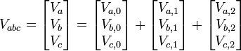
where the subscripts 0, 1, and 2 refer respectively to the zero, positive, and negative sequence components. The sequence components differ only by their phase angles, which are symmetrical and so are radians or 120°. Define the operator phasor vector forward by that angle.
Note that α³ = 1 so that α⁻¹ = α².
The zero sequence components are in phase; denote them as:
and the other phase sequences as:
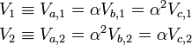
Thus,
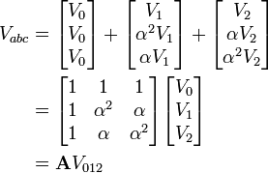
where
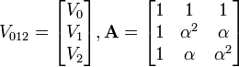
Conversely, the sequence components are generated from the analysis equations
where
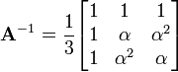
[edit]

Effect of unbalanced load in three phase system
Unbalance. Large amounts of unbalanced current can cause negative sequence and ground relays to operate. There are many problems that result from "too much" unbalance. Understand that no system is perfectly balanced, though.
<><><>
If the load is balanced there will be no current flowing in the neutral. For that reason a neutral wire is sometimes not connected to a balanced three phase load. An unbalanced load will cause neutral current to flow, if a neutral is connected.
due to unbalanced load ,some current will flow through the neutral wire.hence due to I^2R losses voltage drop will occur in neutral.so the voltage regulation will decrease

