COURSE: EEE3112 MINI PROJECT

TITLE: AUTOMATIC LOW-POWER EMERGANCY LIGHT

CIRCUIT DIAGRAM:
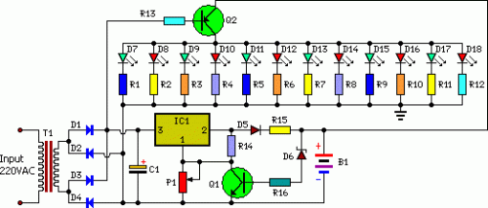

CIRCUIT DESCRIPTION
Here is a white-LED-based emergency light that offers the following advantages.

1-It is highly bright due to the use of white LEDs.
2-The light turns on automatically when mains supply fails, and turns off when mains power resumes.
3-It has its own battery charger. When the battery is fully charged, charging stops automatically.

The charger power supply section is built around 3-terminal adjustable regulator IC LM317 (IC1), while the LED driver section is built around transistor BD140 (Q2).

In the charger power supply section, an input AC main is stepped down by T1 to deliver 9V, 500mA to the bridge rectifier, which comprises diodes D1 through D4. Filter capacitor C1 eliminates ripples. Unregulated DC voltage is fed to input pin 3 of IC1 and provides charging current through D5 and limiting resistor R15. By adjusting preset P1, the output voltage can be adjusted to deliver the required charging current. When the battery gets charged to 6.8V, D6 conducts and charging current from IC1 finds a path throughQT1 to ground and it stops charging of the battery. When mains power is available, the base of Q2 remains high and Q2 does not conduct. Thus LEDs are off.

On the other hand, when mains fails, the base of Q2 becomes low and it conducts. This makes all the LEDs glow. The mains power supply, when available, charges the battery and keeps the LEDs off as Q2 remains cut-off. During mains failure, the charging section stops working and the B1 supply makes the LEDs glow.

WORK
Assemble the circuit on a general-purpose PCB and enclose in a cabinet with enough space for battery and switches.

NOTE: The circuit was tested with twelve 10mm white LEDs. You can use more LEDs provided the total current consumption does not exceed 1.5A. Driver transistor Q2 can deliver up to 1.5A with proper heat-sink arrangement.

PARTS:
- P1 = 2.2K
- R1-R12 = 100R-1/2W
- R13 = 1K-1/2W
- R14 = 180R-1/2W
- R15 = 16R/5W
- R16 = 1.2K
- C1 = 1000uF-25V
- D1-D5 = 1N4007
- D6 = 6.8V-0.5W Zener
- D7-D18 = 10mm- White LEDs
- Q1 = BC548
- Q2 = BD140
- B1 = 6V-4.5Ah Battery
- IC1 = LM317
- T1 = 9Vac-Transformer

TITLE: ELECTRONICS STREET LIGHT SWITCH
Here is a simple, expensive and easy to use electronics street light switch using LDR and NE555. The working of this circuit is truly based on light sensing, i.e. automatic turn it on in night (no sunlight available) and turn It off at sunshine (sunlight available).

CIRCUIT DESCRIPTION:
As electronics street light switch is a switching circuit so, for more detail we can divide this circuit into two section i.e. power supply and switching circuit.
- In this power supply section the work of step-down transformer is done by register R₁ and further rectification to change into 9.1V dc is by diode D₁ and zener diode ZD₁. The output voltage across zener diode is further filtered by capacitor C₁ and C₂.

- The another section of street light is switching section built around light-dependent register LDR₁ with the help of transistor T₁ through T₃ and timer IC NE555 (IC₁), where LDR₁ is used as sensor of this switching circuit.As in day time the resistance of LDR₁ remain low but it is reverse in night time i.e. high resistance is offered by LDR₁. For this property of LDR₁ the timer IC used in this circuit is as inverter. So, high input at pin 3 is provided by low input at pin 2 and vice-versa. Lastly, this inverter is used to turn street bulb B₁ on with the help of triac (triac is activated).
The transistor T₁ and T₂ is remain cut-off to make pin 4 and pin 8 of IC₁ low due to light fall on LDR₁during day time. Due to this transistor T₃ is also cut-off and trigger voltage is not received by IC₁ through pin 2. As a result the output voltage at pin 3 is low which does not activate triac and the street bulb does not glow.
WORK
Assemble the circuit on a general-purpose PCB and enclose in a cabinet with enough space for battery and switches.

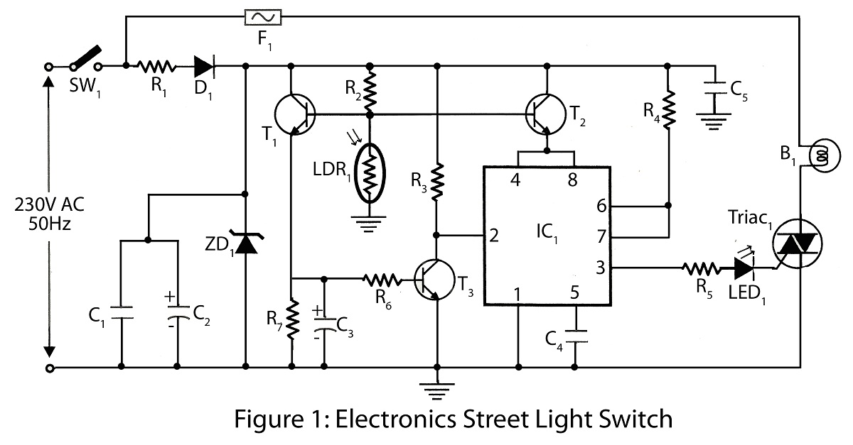

PARTS LIST
Resistors (all ¼-watt, ± 5% Carbon)
R₁ = 10 KΩ/10-watt
R₂ = 33 KΩ
R₃ = 39 KΩ
R₄, R₆, R₇ = 10 KΩ
R₅ = 100 Ω

Capacitors
C₁, C₅ = 0.1 µF
C₂ = 1000 µF/25V
C₃ = 10 µF/25V
C₄ = 0.01 µF

Semiconductors
IC₁ = NE555 timer IC
T₁, T₃ = BC548
T₂ = 2N2222
ZD₁ = 9.1V/0.5V
D₁ = 1N4001
Triac₁ = BT136
LED₁ = RED color
Miscellaneous
LDR₁ = light-dependent resistor
F₁ = Fuse, 5A
B₁ = 100W/ 230V AC
SW₁ = On/off Switch
TITLE: MOBILE CELLPHONE CHARGER
While travelling charging of mobile battery is great problem because power supply source is not generally accessible. Here is a simple project using very common electronics components for charging mobile battery using AA cells.

CIRCUIT DESCRIPTIONS:
The main part of the circuit mobile cellphone charger is timer IC NE555, used to charge and monitor the voltage level. IC₁ get control voltage to pin 5 by zener diode ZD₁. Threshold pin 6 and trigger pin 2 is supplied with a voltage set by VR₁ and VR₂respectively. The trigger pin 2 of IC₁ is below 1/3V_{CC} when discharge battery is connected to the circuit as a result flip-flop of IC₁ is switched on to take output pin 3 high. The process is reversed when battery is fully charged of charged battery is connected. Here transistor T₁ used to enhance the charging current from output pin 3 of IC₁. Adjust potentiometer VR₁ and VR₂ as per require.

LED status for different charging conditions
Load across the Output | Output frequency (at pin 3) | LED₁
No battery connected | 765 kHz | On
Charging battery | 4.5 Hz | Blink
Fully charged battery | 0 | Off

WORK
Assemble the circuit on a general-purpose PCB and enclose in a cabinet with enough space for battery and switches.

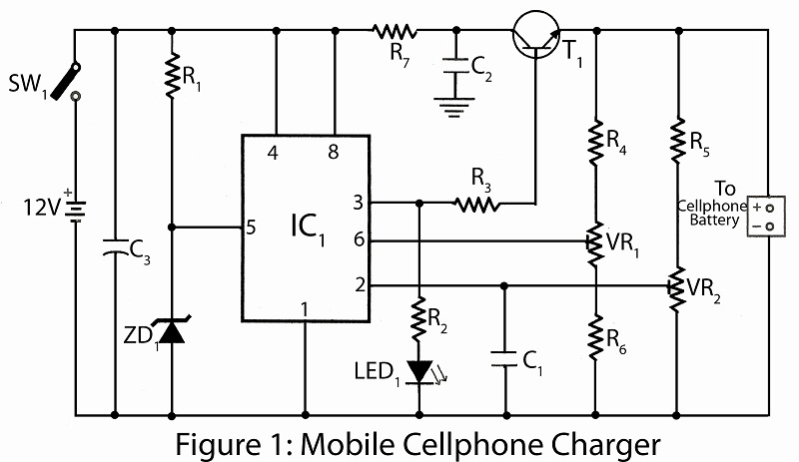

PARTS LIST
Resistors (all ¼-watt, ± 5% Carbon)
R₁ = 390 Ω
R₂ = 680 Ω
R₃ = 39 Ω/1W
R₄ = 27 KΩ
R₅ = 47 KΩ
R₆ = 3.3 KΩ
R₇ = 100 Ω/1W
VR₁, VR₂ = 20 KΩ

Capacitors
C₁ = 0.001 µF (ceramic disc)
C₂ = 0.01 µF (ceramic disc)
C₃ = 4.7 µF/25V (Electrolytic )

Semiconductors
IC₁ = NE555 timer IC
T₁ = SL100 or any Medium power general purpose NPN transistor like: 2N4922 , 2N4921,2N4238, FCX1053A
ZD₁ = 5.6 V/1W
LED₁

Miscellaneous
SW₁ = On/off switch
1.5V*8 AA cells
Mobile connector

