1.0 OBJECTIVE
- Practical training in the use of oscilloscope
- Use of delayed sweep
- Use of storage oscilloscope
- Use of sweep generator and oscilloscope to get frequency responses
2.0 EQUIPMENT
Feedback 459 + kit 461
Double beam oscilloscope with delayed sweep
Analogue storage oscilloscope
Sweep signal generator
2 Unilab signal generators
PM 5705 pulse generator

3. PROCEDURE
1. The output current of a Unilab signal generator was connected to one of the channel inputs and was set to a sine wave, full amplitude.
The one of the students chose a frequency without telling the other two, who should use the oscilloscope to find the frequency of the signal
This was continued until all the students in the group had tried to measure the frequency.
2. The input switch was set to AC and the Unilab signal generator set to square waves, 25 Hz and connected to the oscilloscope. Trig the oscilloscope to make a steady picture on the screen. Switch the input switch to DC and the difference was explained.
3. The Feedback 459 + kit 461 was used, and a highpass filter was made with a 1uF capacitor and 1 k resistor
The high level output from the Unilab oscillator, sine wave 100 Hz was used and coupled this output to the input of the filter and to channel A (or Ch 1 ) of the oscilloscope. Couple the output of the filter to channel ( or Ch 2).
Both A and B, were selected so that you have both signals on the screen at the same time and adjust the gain on each channel so that the signals have almost the same amplitude on the screen.
a) The phase difference between input and output of the filter was measured, directly on the screen.
b) Now you keep the connections, but change the settings, so that you have a X-Y display , with the input to the filter as Y and the output as X.
Now you should see an ellipse and the phase difference between the two signals is given by $\sin{∅}=\frac{A}{B}$
Repeat the phase measurement , both directly and by using the ellipse for 200 Hz and 400 Hz.
4. Use 2 Unilab signal generators. Turn them both on sine wave and adjust them to about the same frequency. Couple one output to the Y deflection and the other to the X deflection. (Use the X-Y position of the time base switch) Adjust the gain for each input so that you have about the same maximum deflection in Y direction as in X direction. Study the Lissajou-figure and adjust the frequency from one of the generators until you have a circle or ellipse standing still.
How is now the relationship between the two frequencies?
Adjust the frequency of one of the generators until you have a figure similar to the number 8.
How is now the relationship between the two frequencies?
Experiment more with these Lissajou-figures.
5. Build a bandpass filter as in the figure . Use a sweep generator to feed the filter. Let it sweep between 10 Hz and 20kHz.
Couple the output of the filter to channel A on the oscilloscope and deflection output from the sweep generator to the X input of the oscilloscope. Now you should get the frequency of the filter directly on the screen.
The sweep generator changes the frequency of its output with time and at the same time it outputs a signal as in the figure to the right to the X deflection of the oscilloscope.
STORAGE OSCILLOSCOPE AND DELAYED SWEEP
6. Use a PM5705 pulse generator and set it on 100us pulse duration and 10ms repetition rate.
Run the storage oscilloscope as an ordinary oscilloscope and get a steady picture of 2 pulses on the screen. Move the indicator for the delayed sweep until it is underneath the second pulse and change its width until it is broader than the pulse. Turn on the delayed sweep and study the pulse. You may move it with the delay time knob.
Now you trig on the first pulse and start the sweep delayed , so that you get the second pulse displayed on the screen.
7. Turn the oscilloscope back to normal display and increase the sweep speed so that the pulse covers about half the screen. Turn the generator to single pulse (ext) and push the single shot button to see whether you are able to see the pulse on the screen.
Turn the oscilloscope on write and the push erase
Now you push the single shot button once more. If you do not get a lasting picture on the screen, erase it, increase the sensitivity and try once more.
Table for lissajous curves
whi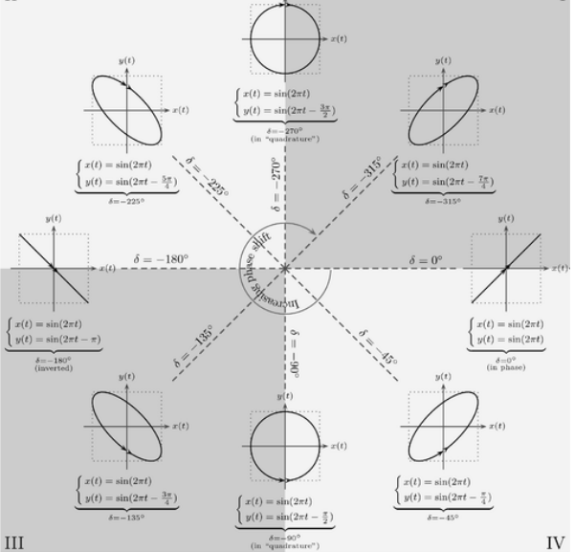
- Note results have been attached to the back of lab report.
4.0 Discussion
Workings and functionality of the oscilloscope were learnt.
During the experiment we had to calculate the phase differences between two waves which have the same frequency. For this we did;
- Read time value between them, this allowed us to calculate corresponding phase angle in degrees. This yielded;
$$\frac{read time}{period}=\frac{phase shift}{360}$$
or
- Lissajous curves are actually the x-y plots of our two waves with same frequency that we wish to measure phase difference between them. In the figure shown above there is a diagram in which a list of lissajous curves to determine phase shift variations of two signals with same frequency. Moreover, Lissajous curves seem more advantageous because they are also employed for identification of frequency variations of the signals compared.

During the experiment we also investigated the high and low pass filter characteristics.

5.0 Conclusion
The experimental objectives were met, thus rendering the experiment a success.
6.0 References
- EEE 3112 Lab manual, School of Engineering. The University of Zambia.
- Internet, Basics of Lissajous curves.

