1.0 OBJECTIVE
The objective of the experiment was to establish the connection between AC waveform and readings on different voltmeters and how to interpret the readings and how to make circuits to widen the measurement range.
2.0 EQUIPMENT AND SPECIMENS
Unilab signal generator with a low impedance (1ohm) output.
Feedback 603 signal generator
Dual beam oscilloscope
Digital voltmeter (Fluke)
AVO analogue voltmeter (used on 3V and 10V AC only)
Feedback trainer 459
Feedback trainer kit 461 with
Capacitor 100nF
Resistor 470R
Resistor 470K
Diode BYX36
2 Banana coaxial converters
3.0 THEORY
Analogue and digital multimeters are aimed at measuring currents and voltages varying sinusoidal with time. When using multimeters on non-sinusoidal periodic currents and voltages we have to be careful when interpreting the readings.
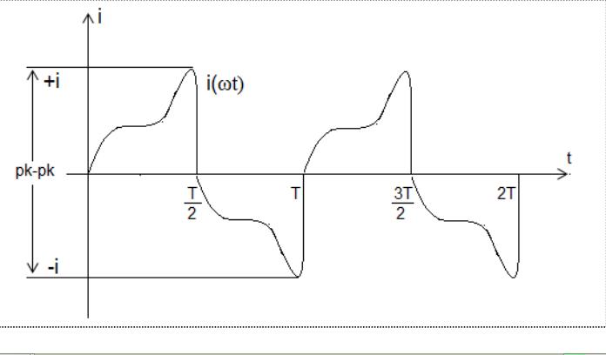
To describe this time varying current we have several quantities.
3.1 Average Value
The average value (mean value) of a time varying current on a time interval is the DC current that will carry the same amount of charge during that time interval. A signal as in Figure 1 (pure Ac signal) will have an average value equal to zero if taken over a one or more complete periods. In order to have an average value attached to a pure AC signal, we calculate the average value over half a period.
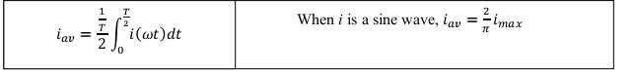
3.2 RMS Value
The rms value of a time varying current on a time interval is the DC current that dissipates the same amount of heat in a resistor during this time interval. Usually we calculate this using a full period as the time interval. The formula for calculating rms value is:
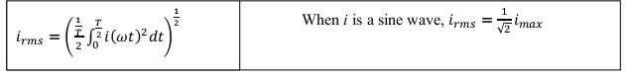
3.3 Form Factor
The form factor is the ratio of rms value to the mean value.
When i is a sine wave, the form factor is
𝐹𝑜𝑟𝑚 𝑓𝑎𝑡𝑜𝑟 =
𝑖𝑚
𝑖
𝑎𝑣
= 1.11
3.4 The connection between Scaling and reading
Some AC instruments have a reading proportional to the average value, some have a reading proportional to the rms value, and some have a reading proportional to the peak value. Usually, all these different meters are scaled in sine wave rms, so that if you use these different instruments to measure on a pure sinewave, they will all show same reading. If the signal is not a pure sine wave, the readings will differ.
3.5 Frequency Limitations
All instruments have an upper frequency limit, which may vary from kHz to some hundred kHz for ordinary multimeters. Usually they are all capable of handling 400Hz, which is widely used frequency for power supply. In order to measure on signals above the cut-off frequency of the meters, we use special high frequency probes. Passive high frequency probes rectify the signal and give DC voltage that can easily be measured by the multimeter. We are then able to use ordinary DC instruments to measure on signals up-to 1GHz.
3.6 Decibel
Decibel is a way of taking the ratio between two signal levels. Therefore, the dB value of a signal is a number relating it to another signal level, a reference level. The basic definition of dB relates power levels:
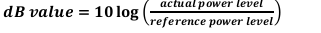
When used to relate voltage levels we often use the formula:
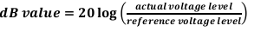
To express how many dB a signal has dropped from a certain level, this becomes the reference level. This level has a dB –value = 0dB
4.0 PROCEDURE
4.1 The oscilloscope was checked to ensure that it was correctly calibrated
by using a 1Vp-p calibrating signal; otherwise the error was to be taken into account when using the oscilloscope. In order to get useful results, accuracy was observed in taking the measurements using the oscilloscope. The AVO was calibrated to show 0 with no input using the screw just below the centre of the scale.
4.2 The output from the Unilab was set to 1kHz and 10V peak to peak (Vp-p) sinusoidal, using the low impedance 1ohn output to endure that the output is not short circuited. The frequency was controlled using the frequency counter function of the Fluke Digital
Voltmeter.
The oscilloscope, the Digital Voltmeter (DVM) and the AVO-meter were coupled in parallel directly on the output of the signal generator. The oscilloscope was used to control the output to 10V peak-peak. The readings were taken note of on the DVM and the AVO-meter.
4.3 The output was set to square wave, 10V peak-peak using an oscilloscope. The readings were taken note of on the DVM and the AVO-meter.
4.4 The output was set to square wave, 10V peak-peak using an oscilloscope. The readings were taken note of on the DVM and the AVO-meter.
4.5 A high-pass filter was made using 100nF capacitor and the 470Ω resistor as shown in
Figure 2 below
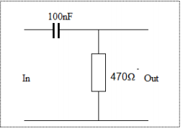
4.6 Vmean, and Vrms were calculated for all the wave forms. To get this from the output from the high-pass filter, numerical integration on the wave forms sketched from the oscilloscope was used.
4.7 Using the diode, 0.1µF capacitor and 150K resistor, a peak value measuring circuit was created as shown in Figure 3 below.
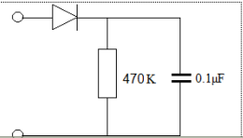
4.8 In order to determine the frequency characteristics of the Fluke Voltmeter, the Feedback SS0603 signal generator with sinusoidal output was used. The oscilloscope was used to keep the output voltage constant at 5V p-p over the whole frequency range and this voltage was measured using the Fluke Voltmeter on AC. The generator was loaded with the peak-peak value circuit while doing these measurements.
This was also done with the peak value circuit, monitoring the output with the Fluke Voltmeter on DC.
4.9 The two frequency responses were plotted in the same axis system on a lin-log graph, using the dB as vertical scale, with 0dB at the plateau of each curve.

Answers to Questions
1 The DVM readings were proportional to the Vr.m.s. This was observed from the difference in readings of the DVM and the calculated r.m.s. values.
2 The AVO readings were proportional to the mean values of peak readings for all the three waveforms.
3 The meters show the r.m.s. value which is the effective voltage in a circuit.
4 The oscilloscope would be the most reliable instrument because it shows the waveform and hence the r.m.s. and mean values can be calculated.
- Note: results and data analysis attached on separate paper.
5.0 DISCUSSION
Percentage error during the experiment was very minimal as obtained values were close to theoretical. This showed that there was proportionality between the calculated rms values and the values measured. The negligible errors could have been due to rounding off of some measurements.
6.0 CONCLUSION
The experiment was successful and the objectives were achieved. It can be concluded that there is a relationship between the readings from the oscilloscope and the readings from the Digital voltmeter and the AVO-meter. The experiment gave me a better understanding of what the values of measurements obtained from the measuring instrument meant.
7.0 APPLICATION
Voltmeters are used in measuring electrical quantities (DC and AC) in electrical circuits to ascertain the circuitry applicable quantities and also fault finding in the circuits
8.0 REFERENCES
1. HUGHES E. ELECTRICAL AND ELECTRONIC TECNOLOGY; 10th edition
(2008); Pearson Education Limited, Edinburgh Gate, Harlow Essex CM20 2JE, England.
2. EEE3112 ENGINEERING PRACTICE LAB MANUAL ; University of Zambia,
Lusaka, Zambia

