TITLE: Power Substation
OBJECTIVE:
To analyse and identify the main components of an power substation
AREA OF STUDY: University of Zambia Electrical Substation
INTRODUCTION:
Electric power is an aspect of energy production that over the years has become increasingly important and imperative to the lives of many human beings for uses such as heating, lighting and communication. Electric power is now the backbone of modern industrial society. It is therefore imperative to study how electric power is generated and transmitted.
Power substations are transformation and switching stations whose purpose is to maintain the high and low voltages that exist between points of generation and points of power delivery to consumers. They act as terminals of power regulation that help preserve the quality of the transmitted voltages from generation points great distances away. Depending upon the availability of resources these stations are constructed different places because they may not be nearer to load centres where the actual consumption of power takes place. Types of substations include;
- Step up substation: These are substations associated with generating stations whose purpose is to step up voltages from the relatively lower generating voltages to higher voltages meant for transmission.
- Step down substation: These are substations associated with load centres whose purpose is to step down voltages from the higher voltages meant for transmission to the lower generating voltages for varying purposes.
- Distribution substation: These are substations transfer power from the transmission system to the distribution system of an area for the purpose of feeding the actual consumers through a distribution network.
- Converter substations: These stations contain power electronic devices to change the frequency of current, or else convert from alternating to direct current or the reverse. They changed frequency to interconnect two systems but nowadays substations today are rare.
- Switching substation: A switching station is a substation without transformers and operating only at a single voltage level. Switching stations are sometimes used as distribution stations. Sometimes they are used for switching the current to back-up lines or for parallelizing circuits in case of failure. Switching is an important action performed by substations where transmission lines are connected to and from other components in the transmission system. These events may be switched with planning or not, but nonetheless when a component or line is to be maintained, worked on or to be replaced it has to undergo de-energisation and isolation before anything can be done.
Overall, substations are three major roles;
- Voltage change: It has transformers to either ‘step-up’ or ‘step-down’ voltages for either transmission or distribution to consumer homes.

- Sharing of Power: It has the role of distributing power from one point to another. This is done through the use of bus-bars that can split the distribution power off in multiple directions, or it facilitates the collection of power from multiple directions and transmitting in more than one direction.

- Switching: It often has circuit breakers and switches so that the substation can be disconnected from the transmission grid or separate distribution lines can be disconnected from the substation when necessary
DATA COLLECTION:- Attached
DATA ANALYSIS:-
DISCUSSION:
The essential parts of the substation were identified, some including;
Transformers: The transformers identified at the UNZA substation were the 11/66Kv step up and 66/3.3kV step down transformers. It is an electrical device that transfers energy between two or more circuits through electromagnetic induction.
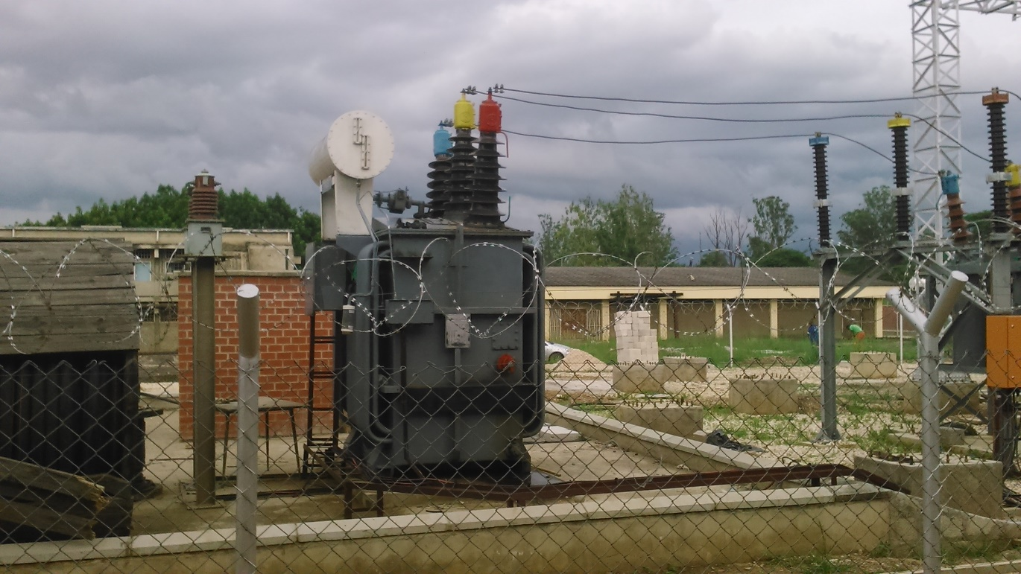
Figure 2: Step-Up transformer at UNZA substation
Surge diverter’s: These are used as a way of protecting substation equipment, as the name implies when there is an over current the surge diverter, as in the event of a lightning strike, will divert the current to earth, to protect the equipment.
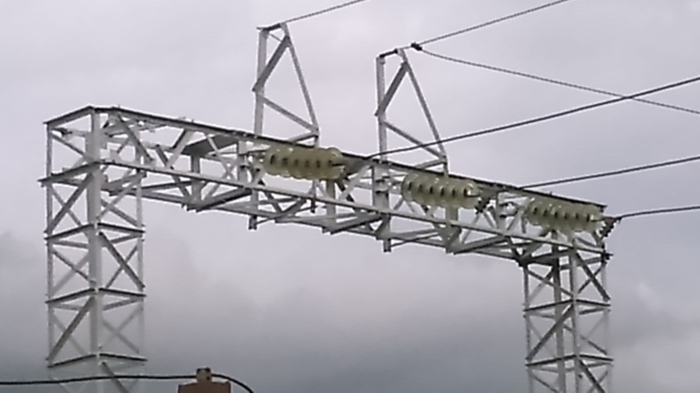
Figure 3: Surge diverter at UNZA substation.
Earth Pit: The earth pit is the main area or grounded voltages are diverted to. It is also a point used to check the grounding system.

Figure 4: Grounding pit at UNZA substation
Isolators: These are very important gadgets in the substation especially were safety is concerned, isolator creates a physical gap in a circuit once operated to an open position, and it also suffices to mention that circuit breakers are operated on load, whilst isolators are operated on no load. At no circumstance should an isolator be operated on load.
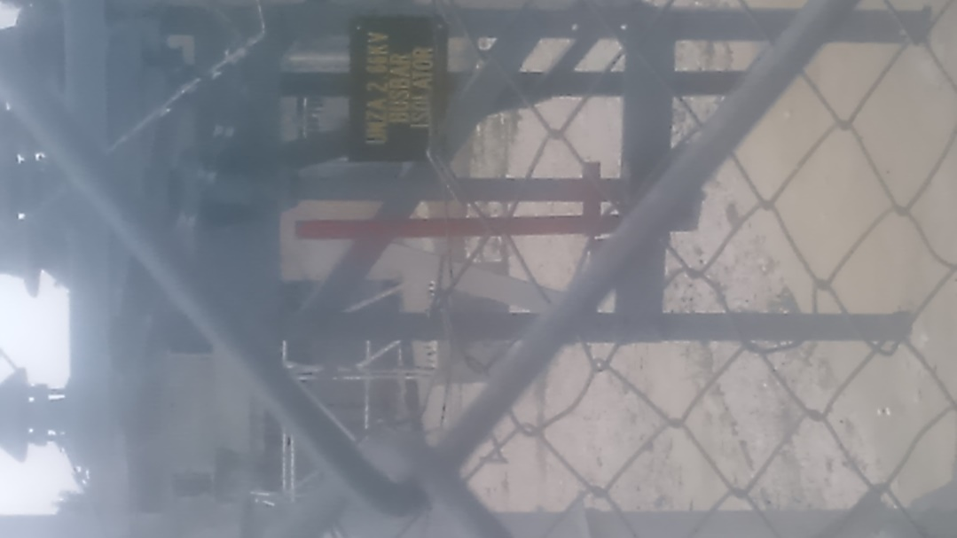
Figure 6: Isolator at UNZA substation
Bus-bars: These are responsible for the distribution of power in multiple directions. Each one has an isolator that can be fitted on it for maintenance purposes and can be fixed with surge diverters as well and bushings that aid increase the dielectric value around its conductors.
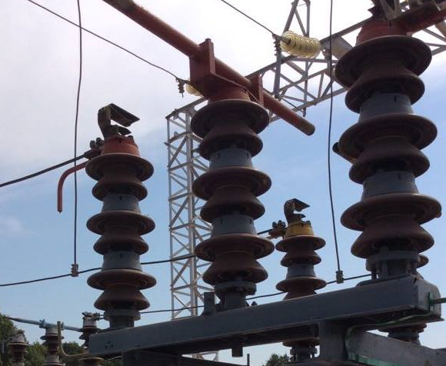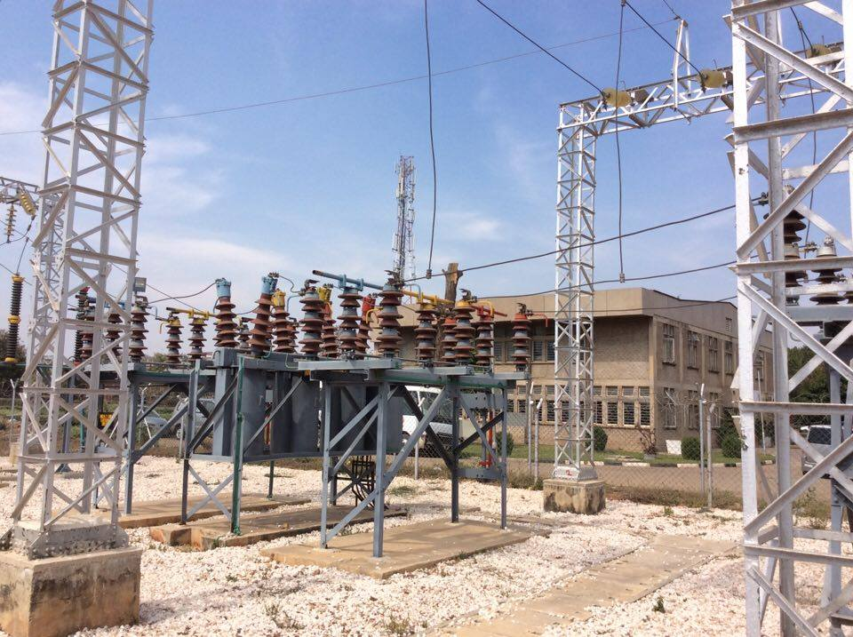
Figure 7: Bus-bar with bushings (l) and bus-bar network (r)
It would have been beneficial to see the substation fully active with running power so that the program, SCADA, used to remotely monitor substations was appreciated, together with the higher level of substation safety required during active transmission.
CONCLUSION:
The line representation of the power substation was shown to summarise and adequately capture the most important aspects of the substation with its most important parts identified.
REFERENCE:
- www.cisco.com/c/en/ustd/docs/routers/access/800/software/configuration/guide/SCG800Guide/SCG800_Guide_BookMap_appendix_010101.html at 8:43PM on 28/07/16
- en.wikipedia.org/wiki/Electrical_substation at 9:23AM on 09/07/16

