EEE 3112
user
COMPUTER NUMBER: 31086723
EEE 3112
REPORT ON THE UNZA SUB-STATION
BY KHWIMA WILIMA
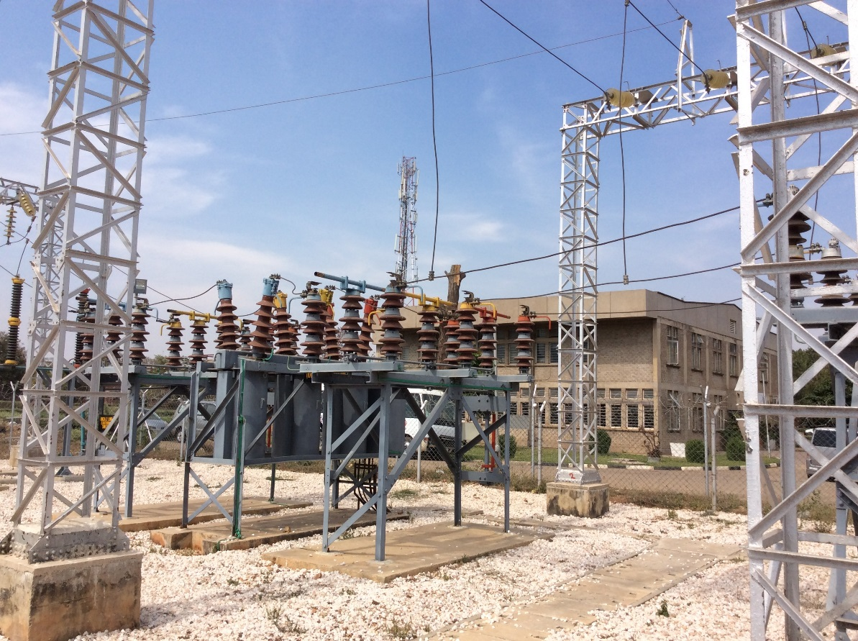
ATTN: MR MPANGA

- ABSTRACT
This report is written as a requirement by our course Lecturer, in the Electrical Engineering Course coded EEE 3112. The report is based on the tour that was under taken on the 21st August 2016. The aim of the tour was to show appreciation and understanding of the Electrical Power System and how Substation operates.

Electric power system: is defined as a network of electrical components used to supply, transmit and use electric power. It can be looked at in terms of transpiration where “columns” of water molecules move up a plant from roots through the stem to the branches the finally the leaves. An example of an electric power system is the network that supplies a region's homes and industry with power - for sizable regions, this power system is known as the grid and can be broadly divided into the generators that supply the power, the transmission system that carries the power from the generating centres to the load centres and the distribution system that feeds the power to nearby homes and industries. Smaller power systems are also found in industry, hospitals, commercial buildings and homes. Most of these systems rely upon three-phase AC power - the standard for large-scale power transmission and distribution across the modern world. Specialised power systems that do not always rely upon three-phase AC power are found in aircraft, electric rail systems, ocean liners and automobiles. It is in this process that a substation comes in.

Substation: A substation is a part of an electrical generation, transmission and distribution system. Substations transform voltage from high to low, or the reverse or perform any of several other important functions. The different types of substations include;
- Transmission substation – it connects two or more transmission lines.
- Distribution substation – transfers power from the transmission system to the distribution system of the area.
- Collector substation – it resembles a distribution although power flow is in the opposite direction, from many wind turbines up into the transmission grid.
- Converter substation – they contain power electronic devices to change the frequency of current, or else convent from alternating to direct current or the reverse.
- Switching substation – it is a substation without transformers and operating only at a sin`gle voltage level.

- INTRODUCTION
Electric power has become increasingly important as a way of transmitting and transforming energy in industrial, military and transportation. Electric power is essential in our daily lives. It can be put to an almost limitless set of applications which include transport, heating, lighting, communications and computation. Electric power is now the backbone of modern industrial society. It is therefore imperative to study how electric power is generated and transmitted. In order to learn more about electric power, a tour was taken at the University Of Zambia Substation.
The tour was under taken under the guidance of Mr Mpanga who took his time to explain in detail each and every part of the tour.

  - Safety
The tour guide, first explained the significance of safety in the Electrical/Electronic Industry and there after inspected to ensure that all of us where dressed in appropriate Personal Protective Equipment (PPE). It was emphasized that safety should never be left to chance in industry especially in the Electrical/Electronic industry, because in the field the difference between life and death is the difference between ON and OFF which at times maybe extremely a very short period of time hence the need to be always conscience of safety.

  - Substation
At the substation which is still under construction, the tour guides introduced us to the Electrical Engineer who was in charge of construction works. The Electrical Engineer took time to explain what a substation is and the various components and equipment that are found in the substation. At the end we were given the opportunity to ask questions about the substation and all what we saw and the responses were given to us from both the Site engineer and the tour guides.

  - Control room
The control room is still under construction, the only things we were shown are the cubicles housing various measuring and monitoring gadgets, the tour guide explained how it will be operating once it is fully in operation.

- POWER ELECTRICAL
  - POWER SYSTEM
“An electric Power System is a network of electrical components used to supply, transmit and use electric power” en.m.wikipedia.org/…/Electri_power_system….
Power is generated by various techniques used to spin a turbine rotor. Some of these are: steam heated using fossil fuel (including coal, gas and oil) or nuclear energy, falling water (hydroelectric power) and wind (wind power).
An example of hydroelectric power can be given where the turbine and generator are located in the dam’s power house , which also houses a transformer. This is where the substation comes in. A substation is a part of an electrical generation, transmission, and distribution system. Substations transform voltage from high to low, or the reverse, or perform any of several other important functions. Between the generating station and consumer, electric power may flow through several substations at different voltage levels.
A typical power system will normally have a Generation plant, which can be thermal, Nuclear or Hydro, the latter being the most common in Zambia. In most cases the power generated will have to be used to places which are further away from the Generating plant.

  - SUBSTATION
A substation is a common and important feature in the power system because it encompasses on of the most important equipment in the power system. As earliermentioned power Generation, Transmission, Distribution and Utilization will require power to be stepped up and down to different levels. In Zambia power at the three major power stations, Kariba North Bank Power Station, Kafue Gorge Power Station and Victoria Falls Power Station all generate power at 18kV which has to be stepped up for transmission from 18kV to 220/330kV for transmission. Later on, this power has to be stepped down 220/330kV to 132/88/66/33 kV for distribution to different consumers.
It is at the point of stepping up/down that a substation is required in order to accommodate the equipment that enables the stepping up/down of power. The map on the next page shows the Zambia National Grid clearly depicting the Generation and transmission of power in Zambia.
A power substation typically does two or three things:
- Change of voltage
It has transformers that step transmission voltages (in the tens or hundreds of thousands of volts range) down to distribution voltages (typically less than 10,000 volts).

- Power sharing
It has a "bus" that can split the distribution power off in multiple directions. Or collection of power from multiple directions and transmitting into one or two direction.

- Switching
It often has circuit breakers and switches so that the substation can be disconnected from the transmission grid or separate distribution lines can be disconnected from the substation when necessary

    - LAYOUT
Substations differ in physical dimensions and sizes equipment involved, however the layout will always the same layout/arrangement. Transformers, Circuit Breakers, Isolators, Bursbars, Current Transformers, Voltage Transformers, Surge diverter’sand off course conductors both overhead and underground. The layout of the substation that we visited, which is under construction at UNZA under the school of Engineering has the setup as shown on the next page.

    - EQUIPMENT
Here are the common equipment’s that are found in the substation such as the one we visited:-
- Transformers
A transformer is an electrical device that transfers energy between two or more circuits through electromagnetic induction. In the toured substation the transformer was to step voltage from the 11kV to 66kV.
- Breakers
A circuit breaker is an automatically operated electrical switch designed to protect an electrical circuit from damage caused by overload or short circuit. It was mentioned that circuit breakers are named mostly after the quenching media, e.g. oil circuit breaker which uses oil to quench the arc and air circuit breaker which uses air to quench the arc. It was mentioned that circuit breakers can be operated either from remote or local depending on the circumstances though it is always very safe to operate them from remote.
- Isolators
These are very important gadgets in the substation especially were safety is concerned, isolator creates a physical gap in a circuit once operated to an open position, and it also suffices to mention that circuit breakers are operated on load, whilst isolators are operated on no load. At no circumstance should an isolator be operated on load.
- Surge diverter’s
These are used as a way of protecting substation equipment, as the name implies when there is an over current they surge diverter will divert the current to earth, to protect the equipment.

- Current transformersand Voltage transformers
These two important gadgets are used for protection and metering purposes, for they step down voltage and current to relatively lower levels that can be now used in the control room safely.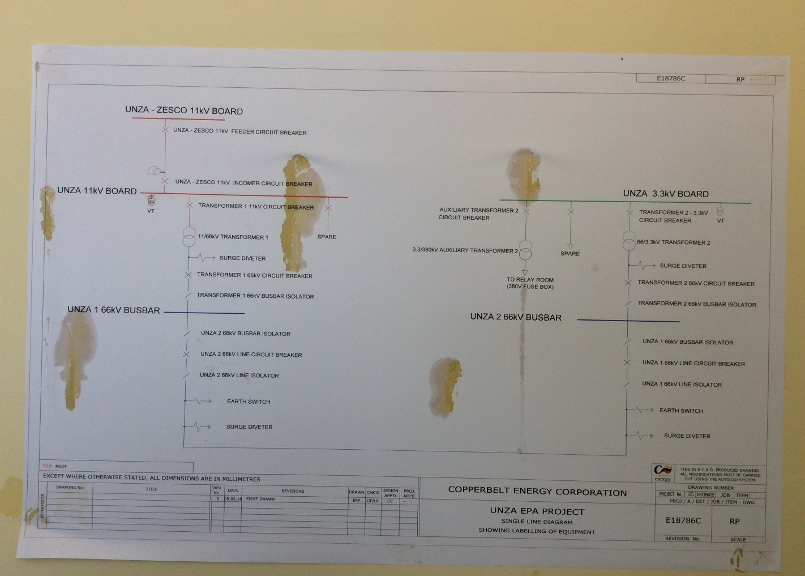
Single Line Diagram showing labeling of equipment of the UNZA Substation.

- CONCLUSION
The tour was overwhelming and successful, for the objectives where achieved and I have been enlightened in the following areas:-
- Safety awareness in electrical industry
- Holistic understanding of the power system
All in all, it suffices to say the tour was an eye opener to what the Power Industry is far above the myopic view that the industry only about a Generator and motor its far beyond this and it cuts across all professions that human being will forever involve him(her)self with.

- REFERENCES
  - www.emfs.imfo/sources/substations/
  - www.en.m.wikipedia.org/…/Electri_power_system…564
  - International Maritime Dictionary by Rene & Kerchove, published 1961, Van Nostrand Reinheld Co.
  - Electrical FAQ

