1.0 OBJECTIVE
- To understand how electric and magnetic fields give unwanted signals in leads and circuits.
- To learn good design methods aimed at reducing interference signals.
- To avoid serious pitfalls when interconnecting equipment
2.0 EQUIPMENT AND SPECIMENS
1 AM/FM radio
1 “chicken cage”
1 oscilloscope
1 probe
1 coax –to banana converter
1 UNILAB signal generator
1 power supply
1 Ground plate
2 plastic tubes
1 ordinary cable with 1.kohm resistor in series
1 Shielded cable with 1.kohm resistor in series
1 Twisted pair cable with 1.kohm resistor in series
4 wooden blocks, 10× 5 × 5cm
Lab cables of different lengths
3.0 INTERFERENCE COUPLING
This first part consists of Basic experiment with an oscilloscope, signal generator and different kinds of cables (ordinary, shielded and twisted pair). Aimed to indicate the presence of the electromagnetic fields and create acquaintance within different ways of interference coupling (electric and magnetic field) under different conditions.
3.1 The Presence of Electric and Magnetic Fields
First we investigated the electric and magnetic fields around us by using an oscilloscope, a normal lab cable and a coil.
3.1.1 Electric Fields
The lab cable was connected to one of the oscilloscope inputs (you need a coax-to- banana converter) as shown in Figure 1 below and tried to find some electric signals on the screen.
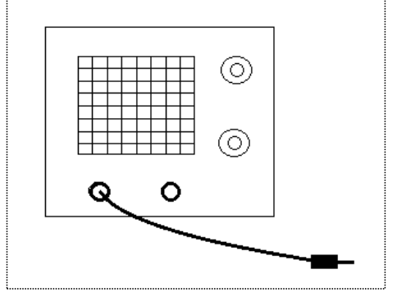
3.1.2 Magnetic Fields
To investigate the magnetic fields we used some kind of cable loop. To achieve a decent deflection on the oscilloscope a good idea was to use a loop with turns, a coil. Here 100 turns of enamelled copper thread around a bobbin was used as a coil. The coil connected to one of the inputs and the coil was moved around to find some signals. The coil was moved near the different parts of the oscilloscope until a maximum voltage was obtained. See Figure 2 below for the connections.
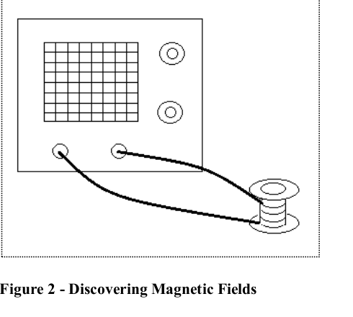
3.2 Capacitive and Inductive Coupling
To be able to investigate the capacitive and inductive coupling in a more controlled way the
UNILAB signal generator was used as a source of interference by feeding a lab cable with signal
and use an oscilloscope to measure the induced voltage in a parallel wire, terminated by a 1kΩ
resistor. See Figure 3 below.
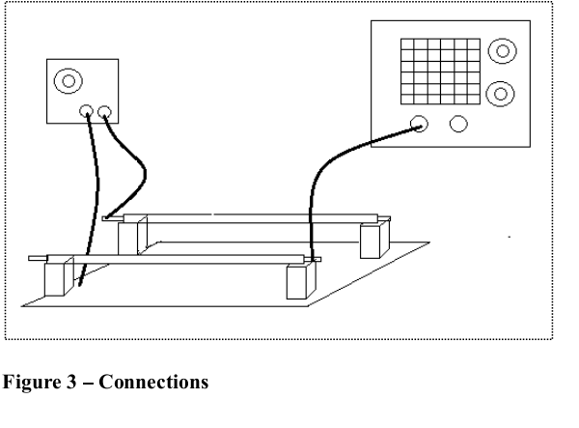3.2.1 Capacitive Coupling
PROCEDURE
An ordinary lab cable was put into a plastic tubes and it was placed on one pair of 10cm high wooden blocks on the ground plane.One of the cable ends was connected to the 100Ω output of the signal generator. The other cable end was left free. The generator ground plane was connected. The unshielded cable was put in the other tube and place it on the other pair of 10 cm high wooden blocks, parallel with the other tube at a distance of 10 cm (centre to centre) The 1k Ω resistor was connected to the ground plane and the other end of the cable to the oscilloscope probe. The ground clip was connected from the probe to the ground plane. The signal generator was adjusted to 50 kHz sinusoid signal and maximum output level The signal generator was adjusted to 50 kHz sinusoid signal and maximum output level (about 6V).
a) The interfering voltage (peak to peak) received by receptor cable was measured.
b) The frequency was increased to 100 kHz and measured the interfering voltage (peak to peak) received by the receptor cable.
c) The wooden blocks were laid down so that the tubes were 5 cm above the ground plain.
10 cm distance was maintained between the two cables. The frequency was restored to
50 kHz and measured the interfering voltage (peak to peak)
d) The cables were moved 5 cm apart (centre to centre) and measured the interfering voltage.
e) Signal generator was switched to square wave and measured the interfering voltage (peak to peak).
f) The cables were connected according to Figure 4 a-d and measured the resulting interfering voltages (using sinusoid signal).
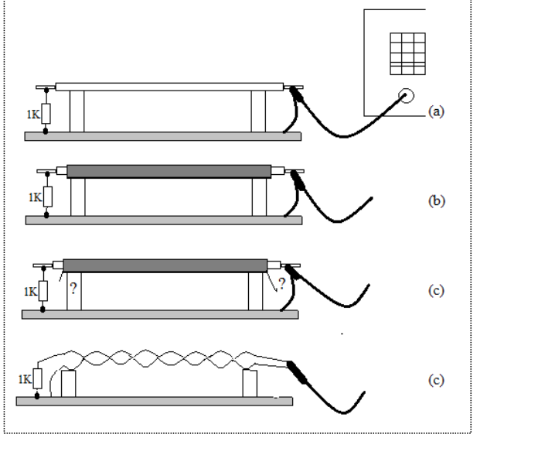
Figure 4 - Receptor Cable Connections
EVALUATION
The values and expectations from the preparation questions were compared with the obtained results from the experiments and comment on each specific point.
3.2.2 Inductive Coupling
Using the low impedance output (1Ω) on the UNILAB signal generator and the loose end of the interfering cable (transmitter cable) was grounded through a series resistance of 6.8Ω (9W).Caution was taken to ensure that the loose end of the cable was not short circuited directly to the ground or else the signal generator would be damaged.In this way, a considerable current would flow through the cable, through the resistor and back to the generator through the ground plane.The receptor cables were connected as before.
PROCEDURE
The output level of the signal generator was adjusted so that there was 0.8 A, 50 kHz sinusoid signal. (The current was measured by measuring the voltage output, using the oscilloscope)
a) The interfering voltage (peak-peak) received by the receptor cable was measured.
b) The frequency was increased to 100 kHz and measured the interfering voltage (peak –peak) received by the cable.
c) The wooden blocks were laid down so that the tubes were 5cm above the ground plane.
d) 10 cm distance between the two cables was maintained. The frequency was restored to
50 kHz and measured the interfering voltage (peak- peak).
e) The cables were moved 5cm apart (centre – centre) and measured the interfering voltage.
f) The signal generator was switched to square wave and measured the interfering voltage (peak-peak).
EVALUATION
The values and expectations from the preparation questions were compared with the obtained results from the experiments and comment on each specific point.
3. Radio Frequency Interference
Throughout this part, an AM/FM-radio receiver was used as a receptor for electromagnetic radiation fields.
3.3.1 Faraday Cage
A simple shield (of faraday – cage type), was made of chicken-net. It totally enclosed the inner volume, and it was quiet close-meshed. The wireless was adjusted so that a station (e.g. radio 4) was clearly heard. The radio was put in the chicken cage so that the cage completely enclosed it (keeping the antenna short and inside the cage).
3.4 Computer Interference
In close proximity to e.g. a computer, the radio would be interfered, due to the quick transitions in the square pulses (high frequency) and also because of other electronic devices like the CRT and disk- units etc in the computer. The radio was put close to the computer and the frequency was adjusted until the varying bit flow could be heard when a program was running on the computer.

- Results attached at the back of the report.
4.0 Discussion
Strength of the electric field is given by E=V/d, from the equation we can see that strength of the electric field is inversely proportional to the distance. This distance being the separating distance between the two conducting plates. It was seen that with voltage kept constant and d varied, E will be approaching zero as d is approaches infinite. A further observation was that the closer the cables were to ground the greater the interference.
Square wave produced higher amplitude of the interference voltage. After the radio was placed in the chicken cage the signal was poor, it became better only after protruding the antenna out of the cage. This simply implied that the cage had magnetic interference around it.
The following are a few ways of reducing interference signals to a device receiving signals wirelessly;
1. Position your wireless router in a centralized location: In the old days, you could put a router anywhere as long as you had enough cable. With wireless, you get a circle of transmission that centers on the antenna of your router. If you have it located on the far end of your house, your neighbor could pick it up better than you can on the other side of you house. You will avoid the problems of weak reception if you locate your wireless router in the middle of your home where you will get the most access to its strong signal.
2. Ditch your cordless phone: If your cordless phone runs on the same frequency as your wireless device, you could be dealing with serious interference, especially when the phone rings or during a conversation. Try using a phone based on a different frequency or get a router that is on a different frequency. You could eliminate all doubt and stop using a cordless phone.
3. Move your device away from other electronics: Places like next to computer monitors, microwave ovens, or televisions are good sources of interference, especially in wireless signals. You want to keep your wireless router away from those to minimize their potential impact on your network.
5. Mount your router away from the floor and away from metal walls: In fact, choose the area of your home where as few walls as possible come in between your wireless devices and your router. This will minimize interference and help deliver the best possible speed.
6. Adjust the internal radio channel on your router: If you are still getting problems with your wireless network connections, try setting your router to use a different channel. This is usually done by logging into it using your Web browser and then changing the applicable settings.
7. Get an auxiliary external antenna: Most consumer grade wireless routers will have cheap antennas that are not designed for high performance. To improve your immunity to interference get a third party external antenna that will have transmission strong enough to overcome the interference that is in your area. Be sure to check with your manufacturer first to make sure you buy an antenna that is compatible with your device.

5.0 Conclusion
Objectives of the experiment were met, rendering the experiment a success.
Just as well during further reading, insight of interfering signals and ways and methods of reducing them was known.
6.0 References
1. HUGHES E. ELECTRICAL AND ELECTRONIC TECNOLOGY; 10th edition
(2008); Pearson Education Limited, Edinburgh Gate, Harlow Essex CM20 2JE, England.
2. EEE3112 ENGINEERING PRACTICE LAB MANUAL ; University of Zambia,
Lusaka, Zambia.

