
SCHOOL OF MINES
Department of Geology
THE UNIVERSITY OF ZAMBIA
  - NAME: EMMANUEL CHATE
COURSE: ENGINEERING GEOLOGY (GGY 3051)
LECTURER: Dr. K Banda
E-learning Assignment #: 1
Topic : Geologic Structures

- What types of plate boundaries are most likely to contribute to the following?
- Compression – Convergent plate boundaries
- Extension – Divergent plate boundaries
- Shearing – Transform fault/boundary
- Explain the difference between elastic strain and plastic strain.
Strain is a result of stress on a rock. Therefore, Elastic strain occurs when a rock is able to retain its initial size, shape or form once the stress is removed while Plastic strain occurs when a rock deforms and maintains the new shape, size or form when the stress is removed.
- List some of the factors that influence whether a rock will deform (in either an elastic or plastic manner) or break when placed under stress.
- Time
- Temperature
- Pressure
- Nature of the rock
- Label the types of folds in this diagram, and label any of the important features of the folds.
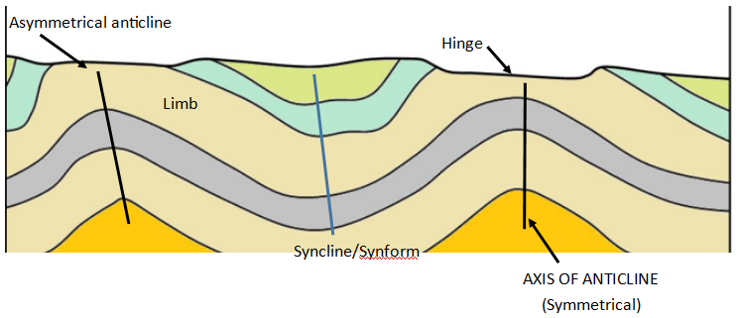
- The hinge is the point of maximum curvature.
- Limbs occur on either side of the fold hinge
- Explain why fractures are common in volcanic rocks.
A volcanic rock or an igneous rock commonly have fractures due to the change in conditions that the magma goes through, from underground to surface. Therefore, the changes in temperature and pressure cause the magma to cool at averagely fast rates. This affects things like the volume and crystal size of the rocks and increases the likelihood of the formation of fractures in these rocks.
- What is the difference between a normal fault and a reverse fault, and under what circumstances would you expect these to form?
A fault is a fracture in a rock that causes one side of it to move relative to the other. Therefore, a normal fault is one in which the hanging wall moves down relative to the footwall while a reverse fault is one in which the hanging wall moves up relative to the footwalls position. The normal fault happens due to tensional stress and the reverse fault happens due to compressional stress.
- What type of fault would you expect to see near to a transform plate boundary?
- Strike slip fault
- This diagram is a plan view (map) of the geology of a region. The coloured areas represent sedimentary beds.
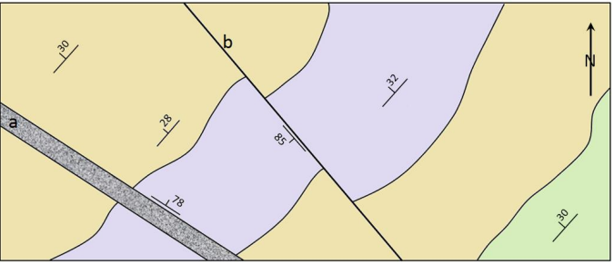
- Describe in words the general attitude (strike and dip) of these beds.
These beds are dipping at an average of 30° northwest
- Which of these beds is the oldest? Green bed
- What is “a” and what is its attitude? This is a dyke that is dipping at 78° to the northeast.
- What is “b” and what is its attitude? This is a strike and slip fault dipping at 85° to the southwest.
- Which of these terms applies to “b”: “left lateral” or “right lateral”? left lateral

