1.0 TITLE: SATURATION TEMPERATURE AND PRESSURE.
2.0 OBJECTIVE:
- To determine the relationship between saturation temperature and pressure.
3.0 THEORY
The saturation temperature is the temperature for a corresponding saturation pressure at which a liquid boils into its vapor phase. The liquid can be said to be saturated with thermal energy. Any addition of thermal energy results in a phase transition.
When a mass of water is heated, its temperature and pressure accompanied by a small increase in volume. Further heating produces temperature rise and steam is produced at constant pressure. This pressure can be higher or lower as the case maybe. With a further increase in temperature, finally, the water mass will be at such a temperature that the steam (the vapor into which water is converted when heated, forming a white mist of minute water droplets in the air) will be able to completely rise through the water and escape from the surface.
The turbulent state of steam formation is called BOILING. Boiling will occur at saturation temperature and it is found that saturation temperature depends upon the pressure exerted at the surface of the water and as long as there is water present, and at a constant pressure, it is impossible to increase the temperature beyond the saturation temperature.
In order to determine the relationship between the saturation temperature and pressure it is necessary to obtain a number of corresponding values of the two variables and then plot a graph.

3.1 DESCRIPTION OF EQUIPMENT AND APPARATUS
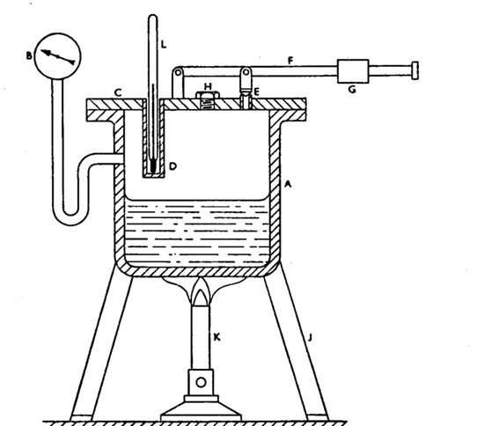
A high pressure tank A is fitted with a flange at its top. Into the side of the tank is fitted a pressure gauge B. onto the tank flange is fitted a cover plate C and a steam-tight joint is made between the cover plate and flange by means of a gasket. The cover plate has a thermometer pocket D fitted together with a relief valve E. The relief valve is loaded by means of a loading arm F on which slides the jockey weight G. The cover plate is also fitted with a screwed filler cap H and the whole apparatus is mounted on a stand J and placed over the heater K. The thermometer L is placed into the thermometer pocket D.
The diagram below shows the apparatus described above.

4.0 PROCEDURE
- The filler cap was removed and a quantity of water was poured into the tank. After the water was poured into the tank, the filler cap was replaced and screwed down tightly.
- Then the electric heater was turned on. The pressure at which the steam was generated was controlled by the jockey weight on the relief valve loading arm. Thus, the first position of the jockey weight from the pivot was measured and recorded.
- Two positions of the jockey weight were used for the experiment; one at 140mm from the pivot and the other at 220mm. It was found that the higher the pressure required, the further along the loading arm the jockey weight was placed.
- When the required steam pressure was reached, the relief valve blew off. The steam generated was wet steam and this steam was recorded to have been at saturation temperature. This temperature was read from the thermometer and the pressure was also read from the pressure gauge.
- A series of steam pressures and steam temperatures were recorded and to each pressure gauge, atmospheric pressure was added in order to obtain a series of absolute pressures.
- The results for this experiment were tabulated in tables and they can be seen from the results and data analysis section.

Reading  No. | Pressure  kg/cm² | Temperature  ⁰C | READING  NO. | Pressure  Kg/Cm2 | Temperature
1 | 0.2 | 99 | 10 | 2.0 | 129.7
2 | 0.4 | 104.3 | 11 | 2.2 | 132.2
3 | 0.6 | 108.1 | 12 | 2.4 | 134.3
4 | 0.8 | 112.1 | 13 | 2.6 | 135.5
5 | 1.0 | 115.6 | 14 | 2.8 | 137.5
6 | 1.2 | 119.1 | 15 | 3.0 | 139.9
7 | 1.4 | 122.0 | 17 | 3.2 | 141.7
8 | 1.6 | 124.6 | 18 | 3.4 | 143.6
9 | 1.8 | 127.5 | 19 | 3.8 | 144.5
5.0 DATA COLLECTION AND ANALYSIS
TABLE 6.0 FOR VALUES OF TEMPERATURE WITH Disc JOCKEY AT 1ST POSITION
(At 0.14m From Pivot)

TABLE 6.2 FOR VALUES OF TEMPERATURE WITH JISC JOCKEY AT 2ND POSITION
(At 0.22m from pivot)
Reading  No. | Pressure  Kg/Cm2 | Temperature  ⁰c | Reading  No. | Pressure  Kg/Cm² | Temperature
1 | 0.2 | 94.6 | 12 | 2.4 | 134.6
2 | 0.4 | 103.7 | 13 | 2.6 | 136.0
3 | 0.6 | 108.4 | 14 | 2.8 | 138.0
4 | 0.8 | 112.2 | 15 | 3.0 | 139.9
5 | 1.0 | 115.7 | 16 | 3.2 | 141.4
6 | 1.2 | 119.1 | 17 | 3.4 | 143.3
7 | 1.4 | 121.9 | 18 | 3.6 | 144.7
8 | 1.6 | 124.9 | 19 | 3.8 | 146.0
9 | 1.8 | 127.2 | 20 | 4.2 | 149.3
10 | 2.0 | 129.6 | 21 | 4.4 | 151.0
11 | 2.2 | 132.0 | 22 | 4.6 | 152.2
;

Assumptions
- Pressure tank is initialy at the room temperature of 18ºC.
- 66.2mHg as initial pressure.
- 662mm/Hg, the final pressure

Reading  No. | Pressure  kg/cm² | Temperature  ⁰C | Reading  No. | Pressure  kg/cm² | Temperature  ⁰C
1 | 0.2 | 96.8 | 10 | 2.0 | 129.15
2 | 0.4 | 104 | 11 | 2.2 | 132.1
3 | 0.6 | 108.25 | 12 | 2.4 | 134.45
4 | 0.8 | 112.15 | 13 | 2.6 | 135.75
5 | 1.0 | 115.65 | 14 | 2.8 | 137.75
6 | 1.2 | 119.1 | 15 | 3.0 | 139.9
7 | 1.4 | 121.95 | 16 | 3.2 | 141.55
8 | 1.6 | 124.75 | 17 | 3.4 | 143.55
9 | 1.8 | 127.35 | 18
TABLE OF AVERAGE VALUES

Data Analysis
Sample calculation.
Average temperature ⁼ $\frac{satuation temperature1 +saturation temperature2 }{2}$

Average temperature ⁼ $\frac{99+94.6 }{2}$ =96.8

7.0 DISCUSSION
This laboratory session provided key insights into various facets of saturation temperature and pressure. The relationship between saturation pressure and temperature was explored an a successful attempt was made to establish a link between the two.
From the graph depicting the relationship between the two, results from the data obtained shows that with each absolute pressure there is a corresponding saturation temperature which increases as the pressure increases. It was noted that the rate of increase of saturation temperature is not as great at the higher temperatures as it is at the lower temperatures.
Errors associated with the lab became much more evident in light of the graph of the standard graph of saturation temperature and Saturation pressure and that obtained from the experiment. It was found that the distinction between the two graphs was consistent indicating that the experiment was relatively accurate but just imprecise. From this it was surmised that a systematic error as opposed to a random error was propagated during the acquisition of experimental data.
 | Part | Functionality
A | Pressure Tank | idealised adiabatic containment with a top flange
B | Pressure gauge | Measurement of internal pressure
C | Cover plate | Steam Tight seal for containment
D | Thermometer pocket | Port provision for thermometer
E | Relief valve | Steam outlet at ‘blow off’
F | Loading arm | Mounts a jockey for resetting of different pressure points
G | Jockey weight | Provides needed weight for adjustable pressure onto the relief valve
H | Filler cap | Water inlet point
J | Stand | Mounts entire contraption
K | Bunsen burner | Provides the heat energy required
L | thermometer | Temperature measurement of the inside of the chamber
Other Possible causes of error could have arisen at a few notable points during the lab. The relief valve and jockey weight that had to be physically and manually stimulated for it to ‘blow off’. This can be attributed to the old equipment that may have slipped off into inprecision. Keeping of the aforementioned in good and precise working condition is the recommendation submitted.
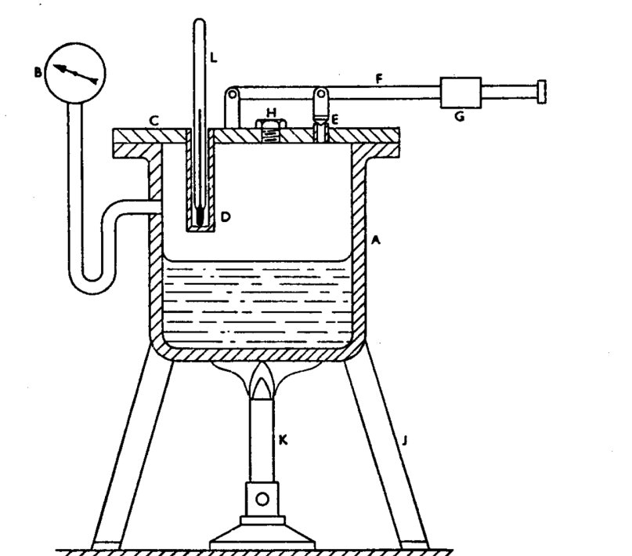
.

8.0 CONCLUSION
The laboratory session at hand provided valuable understanding of saturation temperature and pressure. Essentially it was found to be true the following as encapsulated below:
- Results from the data obtained shows that with each absolute pressure there is a corresponding saturation temperature which increases as the pressure increases.
- It was noted that the rate of increase of saturation temperature is not as great at the higher temperatures as it is at the lower temperatures.
9.0 REFERENCES
- Joel Rayners, Basic engineering Thermodynamics

- Rogers G.F.C and Meyhew V.R, engineering thermodynamics, 3rd Edition.

