

THE UNIVERSITY OF ZAMBIA
SCHOOL OF ENGINEERING
DEPARTMENT OF CIVIL AND ENVIRONMENTAL ENGINEERING
CEE 3811- FLUID MECHANICS
LABORATORY REPORT TWO: HYDROSTATICS AND MANOMETRY

NAME: ALICE MWENYA

COMPUTER#: 2019087103

DUE DATE: 6TH JUNE, 2022

ATTENTION OF: MR. HANDIA

Table of Contents
OBJECTIVE: 3
INTRODUCTION 3
THEORY 4
DESCRIPTION OF APPARATUS 5
PROCEDURE 6
RESULTS AND DATA ANALYSIS 6
EQUATION DERIVATIONS 7
Derivation of the three equations that are involved in this experiment: 7
THE RANDOM ERRORS 9
ANSWERS TO THE QUESTIONS: 10
DISCUSSION 14
CONCLUSION: 14
REFERENCES: 15

OBJECTIVES
The objective of the experiment that was carried out was:
- To learn how to use the differential manometers to measure static pressure at a point in a fluid.
- To measure static pressure differences within a fluid system.
- To estimate the relative errors in measuring pressure differences by different methods.

INTRODUCTION
The combination of experiments, the mathematical analysis of hydrodynamics and the new theories is known as ‘Fluid Mechanics’. Fluid Mechanics encompasses the study of all types of fluids under static, kinematic and dynamic conditions. Experiments developed for the practical understanding and analysis of fluids are Hydrostatic Pressure and Manometry laboratory experiments. Hydrostatics deals with forces and pressures exerted by fluids at rest.
PASCAL’S LAW
In fluids under static conditions pressure is found to be independent of the orientation of the Area. This concept is explained by Pascal’s law which states that the pressure at a point in a fluid at rest is equal in magnitude in all directions. Tangential stress cannot exist if a fluid is to be at rest. This is possible only if the pressure at a point in a fluid at rest is the same in all directions so that the resultant force at that point will be zero. The direction of such a pressure is always perpendicular to the surface on which it acts.
MANOMETERS
Manometers are defined as devices that are used for measuring the pressure at a point in fluid by balancing the column of fluid by the same or another column of liquid, Manometer is a device used to measure pressure or the difference in pressures using a column of liquid to balance the pressure. It is a basic instrument and is used extensively in flow measurement. It needs no calibration.
Very low pressures can be measured using micro manometers. The basic principle of operation of manometers is that at the same level in continuous fluid at rest, the pressure is the same. Manometers are classified according to the pressure we are required to measure; a differential manometer for instance measures two different pressure points. These include
- Mechanical gauges
- Barometers
- U- tube manometers
- Differential manometers
- Micro manometers
- Piezometers
- Inverted manometers

THEORY
The basic principle of operation of manometers is that at the same level in contiguous fluid at rest, the pressure is the same. The pressure due to a constant density liquid () column if height h is equal to gh.
The pressure at various points can be calculated using the basic hydrostatic equation and continuing the summation from the starting point at which pressure is known, to the end point, where the pressure is to be determined.
dP/dy = – ................ hydrostatic equation

Alternatively, is to start from a point of known pressure as datum and adding 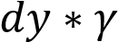 when going downwards and subtracting of 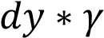 while going upwards. The pressure at the end point will be the result of this series of operations.

Manometers are advantageous in that they do not require much skill in their usage and are independent of any gauge calibration readings. However depend on the accuracy of the measuring instruments used and subject to parallax error if not careful.

DESCRIPTION OF APPARATUS
The apparatus consisted of four experimental stations with two junctions, A and B which were connected to the Manometry tubing mounted on boards in the Hydraulics Section of the Laboratories as shown in the diagram below. A constant head reservoir supplied water to junction A allowing the water levels a3 to be equal to that of the reservoir. The water level a3 remained constant throughout the experiment; however there was a drain pipe connected to B that was allowing water to leave the tubing at B and hence varying the height b3. As shown in Fig. 1, two manometer fluids are used in the system: water, which is clear (SG=1.0) and mercury, which is silver (SG=13.55).
The following diagram shows the set up of the apparatus:
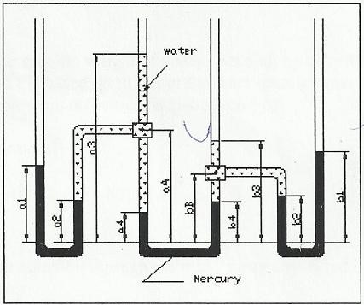
Diagram 1: the experiment setup

PROCEDURE
The instructor set up the apparatus prior to the lab. Before carrying taking any initial values the supply valve was left opened for some time to ensure that the controlled maximum water height above the junction B was obtained whilst the drain valve was closed. The supply valve was then closed after the initial height of water b3 has been set, and remained closed for the remainder of the experiment.
The maximum height b3 was recorded and adjusted using a sequential increment change in height hence obtaining different values for a1, b1, a2, b2, a4 and b4. The height b3 was adjusted at 50.00 mm intervals by opening and closing the drain valve to obtain 5 incremental changes of the pressure difference PA- PB, and repeat the data collection sequence described above. These heights were measured relative to the common datum line by means of a Rule.
The heights of the junction points A and B, as well as all fluid heights were recorded, by using the provided data sheet completed in the table under results and analysis.
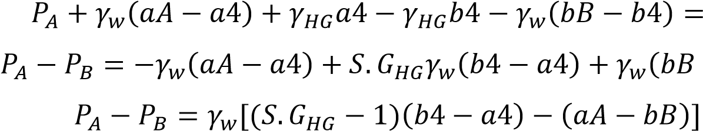

EQUATION DERIVATIONS

Derivation of the three equations that are involved in this experiment:
Piezometric equations
Since the piezometer is the simplest manometer with one column, the following is the derivation.

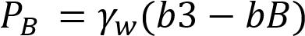

The outer mercury filled tubes


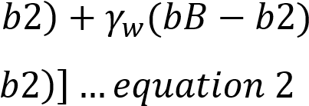
Theory:  and also 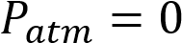 (since atmospheric pressure is the reference pressure).
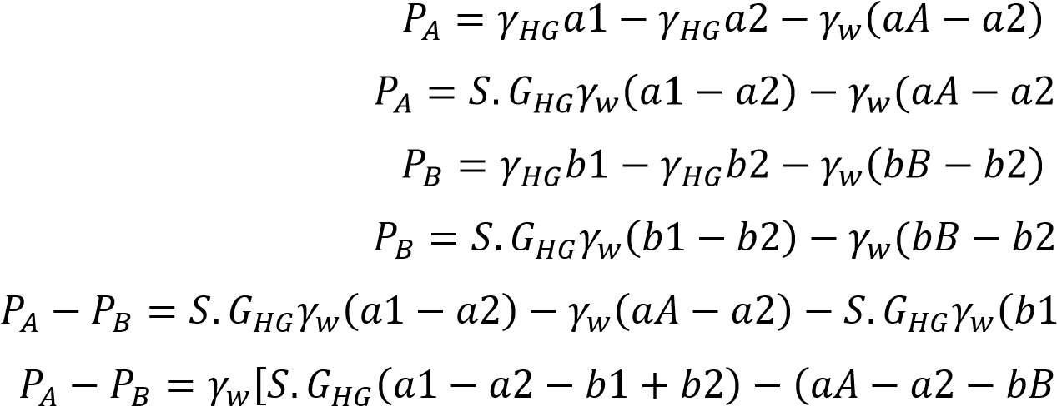

Middle U-tube Manometer
Starting at junction A and ending at junction B. the derivation is as follows.
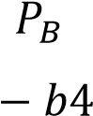
Hence the equation;

RESULTS AND DATA ANALYSIS
The table below shows the results obtained from the experiment.
Table1: The Heights recorded in experiment in mm
a1 | a2 | a3 | a4 | aA | bB | b4 | b3 | b2 | b1
95.00 | 48.00 | 790.00 | 82.00 | 480.00 | 220.00 | 92.00 | 790.00 | 53.00 | 110.00
100.00 | 45.00 | 790.00 | 80.00 | 430.00 | 220.00 | 88.00 | 710.00 | 55.00 | 105.00
98.00 | 50.00 | 790.00 | 75.00 | 430.00 | 220.00 | 98.00 | 630.00 | 59.00 | 102.00
97.00 | 53.00 | 782.00 | 73.00 | 430.00 | 220.00 | 93.00 | 550.00 | 61.00 | 99.00
97.00 | 48.00 | 780.00 | 68.00 | 430.00 | 220.00 | 98.00 | 370.00 | 64.00 | 95.00

Table2: Calculated Pressure difference
Height b3 | Piezometric (kN/m²) | Outer Hg(kN/m²) | U-Tube Hg(kN/m²)
b3=0.790m | -2.551 | -3.929 | -1.319
b3=0.710m | -1.275 | -1.494 | -1.075
b3=0.630m | -0.491 | -1.484 | 0.772
b3=0.550m | 0.216 | -1.341 | 0.402
b3=0.370m | 1.962 | 0.176 | 1.633
Mean | -0.627 | -1.685 | 0.413
Standard deviation | 1.752 | 1.356 | 1.370

THE RANDOM ERRORS
Random error for the piezometer:
$$Mean \left(\overline{a}\right)= \frac{-2.551-1.275-0.491+0.216+1.962}{5}$$
= -0.428 KN/$m^{2}$

Standard Deviation (SD)
=$\sqrt{\frac{{(-2.551+0.428)}^{2}{+(-1.275+0.428)}^{2}+{(-0.491+0.428)}^{2}+{(0.216+0.428)}^{2}+{(1.962+0.428)}^{2}}{5-1}}$
= 1.685
Random error (piezometer) $\frac{SD}{\sqrt{n}}= \frac{1.685}{\sqrt{5}}=0.753$

Similarly, the mean, standard deviation & Random error were found for the outer tube and middle tube manometer using same formulas.

Random errors for the Outer tube manometer:

$$Mean \left(\overline{a}\right)=-1.685KN/m^{2}$$
Standard Deviation (SD) = 1.356
Random error (Outer tube manometer) $\frac{SD}{\sqrt{n}}= \frac{1.356}{\sqrt{5}}=0.606$

Random errors for Middle U-tube manometer:
$$Mean \left(\overline{a}\right)=0.413KN/m^{2}$$
Standard Deviation (SD) = 1.370
Random error (Middle U-tube manometer) $\frac{SD}{\sqrt{n}}= \frac{1.370}{\sqrt{5}}=0.613$

GRAPH OF PIEZOMETRIC/OUTER Hg/U-Tube Hg Vs PIEZOMETRIC

ANSWERS TO THE QUESTIONS:
Q 1:
The piezometric setup
For the first reading P_{A} – P_{B} = -2.551KN/m²

$h=\frac{PA-PB}{pg}=\frac{-2.551x{10}^{3}}{9810}=-0.26m$ …………… Therefore h=0.26m

The potential errors is 1mm as stated, so since four measurements of heights that are used in the formula, so the error is:- 1mm*0.001*4 = 0.004m
$\%error=\left(\frac{0.004}{0.26}\right)*100=1.54\%$

The outer mercury tubes setup
For the first reading:
P_{A} –P_{B} = 1.752kN/m²
$h=\frac{PA-PB}{pg}=\frac{-3.929x{10}^{3}}{9810}=-0.4m$…………. Therefore, h=0.4m

There are 8 measurements involved in the formula, so error
$\%error=\frac{0.008}{0.4}*100=2\%$

For the inner mercury tube The first reading:
P_{A} – P_{B} = -1.319 kN/m²
$h=\frac{PA-PB}{pg}=\frac{-1.319*{10}^{3}}{9810}=-0.134m$…………. Therefore, h=0.134m

Potential error is
$\%error=\frac{0.004}{0.134}*100=2.99\%$

$$mean=\frac{0.26+0.4+0.134}{3}=0.265m$$
Standard Deviation (SD) = 0.662

Random error=$\frac{SD}{\sqrt{n}}=\frac{0.662}{\sqrt{3}}=0.382$

Q 2: for the final readings
The piezometric setup
For the final reading:
P_{A} – P_{B} = 1.962kN/m²
$h=\frac{1.962*{10}^{3}}{9810}=0.2m$
The potential errors are 1mm as stated, so since four measurements of heights that are used in the formula, so the error is:

$$\%error=\frac{0.004}{0.2}*100=2.0\%$$
The outer mercury tubes setup
For the final reading
P_{A} – P_{B} = -0.176kN/m²
$$h=\frac{-0.176x{10}^{3}}{9810}=0.018m$$

There are 8 measurements involved in the formula, so error
$\%error=\left(\frac{0.008}{0.018}\right)*100=44.4\%$
or the inner mercury tube
The final reading:
$PA – PB= 1.633kN/m2$

$$h=\frac{1.633x{10}^{3}}{9810}=0.166m$$

Potential error is

$\%error=\left(\frac{0.004}{0.166}\right)*100=2.4\%$

Mean=$\frac{\left(0.2+0.018+0.166\right)}{3}=0.128m$
Standard deviation, SD = 3.832

Random error=$\frac{SD}{\sqrt{n}}=\frac{3.832}{\sqrt{3}}=2.212$
Q 3: Advantages of using mercury:
- It is a high-density fluid which is required for manometric fluid.
- It has a silvecolour which makes it easily visible through glass unlike water.
- Unlike water it does not stick to the wall of tubing, hence accurate reading of measurements.
- Its accuracy when taking a reading is on basis that it forms an upper meniscus.
- It is not a highly reactive fluid to its environment.
Disadvantages of using mercury:
- It is a very poisonous liquid and is harmful to both exposure to skin and if taken orally.
- It has a toxic vapour and is thus hazardous if inhaled.
- It has a high sensitivity to temperature changes.
- Mercury is very expensive on the market.

DISCUSSION
The experiment which involved the measuring of pressure differences between junction A and B was obtained by three different ways; piezometric, Outer mercury filled tubes and middle U-tube manometers.
Sources of errors could have also been due to the opening and closing of the valves which when not accurately done allowed air bubbles. The mounting board on which the manometers were mounted was not vertical hence making it difficult to set the ruler in the vertical direction. The experiment was subject to parallax error.
Comparing the graphs plotted the results were conclusive and consistent. The lines were almost collinear indicating relatively same gradient. Thus the pressure difference can be measured using any of the three ways.
Recommendations are for the experimental setup to be replaced by a latest one. The mounting board should be set in a vertical position to facilitate accuracy.

CONCLUSION:
The objectives of the laboratory experiment were achieved. By carrying out the aforesaid procedure a practical understanding on the use of manometers to obtain static pressure at a point in a fluid and to measure static pressure differences within a Fluid system was at end.
An estimate of relative errors in measuring pressure differences was made from the results obtained. The percentage errors were thus calculated making the experiments accuracy conclusive.
It was concluded that the piezometric method of pressure measurement is more consistent as it can be seen from the difference in percentage errors between its first reading and final reading (This was concluded from the gradients of the graphs obtained).

REFERENCES:
- Kothandaraman C.P & Rudramoorthy R. (1999), Fluid Mechanics and Machinery (2ND edition), New Age International Ltd., Publishers, New Delhi, India.
- Rajput R.K (2006), Fluid Mechanics, S.Chand Company, Ram Nagar, India.
- White F.M (2011), Fluid Mechanics (SIE,7th edition),McGraw-Hill companies, Inc, New York, United States of America

