
0

THE UNIVERSITY OF ZAMBIA
SCHOOL OF ENGINEEERING
DEPARTMENT OF CIVIL AND ENVIRONMENTAL ENGINEERING
CEE 3311-FLUID MECHANICS

LAB REPORT NUMBER 3

NAME: KENA MWANSA MAMBWE
COMPUTER NUMBER: 2019071983
ATTENTION: MR L. HANDIA
DUE DATE: 10th JUNE, 2022

TABLE OF CONTENTS
OBJECTIVE……………………………………………………………….1
THEORY…..……………………………………………………………….2
APPARATUS …………………………………………………………....3
MATERIALS……………………………………………………………..4
PROCEDURE…………………………………………………………….5
DATA COLLECTION AND CALCULATION…………………6
DISCUSSION…………………………………………………………….7
CONCLUSION…………………………………………………………..8

IMPACT OF A FLUID JET
OBJECTIVES
To compare the momentum in a fluid with the force generated when it strikes a fixed surface.

THEORY
A liquid that is passing through a nozzle as jet can have a lot of momentum but no force. The forces are developed due to the change in momentum (due to change in velocity (v)), that is when the fluid makes impact on the hemispherical plate or the flat plate. The change in momentum is due to the change in the velocity before impact to a new velocity of deflected fluid. This change in momentum is governed by newton’s second law of motion, which states that the force on the exerted on the body is equal to the change of momentum of that body which is equal to the product of the mass of the body and its acceleration.
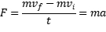
WHERE,

WHERE,

Taking the direction of as x direction and the angle between and to be β, the equation becomes
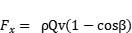

For a flat plate, hence the equation becomes,
For a hemispherical plate, hence the equation becomes,

APPARATUS
The diagram of the entire apparatus is as show below:
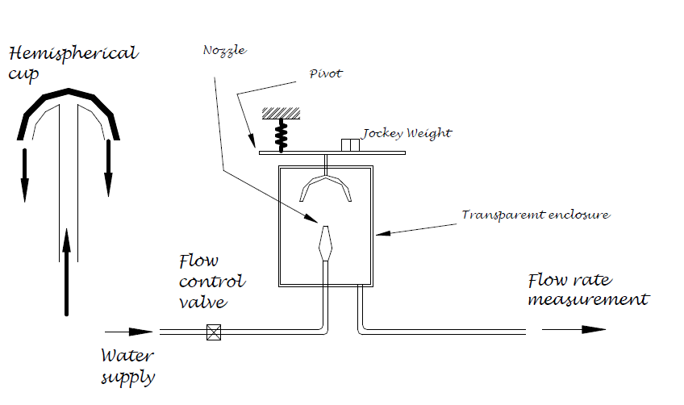
The apparatus consist of an upper precise weight beam that is pivoted on a knife edge at one end and carries along its length the fixed test plate. It also consists of a jockey weight that is used for measuring the force. It has an adjustable spring that supports the lever and is used for setting the initial zero level of the beam. The vertical tapered nozzle produces the high velocity jet. Both the nozzle and the test plate are contained in a transparent cylinder for clear observation. The apparatus has a drain tube in the base of the cylinder vessel, which is used to direct the water to the weight bucket where the flow can be measured.
PROCEDURE
- First the flat plate was set in the position in the apparatus.
- The apparatus was then carefully leveled, that is, before the starting the test, with no flow and the jockey weight at zero position, the beam was brought to horizontal by using the spring adjuster.
- The water supply was then admitted to the nozzle at full supply and then the force was measured by adjusting the position of the jockey weight until the horizontal position was restored again.
- The water supply was reduced and then the position of the jockey was adjusted so the horizontal position configuration of the beam was restored again.
- The same procedure was repeated for 3 tests of different positions of the jockey weight with various rates of water supply.
- Time was recorded for how long it took water to fill the tank for each test.
- The entire above procedure was repeated of the hemispherical plate.

DATA COLLECTION AND CALCULATION
TABLE 1.RESULTS FO R FLAT PLATE (β=90⁰).
Mass of water collected (kg) | Time (s) | Q (m³/s) | V (m/s) | U (m/s) | Position of jockey weight (mm) | F_{x} (N) | ρQV (N)
6 | 6.36 | 0.00094 | 11.999 | 11.97 | 200 | 7.848 | 11.28
6 | 7.68 | 0.00078 | 9.96 | 9.93 | 150 | 5.886 | 7.77
6 | 13.73 | 0.00044 | 5.66 | 5.60 | 100 | 3.924 | 2.49

TABLE 2.RESULTS FOR HEMISPHERICAL PLATE (β=180⁰).
Mass of water collected (kg) | Time (s) | Q (m³/s) | V (m/s) | U (m/s) | Position of jockey weight (mm) | F_{x} (N) | ρQV (N)
6 | 8.15 | 0.000736 | 9.41 | 9.37 | 200 | 7.848 | 6.926
6 | 11.21 | 0.000535 | 6.86 | 6.81 | 150 | 5.886 | 3.67
6 | 17.89 | 0.000335 | 4.35 | 4.27 | 100 | 3.924 | 1.46

The following measurements were taken down:
Diameter of nozzle = 10mm
Height of impact above the nozzle tip = 35mm
Distance from pivot to center line = 150mm
Jockey weight = 600 grams

SAMPLE CALCULATIONS
Calculation of Volume:
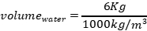
Calculation of flow rate Q;
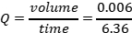

Calculation of u:
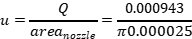
Calculation of v:
Calculation of
To calculate;
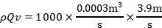
- DEVELOPING THE RELATIONSHIP
Taking the following assumption:
- That the fluid is non frictional
- Has a steady flow
- Is incompressible
Using the control volume method;
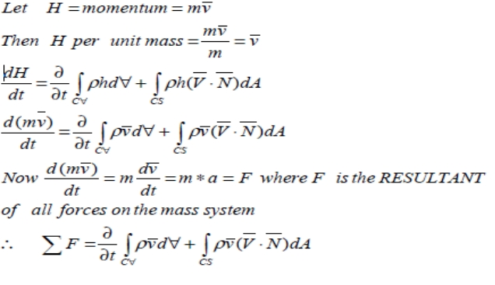
But the control volume has a steady flow, therefore:
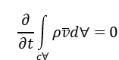
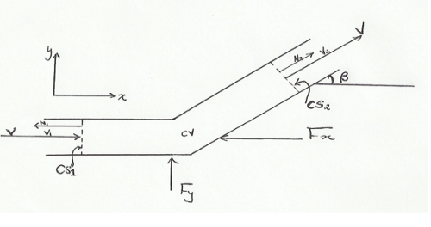

Thus,

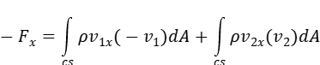
But,
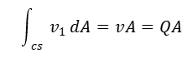
- 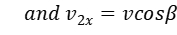
This will give,
Hence the relationship developed

GRAPHS
FLAT PLATE

HEMISPHIRICAL PLATE

DISCUSSION
It was also observed that the change in momentum of the jet water brought about the change in the force exerted on both the two the plates. Hence, from the graph that was obtained and the data collected, it was seen that the impact force is directly proportional to the flow rates or discharge of the fluid
The errors that were encountered were mainly due to inaccuracy in recording the time it took for the water to fill the tank and the inaccuracy in bring the beam to a proper horizontal position.

CONCLUSION
The experiment was a success and it was seen that the impact force of the fluid is directly proportional to flow rate or discharge of the fluid, therefore, the greater the flow rate or discharge the greater the impact force of the fluid.

REFERENCES
1. Kothandaraman C.P & Rudramoorthy R. (1999), Fluid Mechanics and Machinery (2ND edition), New Age International Ltd., Publishers, New Delhi, India.
2. Rajput R.K (2006), Fluid Mechanics, S.Chand Company, Ram Nagar, India.
3. White F.M (2011), Fluid Mechanics (SIE,7th edition),McGraw-Hill companies, Inc, New York, United States of America

