

SCHOOL OF ENGINEERING
DEPARTMENT OF CIVIL AND ENVIRONMENTAL ENGINEERING
CEE3311- FLUID MECHANICS I
LAB 3. IMPACT OF FLUID TEST
NAME: BERNARD SIKAZWE

COMPUTER#: 2019053560

DUE DATE: 10TH JUNE, 2022.

ATTENTION OF: MR. HANDIA

INTRODUCTION
Moving fluid, in natural or artificial systems, may exert forces on objects in contact with it. In order to analyse fluid motion, a finite region of the fluid (control volume) is usually selected, and the gross effects of the flow, such as its force or torque on an object, is determined by calculating the net mass rate that flows into and out of the control volume. These forces can be determined, as in solid mechanics, by the use of Newton’s second law, or by the momentum equation. The force exerted by a jet of fluid on a flat or curve surface can be resolved by applying the momentum equation. The study of these forces is essential to the study of fluid mechanics and hydraulic machinery. Engineers and designers use the momentum equation to accurately calculate the force that moving fluid may exert on a solid body. For example, in hydropower plants, turbines are utilized to generate electricity. Turbines rotate due to force exerted by one or more water jets that are directed tangentially onto the turbine’s vanes or buckets. The impact of the water on the vanes generates a torque on the wheel, causing it to rotate and to generate electricity.

OBJECTIVE:
To compare the momentum in a fluid with the force generated when it strikes a fixed surface.

THEORY:

When a jet of liquid strikes a fixed surface, a stream of fluid is formed which moves over the surface until the boundaries are reached and the fluid will then leave the surface tangentially. The surface is assumed to be large compared to the cross section of the set. A liquid that is passing through a nozzle as jet can have a lot of momentum but no force. The forces are developed due to the change in momentum (due to change in velocity (v)). According to Newton‘s 2nd law of motion, the rate of change of momentum is equal to the force.
$$F=\frac{mv_{f}-mv_{i}}{t}=ma$$
Where $m=mass; v_{f}=final velocity; v_{i}=initial velocity;t=time;a=acceleration$
From the above, considering two points in a fluid stream of steady flow. Also assuming the fluid is uniform and normal to the inlet and the outlet, and considering the conservation of mass. It can be obtained that;

$$F_{x}=ρQ(v_{1}\cos{θ_{1} }-v_{2}cosθ_{2} )$$
Where $ρ=density of fluid;Q=flow rate; F_{x}=force in x-component; θ=angle of inclination from horizontal$
Taking the direction of $v_{i}$as x direction and the angle between $v_{1}$and $v_{2}$ to be $β$, the equation becomes
$$F_{x}= ρQv(1-cosβ)$$
Where $β$ is the angle between initial and final velocity direction of the fluid before and after striking the surface respectively.
For a Flat plate, $β={90}^{0}$ hence the formula becomes

$$F_{x}= ρQv$$
For a hemispherical plate, $β={180}^{0}$, the equation becomes
$$F_{x}= 2ρQv$$

DESCRIPTION OF APPARATUS:
The apparatus used is as shown below:
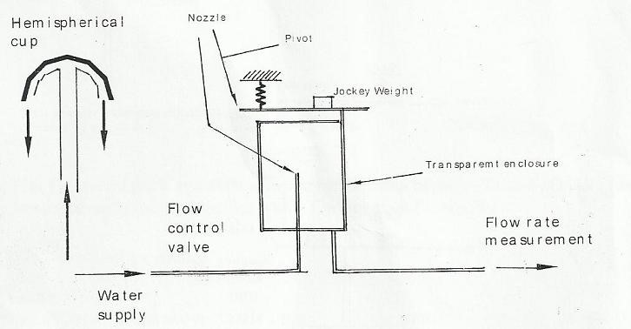

fig.1. Apparatus
The water supply is connected to a vertical pipe with a tapered nozzle as the outlet.
The surfaces used were a flat plate 90 and a hemispherical plate 180 .
For a transparent observation, both the nozzle and the test plate are contained in a transparent cylinder.
A drain tube, in the base of the cylindrical vessel was used to direct the water to the weight bucket where the low can be measured.
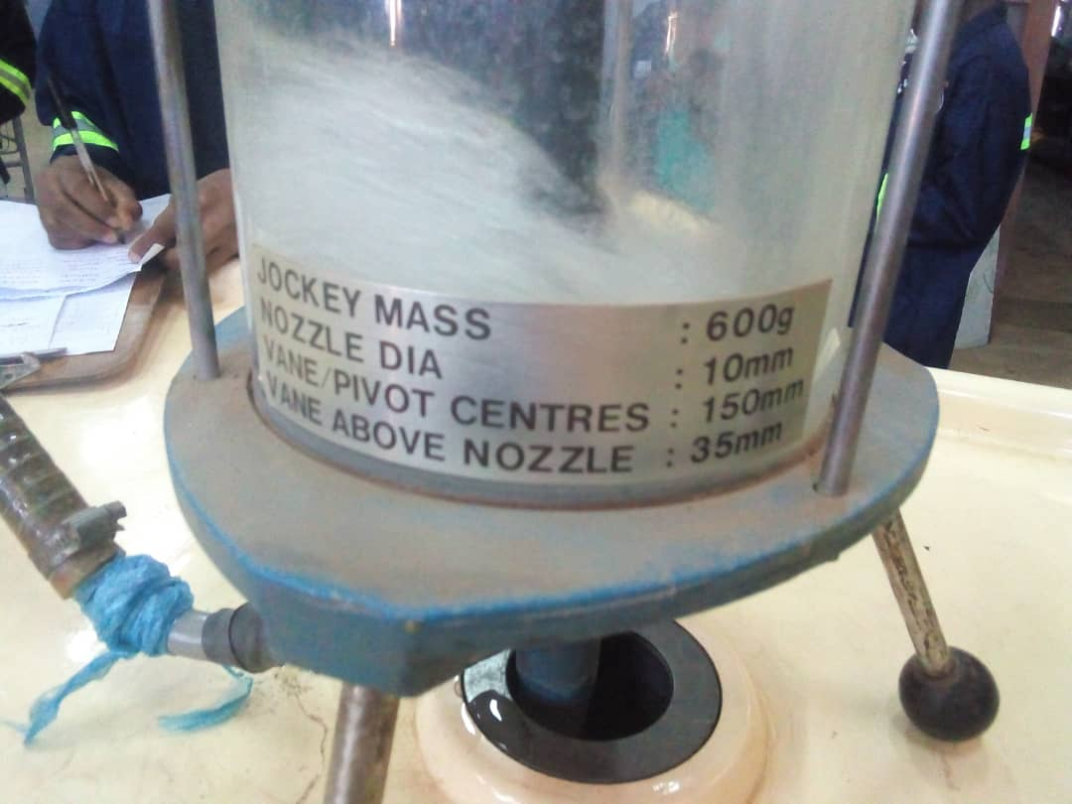

PROCEDURE:
The apparatus was set up as illustrated in the figure captioned under description of apparatus.
The hemispherical plate and the flat plate were used in the experiment, one plate at a time. Firstly a flat plate was initially installed before starting the actual experiment. The apparatus was then levelled when there was no flow; this was done ensuring that the beam was horizontal.
Using he control valve, the water supply was opened to the maximum. The jockey weight was then moved until the horizontal balanced position was attained again. The time it took to fill 6kg of water was recorded. This procedure was repeated for varied pressures.
The exact same procedure was done for a hemispherical plate.
Determining 

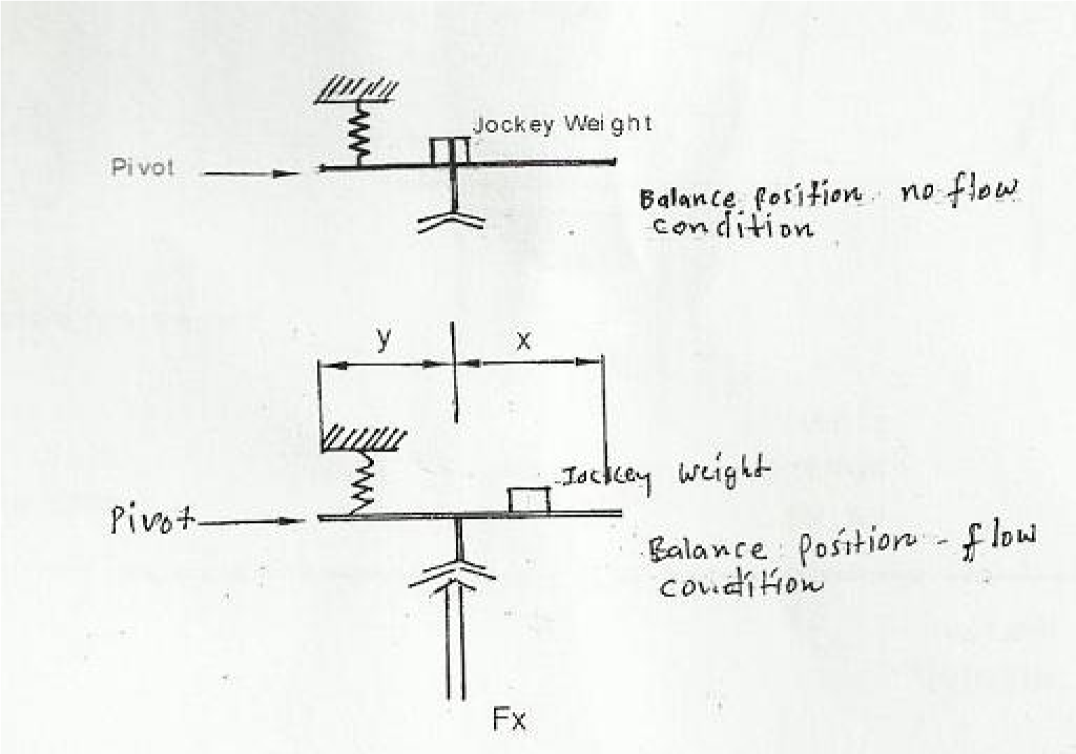

fig.2. Measuring 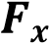
This was balanced by an additional moment due to mass m of the jockey.
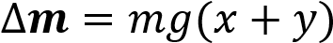
Thus equating the two, we have
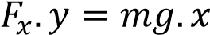
Hence,
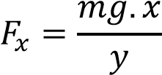
Calculating flow rate Q

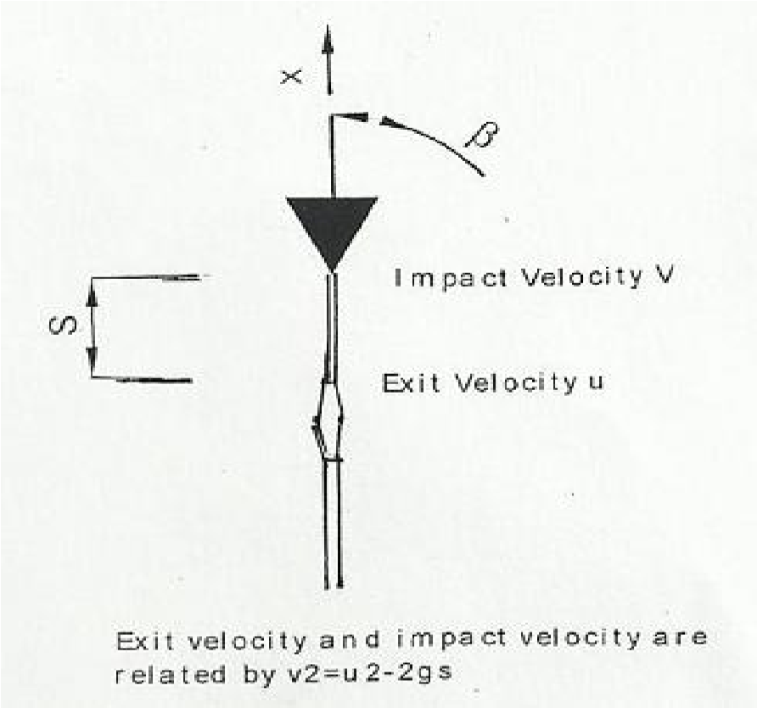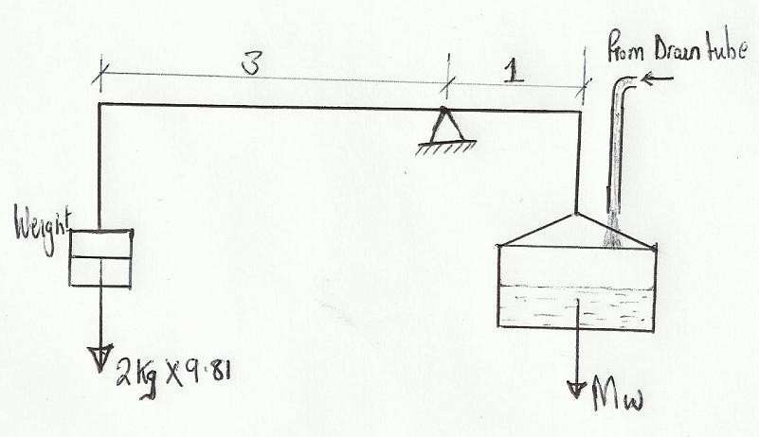

fig.3 Calculating the flow rate Q
Mass used was a 2kg, with a ratio of 3:1 the actual mass of the water collected was 3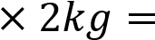
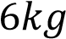
From the mass of the water, the volume is calculated as follows
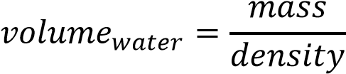
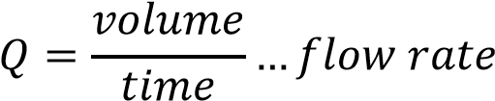
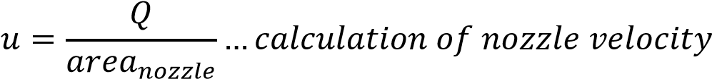
Where

RESULTS:
The table below shows the results obtained from the experiment. Mass of weight used to measure mass of water was 2kg. Thus, mass of water was 6kg from ratio 3:1 of the ratio of the weight in apparatus used to actual mass of water collected.

Table 1: results for flat plate (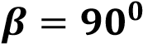)
Mass of  water (kg) | Time (s) | Q (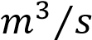) | 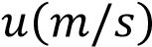 | 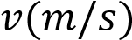 | Position of jockey x | 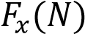 | 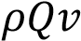

Table 2: results for hemispherical plate (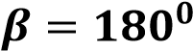)
Mass of  water (kg) | Time (s) | Q () |  |  | Position of jockey x

Where:
- Nozzle dia. = 10mm
- Vane above nozzle. (Height of impact above the nozzle tip) = 35mm=s
- Distance from pivot to centre line = 150mm=y
- Jockey weight = 600g=0.6kg

DATA ANALYSIS:

a) The relationship 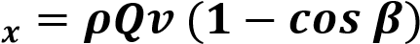 is derived as follows:

Assumptions:
- The fluid is uniform and normal to the inlet and the outlet
- conservation of mass
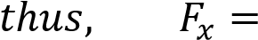

Where:
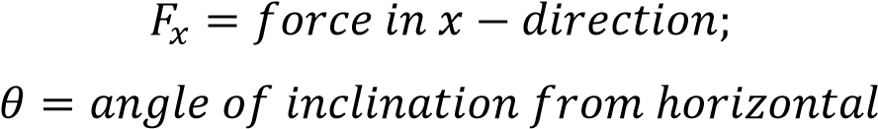

Using CONTROL VOLUMES

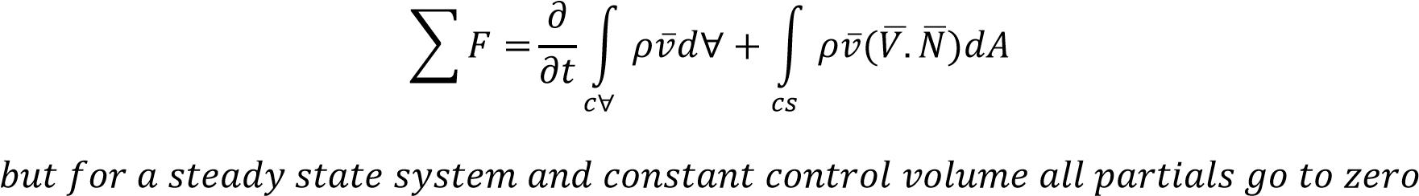
Thus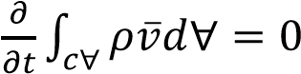,
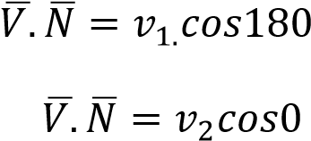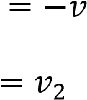

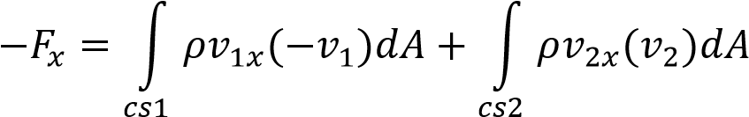
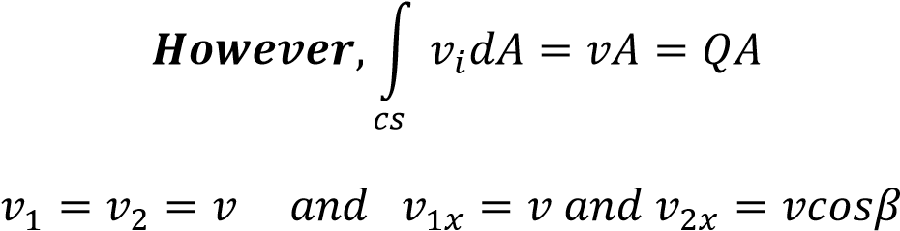

Therefore;

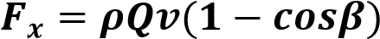.........equation derived.

b) Sample Calculation; s=35mm=0.035m; y=150mm=0.15m; dia.=10mm=0.01m

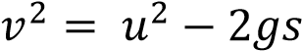.............equation relating exit velocity and impact velocity
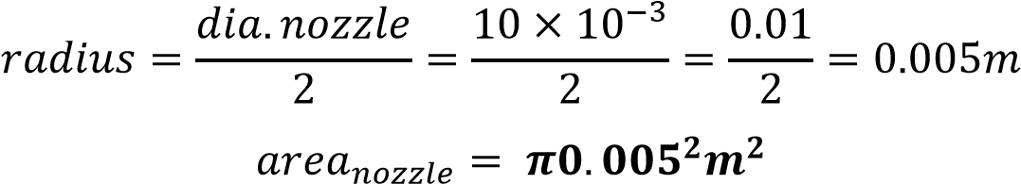
Taking the first reading of table 1 as sample calculation, we have.
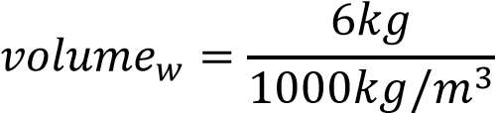
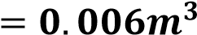

Calculating the flow rate Q;
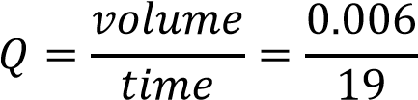
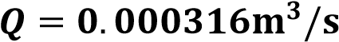

Calculating u:
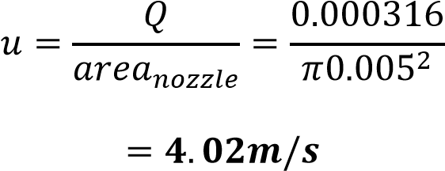

To calculate v:
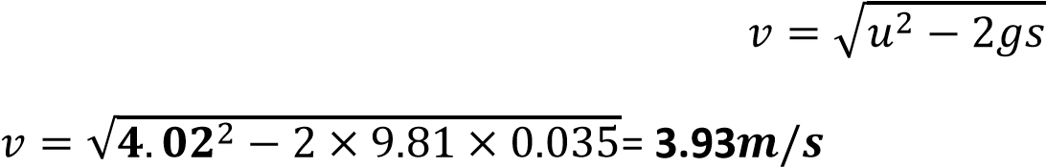
To calculate Fx: x=0.037m; y=0.15m
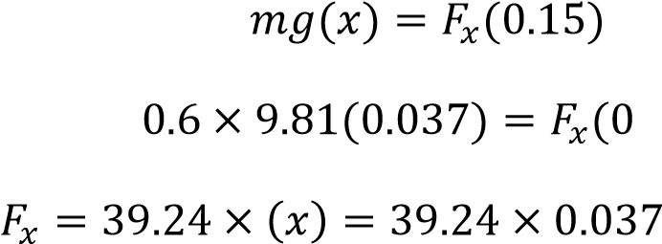
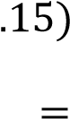


c) To calculate 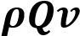;
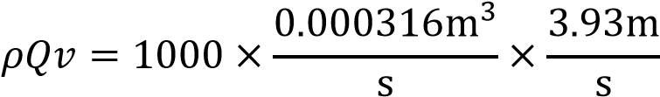
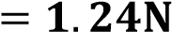
FOR A FLAT PLATE 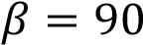 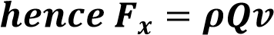
FOR A HEMISPHERICAL PLATE 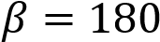 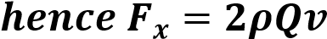
here 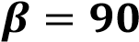 for sample calculation;
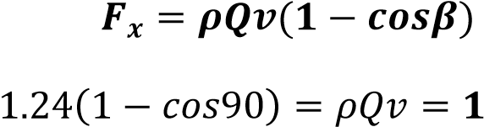


d) ABSOLUTE ERROR= 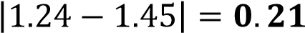
PERCENT ERROR=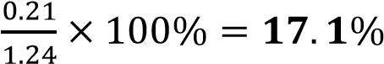

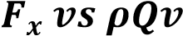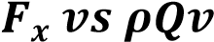
e)

graph of

f)

graph of

0

0.5

1

1.5

2

2.5

3

3.5

4

4.5

0

2

4

6

8

degrees
90

degrees
90

Linear (90 degrees)

0

1

2

3

4

5

6

7

8

0

1

2

3

4

180
Degrees

Degrees
180

Linear (180 Degrees)

g) Slope as calculated from graphs by linear regression;
From theory slope=1
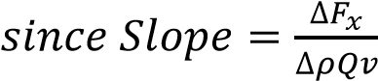 Then the error for each plate is found as follows:
- FOR A FLAT PLATE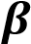  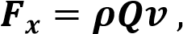
Slope from linear regression=1.54 Therefore
=
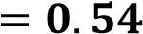
- FOR A HEMISPHERICAL PLATE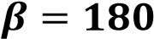 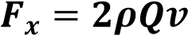,
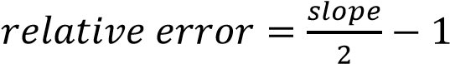
Slope from linear regression=2.26
Therefore 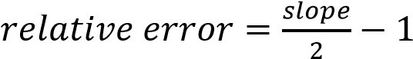
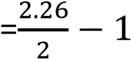
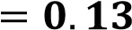

DISCUSSION:
For the time t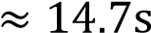the forces of the separate surfaces showed that there was a greater impact for this time (16.257N) for the hemispherical plate.
The errors found were 0.54 and 0.13 for the plates 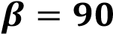  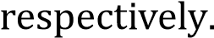The
graphical plot showed a linear correlation of values implying the linear relationship between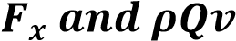. The errors were due to inaccuracies that could have resulted by experimental errors such as when recording time and also due to rounding off.
Discussing the results, the impact force was observed to be directly proportional to the flow rate as seen from the slopes. Hence the greater the discharge, the greater the value of the impact force.

CONCLUSION:
The objectives of the laboratory experiment were achieved. The force generated by the momentum of a fluid when it strikes a fixed surface was determined. It was concluded that 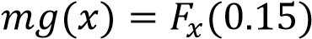 was appreciably valid to find the value of 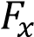 experimentally as its value was

REFERENCES:
- Kothandaraman C.P & Rudramoorthy R. (1999), Fluid Mechanics and Machinery (2ND edition), New Age International Ltd., Publishers, New Delhi, India.
- Rajput R.K (2006), Fluid Mechanics, S.Chand Company, Ram Nagar, India.
- White F.M (2011), Fluid Mechanics (SIE,7th edition),McGraw-Hill companies, Inc, New York, United States of America

