THE UNIVERSITY OF ZAMBIA
SCHOOL OF ENGINEERING
DEPARTMENT OF CIVIL AND ENVIRONMENTAL ENGINEERING

CEE 3311-FLUID MECHANICS 1

LAB TITLE: FLUID JET IMPACT

GROUP MEMBERS: MARTIN CHALONGA (2016140076)
DOMINIC BANDA (2016140005)
ASTON DAKA (2016135391)
CHALWE LUSWILI (15004953)

ATTENTION: MR. LENGANJI SIMWENDA

TABLE OF CONTENTS
 | PAGE NUMBER
INTRODUCTION | 2
AIM | 2
OBJECTIVES | 2
THEORY | 2
APPARATUS | 5
METHODOLOGY | 5
DATA COLLECTION | 7
DATA ANALYSIS | 8
DISCUSSION | 9
CONCLUSION | 10
RECOMMENDATIONS | 10
REFERENCES/BIBILIOGRAPHY | 10

INTRODUCTION
Momentum is defined as the quantity of motion of moving body (fluids-in the study of fluid momentum) and it is the product of its mass and velocity. In this lab, Fluid momentum will be studied by observing the force generated by the fluid jet as it strikes a deflector.
AIM
- To compare the momentum in a fluid with the force generated when it strikes a fixed surface.
OBJECTIVES
- Compare momentum of fluid as it strike the flat plate
- Compare momentum of fluid as it strike the spherical plate
THEORY
Momentum is defined as the quantity of motion of moving body (fluids-in the study of fluid momentum) and it is the product of its mass and velocity.
Fluid momentum in fluid is studied using both the Law of conservation of Momentum and Newton’s second law of Motion. Using the control volume equation $\frac{dN}{dt}=\frac{d}{dt}\int_{cv}{ηρdv}+\int_{cs}{ηρ(\overline{V}d\overline{A}}), where N=Momentum=MV, and η=intensive property=\frac{MV}{M}=v, the momentum equation becomes \frac{d(mv)}{dt}=\frac{d}{dt}\int_{cv}{vρdv}+\int_{cs}{vρ(\overline{V}d\overline{A}}),$
Now according to Newton’s second law of motion, summation of all forces acting on a system is equal to the rate of change of momentum. That is $\sum{F}=\frac{d(mv)}{dt}=\frac{d}{dt}\int_{cv}{vρdv}+\int_{cs}{vρ(\overline{V}d\overline{A}}),$
But $\sum{F}=\frac{d\left(mv\right)}{dt}, and where mass=ρV, and \frac{dV}{dt}=Discharge\left(Q\right),$
$\sum{F}= ρVQdv=ρQΔV.$ Where $ρ=density of fluid;Q=flow rate; F_{x}=force in x-component; θ=angle of inclination from horizontal$
This is a very useful equation in the study of application of Momentum in fluids. It can be used to compute forces acting on a deflector for instance.
For the control volume in figure 1 below, it can be shown that$\sum{Fx}=ρQ\left(V_{2}cosθ-V_{1}\right)=ρQV_{1}\left(cosθ-1\right)={-R}_{x}$
$$and \sum{Fy}=ρQ\left(V_{2}sinθ-V_{1}\right)=ρQV_{1}\left(sinθ-1\right)=R_{y}$$
Where $ρ=density of fluid;Q=flow rate; R_{x/y}=force acting on the fluid by the deflector; θ=angle of inclination from horizontal$
Figure 1.
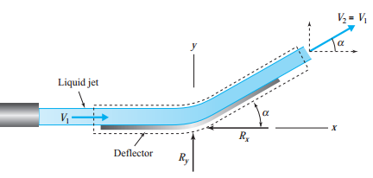
For a Flat plate, $θ={90}^{0},$the formula becomes
$$R_{x}= ρQv$$
For a hemispherical plate, $θ={180}^{0}$, the equation becomes
$$R_{x}= 2ρQv$$

APPARATUS
Refer to figure 2 below.
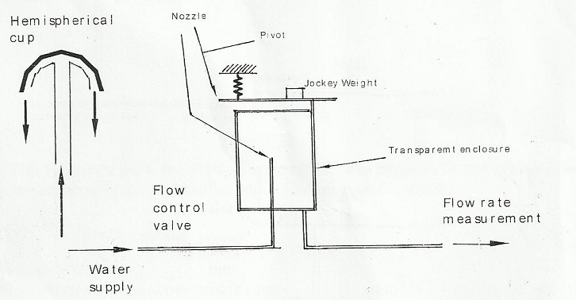
An upper precision weigh-beam is pivoted on a knife-edge at one end, and carries along its length a fixed test plate. A jockey weight is used to measure the force. An adjustable spring supports the lever and is used for setting the initial zero level of the beam.
A high velocity jet is then produced by the vertical tapered nozzle. For clear observation, both the nozzle and the test plate are contained in a transparent cylinder. The drain tube in the base of the cylindrical vessel is used to direct the water to the weigh bucket where the flow can be measured.
METHODOLOGY
Both the hemispherical plate and the flat plate were used in the experiment, one plate at a time. The apparatus were carefully levelled. Using the spring adjuster, the beam was brought to the horizontal position before the jockey weight was added and the flow started. The water was admitted to the nozzle to full supply and by adjusting the jockey weight until the horizontal configuration is restored, the force was measured.
The water supply was reduced and simultaneously the jockey weight was adjusted to the horizontal configuration of the beam until it was balanced, then the procedure was repeated for various rates of water supply.
- Measurement of Jet force $Fx=Rx;$
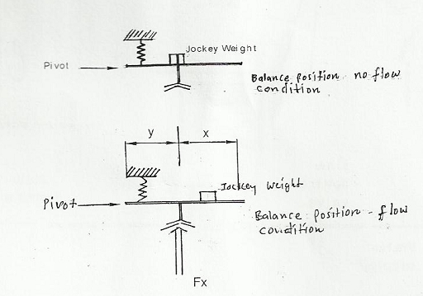
Equipment Property
Nozzle diameter =10mm
Vane/pivot center=150mm
Vane above nozzle=35mm

Fig 3: Measuring Rx
The additional moment due to $F_{x}$is
$$∆M=F_{x}×y$$
This moment is balanced by the additional moment due to mass m of the jockey.
$$∆M=mg(x+y)$$

DATA COLLECTION
The following table shows data collected.
Table 1. Data collected from the experiment.
Mass of water  (kg) | Time  (s) | Discharge  (m^3/s) | Initial Velocity  (m/s) | Final Velocity  (m/s) | Jockey weight position  (m) | Fx | $$ρQV(N)$$
2 | FLAT PLATE
2 | 9.9 | 0.000202 | 2.572 | 2.702 | 0.2 | 13.7340 | 0.54594
2 | 11.6 | 0.000172 | 2.195 | 2.346 | 0.15 | 11.772 | 0.40456
2 | 13.3 | 0.00015 | 1.915 | 2.086 | 0.1 | 9.81 | 0.31373
2 | 13.6 | 0.000147 | 1.872 | 2.048 | 0.05 | 7.848 | 0.30112
2 | SPHERICAL PLATE
2 | 19.1 | 0.000105 | 1.333 | 1.421 | 0.04 | 7.4556 | 0.14882
2 | 11.8 | 0.000169 | 2.158 | 1.687 | 0.08 | 9.0252 | 0.28587
2 | 10.5 | 0.00019 | 2.425 | 1.764 | 0.12 | 10.5948 | 0.33601
2 | 9.2 | 0.000217 | 2.768 | 1.859 | 0.16 | 12.1644 | 0.40406

DATA ANALYSIS
Discharge (Q) Calculation
$$Q=\frac{(\frac{m}{ρ})}{t}=\frac{\frac{2}{1000}}{9.9}=0.000202 m^{3}/s$$
Initial Velocity $\frac{Q}{A}=\frac{0.000202 m^{3}/s}{π*.01^2/4}=2.57m/s$
Final Velocity
$v=\sqrt{u^{2}+2gs}==\sqrt{{2.57}^{2}+2g*.035}=$2.702m/s
Fx=$\frac{mg\left(x+y\right)}{y}=\frac{.6*9.81*(.15+0.2)}{.15}=13.734$N
$$ρQV=1000*.000202*2.702=0.546N$$
Figure 3

Figure 4

DISCUSSION
Two different plate shapes were used in this lab. The results obtained from each plate shape (deflector) and respective analysis showed that the force generated on the flat plate was bigger but inversely proportional to time, but directly proportional to jockey weight position. For the spherical plate, the generated force was lesser compared to one obtained in flat plate. It was directly proportional to time and inversely proportional to jockey distance from the pivot.
This momentum/plate shape relationship is well illustrated in figure 3 and 4. An almost linear graph was obtained in for spherical plate.
Possible sources of errors could have been from balancing of weight and time recording.

CONCLUSION
The lab aimed at comparing the momentum in a fluid with the force generated when it strikes a fixed surface. As far as that was concerned, the aim was successfully achieved.

RECOMMENDATIONS
One major recommendation; Let the equipment be improved.
BIBLIOGRAPHY
- White F.M (2011), Fluid Mechanics (SIE,7The edition),McGraw-Hill companies, Inc. New York, United States of America
- Rajput R.K (2006), Fluid Mechanics, S.Chand Company, Ram Nagar, India.

