THE UNIVERSITY OF ZAMBIA
SCHOOL OF ENGINEERING
DEPARTMENT OF CIVIL AND ENVIRONMENTAL ENGINEERING

LAB TITLE: HYDROSTATICS AND MANOMETRY

COMPUTER NUMBER: 2019032252
NAME: THERESA CHILESHE
COURSE CODE: CEE 3311
TASK: LAB REPORT 02
ATTENTION: MR HANDIA

TABLE OF CONTENTS
 | PAGE NUMBER
INTRODUCTION | 2
AIM | 2
OBJECTIVES | 2
THEORY | 3
APPARATUS | 4
METHODOLOGY | 5
DATA COLLECTION | 5
DATA ANALYSIS | 7
DISCUSSION | 8
CONCLUSION | 9
RECOMMENDATIONS | 10
REFERENCES/BIBILIOGRAPHY | 11

INTRODUCTION
The principle of Hydrostatics simply states that the pressure at any point in a fluid at rest (Hydrostatic) is simply due to the weight of the overlying fluid.
Manometry refers to the use of devices called Manometers that use columns of fluids to measure pressure. The principle of manometry suggests that the difference in pressure at two different elevations is directly proportional to the difference in elevation
These two principles will be used in this experiment.
AIM
- To calculate the pressure difference between two points using the principle of Hydrostatics and Manometry.
OBJECTIVE
- To learn to use differential Manometers to measure static pressure at a point in fluids
- To measure static pressure difference within a fluid system
- To estimate the relative errors in measuring pressure difference using different methods
THEORY
HYDROSTATICS
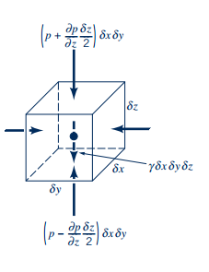
For a fluid element in figure above, summing forces vertically; we have:
Simplifying this gives
Which since P is independent of X and Y can be written as
.
This expression implies that there is no pressure variation in X and Y, but only varies vertically, and if density is assumed constant, the expression can be integrated to get
.
For a fluid at rest below, it is convenient to measure distances vertically downward from the free liquid surface. If h is the distance below the free liquid surface and if the pressure of air and vapor on the surface is arbitrarily taken to be zero, equation above can be written as
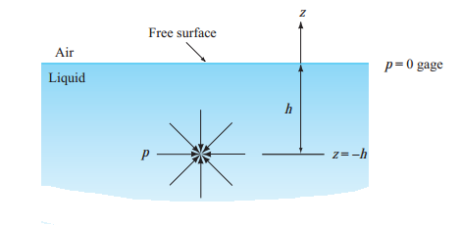
MANOMETRY
Manometers use the principle of Hydrostatics to measure pressure. For simple U-Tube Manometers used to measure relatively small pressures, a single fluid is used.
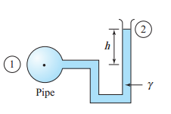
In this case, taking the datum through point 1, z₁ and z₂ are measured, and using gage pressure P₂ = 0 (if absolute pressure is desired, we would select p₂ = p_{atm}) and z₂ – z₁= h, then we have
Thus by measuring height h, one computes P₁, the pressure in the pipe.
For Manometers using more than one fluids (like below), the hydrostatic equation can applied to each section of fluid and the pressure can be determined by introducing three points as indicated.
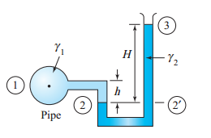
This is necessary because applies throughout one ﬂuid; γ must be constant. The value of γ changes abruptly at point 2; hence we write
For γ₁
For γ₂
Adding these two equations and setting P₃ = 0 (Using gauge pressures) we obtain

APPARATUS
The apparatus consists of four experimental stations of manometry tubing mounted on boards in the Hydraulics Section in the Laboratories. The equipment for each station consists of two junctions, A and B, which are connected to manometry tubing as shown in Figure 1. Water enters junction A from a constant-head reservoir, allowing water level a3 to remain equal to that of the reservoir throughout the experiment. The same reservoir also feeds junction B by means of a supply pipe that allows the initial water level b3 to be set, and there is a drain pipe that allows water to leave the tubing at B. As shown in Fig. 1, two manometer fluids are used in the system: water, which is clear (SG=1.0) and mercury, which is silver (SG=13.55).

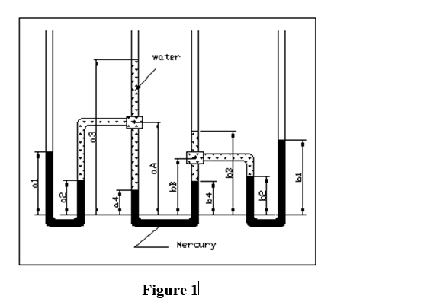

METHODOLOGY
Before the initial data was recorded, the supply valve was opened to obtain a controlled maximum height of water above junction B, while the drain valve was closed. The supply valve was then closed after the initial height of water b3 had been set, and it remained closed for the remainder of the experiment.

For each setting, the fluid heights indicated in Fig. 1 relative to the common datum line was measured by means of a meter stick in a table.
After recording data for the maximum height b3, the settings were adjusted by opening and closing the drain valve to obtain 5 decremental changes of the pressure difference PA-PB. The measurements of heights was done for decrement.

DATA COLLECTION
The following table shows data collected in the experiment.
Table 1: The Heights recorded in experiment in mm

HEIGHTS | a1 | b1 | a2 | b2 | a3 | b3 | a4 | b4 | aA | Bb
INTIAL | 95 | 110 | 48 | 53 | 790 | 790 | 82 | 92 | 430 | 220
8 | 100 | 105 | 45 | 55 | 790 | 710 | 80 | 88 | 430 | 220
16 | 98 | 102 | 50 | 59 | 790 | 630 | 75 | 98 | 430 | 220
24 | 97 | 99 | 53 | 61 | 782 | 550 | 73 | 93 | 430 | 220
32 | 97 | 95 | 48 | 64 | 780 | 470 | 68 | 98 | 430 | 220
Table 2: Calculated Pressure difference
Height B3 | Piezometric (KN/m²) | Outer Hg (KN/m²) | U-Tube Hg (KN/m²)
B3= 0.79m | -2.060 | -3.438 | 2.585
B3=0.71m | -1.275 | -1.494 | 2.358
B3= 0.63m | 0.491 | -1.484 | 4.254
B3=0.55m | 0.216 | 0.580 | 3.904
B3= 0.47m | 0.981 | -4.141 | 5.185
Mean | -0.329 | -1.995 | 3.657
Standard deviation | 1.282 | 1.859 | 1.397

DATA ANALYSIS

EQUATION DERIVATIONS.
Derivation of the three equations that are involved in the experiment:

- PIEZOMETRIC EQUATIONS
Since the piezometer is the simplest manometer with one column, the following is the derivation.

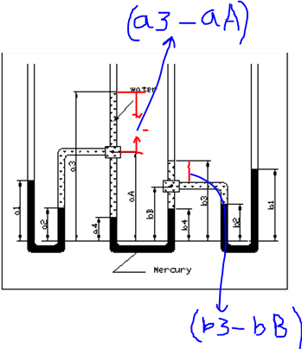

$$P_{A}= γ_{w}(a_{3}-a_{A})$$
$$P_{B}=γ_{w}(b_{3}-b_{B})$$
$$P_{A}-P_{B}=γ_{w}\left(a_{3}-a_{A}\right)-γ_{w}(b_{3}-b_{B})$$
$$=γ_{w}\{\left(a_{3}-a_{A}\right)-\left(b_{3}-b_{B}\right)\}$$
$$=γ_{w}\left\{\left(a_{3}-a_{A}-b_{3}+b_{B}\right)\right\}$$
- The outer mercury filled tubes.
Derivation of pressure difference equation from outer manometers.
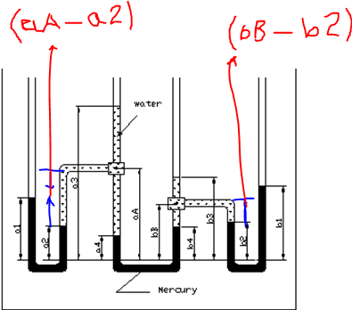

FROM left Manometer
$$P_{A}=γ_{Hg}*a_{1}-γ_{Hg}*a_{2}-γ_{w}(a_{A}-a_{2})$$
$$P_{B}=γ_{Hg}*b_{1}-γ_{Hg}*b_{2}-γ_{w}(b_{B}-b_{2})$$
$$P_{A}-P_{B}=γ_{Hg}*a_{1}-γ_{Hg}*a_{2}-γ_{w}\left(a_{A}-a_{2}\right)-γ_{Hg}*b_{1}-γ_{Hg}*b_{2}-γ_{w}\left(b_{B}-b_{2}\right)$$
$$=γ_{w}\{{SG}_{Hg}*(a_{1}-a_{2})-\left(a_{A}-a_{2}\right)\}-{γ_{w}\{SG}_{Hg}*(b_{1}-b_{2})-\left(b_{B}-b_{2}\right)\}P_{A}-P_{B}=γ_{w}\{{SG}_{Hg}*(a_{1}-a_{2})-\left(a_{A}-a_{2}\right)\}-{SG}_{Hg}*(b_{1}-b_{2})-\left(b_{B}-b_{2}\right)\}$$
$${=γ}_{w}\{{SG}_{Hg}\left\{\left(a_{1}-a_{2}\right)-\left(b_{1}-b_{2}\right)-\left(a_{A}-a_{2}\right)\right\}+\left(b_{B}-b_{2}\right)\}$$
$${=γ}_{w}\{{SG}_{Hg}\left(a_{1}-a_{2}-b_{1}+b_{2}\right)-(a_{A}-a_{2}-b_{B}+b_{2}\}$$
`
- Middle U-tube Manometer
Derivation of pressure difference from Middle Manometers.
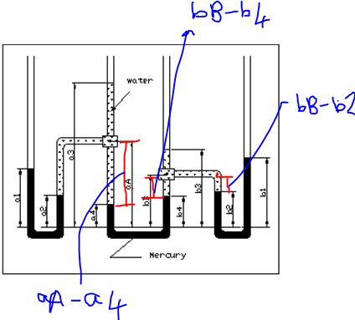

$$P_{A}+γ_{W}\{\left(a_{A}-a_{4}\right)-\left(b_{B}-b_{4}\right)\}+γ_{w}\{{SG}_{Hg}{*(a}_{4}-b_{4})\}=P_{B}$$
$$P_{A}-P_{B}=γ_{w}\{{SG}_{Hg}{*(a}_{4}-b_{4})\}-γ_{W}\{\left(a_{A}-a_{4}\right)-\left(b_{B}-b_{4}\right)\}$$
$$P_{A}-P_{B}=γ_{W}\left\{{SG}_{Hg}{*(b}_{4}-a_{4}\right)-\left(b_{a}-a_{4}\right)-(a_{A}-b_{B})\}$$
$$=γ_{w}\{\left(b_{4}-a_{4}\right)\left( {SG}_{Hg}-1\right)-\left(a_{A}-b_{B}\right)\}$$
THE RANDOM ERRORS
Random error for the piezometer:
Average (mean value) = -2.060 -1.275 + 0.491 + 0.216 + 0.981
5
= -0.329
Standard deviation (SD)
= $√( (-2.060+0.329)2+(-1.275+0.329)2+(0.491+0.329)2+(0.216+0.329)2+(0.981+0.329)2) )/4$
= 1.282
Similarly the mean, standard deviation & Random error were found for the outer tube and middle tube manometer using same formulas.

GRAPH OF PIEZOMETRIC/OUTER Hg/U-Tube Hg Vs PIEZOMETRIC

ANSWERS TO THE QUESTIONS:
Q 1: The piezometric setup
For the first reading
P_{a} – P_{b}$=γ_{w}\{\left(a_{3}-a_{A}\right)-\left(b_{3}-b_{B}\right)\}$
= - 2060N/m²
$h=\frac{Pa-Pb}{9.81*10^{3}}=\frac{-2060}{9.81*10^{3}}$ = -0.210m
Hence, h = 0.210m

The potential errors is 1mm as stated, so since four measurements of heights that are used in the formula, so the error is;
$$1mm×4×0.001=0.004m$$

Therefore, % error$=\frac{0.004}{0.210}×100=1.90\%$

The outer mercury tubes setup
For the first reading
Pa-Pb${=γ}_{w}\{{SG}_{Hg}\left(a_{1}-a_{2}-b_{1}+b_{2}\right)-(a_{A}-a_{2}-b_{B}+b_{2}\}$
= -3.438 $×10^{3}=-\frac{3438N}{m^{2}}$

$$h=\frac{p}{γ_{w}×10^{3}}=-\frac{\frac{3438N}{m^{2}}}{9}.81×10^{3}=-0.350m$$

Hence, h=0.350m

There are 8 measurements involved in the formula, so error is;

$$1mm×8×0.001=0.008m$$

$\% error=\frac{0.008}{0.350}×100=2.29\%$

For the inner mercury tube:
The first reading:

Pa-Pb$=γ_{w}\{\left(b_{4}-a_{4}\right)\left( {SG}_{Hg}-1\right)-\left(a_{A}-b_{B}\right)\}$
=$2.585×10^{3}=\frac{2585N}{m^{2}}$
$h=\frac{p}{γ_{w}×10^{3}}=\frac{2585}{9.81×10^{3}}=0.264m$

Potential error is;
$1mm×4×0.001=0.004m$

$$Therefore \% error=\frac{0.004}{0.264}×100=5.76\%$$

Mean=$\frac{1.90+2.29+5.76}{3}=3.317$

Standard deviation (SD) =1.735

Random error= $\frac{SD}{\sqrt{n}}$ =$\frac{1.735}{\sqrt{3}}=$1.732

Q 2: The piezometric setup
For the final reading
P_{a} – P_{b}$=γ_{w}\{\left(a_{3}-a_{A}\right)-\left(b_{3}-b_{B}\right)\}$
= 0.981$×10^{3}$N/m²
$h=\frac{p}{γ_{w}×{10}^{3}}$ =$\frac{0.981}{9.81×10^{3}}=0.100m$

The potential errors is 1mm as stated, so since four measurements of heights that are used in the formula, so the error is;
$$1mm×4×0.001=0.004m$$

Therefore, % error$=\frac{0.004}{0.100}×100=4\%$

The outer mercury tubes setup
For the final reading
Pa-Pb${=γ}_{w}\{{SG}_{Hg}\left(a_{1}-a_{2}-b_{1}+b_{2}\right)-(a_{A}-a_{2}-b_{B}+b_{2}\}$
= -4.141 $×10^{3}=-\frac{4141N}{m^{2}}$

$$h=\frac{p}{γ_{w}×10^{3}}=-\frac{\frac{4141N}{m^{2}}}{\left(9.81×10^{3}\right)}=-0.422m$$

Hence, h= 0.422m

There are 8 measurements involved in the formula, so error is;

$$1mm×8×0.001=0.008m$$

$\% error=\frac{0.008}{0.422}×100=1.90\%$

For the inner mercury tube:
The final reading:

Pa-Pb$=γ_{w}\{\left(b_{4}-a_{4}\right)\left( {SG}_{Hg}-1\right)-\left(a_{A}-b_{B}\right)\}$
=$5.185×10^{3}=\frac{5185N}{m^{2}}$
$h=\frac{p}{γ_{w}×10^{3}}=\frac{5185}{9.81×10^{3}}=0.529m$

Potential error is;
$1mm×4×0.001=0.004m$

$$Therefore \% error=\frac{0.004}{0.529}×100=0.76\%$$

Mean=$\frac{4.00+1.90+0.76}{3}=2.219$

Standard deviation (SD) =1.342

Random error= $\frac{SD}{\sqrt{n}}$ =$\frac{1.342}{\sqrt{3}}=$0.775

Q 3: Advantages of using mercury:
- It is a high density fluid which is required for manometric fluid.
- It has a silver colour which makes it easily visible through glass unlike water.
- Unlike water it does not stick to the wall of tubing, hence accurate reading of measurements.
- Its accuracy when taking a reading is on basis that it forms an upper meniscus.
- It is not a highly reactive fluid to its environment.

Disadvantages of using mercury:
- It is a very poisonous liquid and is harmful to both exposure to skin and if taken orally.
- It has a toxic vapour and is thus hazardous if inhaled.
- It has a high sensitivity to temperature changes.
- Mercury is very expensive on the market

DISCUSSION
The experiment which involved the measuring of pressure differences between junction A and B was obtained by three different ways; piezometric, Outer mercury filled tubes and middle U-tube manometers. Sources of errors could have also been due to the opening and closing of the valves which when not accurately done allowed air bubbles. The mounting board on which the manometers were mounted was not vertical hence making it difficult to set the ruler in the vertical direction. The experiment was subject to parallax error. Comparing the graphs plotted the results were conclusive and consistent. The lines were almost collinear indicating relatively same gradient. Thus the pressure difference can be measured using any of the three ways. Recommendations are for the experimental setup to be replaced by a latest one. The mounting board should be set in a vertical position to facilitate accuracy

CONCLUSION:
The objectives of the laboratory experiment were achieved. By carrying out the aforesaid procedure a practical understanding on the use of manometers to obtain static pressure at a point in a fluid and to measure static pressure differences within a Fluid system was at end. An estimate of relative errors in measuring pressure differences was made from the results obtained. The percentage errors were thus calculated making the experiments accuracy conclusive. It was concluded that the piezometric method of pressure measurement is more consistent as it can be seen from the difference in percentage errors between its first reading and final reading (This was concluded from the gradients of the graphs obtained)

REFERENCES:
1. Kothandaraman C.P & Rudramoorthy R. (1999), Fluid Mechanics and Machinery (2ND edition), New Age International Ltd., Publishers, New Delhi, India.
2. Rajput R.K (2006), Fluid Mechanics, S.Chand Company, Ram Nagar, India.
3. White F.M (2011), Fluid Mechanics (SIE,7th edition),McGraw-Hill companies, Inc, New York, United States of Americ

