

THE UNIVERSITY OF ZAMBIA
SCHOOL OF ENGINEERING
DEPARTMENT OF CIVILAND ENVIRONMENTAL ENGINEERING

CEE 3111 LABORATORY NUMBER 1
REPORT

TITLE: COMPRESSION TEST

AUTHOR : BANDA WINSTONE

COMPUTER NUMBER : 15040518

DUE DATE : 14TH MARCH, 2017

ATTENTION : DR. Eng. I N BANDA

- LAB OBJECTIVE(S)
  - To carry out a compression test of concrete
- REQUIREMENTS

EQUIPMENT AND MATERIALS
Equipment | Materials
Digital Scale | 3 concrete cubes
Steel rule | 2 concrete blocks
Compression testing machine

- THEORY
  - The compressive strength of concrete depends on the particular structure/purpose and must be specified in the design so as to achieve an economical, stable and cost effective structure.
  - Curing is a process by which cement undergoes hydration within the concrete mixture thereby binding the aggregates. In practice, seven days of curing subtends significant attainment of the targeted strength, but maximum strength is struck at 28 days of curing.
  - A compression test of concrete is a procedure used to measure the compressive strength of concrete. The test results give an indication of the quality of the concrete used.
  - The cube strength is the stress failure after seven days when the cubes are subjected to pressure on a compression machine of greater than 1Mpa. A further test is taken after 28 days to ascertain the characteristic strength of the concrete cast.
  - Cube making and testing can be ordered on-spot by Engineer on-site as a check and control measure on the contractor’s adherence to the specifications of the type of concrete as stipulated in the project document.
  - Concrete is strong in compression and weak in tension. Tensional strength of concrete can be enhanced by addition of reinforcements
  - As a guide, Shear stress of a given concrete is one-tenth of its stress in compression

  - PROCEDURE

  - The cubes were carefully removed from their molds and placed besides the digital scale. Measurements were taken to check if there was any changes on the cube dimensions during the seven days of curing that had past.
  - Each cube was then weighed and their weights recorded
  - Two concrete blocks were also measured and weighed with the results recorded like wise.
  - The machine was then set to a lower strength mode. Here, care was taken to ensure that the machine operated in the correct mode for correct correlation of data in analysis.
  - Each specimen was then placed on the center of the compression testing machine table. The Automated machine was then turned on and the two anvils closed up the packing gap and applied direct pressure on the specimen. The dial pointers moved up the readings as pressure applied on the specimen increased gradually until failure was noticed (crushing point).Crushing point was indicated by retardation of the guiding scale pointer back to its initial mark. The second pointer was immediately locked in place in readiness for taking of reading.
  - Each specimen was measured and recorded accordingly

- OBSERVATIONS AND DISCUSSIONS
  - Concrete Blocks

It is imperative to note that according to ZBS 0007 1973, successful compression test of each type of concrete blocks must be carried out on at least 10 samples with acceptable average values as tabulated here below;

Block size | Dimensions (mm) | Strength _{min} (average)
4 inches | 390 * 90 * 190 | 1.0 N/mm
6 inches | 390 * 140 * 190 | 1.5 N/mm
8 inches | 390 * 190 * 190 | 2.0 N/mm

For the purposes of this experiment, however, two by six inch blocks were used strength values in conformity with the standard above.
It was observed that there was no difference in concrete cube dimensions compared to the initial dimensions measured from the mold during cube casting. Indeed, the hydration process of the cement in the concrete mass draws aggregates in to a firm cluster, dimensional effect this may cause could be microscopic if any. A well compacted concrete will set and cure maintaining the original dimensions at macroscopic observation.
Dimensions of the block samples were measured and tested for compression strength and results obtained were as tabulated here below. B₁

 | Block size | Dimensions (mm) | Compression  Scale value Kg
Block 1 | 8 inches | 390 * 190 * 190 | 20,400
Block 2 | 8 inches | 390 * 190 * 190 | 18,200

$${Strength (B1)}^{ }=\frac{20,400 x 9.81}{74,100}=2.7 MPa$$

$${Strength (B2)}^{ }=\frac{18,200 x 9.81}{74,100}=2.41MPa$$

$${Strength (ave)}^{ }=\frac{2.70+2.41}{2}=2.56 MPa$$
Clearly, the result obtained showed strength characteristic above the minimum value according to the ZBS 0007 1973 specification for the 8 inch concrete block. It implies that the blocks in question had passed the strength test and can be used for construction

  - Concrete Cubes
Despite being made from the same sample of concrete, the cubes recorded different compressive strength. Clearly, strength of concrete does not only depend of the ratio adopted. Other factors including fluidity of fresh concrete, cleanliness of aggregate materials, type and condition of cement to mention but a few.
 | Cube volume  l*b*h (m³⁾ | Mass (Kg) | Compression  Scale value (Kg) | Compression  Strength (Mpa)
Cube 1 | 3.375 x 10⁻³ | 8.404 | 34,400 | 15
Cube 2 | 3.375 x 10⁻³ | 8.422 | 20,400 | 8.9
Cube 3 | 3.375 x 10⁻³ | 8.378 | 21,600 | 9.42

As seen above the average strength was less than half the design strength of 30KN.

$${Strength (Cube1)}^{ }=\frac{34,400 x 9.81}{22,500}=15 MPa$$

$${Strength (Cube2)}^{ }=\frac{20,400 x 9.81}{22,500}=8.9 MPa$$

$${Strength (Cube3)}^{ }=\frac{21,600 x 9.81}{22,500}=9.42 MPa$$

$${Strength (ave)}^{ }=\frac{15+8.9+9.42}{3}=11.1 MPa$$
At 7 days, the concrete is anticipated to have gained strength of two-thirds the envisaged maximum strength according to recommended specifications. In this experiment, the cubes were expected to have cured to a compression strength value of

$${Strength (7days)}^{ }=\frac{30* 2}{3}=20 MPa$$

However, the actual value was found to be 11.1 MPa as average which was far below the anticipated value. This could be an indication that the concrete was not to attain the targeted maximum strength value at 28 days. None the less, such results could require that another test be carried out at 28 days of curing to verify this assertion or prediction. For works in progress, this result calls for review of on-site concrete handling regime and practices such as mixing, checking the purity of the aggregates, curing procedure, water quality, and type and condition of cement as these factors could significantly affect the strength of concrete. Alternatively, an adjustment in the ratio could be made subsequently as a control measure. Fresh cubes can be ordered by the engineer for further testing.

Concrete exhibits superiority in compressive strength but is weak in tension. As a guide, nonetheless, shear strength of concrete can be computed as one-tenth of the stress under compression. The Crushing cleavage or lines give indication of the strength in shear.
In this experiment the cubes failure was such that cracks travelled slanting direction.

On the other hand, the two concrete blocks were measured and conformed to the six inches block dimensions indicated on the ZBS table above.

  - Experiment Highlights
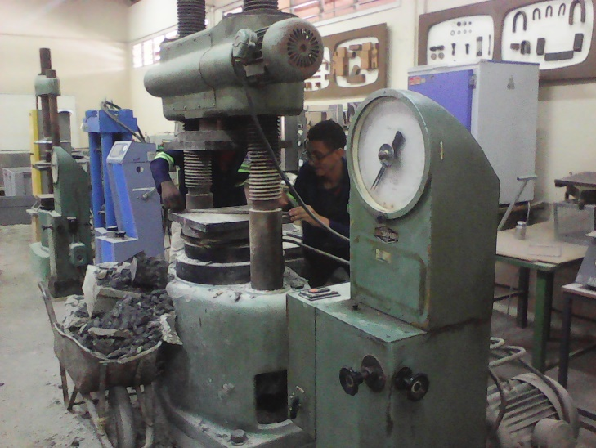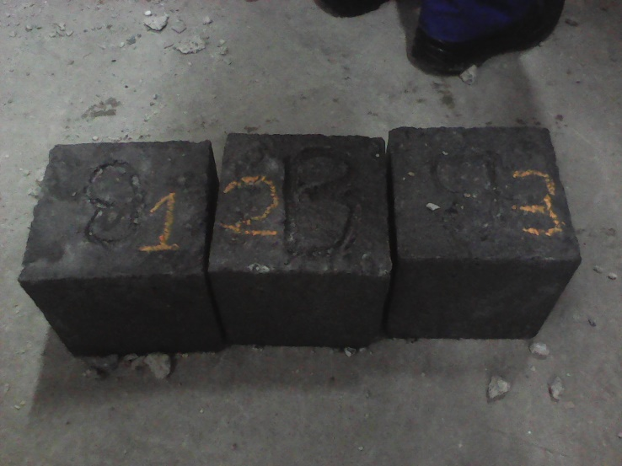
The labeled concrete cubes – 7 days old
Compression testing machine

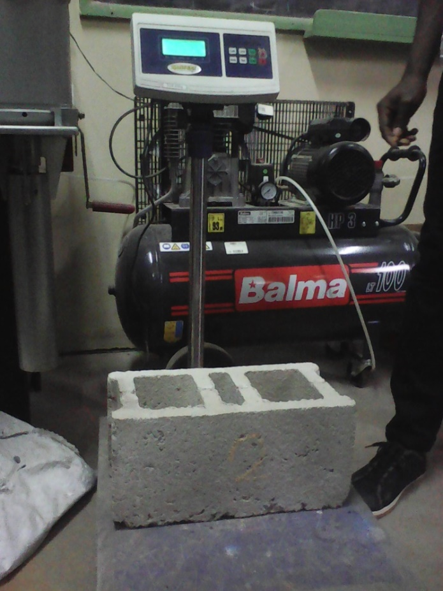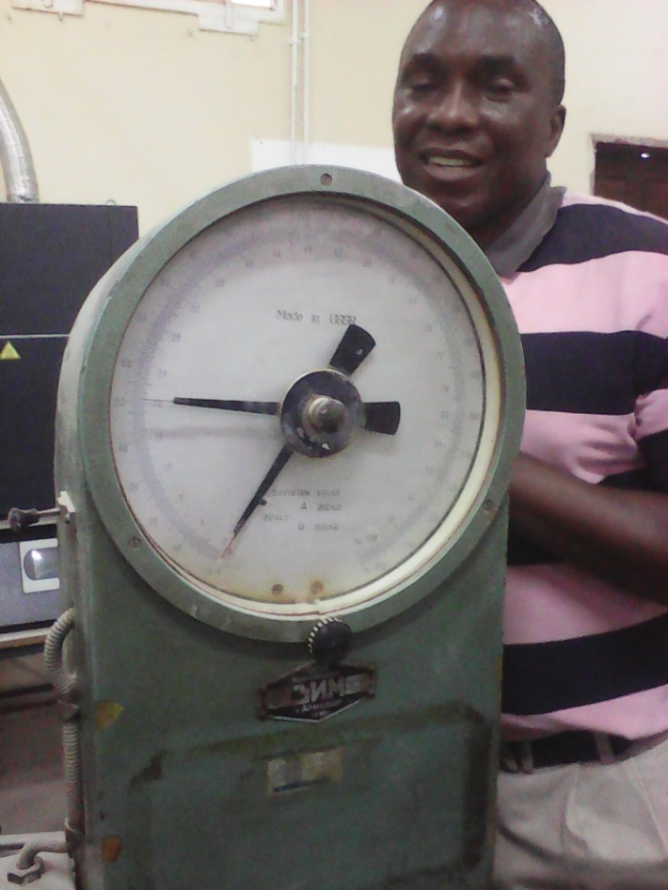
Dial reader
Specimen weighing
Mode Selector
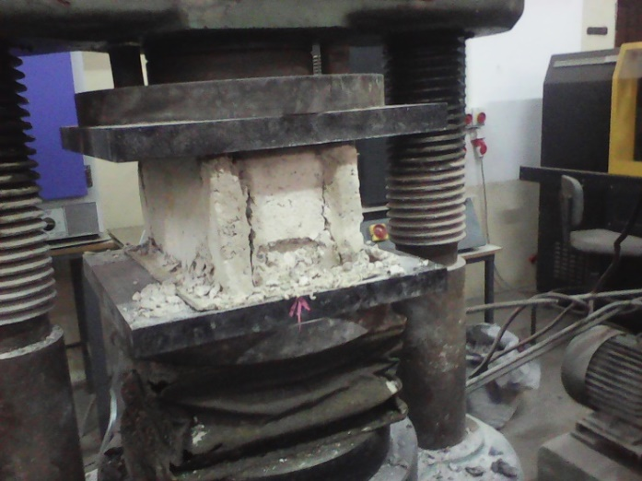
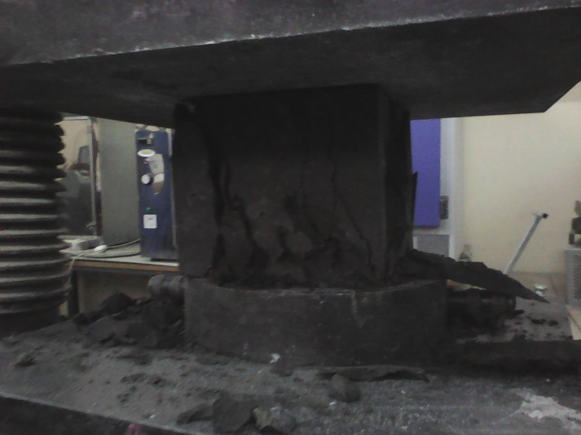

Concrete Cube at crushing point
Concrete block at crushing point

- ANSWERS TO QUESTIONS
  - To ensure that the concrete cubes cast are from the actual concrete, consulting engineer should;
    - Order for casting of concrete cubes at random and on-site
    - Not allow contractor to cast concrete cubes in the absence of the engineer. The engineer must ensure that the cubes are cast in his presence, on site and during works.
    - Regularly monitor the cubes as they set to ensure that they are not replaced with fresh ones. Once they attain sufficient rigidity, the cubes must be marked for identity.
  - Presence of impurities in the constituent materials such as debris, plastic organic matter or crop residue, if not taken care of, can hinder normal hardening process of concrete. These materials usually sit at inter-aggregate locations thereby making the cement bond weak due to their tendency to easily change shape due to temperature, or even rotting hence creating voids. Further, too much water increases fluidity and can adversely affect concrete strength as the slurry may easily flow off with cement from certain sections on the concrete mass. Poorly compacted concrete will also hold air pockets within, which become discontinuities or weak points in the concrete.
  - Tests can be done to the already casted concrete.
    - Such tests include the Schmidt Hammer, commonly referred to as Rebound Hammer which provides convenient and quick indication of compressive strength of concrete. It measures the hardness of the concrete by the scale of extent of the rebound of the spring controlled mass in the instrument. The results of the rebound hammer test can be used to assess concrete parameters such as compressive strength, concrete uniformity, quality of concrete etc.
    - Ultrasonic test is another indicative concrete test procedure which uses the travel time of 50 to 54 Hz pulses sent into the concrete mass in contact. High elastic modulus concrete with good density and integrity will produce higher pulse velocity. It is known to be a non-destructive test. Slow pulse velocity values indicate presence of potential sound barrier, voids, which create weak points in the concrete. The test results can however be influenced by factors such as specimen dimensions, reinforcement, moisture etc. 3.5 to 4 Km/s indicate good to very good but porosity may be present whilst 3 to 3.5 Km/s give satisfactory but there could be loss of integrity. Velocities above 4 Km/s indicate very good to excellent concrete.
    - Another method involves extraction of a core-sample of the concrete in question. A small portion of the slab is cut-off from the existing concrete to a sufficient depth using electrical rotary cutters. The cut portions are taken for compressive strength testing in the lab. This method is destructive in nature, but perforations can easily be mended.

- CONCLUSION
The compression test was done successfully as per intended objective of the experiment. The results of this experiment proved that verification of quality in engineering works is particularly essential in the development of robust infrastructure. Good concrete mixture may produce weak product (concrete due to other factors as learnt during this experiment. It is desired that concrete and other engineering materials used to make structural beams exhibit considerable consistence in mechanical properties so as to enhance resilience against bending, buckling, deflection or overturning in their functionality.
The experiment provided learning points for the author stemming from preliminaries down to actual execution of the compression test. It also provided an opportunity to have hands-on experience of compression test procedure as practiced in reality.

References
- Construction Technology 5th Edition Roy Chudley, Roger Greeno, Mike Hurst, Simon Topliss
- Class notes Dr. Eng. I N Banda

