

THE UNIVERSITY OF ZAMBIA

SCHOOL OF ENGINEERING

DEPARTMENT OF CIVIL AND ENVIRONMENTALENGINEERING

CEE 3111 LAB REPORT NUMBER ONE

TITLE: TEST FOR CONCRETE

NAME: BONDO CHANDA

COMP #: 15000371

DUE DATE: 26-04-2018

ATTENTION: DR. Eng. I N BANDA

OBJECTIVES
- To perform the slump test to establish the uniformity and workability of fresh concrete.
(1) SLUMP TEST
THEORY
The slump test is used to establish the uniformity and workability of the mixes subsequent batches or deliveries. Workability of concrete generally implies the ease with which mix can be handled from the mixer to its finally compacted shape .The measurements of the workability of fresh concrete is important in assisting the compacting of the mix and also in maintaining the consistency throughout the job. A batch of concrete wetter than the rest will mean batch of concrete that is weaker less durable in the finished job. A batch of concrete that is too dry will lead to difficulties in placing, compacting and finishing, hence importance of the slump test cannot be over emphasized.
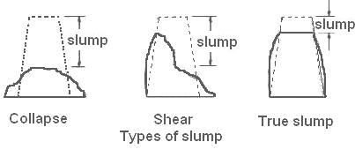
Figure showing likely or possible results of the slump test
EQUIPMENT AND MATERIAL
EQUIPMENT AND MATERIALS
Equipment | Materials
Digital Scale | Cement
Trays | Fine Sand (fine aggregate)
Shovels | Crushed stones (Coarse aggregate)
Mixing pan | Water
Conical mold
Tamping rod
Rule

The following table shows the quantities of trial mix for 3 cubes that were used.

ITEM IDENTIFICATION | TRIAL TEST QUANTITIES (Kg)
Dangote cement (32.5 R) | 4.20
Water | 2.52
Sand | 9.32
Coarse aggregates | 13.56

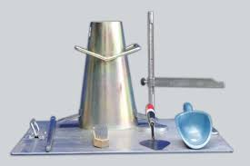
Figure showing some equipment which were utilized during the test
PROCEDURE
1) The fine aggregate (building sand), cement, water and the coarse aggregate were weighed on the digital scale according to the specifications of the masses of aggregates, water and cement for C20 concrete.
2) First, the cement and the fine aggregates were thoroughly mixed on the mixing pan, thorough mixing was achieved by rotating the shovel on the axis of the handle.
3) Then the coarse aggregate was added to the already mixed fine aggregate and cement and then followed by thorough mixing.
4) The weighed impurity- free water was added to the mixed aggregates and cement. The addition of water is done in such a way that only little water is added at a time and mixing thoroughly until a consistent mix is achieved.
5) A slump was cleaned and oil applied in the internal surfaces then it was placed on a clean flat non-absorbent base with the wider opening on the base. Concrete was placed into the cone in three layers of, each time it was tamped 35 times using the tamping rod. At the end of the third stage, concrete was struck off flush to the top of the mold. While concrete was being filled into the cone, a student was asked to step on the foot rests of the cone.
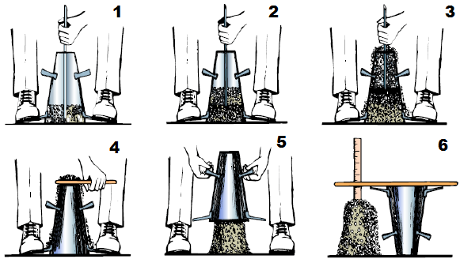
Figure showing how the mold was filled
6) The mold was carefully lifted vertically upwards, so as not to disturb the concrete cone and the type of slump obtained was observed and measured.
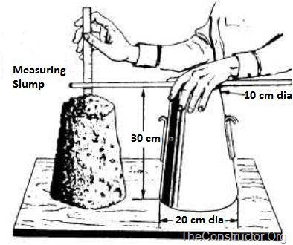
Figure showing how slump was measured.
OBSERVATIONS AND DISCUSSION
The optimal amount of water must be used in making concrete to avoid shear failure and segregation of concrete constituents. In this test, a true slump which measured 60 mm was obtained. The maximum attainable slump is 300 mm, this means the obtained value of 60 mm is not the best result attainable also that the cement to water ratio obtained is not the best. The following must have affected the result; presence of organic impurities such as weeds in the mix, the organic impurities reduce the binding properties of cement, use of water with impurities also reduces the binding properties of cement, poor tamping of the concrete, use of wet aggregates increases the amount of water in the concrete and must, therefore, be accounted for, and poor mixing of the aggregates, cement and water. Otherwise, the slump test has been found to be useful in ensuring the uniformity among the different batches of supposedly similar concrete under field conditions. Its simplicity makes it a very useful test.
INTERPRETATION OF RESULTS
1) The slump obtained was a true slump.
2) a. Uniformity of concrete material distribution
b. amount of water added
c. Caution applied during withdrawal of the slump mold from the fresh concrete
d. presence of impurities in the water and in the aggregates.
3) a. in reinforced concrete
b. manually compacted flat slabs
4) a. use of water with impurities
b. poor compaction of the concrete
c. use of already wet aggregates
d. use of the wrong ratios of water cement, aggregates and water.
CONCLUSION
The slump was a true slump and was measured to be 60 mm. The higher the water content in the concrete the higher the workability but the lower the strength hence the optimum amount of water must be used. The degree of the workability of the concrete was found to be medium according to the measured slump and concrete of this workability is used for normal reinforced concrete placed with vibration.
(2) COMPRESSION TEST
OBJECTIVES
- To prepare concrete cubes from the concrete on which slump test has been performed for compression test.
THEORY
Compression tests are conducted to determine the compressive strength of concrete (or its ability to resist a crushing force). Compression tests are carried out on brittle materials which concrete is. In this test, a standard test load is applied parallel to the longitudinal axis of a pre-moulded and properly cured concrete cylinder of a standard size. When the test is properly conducted, a maximum load is obtained at the point at which the cylinder ruptures. The strength result obtained gives an overall picture of the quality of concrete used.
The results of the compression test are primarily used to determine that the concrete mixture as delivered meets the requirements of the specified strength in the job description or it may be used as quality control, acceptance of concrete or for estimating the concrete strength in a structure for the purpose of scheduling construction operations such as form removal or for evaluating the adequacy of curing and protection accorded to the structure.
EQUIPMENT AND MATERIAL
The following table shows the equipment and material which were used in this test.
EQUIPMENT | MATERIAL
Compression-testing machine | Concrete on which slump test was performed
150mm by 150mm by 150mm steel cube moulds | oil
Concrete vibrator | 10 to 20 degrees degree Celsius in an open drum

Figure showing compression-testing machine

PROCEDURE
1) The already mixed concrete from the slump test was placed in the 150mm by 150mm by 150mm steel cube moulds. Oil was applied to the walls of the steel cube moulds to prevent the concrete from sticking to the walls of the moulds.
2) The three moulds were then placed on the concrete vibrator to eliminate air bubbles and compact the concrete by vigorous shaking.
3) The samples of concrete remained in the moulds for at least 24 hrs after which they were marked and placed in an open drum filled with water of. Temperature 10 to 20 degrees celsius.
4) The cubes were then subjected to compression one at a time until failure (crushing) occurred. The values of the force at failure were recorded.
DATA COLLECTION AND ANALYSIS
1) The following table shows the kilogram forces corresponding compressive strength for the respective cubes that were obtained.
Cube | Kilogram force (kg) | Compressive strength (MPa)
1 | 39,400 | 17.1784
2 | 37,400 | 16.3064
3 | 33,200 | 14.47
Average |  | 15.9866

$strength=\frac{kilogram force × g}{cross sectional area}$
$average=\frac{17.1784+16.3064+14.47}{3}$=15.9866

$$784+estimated strength=average strength ×1.5$$

$estimated strength=1.5×15.9866=23.9799 MPa$

DISCUSSION
The test exceeded the expectations according to the theory. The value of the estimated strength exceeded the expected compressive strength of 20 MPa as per mixing ratios when in the actual sense it was supposed to be two-thirds of the expected strength of 20 MPa. Such a result was possible due to: use of water and aggregates which were free of impurities, the use of the optimal amount of water i.e. less water was required/used than that specified because a consistent mix was obtained with less water, proper mixing and weighing of the water, aggregates and cement, effective compaction of the concrete using the concrete vibrator, proper curing of the concrete cubes in water at the specified temperature for the specified period of seven days. Curing is the process by which cement is allowed to hydrate (chemical reactions that occur between cement and water. The compressive strengths of the cubes varied due to the precautions not being taken when operating the compression-testing machine such as; placing the specimen on the centre of cross-head so that a uniform compressive loading was assured on the specimen and parallax error when reading from the scale.
CONCLUSION
The concrete cubes were made and cured for seven days thereafter the compressive test was performed on the cubes and the cubes were found to have an estimated strength of 23.9799 MPa. This value exceeded the expected value of strength expected after 28 days i.e. 20 MPa indicating that the test was a success.
REFFERENCES
1. "Principles of Materials Science and Engineering" by W.F. Smith
2. Construction Technology 5th Edition Roy Chudley, Roger Greeno, Mike Hurst, Simon Topliss

