University of Zambia
School of Agricultural Sciences
Department of Soil Science

AGS 2110 Fundamentals of Soil Science 2021/2022
Lecturer: Professor Obed I. Lungu, Ph.D
ALUMINOSILICATE MINERALS: Fundamental properties of Colloids
- All colloids exhibit a large specific surface area (SSA). A large specific surface area is important for soil chemical reactions which occur on colloid surface such as ion and water retention. This concept can be demonstrated using a cube that has equal dimensions on all sides. Visualize this from the Rubik’s Cube. Observe the following:

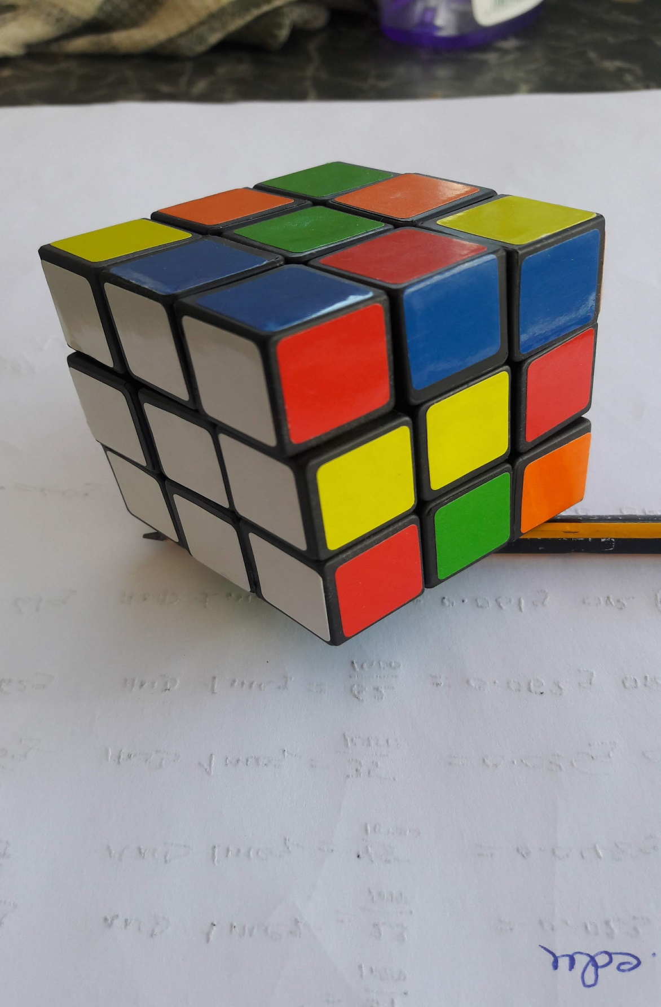
a). An imaginary cube measuring 2.0 mm on all sides (size of a coarse Sand grain) and weighing 1 g, has a estimated SSA of 2.4 x 10⁻⁵ m²/g .
b). If the same original cube in a) were subdivided into 10¹² smaller cubes (size of a silt particle), the estimated aggregate SSA of the same cube would be 0.24 m²/g .
c). If the same original cube in a) were subdivided into 10¹⁵ even smaller cubes (size of clay particles), the estimated aggregate SSA is 2.4 m²/g.
NB. Appreciate from this hypothetical example the fact that soils containing high amounts of clay have a greater capacity to retain ions and water and therefore are potential more fertile.

- All colloids exhibit a surface charge which is key to their electrochemical behaviour. Gain an appreciation of the origin of surface charge through isomorphous substitution in crystal lattices of these seven secondary aluminosilicate minerals e.g. clays) and from unbalanced charges at the broken edges of some of the clay minerals.
- ISOMORPHOUS SUBSTITUTION resulting in Permanent Surface negative Charge on Aluminosilicate Minerals such as Clays. Closely examine the following:
Clay mineral Octahedral sheet Tetrahedral sheet No. of Between Unit
(Al sheet) (Si sheet) O, OH crystal units Charge
Kaolinite Al₄ Si₄ O₁₀(OH)₈ 0
Pyrophyllite Al₄ Si₈ O₂₀(OH)₄ 0
Monti- Al_{3.5}Mg_{0.5} Si₈ O₂₀(OH)₄ -0.5
[Na 0.5]
Vermiculite Mg₆ Si₇Al O₂₀(OH)₄ XH₂O, Mg⁺⁺ -1.0
[Mg 0.5]
Chlorite Mg₆ Si₆Al₂ O₂₀(OH)₄ Mg₆(OH)₁₂ -2.0
Illite Al₄ Si₇Al O₂₀(OH)₄ K⁺ = 0.8 -1.0
[K0.2]
Muscovite Al₄ Si₆Al₂ O₂₀(OH)₄ K⁺ =2.0 -2.0
______________________________________________________________________________
NB. The resulting charge from the substitution of Mg for Al and Al for Si is compensated/balanced or neutralized by either exchangeable[x] or inter-crystal unit ions. DO THE CALCULATIONS AND VERIFY THE UNIT CHARGES!

- UNSATISFIED CHARGES AT BROKEN EDGES OF MINERALS. Demonstrate surface charge development on the crystal edge of the broken clay mineral such as kaolinite at surfaces marked X in the sketch under acid conditions (high concentration of H⁺ and under alkaline conditions (low concentration of H⁺ and high concentration of OH⁻). [3]

OH OH O--> -1½----available for bonding and reaction----X
-½ -½
Al ³⁺ -½ Al³⁺ <---------------------- Soil solution
-½ -½ -----------------------> (H⁺, OH⁻)
-½
O OH O---> -1½-----available for bonding and reaction--X

Si⁴⁺ O H

Broken edge of a mineral

NB Observe that adsorption of H⁺ (protonation) at the location X would lead to development of either a positive or negative surface charge. This is what is referred to as variable surface charge or pH-dependent surface charge.

In soil pH-dependent surface charge is associated with humic acids (humus or generally soil organic matter), broken edges of kaolinite and hydrous oxides of Al and Fe (sesquioxides).

References

Brady, Nyle C. 1974 (8th Ed). The Nature and Properties of Soils

