
THE UNIVERSITY OF ZAMBIA
SCHOOL OF ENGINEERING
DEPARTMENT OF MECHANICAL ENGINEERING

STUDENT NAME : CHIMANGO NDHLOVU
COMPUTER NUMBER : 2019031892
COURSE : MECH 2309
THEME : LAB REPORT
DUE DATE : 10TH OCTOBER, 2021.

1 TITLE: TENSILE TEST FOR METALS
2 OBLECTIVES
- To carry out the tensile test to the point of destruction, in order to obtain a stress – strain curve.
- To understand test result on the mechanical properties of the specimen such as Young’s modulus, yield strength, ultimate stress, %elongation, %reduction in area.
- To understand the effect of heat treatment of steel in relation to the above test result.

3 THEORY
Most machinery and structures designed undergo stress, hence the Design Engineer need to know the behavior of the material used when subjected to these stresses. Stress, which is force acted per unit area can either be uni, bi, or tri-axial in application and can either be static or dynamic. Dynamic stress can also be cyclic (i.e. periodic), which introduces problems not found with static stress. Therefore, since materials behave differently to different kind of stresses and their rate of application, the Design Engineers should know what kind of stresses their design would undergo so as to choose the right materials with desired properties.
Tensile strength (σ_{UTS} or S_{U}) is indicated by the maxima of a stress-strain curve and, in general, indicates when necking will occur. As it is an intensive property, its value does not depend on the size of the test specimen. It is, however, dependent on the preparation of the specimen and the temperature of the test environment and material.
Here are three definitions of tensile strength:

Yield strength
The stress at which material strain changes from elastic deformation to plastic deformation, causing it to deform permanently.
Ultimate strength
The maximum stress a material can withstand when subjected to tension, compression or shearing. It is the maximum stress on the stress-strain curve.
Breaking strength
The stress coordinate on the stress-strain curve at the point of rupture.
The various definitions of tensile strength are shown in the following stress-strain graph for low-carbon steel:
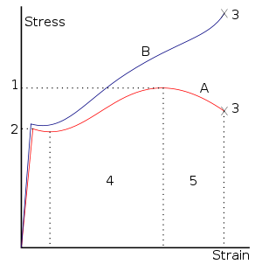
1. Ultimate Strength
2. Yield strength
3. Rupture
4. Strain hardening region
5. Necking region.
A: Apparent (engineering) stress (F/A₀)
B: Actual (true) stress (F/A)

Figure1: Stress vs. Strain curve typical of structural steel

Metals including steel have a linear stress-strain relationship up to the yield point, as shown in the figure. In some steels the stress falls after the yield point. This is due to the interaction of carbon atoms and dislocations in the stressed steel. Cold worked and alloy steels do not show this effect. For most metals yield point is not sharply defined. Below the yield strength all deformation is recoverable, and the material will return to its initial shape when the load is removed. This recoverable deformation is known as elastic deformation. For stresses above the yield point the deformation is not recoverable, and the material will not return to its initial shape. This unrecoverable deformation is known as plastic deformation. For many applications plastic deformation is unacceptable, and the yield strength is used as the design limitation.
After the yield point, steel and many other ductile metals will undergo a period of strain hardening, in which the stress increases again with increasing strain up to the ultimate strength. If the material is unloaded at this point, the stress-strain curve will be parallel to the original elastic portion of the curve, between the origin and the yield point. If it is then re-loaded it will follow the unloading curve up again to the previous load, which has become the new yield strength, and will then continue following the original plastic curve.
After a metal has been loaded to its yield strength it begins to "neck" as the cross-sectional area of the specimen decreases due to plastic flow. When necking becomes substantial, it may cause a reversal of the engineering stress-strain curve, where decreasing stress correlates to increasing strain because of geometric effects. This is because the engineering stress and engineering strain are calculated assuming the original cross-sectional area before necking. If the graph is plotted in terms of true stress and true strain the curve will always slope upwards and never reverse, as true stress is corrected for the decrease in cross-sectional area. Necking is not observed for materials loaded in compression. The peak stress on the engineering stress-strain curve is known as the ultimate strength. After a period of necking, the material will rupture and the stored elastic energy is released as noise and heat. The stress on the material at the time of rupture is known as the breaking strength.
Ductile metals do not have a well defined yield point. The yield strength is typically defined by the "0.2% offset strain". The yield strength at 0.2% offset is determined by finding the intersection of the stress-strain curve with a line parallel to the initial slope of the curve and which intercepts the abscissa at 0.2%. A stress-strain curve typical of aluminium along with the 0.2% offset line is shown in the figure below.
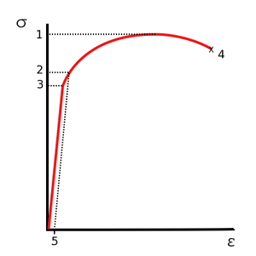
1. Ultimate Strength
2. Yield strength
3. Proportional Limit Stress
4. Rupture
5. Offset Strain (typically 0.2%).
Figure2: Stress vs. Strain curve typical of aluminum

Brittle materials such as concrete and carbon fiber do not have a yield point, and do not strain-harden which means that the ultimate strength and breaking strength are the same. Typical brittle materials do not show any plastic deformation but fail while the deformation is elastic. A typical stress strain curve for a brittle material will be linear. The curve shown below would be typical of a brittle polymer tested at very slow strain rates at a temperature above its glass transition temperature. Some engineering ceramics show a small amount of ductile behaviour at stresses just below that causing failure but the initial part of the curve is a linear.
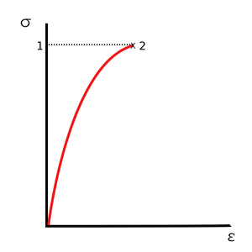
1. Ultimate Strength
2. Tensile strength.

Figure 3: Stress vs. Strain curve of a very atypical brittle material

Tensile strength is measured in units of force per unit area. In the SI system, the units are newtons per square metre (N/m²) or pascals (Pa).
The simple most useful test from the metallurgical point of view is the tensile test. This is a slow, uni-axial application of stress through the elastic range and usually through the plastic deformation range until failure of the material. Typically, the testing involves taking a small sample with a fixed cross-section area, and then pulling it with a controlled, gradually increasing force until the sample changes shape or breaks. The specimen to be tested should be shaped as shown below, with a reduced cross-sectional area in the central region, so as to maximum stress occur in this region. The discontinuity in stress at the grips holding the specimen at the end is isolated from the centre or gauge section by smooth radii at the transitions in the area.

The following are the equations relevant for the calculation:
- Stress: This is load applied per unit area
$$stress σ=\frac{force}{cross-sectional area}$$
- Strain: the change of length per unit length.
$$strain ε= \frac{l_{f}-l_{0}}{l_{0}}=\frac{∆l}{l_{0}}$$
- Young’s Modulus of elasticity: This is the ratio of stress to the linear strain.
$$Young’s Modulus E=\frac{σ}{ε}$$

$$Ductility \%elongation=\left[\frac{l_{f}-l_{0}}{l_{0}}\right]×100\%$$
$$\% reduction in area=\left[\frac{A_{0}-A_{f}}{A_{0}}\right]×100\%$$

4 EQUIPMENT/ APPERATUS
4.1 Specimen:
All specimens, made of mild steel, except one were products of annealing and cooled as specified below;
- Specimen A - untreated steel
- Specimen B – furnace cooled
- Specimen C – Air cooled
- Specimen D – Water cooled
The diagram below the shape of the specimens;
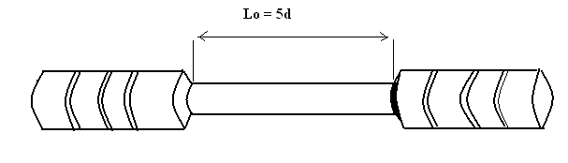

Figure 4: Sample of specimen

4.2 Equipment:

Figure 5: Vanier Calipers.
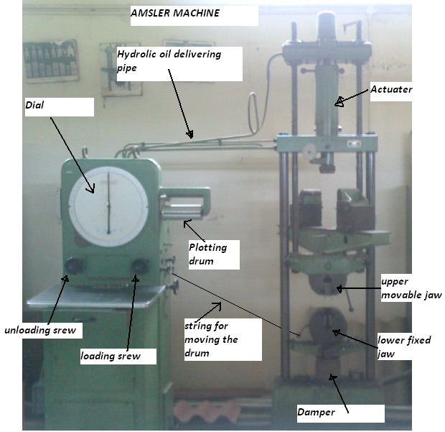

Figure 6: Amsler Testing Machine.

5 PROCEDURE
The mean diameter and the gauge length L₀ of the specimen were measured using the Vanier Caliper and recorded. Afterwards, the graph paper rolled and clipped on the plotting drum. Whilst the plotting pencil was not yet placed on the graph paper, the furnace cooled steel specimen was clamped firmly using the tappers on the upper and lower jaws of the Amsler testing equipment and gradually increasing load applied. Whilst observing the readings closely, a point where the dial stooped moving momentarily was reached and this load was recorded as the yield strength. The loading continued to the point of material failure, and then the reading on the dial was recorded. The two pieces of the specimen were removed from the jaws and the final diameter and gauge length were measured and recorded.

The process was repeated for the entire specimens except that the same graph paper was used in each of the runs.

Note: It was easy to measure L₀ and L_{f} on the specimen as the points are visible other than l₀ and l_{f}. Since l₀ was known before the experiment which was 45mm for all the specimen, l_{f} was calculated using ∆L.

6 DATA COLLECTION

The results obtained are as tabulated below;
Note: unit conversions,
- 1kip = 1000 pound(lb)
- 1 pound(lb) = 4.448444 Newton (N)

Table 1: Tabulation of results

Readings |  | SPECIMENS
 |  | Furnace cooled  ‘ B’ | Air cooled  ‘C’ | Untreated  ‘A’ | Water cooled  ‘D’
L_{o} (mm) |  | 53.0 | 53.0 | 57.0 | 58.5
L_{f} (mm) |  | 60.47 | 67.03 | 72.05 | 67.06
∆l (mm) |  | 7.47 | 13.03 | 15.05 | 8.56
l_{o} (mm) |  | 45 | 45 | 45 | 45
l_{f} (mm) |  | 52.47 | 58.03 | 60.02 | 53.56
d_{o} (mm) |  | 9.0 | 9.0 | 9.0 | 9.0
d_{f} (mm) |  | 5.5 | 5.2 | 5.7 | 6.1
∆d (mm) |  | 3.5 | 3.8 | 3.3 | 2.9
Yield load | kip | 4.9 | 4.2 | 4.75 | 8.4
Yield load | (kN) | 21.80 | 18.68 | 21.13 | 37.37
Ultimate load | kip | 6.9 | 6.1 | 6.85 | 8.4
Ultimate load | (kN) | 30.69 | 27.14 | 30.47 | 37.37

Note: the graph paper is attached as appendix 1.

6.1 Sample calculation: for Furnace cooled specimen

$$l_{f}=45+ ∆l=45+7.47=52.47mm$$

$$initial area=πr^{2}={\left(4.5\right)}^{2}π=63.62{mm}^{2}$$

$$fracture cross-sectional area=πr^{2}={\left(2.75\right)}^{2}π=23.76{mm}^{2}$$

$stress at fracture \left(σ\right)=\frac{P_{max}}{final area}=\frac{30.69}{23.76}=1.292{kN}/{{mm}^{2}}$

$$Engineering strain at fracture \left(ε\right)=\frac{∆l}{l_{0}}=\frac{7.47}{45}=0.166$$
$$True strain=ln\left[\frac{l_{f}}{l_{0}}\right]=ln\left[\frac{52.47}{45}\right]=0.154$$

$$Youg^{'}s modulus\left(E\right)=\frac{σ_{fracture}}{ε_{fracture}}=\frac{1.292}{0.166}=7.783{kN}/{{mm}^{2}}$$
$$ultimate Tensile strength=\frac{P_{max}}{initial area}=\frac{30.69}{63.62}=0.482{kN}/{{mm}^{2}}$$

$$Yield Tensile strength=\frac{P_{yield}}{initial area}=\frac{21.80}{63.62}=0.343{kN}/{{mm}^{2}}$$

$$Ductility \%elongation=\left[\frac{l_{f}-l_{0}}{l_{0}}\right]×100=\left[\frac{7.47}{45}\right]×100=16.6\%$$
$$\% reduction in area=\left[\frac{A_{0}-A_{f}}{A_{0}}\right]×100=\left[\frac{63.62-23.76}{63.62}\right]×100=62.7\%$$

Table 2: Tabulation of results
Calculations | SPECIMENS
Calculations | Furnace cooled  ‘ B’ | Air cooled  ‘C’ | Untreated  ‘A’ | Water cooled  ‘D’
Initial area (${mm}^{2}$) | 63.62 | 63.62 | 63.62 | 63.62
final area (${mm}^{2}$) | 23.76 | 21.24 | 25.52 | 29.22
Stress at fracture (${kN}/{{mm}^{2}})$ | 1.292 | 1.278 | 1.194 | 1.279
Engineering strain | 0.166 | 0.290 | 0.334 | 0.190
True strain | 0.154 | 0.254 | 0.288 | 0.176
Yield strength(${kN}/{{mm}^{2}})$ | 0.343 | 0.294 | 0.332 | 0.587
Ultimate strength (${kN}/{{mm}^{2}})$ | 0.482 | 0.427 | 0.479 | 0.587
% elongation (%) | 16.6 | 29.0 | 33.4 | 19.0
% area reduction (%) | 62.7 | 66.6 | 59.9 | 54.1
Young’s Modulus (E)  $${kN}/{{mm}^{2}})$$ | 7.78 | 4.41 | 5.10 | 6.73

6.2 Comparison of Young’s Modulus

The chart above shows that the furnace cooled specimen has the highest Young’s Modulus with the air cooled having the least or lowest. This means that the furnace cooled need 1.7 times more stress to cause the same stress as in the air cooled one.

6.3 Comparison of ductility in terms %elongation and %area reduction

From the chart above, the most ductile specimen is the untreated specimen because it elongates more with relatively small reduction in area.

7 DISCUSION
The measurements and the calculations on the experiment reveal that the furnace cooled mild steel had the greatest Young’s modulus value than the other, and that the untreated elongated more. Though the results are not that consistent or in correlation with the hardness test which was performed on the same specimen in the previous lab, it can be deduced that the more ductile the material, the smaller the Young’s Modulus value.
It can also be seen that the water cooled specimen is the most brittle, since the yield tensile strength was the same as the ultimate tensile strength. This was so because it was difficult to distinguish the limit of elastic deformation and the point of material failure.
From the theory and the experiments that have be taken before it was expected that the most ductile specimen with the smallest Young’s modulus value should have been the furnace cooled. This would have agreed with the results in the previous lab as it was discovered to be the softest material. This inconsistence in the results must have been caused by some experimental errors.
These errors would have arisen when taking the reading of the gauge length using the Vanier Calipers due to the parallax errors. It should also be noted that the same material can behave differently to different rates of stress application. This would have been another cause of errors since the rate of stress application (i.e. loading) was done manually.
The reading on the yield load and ultimate load would not have been as accurate as possible since the time that the dial stopped moving was so short that reading had to be taken quickly. For other specimen the dial stopped on several times, so it was difficult to determine the yield load.

8 CONCLUSION
Therefore, from the graphs and the data in the tables it can be deduced that the water cooled mild steel was the most brittle since, the largest yield load, immediately after which it failed. And the most ductile was the untreated. Heat treatment manipulates the mechanical properties of steel of which Tensile Strength is one of them; hence rapid cooled specimen posses the highest tensile strength, the trend continue until the slowest cooled specimen.

9 RECOMMENDATION
It must be recommended that there is much need to use digital equipments as parallax errors are eliminated and the rate of feed of stress application would be constant for all the specimen being tested.
10 REFERENCES
- Correlation of Yield Strength and Tensile Strength with Hardness for Steels , E.J. Pavlina and C.J. Van Tyne, Journal of Materials Engineering and Performance, Volume 17, Number 6 / December, 2008
- http://en.wikipedia.org/wiki/Tensile_strength"
- John V B, 1994, Engineering Materials, London: Macmillan.

