UNIVERSITY OF ZAMBIA
SCHOOL OF ENGINEERING
DEPARTMENT OF MECHANICAL ENGINEERING
2012/2013 ME 331 ASSIGNMENT No.2: Solutions Guide
- A single crystal sample of a metal with a HCP structure is subjected to an axial tensile force. The sample is of circular cross-section, with a diameter of 4 mm, and is of 50 mm length. An elastic extension of 0.047 mm is measured when an axial tensile force of 1.25 kN is applied. When the tensile force is increased to 2.8 kN plastic deformation commences.

- Given that Poisson’s ratio for the metal is 0.35, estimate the theoretical shear strength of the material.
Solution
- τ = G / 2π, [0.5] and E = 2G ( 1 + υ ) [0.5]

but E = σ / ε, and σ = F/A = [1.25 x 10³ /( π x 0.004²)/4] = 99.471 x 10⁶ Pa [0.5]

ε_{long} = Δl/l_{o} =0.047/50 = 0.00094 [0.5]

Hence, E = 99.471 x 10⁶ /0.00094 = 105.820 x 10⁹ Pa [0.5]

Therefore, G = E / 2 (1 + υ ) = 105.820 x 10⁹ / 2 ( 1 + 0.35 ) = 39.19 x 10⁹ Pa [0.5]

and τ = G / 2π = 39.19 x 10⁹ / 2π = 6.237 x 10⁹ Pa [1]

- Given that the [0001] slip direction and the (0001) slip plane are both aligned at 35º to the tensile force axis, calculate the critical shear stress for the metal.
Solution
- τ_{c} = σ x cosθ cosϕ [1]
= (2.8 x 10³ / π x 0.002² ) x cos 35º cos 55º [1]
= 104.69 MPa [3]

NB. The 55º is the angle normal to the slip plane.

- Why do the values from (a) and (b) differ by so much ?
- Theoretical strength assumes a perfect crystal with no dislocations or other defects [ 2 ]

- Given that slip in a FCC metal is across a (111) plane in a [110] direction, calculate the length of the Burger’s vector, b, in a sample of silver. ( Lattice parameter for silver is 0.420 nm ).

Solution
- Burgers vector, b, taken along direction or vector [110], i.e [2]

b = d_{[110]} = a / √(h² + k² + l² ) = 0.420 x 10⁻⁹ / √(1² + 1² + 0² ) = 0.297 x 10⁻⁹ m [3]

------------------------------------------------------------------------------------------------------------------------------
- Samples of cold worked and annealed commercial purity aluminium were subjected to tensile testing and the average grain size in each sample is determined. The results obtained were:

Sample | Tensile Strength (MPa) | Grain Size (grains/mm²)
A | 97.5 | 800
B | 85.0 | 190
C | 95.0 | 600

- Estimate the maximum grain size allowable if the minimum tensile strength required in the aluminium product is 87.5 MPa.
Solution
- Average grain sizes, d, and corresponding d⁻¹ for the three samples are:

Sample A: d_{A} = √(1/800) = 0.035 mm, d^{-1/2} = 28.57 [0.5]

Sample B: d_{B} = √(1/190) = 0.073 mm, d^{-1/2} = 13.698 [0.5]

Sample C: d_{C} = √(1/600) = 0.041 mm, d^{-1/2} = 24.39 [0.5]

Plot a graph of σ_{y} versus d⁻¹ .
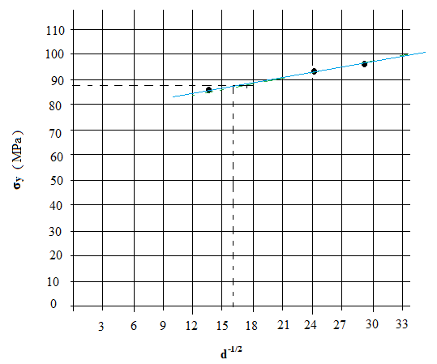[1]
A tensile strength of 87.5 MPa corresponds to a d^{-1/2} value of 16. Thus,

d^{-1/2} = 16, d = 0.0039= (1/256.41 ) [0.5]

Hence, the average grain size at 87.5 MPa is 256.41 grains/mm² [1]
------------------------------------------------------------------------------------------------------------------------------
- Determine the value of σ_{o} in the Petch relationship given below and explain its significance.

σ_{y} = σ_{o} + kd^{-1/2}
Solution
- σ_{y} = σ_{o} + kd^{-1/2} , hence σ_{o} = σ_{y} - kd^{-1/2} [1]

k is intercept, i.e k = Δy/Δx = (97.5 – 85)/(28.57 -13.69)= 0.84
Hence, σ_{o} = 87.5 - (0.84 x 16) [1]
= 74.06 MPa [2]
σ_{o} = 74.06 MPa is the estimated strength of a single crystal [1]

